APPLICATION FOR ADVERTISEMENT CONSENT CASE OFFICER REPORT

APPLICATION REFERENCE: | PL/2026/03652
APPLICATION TYPE: | Consent to display an advertisement
SITE ADDRESS: | Esso Service Station, Junction of Larkhill road and Bulford Road, Durrington, Salisbury, SP4 8DP
DEVELOPMENT DESCRIPTION: | Erection of a D6 Small Format Advertisement Display
RECOMMENDATION: | Refuse

SITE DESCRIPTION/CONTEXT

The application relates to the ESSO garage located on a corner plot fronting Larkhill Road and Bulford Road; adjacent to a mini roundabout which also provides access to Robin Hill Lane ( a no-through road).

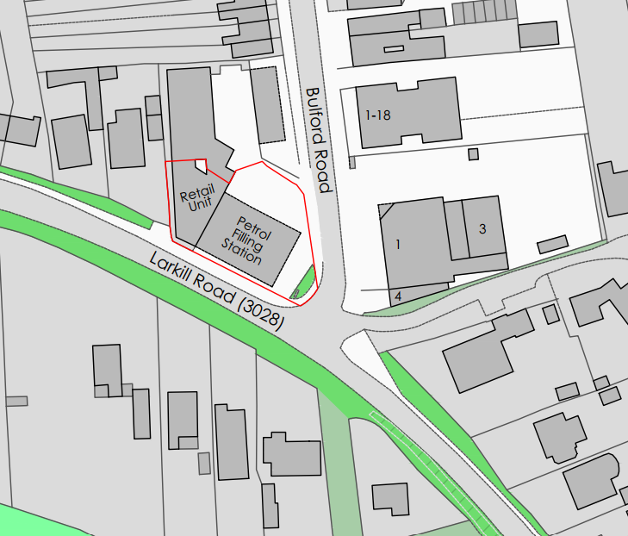

The site is located within the settlement boundary of Durrington, which is designated as a Market Town, defined as such by Core Policies 1, 2 and 4 of the Wiltshire Core Strategy. The site has residential neighbours to the north, west and south; to the east are commercial properties which include Tesco and a barber shop; there are other commercial premises in the locality.

The site is located approx. 250 metres to the north west of the boundary of Bulford conservation area.

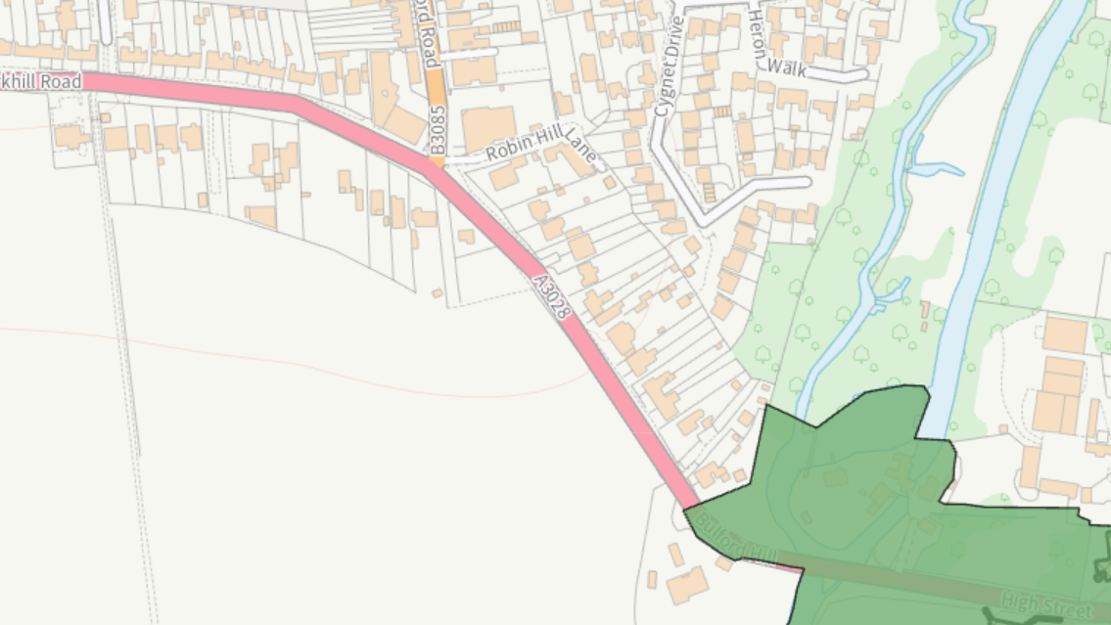

PROPOSAL:

The application seeks advertisement consent for the installation of a free standing internally illuminated digital sign. The proposed sign will replace an existing free standing sign.

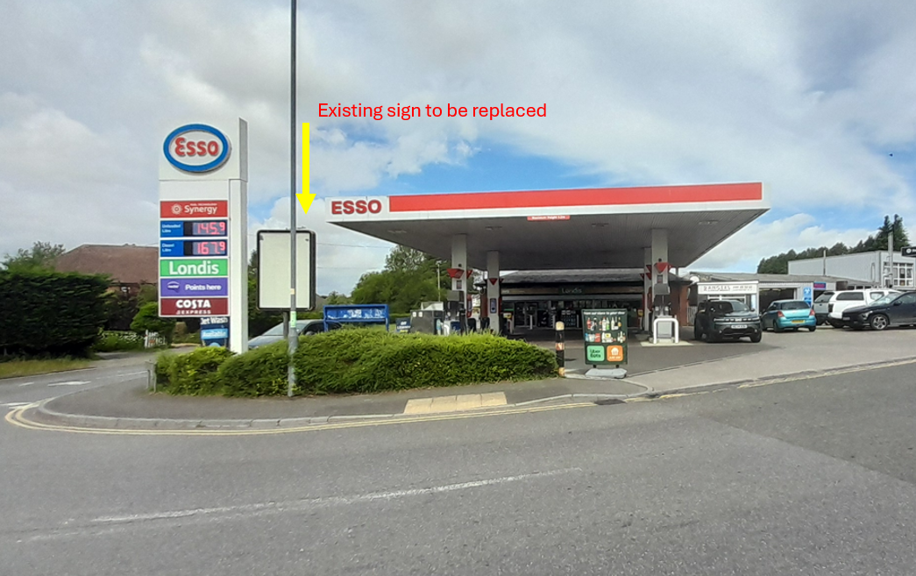

The proposed advertisement will measure approximately 2.45 metres in height with a width of 1.23 metres and depth of 0.34 metres, as shown in the proposed elevations below.

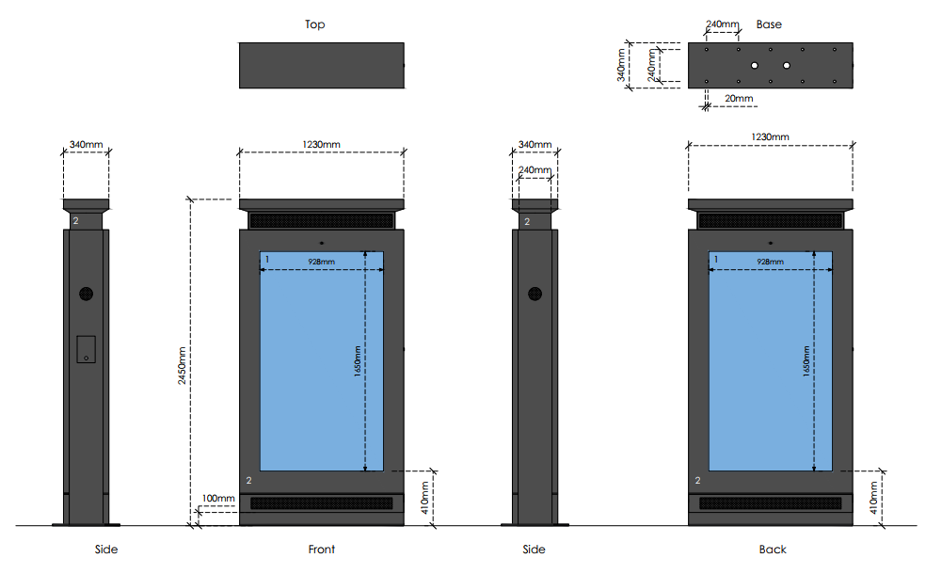
The application includes a CGI showing the proposed sign as it might appear once installed.

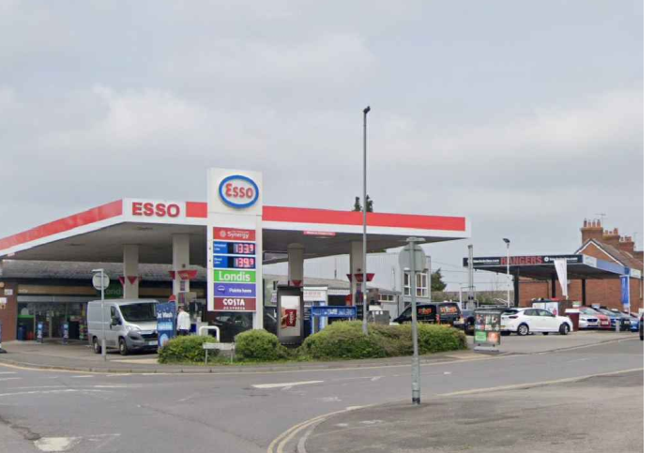

It is understood that the proposed sign will show a mix of local campaigns, national campaigns, and products/services sold on the petrol station site and will be capable of displaying 6 advertising campaigns at a time, sequencing every ten seconds.

RELEVANT LEGISLATION, POLICIES AND GUIDANCE

Planning (Listed Building and Conservation Areas) Act 1990 – section 72

The Town and Country Planning (Control of Advertisements) (England) Regulations 2007

National Planning Policy Framework (NPPF)
Paragraph 141

Planning Practice Guidance (PPG)
Advertisements

Wiltshire Core Strategy 2015 (WCS):

CP1 (Settlement Strategy)
CP2 (Delivery Strategy)
CP4 (Spatial Strategy for the Amesbury Community Area)
CP57 (Ensuring High Quality Design & Space Shaping)
CP58 (Ensuring the Conservation of the Historic Environment
CP62 Development Impacts on the Transport Network

Supplementary Planning Documents:

Wiltshire Design Guide
Creating Places Design Guide
Institute of Lighting Professionals: The Brightness of Illuminated Advertisements (2014) PLG 05.
Salisbury Shopfronts and Advertisements Design Guide

RELEVANT PLANNING HISTORY:

Proposal / Summary
S/2010/0280 - Consent to display an advertisement Decision - Approve with Conditions Date: 20/4/2010 – 1no. internally illuminated pole mounted display unit

ISSUES

The issues that are relevant to the consideration of an application for consent to display advertisements are the effects of the proposal on ‘amenity’ and ‘public safety’.

CONSULTEE RESPONSES

The following consultees were invited to comment on this application:

Town Council: Durrington Town Council has considered this application and wishes to raise concerns regarding the potential impact of the proposed signage on highway safety.
The Council is aware that the existing signs associated with the site already present visibility issues for road users at this junction. Given the location of the proposed sign, Members are concerned that any additional signage could further impede visibility or distract drivers, particularly when approaching or emerging from the junction.
The Council therefore requests that the Local Planning Authority gives careful consideration to the highway safety implications of the proposal and seeks the views of the Highway Authority as appropriate. In particular, the Council asks that the cumulative impact of the existing and proposed signage on visibility and the safe operation of the junction is fully assessed before any decision is made.
Whilst the Council makes no comment on the design of the proposed sign itself, it considers that road safety should be a primary consideration in determining this application.

Wiltshire Council’s Highways Engineer: No objection subject to conditions

RESPRESENTATIONS

Below is a summary of the representations received during the consultation period. Only material planning considerations have been taken into account in the assessment of this application. Non-material issues, such as property values or private legal disputes, cannot be considered in the determination process.

No third party comments have been received.

ASSESSMENT

Regulation 3 of The Town and Country Planning (Control of Advertisements) (England) Regulations 2007 requires that local planning authorities exercise their powers in relation to the display of advertisements in the interests of amenity and public safety, taking into account the provisions of the development plan, in so far as they are material, and any other relevant factors.

The NPPF (141) is clear that the quality and character of places can suffer when advertisements are poorly sited and designed and should be subject to control only in the interests of amenity and public safety, also considering the cumulative impacts.

Impact on Amenity:

“Amenity” is not exhaustively defined in the Town and Country Planning (Control of Advertisements) (England) Regulations 2007 but is generally understood to include both visual and aural amenity. Factors relevant to amenity include the general characteristics of the locality, such as the presence of features of historic, architectural, cultural, or similar interest.

In broader planning terms, as reflected in the National Planning Policy Framework (NPPF), amenity refers to the quality or character of an area and the elements that contribute to the overall enjoyment and liveability of a place.

Core Policy 57 of the Wiltshire Core Strategy requires a high standard of design and seeks development that responds positively to local character and distinctiveness. Criterion (x) specifically requires the sensitive design of advertisements and signage that are appropriate and sympathetic to their local setting by means of scale, design, lighting and materials.

The Wiltshire Design Guide aims to improve the quality of development across Wiltshire by ensuring new places are attractive, locally distinctive, sustainable, climate-resilient and supportive of healthy communities, while providing practical guidance for implementing Core Policy 57.

Policy CP58 relates to heritage assets – the Bulford conservation area is close by.

Paragraph 141 of the National Planning Policy Framework states that the quality and character of places can suffer when advertisements are poorly sited and designed. The Planning Practice Guidance confirms that visual amenity must be assessed having regard to the general characteristics of the locality and the effect of the advertisement upon the immediate neighbourhood.

The application seeks consent for the erection of a freestanding internally illuminated digital advertisement display. Whilst the proposal would replace an existing freestanding advertisement structure, it is not considered that visual impact can be assessed solely by reference to the number of signs present on the site. The proposed display would introduce a form of advertisement materially different in character to the sign it replaces. By virtue of its internally illuminated digital display and regularly changing content, the advertisement would have a significantly greater visual presence within the streetscene and would draw attention to a far greater degree than the existing static display. It is this increased visual prominence, rather than (or in conjunction with) the simple number of signs on the site, that gives rise to concern.

Officers acknowledge that digital advertising is increasingly common within many town and city centre locations. However, the prevalence of digital advertising elsewhere does not in itself indicate that it would be appropriate in every location. Advertisement proposals must be assessed having regard to the characteristics of their specific surroundings.

The site occupies a prominent corner position at the junction of Larkhill Road and Bulford Road and is readily visible within the wider streetscene from a number of public viewpoints. Whilst the physical dimensions of the proposed structure are relatively modest in comparison with some surrounding built form, the principal concern does not relate solely to its size. It is considered that the combination of illumination, changing digital content and prominent corner siting would result in a visually intrusive feature that would draw disproportionate attention within the streetscene.

Officers acknowledge that the site forms part of a commercial petrol filling station and contains existing signage associated with that use. However, the presence of existing commercial signage does not automatically justify the introduction of a digitally illuminated advertisement display. Whilst commercial uses are present within the vicinity, residential properties are also located to the north, west and south of the site. The proposed display would therefore be experienced not only by passing motorists and pedestrians but also by nearby residents. It is considered that the illuminated and changing nature of the display would introduce a conspicuous commercial feature into the locality which would be harmful to visual amenity, particularly during hours of darkness when the display would be most prominent.

The applicant has advised that the display would not incorporate moving images, flashing content or transitional effects and that changes between advertisements would occur instantaneously. The applicant also advises that illumination levels would be controlled and adjusted to ambient lighting conditions. Officers acknowledge that such measures would reduce the visual impact of the proposal when compared to unrestricted digital advertising displays. However, it is not considered that these measures overcome the fundamental concern that the proposal would introduce a prominent internally illuminated digital advertisement into a highly visible location. Notwithstanding any controls on luminance or advertisement changes, the display would remain materially more visually prominent than the existing static advertisement by reason of its illuminated format and changing content.

The applicant has referred to examples of digital advertising displays elsewhere in support of the proposal. However, each application must be considered on its own merits and having regard to its own site-specific context. It is considered that digital advertisements possess a materially different visual presence to static advertisements due to their illumination and changing content. Consequently, the replacement of a static display with a digital display cannot be regarded as a neutral alteration in visual amenity terms.

Whilst the site is not located within the conservation area, the site is viewed when leaving the conservation area heading uphill from Bulford to Durrington, the illuminated sign will be highly visible when travelling in this direction. Of note and relevant is a recent appeal at a site at 57 Wilton Road in Salisbury (PL/2024/04269) which proposed the replacement of a poster sign with a digital advertisement. This site is outside of the conservation area but views from the conservation area were affected, this application was refused for the following reason –

The proposed digital poster would replace an existing, unauthorised static poster advertisement. It would be significantly bolder and a more eye-catching display than the existing poster during the day and particularly during the hours of darkness. It would be readily visible in long range views including from within the nearby Old Manor Hospital conservation area.

It is concluded that the proposed digital poster would negatively impact on the visual qualities of the area by reason of its inappropriate scale, illumination and the fact it would be significantly bolder than the existing static poster sign.

The proposal is therefore considered to be contrary to the aims of the NPPF in particular paragraphs 8 and 141 and Core Policies 57 and 58 of the adopted Wiltshire Core Strategy.

This was dismissed at appeal (3351421), the Inspector concluded -

“I consider that the proposal conflicts with paragraph 141 of the National Planning Policy Framework and whilst not decisive, I have had regard to Policies 57 and 58 of the Wiltshire Core Strategy adopted January 2015 which require the sensitive design of advertisements which are appropriate and sympathetic to their local setting by means of scale, design, lighting and materials, and require proposals to conserve the settings of designated heritage assets, including the special character or appearance of Conservation Areas, especially in regard to orientation, size and night-time illumination.”

Having regard to the character of the area, the prominent siting of the display and the presence of nearby residential properties, it is considered that the proposal would result in unacceptable harm to visual amenity. The advertisement would appear as an unduly prominent and intrusive feature within the streetscene, to the detriment of the character and appearance of the locality. Accordingly, it is considered that the proposed advertisement would conflict with Core Policy 57 of the Wiltshire Core Strategy, the Council’s Supplementary Planning Guidance on Shopfronts and Advertisements, paragraph 141 of the National Planning Policy Framework and the provisions of the Town and Country Planning (Control of Advertisements) (England) Regulations 2007.

Impact on Public Safety:

“Public safety” is not exhaustively defined in the Town and Country Planning (Control of Advertisements) (England) Regulations 2007, but it generally refers to the potential impact of a development or advertisement on the safe use and operation of public spaces, including roads, footpaths, and other areas accessible to the public.

In assessing public safety, the Local Planning Authority (LPA) may consider:

Whether the proposal would obstruct visibility for road users or pedestrians;
Whether it could distract, confuse, or mislead drivers, particularly near junctions or crossings;
Whether it interferes with traffic signs, signals, or street lighting;
Whether it poses a physical hazard, such as through poor structural integrity or inappropriate siting.

The National Planning Policy Framework (NPPF) also supports the principle that planning decisions should ensure developments create places that are safe, inclusive, and accessible, and that they do not undermine public safety or security.

CP62 advises that proposals should provide appropriate mitigating measures to offset any adverse impacts on the transport network at both the implementation and operational stages.

The proposed advertisement is located within the forecourt of a petrol filling station on a prominent roadside site and would be visible to motorists travelling along the adjoining highway, to the junction of Larkhill Road, Bulford Road and Robin Hill Lane. The display would comprise an internally illuminated digital advertising screen designed to attract attention from passing members of the public. The proposal has therefore been assessed having regard to its potential effects on public safety.

Concerns have been raised by Durrington Town Council and the local Ward Member regarding the possible implications of the proposed advertisement for highway safety, particularly given its location adjacent to a busy junction. These comments have been carefully considered as part of the assessment.

The proposed display would comprise an internally illuminated digital advertisement. The display would be capable of presenting a sequence of advertisements and is therefore inherently more visually prominent than a traditional static sign. However, the submitted information confirms that the display would not incorporate moving images, animation, flashing content or scrolling text. Advertisements would change instantaneously at fixed intervals (every 10 seconds) rather than through transitional effects.

Wiltshire Council's Highways Engineer has reviewed the proposal and has raised no objection, subject to appropriate conditions. No evidence has been provided to demonstrate that the proposed display would obstruct visibility at the junction, interfere with traffic signs or highway equipment, or otherwise compromise the safe operation of the highway network.

Whilst officers acknowledge that the advertisement would be designed to attract attention, this is an inherent characteristic of advertising displays generally and, in this instance, insufficient evidence has been submitted to demonstrate that the proposal would result in a degree of driver distraction that would give rise to an unacceptable risk to highway users. Furthermore, the operational controls proposed would limit features commonly associated with increased driver distraction.

Having regard to the consultation response from the Highway Authority, the nature of the proposed display and the absence of substantive evidence demonstrating highway safety harm, officers do not consider that a refusal on public safety grounds could be reasonably sustained. The proposal is therefore considered acceptable in respect of public safety for the purposes of the Advertisement Regulations.

Benefits and Public Interest

The applicant has identified benefits associated with the digital display and has referred to wider trends in digital advertising.

Whilst officers acknowledge the applicant's submissions regarding the wider trend towards digital advertising and the potential commercial benefits associated with the display, it is considered that such benefits do not outweigh the identified harm to visual amenity arising from the prominent, internally illuminated and changing nature of the proposed advertisement.

The proposal principally comprises a commercial advertising display. Whilst commercial advertising is not objectionable in principle, it does not automatically outweigh identified harm to visual amenity.

Officers therefore attribute only limited weight to the benefits identified by the applicant. Such benefits do not outweigh the harm arising from the scale, prominence and internally illuminated nature of the proposed advertisement.

CONCLUSION:

The proposed advertisement has been assessed in accordance with the relevant provisions of the Town and Country Planning (Control of Advertisements) (England) Regulations 2007.

It is considered that the proposal would introduce an incongruous, internally illuminated digital advertising display into an area already characterised by a substantial amount of signage and commercial activity. The display would add to visual clutter, introduce an unnecessarily dominant advertising feature and materially alter the character of the site when compared with the existing static signage.

The proposal would therefore result in unacceptable harm to visual amenity and the character and appearance of the locality, contrary to Core Policy 57 of the Wiltshire Core Strategy, the Wiltshire Design Guide, the Council's Shopfronts and Advertisements Guidance and the aims of paragraph 141 of the National Planning Policy Framework.

RECOMMENDATION: That Advertisement Consent be REFUSED.

The proposed freestanding internally illuminated digital advertisement, by reason of its scale, illumination, changing digital content and prominent siting, would appear as a visually dominant and intrusive feature within the streetscene. The advertisement would add to the existing concentration of signage on the site, resulting in visual clutter and detracting from the character and appearance of the locality. By virtue of its prominent corner location and visibility from surrounding public viewpoints, the display would have an adverse effect on visual amenity.

The proposal is contrary to Core Policy 57 of the Wiltshire Core Strategy, the Wiltshire Design Guide, Salisbury Shopfronts and Advertisements Design Guide and paragraph 141 of the National Planning Policy Framework, which seek to ensure that advertisements are appropriately designed and do not harm amenity.

Informative

For the avoidance of doubt the documents and plans considered in reaching the above decision, all received 09/06/2026 are as follows:

Application form
Existing site plan Drg no FS763 PA 02
Proposed site plan Drg no FS763 PA 03
Proposed site plan Drg no FS763 PA 04
Existing and proposed elevations Drg no FS763 PA 05
Design specification Drg no FS763 PA 06
Existing and proposed sign CGI’s Drg no FS763 PA 07
Planning statement
Highway safety report

