APPLICATION FOR LISTED BUILDING CONSENT
OFFICER DELGATED REPORT

APPLICATION REFERENCE: | PL/2026/03071
APPLICATION TYPE: | Listed building consent (Alt/Ext)
SITE ADDRESS: | 50 Market Place, Chippenham, SN15 3HU
DESCRIPTION OF WORKS: | Installation of defibrillator and bleed kit cabinets to external wall of Nationwide Building Society branch
RECOMMENDATION: | Approve with Conditions

SITE DESCRIPTION/CONTEXT
The subject property is GII-designated, C19, 3-storey terraced building, probably a remodelling of an older building, currently operating as a Nationwide Building Society with flats above.

Built in limestone ashlar under a slate roof, with plat bands, cornice and single/tripartite sash windows, the shop front at ground floor level is modern.

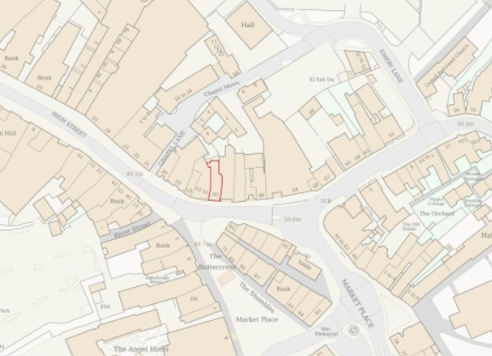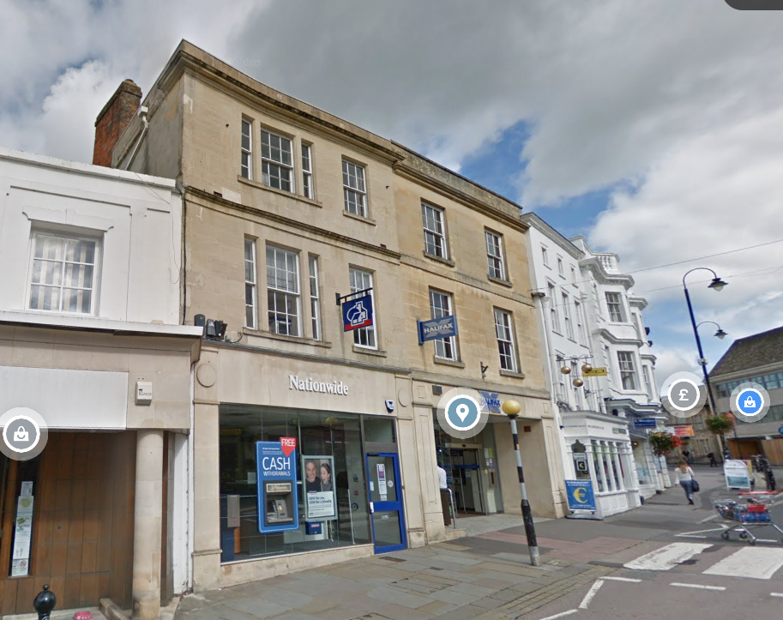
Location Plan and Google Earth Site Photo

The building is within the historic core of Chippenham, with medieval layout and character still legible, and with many listed retail and civic buildings around the market place. The bank is highly visible within the Chippenham Conservation Area.

PROPOSAL
The proposal is for the installation of individual defibrillator and bleed kit cabinets to an external, front elevation wall of the building. All as per drawings and details below.

The cabinets would be 44cm x 62.5cm, with both St John’s Ambulance and Nationwide Building Society branding, and are at a height for easy access, shaped and located to be discrete whilst recognisable.

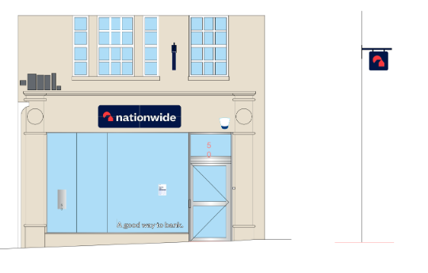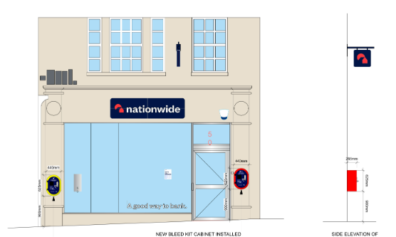
Existing and Proposed Front Elevation
Existing and Proposed Side Elevation

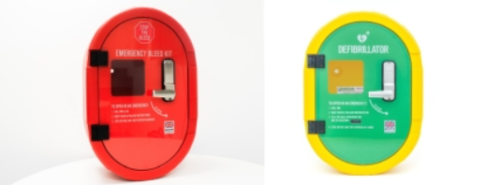
Proposed Bleed Cabinet and Defibrillator

RELEVANT PLANNING HISTORY
N/04/03590/FUL - Full planning permission Decision - Approve with Conditions Date: 9/2/2005 – ALTERATIONS TO SHOP FRONT IN ASSOCIATION WITH DISABLED RAMP
N/04/03591/LBC - Listed building consent Decision - Approve with Conditions Date: 9/2/2005 – INTERNAL AND EXTERNAL ALTERATIONS IN ASSOCIATION WITH THE PROVISION OF A DISABLED RAMP
N/08/01321/ADV - Consent to display an advertisement Decision - Approve with Conditions Date: 24/7/2008 – Installation of Non-Illuminated Letters and Hanging Sign on Front Elevation
N/07/01758/LBC - Listed building consent Decision - Approve with Conditions Date: 21/8/2007 – Refurbishment, Including Stainless Steel New Shopfront, Incorporating New ATM and Wheelchair Lift
N/07/01759/FUL - Full planning permission Decision - Approve with Conditions Date: 21/8/2007 – Refurbishment, Including Stainless Steel New Shopfront, Incorporating New ATM and Wheelchair Lift
N/08/01336/LBC - Listed building consent Decision - Approve with Conditions Date: 24/7/2008 – Installation of Non-Illuminated Individual Letter Sign
N/08/01532/LBC - Listed building consent Decision - Approve with Conditions Date: 12/8/2008 – Installation of Non-Illuminated Timber Painted Hanging Sign
17/07316/FUL - Full planning permission Decision - Approve with Conditions Date: 4/10/2017 – ATM swap - existing raised floor to be lowered. New metal and glass safety rails to be installed around floor recess
17/07317/LBC - Listed building consent Decision - Approve with Conditions Date: 4/10/2017 – ATM swap - existing raised floor to be lowered. New metal and glass safety rails to be installed around floor recess
17/04672/LBC - Listed building consent Decision - Approve with Conditions Date: 23/11/2017 – The upgrade of existing signage and refresh of shopfront.
17/03430/ADV - Consent to display an advertisement Decision - Approve with Conditions Date: 23/11/2017 – 1 no. non-illuminated fascia sign, 1 no. internally illuminated hanging sign, new ATM surround and window vinyls
19/08654/LBC - Listed building consent Decision - Approve with Conditions Date: 8/11/2019 – Replacement of existing front (main access) door with new door that meets current security requirements.
18/01762/LBC - Listed building consent Decision - Approve with Conditions Date: 24/4/2018 – Colour change of the existing fascia signage lettering from bronze to blue.
18/01761/ADV - Consent to display an advertisement Decision - Approve with Conditions Date: 24/4/2018 – Colour change of existing fascia signage letters from bronze to blue.
19/07712/FUL - Full planning permission Decision - Approve with Conditions Date: 1/10/2019 – Minor internal alterations
19/07764/LBC - Listed building consent Decision - Approved Date: 1/10/2019 – Minor internal alterations
PL/2024/00968 - Listed building consent (Alt/Ext) Decision - Approve with Conditions Date: 10/4/2024 – Proposed fascia sign, projecting sign, ATM surround, statutory signage and associated works
PL/2024/00967 - Consent to display an advertisement Decision - Approve with Conditions Date: 10/4/2024 – Proposed fascia sign, projecting sign, ATM surround, statutory signage and associated works
13/02494/ADV - Consent to display an advertisement Decision - Approve with Conditions Date: 6/9/2013 – 1 Non-Illuminated Fascia Sign, 1 Non-Illuminated Projecting Sign and 1 Non-Illuminated ATM Tablet Sign.
13/03733/FUL - Full planning permission Decision - Approve with Conditions Date: 29/10/2013 – Change of Use from A1/A3 (sui generis) to A1
N/06/00338/ADV - Consent to display an advertisement Decision - Refused Date: 29/3/2006 – Display of External and Internally Illuminated Fascia Sign
N/07/00152/COU - Full planning permission Decision - Approve with Conditions Date: 14/3/2007 – Change Of Use from Class A2 (Financial and Professional Services) to Mixed Class A1/A3 (Sui generis)
N/07/00565/S73A - Full planning permission Decision - Approve with Conditions Date: 26/6/2007 – Four Air Conditioning Units
N/07/02587/ADV - Consent to display an advertisement Decision - Approve with Conditions Date: 3/1/2008 – Erection of One Externally Illuminated Fascia Sign and One Projecting Sign
PL/2025/03775 - Prior approval part 3 Class G - COU from Use Class E, Betting Office or Pay Day Loan Shop to a mixed use including up to 2 Flats Decision - Prior Approval Granted with Conditions Date: 16/6/2025 – Proposed change of use of two upper floors (first floor and second floor) from commercial banking use to 2 self-contained apartments including associated internal alterations
PL/2026/01822 - Full planning permission Decision - Approve with Conditions Date: 7/5/2026 – Alterations to, and replacement of shopfront.
PL/2026/03025 - Full planning permission – Proposed partial change of use of ground floor of existing commercial floorspace, (Class E) to a domestic apartment, (Class C3). Some commercial floor space is to be retained as Class E.

RELEVANT LEGISLATION, POLICIES AND GUIDANCE

Legislation
From the point of view of the historic environment the main statutory tests are set out within the Planning (Listed Building and Conservation Areas) Act 1990. Section 16 requires that special regard be given to the desirability of preserving listed buildings, their settings or any features of special architectural or historic interest which they possess.

Section 72(1) of the Planning (Listed Building and Conservation Areas) Act 1990 also requires the Council to pay special attention to the desirability of preserving or enhancing the character or appearance of designated Conservation Areas.

National Policy and Guidance
The National Planning Policy Framework (NPPF) sets out government policy, including in respect of the historic environment.

Section 16 of the NPPF ('Conserving and enhancing the historic environment') sets out the Government's high-level policies concerning heritage and sustainable development.

Paragraphs 213-215 of the NPPF require a balanced approach with any harm which would be caused being weighed against the potential public benefits which might be achieved. Paragraph 210 requires local planning authorities to take account of the desirability of sustaining and enhancing the significance of heritage assets and of new development making a positive contribution to local character and distinctiveness.

National Planning Practice Guidance provides guidance on interpreting the NPPF.

Historic England Advice Note 2: Making changes to Heritage Assets, illustrates the application of policies set out in the NPPF in determining applications for LBC (and planning permission).

Wiltshire Core Strategy:
Whilst not directly relevant to listed building consent applications, the below policies give an indication of the Council’s approach to development affecting heritage assets:

- Core Policy 57 ‘Ensuring high quality design and place shaping’: A high standard of design is required in all new developments, including extensions, alterations, and changes of use of existing buildings. Development is expected to create a strong sense of place through drawing on the local context and being complementary to the locality.

- Core Policy 58 ‘Ensuring the conservation of the historic environment’ requires that “designated heritage assets and their settings will be conserved, and where appropriate enhanced, in a manner appropriate to their significance.”

ISSUES
Impact upon the preservation of the listed building and its setting within the Conservation Area.

CONSULTATION RESPONSES
Chippenham Town Council: support. With the following suggested Informative: Please could the Case Officer inform the Community Safety Partnership of this proposal in order that the location of such kits can be better co-ordinated moving forward.

REPRESENTATIONS
In accordance with the requirements of Section 5(1) of the Planning (Listed Buildings and Conservation Areas) Regulations 1990 (as amended) the application for listed building consent was publicised by way of:

- A site notice displayed near the site;
- An advertisement placed in the local press.

These methods were used to inform interested parties and to allow a statutory consultation period of 21 days for representations to be submitted.

There were no representations received during the consultation period. In accordance with the provisions of the Planning (Listed Buildings and Conservation Areas) Act 1990, only matters relevant to the consideration of the building’s special architectural or historic interest have been taken into account in the assessment of this Listed Building Consent application.

ASSESSMENT
In accordance with Section 16(2) of the Planning (Listed Buildings and Conservation Areas) Act 1990, special regard has been given to the significance of the listed building, including its architectural and historic interest, and the desirability of preserving both the building and its setting. Relevant policies within the National Planning Policy Framework (NPPF), particularly Section 16: Conserving and Enhancing the Historic Environment, have also been taken into account. These policies require that any harm to the significance of a designated heritage asset must be clearly justified and weighed against the public benefits of the proposal.

In order to be acceptable, the application needs to be assessed against the following criteria:

Information considered/submitted
Paragraph 207 requires that applicants describe the significance of any heritage assets affected, including any contribution made by their setting. This should include sufficient information to provide a clear understanding of the significance of the heritage asset and its setting and the potential impact of any proposals on that significance.

The application is supported by a Planning Statement explaining the requirements of the proposal.

Paragraph 208 also provides for the local planning authority to make its own assessment of impact and the following heritage recommendations are offered on this basis.

Assessment of significance:
According to the National Planning Policy Framework (NPPF), significance is defined as:

“The value of a heritage asset to this and future generations because of its heritage interest. The interest may be archaeological, architectural, artistic or historic. Significance derives not only from a heritage asset’s physical presence, but also from its setting.”

Historic England further categorises significance into four key values:

- Evidential – the potential of the asset to yield evidence about past human activity.
- Historic – the ways in which the asset illustrates aspects of history.
- Aesthetic – the sensory and design qualities of the asset.
- Communal – the meanings and associations attached to the asset by people.

The significance of the subject building lies largely with its historic fabric and architecture - its form, layout and architectural expression/detailing and use of high-quality design materials which have significant aesthetic and architectural interest, and which contribute to the character of the Conservation Area.

The fully glazed shop front between the pilasters is entirely modern and so lacks any special character. The two cabinets would be fixed to the two pilasters.

Impact of proposals on the significance and setting of the building/structure:
Understanding the impact of proposed works on a listed building requires a careful and proportionate assessment of how those changes affect the asset’s heritage significance and its setting. This includes both the physical alterations to the building itself and any changes to its spatial or visual relationship with surrounding structures or spaces.

The significance of a heritage asset is not static; it is shaped by its architectural, historic, and communal values, and by how these are experienced in context. Therefore, any intervention must be considered in light of the asset’s identified significance, with attention given to both potential harm and benefits. Benefits may include repairs that support the long-term conservation of the building, improved energy performance, or enhanced public access and understanding.

This assessment is grounded in the statutory duty under Section 16 of the Planning (Listed Buildings and Conservation Areas) Act 1990, which requires special regard to be given to the desirability of preserving the building and its features of special interest. It is also informed by national policy, particularly paragraphs 212-221 of the National Planning Policy Framework (NPPF), and relevant local heritage policies and guidance.

The proposal does not seek to harm the form, layout or architectural detailing or high-quality materials, but affix to the two pilasters, and so would entail minimal harm to the historic fabric; only fixing points that can be easily repaired when required so as to be unnoticeable.

The cabinets could be seen as additional modern clutter, but in a high street of shop fronts, signs, adverts, besides the subject dwelling’s modern shop front, this is not considered inappropriate to the subject dwelling or Conservation Area. The prominent high street location and small scale but recognisable colours of the cabinet supports the purpose of the cabinets.

Both units would be small, with minimal projection outwards and at a height, rounded shape and bright colour to mitigate any potential harm.

As such the proposals would lead to minimal harm to the significance of the building, offset by substantial community benefits, such that it is justified.

CONCLUSION
In this case, the impact of the proposals on heritage assets will be largely neutral and the requirements of current conservation legislation, policy or guidance are considered to be met. In this case, the proposals will also result in considerable community benefits.

The requirements of current conservation legislation, policy or guidance are considered to be met.

RECOMMENDATION:
That Listed Building Consent be GRANTED, subject to conditions.

