CASE OFFICER'S REPORT

Application Reference: PL/2025/05845
Application Type: Full planning permission
Consultation ends: 11/08/2025
Case officer: Russell Brown

Site Address: Land at Manor Farm, Main Street, Keevil, Trowbridge, BA14 6LU
Proposal: Erection of one self-build dwelling and associated works
Recommendation: Approve subject to conditions and s106 agreement

POLICIES

The Wiltshire Core Strategy (WCS) - The following Core Policies (CP) are relevant when assessing this application: CP1 (Settlement Strategy), CP2 (Delivery Strategy), CP3 (Infrastructure Requirements), CP15 (Melksham Area Strategy), CP50 (Biodiversity and Geodiversity), CP51 (Landscape), CP52 (Green Infrastructure), CP57 (Ensuring High Quality Design and Place Shaping), CP58 (Heritage), CP60 (Sustainable Transport), CP61 (Transport and Development), CP62 (Development Impacts on the Transport Network), CP64 (Demand Management), CP67 (Flood Risk).

When adopting the WCS, some policies remain saved from the West Wiltshire District Local Plan (1st Alteration) (WWDLP). Those which are relevant to this application include: U1a (Foul Drainage/sewerage treatment)

Wiltshire Waste Core Strategy - WCS6 (Waste Audit)

The following document list also merits due consideration:
Wiltshire’s Community Infrastructure Levy – Planning Obligations Supplementary Planning Document (Planning Obligations SPD)
Wiltshire’s Community Infrastructure Levy - Charging Schedule (Charging Schedule)
Wiltshire’s Community Infrastructure Levy - Regulation 123 List (123 List)
Wiltshire Local Transport Plan 2011-2026 – Car Parking Strategy
Wiltshire Housing Land Supply Statement (Updated Base Date April 2023 – Published June 2024).
Update on Housing Land Supply in light of Revised NPPF (December 2024).
Wiltshire Design Guide (2024)

The National Planning Policy Framework (NPPF) and National Planning Practice Guidance (NPPG)

Draft Wiltshire Local Plan Policies

- Policy 1: Settlement Strategy
- Policy 2: Delivery Strategy
- Policy 3: Reserve sites and broad locations for growth
- Policy 4: Addressing climate change
- Policy 5: Securing infrastructure provision from new development
- Policies 52 – 63: Trowbridge Area Strategy
- Policies 76 – 84: Social, housing, community, public open space and wellbeing
- Policies 85 – 101: Sustainability, ecology, water and landscape, heritage, air quality

At Full Council on 19 May 2026, the elected members of Wiltshire Council agreed to withdraw the emerging Wiltshire Local Plan. The said Plan has no material weight for the purposes of the application.
In accordance with Regulation 19 of the Town and Country Planning (Local Planning) (England) Regulations 2026, on 30th June 2026 Wiltshire Council published a notice of intention to prepare a new local plan for Wiltshire. The next stage is a Scoping Consultation which commences on 2nd September 2026. This plan is at a very early stage and currently carries no weight for decision making.
CONSULTATION RESPONSES

Keevil Parish Council

Keevil Parish Council has resolved to COMMENT on the application as follows, based on its adopted Village Planning Policy and taking into account community factors which, in its view, should be considered by the LPA:
COMMUNITY CONTEXT
Building and strengthening a strong sense of community is important anywhere, but none more so than in rural environments, where our landscape has been shaped and preserved by our farming families over generations. These values are important to our Parish, and it is this connection which is felt differentiates this application from others in similar vein.
The applicants are the 4th generation of a local farming family who wish to create a long-term family home for themselves and their daughters, raising the children on the family farm, evolving the traditional farm holding, and perpetuating the family’s connection with the historic farmstead, school, and community. The proposed design and materials appear sympathetic to the historic setting, set well back from Main Street and constructed to blend in with the surroundings.
Trees and hedgerows, including the ancient landmark horse chestnut tree, are to be preserved, and measures implemented to encourage wildlife to flourish. The plot is a small field separated by the farm track (which would provide the dwelling's access) from the larger pasture for many years, and redundant due to its unsuitability for grazing or heavy farm machinery.
The Parish Council understands the applicants are willing to make adjustments such as relocating solar panels so they will not be visible from the street and reviewing the measures for sewage and drainage.
However, this must be viewed in the context of other policy factors important to the preservation of the historic village setting, and in this respect the Council has a duty to be consistent in how these factors are considered. The policy is attached to this submission for reference.
1. VILLAGE SETTING:
The preservation of the conservation area, landscape and historic character is paramount. Whilst growth is a necessary part of life, the proposal will change the setting at one of only two approaches to the most historic part of the village. We urge the applicants to work closely with the Conservation Officer to minimise impact and enhance the historic character.
2. SETTLEMENT:
Our open spaces make a significant contribution to the character of the street scene, particularly where they provide views to the open countryside, which is why we do not wish to see development on green fields or farmland. However, we recognise the plot, separated as it is by the farm track, has been redundant and unsuitable for modern farming for many years, and that neighbours most impacted have expressed support.
Nonetheless, the Council is concerned by the detrimental impact on the street scene and views of solar panels on the front of the house, which should be relocated. Furthermore, it would like to see a preservation condition relating to the ancient horse chestnut tree, such that the root system is protected from damage during construction works, and no changes made to the tree as a result of the existence of the new dwelling, in perpetuity.
In addition, plans were not clear whether sufficient soakaways were included or how sewage and drainage would be effectively managed. The Council is concerned that any increase in load on the infrastructure would increase flood risk further down the hill where there are already weak points due in part to run-off from the top of Main Street contributing to flooding at the bottom.
3. NEW BUILDING
In an historic village setting it is vital that all development remains in keeping with the existing landscape and character setting, incorporating materials and designs in harmony with the built environment, and this becomes ever more paramount on the edge of the natural village limits. We urge the applicants to work closely with the Conservation Officer to find ways to meet the special character needs of this location.

Conservation

Detailed comments provided, summarised as follows:

The proposal will result in harm to the setting of the listed buildings and character and appearance of the conservation area via impact of the proposed development on the agricultural setting of the historic isolated farmstead. The proposals could be considered as causing ‘less than substantial harm’ for the purposes of interpreting the NPPF, but they involve the erosion of the setting of the neighbouring listed buildings and the character and appearance of the conservation area, and as such should not be seen as being of lesser consequence. Indeed, the wording of the NPPF, and the ‘special regard’ by Section 66 and ‘special attention’ by Section 72 of the Act requires that any level harm caused should be taken seriously.

Whilst paragraph 208 allows that a level of harm may be offset by public benefits, which could include conservation benefits, in this case no objective justification has been provided for the works and the proposals are articulated as being primarily for the convenience of the occupants i.e. a private benefit. As a result, the proposals fail to meet with the requirements of current conservation legislation, policy or guidance and I therefore recommend refusal.

Highways

The site is served by an existing, established access and therefore, if you support such planning application, no highway objection is raised.

Ecology and Natural England

The Council’s ecologist has no objections. The information was received to allow an Appropriate Assessment to be undertaken positively, which Natural England has endorsed, also with no objections.

REPRESENTATIONS

Eleven letters have been received from members of the public, all in support of the application. The full comments are available on the public file, but can be summarised as follows:

- Fully support this application for development as it provides for the housing of a new and growing generation of Keevil residents who understand the importance of maintaining the village life in Keevil. Who will grow to support the community and the facilities enjoyed e.g. the village school, the church and the social hub so important to village life.
- This development only adds to that world renown image of Wiltshire with a traditional design to seamlessly blend in with the ethos of the surroundings with no detriment to the outlook and it poses no threat to traffic or security for other residents.
- The proposed design fits in well with the character of Keevil and makes good use of the land.
- The proposed house and the materials to be used I feel would enhance the street scene. I agree with the proposed plans that the beautiful chestnut tree should be preserved.
- It will be well set back from the road that it will hardly be noticeable.
- The applicants have clearly designed this family home to a high standard, incorporating energy-efficient features and a layout that will be both functional and aesthetically pleasing. It will only enhance the beauty surrounding this family home.
- I do not believe the proposal will impact adversely on the integrity of the Conservation Area (CA) or listed buildings, being of a traditional design and sympathetic to surroundings, close to existing farm buildings and within the built environment of the farm and village itself. There is already precedent within Keevil for new build within the CA close to a listed building, and also within the curtilage of a listed building itself.

PLANNING HISTORY

No relevant planning history on this application site. However, it is notable that other single houses have been built in the immediate area with similar relationships to the local heritage assets.

ASSESSMENT

Section 70(2) of the Town and Country Planning Act 1990 and section 38(6) of the Planning and Compulsory Purchase Act 2004 require that the determination of planning applications must be made in accordance with the Development Plan, unless material considerations indicate otherwise. The National Planning Policy Framework (NPPF) is a key material planning consideration. Local planning authorities should consider whether otherwise unacceptable development could be made acceptable through the use of conditions or planning.

Core Policy 57 of the Wiltshire Core Strategy states: “A high standard of design is required in all new developments … Development is expected to create a strong sense of place through drawing on the local context and being complementary to the locality. Applications for new development must be accompanied by appropriate information to demonstrate how the proposal will make a positive contribution to the character of Wiltshire …”

Site and Proposal

The application site is located within the open countryside, on the edge of the Small Village of Keevil. The site sits between two farms, without other residential dwellings in the vicinity.

Location Plan:
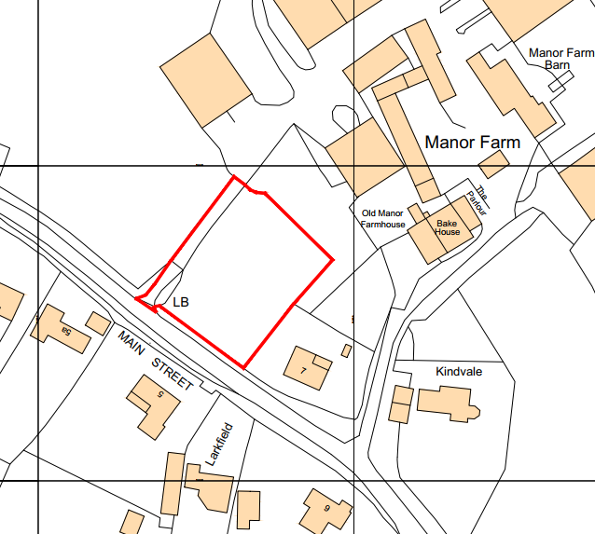

The site is a small paddock that does not provide much agricultural value to the farm. The proposal is to place a two-storey traditional dwelling on this site, as a self-build scheme.

The site is within the Bath and Bradford on Avon Bat Special Area of Conservation. It also lies within a Conservation Area and is close to listed buildings.

Listed building map (hatched buildings are all Grade II listed):
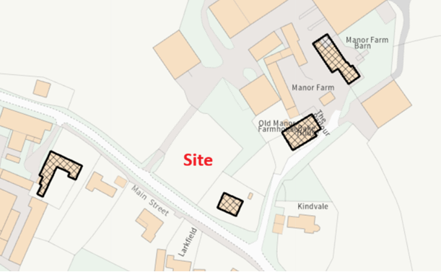

Principle of development

Section 70(2) of the Town and Country Planning Act 1990 and section 38(6) of the Planning and Compulsory Purchase Act 2004 require that the determination of planning applications must be made in accordance with the Development Plan, unless material considerations indicate otherwise.

Assessment against the WCS
The Wiltshire Core Strategy (WCS) sets out the ‘Settlement Strategy’ and ‘Delivery Strategy’ for development within the Local Authority area. Core Policy 1 defines the settlement strategy and identifies four tiers of settlements, including: Principal Settlements, Market Towns, Local
Services Centres, Large Village and Small Villages. Outside of these settlements is defined as the open countryside.

The site within but on the edge of Keevil. Keevil is a Small Village and the site is outside of any settlement boundaries within the Melksham Community Area, it is therefore considered to be situated within the defined open countryside, where new open-market housing development is generally contrary to Core Policies 1, 2 and 15 of the WCS.

As the application site is contrary to Core Policies 1, 2 and 15, the principle of development cannot be supported by the strategic, delivery or exceptional policies within the WCS.

The Council’s five-year housing land supply
The National Planning Policy Framework (NPPF) was revised in December 2024. This has reintroduced the requirement to meet five years’ worth of deliverable housing sites and a buffer to be applied to the five-year housing requirement in all circumstances. It has also revised the Local Housing Need calculation to establish the five-year housing requirement. These factors have resulted in a substantial increase in the five-year housing requirement to be met from the previous calculation. When this is assessed against the housing land supply which can be delivered within five years, the recalculation shows a significant reduction in the number of years supply. The resulting position shows that the Council can currently demonstrate a 2.8 years housing land supply of housing at a unitary authority level. This is considered to be a substantial shortfall.

The absence of a five-year housing land supply is a material consideration in the determination of this application. In accordance with Paragraphs 78 and 11(d) of the National Planning Policy Framework (NPPF), for applications involving the provision of housing, where there is a shortfall in the supply of deliverable housing sites, the most important policies for determining the application should be considered out of date.

The current housing land supply shortfall is a factor that must be considered in the planning balance and in this case, as a five-year housing land supply cannot be demonstrated, the weight that can be applied to the most important policies for determining this application should be assessed and altered in the light of the shortage in housing land supply. The proposal must be assessed against the national policy context of the need to boost housing supply and the
benefits of delivering new homes whilst having particular regard to the key policies set out in paragraph 11(d) and Footnote 9 of the NPPF.

The NPPF sets out that the purpose of the planning system is to contribute to the achievement of sustainable development, including the provision of homes.

Whilst the site may be unsustainable from a policy perspective. The site sits between two farms and other dwellings and so can be considered as in-fill development.

Self-build and Custom Housebuilding
The Self-build and Custom Housebuilding Act 2015 (as amended) places a duty on local authorities in England to keep a register of individuals and associations of individuals who are seeking to acquire serviced plots of land for self-build or custom housebuilding projects. This Act, amended by the Housing and Planning Act 2016 and the Levelling Up and Regeneration Act 2023, aims to facilitate the delivery of more self-build and custom-built homes, including a duty to grant planning permission for self-build and custom build homes to meet the demand for this type of housebuilding arising in an authority’s area.

It is suggested within the application form that the proposed dwelling would be self-build. It is therefore pertinent to assess against the legislative definition of self-build and custom dwellings.

The Self-build and Custom Housebuilding Act 2015 (as amended) (SBCH Act) defines Selfbuild and Custom Housing (SCH) housing as:
(A1)...the building or completion by—
(a)individuals,
(b)associations of individuals, or
(c)persons working with or for individuals or associations of individuals, of houses to be occupied as homes by those individuals.
(A2) But it does not include the building of a house on a plot acquired from a person who builds the house wholly or mainly to plans or specifications decided or offered by that person...

In addition to the SBCH Act, the PPG offers further advice on the benefits of SCH:

Self-build and custom housebuilders choose the design and layout of their home, and can be innovative in both its design and construction.

Paragraph 63 of the NPPF also states that the needs of “people wishing to commission or build their own homes should be considered”.

Wiltshire Council does not currently have an adopted policy or supplementary planning document that covers development of SCH at a local level. The adopted Wiltshire Design Guide is also silent on matters relating to the delivery of SCH.

In addition to the SBCH Act definition, various Appeal decisions have considered that a key element of SCH housing includes the requirement to be clear that the owner of the home will have the primary input into the final design and layout of the property. Based on the Applicant’s submitted statements, the LPA accepts the proposal would be a self-build home with the primary design input able to be exercised by the applicant.

As well as providing a definition for SCH, the SBCH Act also places a duty on LPAs to provide a certain number of SCH per year. This should be achieved partly by keeping a self-build register where those interested in building their own home can register an interest. This site is not proposed to be brought forward by an individual registered with the Council, but it can contribute towards the council’s duty to grant permission for a certain number of SCH. As such, the self-build element of this proposal is considered to have several benefits; the main being that it will add to the Council’s self-build housing supply and that secondly, it will enable the applicant to meet their needs in terms of specialist housing that normal market homes cannot provide for.

To ensure the LPA has control over these benefits the applicant has agreed to enter into a Unilateral Undertaking (UU) to secure the dwelling as a self-build unit to be occupied by them.

Layout and detailed design

Existing layout:

Proposed layout:
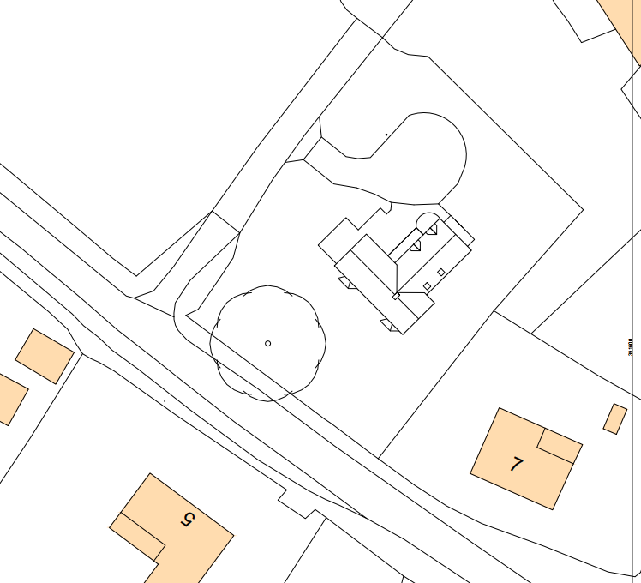

Detailed layout:
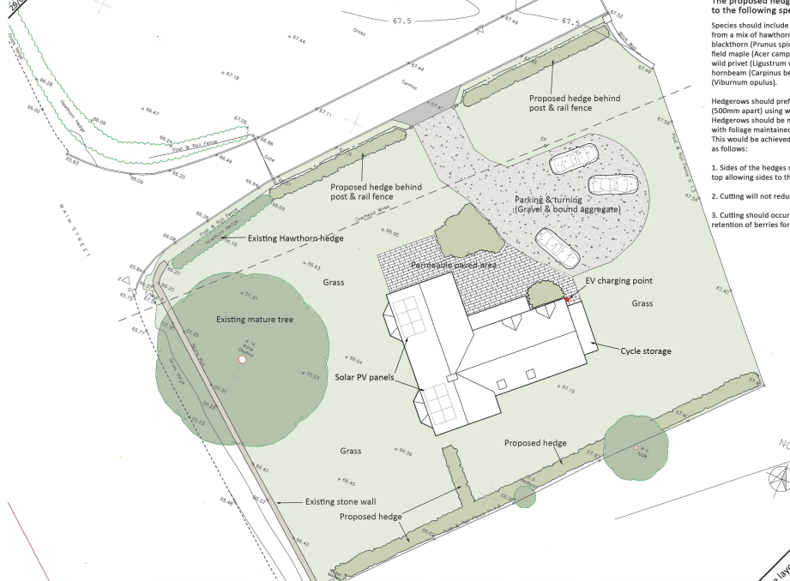

The proposed dwelling would be two-storey in height and of a traditional farmhouse aesthetic. The design would reference local traditional features and natural materials would be used – brick, stone and slate with oak posts and lintels.

Proposed elevations:
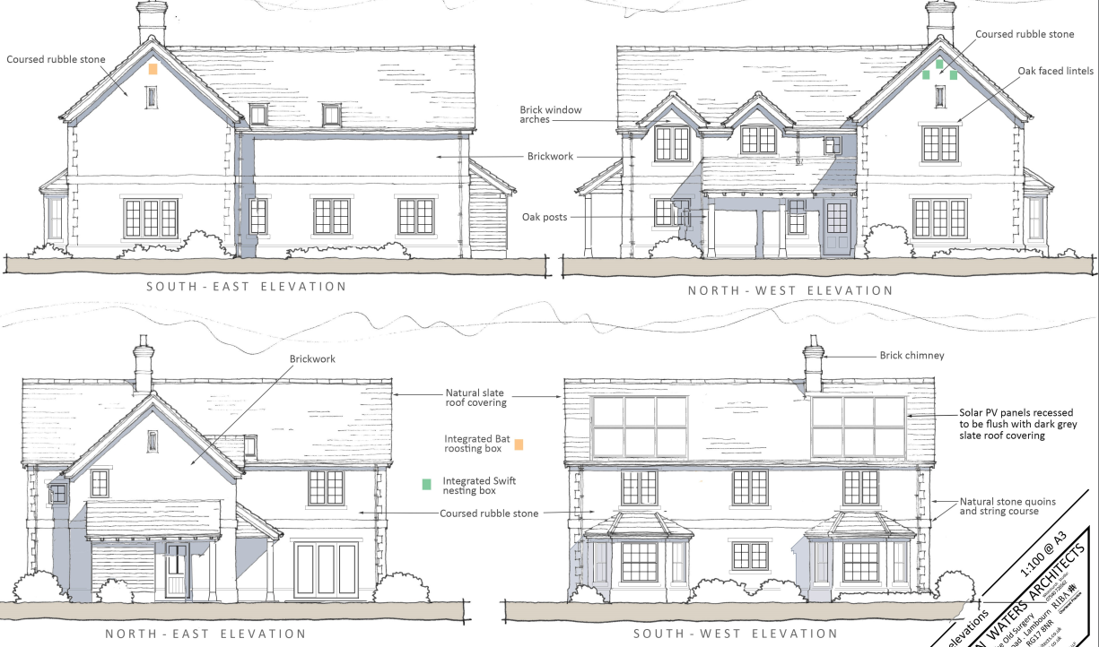

This is considered to be an acceptable design response to the surroundings, and giving due credit to the agricultural and edge of village character of the site.

Impact on heritage assets

The Council’s Core Strategy Policy CP58 ‘Ensuring the conservation of the historic environment’ requires that “designated heritage assets and their settings will be conserved, and where appropriate enhanced, in a manner appropriate to their significance.”

The NPPF defines significance as the “value of a heritage asset to this and future generations because of its heritage interest. The interest may be archaeological, architectural, artistic or historic. Significance derives not only from a heritage asset’s physical presence, but also from its setting.”

Listed building arrangement around the site:

Manor Farm Barn would not be affected by the proposed dwelling, due to the intervening farm buildings.

The Old Manor Farmhouse, to the east of the site, addresses the south east from its front elevation. The main farm entrance has always been the route in the above map to the west of Kindvale. The access to the rear farmyard to the west of the application site started as a track that has become formalised over time to reach that rear yard.

The application site therefore lies to the rear of the listed farmhouse. The farmhouse can be glimpsed from Main Street, as shown below. The setting of the farmhouse is of lesser significance from this approach. The main significance of its setting is to the front (east) of the farmhouse. Therefore, a traditional dwelling of natural materials, such as the proposed, would not harm the setting of that listed building.

View across site to the glimpse of Old Manor Farmhouse:
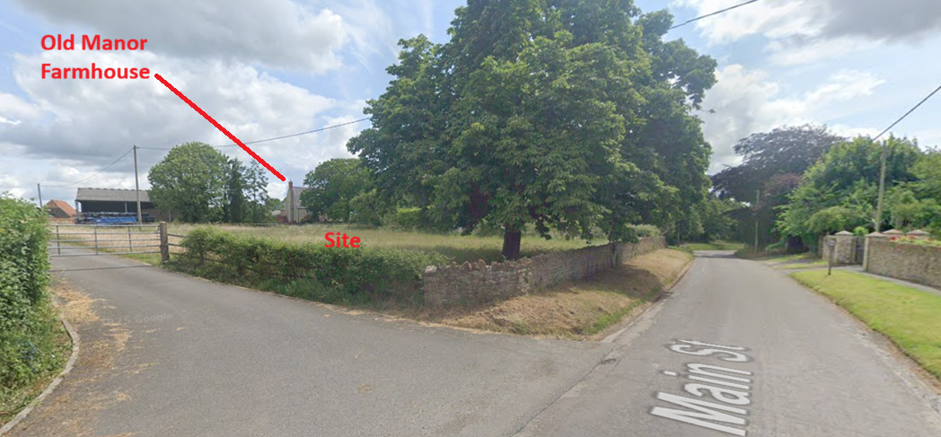

There are also modern buildings in the vicinity of the farmhouse, notably Kindvale, which also sits within the setting of the farmhouse, but arguably the most important part of the historic setting at the front of the listed building.

View along main farm entrance with the listed farmhouse glimpsed at the top, with the modern Kindvale in the right of the image:
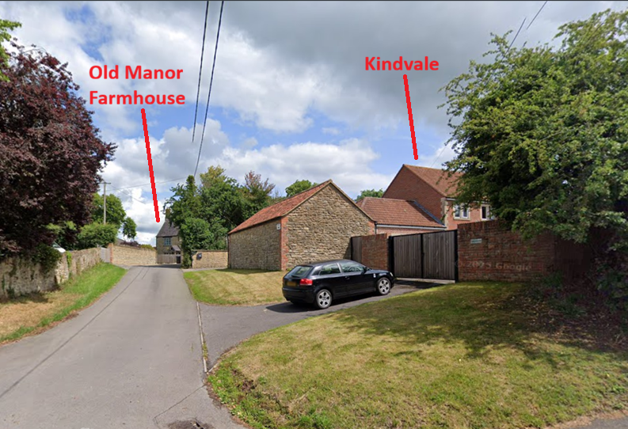

The neighbouring property to the site is a Grade II listed building, 7 Main Street. The proposed dwelling would be over 40m away from that dwelling, and the use of traditional details and materials would be a complementary addition to the street scene and historic setting. There may be the perception of some less than substantial harm to the setting of that building as the currently empty paddock would be built on.

Relationship between site and neighbouring property:
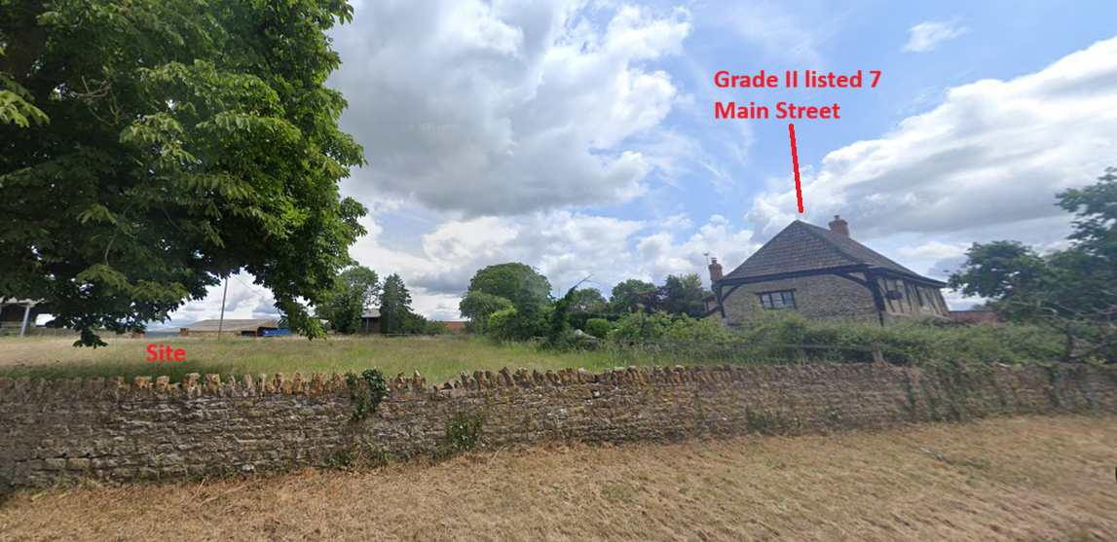

In conclusion, the dwelling would be visible within the setting of 7 Main Street, but due to the traditional approach to the new dwelling, the less than substantial harm to the historic setting would be minimised.

There would not be a demonstrable impact to the other listed building settings, given the distances, orientations and intervening buildings involved in the relationships between the buildings. Other modern dwellings have been built in similar locations in the immediate area, showing that a mixed character at this point is the reality.

Impact on highways

The Highways team have no objection as the site is served by an existing, established access which does not compromise highway safety.

Impact on ecology and BNG

The application is located within a 2km core buffer zone for lesser horseshoe bats associated with the Bath and Bradford-on-Avon Bat SAC. However, as no physical structures are present on the site, and no vegetation other than modified grassland would be affected by the development, the impact on bats would be minimal if any impact at all.

The applicant has provided surveys that have allowed our Ecology team to undertake an Appropriate Assessment, which concluded favourably. This has been assessed by Natural England against the Habitat Regulations, and they agree that there would be no impact.

BNG is not required in this case given that it is exempt as a self-build scheme. This will be secured by a legal agreement to which the applicant has committed.

Impact on neighbouring and public amenity

In terms of overlooking, the proposed new dwelling would be over 40m away from the nearest neighbour to the south east, 7 Main Street. This is more than an acceptable distance between the sides of buildings. The house opposite the proposal would be at a distance of over 90m, front elevation to front elevation, again this is an acceptable distance, especially given the intervening road.

The house would be a traditional two storey rural dwelling built in natural materials. It is distant enough from other dwellings such that it would not result in any overbearing or overshadowing impact.

Impact on landscape

As described in the above sections, the siting of the dwelling, between two farms with other houses in the vicinity, means that it would fit into the edge of village character.

The detailed design of the dwelling being traditional and using natural materials would further recess into village character in the wider landscape.

Therefore, the visual impact of the proposed dwelling on the wider landscape would be minimal.

CONCLUSION

The proposed dwelling would be in the open countryside, although very well related to the village of Keevil. There would be a small amount of less than substantial harm to the setting of 7 Main Street, Grade II listed building due to the proximity and high visibility along the road. The self-build nature of the proposal does fulfil a Council need, as well as adding to the housing stock at a time when the Council does not have a 5 year housing land supply.

Paragraph 215 of the NPPF states: Where a development proposal will lead to less than substantial harm to the significance of a designated heritage asset, this harm should be weighed against the public benefits of the proposal including, where appropriate, securing its optimum viable use.

It is considered that the benefit of the additional house, as a self-build, outweighs the minor less than substantial harm to the setting of the listed building.

RECOMMENDATION
Approve subject to successful completion of a s106 agreement (in this case a UU) for the restriction of the development to form a true self-build scheme.

Conditions:

1. The development hereby permitted shall be begun before the expiration of three years from the date of this permission.

REASON: To comply with the provisions of Section 91 of the Town and Country Planning Act 1990 as amended by the Planning and Compulsory Purchase Act 2004.

2. The development hereby permitted shall be carried out in accordance with the following approved plans:

Application Forms, Drawing Nos. 25002-105-A, 25002-104-A, 25002-102-D, 25002-103-D, 25002-100-C received on 10th July 2025

External Lighting Design Rev B received on 24th February 2026

REASON: For the avoidance of doubt and in the interests of proper planning.

3. No development shall proceed above slab level until the exact details of the materials to be used for the external walls and roofs have been submitted to and approved in writing by the Local Planning Authority. Development shall be carried out in accordance with the approved details.

REASON: The matter is required to be agreed with the Local Planning Authority in order that the development is undertaken in an acceptable manner, in the interests of visual amenity and the character and appearance of the area.

4. Notwithstanding the submitted details, the proposed development shall not be occupied until means/works have been implemented to avoid private water from entering the highway.

REASON: To ensure that the highway is not inundated with private water.

5. No part of the development hereby permitted shall be first occupied until the access, turning and parking area have been completed in accordance with the details shown on the approved plans. The areas shall always be maintained for those purposes thereafter.

REASON: In the interests of highway safety.

6. No external lighting, other than that shown on the approved plans, shall be installed on site until plans showing the type of light appliance, the height and position of fitting, illumination levels and light spillage in accordance with the appropriate Environmental Zone standards set out by the Institute of Lighting Engineers in their publication “Guidance Notes for the Reduction of Obtrusive Light” (ILE, 2021)”, have been submitted to and approved in writing by the Local Planning Authority. The approved lighting shall be installed and shall be maintained in accordance with the approved details and no additional external lighting shall be installed.

REASON: In the interests of the amenities of the area and to avoid harm to bats.

Informatives:

CIL Informative:
The applicant is advised that the development hereby approved may represent chargeable development under the Community Infrastructure Levy Regulations 2010 (as amended) and Wiltshire Council's CIL Charging Schedule. If the development is determined to be liable for CIL, a Liability Notice will be issued notifying you of the amount of CIL payment due. If an Additional Information Form has not already been submitted, please submit it now so that we can determine the CIL liability. In addition, you may be able to claim exemption or relief, in which case, please submit the relevant form so that we can determine your eligibility. The CIL Commencement Notice and Assumption of Liability must be submitted to Wiltshire Council prior to commencement of development. Should development commence prior to the CIL Liability Notice being issued by the local planning authority, any CIL exemption or relief will not apply and full payment will be required in full and with immediate effect. Should you require further information or to download the CIL forms please refer to the Council's Website https://www.wiltshire.gov.uk/dmcommunityinfrastructurelevy.

Ecology informative:
1.Please note that this consent does not override the statutory protection afforded to any protected species. All British bat species are protected under The Conservation of Habitats and Species Regulations 2010 (as amended), which implements the EC Directive 92/43/EEC in the United Kingdom, and the Wildlife and Countryside Act 1981 (as amended). This protection extends to individuals of the species and their roost features, whether occupied or not. If bats are discovered, all works should stop immediately and a licensed bat worker should be contacted for advice on any special precautions before continuing (including the need for a derogation licence from Natural England).
2.Please also be advised that works should not take place that will harm nesting birds from March to August inclusive. All British birds (while nesting, building nests and sitting on eggs), their nests and eggs (with certain limited exceptions) are protected by law under Section 1 of the Wildlife and Countryside Act 1981 (as amended) and the Countryside and Rights of Way Act 2000. If birds are nesting on/in or within the vicinity of the proposed development, work should be undertaken outside the breeding season for birds to ensure their protection, i.e. works should only be undertaken between August and February. Further advice on the above can be sought from the Council Ecologists.
3.Barn Owls are included in Schedule 1 of the Wildlife & Countryside Act 1981. Within Part 1, Section 21 (1) the penalty for an offence involving a Barn Owl, it's nest, or egg, includes a fine of up to £5,000, or up to six months imprisonment, or both, per bird, nest or egg.

