APPLICATION FOR HOUSEHOLDER PLANNING PERMISSION DELEGATED REPORT

APPLICATION REFERENCE: | PL/2026/03759
APPLICATION TYPE: | Householder planning permission
SITE ADDRESS: | 5 Tinneys Close, Woodfalls, Salisbury, SP5 2LU
DEVELOPMENT DESCRIPTION: | Proposed a single storey flat roof side extension.
RECOMMENDATION: | That Planning Permission be GRANTED

PROPOSAL

The proposal seeks planning permission for the erection of a single storey flat roof side extension.

During the course of the application process, amended plans were received to remove the window in the west elevation of the proposed extension due to Officer concerns regarding the amenity impacts of this window.

Existing elevations -

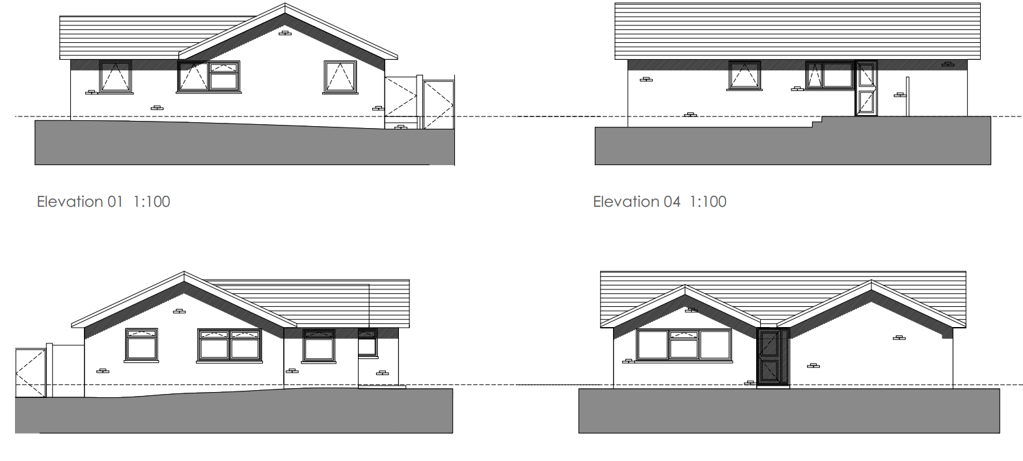

Proposed elevations -

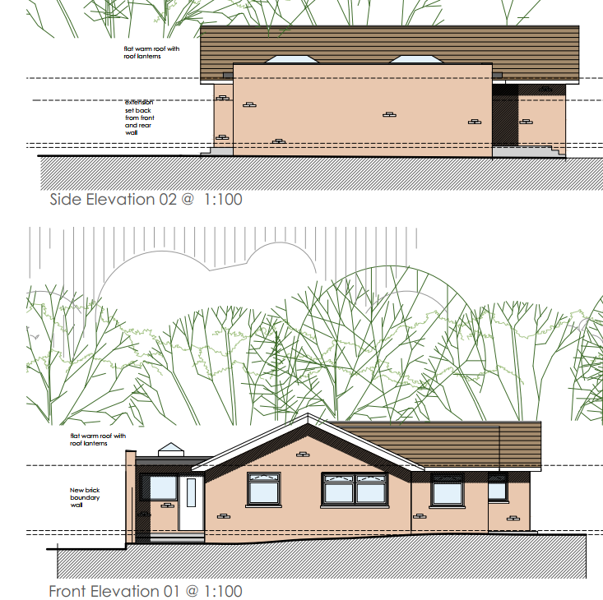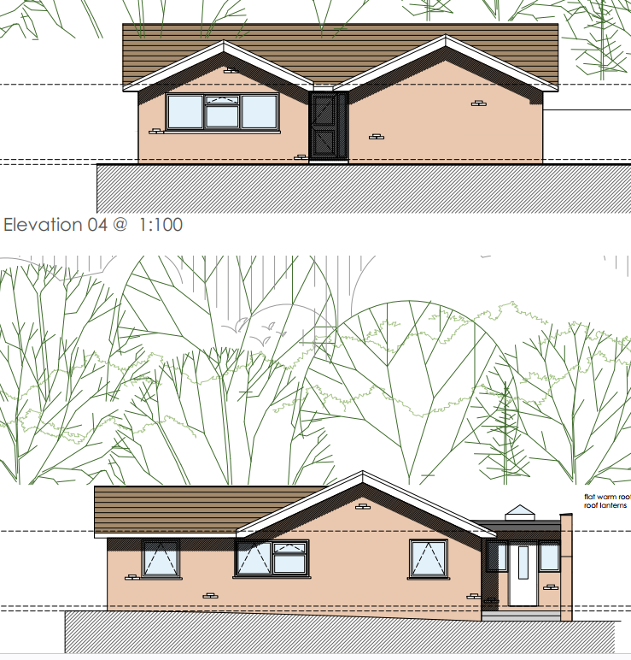

Existing plans –

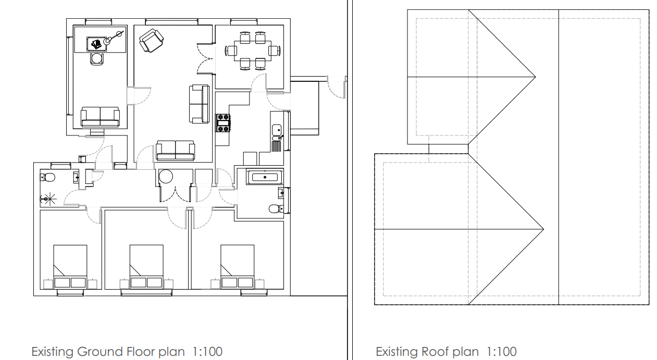

Proposed plans –

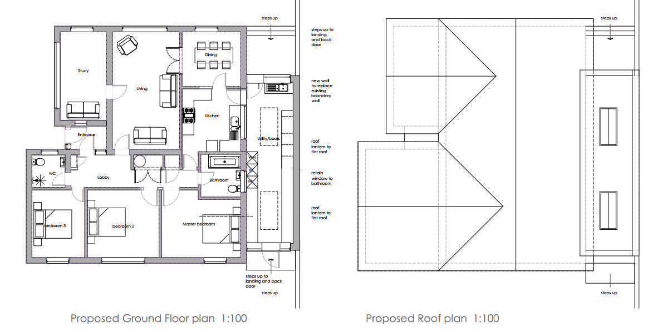

SITE DESCRIPTION/CONTEXT

The application site relates to a modest single storey dwelling located within a cul-de-sac comprising similar single storey dwellings. The property is set back from the road and has an open front garden laid to lawn. To the rear is a level enclosed garden. A garage and off road parking are provided to the east side of the dwelling.

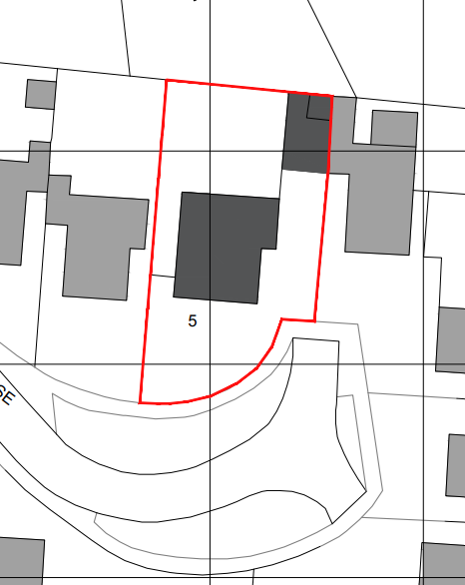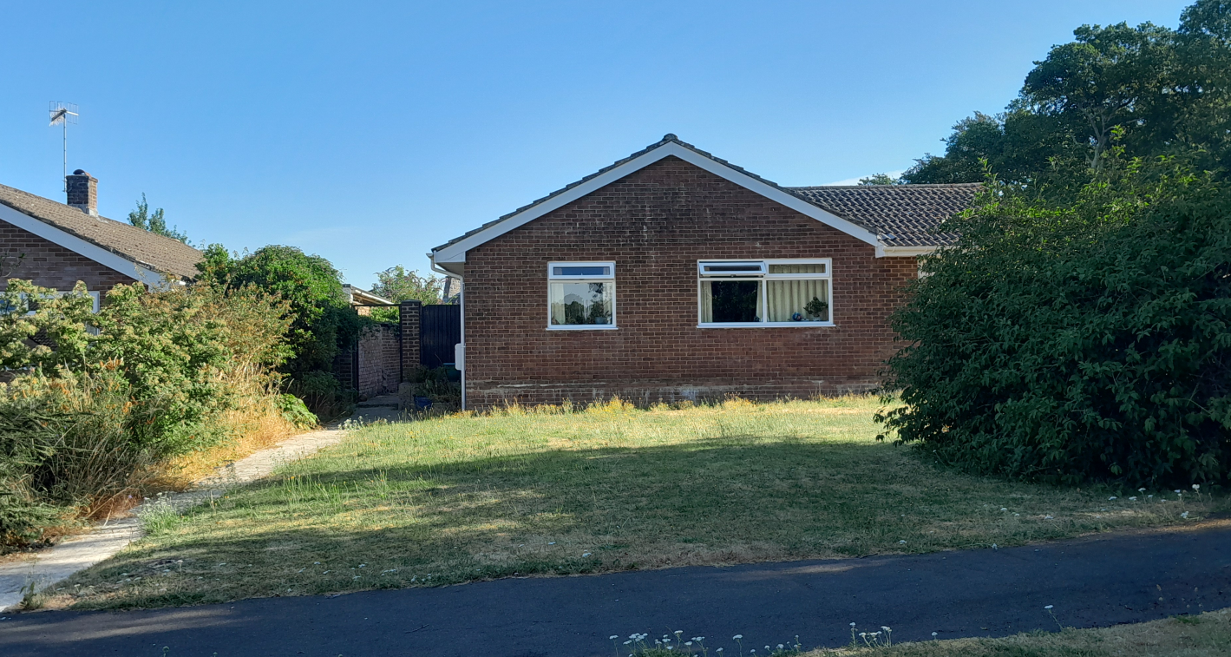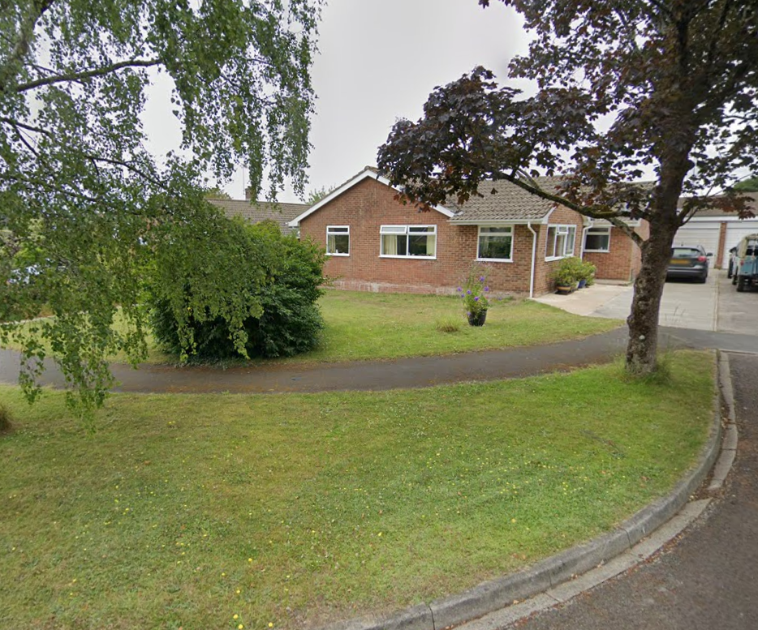

The site is located on the southern edge of the large village of Woodfalls, as defined by Wiltshire Core Strategy (WCS) policies CP1, CP2 and CP23. The limits of the settlement boundary are shown on the map extract below marked with a thick black line. The site lies just outside of The New Forest National Park, shown below in blue.

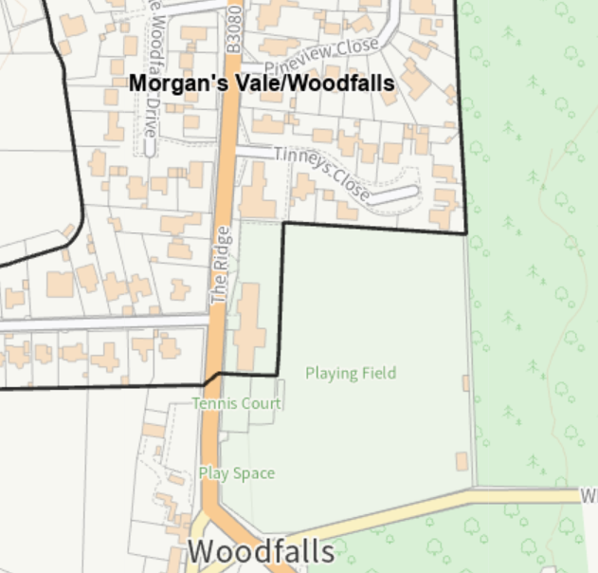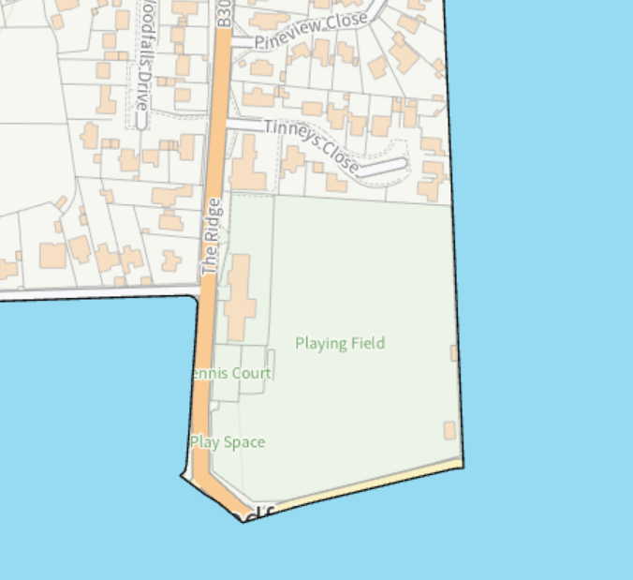

The application site is also within a Special Landscape Area, as defined by saved Salisbury District Local Plan policy C6. Whilst the site is in Flood Zone 1 and is not in the immediate vicinity of any rivers, it is situated within the Hampshire River Avon Catchment and is within the 13.8-kilometre recreational buffer of the New Forest Special Protection Area (SPA).

PLANNING HISTORY

None

RELEVANT POLICIES AND GUIDANCE

The National Planning Policy Framework (NPPF)
The Planning Practice Guidance
National Design Guide

Wiltshire Core Strategy:

Core Policy 1: Settlement Strategy
Core Policy 2: Delivery Strategy
Core Policy 23: Spatial Strategy: Southern Wiltshire Community Area
Core Policy 50: Biodiversity
Core Policy 51: Landscape
Core Policy 57: Ensuring High Quality Design and Place Shaping
Core Policy 69 Hampshire River Avon Catchment

Saved Salisbury District Local Plan Policies - Saved Policy C6: Special Landscape Area

Wiltshire Design Guide: Appendix D – Design Guidance for Householder extensions
Creating Places Design Guide

CONSULTATION RESPONSES

Parish Council: Support

REPRESENTATIONS

No comments were received.

ASSESSMENT

Section 38(6) of the Planning and Compulsory Purchase Act 2004 states:

"If regard is to be had to the development plan for the purposes of any determination to be made under the planning Acts, the determination must be made in accordance with the plan unless material considerations indicate otherwise."

In accordance with this statutory requirement, this application has been assessed against the relevant policies of the Development Plan, including the adopted Wiltshire Core Strategy (2015) and, where applicable, any made Neighbourhood Plans.

Design and Impact upon the character and context of the area

Core Policy 57 - Ensuring High Quality Design and Place Shaping of the Wiltshire Core Strategy seeks to ensure that all new development is of high design quality, reflecting local context, character, and distinctiveness.

The proposed development comprises a modest single storey flat roof side extension positioned alongside the existing bungalow. The roof will include two roof lanterns. Although flat roofs are not typically regarded as the most sympathetic form or most visually appealing form of extension design, the immediate locality contains examples of flat-roofed built form. In this context, it would be difficult to substantiate an objection solely on the basis of the proposed roof form. When considered alongside the modest scale of the extension, its subordinate relationship with the host dwelling and the use of matching materials, the development is not considered to result in harm to the character or appearance of the dwelling or surrounding area. The proposed materials, including brickwork to match the existing dwelling and white UPVC fenestration, would ensure the extension integrates appropriately with the host property. Furthermore, whilst visible from the street scene, the development would appear as a proportionate addition and would not result in harm to the character and appearance of either the dwelling or the wider area.

Having regard to the scale, siting, design and proposed materials, the development is considered to represent an acceptable form of householder development that respects the character of the existing dwelling and its surroundings. The proposal is therefore compliant with Core Policy 57 of the Wiltshire Core Strategy, together with the guidance contained within Appendix D of the Wiltshire Design Guide

Amenity

Point vii of Core Policy 57 - Ensuring High Quality Design and Place Shaping of the Wiltshire Core Strategy seeks to ensure that developments do not adversely affect neighbouring properties.

The National Planning Policy Framework (NPPF), particularly Paragraph 135(f), stresses that planning decisions should ensure developments provide a high standard of amenity for existing and future users.

The proposed development has been assessed in terms of its potential impact on the residential amenity of neighbouring properties, with particular regard to loss of light, overshadowing, loss of privacy, and overbearing effects.

No neighbour comments or representations were received during the consultation period.

The proposed extension would be located on the western side of the dwelling, adjacent to the shared boundary with No. 4 Tinneys Close. It was noted during the site visit that the proposed extension would be positioned in close proximity to the neighbouring property.
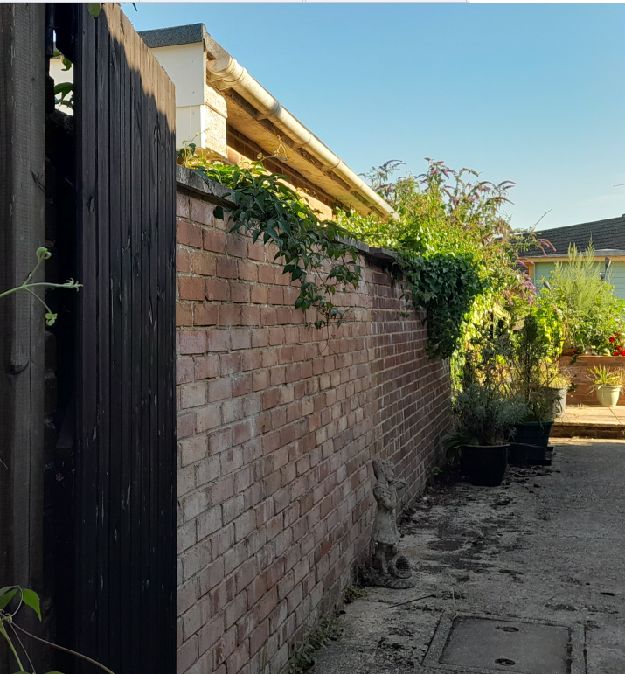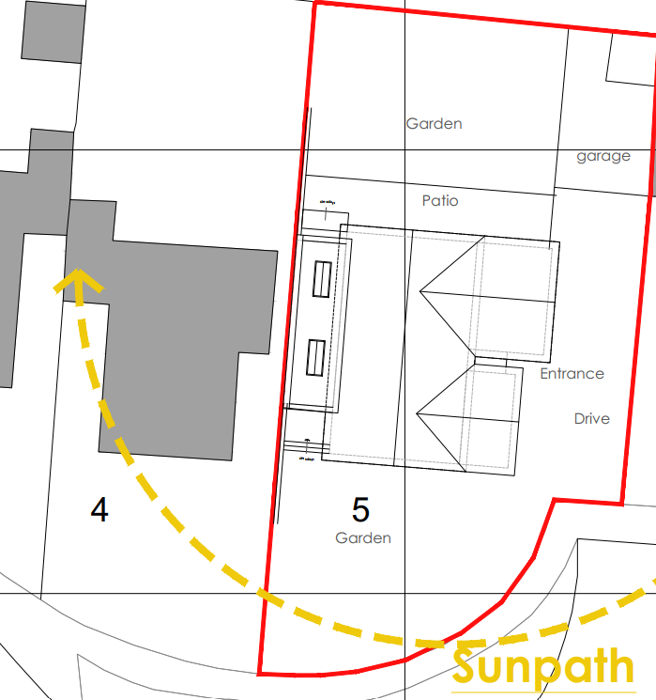

Floor plans obtained from a publicly available estate agent's listing for No. 4 indicate that the rooms closest to the shared boundary are a study/bedroom and hallway. These rooms do not contain side-facing windows that would be directly affected by the proposed extension. Furthermore, the existing boundary wall already limits the opportunity for light to be received from this direction. The principal habitable room serving No. 4, namely the lounge, is positioned further from the shared boundary and benefits from windows within the south and east elevations.

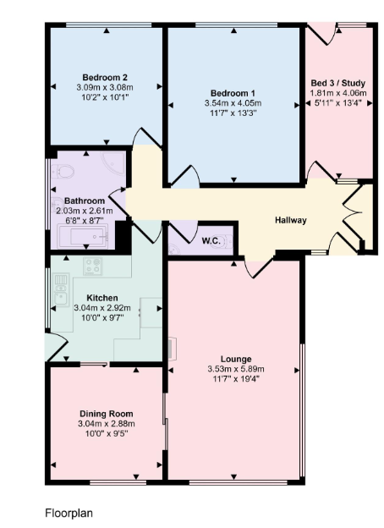
However, as the proposal relates to a single-storey side extension, and having regard to its height, scale, design and siting set in from the front elevation of the host dwelling, it is not considered to result in any unacceptable impacts in terms of loss of light, overshadowing, overbearing effects or loss of privacy to No. 4.

Having regard to the single-storey nature of the proposal, together with its scale, height and siting, the development is not considered to create any unacceptable loss of light, overshadowing, overbearing impact or loss of privacy to the occupiers of No. 4. The proposal would therefore not result in material harm to neighbouring residential amenity.

It is acknowledged that the extension is proposed on the shared boundary with No. 4 and that the construction of the development may require consideration under the Party Wall Act. However, matters relating to construction access, foundations, party wall procedures and rights of entry onto neighbouring land are civil matters and do not form part of the planning assessment. The applicant is advised that planning permission does not confer any right to enter land outside their ownership or undertake works on third-party land without the necessary consent.

There are no other neighbouring dwellings that are considered to be affected by the proposed development.

The proposal therefore accords with Core Policy 57 (vii) of the Wiltshire Core Strategy and the guidance contained within Appendix D of the Wiltshire Design Guide.

Ecology Impact

Core Policy 50 of the Wiltshire Core Strategy seeks to protect and enhance biodiversity and geodiversity, including through ensuring that development avoids harm to protected species and habitats.

The National Planning Policy Framework (NPPF), at Paragraph 193, requires that development minimises impacts on and provides net gains for biodiversity, including ensuring mitigation is secured where harm cannot be avoided.

As identified above, the site lies within the Hampshire River Avon Catchment and within the New Forest SAC, however, as the proposed development relates to a householder extension and does not include the creation of an additional residential unit of accommodation, there are no likely adverse harms arising which would impact on these special ecological designations.

Biodiversity Net Gain -Householder planning applications are exempt from the requirement to deliver Biodiversity Net Gain under Schedule 7A, Section 4(2)(a) of the Town and Country Planning Act 1990, as inserted by the Environment Act 2021.

As such, the development complies with Core Policy 50 of the Wiltshire Core Strategy and the relevant provisions of the NPPF.

CONCLUSION

The proposed development is considered to be acceptable in terms of its design, scale, and relationship with the surrounding area. It would not result in any unacceptable harm to the character of the locality, the amenities of neighbouring occupiers or ecology.

The proposal is therefore considered to comply with the relevant policies of the Wiltshire Core Strategy, the Wiltshire Local Plan, and the National Planning Policy Framework. As such, the application is recommended for approval, subject to the conditions set out below.

RECOMMENDATION: That Planning Permission be GRANTED subject to conditions.

1. The development hereby permitted shall be begun before the expiration of three years from the date of this permission.

REASON: To comply with the provisions of Section 91 of the Town and Country Planning Act 1990 as amended by the Planning and Compulsory Purchase Act 2004.

2. The development hereby permitted shall be carried out in accordance with the following approved plans:

Application form received 15/06/2026
Location plan and existing site plan Drg no 0546-02-001 received 25/06/2026
Proposed site plan Drg no 0546-02-004 received 25/06/2026
Proposed ground floor and roof plans Drg no 0546-02-005 a received 04/08/2026
Proposed elevations Drg no 0546-02-006 a received 04/08/2026
Proposed elevations Drg no 0546-02-007 received 25/06/2026

REASON: For the avoidance of doubt and in the interests of proper planning.

3. The materials to be used in the construction of the external surfaces of the development hereby permitted shall match those detailed on the application form and to match the existing dwelling.

REASON: In the interests of visual amenity and the character and appearance of the area.

4. Notwithstanding the provisions of the Town and Country Planning (General Permitted Development) (England) Order 2015 (or any Order revoking or reenacting or amending that Order with or without modification), no windows, doors or other form of openings shall be inserted in the west elevation of the development hereby permitted.

REASON: In the interests of residential amenity and privacy.

