COMPARELLI
John Comparelli Architect BA, AA Dip, MSc, ARB
Overhouse, The Avenue, Tisbury, Salisbury, Wiltshire, SP3 6JG
MOB: 07932 025 040 comparelli@btinternet.com www.comparelli.com

Design And Access Statement

For; Weaveland Farmhouse
Hindon Lane, Tisbury SP3 6QE

Date: 30.07.2026

Introduction
Weaveland Farmhouse was a farmstead consisting of a range of farm buildings, fields and gardens. After a period of neglect the farm business was abandoned and the main house was run down. The house itself was renovated between 2011 to 2013.

Within the house curtilage the western barn has subsequently been used for storage. Its roof and stone walls are dilapidated. The current owners are now seeking planning consent to convert it for ancillary accommodation.

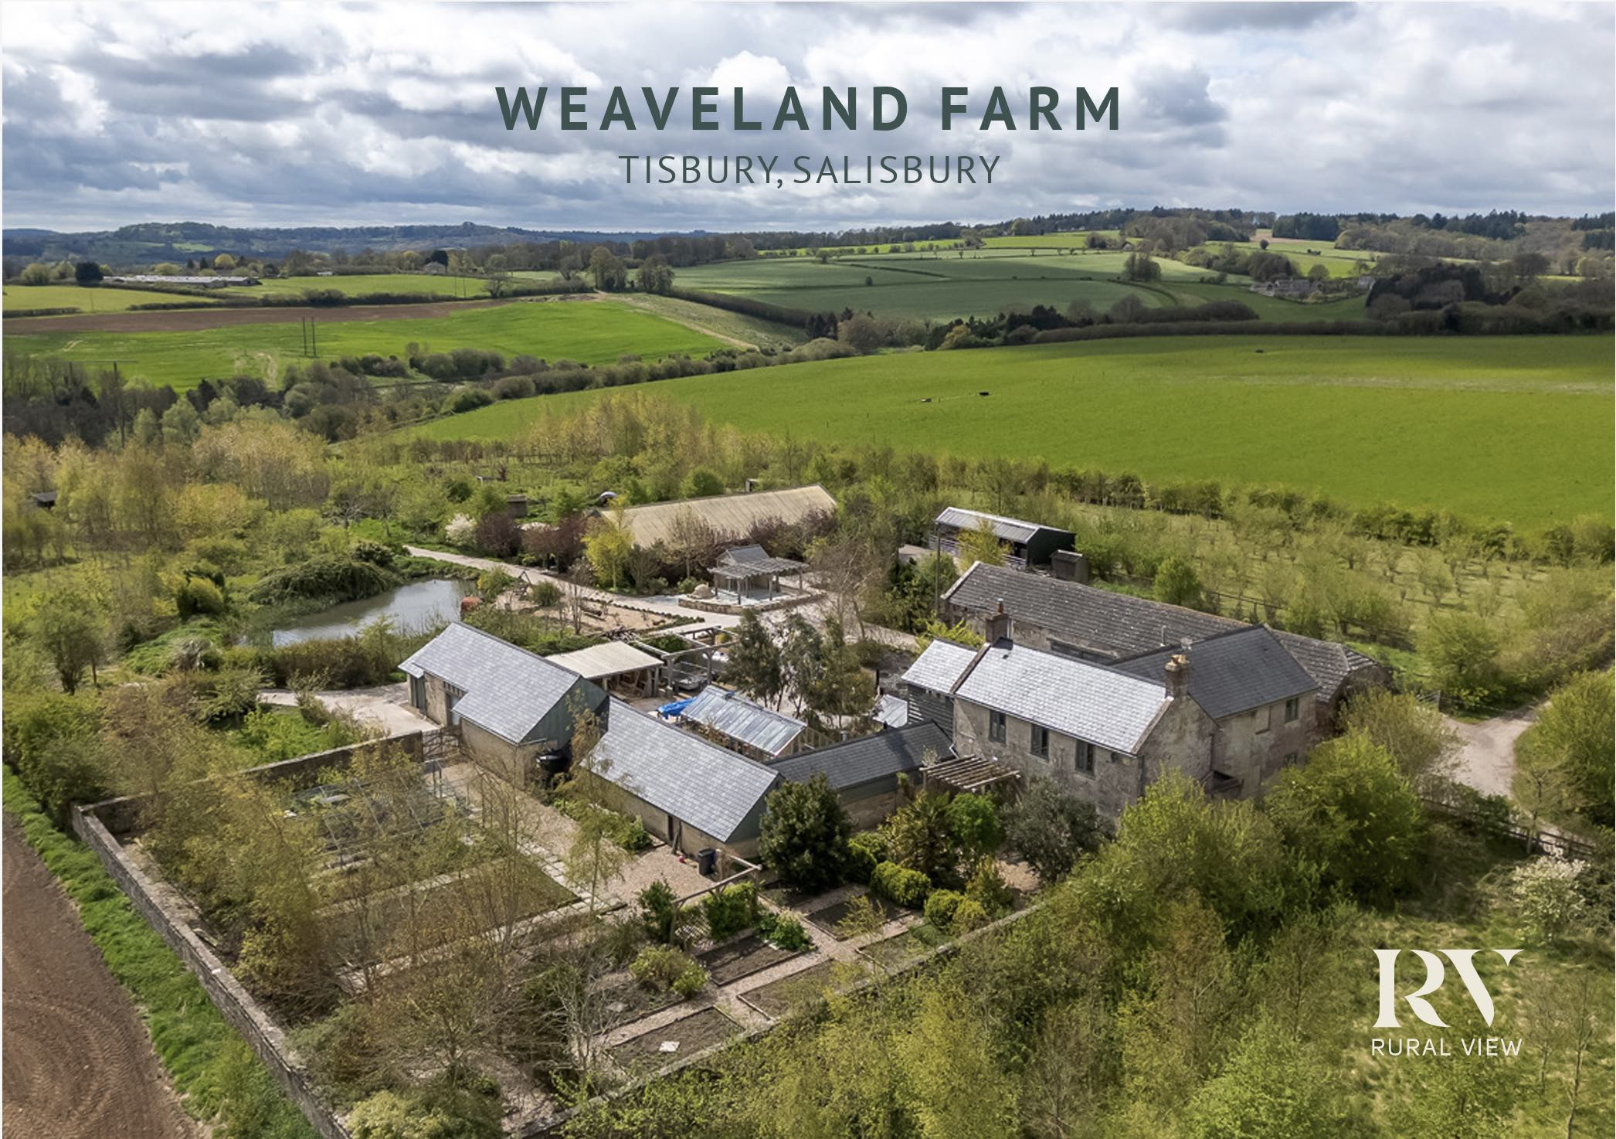

Figure 1 Arieal view of Weaveleand Farmhouse with kind permission from Rural View
NB; proposed barn for conversion in middle right of image

Proposal
This application proposes;
- Adding a second floor to the northern half of the barn for two en-suite bedrooms
- Converting the ground floor of the northern half of the barn for living space
- Extending the southern half of the barn for; two adequately long internal parking spaces, an entry to the ancillary accommodation, a gardener’s WC and a plant room
- Adding a loft over the internal parking for storage
- Adding external parking off the drive

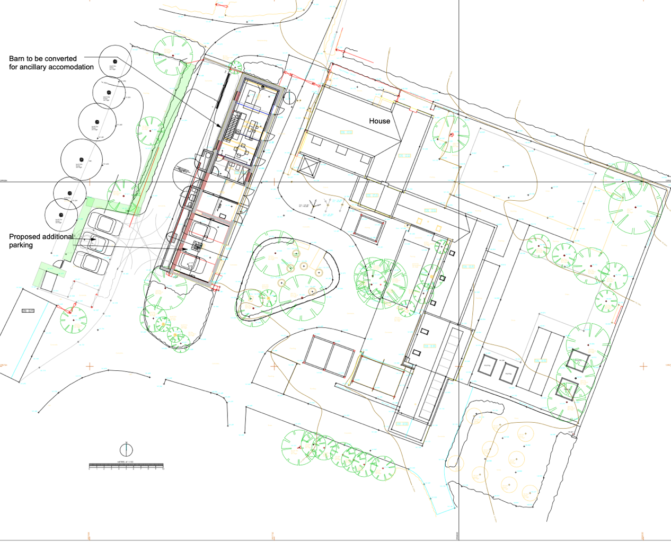
Figure 2 Proposed Site Plan

Amount
Gross Internal Area (GIA)
Existing Barn
GR FL 138.5m2
1st FL 000.0 m2
Total 138.5m2

Proposed Extensions (Gr fl and 1st floor
GR FL 13.5m2 parking bay
2.7m2
1st FL 70.4m2
Total 86.6m2 extensions

Total Proposed Gross internal of Barn
138.5m2 existing barn
+86.6m2 extensions
225.1m2
225.1m2/138.5m2= Barn GIA increase = 62.5%

Existing Barn footprint
167.8m2
25.0m2 gr fl extension to proposed parking bays
192.8m2

192.8ms/ 167.8m2 = Barn footprint increase = 15.0 %

Note; the total area of the house and outbuilding is approx. 905m2
The total area of the curtilage is approximately 2 hectares

Layout House
The layout of the converted barn will be similar to a long house with accommodation to the north and vehicles (rather than animals) to the south.

Ground Floor;
The habitable accommodation to the south will include an entry hall, shower room, staircase and open plan living, dining and kitchen space.

Two internal parking spaces will be formed to the south

First Floor;
Two ensuite bedrooms and stair landing will be formed under the raised roof.
Loft storage will be formed under the existing roof of the southern end of the barn

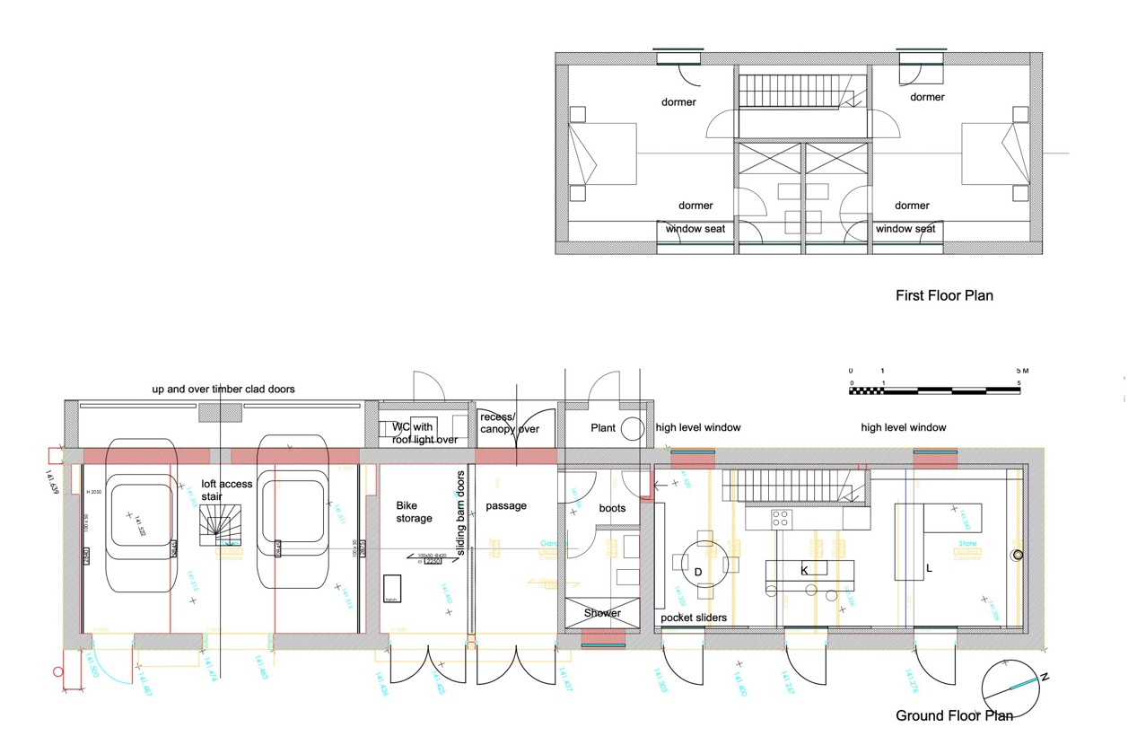

Figure 3. Proposed Plans.

Use
Weaveland Farmhouse will remain a single family dwelling.

Scale
The proposed second storey extension for ancillary accommodation will lift the existing on half of the barn approximately 1800mm. The new ridge to the northern end of the Barn will remain lower than the house ridge by approximately 700mm.

The southern half will retain its ridge height.

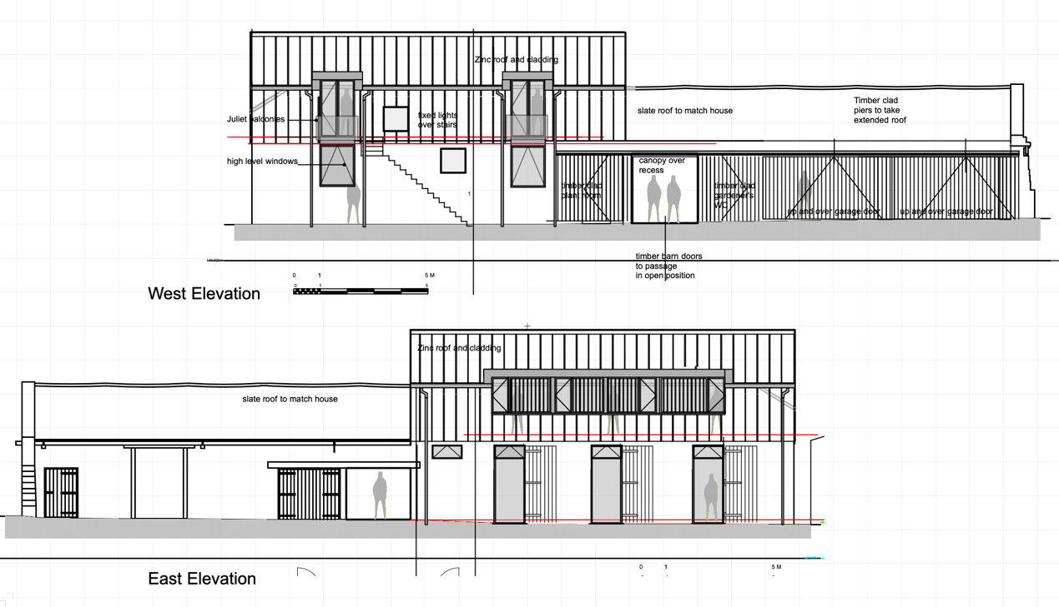
Figure 4. Proposed Flank elevations

Landscaping
The landscape around the barn will remain as existing to the east, facing the house.

The landscape to the west, facing the field and orchard, will be altered slightly. The changes include;

- Removing 12m of relatively new, mixed hedging for the external parking bays and replanting 14m of similar mixed hedging around the parking bays. This will add 2m of hedging.
- Adding a section of paving within the existing concrete drive to signify the pedestrian entry.
- Removing a 2m x 17m strip of planting beds for the extended internal parking bays

Appearance
The proposed extensions will use barn like materials of profiled metal, timber cladding and sliding timber barn doors. These materials will be both sympathetic to the existing stone built barn and, by their arrangement, read as contemporary additions.

Access
Beyond additional parking spaces parking access will remain unchanged.

End of Design and Access Statement

