APPLICATION FOR HOUSEHOLDER PLANNING PERMISSION
DELEGATED REPORT

APPLICATION REFERENCE: | PL/2026/03442
APPLICATION TYPE: | Householder Planning Permission
SITE ADDRESS: | 33 Oldfield Park, Westbury, BA13 3LQ
DEVELOPMENT DESCRIPTION: | Retrospective application for outbuilding workshop and timber framed freestanding gazebo.
RECOMMENDATION: | That Planning Permission be REFUSED

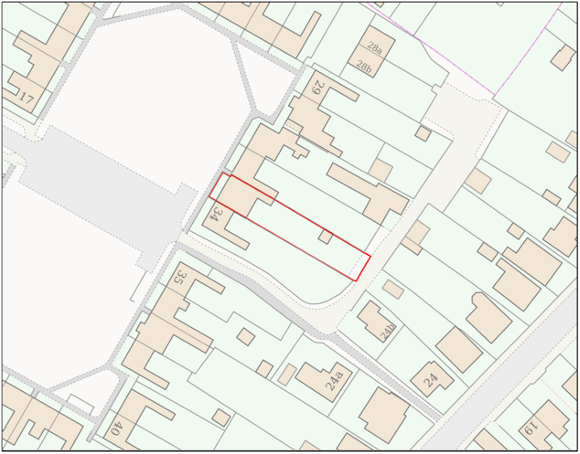
PROPOSAL

Retrospective planning permission is sought for two structures within the residential curtilage of the dwelling. The first comprises a timber-framed gazebo positioned adjacent to the rear elevation, providing a covered outdoor seating area beneath a pitched felt-clad roof. The second element comprises a detached timber-clad workshop/outbuilding located at the eastern end of the rear garden measuring approximately 3.5m by 7.6m with a mono-pitched roof and a maximum height of approximately 4.1m. The outbuilding incorporates white uPVC doors and windows and is stated to be used for purposes ancillary to the enjoyment of the dwellinghouse.

SITE DESCRIPTION / CONTEXT

The application site relates to a terraced dwelling situated within the settlement boundary of Westbury and forms part of a post-war Radburn-style residential estate arranged around a large central open space and communal parking area. The dwelling is of typical residential appearance comprising red brick elevations, white uPVC fenestration and a pitched tiled roof, reflecting the prevailing character of the surrounding area. The property benefits from a long rear garden which backs onto a rear access lane serving neighbouring gardens and garages. The site lies within Flood Zone 1, within the Salisbury Plain SPA 6.4km buffer and the Grey Zone of the Trowbridge and Westbury Bat Mitigation Strategy. Public Right of Way WEST62 is located immediately to the south of the site and provides pedestrian connectivity between Edenvale Road and Oldfield Park. The Council's Strategic Flood Risk Assessment identifies negligible groundwater flood risk and only a small area of surface water flood risk towards the western extent of the site.

PLANNING HISTORY

No relevant planning history has been identified for the site subject of this application.

RELEVANT LEGISLATION, POLICIES AND GUIDANCE

Wiltshire Core Strategy:

Core Policy 1 Settlement Strategy;
Core Policy 2 Delivery Strategy;
Core Policy 32 Spatial Strategy: Westbury Community Area;
Core Policy 50 Biodiversity and Geodiversity;
Core Policy 51 Landscape;
Core Policy 57 Ensuring High-Quality Design and Place Shaping;
Core Policy 60 Sustainable Transport;
Core Policy 61 Transport and Development;
Core Policy 64 Demand Management;
Core Policy 67 Flood Risk;

Westbury Neighbourhood Plan 2023-2036

The National Planning Policy Framework (NPPF)

The Planning Practice Guidance (PPG)

Wiltshire Design Guide - Appendix D – Design Guidance for Householder extensions

The Wiltshire Local Transport Plan 2011 – 2026: Car Parking Strategy (March 2015).

The Wiltshire Local Transport Plan 4 (LTP4) (March 2025)

New Wiltshire Local Plan

At Full Council on 19 May 2026, the elected members of Wiltshire Council agreed to withdraw the emerging Wiltshire Local Plan. The said Plan has no material weight for the purposes of the application.

In accordance with Regulation 19 of the Town and Country Planning (Local Planning) (England) Regulations 2026, on 30th June 2026 Wiltshire Council published a notice of intention to prepare a new local plan for Wiltshire. The next stage is a Scoping Consultation which commences on 2nd September 2026. This plan is at a very early stage and currently carries no weight for decision making.

CONSULTATION RESPONSES

Westbury Town Council – No Objection

REPRESENTATIONS

One comment of support was received noting that they lived directly opposite the property and had no concerns.

ASSESSMENT

Section 38(6) of the Planning and Compulsory Purchase Act 2004 states:

"If regard is to be had to the development plan for the purposes of any determination to be made under the planning Acts, the determination must be made in accordance with the plan unless material considerations indicate otherwise."

In accordance with this statutory requirement, this application has been assessed against the relevant policies of the Development Plan, including the adopted Wiltshire Core Strategy (2015) and, where applicable, any made Neighbourhood Plans.

The proposed development comprises domestic structures within the established residential curtilage of an existing dwellinghouse located within the settlement boundary of Westbury. The principle of domestic outbuildings and incidental household structures is therefore considered acceptable, subject to detailed assessment of the proposal's design, visual impact and effects upon neighbouring amenity.

Design and Impact the upon the character and context of the area

Core Policy 57 Ensuring High Quality Design and Place Shaping of the Wiltshire Core Strategy requires all new development to achieve a high standard of design that responds positively to its local context. Proposals must reinforce and enhance local character and distinctiveness, relate appropriately to the surrounding landscape, and demonstrate a thoughtful response to existing townscape features. This includes careful consideration of elements such as building height, scale, massing, building line, materials, and overall appearance, ensuring new development integrates harmoniously with its setting.

The proposed gazebo represents a typical domestic garden structure. Owing to its modest scale, lightweight appearance and location immediately adjacent to the dwellinghouse, it would not appear incongruous within the residential curtilage and would have a negligible effect upon the character of the surrounding area.

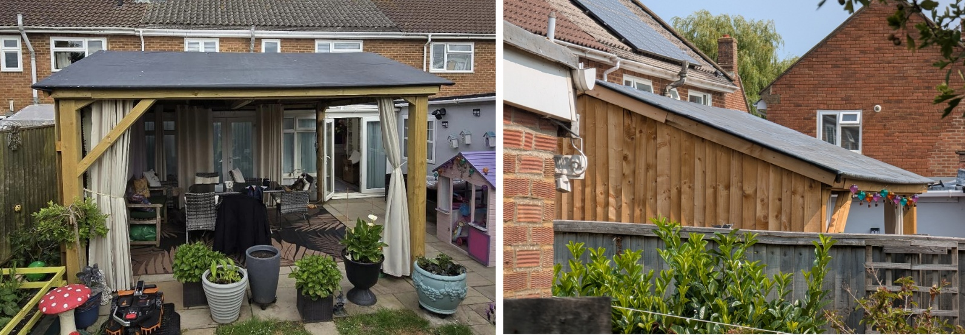
Front and Side View

The workshop outbuilding is materially different in this regard. Whilst domestic outbuildings are not uncommon within residential gardens, the structure's significant height of approximately 4.1m, substantial length of 7.6m and utilitarian form result in a visually dominant feature that exceeds what would ordinarily be expected of an incidental domestic outbuilding. The development comprises extensive uninterrupted timber-clad elevations beneath a mono-pitched roof which together create a stark and functional appearance lacking the domestic design characteristics typically associated with ancillary residential buildings.

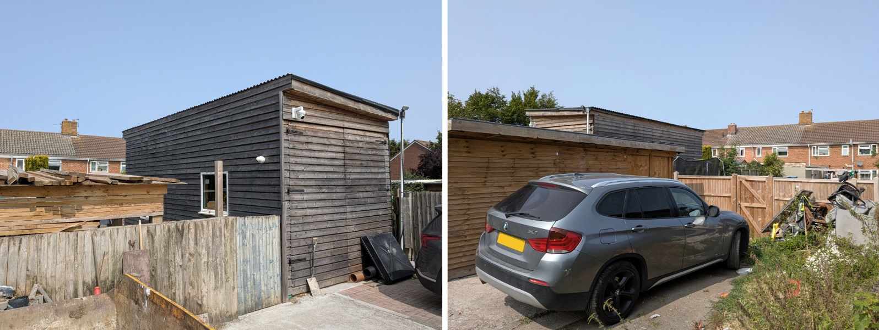
Site Images

Although positioned at the far end of the rear garden, the structure is not entirely screened from public view. The building is readily visible from the rear access lane and can be glimpsed from Public Right of Way WEST62 which links Edenvale Road and Oldfield Park. This view is through a tree and hedge row which forms the boundary of the terrace though and as such would alter seasonally or could become more pronounced should the vegetation be cut back or removed. Consequently, the visual effects of the development do, to some extent, extend beyond the private residential curtilage and are experienced from publicly accessible locations.

Limited weight is afforded to the applicant's comparison with other outbuildings in the locality. Whilst examples of larger outbuildings exist, these generally exhibit more traditional residential forms, including pitched tiled roofs and varied material palettes which assist in reducing their visual bulk and integrating them into their surroundings.

Having regard to its excessive scale, height, massing and unsympathetic appearance, the workshop outbuilding constitutes a prominent and incongruous feature that fails to respond positively to the character of the surrounding residential environment. The proposal is therefore considered contrary to Core Policy 57 of the Wiltshire Core Strategy and the design objectives of the Wiltshire Design Guide.

Amenity

Point vii of Core Policy 57 Ensuring High Quality Design and Place Shaping of the Wiltshire Core Strategy seeks to ensure that developments do not adversely affect neighbouring properties. The National Planning Policy Framework (NPPF), particularly Paragraph 135, stresses that planning decisions should ensure developments provide a high standard of amenity for existing and future users.

The proposed gazebo is modest in scale and located adjacent to the dwellinghouse. Whilst visible from neighbouring gardens, it would not result in any meaningful loss of privacy, outlook or sunlight beyond that which would ordinarily be expected within a residential setting.

With regard to the workshop outbuilding, the structure is located adjacent to the northern boundary and, by reason of its height and length, has an overbearing presence when viewed from the rear-most part of the adjoining garden. Some localised overshadowing is also likely to occur.

However, the affected gardens are substantial in length and the impacts are primarily confined to the far eastern end of the neighbouring garden. The development does not contain first-floor windows and therefore does not give rise to unacceptable overlooking or loss of privacy.

Whilst a degree of adverse effect is acknowledged in relation to outlook and visual enclosure, the impacts upon neighbouring residential amenity are considered limited and would not, in isolation, justify refusal of the application.

Transport and Highways

Core Policy 60 of the WCS states that Council will support and encourage safe and efficient movement of people and, where necessary, mitigate the impact of development on transport users and local communities. Core Policy 61 specifies that development should demonstrate that consideration has been given to a hierarchy of transport users and that proposals must, where relevant, serve as a safe access to the highway network. Paragraph 116 of the NPPF states that “Development should only be prevented or refused on highways grounds if there would be an unacceptable impact on highway safety, or the residual cumulative impacts on the road network, following mitigation, would be severe, taking into account all reasonable future scenarios”.

The proposal does not create additional residential accommodation, introduce additional bedrooms, or alter existing access or parking arrangements. The development therefore gives rise to no additional parking demand or highway impacts. The proposal is considered acceptable in highway terms.

Ecology

The WCS, through Core Policy 50, states that development proposals are expected to avoid and reduce disturbance of sensitive wildlife species and habitats. Biodiversity Net Gain (BNG) was established as a mandatory aspect of planning evaluation through Schedule 7A of the Town and Country Planning Act 1990 (as amended by the Environment Act 2021 Schedule 14). It is considered that the development does trigger the threshold for required BNG in association with the development proposal and as such must be considered further.

The site lies within the Salisbury Plain Special Protection Area buffer, the Core Bat Roost Buffer and the Trowbridge and Westbury Bat Mitigation Strategy area. However, the development relates to structures within an existing residential garden and does not involve the demolition or alteration of buildings with identified bat roost potential, nor does it involve the loss of habitat of known ecological significance.

The proposal is therefore not considered likely to result in adverse impacts upon protected habitats or species and is considered to accord with Core Policy 50.

Flooding and Drainage

Core Policy 67 Flood Risk of the Wiltshire Core Strategy requires all development to be located, designed, and constructed to minimise vulnerability to flooding and to avoid increasing flood risk elsewhere. Proposals must demonstrate that surface water can be managed safely and sustainably, incorporating appropriate drainage solutions—such as sustainable drainage systems (SuDS)—that ensure runoff rates and volumes do not exceed pre‑development levels. Development should provide measurable betterment where necessary, ensuring that drainage strategies are robust, technically compliant, and aligned with national policy. The NPPF sets out the application of a sequential, risk-based approach to the location of new development in paragraph 172.

The site lies within Flood Zone 1, representing the lowest probability of flooding. The Council's Strategic Flood Risk Assessment identifies negligible groundwater flood risk and only a limited area of surface water flood risk affecting the western part of the site, whereas the workshop outbuilding is located at the eastern end of the garden.

Whilst the NPPF notes that site-specific flood risk assessments may be required where other sources of flooding are identified, the scale and nature of the development, alongside the limited flood constraints affecting the site, do not justify the submission of a formal flood risk assessment in this instance. The proposal is therefore considered acceptable with regard to flood risk and drainage and accords with Core Policy 67.

CONCLUSION

The gazebo is considered acceptable and would result in no significant harm. However, the workshop outbuilding, by reason of its excessive height, scale, massing and utilitarian appearance, forms a visually intrusive and incongruous feature that fails to respond positively to the character of the area and is harmful to the visual amenities experienced from the adjoining access lane and Public Right of Way WEST62. The proposal is therefore contrary to Core Policy 57 of the Wiltshire Core Strategy and the guidance contained within the Wiltshire Design Guide.

RECOMMENDATION: That Planning Permission be REFUSED for the following reason(s):

1.
The workshop outbuilding, by reason of its excessive height, scale, massing and utilitarian design, represents a prominent and visually intrusive form of development that fails to relate appropriately to the character and appearance of the surrounding residential environment. The development results in an incongruous feature when viewed from adjacent publicly accessible areas, including the rear access lane and Public Right of Way WEST62, and consequently fails to achieve a high standard of design. The proposal is therefore contrary to Core Policy 57 of the Wiltshire Core Strategy (2015) and the design objectives of the Wiltshire Design Guide.

