APPLICATION FOR FULL PLANNING PERMISSION
DELEGATED REPORT

APPLICATION REFERENCE: | PL/2026/03389
APPLICATION TYPE: | Full planning permission
SITE ADDRESS: | The Black Horse, Frome Road, Trowbridge, BA14 0DU
DEVELOPMENT DESCRIPTION: | Proposed single-storey extension to form a new accessible WC with entrance lobby, erection of detached open-sided timber pergola structure within pub garden, and installation of low-level timber picket fencing.
RECOMMENDATION: | That Planning Permission be GRANTED

PROPOSAL

The proposal seeks planning permission for a single storey extension on the rear elevation of the host building to create a lobby area with ground floor accessible toilet, with associated hard landscaping works to access the new lobby, and erection of a low picket fence. The proposal also seeks permission for erection of a timber garden Pergola within the pub garden and removal of an existing garage store within the existing pub car park.

SITE DESCRIPTION/CONTEXT

The application site relates to The Black Horse Public House that is located on Frome Road in Trowbridge. The principal elevation fronts the public highway with the car park accessed to the south of the building and outdoor seating area and garden to the east.

The application site sits within the grey, hatched zone of the Trowbridge and Westbury Bat Mitigation Strategy (TWBMS) and some listed buildings and structures lie within the vicinity of the building. The application site lies within an area with a risk of surface water flooding,

PLANNING HISTORY

N/a

RELEVANT POLICIES AND GUIDANCE

Wiltshire Core Strategy:
Core Policy 1 Settlement Strategy
Core Policy 2 Delivery Strategy
Core Policy 29 – Spatial Strategy for the Trowbridge Community Area
Core Policy 50 – Biodiversity and Geodiversity
Core Policy 57 - Ensuring High Quality Design and Place Shaping
Core Policy 58 - Ensuring the Conservation of the Historic Environment
Core Policy 67 – Flood Risk
New Wiltshire Local Plan
At Full Council on 19 May 2026, the elected members of Wiltshire Council agreed to withdraw the emerging Wiltshire Local Plan. The said Plan has no material weight for the purposes of the application.

In accordance with Regulation 19 of the Town and Country Planning (Local Planning) (England) Regulations 2026, on 30th June 2026 Wiltshire Council published a notice of intention to prepare a new local plan for Wiltshire. The next stage is a Scoping Consultation which commences on 2nd September 2026. This plan is at a very early stage and currently carries no weight for decision making.

Trowbridge and Westbury Bat Mitigation Strategy SPD, adopted February 2020

Wiltshire Design Guide: Appendix D – Design Guidance for Householder extensions
The National Planning Policy Framework (NPPF)
Planning (Listed Buildings and Conservation Areas) Act 1990
The Planning Practice Guidance
National Design Guide

CONSULTATION RESPONSES

Trowbridge Town Council: No objection

REPRESENTATIONS
Three letters of objection were received from one household adjacent to the application site. The comments received will be appraised within the officer report below.

- The proposal is considered likely to increase use of the outdoor seating area in closer proximity to neighbouring residential properties, resulting in increased noise, general disturbance, cigarette smoke and activity, particularly during evenings and weekends.

- Concerns are raised regarding the potential impact of external lighting associated with the outdoor area on nearby residential properties.

- While the provision of additional toilet facilities is welcomed, concerns remain regarding anti-social behaviour and nuisance, including patrons urinating in nearby driveways, hedges and grassed areas. It is suggested that management measures, signage and monitoring should be implemented to encourage use of the facilities.

- Concerns are raised that the proposal could lead to an increase in customer numbers, vehicle movements and activity within the car park.

- Existing parking pressures within the area are highlighted, including vehicles parking across driveways, on pavements and in locations that obstruct pedestrian movement, including access for pushchairs and wheelchair users.

- Concerns are expressed regarding highway safety, particularly in relation to vehicles exiting the public house car park at excessive speed.

The comments received will be appraised within the officer report below.

ASSESSMENT
Section 38(6) of the Planning and Compulsory Purchase Act 2004 states:

"If regard is to be had to the development plan for the purposes of any determination to be made under the planning Acts, the determination must be made in accordance with the plan unless material considerations indicate otherwise."

In accordance with this statutory requirement, this application has been assessed against the relevant policies of the Development Plan, including the adopted Wiltshire Core Strategy (2015) and, where applicable, any made Neighbourhood Plans.

Principle of Development
CP1 “Settlement Strategy” of the Wiltshire Core Strategy sets out where sustainable development will take place across the plan period.

CP2 “Delivery Strategy” of the Wiltshire Core Strategy states that other than circumstances as permitted by other policies within the plan, development will not be permitted outside the limits of development.

The application site is an existing public house in Trowbridge, the application site sits within the settlement boundary. CP29 identifies Trowbridge as Wiltshire's principal settlement and a focus for growth.

The development comprises extensions to the existing public house for purposes incidental to its use and over land that was already part and parcel of this established use. The development would not therefore conflict with the spatial strategy and would be acceptable in principle, subject to assessment of relevant impacts, its compliance with the development plan as a whole, and other material considerations.

Design and Impact upon the upon the character and context of the area
Core Policy 57 - Ensuring High Quality Design and Place Shaping of the Wiltshire Core Strategy seeks to ensure that all new development is of high design quality, reflecting local context, character, and distinctiveness.

The proposal seeks planning permission for a single storey extension on the rear elevation of the host building which would extend over a paved area to east elevation adjacent to an existing outdoor smoking structure.

The extension would extend over a footprint of 11m2 and would sit at a height of 2.6m and would be accessed from the existing car park area. A pedestrian door would be inserted on the front elevation which would access a lobby area with the toilet accessed off the lobby. No windows are proposed. The extension would be a small-scale extension subservient to the existing built form of the host building.

Some hard landscaping would be undertaken for patrons to access the extension via a sloped path to the accessible toilet. To the south of the improved paving area a small picket fence would be erected to mark the boundary between the car park and the paving area.

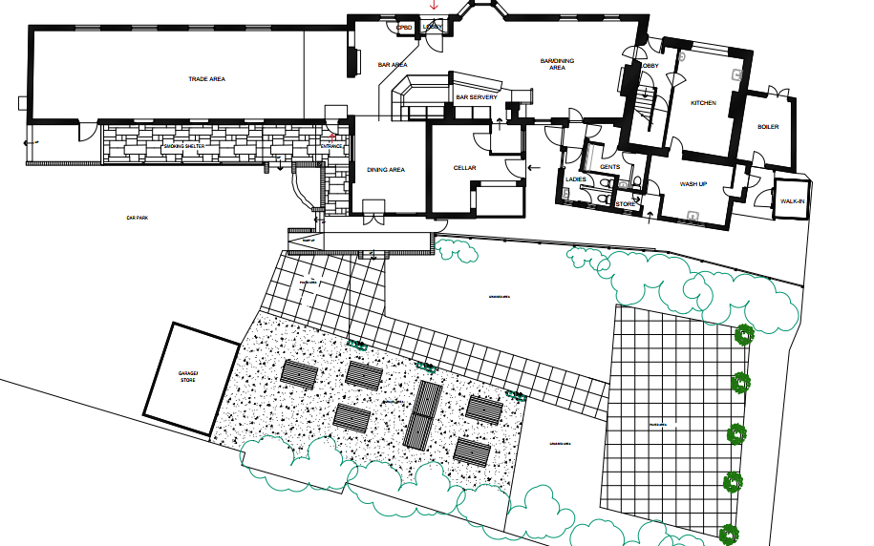

Existing site plan

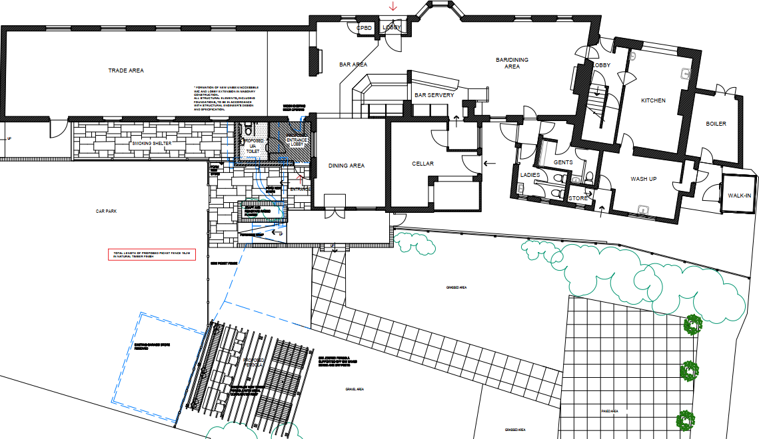
Proposed site plan

To the east of the public house lies the existing garden dining area and within this area the applicant proposes erecting a timber pergola to provide some shade to diners with festoon lighting draped above the pergola for ambient illumination. The pergola would extend over an area of 30m2 and would sit at a maximum height of 2.5m and would be open ended as illustrated in the plan insert below.

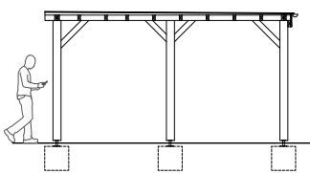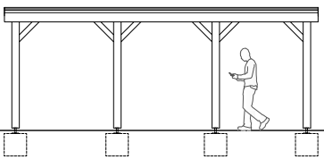

Front and side elevation of the proposed pergola

The use of matching materials (brickwork elevations on the extension with a single ply flat roof and matching timber fenestration) would ensure the proposal would integrate into the surrounding setting and existing street scene and the natural sustainable materials (wood) utilised on the picket fence and pergola are supported. It is considered that the extensions would by virtue of their height, scale and design constitute complementary additions to the host building that would appear commensurate to the size of the property and plot.

Having regard to the above, the proposal complies with the design principles set out in Core Policy 57 of the Wiltshire Core Strategy and Appendix D of the Wiltshire Design Guide

Amenity
Point vii of Core Policy 57 - Ensuring High Quality Design and Place Shaping of the Wiltshire Core Strategy seeks to ensure that developments do not adversely affect neighbouring properties.

The National Planning Policy Framework (NPPF), particularly Paragraph 135(f), stresses that planning decisions should ensure developments provide a high standard of amenity for existing and future users.

The proposed development has been assessed in terms of its potential impact on the residential amenity of neighbouring properties, with particular regard to loss of light, overshadowing, loss of privacy, and overbearing effects.

The proposal relates to an extension that would be set within the confines of the outdoor smoking area to the rear elevation of the public house, all windows would overlook the rear garden area of the public house, therefore no overlooking concerns are raised.

The public house benefits from generous separation distances to any neighbouring occupiers to the rear elevation, with the Wiltshire College positioned to the east and the properties positioned to the south along College Road. Therefore, no adverse overbearing or overshadowing impacts would be experienced by the neighbouring occupiers by the erection of the extension or the outdoor garden pergola.

The neighbouring property to the south has raised concerns that the erection of the pergola may encourage the pub clientele to spend more time outside which could give rise to related noise disturbance later on in the evening, and this is duly noted.

As illustrated below, the pergola would be located some 29m from the objector’s private residential rear curtilage and would be positioned in an area that is already utilised as an outdoor seating area therefore the nature of use would not be changing.

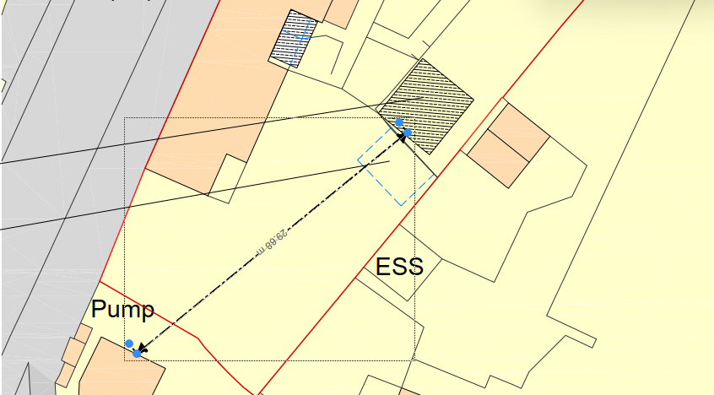
Separation distance from the pergola to the adjacent dwelling.

Issues of noise and antisocial behaviour have been raised by third parties. However, these issues hold only very limited weight in the planning balance, and any antisocial behaviour can be reported to the Police and noise issues to the Council’s Public Protection team.

In addition, hours of operation and amplified music would be controlled by relevant licensing of the premises and in this case, it would be considered unreasonable to impose planning conditions relating to these on the existing operation.

In addition, imposing conditions to control additional extremal lighting, fencing, parking management, traffic calming measures and additional signage are not considered necessary in this case due to the limited scope of the scheme.

The applicant has confirmed that festoon lighting would be draped around the pergola to ensure safe access for patrons and confirmed that this would be lit from the early evening until 11pm when the public house closes.

The lighting would consist of small-scale ambient lighting on a domestic scale and officers consider that surrounding properties would not experience any adverse light pollution given the extended separation distances to neighbouring occupiers.

Third parties have also commented on a potential increase in customer numbers which would increase the existing highway impacts, however the erection of a small accessible toilet extension and a partly covered outdoor seating area is not considered to increase the probability of the existing use to such an extent that any highway safety impacts would be raised. The applicant is also removing an existing garage and storage building within the existing car park area which would introduce an enlarged parking area for patrons.

Antisocial highway safety issues such as poor/ obstructive parking, speeding, poor driving while accessing and egressing the car park also have very limited weight in the planning balance and any issues regarding highway safety can be reported to the Police.

Therefore, given the limited development proposed and the extended separation distances from the extensions to any adjacent residential dwellings, officers raise no concerns in regard to any adverse neighbouring amenity impacts.

The proposal therefore accords with Core Policy 57 point vii in respect of safeguarding residential amenity and Appendix D of the Wiltshire Design Guide.

Heritage Impact
From the point of view of the historic environment the main statutory tests are set out within the Planning (Listed Building and Conservation Areas) Act 1990.

Section 66 requires that special regard be given to the desirability of preserving listed buildings, their settings or any features of special architectural or historic interest which they possess.

The Council’s Core Strategy Policy CP58 ‘Ensuring the conservation of the historic environment’ requires that designated and non-designated heritage assets and their settings will be conserved, and where appropriate enhanced, in a manner appropriate to their significance and encourages proposals which improve the condition of heritage assets at risk.

The Council’s Core Strategy CP 57: Ensuring high quality design requires a high quality of design in all new developments. The policy requires applicants to “demonstrate how the proposal will make a positive contribution to the character of Wiltshire through (amongst other things) responding to the value of the natural and historic environment and being sympathetic to and conserving historic buildings and landscapes. Development is required to respond positively to the existing in terms of building layouts, built form, height, mass, scale, building line, plot size, elevational design, materials, streetscape and rooflines to effectively integrate the building into its setting.

The NPPF outlines government policy for planning. Chapter 16 of the NPPF 'Conserving and enhancing the historic environment' sets out the Government's high-level policies concerning heritage and sustainable development.

Within the vicinity of the public house lie a number of listed buildings, and directly to the south is a Grade II listed pump and drinking fountain. The listed properties and pump are identified by the black hatching in the plan insert below. Therefore, due consideration has to be given on how any proposed development would affect the setting of these heritage assets.
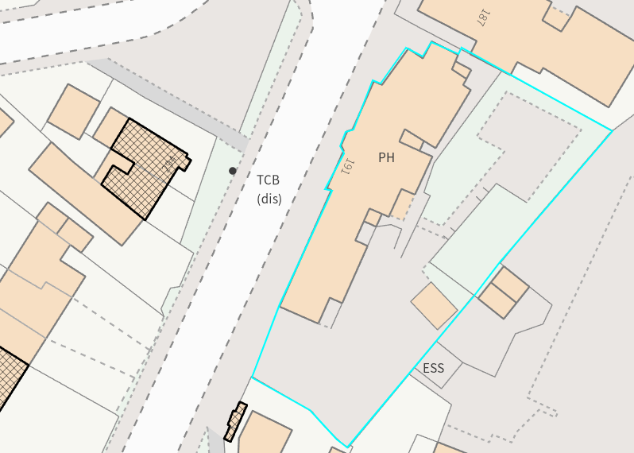

The extension and garden structure proposed would be set back from the public highway, set within the confines of the existing outdoor areas serving the public house, and would mostly be obscured from view from the public realm.

It is observed that the works would utilise materials typical to the development type, and the height and scale of the development is considered to be commensurate to the size of the application site and would therefore not adversely impact the setting of the listed buildings nearby.

It is considered that given the separation distances to the adjacent listed buildings and the limited development on site, proposed within the built envelope of the application site, any harm to the setting of the listed buildings would be nominal. The proposal, by virtue of its scale, design, and use of materials, is considered to preserve the setting of the listed building and it would not result in harm to the significance of any heritage assets.

The development is therefore considered to comply with Core Policy 58 of the Wiltshire Core Strategy and Section 66 of the Planning (Listed Buildings and Conservation Areas) Act 1990, as well as the relevant provisions of the NPPF.

Ecology Impact
Core Policy 50 of the Wiltshire Core Strategy seeks to protect and enhance biodiversity and geodiversity, including through ensuring that development avoids harm to protected species and habitats.

The National Planning Policy Framework (NPPF), in Paragraphs 193, requires that development minimises impacts on and provides net gains for biodiversity, including ensuring mitigation is secured where harm cannot be avoided.

The application site sits within the grey, hatched zone of the Trowbridge and Westbury Bat Mitigation Strategy (TWBMS). Therefore, due consideration has to be given to the potential disturbance of any bats because of the proposed development.

The proposed development comprises an extension consisting of limited built form, close to the existing building and given the established high density urban residential nature of the location, it is considered highly unlikely that any bats would be affected and significant effects relating to the disturbance to bats can be ruled out.

In addition, it is considered the erection of the pergola and proposed festoon lighting, would also not result in harm to bat habitats or adversely affect the Bath and Bradford-on-Avon Bats SAC due to the urban nature of the site and existing use as a beer garden.

As a precautionary measure an informative would be added to any decision that in event any evidence of bat activity is detected that the applicant should follow the advice of a professional ecologist or contact Natural England.

As such, the development complies with Core Policy 50 of the Wiltshire Core Strategy and the relevant provisions of the NPPF.

Drainage and Flood Risk
Core Policy 67 of the Wiltshire Core Strategy and paragraph 181 of the NPPF requires that all new development avoids increasing flood risk on-site or elsewhere and, where appropriate, incorporates sustainable drainage measures. Development must also comply with national policy on flood risk management and drainage design. Paragraph 176 (via footnote 62) of the NPPF states that householder development should not be subject to the sequential test, nor the exception test.

The application site lies within flood zone 1 so does not trigger a consultation with the Environment Agency, however the area where the extension is to be erected lies within an area with a risk of surface water flooding, as illustrated by the blue wash in the map insert below, which gives rise to concern over ground water and surface water flooding.
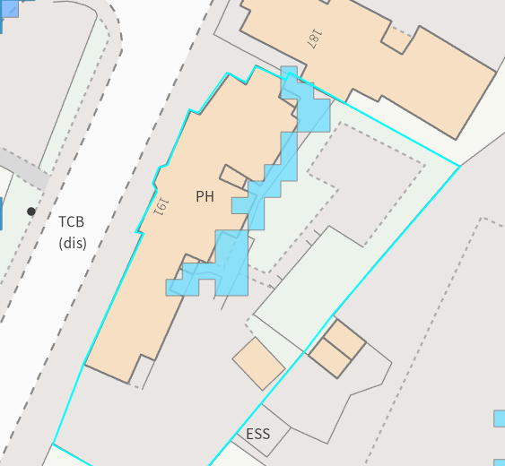
The applicant has submitted plans illustrating the proposed surface water drainage systems for the site, and these are deemed acceptable, and a condition would be added to ensure that these would be adhered to.
The proposal therefore complies with Core Policy 67 of the Wiltshire Core Strategy and the policy in the NPPF, ensuring that flood risk is not increased and that surface water drainage is appropriately managed.

Biodiversity Net Gain
From 12 February 2024 Biodiversity Net Gain (BNG) became mandatory under Schedule 7A of the Town and Country Planning Act 1990 (as inserted by Schedule 14 of the Environment Act 2021).

Th proposed building footprint It is therefore considered that the development meets the following criteria and is therefore below the de minimis threshold, meaning the development:

*does not impact an onsite priority habitat (a habitat specified in a list published under section 41 of the Natural Environment and Rural Communities Act 2006); and
* impacts less than 25 square metres of onsite habitat that has biodiversity value greater than zero and less than 5 metres in length of onsite linear habitat (as defined in the statutory metric).

Developments meeting these criteria may apply the de minimis exemption”

Given the small-scale nature of the works the proposal is deemed to meet the de minimis criteria with limited disruption to any biodiversity and no net loss identified, therefore no concerns are raised in relation to any adverse ecological impacts to be introduced by the proposed scheme. The proposal therefore meets the requirements contained in policy CP50 of the Wiltshire Core Strategy and the relevant provisions of the NPPF.

CONCLUSION
The proposed development is considered to be acceptable in terms of its design, scale, and relationship with the surrounding area. It would not result in any unacceptable harm to the character of the locality, the amenities of neighbouring occupiers, or the interests of highway safety, heritage, or ecology.

The proposal is therefore considered to comply with the relevant policies of the Wiltshire Core Strategy, the Wiltshire Local Plan, and the National Planning Policy Framework. As such, the application is recommended for approval, subject to the conditions set out below.

RECOMMENDATION: That Planning Permission be GRANTED subject to conditions.

