APPLICATION FOR HOUSEHOLDER PLANNING PERMISSION DELEGATED REPORT

APPLICATION REFERENCE: | PL/2026/03729
APPLICATION TYPE: | Householder planning permission
SITE ADDRESS: | 20 Paddock Close, Winterbourne, Dauntsey, Salisbury, SP4 6EL
DEVELOPMENT DESCRIPTION: | Raise existing ridge line, extension into the 1st floor, 5No. Dormer Windows
RECOMMENDATION: | That Planning Permission be REFUSED

PROPOSAL

The proposal seeks planning permission to raise the existing ridge line to create first floor accommodation along with the installation of five dormer windows.

Existing elevations below -

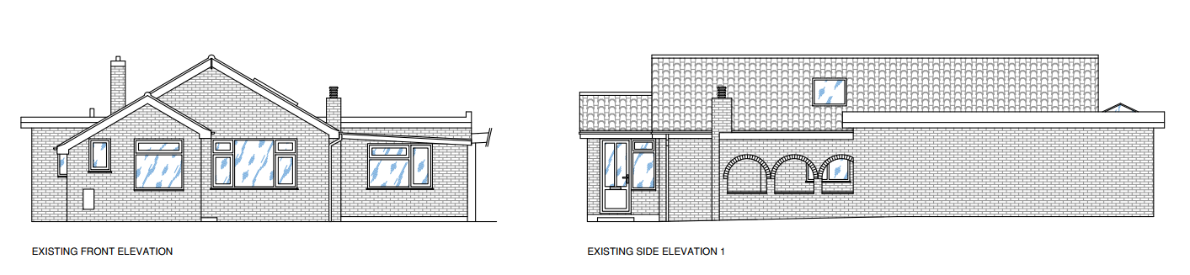

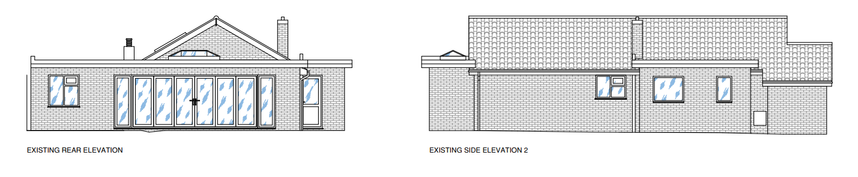

Proposed elevations below -

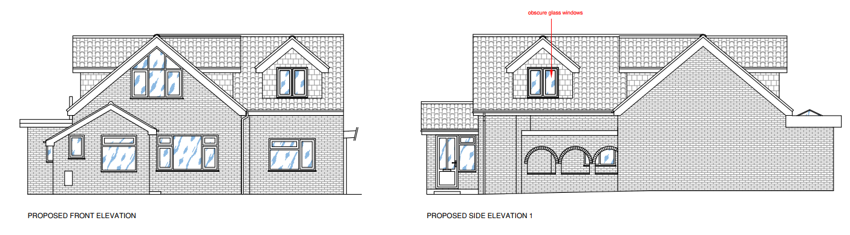

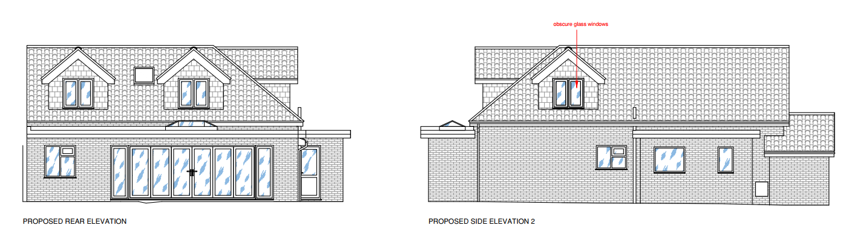

Existing ground floor plan below -

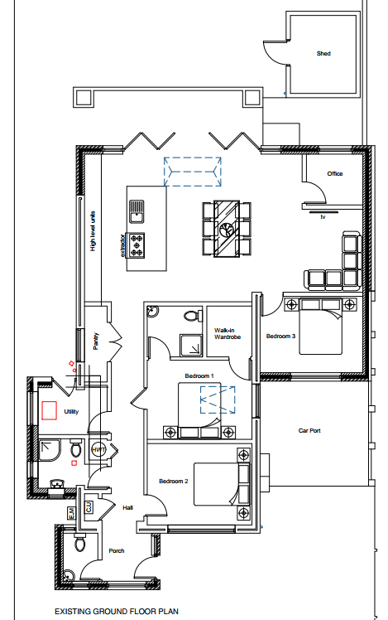

Proposed ground and first floor plans below -

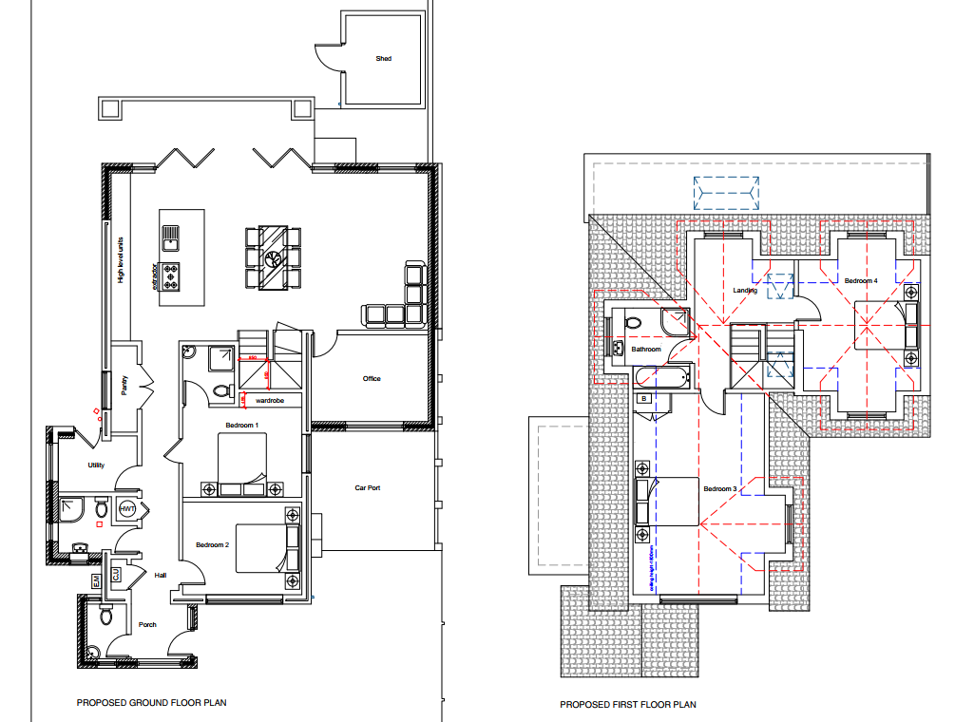

SITE DESCRIPTION/CONTEXT

20 Paddock Close is a modest single-storey detached dwelling situated within a residential cul-de-sac in the village of Winterbourne Dauntsey. Winterbourne Dauntsey together with Winterbourne Earls, Winterbourne Gunner and Hurdcott, these villages are collectively defined as a Large Village by Wiltshire Core Strategy (WCS) policies CP1 (Settlement Strategy), CP2 (Delivery Strategy) and CP4 (Amesbury Community Area) and are known as The Winterbournes. As a Large Village they have a defined village boundary.

The site lies on the eastern side of Paddock Close; the cul-de-sac is broadly divided into two distinct sections. The southern part, within which No. 20 is located, is predominantly characterised by bungalows of a similar scale, form and appearance. Towards the northern end of the cul-de-sac, the pattern of development changes, comprising two-storey dwellings of a consistent design and character.

The images below are taken from Google map and show the two distinct character areas of Paddock Close.

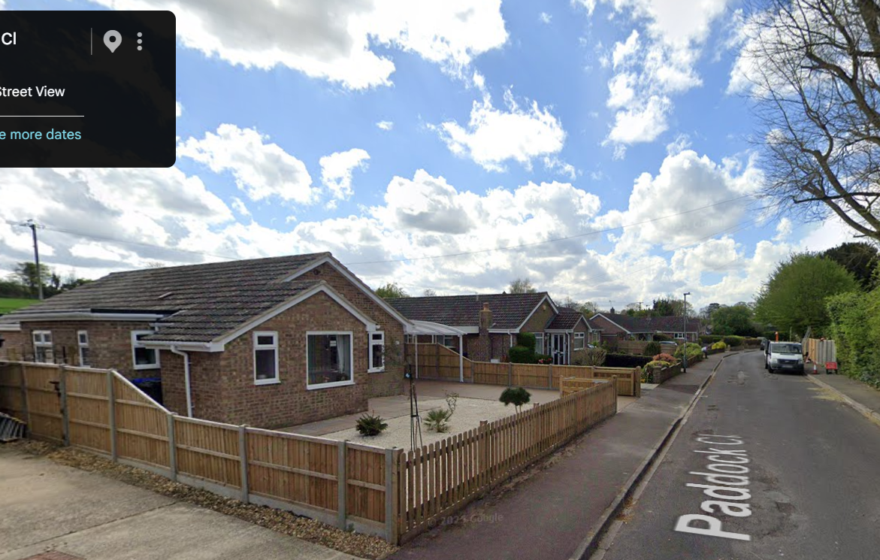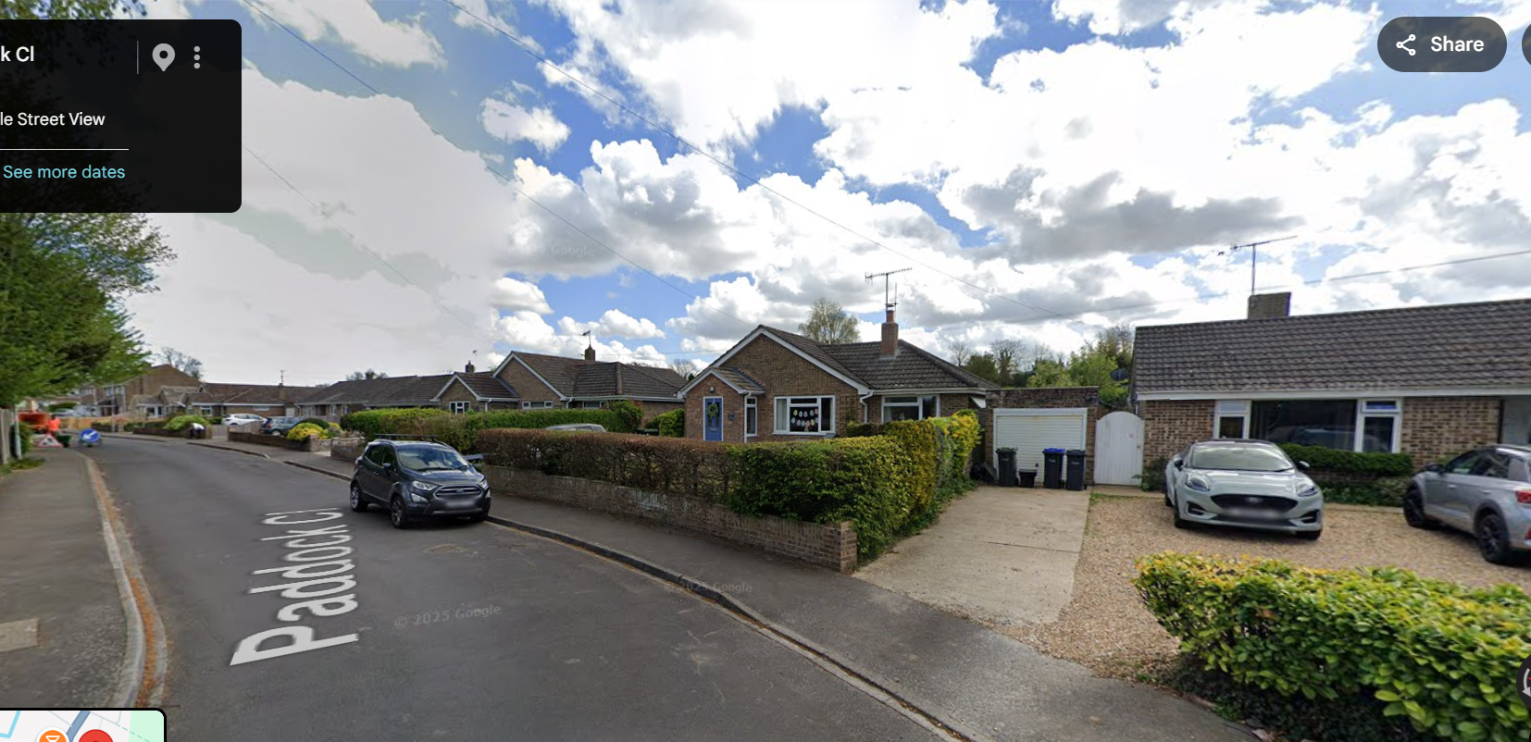

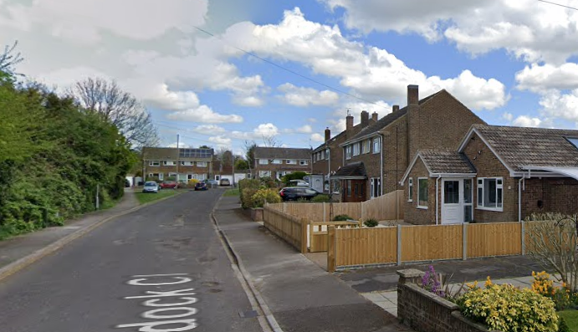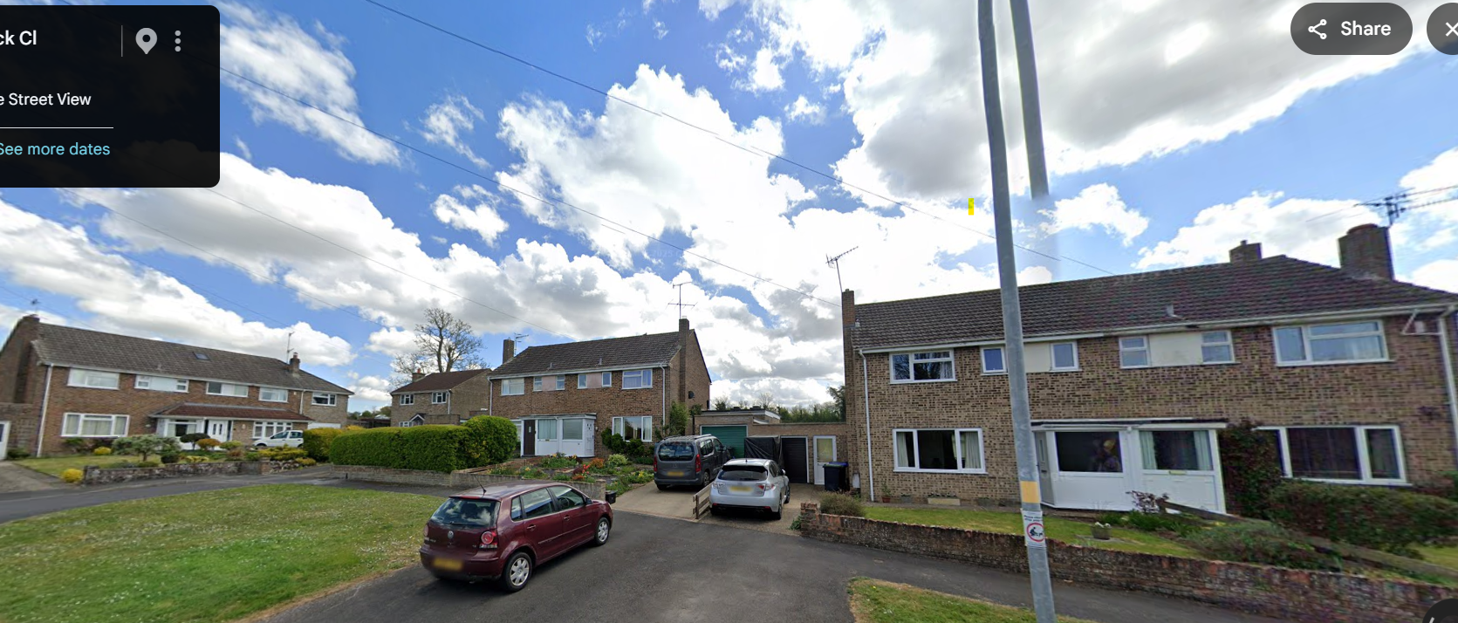

The application site occupies a residential plot with frontage onto Paddock Close and benefits from an enclosed split level rear garden which backs onto open agricultural fields. The property has neighbouring dwellings to the north, south and west.

The application site just outside the boundary of the Winterbourne Earls Conservation Area.

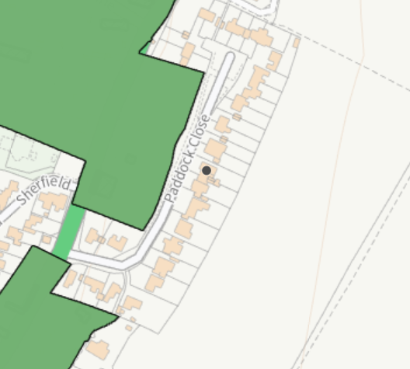

The site is also within the Special Landscape Area (saved policy C6 of the Salisbury District Local Plan).

According to the strategic flood risk assessment 2024, it is located within Flood Zone 1 with a risk of flooding to subsurface assets, but surface manifestation of groundwater is unlikely. The site is also located within the Hampshire River Avon Catchment Area and the New Forest Protected Sites 15km recreation zone of influence. However, these designations have no implication to this householder planning permission due to the nature of the proposed works.

PLANNING HISTORY

Proposal / Summary
PL/2023/10466 - Householder planning permission Decision - Approve with Conditions Date: 9/1/2024 – Alterations to an existing porch and a rear and side extension
S/1981/0060 - Historic apps 1974 to 1983 Decision - Approve Date: 18/3/1981 – Increase in area of lounge and provision of new study, conservatory and carport residential.

RELEVANT POLICIES AND GUIDANCE

The National Planning Policy Framework (NPPF)
The Planning Practice Guidance
National Design Guide

Wiltshire Core Strategy:

Core Policy 1: Settlement Strategy
Core Policy 2: Delivery Strategy
Core Policy 4: Spatial Strategy: Amesbury Community Area
Core Policy 50: Biodiversity and Geodiversity
Core Policy 51: Landscape
Core Policy 57: Ensuring High Quality Design and Place Shaping
Core Policy 61: Transport and New Development
Core Policy 64: Demand Management
Core Policy 69: Hampshire River Avon SAC

The Winterbourne’s Neighbourhood Plan
Wiltshire Design Guide: Appendix D – Design Guidance for Householder extensions
Creating Places Design Guide SPG (April 2006)
Achieving Sustainable Development SPG (April 2005)
Wiltshire Local Transport Plan – Car Parking Strategy

CONSULTATION RESPONSES

Parish Council: None received

REPRESENTATIONS

No comments were received.

ASSESSMENT

Section 38(6) of the Planning and Compulsory Purchase Act 2004 states:

"If regard is to be had to the development plan for the purposes of any determination to be made under the planning Acts, the determination must be made in accordance with the plan unless material considerations indicate otherwise."

In accordance with this statutory requirement, this application has been assessed against the relevant policies of the Development Plan, including the adopted Wiltshire Core Strategy (2015) and, where applicable, any made Neighbourhood Plans.

Design and Impact upon the upon the character and context of the area

The National Planning Policy Framework sets out the Government’s planning policies for England and how these should be applied. The NPPF seeks to secure high-quality, beautiful and sustainable development that functions well, is visually attractive, responds positively to local character, creates a strong sense of place, makes efficient use of land and delivers safe, inclusive and accessible environments. In particular, Chapter 12 details how development should strive to achieve well designed places.

Paragraph 131 states: The creation of high quality, beautiful and sustainable buildings and places is fundamental to what the planning and development process should achieve. Good
design is a key aspect of sustainable development, creates better places in which to live and work and helps make development acceptable to communities.

Paragraph 135 states that - Planning policies and decisions should ensure that developments:

a) will function well and add to the overall quality of the area, not just for the short term but over the lifetime of the development;
b) are visually attractive as a result of good architecture, layout and appropriate and effective landscaping;
c) are sympathetic to local character and history, including the surrounding built environment and landscape setting, while not preventing or discouraging appropriate innovation or change (such as increased densities);
d) establish or maintain a strong sense of place, using the arrangement of streets, spaces, building types and materials to create attractive, welcoming and distinctive places to live, work and visit;
e) optimise the potential of the site to accommodate and sustain an appropriate amount and mix of development (including green and other public space) and support local facilities and transport networks; and
f) create places that are safe, inclusive and accessible and which promote health and well-being, with a high standard of amenity for existing and future users; and where crime and disorder, and the fear of crime, do not undermine the quality of life or community cohesion and resilience.

Para 139 states that Development that is not well designed should be refused, especially where it fails to reflect local design policies and government guidance on design, taking into
account any local design guidance and supplementary planning documents such as design guides and codes. Conversely, significant weight should be given to:

a) development which reflects local design policies and government guidance on design, taking into account any local design guidance and supplementary planning documents such as design guides and codes; and/or
b) outstanding or innovative designs which promote high levels of sustainability or help raise the standard of design more generally in an area, so long as they fit in with the overall form and layout of their surroundings.

National Design Guide para 40 states “Well-designed places are: based on a sound understanding of the features of the site and the surrounding context, using baseline studies as a starting point for design; integrated into their surroundings so they relate well to them; influenced by and influence their context positively”

National Design Guide para 43 states Well-designed new development is integrated into its wider surroundings, physically, socially and visually. It is carefully sited and designed and is demonstrably based on an understanding of the existing situation, including: the landscape character and how places or developments sit within the landscape, to influence the siting of new development….. patterns of built form……. the architecture prevalent in the area, including the local vernacular and other precedents that contribute to local character, to inform the form, scale, appearance, details and materials of new development…………………..”

Core Policy 57 states “a high standard of design is required in all new developments, including extensions… Development is expected to create a strong sense of place through drawing on the local context and being complimentary to the locality”.

i. enhancing local distinctiveness by responding to the value of the natural and historic environment, relating positively to its landscape setting and the existing pattern of development and responding to local topography by ensuring that important views into, within and out of the site are to be retained and enhanced

iii. responding positively to the existing townscape and landscape features in terms of building layouts, built form, height, mass, scale, building line, plot size, elevational design, materials, streetscape and rooflines to effectively integrate the building into its setting

vi. making efficient use of land whilst taking account of the characteristics of the site and the local context to deliver an appropriate development which relates effectively to the immediate setting and to the wider character of the area

vii. having regard to the compatibility of adjoining buildings and uses, the impact on the amenities of existing occupants, and ensuring that appropriate levels of amenity are achievable within the development itself, including the consideration of privacy, overshadowing, vibration, and pollution (e.g. light intrusion, noise, smoke, fumes, effluent, waste or litter).

The Creating Places Design Guide Part 20 relates to householder extensions and advises that development should avoid large extensions which overwhelm the original dwelling. As a rule, they should be subservient, and this may sometimes be best achieved by setting back the extension behind the wall of the main house with a corresponding drop in the roofline. An extension that is too large will not be in balance with the form of the existing dwelling and may destroy the original character. In all circumstances the key principle is that it will still be obvious
what part of the building was original, with later extensions being clearly subordinate.

For dormer roof extensions, the Design Guide states that extensions to the roof space can make the most of a buildings volume. However great care is required if dormers and rooflights are to be sympathetic to the original house and goes on to advise at Part 23 that .. It may be tempting when trying to convert your loft to try and maximise the new living space by adding the largest flat roof dormers possible. Such dormers at both the front and back of the roof slope in effect represent the addition of another floor to the property. In reality crude approaches such as this are rarely acceptable. They will look top heavy, swamp the character of the original property and form a prominent and incongruous feature within the streetscene.

The use of dormers should respect the proportion of the existing window openings and scale of the property to avoid the dormer dominating and unbalancing the roofscape. They should, in general, be simple and low key methods of illuminating upper floorspace and not features in themselves.

The application property forms part of the southern section of Paddock Close, an area characterised by modest single-storey bungalows of broadly similar scale, height and form. Whilst the northern end of the cul-de-sac contains two-storey dwellings, these properties were designed and constructed as two-storey houses and comprise a consistent character distinct from the bungalow development within which the application site is located.

The proposal would substantially alter the appearance of the dwelling through the increase in ridge height, the creation of first-floor accommodation and the introduction of five dormer windows. Collectively, these works would fundamentally change the dwelling from a modest bungalow to a building with a scale, massing and visual presence more akin to a two-storey dwelling, albeit of a lesser scale than the purpose-built two-storey dwellings located to the north.

The increased roof height and extensive dormer additions would erode the simple, low-profile form that presently contributes positively to the character of this part of Paddock Close. Rather than appearing as subordinate additions, the dormers would become dominant features of the building, introducing a visually heavy and overly complex roof form that would draw undue attention within the street scene. The proposal would therefore fail to remain subservient to the original dwelling and would appear incongruous when viewed alongside the surrounding bungalows.
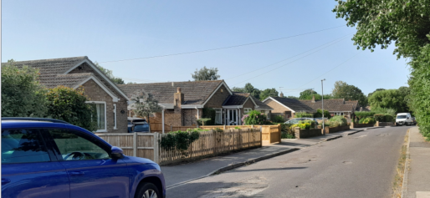
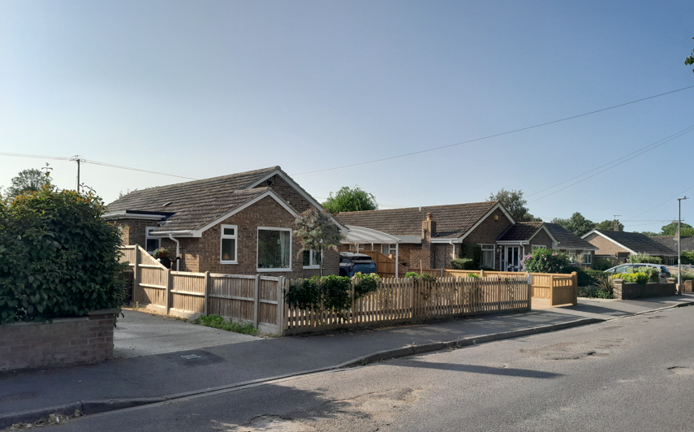
The Council acknowledges that domestic extensions and alterations can contribute to the evolution of residential areas. However, the cumulative effect of the raised roof and five dormers would result in a disproportionate form of development that fails to respect the prevailing pattern of built form, roofscape and building heights that define this part of Paddock Close. The proposal seeks to implement dormer windows on the front, rear, and both side elevation roof slopes, which would be a significant impact on visual amenity. This, coupled with the raised roof height, would be of significant impact on the streetscene, and contradict the existing character and form of neighbouring bungalows. The proposal would neither respond positively to local character nor maintain the strong sense of place identified within national and local design policy.

Furthermore, the proposal directly conflicts with the guidance contained within the Wiltshire Design Guide and Creating Places Design Guide, which advise that roof extensions and dormers should remain sympathetic to the original dwelling and warns against overly large dormer additions that effectively create an additional storey, resulting in development that appears top-heavy, swamps the character of the original property and forms a prominent and incongruous feature within the street scene.

For these reasons, the proposal is considered to represent poor quality design which would cause significant harm to the character and appearance of the host dwelling and the wider street scene. The development is therefore contrary to Core Policy 57 (particularly criteria i, iii and vi) of the Wiltshire Core Strategy, Appendix D of the Wiltshire Design Guide, Creating Places Design Guide, the National Design Guide, and paragraphs 135(c) and (d), and 139 of the National Planning Policy Framework

Amenity

Point vii of Core Policy 57 - Ensuring High Quality Design and Place Shaping of the Wiltshire Core Strategy seeks to ensure that developments do not adversely affect neighbouring properties.

The National Planning Policy Framework (NPPF), particularly Paragraph 135(f), stresses that planning decisions should ensure developments provide a high standard of amenity for existing and future users.

The proposed development has been assessed in terms of its potential impact on the residential amenity of neighbouring properties, with particular regard to loss of light, overshadowing, loss of privacy, and overbearing effects.

The proposal would introduce new first-floor accommodation within a currently single-storey dwelling through the increase in roof height and the insertion of five dormer windows. As a consequence, the development would create new elevated opportunities for overlooking and increased intervisibility with neighbouring residential properties to the north and south.

Particular concern arises from the size, number and distribution of the proposed dormers, which would introduce first-floor windows facing in all directions. Whilst the plans indicate obscure glazing to the side-facing dormers, one of these dormers serves a first-floor bedroom, a habitable room for which occupants would reasonably expect a clear-glazed outlook. In such circumstances, obscure glazing is unlikely to represent a satisfactory long-term solution given the reasonable expectation that future occupants would seek clear-glazed windows to serve this room. Limited weight is therefore afforded to the proposed obscure glazing when considering the enduring amenity impacts of the development.

Furthermore, even if the side-facing dormers were permanently maintained as obscure glazed, the proposed dormers would nevertheless result in large and prominent glazed structures at first-floor level. The scale, position and extent of glazing would create a pronounced perception of overlooking and a materially greater sense of overlooking than currently experienced by neighbouring occupiers. The proposal would therefore fail to maintain the level of privacy presently enjoyed by adjoining residential properties.

This impact is particularly significant given that the existing dwelling is single-storey and therefore does not currently afford comparable opportunities for elevated views towards neighbouring properties

In addition, the increase in the height and bulk of the dwelling, together with the introduction of extensive dormer structures across the roof slopes, would result in a more dominant and visually intrusive form of development. The proposal would appear unneighbourly when viewed from adjoining residential gardens and habitable room windows, creating an increased sense of enclosure and materially altering the relationship between the dwelling and its neighbours.

Overall, the increased opportunities for overlooking, the perception of overlooking arising from the extensive first-floor glazing, and the more dominant built form would result in unacceptable harm to the living conditions of neighbouring occupiers. The proposal therefore fails to comply with Core Policy 57(vii) of the Wiltshire Core Strategy, Appendix D of the Wiltshire Design Guide and paragraph 135(f) of the National Planning Policy Framework.

Highways Impact

Core Policy 57 (xiv) of the Wiltshire Core Strategy seeks to ensure that development must meet the requirements of Core Policy 61. This policy requires proposals to be capable of being served by safe access to the highway network. Core Policy 64 seeks to ensure compliance with parking standards set out in the Local Transport Plan.

The National Planning Policy Framework (NPPF), particularly Paragraph 115 and 116, requires that development proposals do not have an unacceptable impact on highway safety and that safe and suitable access to the site can be achieved for all users.

Current parking policy, and the terms and conditions for Wiltshire’s resident parking permit schemes, are presented in ‘LTP3’, which is the third evolution of the Wiltshire Local Transport Plan. LTP3 sets out the Council’s objectives, implementation plans and targets for transport in Wiltshire for the period from 2011 to 2026.

Regarding parking standards, LTP3 sets out minimum space requirements for residential developments. The standards follow:

Bedrooms | Minimum Spaces
1 | 1 space
2 to 3 | 2 spaces
4+ | 3 spaces
Visitor Parking | 0.2 spaces per dwelling (unallocated)

The proposals will increase the number of bedrooms from three to four bedrooms and therefore three off road parking spaces are required. No parking plan ahs been provided however, it is likely that the provision of three off road parking spaces is achievable within the site. Notwithstanding this, Paddock Close is a small, quiet cul-de-sac with unrestricted on street parking, therefore it is not considered that there are grounds to refuse the proposed development on lack of parking/highway safety reasons.

Had the proposed development for the creating of first floor accommodation been acceptable and the application heading for approval, it would have been prudent to request a parking plan, however, it was not considered necessary in this instance due to Officer objections on design and amenity grounds.

The proposal is therefore considered to comply with Core Policies 57 (xiv), 61 and 64 of the Wiltshire Core Strategy, the NPPF, and the Wiltshire Local Transport Plan.

Ecology Impact

Core Policy 50 of the Wiltshire Core Strategy seeks to protect and enhance biodiversity and geodiversity, including through ensuring that development avoids harm to protected species and habitats.

The National Planning Policy Framework (NPPF), in Paragraphs 193, requires that development minimises impacts on and provides net gains for biodiversity, including ensuring mitigation is secured where harm cannot be avoided.

The application site is not subject to any statutory or non-statutory ecological designations, and the scale and nature of development is such that significant harm to biodiversity is unlikely.

Biodiversity Net Gain - Householder planning applications are exempt from the requirement to deliver Biodiversity Net Gain under Schedule 7A, Section 4(2)(a) of the Town and Country Planning Act 1990, as inserted by the Environment Act 2021.

As such, the development complies with Core Policy 50 of the Wiltshire Core Strategy and the relevant provisions of the NPPF.

CONCLUSION

The proposed development would result in the substantial alteration and enlargement of a modest bungalow through the raising of the ridge, creation of first-floor accommodation and installation of five dormer windows. The cumulative effect of these works would fundamentally alter the character, scale and appearance of the dwelling, resulting in a visually dominant and incongruous form of development that would fail to respect the established bungalow character of this part of Paddock Close.

Furthermore, the creation of the first-floor accommodation and multiple dormer windows would introduce unacceptable opportunities for overlooking, an increased perception of overlooking and a more dominant and unneighbourly relationship with neighbouring residential properties, resulting in harm to residential amenity.

For these reasons, the proposal conflicts with Core Policy 57 of the Wiltshire Core Strategy, Appendix D of the Wiltshire Design Guide, the National Design Guide and the relevant provisions of the National Planning Policy Framework. No material considerations have been identified that outweigh these harms, accordingly, planning permission is recommended for refusal

RECOMMENDATION: That Planning Permission be REFUSED.

1. The proposed development, by reason of the increase in ridge height, creation of first-floor accommodation and introduction of five prominent dormer windows, would fundamentally alter the scale, massing, proportions and roof form of the host dwelling. The resulting development would appear overly dominant, top-heavy and visually incongruous within the established bungalow character of the southern part of Paddock Close, failing to respond positively to local character or respect the prevailing pattern of development. The proposal would consequently result in significant harm to the character and appearance of both the host dwelling and the surrounding street scene.

Furthermore, the increased height and massing of the dwelling, together with the introduction of first-floor accommodation and dormer windows, would create unacceptable opportunities for overlooking and a harmful perception of overlooking of neighbouring residential properties. The development would also appear unduly dominant and unneighbourly when viewed from adjoining properties, materially eroding the privacy and residential amenity currently enjoyed by neighbouring occupiers.

The proposal is therefore contrary to Core Policy 57 (i, iii, v, vi and vii) of the Wiltshire Core Strategy, the Wiltshire Design Guide, Creating Places Design Guide, Wiltshire Design Guide, the National Design Guide, and paragraphs 135 and 139 of the National Planning Policy Framework.

INFORMATIVE

For the avoidance of doubt, the plans and supporting documents considered in this refusal, all received 12/06/2026 are as follows:
Application form
Location plan Drg no DAK/PC/01
Proposed block plan Drg no DAK/PC/02
Existing floor plan Drg no DAK/PC/03
Existing elevations Drg no DAK/PC/04
Proposed floor plans Drg no DAK/PC/05
Proposed elevations Drg no DAK/PC/06
Proposed section through Drg no DAK/PC/07
Existing roof plan Drg no DAK/PC/08
Proposed roof plan Drg no DAK/PC/09

