APPLICATION FOR HOUSEHOLDER PLANNING PERMISSION
DELEGATED REPORT

APPLICATION REFERENCE: | PL/2026/03597
APPLICATION TYPE: | Householder planning permission
SITE ADDRESS: | 6 Winsley Road, Bradford on Avon, BA15 1QR
DEVELOPMENT DESCRIPTION: | Installation of a single domestic electric vehicle (EV) charge point on the front elevation of the property
RECOMMENDATION: | That Planning Permission be GRANTED

PROPOSAL

The proposal seeks planning permission for the installation of a single domestic electric vehicle (EV) charge point on the front elevation of the property. The host dwelling does not benefit from any off-road parking provision. The permission relates to the installation of the charger only and not any cross-pavement cable solution, cable channel, or on-street charging arrangement.

SITE DESCRIPTION/CONTEXT

This application relates to a two storey mid-terraced dwelling, 6 Winsley Road, located within the historic core of Bradford on Avon. The host dwelling sits within the Bradford on Avon conservation area and lies within the Bath and Bradford on Avon Special Area of Conservation for bats. To the east of the host dwelling lie the Grade II listed semi-detached buildings, No’s 1 and 2 Winsley Road

PLANNING HISTORY

Proposal / Summary
20/05310/FUL - Full planning permission Decision - Approve with Conditions Date: 2/9/2020 – Demolition of existing rear extension, replacement single store extension, internal works including stair relocation and works to the street facade including replacement windows.
ENQ/2026/01123 - PD Enquiries Decision - PP Required Date: – EV charger mounted on front elevation

RELEVANT POLICIES AND GUIDANCE

Wiltshire Core Strategy:

CP2 - Delivery Strategy
CP7 – Spatial Strategy for the Bradford on Avon Community Area
CP41 - Sustainable Construction and Low Carbon Energy
CP50 – Biodiversity and Geodiversity
CP57 - Ensuring High Quality Design and Place Shaping
CP58 - Ensuring the Conservation of the Historic Environment
CP60 – Sustainable Transport
CP61 – Transport and Development
CP64 – Demand Management

New Wiltshire Local Plan
At Full Council on 19 May 2026, the elected members of Wiltshire Council agreed to withdraw the emerging Wiltshire Local Plan. The said Plan has no material weight for the purposes of the application.

In accordance with Regulation 19 of the Town and Country Planning (Local Planning) (England) Regulations 2026, on 30th June 2026 Wiltshire Council published a notice of intention to prepare a new local plan for Wiltshire. The next stage is a Scoping Consultation which commences on 2nd September 2026. This plan is at a very early stage and currently carries no weight for decision making.

Bradford on Avon Neighbourhood Plan 2013 – 2026 Made October 2017
Bradford on Avon Conservation Area Statement
Bath and Bradford on Avon Bat SAC Guidance
Wiltshire Local Transport Plan 3 2011 – 2026 (March 2015)
Wiltshire Design Guide
The National Planning Policy Framework (NPPF)
The Planning Practice Guidance
National Design Guide

CONSULTATION RESPONSES

Bradford on Avon Town Council: No objection subject to the WC conservation officer being satisfied that there are no adverse visual impacts on this historic building from the development

REPRESENTATIONS
No comments were received.

ASSESSMENT
Section 38(6) of the Planning and Compulsory Purchase Act 2004 states:

"If regard is to be had to the development plan for the purposes of any determination to be made under the planning Acts, the determination must be made in accordance with the plan unless material considerations indicate otherwise."

In accordance with this statutory requirement, this application has been assessed against the relevant policies of the Development Plan, including the adopted Wiltshire Core Strategy (2015) and, where applicable, any made Neighbourhood Plans.

Design and Impact upon the upon the character and context of the area
Core Policy 57 - Ensuring High Quality Design and Place Shaping of the Wiltshire Core Strategy seeks to ensure that all new development is of high design quality, reflecting local context, character, and distinctiveness.

Core Policy 41 (Sustainable Construction and Low Carbon Energy) of the Wiltshire Core Strategy seeks to mitigate the impacts of climate change through sustainable design and construction methods, encouraging development that improves energy efficiency, reduces carbon emissions and supports the incorporation of low-carbon and renewable energy technologies where appropriate

The proposal seeks planning permission for the installation of a wall mounted untethered single domestic electric vehicle (EV) charge point on the front elevation of the property. The host dwelling does not benefit from any off-road parking provision so any permission would relate to the installation of the charger only and not any cross-pavement cable solution, cable channel, or on-street charging arrangement for which separate consent would be required.

The charger box would be inserted on the front elevation of the host dwelling and would measure 0.23m high, 0.14m wide and would project 0.10m in depth mounted flush to the wall. The charger would be black in colour and would not have a permanently hanging cable when not in use.

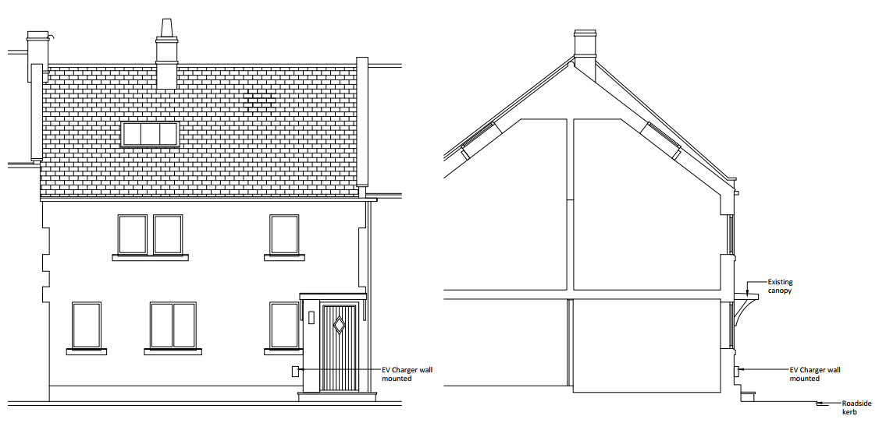

Proposed front (left) and side (right) elevation of the property with EV charger installed

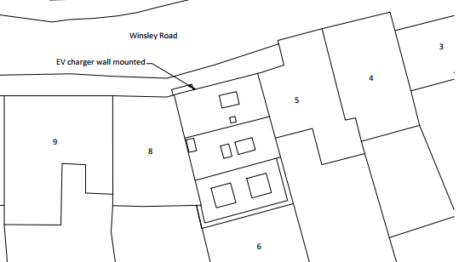
Position of the charger illustrated

The proposed EV charging point would facilitate the use of electric vehicles and support the transition to lower-carbon forms of transport. As such, the development is considered to accord with the aims of Core Policy 41: Sustainable Construction and Low Carbon Energy, which seeks to reduce Wiltshire's contribution to climate change through improved sustainability measures and low-carbon technologies.

The use of appropriate materials would ensure the proposal would integrate into the surrounding setting and existing street scene. It is considered that the proposal would by virtue of its height, scale and design constitute an acceptable addition to the host dwelling that would appear commensurate to the size of the property and plot.

Having regard to the above, the proposal complies with the design principles set out in Core Policy 57 of the Wiltshire Core Strategy and Appendix D of the Wiltshire Design Guide.

Amenity
Point vii of Core Policy 57 - Ensuring High Quality Design and Place Shaping of the Wiltshire Core Strategy seeks to ensure that developments do not adversely affect neighbouring properties.

The National Planning Policy Framework (NPPF), particularly Paragraph 135(f), stresses that planning decisions should ensure developments provide a high standard of amenity for existing and future users.

The proposed development has been assessed in terms of its potential impact on the residential amenity of neighbouring properties, with particular regard to loss of light, overshadowing, loss of privacy, and overbearing effects.

Given the nature of the proposal and small-scale nature of the works officers raise no concerns in regard to any adverse neighbouring amenity impacts.

The proposal therefore accords with Core Policy 57 point vii in respect of safeguarding residential amenity and Appendix D of the Wiltshire Design Guide.

Highways Impact
Core Policy 57 (xiv) of the Wiltshire Core Strategy seeks to ensure that development must meet the requirements of Core Policy 61. This policy requires proposals to be capable of being served by safe access to the highway network. Core Policy 64 seeks to ensure compliance with parking standards set out in the Local Transport Plan.

The National Planning Policy Framework (NPPF), particularly Paragraph 115 and 116, requires that development proposals do not have an unacceptable impact on highway safety and that safe and suitable access to the site can be achieved for all users.

Given the host dwelling does not benefit from any off road parking provision if the EV charging point were to be utilised then a charging cable would have to be positioned across the existing public footpath directly to the north of the terraced row and the cable would require access to a charging point on a vehicle that would be parked on the public highway, which would introduce an adverse highway safety impact.

However, as previously stated, the proposal relates to the installation of the charger only and not any cross-pavement cable solution, cable channel, or on-street charging arrangement. The applicant has advised that the scheme “relates solely to the installation of the EV charge point. The application is not subject to participation in the ‘Wiltshire Cable Channel Trial.’ Any future arrangements for actually charging a vehicle parked on-street would be subject to separate consideration and approval. The separate consideration may be part of the trial or via permitted development if / when planning regulations permit”

The Council’s Highway team have stated that
’ We have to advise the applicant that a proposed cross-footway EV charging cable channel is not currently permissible unless approved within the existing WC trial programme. Therefore, we recommend that the applicant investigates the details of this trial using the below web link and contacts the EVI Team using the below email address for further information; https://www.wiltshire.gov.uk/ev-cable-channel-trial and EVITeam@wiltshire.gov.uk’

Given the limited development proposed, the installation of the EV charger only, that would require further permission to function in its intended capacity, officers raise no concerns in regard to any adverse impact on highway safety.

The proposal is therefore considered to comply with Core Policies 57 (xiv), 61 and 64 of the Wiltshire Core Strategy, the NPPF, and the Wiltshire Local Transport Plan.

Heritage Impact
From the point of view of the historic environment the main statutory tests are set out within the Planning (Listed Building and Conservation Areas) Act 1990.

Section 66 requires that special regard be given to the desirability of preserving listed buildings, their settings or any features of special architectural or historic interest which they possess.

Section 72(1) of the Act requires the Council to pay special attention to the desirability of preserving or enhancing the character or appearance of designated Conservation Areas.

The Council’s Core Strategy Policy CP58 ‘Ensuring the conservation of the historic environment’ requires that designated and non-designated heritage assets and their settings will be conserved, and where appropriate enhanced, in a manner appropriate to their significance and encourages proposals which improve the condition of heritage assets at risk.

The Council’s Core Strategy CP 57: Ensuring high quality design requires a high quality of design in all new developments. The policy requires applicants to “demonstrate how the proposal will make a positive contribution to the character of Wiltshire through (amongst other things) responding to the value of the natural and historic environment and being sympathetic to and conserving historic buildings and landscapes. Development is required to respond positively to the existing in terms of building layouts, built form, height, mass, scale, building line, plot size, elevational design, materials, streetscape and rooflines to effectively integrate the building into its setting.

The NPPF outlines government policy for planning. Chapter 16 of the NPPF 'Conserving and enhancing the historic environment' sets out the Government's high-level policies concerning heritage and sustainable development.

The host dwelling sits within the Bradford on Avon Conservation Area and to the east of the host dwelling lie two Grade II listed semi-detached buildings, No’s 1 and 2 Winsley Road, therefore due consideration needs to be given to the impact of any development on the heritage assets nearby. The proximity of the buildings is illustrated by the black hatching in the map insert below and green wash indicates the extent of the conservation area.

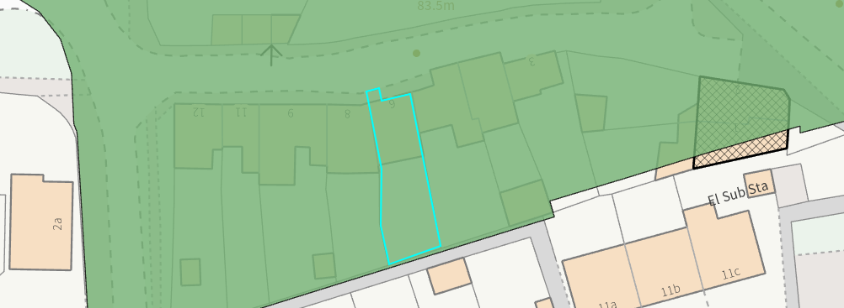

Given the limited works proposed, that would be set within the built envelope of the application site, it is considered that there would be nominal harm to the conservation area. The proposal, by virtue of its scale, design, and use of appropriate materials, is considered to preserve the character and appearance of the conservation area and the setting of the listed buildings nearby.

Officers consider that it would not result in harm to the significance of any heritage assets, the development is therefore considered to comply with Core Policy 58 of the Wiltshire Core Strategy and Sections 66 and 72 of the Planning (Listed Buildings and Conservation Areas) Act 1990, as well as the relevant provisions of the NPPF.

Ecology Impact
Core Policy 50 of the Wiltshire Core Strategy seeks to protect and enhance biodiversity and geodiversity, including through ensuring that development avoids harm to protected species and habitats.

The National Planning Policy Framework (NPPF), in Paragraphs 193, requires that development minimises impacts on and provides net gains for biodiversity, including ensuring mitigation is secured where harm cannot be avoided.

The application site sits within the Bath and Bradford on Avon Special Area of Conservation for bats therefore due consideration has to be given to the potential disturbance of any bats because of the proposed development.

The proposed development comprises small scale works installed on the front elevation of the host dwelling, close to the existing building which does not involve works to the roof. Given the established high density urban residential nature of the location, it is considered highly unlikely that any bats would be affected and significant effects relating to the disturbance to bats can be ruled out.

As a precautionary measure an informative would be added to any decision that in event any evidence of bat activity is detected that the applicant should follow the advice of a professional ecologist or contact Natural England. As such, the development complies with Core Policy 50 of the Wiltshire Core Strategy and the relevant provisions of the NPPF.

Biodiversity Net Gain
Householder planning applications are exempt from the requirement to deliver Biodiversity Net Gain under Schedule 7A, Section 4(2)(a) of the Town and Country Planning Act 1990, as inserted by the Environment Act 2021.

CONCLUSION
The proposed development is considered to be acceptable in terms of its design, scale, and relationship with the surrounding area. It would not result in any unacceptable harm to the character of the locality, the amenities of neighbouring occupiers, or the interests of highway safety, heritage, or ecology.

The proposal is therefore considered to comply with the relevant policies of the Wiltshire Core Strategy, the Wiltshire Local Plan, and the National Planning Policy Framework. As such, the application is recommended for approval, subject to the conditions set out below.

RECOMMENDATION: That Planning Permission be GRANTED subject to conditions.

