APPLICATION FOR HOUSEHOLDER PLANNING PERMISSION
DELEGATED REPORT

APPLICATION REFERENCE: | PL/2026/04231
APPLICATION TYPE: | Householder Planning Permission
SITE ADDRESS: | Whitepits, 23 Kingston Deverill, Warminster, BA12 7HE
DEVELOPMENT DESCRIPTION: | Revamp Your Tank Scheme - replacement of septic tank with a treatment plant
RECOMMENDATION: | That Planning Permission be GRANTED

PROPOSAL

The application is seeking approval for the replacement of an existing non-mains sewerage system with a new sewage treatment plant. This development would include the installation of associated equipment such as pipes and cables.

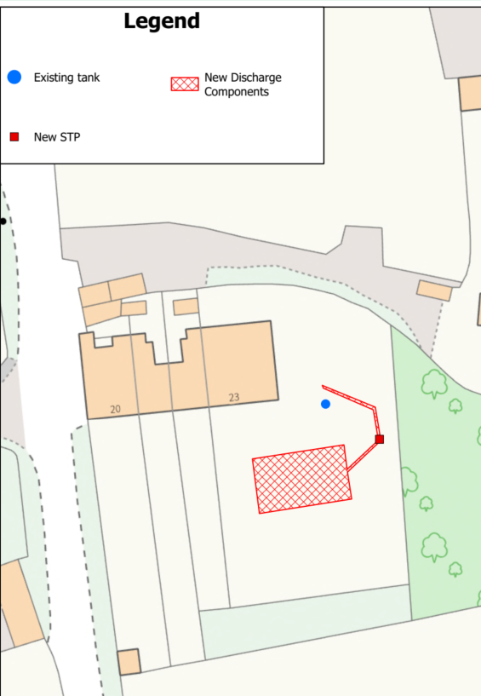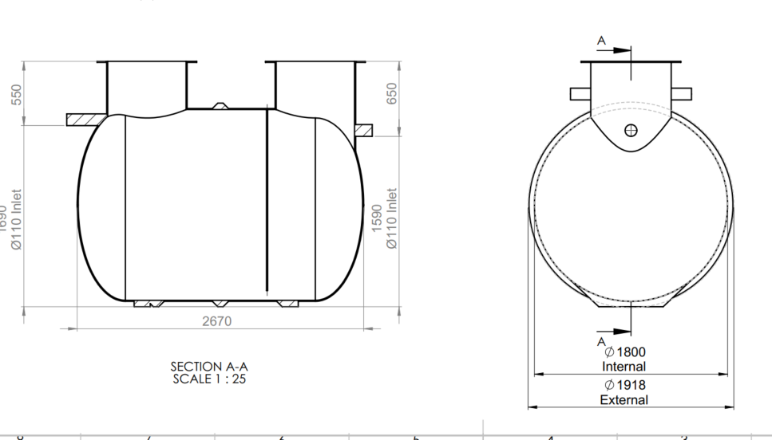

Proposed Site Plan and Proposed Treatment Plant

SITE DESCRIPTION / CONTEXT

The application site is subject to the following planning policy constraints:

- River Avon Catchment
- Source Protection Area
- Cranborne Chase and West Wiltshire Downs National Landscape

The site is not subject to any other policy designation and there are no heritage or flood risk (ground water is 0.5-5m below the surface) issues.

PLANNING HISTORY

Proposal / Summary
W/05/02905/FUL - Full planning permission Decision - Approve with Conditions Date: 9/3/2006 – Two storey side and rear extension

RELEVANT LEGILSATION, POLICIES AND GUIDANCE

National Context:

The National Planning Policy Framework (NPPF)

The Planning Practice Guidance

Local Context:

The adopted Wiltshire Core Strategy (WCS), with particular regard to:

- Core Policy 1 Settlement Strategy;
- Core Policy 2 Delivery Strategy;
- Core Policy 31 Spatial Strategy Warminster Community Area
- Core Policy 50 Biodiversity and Geodiversity;
- Core Policy 51 Landscape
- Core Policy 57 Ensuring High Quality Design and Place Shaping;
- Core Policy 58 Ensuring the Conservation of the Historic Environment;
- Core Policy 68 Water Resources

Upper Deverells does not have a Neighbourhood Plan or Area Designation

CONSULTATION RESPONSES

Upper Deverills Parish Council: No comments received

WC Drainage Officer: No consultation required

Environment Agency: No consultation required

REPRESENTATIONS

The application was advertised by 4 neighbour notification letters and by site notice allowing for 21 day consultation.

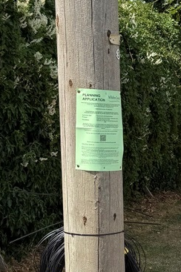

No comments were received.

ASSESSMENT

Section 38(6) of the Planning and Compulsory Purchase Act 2004 states:

"If regard is to be had to the development plan for the purposes of any determination to be made under the planning Acts, the determination must be made in accordance with the plan unless material considerations indicate otherwise."

In accordance with this statutory requirement, this application has been assessed against the relevant policies of the Development Plan, including the adopted Wiltshire Core Strategy (2015) and, where applicable, any made Neighbourhood Plans.

The application proposes the replacement of existing sewerage equipment within a residential property. The nature and scale of the works are considered acceptable in principle, and the proposal will be assessed in further detail throughout the remainder of this report.

Flooding and Drainage

Core Policy 67 of the Wiltshire Core Strategy sets out the approach to managing flood risk, while paragraph 172 of the NPPF requires a sequential, risk-based strategy for locating development. The site lies within Flood Zone 1, indicating the lowest risk of fluvial flooding, and is also at low risk of surface and groundwater flooding. The proposed replacement of sewerage equipment is a like-for-like installation and is not expected to alter existing drainage characteristics. Accordingly, no flood risk concerns are identified.

The application outlines, in the accompanying drainage report, that the existing method of discharge is to a ground soakaway. The Design and Access Statement and Site Plan indicate that the proposal would retain this method of discharge through modification and updating a newly established soakaway system within the property curtilage. As such, it is considered that the proposed drainage arrangements would represent a neutral to positive alteration to the existing sewage treatment method and would not give rise to any undue impacts in relation to Core Policy 67.

Core Policy 68: Water Resources, requires that development proposals within a Source Protection Zone, Safeguard Zone, or Water Protection Zone assess potential risks to groundwater resources and quality. Proposals must demonstrate that these resources will be safeguarded throughout both the construction and operational phases. In light of this, it is considered appropriate to include a condition preventing chemical dosing in connection with the development or operation of the proposed system, should planning permission be granted.

Core Policy 50: Biodiversity and Geodiversity requires development to safeguard ecological and geological interests, ensuring long-term protection and functionality. Additionally, Core Policy 69: Protection of the River Avon SAC emphasises the need to avoid pollution and mitigate disturbance to the SAC through appropriate design and operational measures. Any future modification to the proposed system must maintain or enhance phosphorus removal efficiency, and a condition should be imposed to secure this requirement as part of any approval.

Design and Impact upon the upon the character and context of the area

Core Policy 57 - Ensuring High Quality Design and Place Shaping of the Wiltshire Core Strategy seeks to ensure that all new development is of high design quality, reflecting local context, character, and distinctiveness.

The development is to replace an underground sewerage system. Although the development works would involve excavation, the completed works would essentially be hidden and would therefore result in no identified harm to the appearance of the site or its locality.

Having regard to the above, the proposal complies with the design principles set out in Core Policy 57 of the Wiltshire Core Strategy and Appendix D of the Wiltshire Design Guide.

Impact on the National Landscape

Core Policy 51 of the Wiltshire Core Strategy requires all development to protect, conserve, and where possible enhance the character and quality of Wiltshire’s landscapes, giving particular weight to designated areas such as National Landscapes.

The National Planning Policy Framework (NPPF), in Paragraph 176, states that “great weight” should be given to conserving and enhancing landscape and scenic beauty in National Landscapes (formerly Areas of Outstanding Natural Beauty). Development within or affecting the setting of a National Landscape must demonstrate that it will not result in unacceptable harm to the special qualities of that area.

Given the minimal scale, underground siting, and functional nature of the proposed septic tank, the development would not harm the special qualities or scenic character of the Cranborne Chase and West Wiltshire Downs National Landscape.

The development therefore complies with Core Policy 51 of the Wiltshire Core Strategy and Paragraph 176 of the NPPF in conserving and enhancing the National Landscape.

Amenity

Point vii of Core Policy 57 - Ensuring High Quality Design and Place Shaping of the Wiltshire Core Strategy seeks to ensure that developments do not adversely affect neighbouring properties.

The National Planning Policy Framework (NPPF), particularly Paragraph 135, stresses that planning decisions should ensure developments provide a high standard of amenity for existing and future users.

No amenity concerns are identified, as the proposed upgrade would be contained within the property curtilage and would not result in any visual or overbearing impact. The system is appropriately sited, designed, and oriented to avoid any unacceptable effects on neighbouring residential amenity, including outlook, privacy, and access to natural light.

The proposal therefore accords with Core Policy 57 point vii in respect of safeguarding residential amenity and Appendix D of the Wiltshire Design Guide.

Ecology

Core Policy 50 of the WCS requires development to avoid and minimise disturbance to sensitive habitats and species.

The proposed development involves a like-for-like replacement of residential equipment within existing curtilage, an area already subject to development. It is therefore unlikely to impact sensitive habitats or species. Furthermore, the updated drainage system retains the existing discharge method while improving nutrient filtration, resulting in a neutral to positive environmental outcome. The proposal is considered to comply with Core Policy 50 and is acceptable in this regard.

Biodiversity Net Gain (BNG) became a statutory requirement under Schedule 7A of the Town and Country Planning Act 1990, as amended by Schedule 14 of the Environment Act 2021. However, householder applications are exempt from this requirement under Section 4(2)(a) of Schedule 7A.

CONCLUSION

The proposal is considered to comply with the relevant policies of the Wiltshire Core Strategy and the National Planning Policy Framework. As such, the application is recommended for approval, subject to the conditions set out below.

RECOMMENDATION: That Planning Permission be GRANTED subject to conditions:

