APPLICATION FOR HOUSEHOLDER PLANNING PERMISSION DELEGATED REPORT
APPLICATION REFERENCE: | PL/2026/02582
APPLICATION TYPE: | Householder planning permission
SITE ADDRESS: | 32 Chichester Close, Harnham, Salisbury, SP2 8AQ
DEVELOPMENT DESCRIPTION: | Single storey front extension to create additional accommodation
RECOMMENDATION: | That Planning Permission be GRANTED

PROPOSAL

The proposal seeks planning permission for the erection of a single storey front extension.

During the course of the application process, amended plans were received to make design changes to the proposed extension to set the front elevation of the extension back from the adjacent front projection which currently forms a garage to the host dwelling and to add a hipped roof.

Existing and proposed front (west) elevation included below

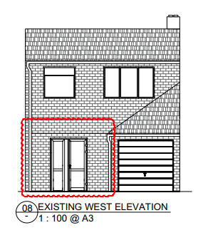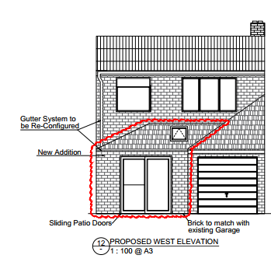

Existing and proposed side (north) elevation included below.

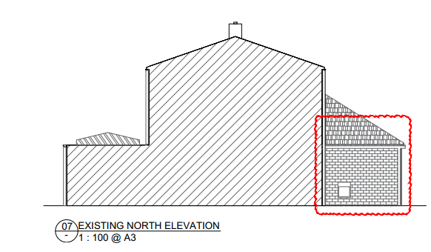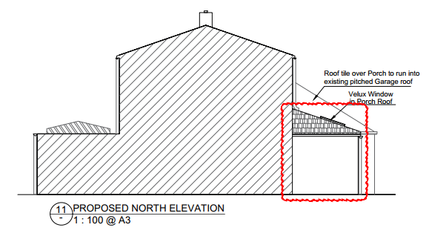

There are no proposed changes to the rear or side (south) elevation.

Existing floor plans included below.

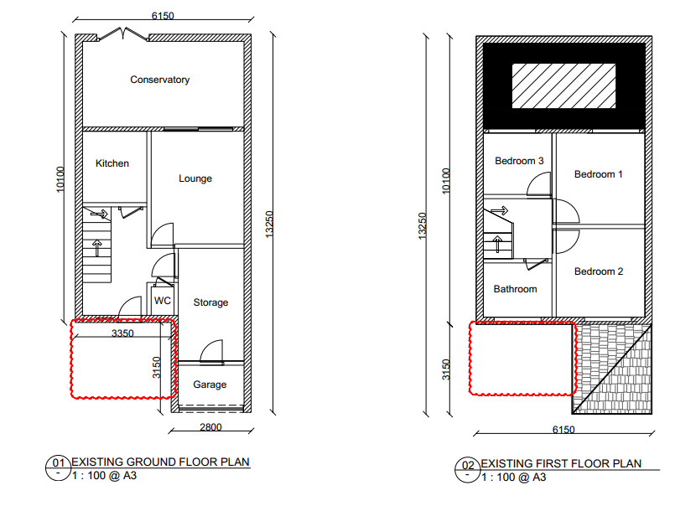

Proposed floor plans included below.

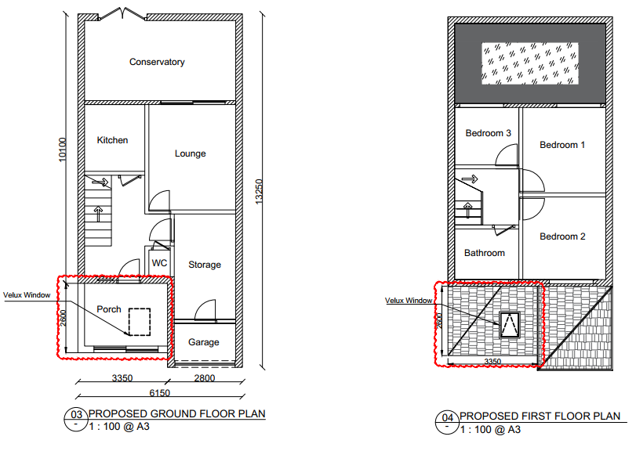

SITE DESCRIPTION/CONTEXT

The application site is a two-storey mid terrace dwelling located on a residential cul-de-sac within the built-up area of Salisbury. It is situated within the settlement boundary of the principal settlement of Salisbury, as defined by Wiltshire Core Strategy (WCS) policies CP1, CP2 and CP20. Whilst the site is in Flood Zone 1 and is not in the immediate vicinity of any rivers, it is situated within the Hampshire River Avon Catchment; and is within the 13.8- kilometre recreational buffer of the New Forest Special Protection Area (SPA) and RAMSAR site. However, due to the nature of the application, these designations do not have any bearing on the assessment of this application.

PLANNING HISTORY

None

RELEVANT POLICIES AND GUIDANCE

The National Planning Policy Framework (NPPF)
The Planning Practice Guidance
National Design Guide

Wiltshire Core Strategy:

Core Policy 1 Settlement Strategy
Core Policy 2 Delivery Strategy
Core Policy 50 Biodiversity
Core Policy 20 Spatial Strategy: Salisbury Community Area
Core Policy 57 Ensuring High Quality Design and Place Shaping
Core Policy 69 River Avon SAC

Wiltshire Design Guide: Appendix D – Design Guidance for Householder extensions
Salisbury Neighbourhood Development Plan 2020 to 2038
Creating Places Design Guide

CONSULTATION RESPONSES

City Council: Salisbury City Council notes the concerns of the neighbours.

REPRESENTATIONS

Three letters of objection have been received from third parties, issues raised are summarised below.

- Primary concern relates to boundary alignment: Objectors state the proposal incorrectly shows a straight boundary, whereas HM Land Registry indicates an angled boundary between Nos. 30 and 32.
- The angled boundary is longstanding (since original development) and historically enabled adequate shared access to adjacent driveways (Nos. 28 and 30).
- A recent fence not reflecting the angled alignment has already led to restricted access and manoeuvrability issues, which residents consider would be exacerbated by the proposed extension if built as shown.
- No in-principle objection from adjoining occupiers at Nos. 26 and 28, subject to the development respecting the correct boundary line.
- Potential restriction of access
- Loss of light to the entrance
- Impacts on parking and safe vehicle access
- Possible effect on property value

A further representation was received following the re-consultation on the amended plans stating –

We have no further objections apart from our previously stated concern over the angle of the boundary wall which if altered from the original Land Survey plan as previously provided will impact upon our parking.

A letter from the applicant was also received at the end of the re-consultation period commenting on the objections received, specifically in relation to the issue of the location of the boundary.

ASSESSMENT

Section 38(6) of the Planning and Compulsory Purchase Act 2004 states:

"If regard is to be had to the development plan for the purposes of any determination to be made under the planning Acts, the determination must be made in accordance with the plan unless material considerations indicate otherwise."

In accordance with this statutory requirement, this application has been assessed against the relevant policies of the Development Plan, including the adopted Wiltshire Core Strategy (2015) and, where applicable, any made Neighbourhood Plans.

Design and Impact upon the character and context of the area

Core Policy 57 - Ensuring High Quality Design and Place Shaping of the Wiltshire Core Strategy seeks to ensure that all new development is of high design quality, reflecting local context, character, and distinctiveness.

The proposed development relates to the erection of a single storey hipped roof extension located to the front of the existing dwelling to fill in a gap between the side elevation of the existing front extension and site boundary with No 30 Chichester Close. As can be seen from the photos below, the character of Chichester Close incorporates a mix of single storey front extensions with a range of design and roof type including flat roofs, mono-pitch and pitched roofs.

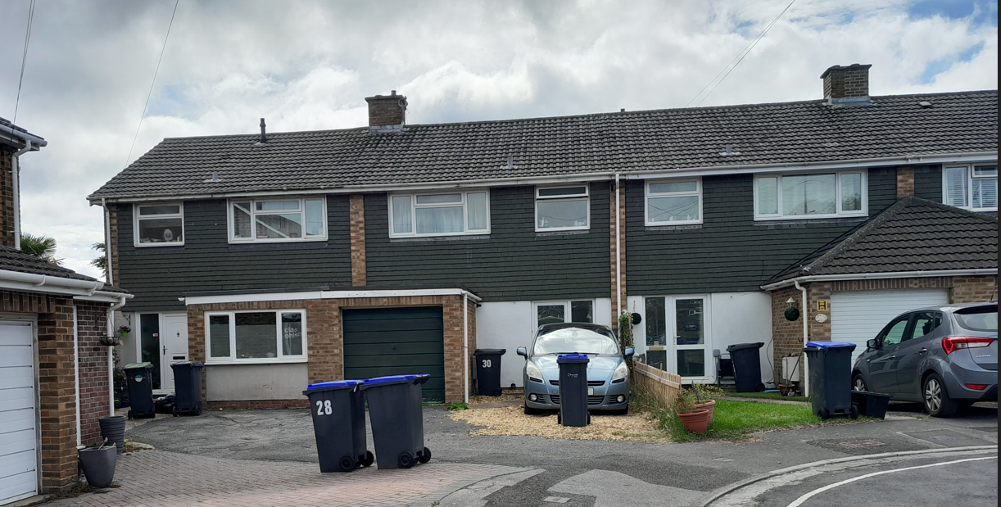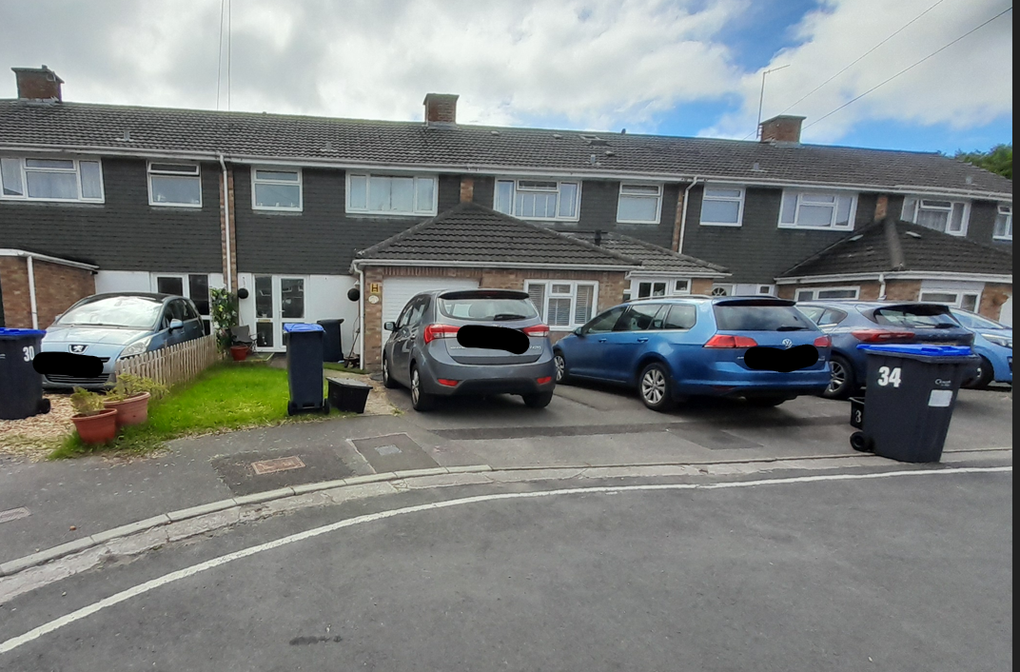

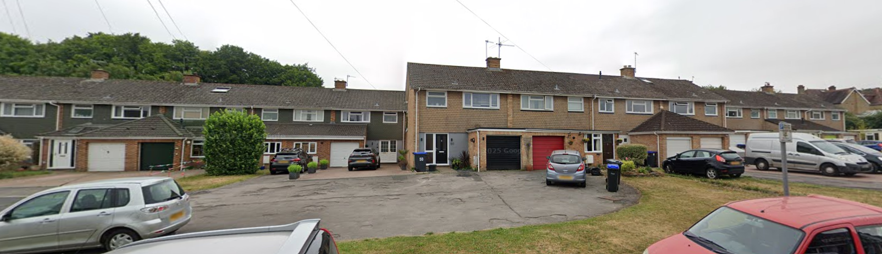

The hipped roof design, set back front elevation and overall appearance of the proposed extension is similar to the addition to the front of the adjoining dwelling No 34 Chichester Close, creating a symmetrical and balanced appearance to the front of these properties.

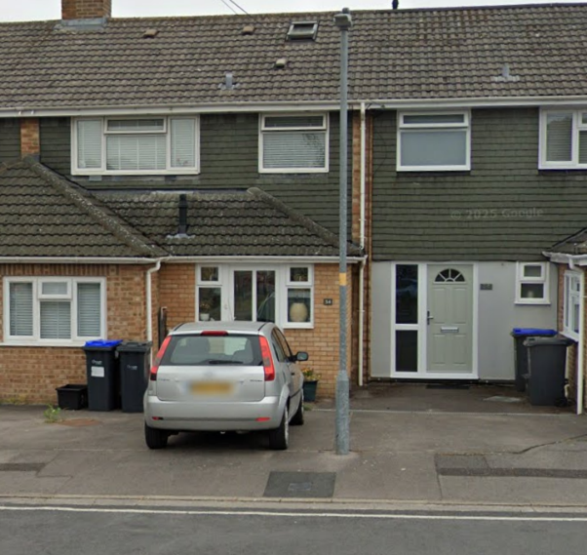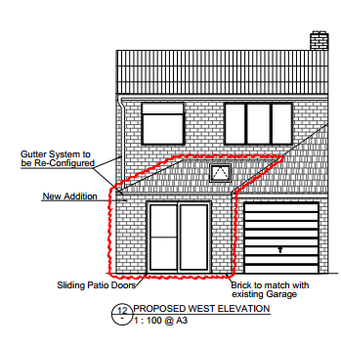

The design, scale and siting of the proposed extension are considered to be in keeping with the character of the area and would preserve the appearance of the host dwelling.

In addition, it is proposed to construct the proposed extension using materials to match the host dwelling, this is considered appropriate in this context, and a condition will be added to any permission to secure matching materials.

Having regard to the above, the proposal complies with the design principles set out in Core Policy 57 of the Wiltshire Core Strategy and Appendix D of the Wiltshire Design Guide.

Amenity

Point vii of Core Policy 57 - Ensuring High Quality Design and Place Shaping of the Wiltshire Core Strategy seeks to ensure that developments do not adversely affect neighbouring properties.

The National Planning Policy Framework (NPPF), particularly Paragraph 135(f), stresses that planning decisions should ensure developments provide a high standard of amenity for existing and future users.

The proposed development has been assessed in terms of its potential impact on the residential amenity of neighbouring properties, with particular regard to loss of light, overshadowing, loss of privacy, and overbearing effects.

Due to the siting of the proposed extension, it is considered that only the adjoining neighbour No 30 has the potential to be affected by the proposed development in terms of direct amenity impacts. The occupiers of No 30 have objected to the proposed development, the objections include impacts on the value of the property, this is not a material consideration and not a matter that can be taken into account when assessing the merits of a proposed development.

A further concern relates to blocking access and light to No 30 making the house darker and affecting the parking on this property. Officers noted during the site visit that No 30 has a glass front door and side glass panel that would be affected by the proposed extension, see photo below taken from an Estate Agents website relating to No 30.

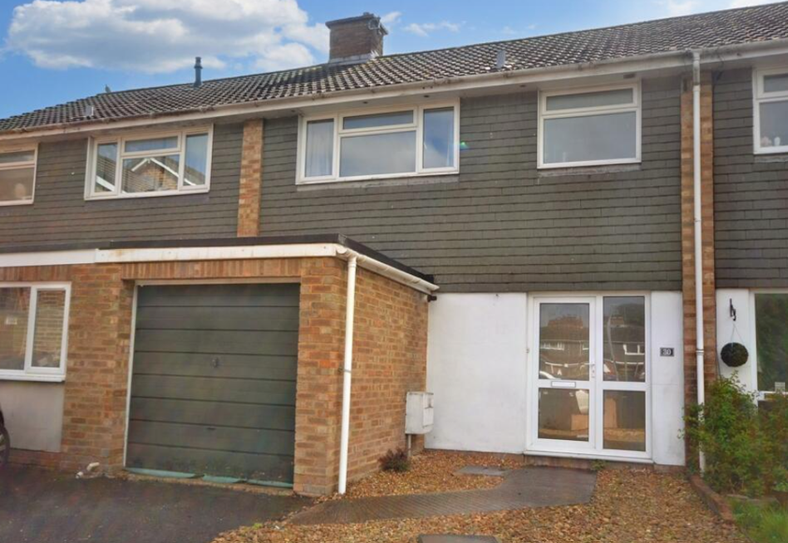
Again, below are the floor plans for No 30 taken from an Estate Agents website, this shows the front door leads into a hallway with doors leading to the siting room and kitchen. Both the sitting room and kitchen are served by windows/doors in the rear elevation which provide the main source of natural light to both these rooms. Generally, in planning terms, a hallway is not considered to be a habitable room like a sitting/living room would be and therefore loss of light to such a room/area within a dwelling carries less weight in the assessment of impacts. Whilst these concerns are noted, in this instance it is not considered that the loss of light to the front door is significant enough to warrant a refusal.
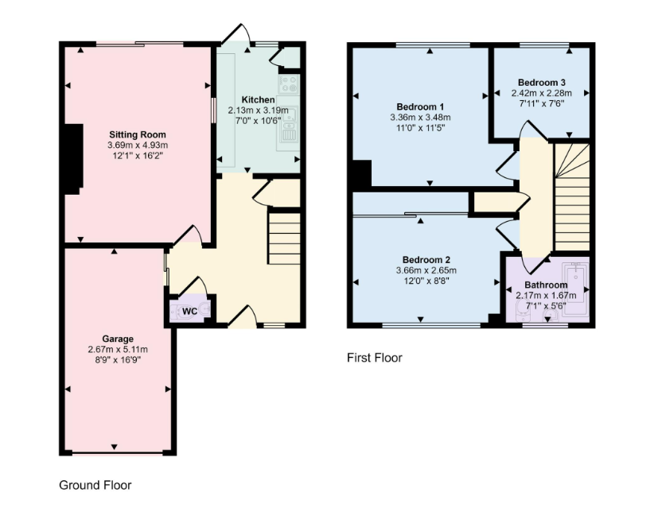
Whilst the extension would be positioned on the shared boundary, it would remain single storey in scale and has been amended during the course of the application to incorporate a hipped roof. The hipped roof slopes away from the boundary with No. 30, reducing the perceived bulk and visual prominence of the development. As such, it is not considered to appear unduly dominant or overbearing when viewed from the neighbouring property.

In terms of the concerns relating to blocking access and affecting the parking at No 30, the proposed development would need to be built on land owned by the applicant, they cannot build on third party land, therefore the proposed development should not restrict or prevent lawful access to No 30. However, given that the proposed extension will be constructed along the shared boundary with No 30, the Party Wall Act may apply. Any matters arising under that legislation are not planning considerations and are private legal matters between the affected parties.

Concerns have been raised by neighbouring occupants regarding the alignment of the shared boundary and the extent of land ownership. Whilst land ownership is not a planning matter, it has been raised by neighbouring occupiers and therefore warrants consideration within this report. It is noted that Land Registry plans can show differing boundary interpretations between properties, and in this instance the applicant’s title indicates a straight boundary line.

The extract below is taken from land registry plan provided by the applicant dated from 2002 when they bought the property

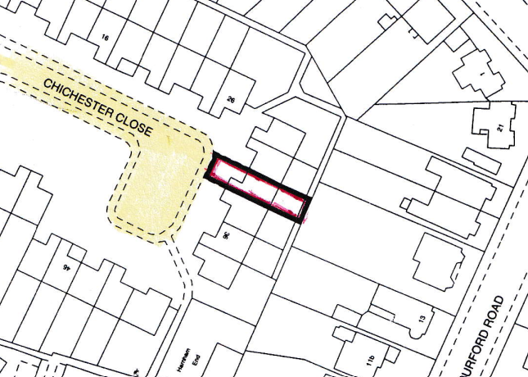

The title deeds and land registry maps provided by the occupiers of No 26 do show a different alignment of the boundary at No32.
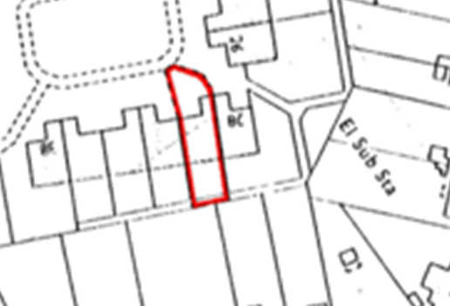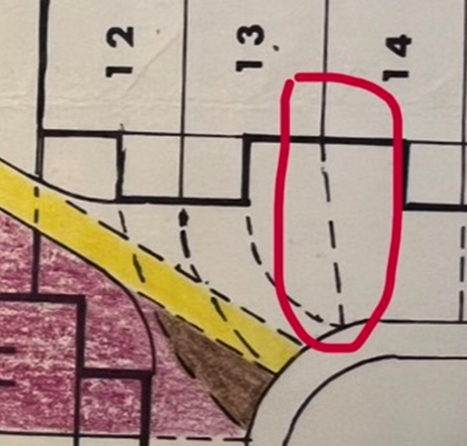

The Local Planning Authority is able to determine the application based on the information submitted; however, any planning permission granted does not override private property rights. It remains the responsibility of the applicant to ensure that the development is carried out entirely within land under their control. Should it transpire that the land is not within their ownership, this would be a separate legal matter and could prevent the development from being implemented as approved.

The proposal therefore accords with Core Policy 57 point vii in respect of safeguarding residential amenity and Appendix D of the Wiltshire Design Guide.

Highways Impact

Core Policy 61 of the Wiltshire Core Strategy seeks to ensure that development can be served by safe access to the highway network. Core Policy 64 seeks to ensure compliance with parking standards set out in the Local Transport Plan.

The National Planning Policy Framework (NPPF), particularly Paragraph 115 and 116, requires that development proposals do not have an unacceptable impact on highway safety and that safe and suitable access to the site can be achieved for all users.

The proposed extension does not increase the number of bedrooms within the application site and will not be built over an existing parking area. The site visit shows the area where the extension is to be constructed as lawn with bins and outside seating.
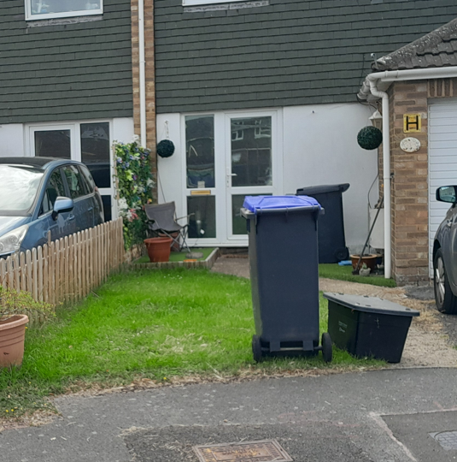

The comments from third parties in relation to impacts on the parking on their properties has been covered previously within this report but to reiterate, the granting of planning permission does not give the applicant the right to build on third party land and therefore cannot build on the neighbours’ driveway. The narrow access and issues relating to parking are noted within Chichester Close where parking appears to be limited however in this instance Officers cannot reasonably consider the parking/access issues raised to justify a refusal.

The proposed development would not result in any adverse impact on highway safety. The proposal is therefore considered to comply with Core Policies 57 (xiv), 61 and 64 of the Wiltshire Core Strategy, the NPPF, and the Wiltshire Local Transport Plan.

Ecology Impact

Core Policy 50 of the Wiltshire Core Strategy seeks to protect and enhance biodiversity and geodiversity, including through ensuring that development avoids harm to protected species and habitats.

The National Planning Policy Framework (NPPF), in Paragraphs 193, requires that development minimises impacts on and provides net gains for biodiversity, including ensuring mitigation is secured where harm cannot be avoided.

Biodiversity Net Gain - Householder planning applications are exempt from the requirement to deliver Biodiversity Net Gain under Schedule 7A, Section 4(2)(a) of the Town and Country Planning Act 1990, as inserted by the Environment Act 2021.

As such, the development complies with Core Policy 50 of the Wiltshire Core Strategy and the relevant provisions of the NPPF.

CONCLUSION

The proposed development is considered to be acceptable in terms of its design, scale, and relationship with the surrounding area. It would not result in any unacceptable harm to the character of the locality, the amenities of neighbouring occupiers, or the interests of highway safety and ecology.

The proposal is therefore considered to comply with the relevant policies of the Wiltshire Core Strategy, the Wiltshire Local Plan, and the National Planning Policy Framework. As such, the application is recommended for approval, subject to the conditions set out below.

RECOMMENDATION: That Planning Permission be GRANTED subject to conditions.

1.The development hereby permitted shall be begun before the expiration of three years from the date of this permission.

REASON: To comply with the provisions of Section 91 of the Town and Country Planning Act 1990 as amended by the Planning and Compulsory Purchase Act 2004.

2.The development hereby permitted shall be carried out in accordance with the following approved plans and documents:

Application form received 21/04/2026
Location plan received 18/05/2026
Proposed plans Drg no 025-03-19-PP-171 Rev 03 received 16/07/2026
Proposed elevations Drg no 025-03-19-PP-173 Rev 03 received 16/07/2026

REASON: For the avoidance of doubt and in the interests of proper planning.

3. Materials to be used in the construction of the works hereby permitted shall be as stated on the application form and in the submitted documents and to match the existing dwelling.

REASON: In the interests of visual amenity and the character and appearance of the area.

