APPLICATION FOR A CERTIFICATE OF LAWFULNESS FOR EXISTING USE OR DEVELOPMENT

APPLICATION REFERENCE: | PL/2026/02952
APPLICATION TYPE: | Lawful development: Existing use
SITE ADDRESS: | 20 Union Street, Trowbridge, BA14 8RU
DEVELOPMENT DESCRIPTION: | Use of the top floor as an office (a small room at the front of the building) and the larger room being used for talking therapies/staff room
RECOMMENDATION: | That a Certificate of Lawfulness for Existing Use or Development be GRANTED

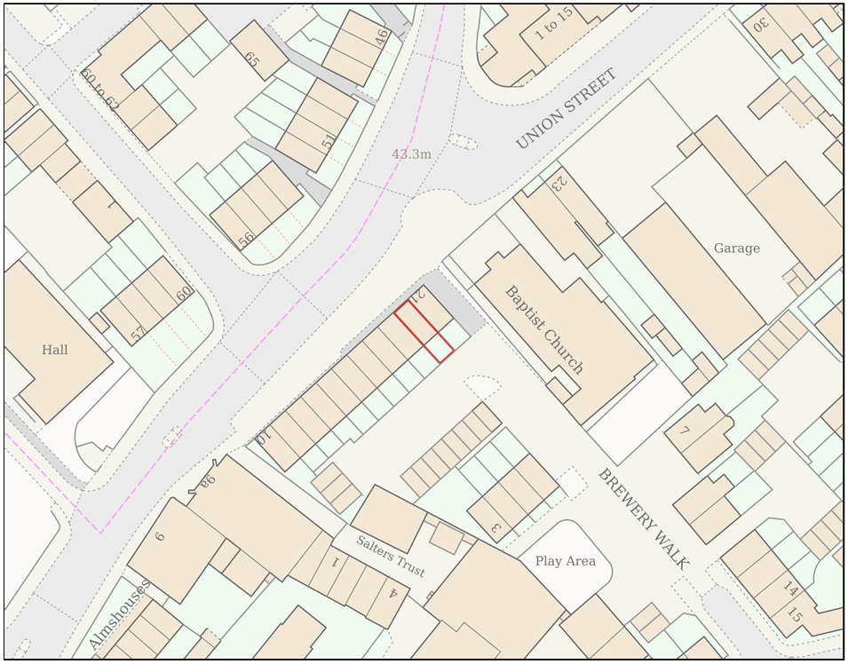

SITE DESCRIPTION AND PROPOSAL

This application is submitted under Section 191 of the Town and Country Planning Act 1990 (as amended) for a Certificate of Lawfulness of Existing Use or Development (CLEUD).

The application relates to the continued use of the upper floor rooms at 20 Union Street, Trowbridge, BA14 8RU as part of the established osteopathic and wellbeing business operating from the premises. Specifically, the applicant seeks to establish that the smaller front room on the top floor has been used as an office for administrative functions associated with the business, and that the larger upper floor room has been used for talking therapies, staff meetings and related wellbeing services, rather than for residential purposes. The applicant contends that these uses commenced in 2016 and have continued without material interruption for a period in excess of ten years.

The site has an established planning history relating to osteopathic and musculoskeletal treatment services, with planning permission previously granted for treatment rooms within the ground and middle floors of the building. The applicant advises that the property was formerly occupied as both a dwellinghouse and osteopathic clinic, but that the upper floor rooms became incorporated into the operation of the business from 2016 onwards. The application seeks confirmation that this use is now lawful through the passage of time and is therefore immune from enforcement action.

The evidence submitted in support of the application includes witness statements from current and former employees and practitioners, invoices relating to room hire at the premises, social media posts associated with "Trowbridge Osteopaths & Wellbeing Centre", and marketing material advertising therapy rooms within the building. The applicant relies on this evidence to demonstrate the continuous business use of the upper floor rooms for a period exceeding ten years.

RELEVANT LEGISLATION AND CONSIDERATIONS

The statutory framework governing Certificates of Lawfulness for Existing Use or Development (CLUED) is primarily set out in Section 191(2) of the Town and Country Planning Act 1990 (as amended). This section establishes that "lawful development" refers to development against which no enforcement action may be taken and where no enforcement notice is in force, or development for which planning permission is not required.

Section 191(4) of the Town and Country Planning Act 1990 (as amended) further stipulates that a Local Planning Authority (LPA) shall issue a Certificate of Lawfulness upon request, provided that, on the balance of probabilities, the LPA is satisfied that the existing development or use described in the application is lawful. The time limits for taking enforcement action are set out in s171B of the Act.

The Planning Practice Guidance (PPG) on Lawful development certificates clarifies that the burden of proof lies with the applicant. It is the applicant's responsibility to provide sufficiently clear, precise, and unambiguous evidence to demonstrate the lawfulness of the existing development or use.

In considering whether the use or development has become immune from enforcement action, the test for granting a Certificate of Lawfulness is whether, on the balance of probabilities:
- the works were substantially completed, or,
- the use has been continuous for the required time period without interruption.

The applicant must prove that the use or development has occurred for the necessary period. A continuous use must be demonstrated without significant interruption.

It is important to note that when determining a CLUED application, the LPA must focus solely on whether, based on the facts and applicable planning law, the specific use or development is lawful. Planning merits or considerations relating to the quality or suitability of the development are not relevant.

REPRESENTATIONS

There is no legal obligation to consult third parties for this type of application, including Town/Parish Councils or neighbouring properties. However, the PPG recognises that it may be reasonable for a local planning authority to seek evidence from these sources, if there is good reason to believe they may possess relevant information about the content of a specific application.

Trowbridge Town Council – No Objection

RELEVANT SITE HISTORY
The site has the following relevant planning history:

Reference | Development | Decision
W/06/00831/FUL | Change of use of three rooms within dwelling to reception consulting rooms for Osteopathy | Approved

ASSESSMENT
This application seeks a Certificate of Lawfulness for an Existing Use or Development under Section 191 of the Town and Country Planning Act 1990 (as amended).

The application relates to the use of the upper floor rooms at 20 Union Street as part of the operation of the established osteopathic and wellbeing business operating from the premises. The applicant contends that the smaller front room on the upper floor has been used as an office and that the larger room has been used for talking therapies, counselling, hypnotherapy, staff meetings and associated wellbeing services since 2016.

As the application relates to an alleged material change of use, the relevant immunity period is ten years. Accordingly, the applicant must demonstrate, on the balance of probabilities, that the use has subsisted continuously for at least ten years prior to the date of the application and that no evidence exists which would indicate that the use was abandoned or otherwise interrupted during that period.

The determination of a Certificate of Lawfulness application is not concerned with the planning merits of the use. The sole issue is whether sufficient evidence has been provided to demonstrate that the use is lawful through the passage of time.

Evidence Submitted by the Applicant

The applicant has submitted the following evidence in support of the application:

- Social media posts from the "Trowbridge Osteopaths & Wellbeing Centre" Facebook page dated between May 2019 and August 2024 showing activities associated with the wellbeing centre and photographs of the rooms in use.
- Social media posts dated March 2020, April 2021, January 2022, February 2022 and August 2024 showing rooms within the building containing furniture and equipment associated with therapy, meeting and office functions.
- Invoices dated between April 2018 and July 2019 relating to room hire at 20 Union Street by practitioners operating through Trowbridge Osteopaths & Wellbeing Centre.
- A written statement from Philip Gregory Smith confirming use of the smaller upper floor room as an office since assuming responsibility for accounts and payroll in 2022.
- A written statement from Karen Lucas confirming that she practised hypnotherapy from the upper floor room between approximately 2016 and 2018.
- A written statement from Pamela Gregory confirming that she worked as Practice Manager between 2007 and 2018 and that, from 2016, her office was relocated to the upper floor front room where she undertook administrative, marketing and accounts functions.
- Marketing material and screenshots from the "UK Therapy Rooms" website advertising wellbeing and therapy rooms at the premises.

The applicant has also provided a written statement explaining the historic use of the building and the incorporation of the upper floor rooms into the operation of the osteopathic and wellbeing business.

Assessment

The principal issue is whether the submitted evidence is sufficient to demonstrate that the claimed business use of the upper floor rooms commenced in 2016 and has continued without material interruption for a period exceeding ten years.

The social media evidence, invoices and therapy room marketing material provide reasonably consistent evidence that the upper floor rooms were being used as part of the wellbeing business from at least 2018 onwards. The invoices demonstrate room hire by third-party practitioners from April 2018 to July 2019, whilst the social media posts provide a chronology of activity associated with the business from 2019 onwards. Collectively this evidence supports the applicant's contention that the rooms formed part of an established wellbeing and therapy operation over a prolonged period.

The earlier period between 2016 and 2018 is primarily evidenced by written statements from Pamela Gregory and Karen Lucas.

The statement provided by Pamela Gregory identifies her role as Practice Manager and confirms that, from 2016, she occupied the upper floor front room as an office from which accounts, marketing and administrative activities associated with the business were undertaken. The statement identifies the room, describes the nature of the use and confirms that this arrangement remained in place until her departure from the business in 2018.

The statement provided by Karen Lucas confirms that she undertook hypnotherapy sessions from the upper floor room between approximately 2016 and 2018. Whilst the dates provided are less precise than those contained within the statement of Pamela Gregory, the statement nonetheless provides corroborative evidence that talking therapy activities were being undertaken from the upper floor accommodation during the relevant period.

The Council has carefully considered the weight that should be attached to these statements. Whilst neither statement is provided in the form of a statutory declaration and neither identifies a precise commencement date within 2016, both are consistent with the wider body of documentary evidence submitted by the applicant and with the subsequent pattern of use demonstrated by invoices, marketing material and social media activity. The Council is not aware of any evidence that directly contradicts the applicant's account, nor is there evidence available to indicate that the upper floor rooms continued to be used solely for residential purposes after the claimed change of use occurred.

It is acknowledged that the precise month during which the upper floor rooms became incorporated into the business operation cannot be established with certainty from the evidence submitted. However, the test applicable to a Certificate of Lawfulness application is whether the claimed use is demonstrated on the balance of probabilities. Having regard to the consistency of the evidence submitted, the continuity of the subsequent use, the absence of contradictory evidence and the corroborative nature of the witness statements, it is considered more likely than not that the upper floor rooms were incorporated into the operation of the osteopathic and wellbeing business from 2016 and have remained in that use continuously thereafter.

The Local Planning Authority holds no evidence of any interruption, abandonment or cessation of the use and no enforcement action has been taken in respect of the alleged breach during the relevant immunity period.

Accordingly, it is considered that the applicant has discharged the burden of proof required by Section 191 of the Town and Country Planning Act 1990.

CONCLUSION

On the balance of probability, sufficient evidence has been provided to demonstrate that the upper floor rooms at 20 Union Street, Trowbridge have been used continuously as part of the operation of the established osteopathic and wellbeing business for a period exceeding ten years.

The evidence demonstrates that the smaller front upper floor room has been used for office and administrative purposes associated with the business and that the larger upper floor room has been used for talking therapies, counselling, hypnotherapy, staff meetings and associated wellbeing functions. The submitted evidence indicates that these uses commenced in 2016 and have continued without material interruption.

Whilst some elements of the evidence relating to the commencement date are not precise, the evidence taken as a whole is considered sufficiently coherent, consistent and persuasive to demonstrate the claimed use on the balance of probabilities. The Council has no clear or unambiguous evidence to the contrary and no enforcement action has been taken during the relevant immunity period.

It is therefore considered that the use has become lawful through the passage of time and that a Certificate of Lawfulness should be issued.

RECOMMENDATION
It is recommended that a Certificate of Lawfulness for Existing Use or Development be granted for the following use:

The use of the upper floor rooms at 20 Union Street, Trowbridge, BA14 8RU as part of the operation of the established osteopathic and wellbeing business, comprising office accommodation ancillary to the business and rooms used for talking therapies, counselling, hypnotherapy, staff meetings and associated wellbeing services.

Reason for approval: The evidence submitted demonstrates, on the balance of probabilities, that the use of the upper floor rooms as part of the osteopathic and wellbeing business has subsisted continuously for a period in excess of ten years immediately preceding the application. No evidence has been identified by the Local Planning Authority to contradict the applicant's account. The use is therefore lawful pursuant to Section 191 of the Town and Country Planning Act 1990 (as amended).

