APPLICATION FOR HOUSEHOLDER PLANNING PERMISSION DELEGATED REPORT

APPLICATION REFERENCE: | PL/2026/03781
APPLICATION TYPE: | Householder planning permission
SITE ADDRESS: | Weather Oak, Moor Hill, Fovant
DEVELOPMENT DESCRIPTION: | proposed greenhouse attached to existing garage (part retrospective)
RECOMMENDATION: | That Planning Permission be GRANTED

PROPOSAL

Planning permission is sought for the erection of a greenhouse attached to the existing garage. The proposed structure would be constructed on the south-western side of the garage and would comprise a mono-pitched greenhouse with a glazed roof supported by aluminium framing, with a mix of glazing and timber-clad walls on a stone plinth.

Proposed elevations

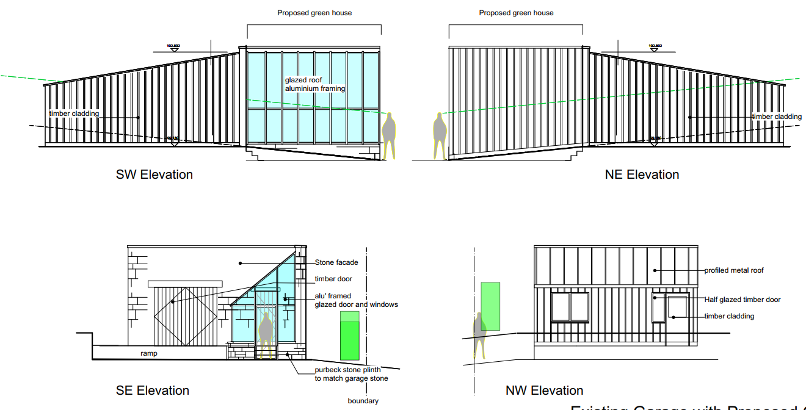

The works also include alterations to the south-eastern elevation of the garage involving the replacement of the existing double garage door with a single garage door and infilling of the remaining opening. These works are considered likely to constitute permitted development but nevertheless raise no planning concerns.

SITE DESCRIPTION/CONTEXT

The application site comprises Weather Oak, Moor Hill, Fovant, a substantial residential plot situated on the edge of the village and outside the defined settlement boundary of Fovant, within the open countryside. The site lies within the Cranborne Chase National Landscape and is accessed directly from Moor Hill. Planning permission was recently granted under application reference PL/2024/09263 for the demolition of the former dwelling and erection of a replacement self-build dwelling. Construction of the replacement dwelling is currently well advanced, although not yet complete. The site also contains an existing garage building adjacent to the dwelling and benefits from a large residential curtilage, mature landscaping and established tree cover along its boundaries. The site falls within Flood Zone 1 and the Chilmark Quarries Bat SAC consultation area.

PLANNING HISTORY

PL/2025/03704 Discharge of condition 6 (details and location of birds & bat boxes) and condition 7 (scheme of hard & soft landscaping) of PL/2024/09263 - Demolition of existing dwelling and the erection of a replacement self-build dwelling. Approved

PL/2024/09263 Demolition of existing dwelling and the erection of a replacement self-build dwelling. Approved
PL/2023/08642 Demolition of existing dwelling and replacement with new dwelling with associated works. Approved

PL/2023/04702 New drive for existing west gate, 2 storey rear extension, 1 storey side extension. Approved

18/07798/FUL Demolish existing flat roof lobby & construction of a proposed pitched glazed porch. Approved

RELEVANT POLICIES AND GUIDANCE

The National Planning Policy Framework (NPPF)
The Planning Practice Guidance
National Design Guide

Wiltshire Core Strategy

Core Policy 1 Settlement Strategy
Core Policy 2 Delivery Strategy
Core Policy 27 Tisbury Community Area
Core Policy 50 and 52 Biodiversity and Geodiversity
Core Policy 51 Landscaping
Core Policy 57 Ensuring high quality design and place shaping
Core Policy 58 Ensuring the conservation of the historic environment
Core Policy 61 Transport and Development
Core Policy 64 Demand Management

Supplementary Planning Documents:

Wiltshire Local Transport Plan 2015-2026: Car Parking and Cycling Strategy
Creating Places Design Guide SPD (April 2006)
Wiltshire Design Guide 2024
National Landscape Management Plan

CONSULTATION RESPONSES

Parish Council: No comment

Highways: No objection

REPRESENTATIONS

No comments were received.

ASSESSMENT

Section 38(6) of the Planning and Compulsory Purchase Act 2004 states:

"If regard is to be had to the development plan for the purposes of any determination to be made under the planning Acts, the determination must be made in accordance with the plan unless material considerations indicate otherwise."

In accordance with this statutory requirement, this application has been assessed against the relevant policies of the Development Plan, including the adopted Wiltshire Core Strategy (2015) and, where applicable, any made Neighbourhood Plans.

Character, design and impact on National Landscape

Core Policy 57 - Ensuring High Quality Design and Place Shaping of the Wiltshire Core Strategy seeks to ensure that all new development is of high design quality, reflecting local context, character, and distinctiveness.

Core Policy 51 of the Wiltshire Core Strategy requires all development to protect, conserve, and where possible enhance the character and quality of Wiltshire’s landscapes, giving particular weight to designated areas such as National Landscapes.

The National Planning Policy Framework (NPPF), in Paragraph 189, states that “great weight” should be given to conserving and enhancing landscape and scenic beauty in National Landscapes (formerly Areas of Outstanding Natural Beauty). Development within or affecting the setting of a National Landscape must demonstrate that it will not result in unacceptable harm to the special qualities of that area.

The proposal relates to the erection of a greenhouse attached to an existing garage building within the residential curtilage of Weather Oak. It is noted that works have started and the base for the greenhouse and stone plinth has been constructed, the works therefore are part retrospective. The greenhouse would be modest in scale and domestic in appearance, and would be subservient to both the approved replacement dwelling and the existing garage. Its design incorporates a mono-pitch roof, with glazed elements, aluminium framing, timber cladding and a stone plinth, which are considered appropriate materials within this rural setting and would integrate satisfactorily with the existing building.

In visual terms, the development would be viewed in the context of the existing built form on the site and would not appear as a prominent or isolated feature within the wider landscape. Furthermore, the greenhouse would be located within an established residential plot benefitting from mature boundary vegetation and existing structures, which would largely screen the development from public viewpoints. As a result, the proposal would not result in any significant adverse impact on the character and appearance of the site, the surrounding countryside or the wider National Landscape.

Accordingly, the proposal is considered to accord with Core Policies 51 and 57 of the Wiltshire Core Strategy and the relevant design and landscape objectives of the National Planning Policy Framework.

Amenity

Point vii of Core Policy 57 - Ensuring High Quality Design and Place Shaping of the Wiltshire Core Strategy seeks to ensure that developments do not adversely affect neighbouring properties.

The National Planning Policy Framework (NPPF), particularly Paragraph 135(f), stresses that planning decisions should ensure developments provide a high standard of amenity for existing and future users.

The proposed development has been assessed in terms of its potential impact on the residential amenity of neighbouring properties, with particular regard to loss of light, overshadowing, loss of privacy, and overbearing effects.

The proposed greenhouse would be attached to the existing garage and would serve an ancillary domestic function. Given its modest scale, siting within a large residential curtilage, and separation from neighbouring residential properties, the development would not give rise to any unacceptable overlooking, loss of light, overshadowing or overbearing impacts. The proposal is therefore considered acceptable in respect of residential amenity and compliant with Core Policy 57 point vii in respect of safeguarding residential amenity and Appendix D of the Wiltshire Design Guide.

Highways Impact

Core Policy 57 (xiv) of the Wiltshire Core Strategy seeks to ensure that development must meet the requirements of Core Policy 61. This policy requires proposals to be capable of being served by safe access to the highway network. Core Policy 64 seeks to ensure compliance with parking standards set out in the Local Transport Plan.

The National Planning Policy Framework (NPPF), particularly Paragraphs 115 and 116, requires that development proposals do not have an unacceptable impact on highway safety and that safe and suitable access to the site can be achieved for all users.

The proposed greenhouse would be attached to the existing garage and would not affect the established vehicular access serving the site. The development would occupy a limited footprint within the wider residential curtilage and would not result in the unacceptable loss of any parking or turning space associated with the dwelling. Sufficient off-street parking and turning space would therefore remain available within the site, ensuring that vehicles can continue to enter, park and exit in a safe manner.

The proposed development would not result in any adverse impact on highway safety. Adequate parking and turning provision is provided in accordance with Wiltshire's adopted parking standards, and access arrangements are acceptable.

The proposal is therefore considered to comply with Core Policies 57 (xiv), 61 and 64 of the Wiltshire Core Strategy, the NPPF, and the Wiltshire Local Transport Plan.

Ecology Impact

Core Policy 50 of the Wiltshire Core Strategy seeks to protect and enhance biodiversity and geodiversity, including through ensuring that development avoids harm to protected species and habitats.

The National Planning Policy Framework (NPPF), at Paragraph 193, requires that development minimises impacts on and provides net gains for biodiversity, including ensuring mitigation is secured where harm cannot be avoided.

The proposal comprises a small-scale domestic greenhouse attached to an existing garage. Given the nature and scale of the works, together with the absence of any impacts upon bat habitat or commuting routes, the proposal is not considered likely to have a significant effect upon the Chilmark Quarries SAC.

Biodiversity Net Gain - Householder planning applications are exempt from the requirement to deliver Biodiversity Net Gain under Schedule 7A, Section 4(2)(a) of the Town and Country Planning Act 1990, as inserted by the Environment Act 2021.

The proposal relates to a domestic greenhouse attached to an existing building and would not result in the loss of any notable habitat, trees or landscape features of ecological value.

As such, the development complies with Core Policy 50 of the Wiltshire Core Strategy and the relevant provisions of the NPPF.

Trees

The submitted plans indicate that the greenhouse will encroach into the root protection area of an adjacent tree; the tree is not protected by a tree preservation order, nor is it protected by virtue of being located within a conservation area. The groundworks have already been undertaken with the walls and floor dug; there are no further works required which are intrusive into the ground. Whilst it is unfortunate that the groundworks were undertaken before planning permission was sought, thereby removing the opportunity to secure tree protection measures during construction, the excavation works have already been completed and no further intrusive works within the root protection area are proposed. Having regard to the scale of the development and the unprotected status of the tree, no significant arboricultural concerns are raised.
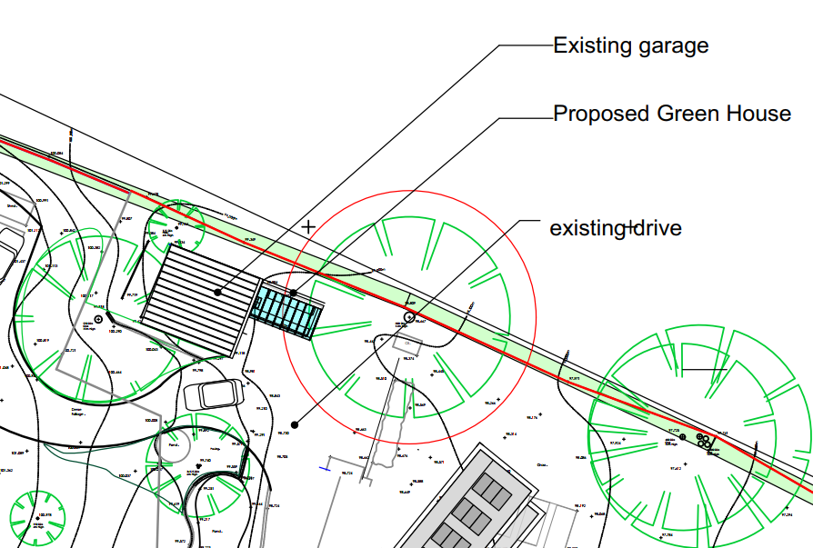

CONCLUSION

The proposed greenhouse represents a modest addition to the existing garage building and is appropriate in scale, design and appearance. By reason of its siting within the established residential curtilage, the development would not result in unacceptable harm to the character and appearance of the site, the wider National Landscape, neighbouring residential amenity, highway safety, ecology or trees.

The proposal is therefore considered to accord with the relevant provisions of the Wiltshire Core Strategy and the National Planning Policy Framework. Accordingly, there are no material planning reasons to object to the proposals, and the application is recommended for approval, subject to conditions.

RECOMMENDATION: That Planning Permission be GRANTED subject to conditions.

1. The development hereby permitted shall be carried out in accordance with the following approved plans:

Application form received 15/06/2026
Location plan Rev A received 08/07/2026
Site plan dwg no SP 01 received 29/06/2026
Proposed plans and elevations dwg no. GA 02 received 15/06/2026

REASON: For the avoidance of doubt and in the interests of proper planning.

