APPLICATION FOR FULL-PLANNING PERMISSION CASE OFFICER REPORT

APPLICATION REFERENCE: | PL/2026/02486
APPLICATION TYPE: | Full planning permission
SITE ADDRESS: | Land East of Cadley Farmhouse, Chute Cadley, Andover, SP11 9EB
DEVELOPMENT DESCRIPTION: | Construct a wooden field store on a concrete base.
RECOMMENDATION: | Approve with Conditions

SITE DESCRIPTION/CONTEXT

The application site comprises an agricultural field located to the east of Cadley Farmhouse, Chute Cadley, within a predominantly rural area. The site lies within the North Wessex Downs National Landscape and is outside of but adjacent to the conservation area (dark green wash in map extract below); Cadley Farmhouse is a grade 2 listed building (shown as black hatching below).

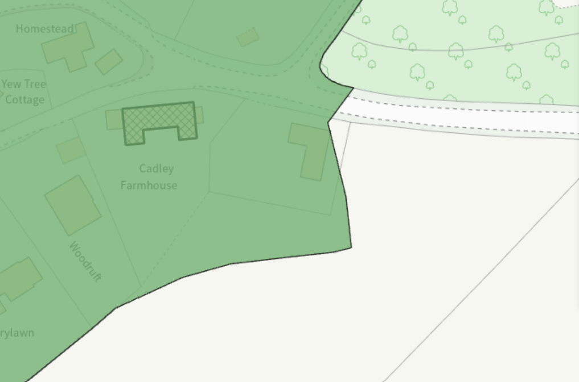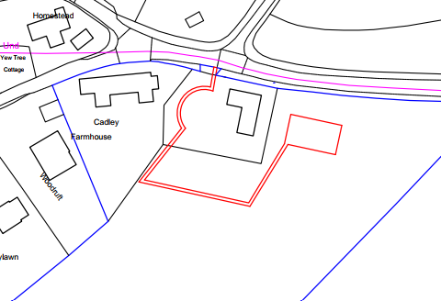

The field to the east of Cadley Farmhouse is topographically much higher than the associated dwelling, outbuilding and gardens; the land slopes steeply from west to east before levelling out within the wider field.

The site falls within Flood Zone 1 (the zone least likely to be affected by fluvial floods) and is not in an area at increased risk of ground water flooding. The site is also situated within the catchment of the River Test and thus feeds into the Solent Maritime Special Area of Conservation (SAC), Chichester and Langstone Harbours Special Protection Area (SPA) and Ramsar site, Portsmouth Harbour SPA and Ramsar site, and the Solent and Southampton Water SPA and Ramsar site.

PROPOSAL

Planning permission is sought for the erection of a field store for the storage of machinery, equipment and ancillary items associated with the management and maintenance of the surrounding land. The building would be a single storey structure with timber-clad elevations and a pitched roof measuring approximately 5.4 metres by 5.4 metres, with a ridge height of approximately 3.1 metres; the building will be constructed on a concrete base.

Proposed plans and elevations included below

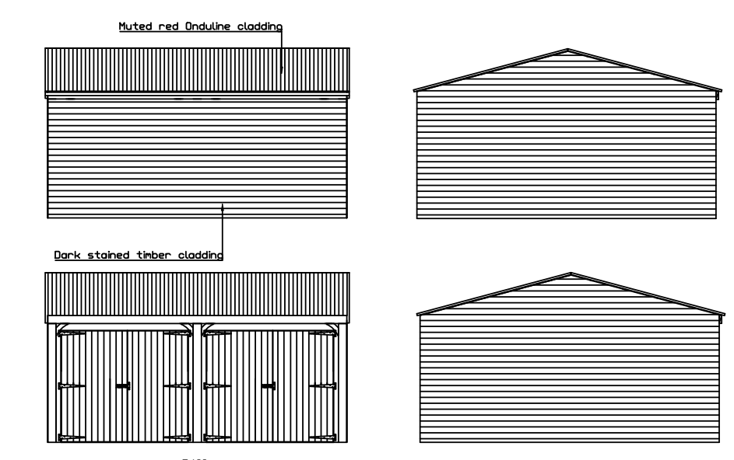

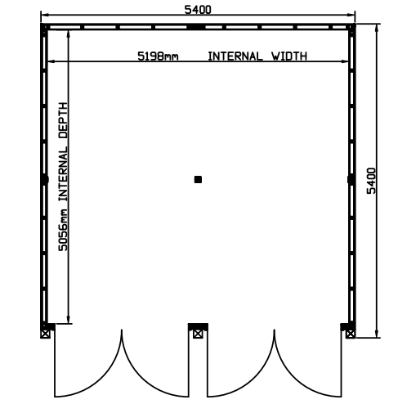

PLANNING HISTORY

Proposal / Summary
17/08022/FUL - Full planning permission Decision - Approve with Conditions Date: 20/10/2017 – Demolish existing outbuilding and replace with new outbuilding with room over

RELEVANT LEGISLATION, POLICIES AND GUIDANCE

Statutory Legislation:

Planning (Listed Buildings and Conservation Areas) Act 1990 – Sections 66 and 72

National Planning Policy:
- National Planning Policy Framework (NPPF)
- Planning Practice Guidance (PPG)
- National Design Guide

Development Plan:
The development plan for Wiltshire comprises the Wiltshire Core Strategy (WCS) (adopted January 2015) and any made neighbourhood plans, which remains the principal statutory planning document guiding development across the county. In line with Section 38(6) of the Planning and Compulsory Purchase Act 2004, planning decisions must be made in accordance with the development plan unless material considerations indicate otherwise.

Though the development plan is considered as a whole, those parts deemed to be particularly relevant to this application are listed below:

The adopted Wiltshire Core Strategy (WCS), with particular regard to:

Core Policy 1: Settlement Strategy
Core Policy 2: Delivery Strategy
Core Policy 26: Spatial Strategy - Tidworth Community Area
Core Policy 34: Additional Employment Land
Core Policy 48: Supporting Rural Life
Core Policy 50: Biodiversity and Geodiversity
Core Policy 51: Landscape
Core Policy 57: Ensuring High Quality Design and Place Shaping
Core Policy 58: Ensuring the Conservation of the Historic Environment

Wiltshire Design Guide
The Chutes Design Guide
North Wessex Downs National Landscape Management Plan

ISSUES

Principle
Character, design, impact on heritage assets and landscape impacts
Neighbour amenity
Ecology
Trees

CONSULTATION RESPONSES

Parish Council – raise no comments or objections

Ecology – no objections subject to conditions

Tree Officer – no objections subject to conditions

Conservation – no comments have been provided

REPRESENTATIONS

None received

ASSESSMENT

Section 38(6) of the Planning and Compulsory Purchase Act 2004 states:

"If regard is to be had to the development plan for the purposes of any determination to be made under the planning Acts, the determination must be made in accordance with the plan unless material considerations indicate otherwise."

In accordance with this statutory requirement, this application has been assessed against the relevant policies of the Development Plan, including the Wiltshire Core Strategy (2015) and, where applicable, any made Neighbourhood Plans. Consideration has also been given to the policies of the National Planning Policy Framework (NPPF) as a material consideration in the assessment.

The assessment below considers each of the main issues identified above. Each topic is assessed in turn with reference to the relevant policy context, the evidence submitted, consultee responses, and all other material considerations, before a conclusion is reached.

Environmental Impact Assessment (EIA) Screening

In accordance with the Town and Country Planning (Environmental Impact Assessment) Regulations 2017 (as amended), the local planning authority has considered whether the proposed development constitutes EIA development.

No formal screening opinion was requested or issued. However, the local planning authority has considered the scale and nature of the development as part of the application process and is satisfied that it does not constitute EIA development under the 2017 Regulations.

In reaching this view, regard has been had to the criteria set out in Schedule 2 of the EIA Regulations, including the scale, location and characteristics of the development. The proposal does not meet the relevant thresholds, nor is it considered likely to give rise to significant environmental effects by reason of factors such as its size or location.

Principle of Development

The site is situated in the countryside where, as per WCS policies CP1 (Settlement Strategy), CP2 (Delivery Strategy) and CP26 (Tidworth Community Area), there is a general presumption against new unsustainable development.

The site comprises existing agricultural/grazing land and the proposal seeks to provide a field store for the storage of machinery, equipment and materials associated with the ongoing management of the land. As such, the proposal is considered to support rural land management and agricultural activities. The applicants supporting statement confirms that the proposed building is not intended for residential, commercial, or intensive use.

WCS policy CP34 (Additional Employment Land) confirms that ‘Outside the Principal Settlements, Market Towns and Local Service Centres, developments that:…ii Support sustainable farming and food production through allowing development required to adapt to modern agricultural practices and diversification…will be supported where they’ amongst other things ‘Are consistent in scale with their location, do not adversely affect nearby buildings and the surrounding area or detract from residential amenity;…Are supported by evidence that they are required to benefit the local economic and social needs; and…Are supported by adequate infrastructure’.

Overall, the principle of development is considered acceptable, subject to assessment of the detailed impacts on the character and appearance of the area, landscape, heritage impacts, ecology and neighbouring amenity.

Character, design, impact on heritage assets and landscape impacts

From the point of view of the historic environment the main statutory tests are set out within the Planning (Listed Building and Conservation Areas) Act 1990.

The Council’s Core Strategy Policy CP58 ‘Ensuring the conservation of the historic environment’ requires that designated and non-designated heritage assets and their settings be conserved, and where appropriate enhanced, in a manner appropriate to their significance and encourages proposals which improve the condition of heritage assets at risk.

The Council’s Core Strategy CP 57: Ensuring high quality design requires a high quality of design in all new developments. The policy requires applicants to demonstrate how the proposal will make a positive contribution to the character of Wiltshire through (amongst other things) responding to the value of the natural and historic environment and being sympathetic to and conserving historic buildings and landscapes. Development is required to respond positively to the existing character of the area in terms of building layouts, built form, height, mass, scale, building line, plot size, elevational design, materials, streetscape and rooflines to effectively integrate the building into its setting.

Core Policy 51 of the Wiltshire Core Strategy requires all development to protect, conserve, and where possible enhance the character and quality of Wiltshire’s landscapes, giving particular weight to designated areas such as National Landscapes.

The National Planning Policy Framework (NPPF), in Paragraph 189, states that “great weight” should be given to conserving and enhancing landscape and scenic beauty in National Landscapes (formerly Areas of Outstanding Natural Beauty). Development within or affecting the setting of a National Landscape must demonstrate that it will not result in unacceptable harm to the special qualities of that area.

The proposed shed is considered to be of an appropriate scale and appearance for its intended use. Whilst the design does not reflect a traditional or overtly agricultural form, it nevertheless adopts a simple and functional appearance that is appropriate within the context of the site, its associated land and its intended use as a field store. The building's modest footprint, limited height and restrained detailing ensure that it would not appear visually dominant or incongruous within its surroundings. Furthermore, given its functional role in supporting the use of the associated land, the proposal is considered to integrate satisfactorily with the rural character of the area and would not give rise to any unacceptable visual harm.

The siting of the development has been carefully chosen adjacent to existing built development and in a location benefiting from substantial screening provided by existing vegetation. As a result, public views of the building would be limited, and any visual impacts would be localised. The proposal would not encroach significantly into the open countryside, nor would it interrupt important views across the landscape.

Having had regard to the great weight afforded to conserving and enhancing landscape and scenic beauty within National Landscapes, it is considered that the limited scale, discreet siting and containment of the development ensures that the proposal would not result in harm to the purposes or special qualities of the North Wessex Downs National Landscape.

In addition, whilst no external lighting is proposed as part of the application, the introduction of lighting could have a greater landscape impact than the building itself within this otherwise dark rural location. Consequently, any permission should be subject to a condition that any external lighting meets the criteria for Environmental Zone E0 as defined by the Institute of Lighting Professionals ‘Guidance Notes for the Reduction of Obtrusive Light’ 2021. Such a condition is necessary in the interests of protecting the character, appearance and tranquillity of the countryside and the North Wessex Downs National Landscape.

In terms of heritage impacts, the proposed building is located some distance from the nearest listed building. Given the topographical differences in land levels and the natural screening provided by existing trees and vegetation, no harm is identified to the setting of the nearby listed building. The site lies just outside of the conservation area; given the scale, design, siting and intended use of the proposed building, it is not considered that there will be substantial harm caused to the setting of the adjacent conservation area. The proposal would preserve the setting of the listed building and would preserve the character and appearance of the adjacent conservation area. Accordingly, the proposal complies with the statutory duties set out in Sections 66 and 72 of the Planning (Listed Buildings and Conservation Areas) Act 1990.

Amenity

Core Policy 57 (criterion vii) of the Wiltshire Core Strategy requires development to safeguard the amenity of existing occupants and provide an appropriate level of amenity for future occupiers.

Paragraph 135 of the National Planning Policy Framework (NPPF) similarly seeks to ensure that developments create places with a high standard of amenity for existing and future users.
These policies provide the framework for assessing the proposal's impact on residential amenity. The matters set out below have been considered in the context of the site's characteristics and the proposed layout.

The proposed building is intended for storage purposes associated with the management of the surrounding land and is not proposed for livestock accommodation. Furthermore, there are no neighbouring residential properties in close proximity that would be adversely affected by the development. It is also noted that the submitted location plan indicates that the land surrounding the proposed building is within the applicant's ownership and extends in all directions.

Having regard to the nature, siting and use of the building, the proposal would not result in unacceptable impacts in terms of overshadowing, loss of light, overbearing effects, or loss of privacy.

The proposal is therefore considered to accord with Core Policy 57 (criterion vii) of the Wiltshire Core Strategy and Appendix D of the Wiltshire Design Guide.

Ecology

Core Policy 50 of the Wiltshire Core Strategy seeks to protect and enhance biodiversity and geodiversity, including through ensuring that development avoids harm to protected species and habitats.

The National Planning Policy Framework (NPPF), at Paragraph 193, requires that development minimises impacts on and provides net gains for biodiversity, including ensuring mitigation is secured where harm cannot be avoided.

The Council's Ecologist has reviewed the submitted information, including the Small Sites Metric and supporting plans. The site lies within the River Test Catchment; however, given the nature of the proposal for a field store, with no increase in overnight accommodation, water supply or drainage, it has been concluded that the development would not result in likely significant effects on the Solent designated sites and has been screened out of Appropriate Assessment.

The Ecologist notes that a pond supporting great crested newts is located approximately 30 metres from the site and that suitable terrestrial habitat is present within the wider area. Whilst the majority of suitable habitat would be retained, a precautionary approach is required during construction. It is therefore recommended that a Construction Method Statement (CMS) be secured by condition to include reasonable avoidance measures for great crested newts, reptiles and nesting birds.

In relation to Biodiversity Net Gain (BNG), the proposal is subject to the statutory requirement to deliver a minimum 10% gain. A completed Small Sites Metric has been submitted and accepted by the Ecologist. The statutory Biodiversity Gain Plan condition would apply automatically should planning permission be granted.

The Ecologist also advises that biodiversity enhancement measures should focus on supporting species such as birds, bats and hedgehogs in accordance with Core Policy 50 and national policy objectives.

Overall, the Council's Ecologist raises no objection to the proposal, subject to conditions securing compliance with the submitted ecological information and the submission and approval of a Construction Method Statement prior to the commencement of development.

Trees and Arboricultural Impact

Core Policy 51 of the Wiltshire Core Strategy seeks to protect and enhance landscape character, including important trees and woodland features.

The proposed field store is located in proximity to a number of existing trees situated along the site boundary. The Council's Tree Officer has assessed the proposal and raises no objection. Whilst an adjacent ash tree has been identified as exhibiting signs of ash dieback, the tree is not protected by a Tree Preservation Order and is located outside the Conservation Area. The condition and potential future management of that tree is not a matter that materially affects the acceptability of the proposed development.

The submitted plans indicate that the proposed building would be located outside the Root Protection Areas of the adjacent trees and is not expected to result in direct harm to their long-term health or retention. Notwithstanding this, it is considered reasonable and necessary to secure appropriate tree protection measures during construction through a planning condition requiring the submission and approval of a Tree Protection Plan prior to the commencement of development.

Subject to the recommended condition, the proposal is not considered to result in any unacceptable arboricultural impacts and complies with Core Policy 51 and 57 of the Wiltshire Core Strategy.

PLANNING BALANCE AND CONCLUSION

Section 38(6) of the Planning and Compulsory Purchase Act 2004 requires planning applications to be determined in accordance with the Development Plan unless material considerations indicate otherwise.

The proposal seeks permission for a modest field store to support the ongoing management and maintenance of the associated land. The principle of such development within the countryside is considered acceptable having regard to Core Policies of the Wiltshire Core Strategy.

In reaching this recommendation, careful consideration has been given to the site's location within the North Wessex Downs National Landscape and adjacent to the conservation area, together with the proximity of nearby heritage assets. However, by reason of the building's limited scale, simple appearance, discreet siting and the presence of existing vegetation and landform screening, it is concluded that the proposal would not result in harmful impacts upon the character and appearance of the area, the National Landscape, the setting of nearby heritage assets, neighbouring amenity, trees or ecology.

Subject to the recommended conditions, the proposal is considered to accord with the above listed Core Policies of the Wiltshire Core Strategy, together with the relevant provisions of the National Planning Policy Framework.

There are no adverse impacts identified that would significantly and demonstrably outweigh the benefits of the development. Accordingly, the application is recommended for approval subject to conditions.

RECOMMENDATION: That Planning Permission be GRANTED, subject to conditions

1. The development hereby permitted shall be begun before the expiration of three years from the date of this permission.

REASON: To comply with the provisions of Section 91 of the Town and Country Planning Act 1990 as amended by the Planning and Compulsory Purchase Act 2004.

2. The development hereby permitted shall be carried out in accordance with the following approved plans:

Application form received 17/04/2026
Location plan Drg no P1 received 17/04/2026
Proposed block plan Drg no P2 received 17/04/2026
Elevations Drg no P3 received 17/04/2026
Small Sites Metric (The Statutory Biodiversity Metric). 10 April 2026. Rev. 0 received 17/04/2026
Existing Block Plan Drg no E2 received 17/04/2026

REASON: For the avoidance of doubt, in the interests of proper planning, and for the protection, mitigation and enhancement of biodiversity

3. No development shall take place on site above slab level until the exact details and samples of the materials to be used for the external walls and roof have been submitted to and approved in writing by the Local Planning Authority.

Development shall be carried out in accordance with the approved details.

REASON: The application contained insufficient information to enable this matter to be considered prior to granting planning permission and the matter is required to be agreed with the Local Planning Authority before development continues above slab level in order that the development is undertaken in an acceptable manner, in the interests of visual amenity and the character and appearance of the area.

4. No development shall commence on site (including any vegetation removal or works to existing structures), until a Construction Method Statement has been submitted to, and approved in writing by the Local Planning Authority. The Construction Method Statement shall include all precautionary measures to be implemented during the construction period, for the protection of sensitive habitats and species known to be present within or adjacent the site, with particular reference to great crested newts, reptiles and nesting birds.

The development shall be carried out in strict accordance with the approved Construction Method Statement.

REASON: The application contained insufficient information to enable this matter to be considered prior to granting planning permission and the matter is required to be agreed with the Local Planning Authority before development continues above slab level in order that the development is undertaken in an acceptable manner and to ensure adequate protection, mitigation and compensation for protected species and priority habitats throughout the construction period.

5. Notwithstanding the provisions of the Town and Country Planning (General Permitted Development) (England) Order 2015 (or any Order revoking or re- enacting or amending that Order with or without modification), the field store shall be used solely for the storage of equipment, machinery and materials associated with the management of the paddock land serving Cadley Farmhouse and for no other purpose.

REASON: The proposed development is in designated countryside and is only granted on the basis of a need for a new building for such purposes of agricultural storage in this location for the management of paddock land associated with Cadley Farmhouse; and to enable the Local Planning Authority to consider individually whether planning permission should be granted for a change of use.

6. No site clearance or development shall commence on site, and; no equipment, machinery or materials shall be brought on to site for the purpose of development, until a Tree Protection Plan showing the exact position of each tree/s and their protective fencing in accordance with British Standard 5837: 2012: “Trees in Relation to Design, Demolition and Construction - Recommendations”; has been submitted to and approved in writing by the Local Planning Authority.

The protective fencing shall be erected in accordance with the approved details. The protective fencing shall remain in place for the entire development phase and until all equipment, machinery and surplus materials have been removed from the site. Such fencing shall not be removed or breached during construction operations.

REASON: The application contained insufficient information to enable this matter to be considered prior to granting planning permission and the matter is required to be agreed with the Local Planning Authority before development commences in order that the development is undertaken in an acceptable manner, to enable the Local Planning Authority to ensure the retention of trees on the site in the interests of visual amenity.

7. Any external lighting that is installed across the site shall be designed and implemented to minimise sky glow, glare and light trespass. It shall be designed in a downward facing position at all times and shall meet the criteria for Environmental Zone E0 as defined by the Institute of Lighting Professionals ‘Guidance Notes for the Reduction of Obtrusive Light’ 2021. Any external lighting installed at the site shall be retained and maintained as such thereafter for the lifetime of the development.

REASON: In the interest of amenity; in the interests of protected species; and to protect the dark skies and special qualities of the National Landscape.

INFORMATIVES

1. BNG required - The effect of paragraph 13 of Schedule 7A to the Town and Country Planning Act 1990 is that planning permission granted for the development of land in England is deemed to have been granted subject to the condition “(the biodiversity gain condition”) that development may not begin unless:

(a) a Biodiversity Gain Plan has been submitted to the planning authority, and
(b) the planning authority has approved the plan.

The planning authority, for the purposes of determining whether to approve a Biodiversity Gain Plan if one is required in respect of this permission would be Wiltshire Council. There are statutory exemptions and transitional arrangements which mean that the biodiversity gain condition does not always apply. For further information on exempt developments please refer to: https://www.gov.uk/guidance/biodiversity-net-gain-exempt-developments

Based on the information available this permission is considered to be one which will require the approval of a biodiversity gain plan before development is begun because none of the statutory exemptions or transitional arrangements are considered to apply. Irreplaceable habitat If the onsite habitat includes irreplaceable habitat (within the meaning of the Biodiversity Gain Requirements (Irreplaceable Habitat) Regulations 2024) there are additional requirements for the content and approval of Biodiversity Gain Plans.

The Biodiversity Gain Plan must include, in addition to information about steps taken or to be taken to minimise any adverse effect of the development on the habitat, information on arrangements for compensation for any impact the development has on the biodiversity of the irreplaceable habitat.

The planning authority can only approve a Biodiversity Gain Plan if satisfied that the adverse effect of the development on the biodiversity of the irreplaceable habitat is minimised and appropriate arrangements have been made for the purpose of compensating for any impact which do not include the use of biodiversity credits.

2. Great Crested Newts and Reptiles - there is a residual risk that great crested newts and reptiles could occur on the application site. These species are legally protected, and planning permission does not provide a defence against prosecution. In order to minimise the risk of these species occurring on the site, the developer is advised to clear vegetation during the winter, remove all waste arising from such clearance and maintain vegetation as short as possible. If these species are found during the works, the applicant is advised to stop work and follow advice from an independent ecologist or the Council Landscape and Design Team (ecologyconsultations@wiltshire.gov.uk).

3. Nesting Birds - all British birds, their nests and eggs are protected under Section 1 of the Wildlife and Countryside Act 1981 (as amended) and the Countryside and Rights of Way Act 2000 while birds are nesting, building nests and sitting on eggs. The applicant is advised to check any structure or vegetation capable of supporting breeding birds and delay removing or altering such features until after young birds have fledged. Damage to extensive areas that could contain nests/breeding birds should be undertaken outside the breeding season. This season is usually taken to be the period between 1st March and 31st August, but some species are known to breed outside these limits.

