APPLICATION FOR HOUSEHOLDER PLANNING PERMISSION AND LISTED BUILDING CONSENT DELEGATED REPORT

APPLICATION REFERENCE: | PL/2026/00033(householder) and Pl/2026/03464 (listed building consent)
APPLICATION TYPE: | Householder planning permission and listed building consent
SITE ADDRESS: | 4 Hilbury Court, Hilperton Road, Trowbridge, BA14 7JW
DEVELOPMENT DESCRIPTION: | Proposal to reconstruct a wooden shed at the back of the garden.
RECOMMENDATION: | That Planning Permission and Listed Building Consent be GRANTED

This is a joint report for PL/2026/00033 (householder) and Pl/2026/03464 (listed building consent)

PROPOSAL

The proposal seeks householder planning permission and listed building consent for the erection of a wooden shed within the rear garden of the host dwelling, an existing dilapidated shed would be removed to facilitate the build.

SITE DESCRIPTION/CONTEXT

The host dwelling is one of four dwellings created following the conversion of the Grade II listed building, Hilbury Court Hotel. The attached neighbouring properties are Grade II listed buildings, and the application site lies within the Trowbridge Conservation Area.

The application site sits within the grey, hatched zone of the Trowbridge and Westbury Bat Mitigation Strategy (TWBMS).

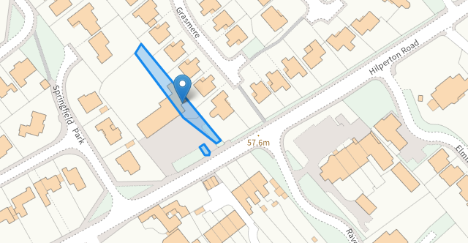

PLANNING HISTORY

Proposal / Summary
18/07281/LBC & 18/07066/FUL – (Hilbury Court Hotel) Minor internal works and external extensions to convert to four dwellings – Approve with conditions
PL/2021/06693 - To regularise minor variations (planning application 18/07281/LBC Conversion of part of hotel to dwelling) - Approve with conditions
PL/2021/08331 - Alterations to 18/07281/LBC - Approve with conditions

RELEVANT POLICIES AND GUIDANCE
Wiltshire Core Strategy:

- CP2 - Delivery Strategy
- CP29 – Spatial Strategy for the Trowbridge Community Area
- CP50 – Biodiversity and Geodiversity
- CP57 - Ensuring High Quality Design and Place Shaping
- CP58 - Ensuring the Conservation of the Historic Environment

Emerging Policy – Wiltshire Local Plan Review
At Full Council on 19 May, the elected members of Wiltshire Council agreed to withdraw the emerging WLP. This WLP has now been withdrawn and has no material weight for the purposes of the application. A new WLP is being prepared and is currently at Regulation 19 stage and therefore carries no weight in this assessment.
Wiltshire Design Guide: Appendix D – Design Guidance for Householder extensions
The National Planning Policy Framework (NPPF)
Planning (Listed Buildings and Conservation Areas) Act 1990
The Planning Practice Guidance
National Design Guide
Trowbridge Bat Mitigation Strategy SPD, adopted February 2020

CONSULTATION RESPONSES

Trowbridge Town Council: No comments received
Wiltshire Council Conservation Officer: No objection

REPRESENTATIONS
No comments were received.

ASSESSMENT
Section 38(6) of the Planning and Compulsory Purchase Act 2004 states:

"If regard is to be had to the development plan for the purposes of any determination to be made under the planning Acts, the determination must be made in accordance with the plan unless material considerations indicate otherwise."

In accordance with this statutory requirement, this application has been assessed against the relevant policies of the Development Plan, including the adopted Wiltshire Core Strategy (2015) and, where applicable, any made Neighbourhood Plans.

Principle of Development
The proposed development comprises a small-scale ancillary outbuilding within the private residential curtilage of an existing residential property within the settlement boundary of Trowbridge. The proposed works would be wholly within the residential curtilage and as such the principle of development is acceptable subject to the following considerations

Heritage, Design and Impact upon the character and context of the area:
From the point of view of the historic environment the main statutory tests are set out within the Planning (Listed Building and Conservation Areas) Act 1990.
Section 66 requires that special regard be given to the desirability of preserving listed buildings, their settings or any features of special architectural or historic interest which they possess.
Section 72(1) of the Act requires the Council to pay special attention to the desirability of preserving or enhancing the character or appearance of designated Conservation Areas.
The Council’s Core Strategy Policy CP58 ‘Ensuring the conservation of the historic environment’ requires that designated and non-designated heritage assets and their settings will be conserved, and where appropriate enhanced, in a manner appropriate to their significance and encourages proposals which improve the condition of heritage assets at risk.
The Council’s Core Strategy CP 57: Ensuring high quality design requires a high quality of design in all new developments. The policy requires applicants to “demonstrate how the proposal will make a positive contribution to the character of Wiltshire through (amongst other things) responding to the value of the natural and historic environment and being sympathetic to and conserving historic buildings and landscapes. Development is required to respond positively to the existing in terms of building layouts, built form, height, mass, scale, building line, plot size, elevational design, materials, streetscape and rooflines to effectively integrate the building into its setting.
The NPPF outlines government policy for planning. Chapter 16 of the NPPF 'Conserving and enhancing the historic environment' sets out the Government's high-level policies concerning heritage and sustainable development.
The proposal seeks to reconstruct a wooden shed to the rear of a Grade II listed building, No.4 Hilbury Court, located off Hilperton Road in Trowbridge. The host dwelling is one of four dwellings created following the conversion of the Grade II listed building, Hilbury Court Hotel.
The attached neighbouring properties are Grade II listed buildings, and the application site lies within the Trowbridge Conservation Area. The proposed shed would be located within the private residential rear curtilage associated with the host dwelling, within the northern corner of the site. An existing dilapidated garden building of timber structure is currently in situ.
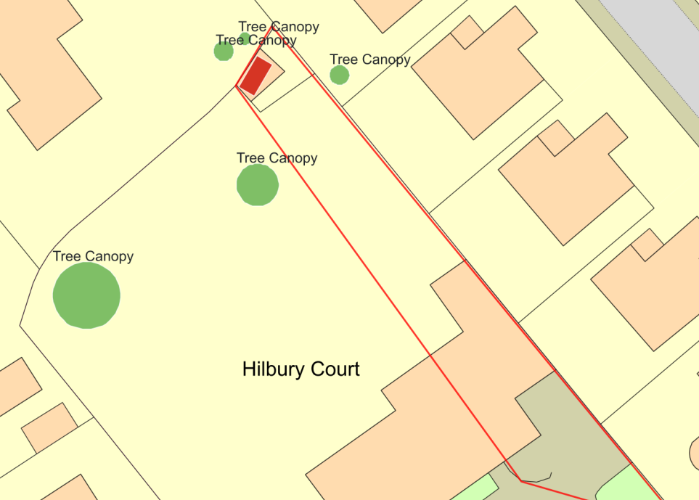
Position of the shed within the rear garden

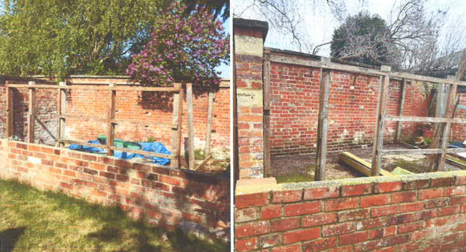
Existing garden structure
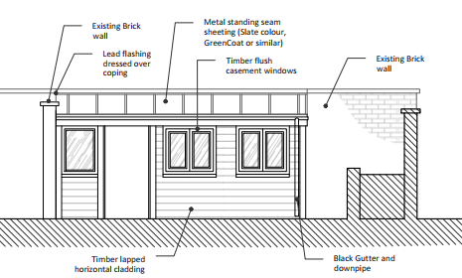
Proposed shed
The shed would consist of monopitch roof with a metal standing seam roof and horizontal timber cladding, with timber casement windows. The shed would be positioned against the back wall facing the host dwelling with three windows and an open access doorway. The building would sit at a height of 2.2m and would project a maximum depth of 3.3m from the existing brick wall.
The Council’s Conservation officer was consulted on the proposal and offered no objections citing
“Site and assets considered: the dwelling comprises a grade II listed former hotel. It is located on Hilperton Road amongst other similar high-status villas constructed during the late C18/early C19 as the wealthy merchants moved outwards from the town centre. The site lies within the Trowbridge (Hilperton Road Conservation Area).
Issues: impact on the listed building, impact on the conservation area (as the development is at a modest scale and to the rear of the listed building, set within an entirely enclosed private garden, the impact on the wider conservation area will be limited – this issue is therefore not considered further).
Information considered/provided: Paragraph 207 requires that applicants describe the significance of any heritage assets affected, including any contribution made by their setting. This should include sufficient information to provide a clear understanding of the significance of the heritage asset and its setting and the potential impact of any proposals on that significance.
In this case, the application is accompanied by a Heritage, Design and Access Statement which provides sufficient information to allow understanding of these relatively simple proposals.
Significance of assets and contribution of setting (as appropriate): The NPPF defines significance as the “value of a heritage asset to this and future generations because of its heritage interest. The interest may be archaeological, architectural, artistic or historic. Significance derives not only from a heritage asset’s physical presence, but also from its setting.” Historic England assesses significance in a similar manner, referring to evidential, historic, aesthetic and communal values of a place.
The interest may be architectural, or historic as set out in the Town and Country Planning (Listed Building and Conservation Areas) Act 1990 S 1.
In this case the significance of the principal building lies largely with its historic fabric and architecture - its form, layout and architectural expression/detailing and use of high-quality design materials which have significant aesthetic and architectural interest, and which contribute to the character of the conservation area. In addition, the development of these high-status villas provide historic evidence for the development of the town and the social context of the period.
Historic mapping indicates the presence of a number of garden structures within this corner of the garden with the blue cross hatching indicating that these were glasshouses – likely greenhouses and cold frames etc:
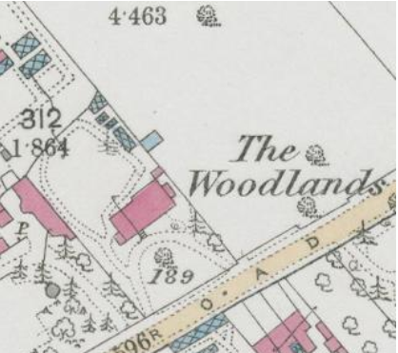
The remaining timber structure appears relatively modern and given that there appears to be no planning history indicating, the previous structure was presumably unauthorised.
Assessment: as recommended at pre-application, the proposed timber structure is appropriately and specifically designed to fit the context and the configuration of the historic garden walls such that the fabric of the walls and the setting of the principal listed building will be preserved.
n.b. the accompanying statement notes that the proposed shed will receive a painted finish, and it is agreed that this would be most appropriate (and similarly for the windows). This is not noted on the plans and a condition simply requiring this to be the case would be prudent.
Summary & conclusion: The NPPF confirms that when considering the impact of a proposed development on the significance of a designated heritage asset, great weight should be given to the asset’s conservation (and the more important the asset, the greater the weight should be). It makes clear that any harm to a designated heritage asset requires clear and convincing justification.
The impact of the proposals on heritage assets will be neutral. On this basis no specific justification is required however it is considered the works will assist in securing the future use of a heritage asset in support of its long-term conservation. The requirements of current conservation legislation, policy or guidance are considered to be met and there is therefore no objection to the approval of the application”
A condition would be added to ensure the shed is completed in a painted finish, in accordance with the conservation officer’s advice. The use of appropriate sustainable materials would ensure the proposal would integrate into the surrounding setting and it is considered that the extension would by virtue of its height, scale and design constitute a complementary addition to the application site that would appear commensurate to the size of the property and plot.

Having regard to the above, the proposal complies with the design principles set out in Core Policies 57 and 58 of the Wiltshire Core Strategy, Section 66 and Section 72 of the Planning (Listed Buildings and Conservation Areas) Act 1990, as well as the relevant provisions of the NPPF and the Wiltshire Design Guide.

Amenity
Point vii of Core Policy 57 - Ensuring High Quality Design and Place Shaping of the Wiltshire Core Strategy seeks to ensure that developments do not adversely affect neighbouring properties.

The National Planning Policy Framework (NPPF), particularly Paragraph 135(f), stresses that planning decisions should ensure developments provide a high standard of amenity for existing and future users.

The proposed development has been assessed in terms of its potential impact on the residential amenity of neighbouring properties, with particular regard to loss of light, overshadowing, loss of privacy, and overbearing effects.

The application site benefits from extended separation distances to any immediate neighbours, with established boundary treatments, therefore officers consider that the erection of a domestic garden shed, over the footprint of existing built form, would not introduce any adverse overlooking, overbearing or overshadowing impacts.

Due to the limited nature of the works, and the extended separation distances to any adjacent
dwellings it is not anticipated that there would any adverse neighbouring amenity impacts to
neighbouring properties.

The proposal therefore accords with Core Policy 57 point vii in respect of safeguarding residential amenity and Appendix D of the Wiltshire Design Guide.

Ecology Impact
Core Policy 50 of the Wiltshire Core Strategy seeks to protect and enhance biodiversity and geodiversity, including through ensuring that development avoids harm to protected species and habitats.

The National Planning Policy Framework (NPPF), in Paragraphs 193, requires that development minimises impacts on and provides net gains for biodiversity, including ensuring mitigation is secured where harm cannot be avoided.

The application site sits within the grey, hatched zone of the Trowbridge and Westbury Bat Mitigation Strategy (TWBMS). Therefore, due consideration has to be given to the potential disturbance of any bats because of the development.

The development consists of the erection of a small domestic wooden shed that would serve the host dwelling and given the established high density residential nature of the location, it is considered highly unlikely that any bats would be affected and significant effects relating to the disturbance to bats can be ruled out.

As a precautionary measure an informative would be added to any decision that in event any evidence of bat activity is detected that the applicant should follow the advice of a professional ecologist or contact Natural England. As such, the development complies with Core Policy 50 of the Wiltshire Core Strategy and the relevant provisions of the NPPF.

Biodiversity Net Gain
As of April 2024, unless exempted, applications need to demonstrate no net loss and a minimum of 10% net gain in biodiversity (BNG) on the site, in line with the requirements of the NPPF, PPG, WCS policy CP50 (Biodiversity and Geodiversity) and the Environment Act. In this case, the application was submitted with a de minimis exemption.

Based on the information available the biodiversity gain planning condition is not considered to apply to this application as the development meets the following criteria and is therefore below the de minimis threshold, meaning the development:

- does not impact an onsite priority habitat (a habitat specified in a list published under
section 41 of the Natural Environment and Rural Communities Act 2006); and

- impacts less than 25 square metres of onsite habitat that has biodiversity value
greater than zero and less than 5 metres in length of onsite linear habitat (as defined
in the statutory metric)

Given the small-scale nature of the works the proposal is deemed to meet the de minimis criteria with limited disruption to any biodiversity and no net loss identified, therefore no concerns are raised in relation to any adverse ecological impacts to be introduced by the proposed scheme. The proposal therefore meets the requirements contained in policy CP50 of the Wiltshire Core Strategy and the relevant provisions of the NPPF.

CONCLUSION
The proposed development is considered to be acceptable in terms of its design, scale, and relationship with the surrounding area. It would not result in any unacceptable harm to the character of the locality, the amenities of neighbouring occupiers, or the interests of heritage, or ecology.

The proposal is therefore considered to comply with the relevant policies of the Wiltshire Core Strategy, the Wiltshire Local Plan, and the National Planning Policy Framework. As such, the application is recommended for approval, subject to the conditions set out below.

RECOMMENDATION: That Householder Planning Permission and Listed Building Consent be GRANTED subject to conditions.

