APPLICATION FOR HOUSEHOLDER PLANNING PERMISSION DELEGATED REPORT

APPLICATION REFERENCE: | PL/2026/03689
APPLICATION TYPE: | Householder planning permission
SITE ADDRESS: | Redlynch House, Bowers Hill, Redlynch, Salisbury, SP5 2HD
DEVELOPMENT DESCRIPTION: | Single storey extension to rear of property
RECOMMENDATION: | That Planning Permission be GRANTED

PROPOSAL

The proposal seeks planning permission for the erection of a single storey extension to be erected on the south elevation of the existing dwelling.

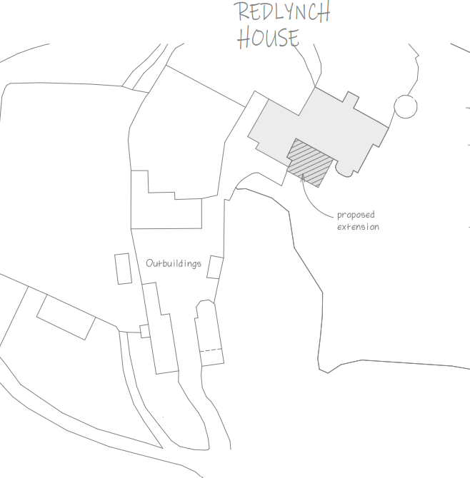

During the course of the application and following comments from the conservation officer, amendments were made to the design of the proposed extension to remove the stone quoins, increase the amount of glazing and reduce the width of the new opening in the existing building to retain more of the existing fabric of the building.

Existing and proposed elevations and plans included below.

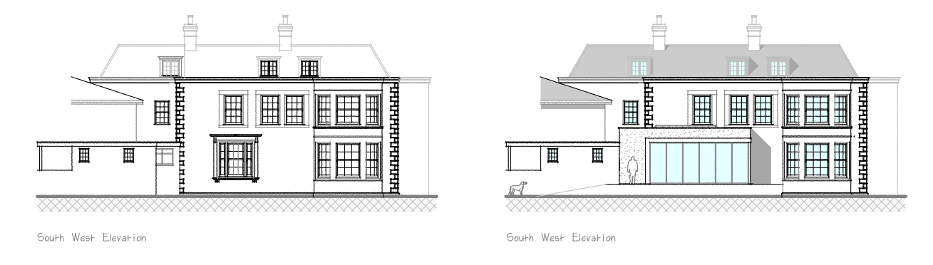

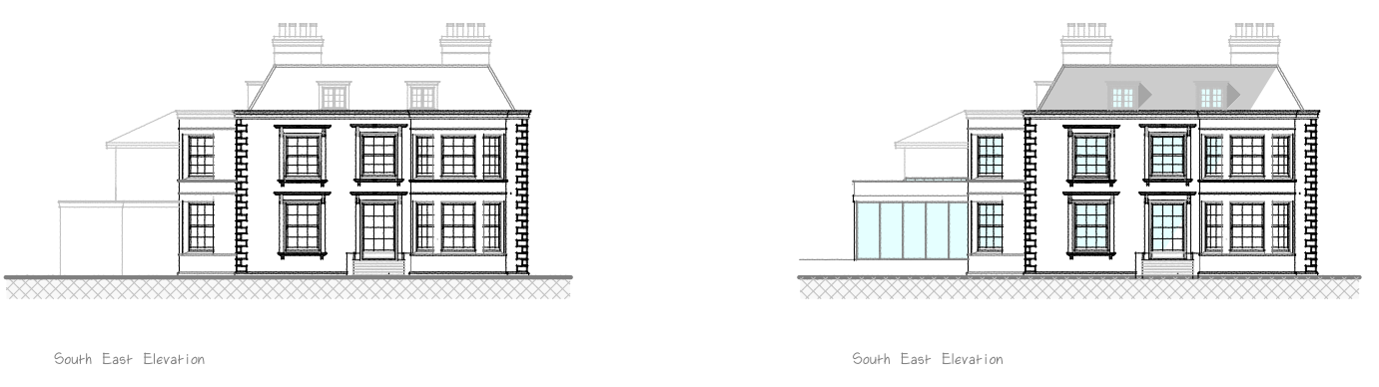

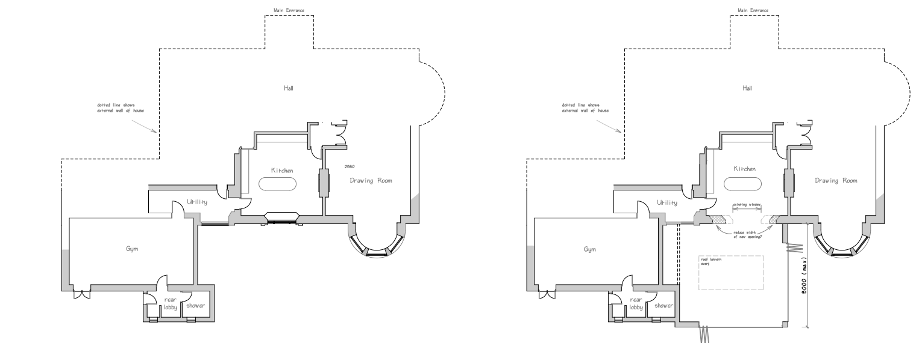

SITE DESCRIPTION/CONTEXT

The application site comprises Redlynch House, a substantial detached early 19th century country house set within approximately 19.6 acres of private parkland at Bowers Hill, Redlynch. The estate includes a Grade II listed Lodge Cottage at the entrance, two semi-detached estate cottages (Park Row), and a range of traditional ancillary outbuildings arranged around a rear courtyard. The site is accessed via a private driveway extending from Bowers Hill and contains formal gardens, walled gardens and open landscaped grounds. The main dwelling is not listed but is considered to be a non-designated heritage asset, is not located within a Conservation Area, and lies within Flood Zone 1. The site lies within the New Forest Protected Sites 13.8km Recreation zone of influence and is within the River Test catchment SAC, Ramsar, SSSI and SPA. The site is also within the Special Landscape Area (saved policy C6 of the Salisbury District Local Plan)

PLANNING HISTORY

There is no planning history directly relevant to the consideration of this application.

RELEVANT POLICIES AND GUIDANCE

The National Planning Policy Framework (NPPF)
The Planning Practice Guidance
National Design Guide

Wiltshire Core Strategy

Core Policy 1: Settlement Strategy
Core Policy 2: Delivery Strategy
Core Policy 23: Spatial Strategy for South Wiltshire Community Area
Core Policy 24: New Forest National Park
Core Policy 50: Biodiversity and Geodiversity
Core Policy 51: Landscape
Core Policy 57: Ensuring high quality design and place shaping
Core Policy 58: Ensuring the conservation of the historic environment
Core Policy 60 and 61: Transport and development

Saved Policies of the Salisbury District Local Plan

C6 Special Landscape Area
C24 Extensions and additions to buildings in the countryside

Wiltshire Design Guide: Appendix D – Design Guidance for Householder extensions
Creating Places Design Guide

CONSULTATION RESPONSES

Parish Council: Support

Conservation: Comments for suggested amendments to improve the proposed development

REPRESENTATIONS

No comments were received.

ASSESSMENT

Section 38(6) of the Planning and Compulsory Purchase Act 2004 states:

"If regard is to be had to the development plan for the purposes of any determination to be made under the planning Acts, the determination must be made in accordance with the plan unless material considerations indicate otherwise."

In accordance with this statutory requirement, this application has been assessed against the relevant policies of the Development Plan, including the adopted Wiltshire Core Strategy (2015) and, where applicable, any made Neighbourhood Plans.

Design and Impact upon the character of the area including impacts on Heritage Assets and Special Landscape Area

The NPPF outlines government policy, including its policy in respect of the historic environment. Section 16 of the NPPF 'Conserving and enhancing the historic environment' sets out the Government's high-level policies concerning heritage and sustainable development. Paragraphs 214-16 of the NPPF require a balanced approach with any harm which would be caused being weighed against the potential public benefits which might be achieved. Paragraph 210 requires local planning authorities should take account of the desirability of sustaining and enhancing the significance of heritage assets and of new development making a positive contribution to local character and distinctiveness.

National Planning Practice Guidance provides guidance on interpreting the NPPF.

The Council’s Core Strategy Policy CP58 ‘Ensuring the conservation of the historic environment’ requires that “designated heritage assets and their settings will be conserved, and where appropriate enhanced, in a manner appropriate to their significance.” It is also required that distinctive elements of Wiltshire’s historic environment, including non-designated heritage assets, which contribute to a sense of local character and identity will be conserved, and where possible enhanced.

Wiltshire Council’s Core Strategy Policy CP57 ‘Ensuring high quality design and place shaping’: A high standard of design is required in all new developments, including extensions, alterations, and changes of use of existing buildings. Development is expected to create a strong sense of place through drawing on the local context and being complementary to the locality.

The property has been subject to a number of alterations over time which have affected aspects of its architectural character and historic integrity. The Council’s conservation officer has been consulted as part of the application process and has raised no objections in principle to the proposed extension but has commented that the loss of an original rear window is regrettable but that this would occur on a secondary elevation that has already been altered. The Conservation officer has suggestions improvements to the proposed design of the extension to provide a lighter more contemporary approach through the increase in glazing and loss of stone quoins with increased render. They have also suggested to include a slimmer roof profile to reduce its visual impact on the host building.

The applicant has provided amended plans to take into account the suggestions made by the conservation officer and has incorporated the majority of the suggested amendments, including the removal of the stone quoins, increased glazing and a reduction in the width of the proposed opening, whilst retaining the originally proposed roof form.

No re-consultation was considered necessary following the submission of amended plans as the amendments related solely to design details and did not materially alter the scale, siting or overall nature of the development. No objections had been raised to the principle of the development.

The proposed single storey extension to be constructed on the south side of the host dwelling in this context is considered to be a subservient addition to the host dwelling which will not detract from its character and appearance. The proposed materials are considered to be appropriate and complement the existing dwelling.

Whilst the loss of the original window is unfortunate, the dwelling is not a listed building and alterations of this nature could be undertaken without separate planning consent. Given the location of the window on a secondary elevation that has already undergone alteration, the level of harm arising is considered to be limited and does not justify a refusal of planning permission.

The siting of the proposed extension will not be visible from public views with views of the addition contained within the site. Therefore, there are no identified harms in relation to the impacts on the character of the wider area. The proposal would also not materially harm the character and appearance of the Special Landscape Area given its limited scale and relationship with the existing built form.

Having regard to the above, the proposal complies with the design principles set out in Core Policies 57 and 58 of the Wiltshire Core Strategy and Appendix D of the Wiltshire Design Guide.

Amenity

Point vii of Core Policy 57 - Ensuring High Quality Design and Place Shaping of the Wiltshire Core Strategy seeks to ensure that developments do not adversely affect neighbouring properties.

The National Planning Policy Framework (NPPF), particularly Paragraph 135(f), stresses that planning decisions should ensure developments provide a high standard of amenity for existing and future users.

The proposed development has been assessed in terms of its potential impact on the residential amenity of neighbouring properties, with particular regard to loss of light, overshadowing, loss of privacy, and overbearing effects.

There are no immediate neighbouring dwellings that will be affected by the proposed development.

The proposal therefore accords with Core Policy 57 point vii in respect of safeguarding residential amenity and Appendix D of the Wiltshire Design Guide.

Ecology Impact

Core Policy 50 of the Wiltshire Core Strategy seeks to protect and enhance biodiversity and geodiversity, including through ensuring that development avoids harm to protected species and habitats.

The National Planning Policy Framework (NPPF), at Paragraph 193, requires that development minimises impacts on and provides net gains for biodiversity, including ensuring mitigation is secured where harm cannot be avoided.

As identified above, the site lies within the River Test SAC and within the New Forest SAC, however, as the proposed development relates to a householder extension and does not include the creation of an additional residential unit of accommodation, there are no likely adverse harms arising which would impact on these special ecological designations.

Biodiversity Net Gain - Householder planning applications are exempt from the requirement to deliver Biodiversity Net Gain under Schedule 7A, Section 4(2)(a) of the Town and Country Planning Act 1990, as inserted by the Environment Act 2021.

As such, the development complies with Core Policy 50 of the Wiltshire Core Strategy and the relevant provisions of the NPPF.

CONCLUSION

The proposed development is considered to be acceptable in terms of its design, scale, and relationship with the surrounding area. It would not result in any unacceptable harm to the character of the locality, the amenities of neighbouring occupiers, heritage, or ecology.

The proposal is therefore considered to comply with the relevant policies of the Wiltshire Core Strategy, the Wiltshire Local Plan, and the National Planning Policy Framework. As such, the application is recommended for approval, subject to the conditions set out below.

RECOMMENDATION: That Planning Permission be GRANTED subject to conditions.

1. The development hereby permitted shall be begun before the expiration of three years from the date of this permission.

REASON: To comply with the provisions of Section 91 of the Town and Country Planning Act 1990 as amended by the Planning and Compulsory Purchase Act 2004.

2. The development hereby permitted shall be carried out in accordance with the following approved plans:

Application form received 10/06/2026
Location plan Drawing no 6 received 10/06/2026
Block plan Drawing no 4 received 10/06/2026
Existing and proposed elevations Drawing no 2 A received 28/07/2026
Existing and proposed floor plans Drawing no 1 B received 28/07/2026
Existing and proposed roof plans Drawing no 3 received 10/06/2026

REASON: For the avoidance of doubt and in the interests of proper planning.

