HOUSEHOLDER PLANNING PERMISSION
CASE OFFICER REPORT

APPLICATION REFERENCE: | PL/2026/01615
APPLICATION TYPE: | Householder
SITE ADDRESS: | 38 Broadstones, Monkton Farleigh, Bradford On Avon, BA15 2QA.
DEVELOPMENT DESCRIPTION: | Single storey side extension and associated works.
RECOMMENDATION: | Approve with Conditions.

PROPOSAL
The proposal seeks planning permission for the construction of a single storey side infill extension between the existing garage and the host principle dwelling; associated works consisting of internal re-configuration of the dwelling’s internal layout are also proposed.

SITE DESCRIPTION/CONTEXT
The site is an area of residential developed land at 38 Broadstones, Monkton Farleigh, Bradford on Avon, which would be utilised for the construction of a single storey side extension, that would act as a link joining the existing garage to the main dwelling and which would be used as ancillary residential accommodation. The site is not located within a Conservation Area.
The site is located within an established residential housing estate and is also within Green Belt land and is close to but outside of the Cotswold National Landscape. The area is also located within the Bath and Bradford on Avon Bat SAC.

RELEVANT PLANNING HISTORY
Proposal / Summary
N/A

RELEVANT POLICIES AND GUIDANCE

Wiltshire Core Strategy:

- Core Policy 57: Ensuring High Quality Design and Place Shaping
- Core Policy 50: Biodiversity and Geodiversity
- Core Policy 51: Landscape
- Core Policy 58: Ensuring the Conservation of the Historic Environment
- Core Policy 61: Transport and New Development
- Core Policy 64: Demand Management
- Core Policy 67: Flood Risk

Wiltshire Design Guide: Appendix D – Design Guidance for Householder extensions

The National Planning Policy Framework (NPPF)

The Planning Practice Guidance

National Design Guide

Emerging Wiltshire Local Plan:
At Full Council on 19 May 2026, the elected members of Wiltshire Council agreed to withdraw the emerging Wiltshire Local Plan. The said Plan has no material weight for the purposes of this application.

CONSULTATION RESPONSES
Monkton Farleigh Parish Council: No objections.

Ecology: No objections, subject to conditions.

Highways: Request plan showing extra car parking space.

REPRESENTATIONS
No comments were received.

PRINCIPLE OF THE PROPOSAL.
The principle of the proposed scheme is acceptable for the reasons as discussed below.

ASSESSMENT
Section 38(6) of the Planning and Compulsory Purchase Act 2004 states:

"If regard is to be had to the development plan for the purposes of any determination to be made under the planning Acts, the determination must be made in accordance with the plan unless material considerations indicate otherwise."

In accordance with this statutory requirement, this application has been assessed against the relevant policies of the Development Plan, including the adopted Wiltshire Core Strategy (2015).

Design and Impact upon the upon the character and context of the area

Core Policy 57 - Ensuring High Quality Design and Place Shaping of the Wiltshire Core Strategy seeks to ensure that all new development is of high design quality, reflecting local context, character, and distinctiveness.

The proposals can be viewed within the following plan snippets taken from the submitted plans:

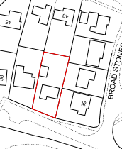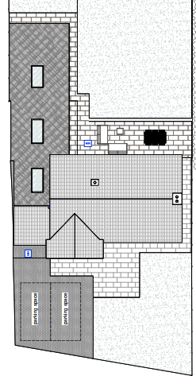
Location Plan Proposed Site Plan

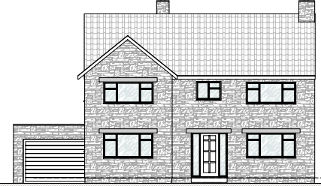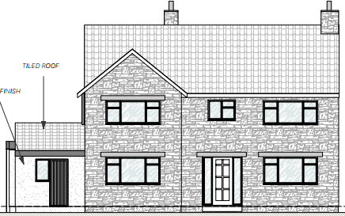
Existing & Proposed Front Elevations.

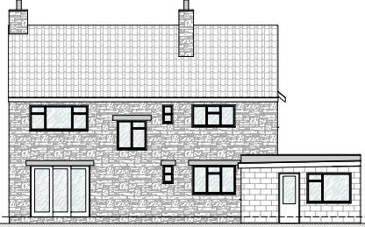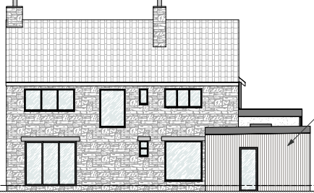
Existing & Proposed Rear Elevations.

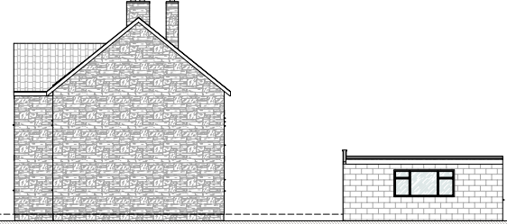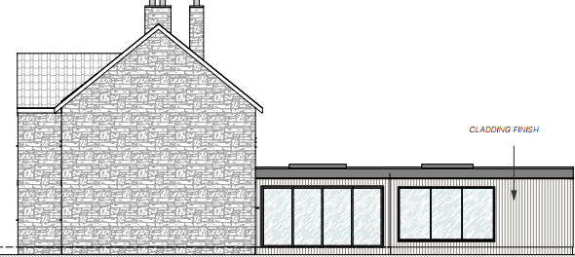
Existing & Proposed Side Elevation.

The proposal would see the construction of a single storey, flat roof linear extension to the west aspect of the site, as located between the existing rear elevation of the dwelling and the area where the garage is located. The garage would be replaced with a single storey timber clad extension which would have inward faced large sized contemporary designed fenestration, looking onto the site’s private rear garden area. A rear outside seating area would also be provided, and the above proposed site plan snippet shows this proposed arrangement. The proposed extension would provide an extended dining and lounge area and there would also be some internal re-configurating of the property, with the number of bedrooms not being increased and remaining at three in total.

In terms of materials, the proposal would consist of a combination of the existing stone, (as found within the garage building), timber cladding, render and an element of matching roof tiles at the front of the extension, which would have its own entrance into the newly created utility room/boot room. All of these aspects are appraised as being acceptable and subservient additions to the principal dwelling.

Therefore, in summary, having regard to the above, the proposal complies with the design principles set out in Core Policy 57 of the Wiltshire Core Strategy and Appendix D of the Wiltshire Design Guide.

Amenity
Point vii of Core Policy 57 - Ensuring High Quality Design and Place Shaping of the Wiltshire Core Strategy seeks to ensure that developments do not adversely affect neighbouring properties. The National Planning Policy Framework (NPPF), particularly Paragraph 135(f), stresses that planning decisions should ensure developments provide a high standard of amenity for existing and future users.
The proposed extension would be single storey and would not have any fenestration within its west facing boundary elevation facing onto the immediate neighbour at No.37. The proposed glazing would look and face onto the site’s own private and enclosed rear garden area.

Likewise, due to the location, size and orientation of the single storey proposal, there would not be any significant overshadowing or loss of light to the most immediate neighbour at No.37, as the extension would be of limited height and mass with no overshadowing, overbearing or loss of light impacts being raised.

The proposal therefore accords with Core Policy 57 point vii. in respect of safeguarding residential amenity and Appendix D of the Wiltshire Design Guide.

Highway Matters.
Core Policy 57 (xiv) of the Wiltshire Core Strategy seeks to ensure that development must meet the requirements of Core Policy 61. This policy requires proposals to be capable of being served by safe access to the highway network. Core Policy 64 seeks to ensure compliance with parking standards set out in the Local Transport Plan.

The National Planning Policy Framework (NPPF), particularly Paragraph 115 and 116, requires that development proposals do not have an unacceptable impact on highway safety and that safe and suitable access to the site can be achieved for all users.

The site with its proposed development would continue to use the established site access, which would not be altered and so would not have any adverse impact on highway safety. In terms of off-road parking space requirements, the council’s adopted policy states that for a two to three bedroom dwelling there is a need to provide two off road car parking spaces, and where there are four or more bedrooms, there is a need to provide three such spaces.

In this instance, the number of bedrooms is not being increased and are remaining at three in total, with two such off road car parking spaces being provided, this being in accordance with the council’s adopted car parking strategy.

The council’s highways officer Highways has asked for details of an additional parking space as she is concerned that the proposed study could be used as a bedroom. Taking such matters at face value, there would not be an increase in the bedroom numbers, and the council is not able to control internal reconfigurations of the property, therefore the provision of two such spaces are wholly adequate and acceptable.

The proposal is therefore considered to comply with Core Policies 57 (xiv), 61 and 64 of the Wiltshire Core Strategy, the NPPF, and the Wiltshire Local Transport Plan.

Green Belt Land.
The site lies within Green Belt land and there are no relevant WCS development plan policies relating to the Green Belt, therefore the NPPF provides the policy direction. The NPPF sets out within paragraph 142 that “The Government attaches great importance to Green Belts, with the fundamental aim of Green Belt policy being to prevent urban sprawl by keeping land permanently open; the essential characteristics of Green Belts are their openness and their permanence”. Openness is the absence of development and Paragraph 143 the NPPF sets out five key purposes of the Green Belt with one being to safeguard the open countryside from encroachment. The NPPF explains how to treat proposals within the Green Belt.

Paragraph 153 of the NPPF states inappropriate development is, by definition, harmful to the Green Belt and should not be approved except in very special circumstances. The two key characteristics of the Green Belt are its openness and its permanence.

Paragraph 154 sets out the categories of development which may be regarded as being ‘appropriate’ or exceptions in the Green Belt, such that in this instance sub-paragraph C allows for extensions as an exception. In this instance the proposed extension consists of a small area of single storey infill between the host dwelling and the existing garage building, to the rear of the dwelling. Therefore, due to the proposal being small in size and located within the defined residential curtilage of the host building, within the established residential area of the village, the proposed works are in accordance with the above policy, and would not result in a disproportionate addition.

Therefore, for the above stated reasons and because the site is not readily open or isolated due to the surrounding built form, the scheme serves to contribute to the character of the site and also to ensure the proportionality of the extension, which fits in and adheres within the context of the surrounding Green Belt.

Cotswold National Landscape.
The site is outside of the Cotswold National Landscape boundary by just over a kilometre, whereby such sensitive land designations are afforded a high level of protection. In this particular instance however, due to the separation distance from the boundary, the overall small scale of the development located within an established residential area, it is appraised that there would be no harm inflicted on the open character of this nearby land designation.

Ecology Impact CP50 requires no net loss of biodiversity on site. The site is located within the Bath and Bradford on Avon Bat SAC.

The submitted Preliminary Roost Assessment identified the existing buildings as having low to negligible potential to support roosting bats. The Ecologist raised no objection to the proposal and advised that the site offers suitable habitat for foraging and commuting bats. The proposed single-storey side extension and associated works would not require the removal of vegetation considered to be functionally important for foraging or commuting bats. The Ecologist concluded that, subject to the retention of key boundary features, the functionality of habitats within the site and their availability to bats would not be adversely affected by the development.

A test of likely significance was carried out by the relevant Competent Authority (Wiltshire Council) as required by Regulation 63 Conservation of Habitats and Species (Amendment) (EU Exit) Regulations 2019. This concluded that given the scale and nature of the development there is no mechanism for adverse effect. The Habitat Regulation Assessment (HRA) has concluded that the application would not result in any mechanism for adverse effect on Annex II bats, or on the conservation objectives of the SAC and so subsequently was screened out of Appropriate Assessment.

The Ecologist requested that two planning conditions relating to compliance with approved ecological documents and the control of external lighting be attached to the decision notice. However, it is considered that a condition requiring control of external lighting would fail the tests for planning conditions. The development is located within an established residential area where there are no existing restrictions on external lighting associated with the dwelling. As such, the imposition of such a condition would be unreasonable, having regard to the scale and nature of the proposed single-storey side extension.

As such, the development complies with Core Policy 50 of the Wiltshire Core Strategy and the relevant provisions of the NPPF.

Biodiversity Net Gain. This application is exempt from the requirement to deliver Biodiversity Net Gain under Schedule 7A, Section 4(2)(a) of the Town and Country Planning Act 1990, as inserted by the Environment Act 2021, because the proposal is a householder extension.

CONCLUSION
The proposed development is acceptable in terms of its design, scale, and relationship with the surrounding area. It would not result in any unacceptable harm to the character of the locality, the amenities of neighbouring occupiers, or the interests of highway safety or ecology.

The proposal is therefore considered to comply with the relevant policies of the Wiltshire Core Strategy, the Wiltshire Local Plan, and the National Planning Policy Framework. As such, the application is recommended for approval, subject to the conditions set out below.

RECOMMENDATION: Planning Permission be GRANTED subject to conditions.

