APPLICATION FOR LISTED BUILDING CONSENT
DELEGATED REPORT

APPLICATION REFERENCE: | PL/2026/03858
APPLICATION TYPE: | Listed Building Consent
SITE ADDRESS: | Kingston House, 13 The Causeway, Chippenham , SN15 3BT
DESCRIPTION OF WORKS: | Reinstatement of a coursed limestone front garden wall, together with the restoration of the stone-paved courtyard/terrace at the front of the property
RECOMMENDATION: | That Listed Building Consent be GRANTED

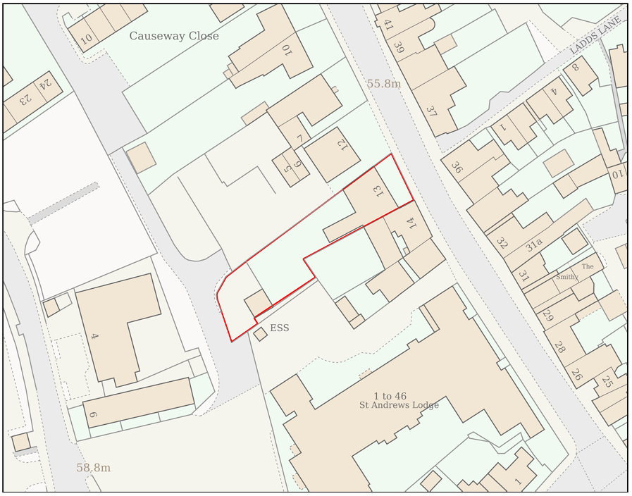

PROPOSAL

The application seeks Listed Building Consent for a range of restoration and repair works within the front garden of Kingston House, 13 The Causeway, Chippenham. The proposed works comprise repairs to areas of deteriorating stone boundary walling including cleaning and repointing, the removal of a section of modern red brick retaining wall and its replacement with coursed limestone walling to match the existing historic boundary treatment, reinstatement of the front courtyard area with natural stone paving, retention of existing coping stones and pier caps, repositioning of existing decorative stone planters and the temporary removal and subsequent reinstatement of a section of boundary hedgerow to facilitate the works. The proposal is principally restorative in nature and seeks to improve the condition and appearance of the front garden and boundary structures associated with the listed dwelling.

SITE DESCRIPTION/CONTEXT

The application site relates to Kingston House, a Grade II listed dwelling located on the western side of The Causeway within the Chippenham Conservation Area. The property dates from the mid-19th century and is constructed principally of limestone ashlar with a slate roof. The listing description identifies the front garden enclosure wall and associated piers as features of significance. The site occupies a prominent position within The Causeway, a historic route into Chippenham town centre characterised by a varied collection of historic and traditional buildings. Whilst much of the street frontage comprises buildings positioned close to the highway, Kingston House forms part of a small group of properties set behind enclosed front gardens and boundary walls, creating a distinctive contribution to the streetscene. Numerous designated heritage assets are located within the immediate vicinity. The site lies within Flood Zone 1, is not subject to any identified ecological constraints, and is accessed from a Classified C Road.

RELEVANT PLANNING HISTORY

Reference No. | Proposal / Summary | Decision
N/03/00929/FUL | CONSTRUCTION OF PITCHED GARAGE ROOF; NEW RAILINGS | Approved
N/03/00930/LBC | INSERTION OF WINDOW/NEW RAILINGS | Approved
14/05380/LBC | Conservation Clean, Necessary Repairs & Repointing | Approved
18/07419/LBC | Repairs and underpinning works to front garden stone walls, and removal and rebuilding of the front garden side brick wall | Approved

RELEVANT LEGISLATION, POLICIES AND GUIDANCE

Legislation

From the point of view of the historic environment the main statutory tests are set out within the Planning (Listed Building and Conservation Areas) Act 1990. Section 16 requires that special regard be given to the desirability of preserving listed buildings, their settings or any features of special architectural or historic interest which they possess.

Section 72(1) of the Planning (Listed Building and Conservation Areas) Act 1990 also requires the Council to pay special attention to the desirability of preserving or enhancing the character or appearance of designated Conservation Areas.

National Policy and Guidance

The National Planning Policy Framework (NPPF) sets out government policy, including in respect of the historic environment.

Section 16 of the NPPF ('Conserving and enhancing the historic environment') sets out the Government's high-level policies concerning heritage and sustainable development.

Paragraphs 213-215 of the NPPF require a balanced approach with any harm which would be caused being weighed against the potential public benefits which might be achieved. Paragraph 210 requires local planning authorities to take account of the desirability of sustaining and enhancing the significance of heritage assets and of new development making a positive contribution to local character and distinctiveness.

National Planning Practice Guidance provides guidance on interpreting the NPPF.

Historic England Advice Note 2: Making changes to Heritage Assets, illustrates the application of policies set out in the NPPF in determining applications for LBC (and planning permission).

Wiltshire Core Strategy

Whilst not directly relevant to listed building consent applications, the below policies give an indication of the Council’s approach to development affecting heritage assets:

- Core Policy 57 ‘Ensuring high quality design and place shaping’: A high standard of design is required in all new developments, including extensions, alterations, and changes of use of existing buildings. Development is expected to create a strong sense of place through drawing on the local context and being complementary to the locality.

- Core Policy 58 ‘Ensuring the conservation of the historic environment’ requires that “designated heritage assets and their settings will be conserved, and where appropriate enhanced, in a manner appropriate to their significance.”

ISSUES

Impact upon the preservation of the listed building or its setting or any features of special architectural and/or historic interest.

CONSULTATION RESPONSES

Chippenham Town Council – Supports
The replacement of the existing modern brick wall section with matching stone walling would enhance both the Grade II listed building and the character and appearance of the Conservation Area, in accordance with Policy TC4 of the Chippenham Neighbourhood Plan. The Council raises no objection to the proposed paving of the front terrace provided there is historic precedent for such treatment, otherwise indicating a preference for a gravel finish.

REPRESENTATIONS

In accordance with the requirements of Section 5(1) of the Planning (Listed Buildings and Conservation Areas) Regulations 1990 (as amended) the application for listed building consent was publicised by way of a site notice displayed near the site;

This was used to inform interested parties and to allow a statutory consultation period of 21 days for representations to be submitted. No representations were received during the consultation period.

ASSESSMENT
In accordance with Section 16(2) of the Planning (Listed Buildings and Conservation Areas) Act 1990, special regard has been given to the significance of the listed building, including its architectural and historic interest, and the desirability of preserving both the building and its setting. Relevant policies within the National Planning Policy Framework (NPPF), particularly Section 16: Conserving and Enhancing the Historic Environment, have also been taken into account. These policies require that any harm to the significance of a designated heritage asset must be clearly justified and weighed against the public benefits of the proposal.

In order to be acceptable, the application needs to be assessed against the following criteria:

Information considered/submitted

Paragraph 207 requires that applicants describe the significance of any heritage assets affected, including any contribution made by their setting. This should include sufficient information to provide a clear understanding of the significance of the heritage asset and its setting and the potential impact of any proposals on that significance.

A Design, Access and Heritage Statement has been submitted in support of the application together with existing and proposed drawings detailing the restoration works. The submitted information includes an assessment of the significance of the listed building and its setting, a description of the proposed works, details of construction methods and materials, and the rationale for the replacement of the modern brick retaining wall with coursed limestone walling. The submitted information is considered proportionate to the scale and nature of the proposed works and provides sufficient detail to enable a clear understanding of the significance of the heritage asset and the impact of the proposals upon that significance.

Assessment of significance

According to the National Planning Policy Framework (NPPF), significance is defined as:

“The value of a heritage asset to this and future generations because of its heritage interest. The interest may be archaeological, architectural, artistic or historic. Significance derives not only from a heritage asset’s physical presence, but also from its setting.”

Historic England further categorises significance into four key values:

- Evidential – the potential of the asset to yield evidence about past human activity.
- Historic – the ways in which the asset illustrates aspects of history.
- Aesthetic – the sensory and design qualities of the asset.
- Communal – the meanings and associations attached to the asset by people.

In this case the significance of the building lies largely within its architectural and historic value as a well-preserved mid-19th Century dwelling and its contribution to the character and appearance of the Chippenham Conservation Area. The statutory listing identifies the limestone ashlar construction, symmetrical principal elevation, Tuscan portico and slate roof as key elements of architectural interest. Importantly, the listing also specifically identifies the enclosed front garden, squared and coursed limestone rubble boundary wall, gate piers, cornices and pyramidal caps as features of special architectural and historic interest.

The asset derives significance primarily from its historic, aesthetic and evidential values. Historic value is reflected in the building's survival as a notable nineteenth-century dwelling and its relationship with the historic development of The Causeway. Aesthetic value derives from the quality of its stone construction, architectural detailing and enclosed garden setting, which together contribute positively to the wider conservation area streetscene. Evidential value is found within the surviving historic fabric of both the dwelling and its associated boundary features, which demonstrate traditional construction techniques and materials. The communal value of the asset is largely derived from its contribution to the character and appearance of the conservation area and its recognition as a designated heritage asset.

The front boundary wall and enclosed garden setting make an important contribution to the significance of the listed building. The Conservation Area Appraisal identifies Nos. 9–13 The Causeway as a distinct group of buildings characterised by their setback position behind raised front gardens and boundary walls, giving them a notably grander presence within the streetscene. As such, the significance of the listed building is experienced not only through the main house itself but also through its relationship with the boundary wall and front garden enclosure.

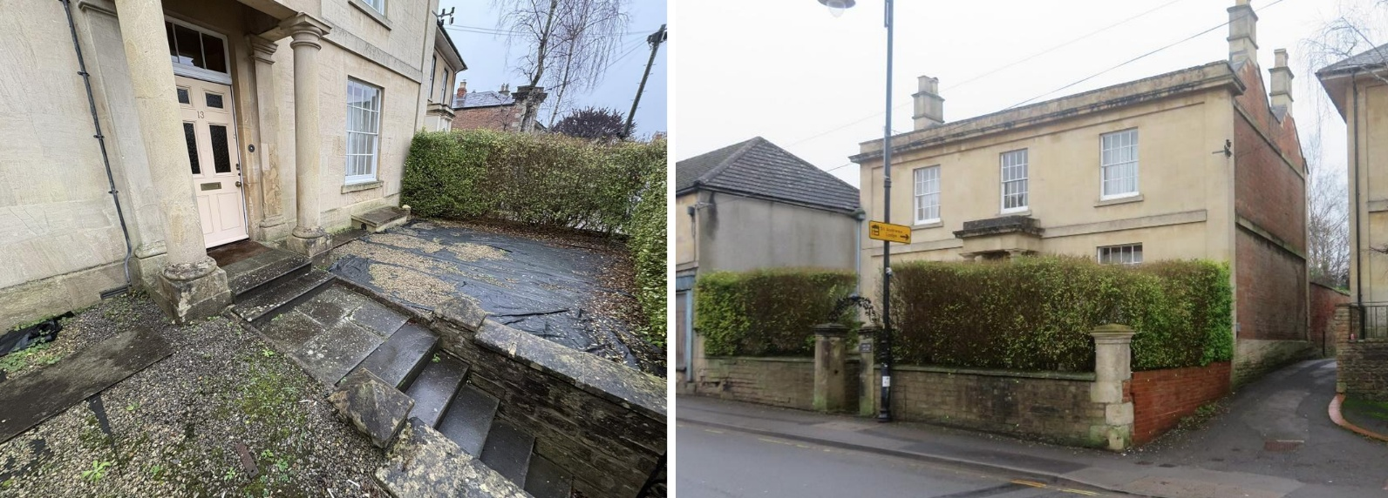
Site Images

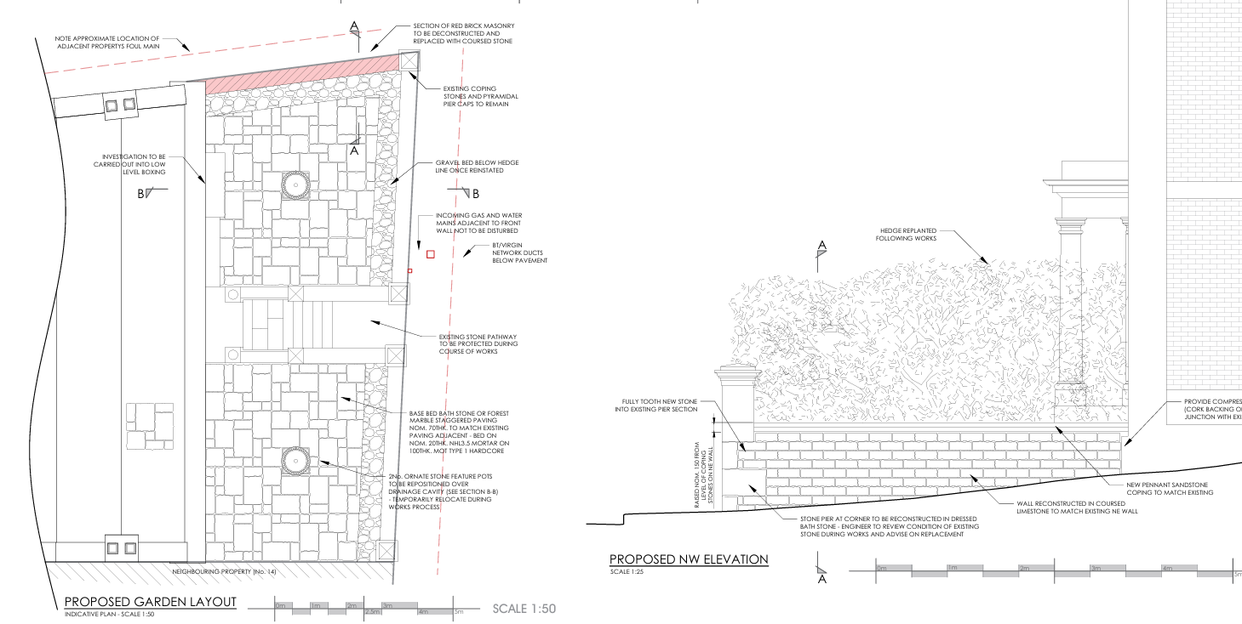
Proposed Elevation and Site Plan

Impact of proposals on the significance and setting of the building/structure:

Understanding the impact of proposed works on a listed building requires a careful and proportionate assessment of how those changes affect the asset’s heritage significance and its setting. This includes both the physical alterations to the building itself and any changes to its spatial or visual relationship with surrounding structures or spaces.

The significance of a heritage asset is not static; it is shaped by its architectural, historic, and communal values, and by how these are experienced in context. Therefore, any intervention must be considered in light of the asset’s identified significance, with attention given to both potential harm and benefits. Benefits may include repairs that support the long-term conservation of the building, improved energy performance, or enhanced public access and understanding.

This assessment is grounded in the statutory duty under Section 16 of the Planning (Listed Buildings and Conservation Areas) Act 1990, which requires special regard to be given to the desirability of preserving the building and its features of special interest. It is also informed by national policy, particularly paragraphs 199–208 of the National Planning Policy Framework (NPPF), and relevant local heritage policies and guidance.

The proposed works are considered to have a neutral to positive impact on the significance of the listed building and its setting.

The proposal comprises predominantly repair, restoration and maintenance works to features already identified as being of significance. The majority of the historic boundary wall would be retained, with works limited to cleaning, repointing and localised repairs using traditional materials and methods. Existing coping stones and pyramidal pier caps would remain in situ. These works would support the continued preservation of the historic fabric and secure its longer-term condition without altering the character or appearance of the asset.

The most substantial alteration relates to the removal of a short section of modern red brick retaining wall along the northern boundary and its replacement with coursed limestone walling detailed to match the existing historic boundary enclosure. The submitted heritage statement indicates that this brickwork is a modern intervention and is not representative of the original form of the boundary wall identified within the statutory listing. The replacement wall would utilise coursed limestone construction and lime mortar, restoring a material palette consistent with both the listed building and the wider conservation area. Consequently, the proposed replacement is considered to enhance the historic character and visual coherence of the boundary treatment.

The proposal also includes the resurfacing of the enclosed front courtyard area with natural stone paving. The existing surface is formed of gravel and membrane and is considered to be of a deteriorated condition. The proposed paving materials comprise traditional natural stone which is considered compatible with the character and age of the listed building. Given the enclosed nature of the courtyard and the limited visibility of this area from the public realm, the works would not detract from the significance of the asset or its setting. Rather, they would improve the overall appearance and functionality of the space whilst remaining sympathetic to its historic context.

The temporary removal of a section of hedgerow is ancillary to the restoration works and would be followed by reinstatement upon completion. As such, no permanent harm would arise to the setting of the listed building or its contribution to the conservation area.

Overall, the proposal would result in the preservation of the listed building, its setting and those features of special architectural and historic interest identified within the statutory listing. No harm to significance has been identified. Instead, the works would secure the repair and restoration of historic features and replace less sympathetic modern fabric with materials more consistent with the heritage significance of the site. The proposal is therefore considered to accord with Sections 16 and 72 of the Planning (Listed Buildings and Conservation Areas) Act 1990, Section 16 of the NPPF and Core Policy 58 of the Wiltshire Core Strategy.

Impact on Ecology

While Sections 16 and 72 of the Planning (Listed Buildings and Conservation Areas) Act 1990 do not explicitly reference protected species, Local Planning Authorities have a statutory duty to consider potential impacts on protected species when determining applications. This responsibility arises from broader environmental legislation and national planning policy, and must be taken into account where relevant.

Does the site or proposed development possess/impact on any of the features where
protected species are likely to be present (assessed against Natural England’s standing
advice) and where species are likely to be found?
 |  | Y / N / NA
(a) | Does the site or proposed development possess/impact on any of the features where protected species are likely to be present (assessed against Natural England’s standing advice) and where species are likely to be found? | N
(b) | If yes, has a protected species survey been submitted? | N/A
(c) | If yes, does the survey show a detailed consideration of ecological impacts, wildlife mitigation and the creation, restoration and enhancement of wildlife corridors to preserve and enhance biodiversity in accordance with the standing advice? | N/A

The proposal relates to repair and restoration works within the curtilage of an existing residential property and does not involve the loss of buildings, trees or habitats commonly associated with protected species. Whilst a section of boundary hedgerow would be temporarily removed to facilitate the approved works, it would be reinstated following completion. The site is not subject to any identified ecological constraints and there is no evidence to indicate the likely presence of protected species or habitats that would be adversely affected by the development. The proposal is therefore acceptable in ecological terms.

CONCLUSION

Paragraph 215 of the NPPF confirms that great weight should be given to the conservation of designated heritage assets and that any harm to significance requires clear and convincing justification. In this instance, no harm to the significance of the listed building, its setting or any feature of special architectural or historic interest has been identified.

The proposed works are primarily restorative in nature and comprise the repair of historic stonework, repointing works, replacement of a modern brick wall section with more sympathetic coursed limestone walling, and improvements to the enclosed courtyard area using traditional materials. The proposals would preserve the special architectural and historic interest of the Grade II listed building whilst enhancing the visual coherence of its boundary treatment and supporting the ongoing maintenance of important historic fabric. Furthermore, the works would preserve the character and appearance of the Chippenham Conservation Area.

Accordingly, it is considered that the proposal accords with Sections 16 and 72 of the Planning (Listed Buildings and Conservation Areas) Act 1990, Section 16 of the National Planning Policy Framework and Core Policy 58 of the Wiltshire Core Strategy.

RECOMMENDATION:
That Listed Building Consent be GRANTED, subject to the following conditions:

1.
The works hereby authorised shall be begun not later than three years from the date of this consent.

REASON: As required by Section 18 of the Planning (Listed Buildings and Conservation Areas) Act 1990.

2.
The works hereby approved shall be carried out in accordance with the approved plans and supporting documents, including:

Location Plan (8 June 2026)
Design Access and Heritage Statement (4677 – Rev C)
Enhanced Retaining and Drainage Cavity Sections (4677-003-C)
Proposed Garden Layout and Elevations (4677-002-C)

REASON: For the avoidance of doubt and in the interests of preserving the special architectural and historic interest of the listed building.

3.
All new stonework and repointing shall match the existing historic walling in respect of stone type, coursing, jointing, mortar composition, colour, texture and finish and shall be carried out in accordance with the approved details.

REASON: To safeguard the special architectural and historic interest of the listed building.

4.
The existing coping stones, pier caps and other historic features identified for retention on the approved drawings shall be retained and maintained as part of the approved works.

REASON: To preserve historic fabric which contributes to the significance of the listed building.

