APPLICATION FOR HOUSEHOLDER PLANNING PERMISSION
DELEGATED REPORT

APPLICATION REFERENCE: | PL/2026/03587
APPLICATION TYPE: | Householder Planning Permission
SITE ADDRESS: | Kingston House, 13 The Causeway, Chippenham , SN15 3BT
DEVELOPMENT DESCRIPTION: | Reinstatement of a coursed limestone front garden wall, together with the restoration of the stone-paved courtyard/terrace at the front of the property
RECOMMENDATION: | That Planning Permission be GRANTED

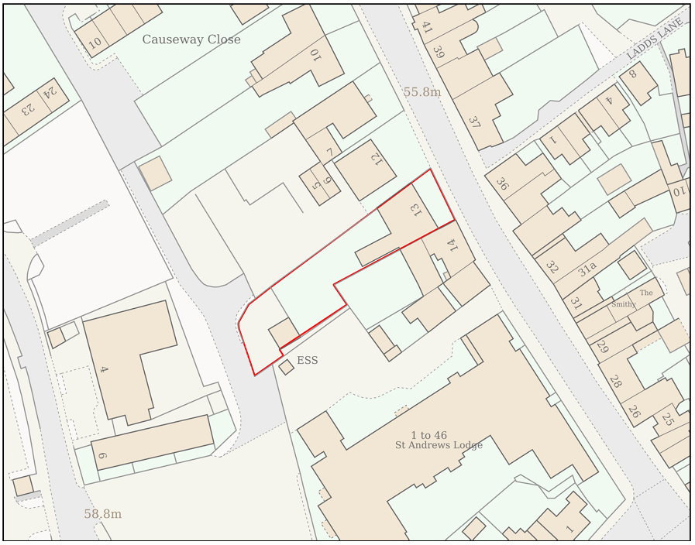
PROPOSAL

The application seeks Householder Planning Permission for a range of restoration and repair works within the front garden of Kingston House, 13 The Causeway, Chippenham. The proposed works comprise repairs to areas of deteriorating stone boundary walling including cleaning and repointing, the removal of a section of modern red brick retaining wall and its replacement with coursed limestone walling to match the existing historic boundary treatment, reinstatement of the front courtyard area with natural stone paving, retention of existing coping stones and pier caps, repositioning of existing decorative stone planters and the temporary removal and subsequent reinstatement of a section of boundary hedgerow to facilitate the works. The proposal is principally restorative in nature and seeks to improve the condition and appearance of the front garden and boundary structures associated with the listed dwelling.

SITE DESCRIPTION / CONTEXT

The application site relates to Kingston House, a Grade II listed dwelling located on the western side of The Causeway within the Chippenham Conservation Area. The property dates from the mid-19th century and is constructed principally of limestone ashlar with a slate roof. The listing description identifies the front garden enclosure wall and associated piers as features of significance. The site occupies a prominent position within The Causeway, a historic route into Chippenham town centre characterised by a varied collection of historic and traditional buildings. Whilst much of the street frontage comprises buildings positioned close to the highway, Kingston House forms part of a small group of properties set behind enclosed front gardens and boundary walls, creating a distinctive contribution to the streetscene. Numerous designated heritage assets are located within the immediate vicinity. The site lies within Flood Zone 1, is not subject to any identified ecological constraints, and is accessed from a Classified C Road.

PLANNING HISTORY

Reference No. | Proposal / Summary | Decision
N/03/00929/FUL | CONSTRUCTION OF PITCHED GARAGE ROOF; NEW RAILINGS | Approved
N/03/00930/LBC | INSERTION OF WINDOW/NEW RAILINGS | Approved
14/05380/LBC | Conservation Clean, Necessary Repairs & Repointing | Approved
18/07419/LBC | Repairs and underpinning works to front garden stone walls, and removal and rebuilding of the front garden side brick wall | Approved

RELEVANT LEGISLATION, POLICIES AND GUIDANCE

Wiltshire Core Strategy:

Core Policy 1 Settlement Strategy;
Core Policy 2 Delivery Strategy;
Core Policy 10 Spatial Strategy: Chippenham Community Area;
Core Policy 50 Biodiversity and Geodiversity;
Core Policy 51 Landscape;
Core Policy 57 Ensuring High-Quality Design and Place Shaping;
Core Policy 58 Ensuring Conservation of the Historic Environment;
Core Policy 60 Sustainable Transport;
Core Policy 61 Transport and Development;
Core Policy 64 Demand Management;
Core Policy 67 Flood Risk;

Chippenham Neighbourhood Plan 2023-2038

The National Planning Policy Framework (NPPF)

The Planning Practice Guidance (PPG)

Wiltshire Design Guide

The Wiltshire Local Transport Plan 2011 – 2026: Car Parking Strategy (March 2015).

The Wiltshire Local Transport Plan 4 (LTP4) (March 2025)

Emerging Policy – Wiltshire Local Plan Review

At Full Council on 19 May, the elected members of Wiltshire Council agreed to withdraw the emerging WLP. The said Plan has no material weight for the purposes of the application.

CONSULTATION RESPONSES

Chippenham Town Council – Supports
The replacement of the existing modern brick wall section with matching stone walling would enhance both the Grade II listed building and the character and appearance of the Conservation Area, in accordance with Policy TC4 of the Chippenham Neighbourhood Plan. The Council raises no objection to the proposed paving of the front terrace provided there is historic precedent for such treatment, otherwise indicating a preference for a gravel finish.

Local Highway Authority (Wiltshire Council) – No Objection

Archaeology (Wiltshire Council) – No Objection

Arboriculture (Wiltshire Council) – No Objection

REPRESENTATIONS

No comments received.

ASSESSMENT

Section 38(6) of the Planning and Compulsory Purchase Act 2004 states:

"If regard is to be had to the development plan for the purposes of any determination to be made under the planning Acts, the determination must be made in accordance with the plan unless material considerations indicate otherwise."

In accordance with this statutory requirement, this application has been assessed against the relevant policies of the Development Plan, including the adopted Wiltshire Core Strategy (2015) and, where applicable, any made Neighbourhood Plans.

The proposal relates to alterations, repairs and restoration works associated with an established residential dwelling located within the Chippenham settlement boundary. The works would not alter the lawful residential use of the property, nor result in the creation of additional residential accommodation. Given the domestic nature of the development and subject to consideration of detailed design, heritage and any other material planning considerations, the principle of the proposed development is considered acceptable.

Design and Impact the upon the character and context of the area

Core Policy 57 Ensuring High Quality Design and Place Shaping of the Wiltshire Core Strategy requires all new development to achieve a high standard of design that responds positively to its local context. Proposals must reinforce and enhance local character and distinctiveness, relate appropriately to the surrounding landscape, and demonstrate a thoughtful response to existing townscape features. This includes careful consideration of elements such as building height, scale, massing, building line, materials, and overall appearance, ensuring new development integrates harmoniously with its setting.

The proposed works are considered to represent a sympathetic and high-quality scheme of restoration and enhancement. The majority of existing historic features, including the principal boundary wall, gate piers, coping stones and established front garden arrangement, would be retained. The replacement of the modern red brick wall section with coursed limestone walling would better reflect the traditional materials and detailing present across the site and surrounding conservation area. Similarly, the introduction of natural stone paving within the enclosed courtyard area would provide an appropriate and durable surface treatment that is consistent with the character of the listed building. Given the limited visibility of much of the internal courtyard space from the public realm, together with the traditional materials proposed, the development is considered to result in a positive visual outcome that preserves and enhances the appearance of the site.

Having regard to the above, the proposal complies with the design principles set out in Core Policy 57 of the Wiltshire Core Strategy and Appendix D of the Wiltshire Design Guide.

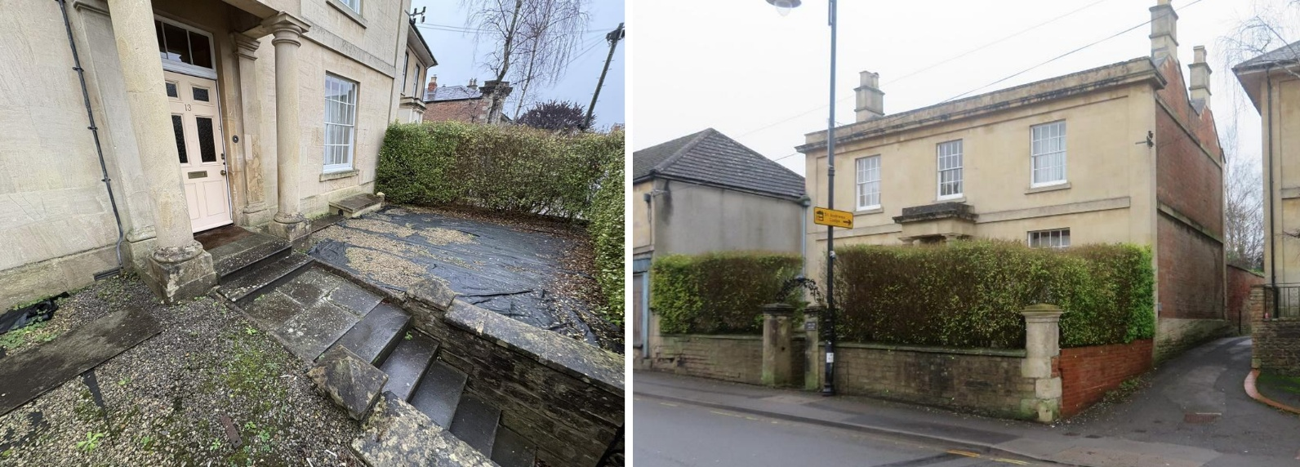
Site Images

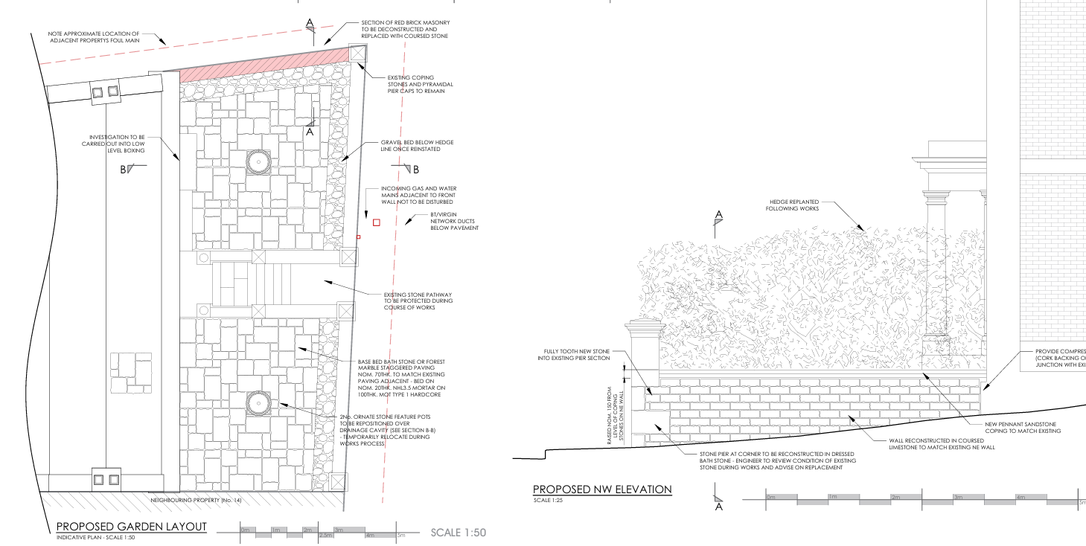
Proposed Elevation and Site Plan

Conservation and Heritage

Core Policy 58 outlines development consideration with regard to the historic environment. The policy states that heritage assets and their settings must be conserved and, where appropriate, enhanced through any proposed development.

Section 66(1) of the Planning (Listed Buildings and Conservation Areas) Act 1990 requires special regard to be paid to the desirability of preserving a listed building, its setting and any features of special architectural or historic interest which it possesses. Additionally, Section 72(1) requires special attention to be given to the desirability of preserving or enhancing the character and appearance of conservation areas.

The host property is Grade II listed, with the listing specifically identifying the front boundary wall and associated piers as features of significance. The site is also located within the Chippenham Conservation Area and within a wider historic streetscape characterised by traditional materials and historic building forms.

The proposed works have been carefully designed to retain and repair the significant historic fabric of the site. The majority of the existing boundary wall would remain in situ, with works largely limited to repairs, cleaning and repointing. Existing coping stones and pyramidal pier caps would be retained. The most notable alteration comprises the removal of a short section of modern red brick retaining wall and its replacement with coursed limestone walling designed to match the appearance, scale, coursing and detailing of the existing historic boundary enclosure. Supporting information submitted with the application indicates that the brick section is a later intervention and does not form part of the original wall referenced within the statutory listing description. The proposal therefore seeks to reinstate a more historically sympathetic treatment using traditional materials and construction methods, including lime mortar.

The resurfacing of the front courtyard area with traditional natural stone paving is also considered acceptable. The existing area comprises a gravel surface and membrane which has deteriorated over time and contributes little to the significance of the heritage asset. The replacement paving would utilise natural stone materials that are appropriate to the age, character and architectural detailing of the host building. Furthermore, the courtyard is substantially enclosed by the boundary wall and hedgerow, limiting wider public views of the space and reducing the visual prominence of the proposed alterations.

The temporary removal of part of the boundary hedgerow is ancillary to the restoration works and the submitted details confirm that the hedge would be reinstated following completion of the development. As such, no lasting adverse effect on the established character of the frontage would occur.

Policy TC4 of the Chippenham Neighbourhood Plan requires development within the Chippenham Conservation Area to preserve or enhance its special character and appearance, be of a high quality design that contributes positively to local distinctiveness, maintain and enhance important views, retain heritage assets which make a positive contribution to the significance of the Conservation Area, and have full regard to the findings of the Chippenham Conservation Area Character Appraisal. In this regard, the proposal would retain and repair the historic boundary wall and associated features identified as contributing positively to the significance of both the listed building and Conservation Area, whilst replacing an unsympathetic section of modern brickwork with coursed limestone more reflective of the site's historic character. The use of traditional materials and the restoration works proposed would reinforce the established character of the area and preserve the distinctive appearance of this prominent frontage. Furthermore, the proposal would maintain the enclosed garden setting identified within the Conservation Area Appraisal as an important characteristic of this group of properties, thereby preserving and modestly enhancing the character and appearance of the Conservation Area.

Overall, the proposal is considered to preserve the special architectural and historic interest of the Grade II listed building and would preserve, and modestly enhance, the character and appearance of the Chippenham Conservation Area through the repair of historic fabric and replacement of less sympathetic modern materials with more appropriate traditional alternatives. The proposal is therefore considered to accord with the statutory duties of Sections 66 and 72 of the Planning (Listed Buildings and Conservation Areas) Act 1990 and relevant heritage policies of the development plan.

Amenity

Point vii of Core Policy 57 Ensuring High Quality Design and Place Shaping of the Wiltshire Core Strategy seeks to ensure that developments do not adversely affect neighbouring properties. The National Planning Policy Framework (NPPF), particularly Paragraph 135, stresses that planning decisions should ensure developments provide a high standard of amenity for existing and future users.

The proposed development consists solely of repair, restoration and resurfacing works within the curtilage of an existing dwelling and would not result in any increase in built form, height, scale, massing or intensity of use. The proposal would not introduce any new windows, openings, external plant or other features capable of giving rise to overlooking, loss of privacy, loss of light, overbearing impacts or disturbance to neighbouring occupiers. Accordingly, it is considered that the proposal would preserve the amenities currently enjoyed by neighbouring properties and would comply with the amenity objectives of the development plan.

Transport and Highways

Core Policy 60 of the WCS states that Council will support and encourage safe and efficient movement of people and, where necessary, mitigate the impact of development on transport users and local communities. Core Policy 61 specifies that development should demonstrate that consideration has been given to a hierarchy of transport users and that proposals must, where relevant, serve as a safe access to the highway network. Paragraph 116 of the NPPF states that “Development should only be prevented or refused on highways grounds if there would be an unacceptable impact on highway safety, or the residual cumulative impacts on the road network, following mitigation, would be severe, taking into account all reasonable future scenarios”.

The development would not alter the existing means of access to the site, affect visibility splays, change parking arrangements or generate any additional vehicular movements. The proposal relates solely to repairs and alterations within the curtilage of the existing dwelling and would therefore have no material impact upon the safe or efficient operation of the adjacent highway network. The proposal is acceptable from a highways perspective.

Ecology

The WCS, through Core Policy 50, states that development proposals are expected to avoid and reduce disturbance of sensitive wildlife species and habitats. Biodiversity Net Gain (BNG) was established as a mandatory aspect of planning evaluation through Schedule 7A of the Town and Country Planning Act 1990 (as amended by the Environment Act 2021 Schedule 14). Householder planning applications are exempt from the requirement to deliver Biodiversity Net Gain under Schedule 7A, Section 4(2)(a) of the Town and Country Planning Act 1990, as inserted by the Environment Act 2021.

The proposal relates primarily to repair and restoration works within an established residential curtilage and involves no significant loss of habitat, trees or ecological features. Whilst a section of hedgerow would be temporarily removed to facilitate the wall reconstruction works, this would be reinstated upon completion of the development. The site is not subject to any statutory ecological designation and there is no evidence before the Council indicating the presence of protected species or habitats that would be adversely affected by the development. Given the scale and nature of the works, the proposal is not considered likely to result in any adverse ecological impacts and is acceptable in this regard.

Flooding and Drainage

Core Policy 67 Flood Risk of the Wiltshire Core Strategy requires all development to be located, designed, and constructed to minimise vulnerability to flooding and to avoid increasing flood risk elsewhere. Proposals must demonstrate that surface water can be managed safely and sustainably, incorporating appropriate drainage solutions—such as sustainable drainage systems (SuDS)—that ensure runoff rates and volumes do not exceed pre‑development levels. Development should provide measurable betterment where necessary, ensuring that drainage strategies are robust, technically compliant, and aligned with national policy. The NPPF sets out the application of a sequential, risk-based approach to the location of new development in paragraph 172.

The site is located within Flood Zone 1 and is not identified as being subject to significant flood risk constraints. The proposal primarily comprises restoration and resurfacing works within an existing domestic courtyard area and would not result in any meaningful increase in the extent of impermeable surfacing compared to the existing situation. Consequently, the development would not be expected to materially alter surface water runoff characteristics or increase flood risk either on-site or elsewhere. The proposal is therefore considered acceptable in drainage terms.

CONCLUSION

The proposed development comprises a sympathetic package of restoration, repair and enhancement works to a Grade II listed dwelling and its associated curtilage structures. The works would preserve the significance of the listed building, preserve and modestly enhance the character and appearance of the Chippenham Conservation Area, and would not result in any unacceptable impacts in respect of design, residential amenity, ecology, highways or drainage. Having regard to all material considerations, the proposal is considered to represent sustainable and appropriate development and is recommended for approval, subject to appropriate conditions.

RECOMMENDATION: That Planning Permission be GRANTED subject to the following conditions:

1.
The development hereby permitted shall be begun before the expiration of three years from the date of this permission.
REASON: To comply with the provisions of Section 91 of the Town and Country Planning Act 1990 as amended by the Planning and Compulsory Purchase Act 2004.

2.
The development hereby permitted shall be carried out in accordance with the following approved plans and documents:

Location Plan (8 June 2026)
Design Access and Heritage Statement (4677 – Rev C)
Enhanced Retaining and Drainage Cavity Sections (4677-003-C)
Proposed Garden Layout and Elevations (4677-002-C)

REASON: For the avoidance of doubt and in the interests of proper planning.

3.
The stone walling, paving materials, pointing mortar and all other external materials used in the development shall be carried out in accordance with the details shown on the approved plans and supporting documentation unless otherwise agreed in writing by the Local Planning Authority.

REASON: In the interests of visual amenity and to preserve the character and appearance of the Chippenham Conservation Area.

4.
Any section of hedgerow removed to facilitate the approved works shall be reinstated in accordance with the approved details within the first planting season following completion of the development.

REASON: In the interests of the character and appearance of the site and surrounding Conservation Area.

Informative
The application may involve works affecting the public highway/footway. The consent hereby granted shall not be construed as authority to carry out works on the highway/footway. The applicant is advised that a notice/licence may be required from Wiltshire’s Highway Authority before any works are carried out on any footway, footpath, carriageway, verge or other land forming part of the highway. Please contact our Street Works Team on streetworks@wiltshire.gov.uk to enquire if an application is necessary.

