APPLICATION FOR HOUSEHOLDER PLANNING PERMISSION
DELEGATED REPORT

APPLICATION REFERENCE: | PL/2026/02436
APPLICATION TYPE: | Householder Planning Permission
SITE ADDRESS: | 36-37 Newtown, Bradford On Avon, BA15 1NF
DEVELOPMENT DESCRIPTION: | Erection of timber steps at the top of the garden adjacent to rear public pathway (retrospective)
RECOMMENDATION: | That Planning Permission be GRANTED

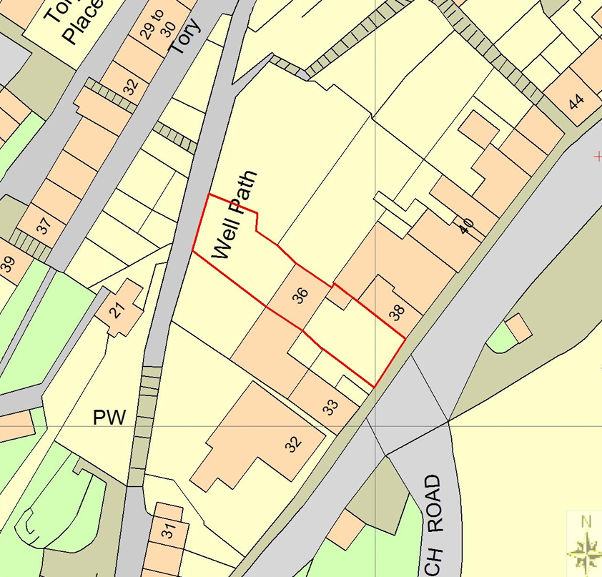
PROPOSAL

The application seeks retrospective planning permission for the erection of a timber staircase within the rear garden of the dwellinghouse. The staircase is positioned against the north-western rear boundary of the site adjacent to the public right of way known as the Well Path (BRAD41), providing a means of access between the garden and the higher land level of the footpath. The submitted plans indicate that the structure measures approximately 3 metres in height, with an overall footprint of approximately 2.5 metres by 1 metre, comprising a flight of timber steps rising to a landing platform with associated handrails. No alterations to the adjacent public footpath, retaining wall or boundary railing form part of the application.

SITE DESCRIPTION / CONTEXT

The application site comprises a three-storey terraced dwelling located within the Bradford on Avon Conservation Area and within the defined settlement boundary of Bradford on Avon. The property is constructed of natural stone under a tiled roof and forms part of the historic built character that defines this part of the town. The site occupies a steeply sloping hillside location, with the rear garden sitting at a significantly lower level than the adjacent public footpath known as the Well Path (BRAD41), which runs along the north-western boundary. The footpath is elevated above the site behind a substantial stone retaining wall and affords expansive views across Bradford on Avon. The area is characterised by historic stone buildings, walls and landscape features, including a number of nearby Grade II and Grade II* listed buildings. The site is also subject to various ecological constraints associated with greater and lesser horseshoe bats, lies within Flood Zone 1, and is identified as being at low risk of fluvial or surface water flooding.

PLANNING HISTORY

Reference No. | Proposal / Summary | Decision
W/98/00305/FUL | Alter existing access to provide improved parking and safer pedestrian access | Approved
W/98/00306/LBC | No 33 - rebuild boundary wall No 38 - work adj flank wall refix gas meter box | Approved
W/06/02582/FUL | Install solar water heating system | Approved

RELEVANT LEGISLATION, POLICIES AND GUIDANCE

Wiltshire Core Strategy:

Core Policy 1 Settlement Strategy;
Core Policy 2 Delivery Strategy;
Core Policy 7 Spatial Strategy: Bradford on Avon Community Area;
Core Policy 50 Biodiversity and Geodiversity;
Core Policy 51 Landscape;
Core Policy 57 Ensuring High-Quality Design and Place Shaping;
Core Policy 58 Ensuring Conservation of the Historic Environment;
Core Policy 60 Sustainable Transport;
Core Policy 61 Transport and Development;
Core Policy 64 Demand Management;
Core Policy 67 Flood Risk;

Bradford on Avon Neighbourhood Plan 2013-2026

The National Planning Policy Framework (NPPF)

The Planning Practice Guidance (PPG)

Wiltshire Design Guide - Appendix D – Design Guidance for Householder extensions

The Wiltshire Local Transport Plan 2011 – 2026: Car Parking Strategy (March 2015).

The Wiltshire Local Transport Plan 4 (LTP4) (March 2025)

Emerging Policy – Wiltshire Local Plan Review

At Full Council on 19 May, the elected members of Wiltshire Council agreed to withdraw the emerging WLP. The said Plan has no material weight for the purposes of the application.

CONSULTATION RESPONSES

Bradford on Avon Town Council – No Objection

Local Highway Authority (Wiltshire Council) – No Objection
Subject to no alteration of the existing railing along the well path.

Rights of Way (Wiltshire Council) - Object
Objects to the proposal on safety grounds, stating that the retained railings would restrict safe access between the new steps and the public footpath, while also risking damage to the retaining wall coping stones. Although the steps may benefit the applicant, the current design is considered unacceptable and would require a revised layout that provides safe, unobstructed access and protects the existing highway infrastructure.

Conservation Officer (Wiltshire Council) – No Objection (subject to condition)
Concluded that the lightweight, open design has a neutral impact on the character of the Bradford-on-Avon Conservation Area and the setting of nearby listed buildings. However, they considered that the bamboo screening attached to the handrail is considered harmful to the conservation area because it blocks important views and introduces an inappropriate material, and its removal is recommended by condition.

REPRESENTATIONS

Five representations were received in respect of the application, comprising three objections and two letters of support. The objections, including comments from the Bradford on Avon Preservation Trust, raise concerns that the timber steps would appear visually incongruous within the Conservation Area, harm the setting of nearby listed buildings and the character of the public footpath, and result in the loss or alteration of part of the historic handrail. Concerns were also raised regarding potential installation of a gate, the impact on views across the town, the ownership and condition of the handrail, the justification for the access, and the extent of neighbour consultation.

The supporting comments state that the proposal relates only to the timber steps and not to a gate or wall, that the steps are comparable to similar structures at neighbouring properties, and that they provide a practical means of removing and recycling garden waste from a steeply terraced garden with no alternative rear access. Supporters consider the steps to be modest in scale, low impact, visually appropriate and in keeping with the established pattern of garden access within this part of Bradford on Avon.

ASSESSMENT

Section 38(6) of the Planning and Compulsory Purchase Act 2004 states:

"If regard is to be had to the development plan for the purposes of any determination to be made under the planning Acts, the determination must be made in accordance with the plan unless material considerations indicate otherwise."

In accordance with this statutory requirement, this application has been assessed against the relevant policies of the Development Plan, including the adopted Wiltshire Core Strategy (2015) and, where applicable, any made Neighbourhood Plans.

The proposal relates to a minor domestic addition within the residential curtilage of an existing dwelling located within the Bradford on Avon settlement boundary. The development does not result in the creation of a new dwelling, intensification of land use, or alteration to the established residential function of the site. Subject to consideration of its detailed impacts, the erection of a staircase to serve a private dwelling is considered to represent an acceptable form of domestic development in principle.

Design and Impact the upon the character and context of the area

Core Policy 57 Ensuring High Quality Design and Place Shaping of the Wiltshire Core Strategy requires all new development to achieve a high standard of design that responds positively to its local context. Proposals must reinforce and enhance local character and distinctiveness, relate appropriately to the surrounding landscape, and demonstrate a thoughtful response to existing townscape features. This includes careful consideration of elements such as building height, scale, massing, building line, materials, and overall appearance, ensuring new development integrates harmoniously with its setting.

The proposed staircase is of a simple and functional timber construction typical of domestic garden structures. Whilst timber is not a material commonly associated with the stone-built historic character of the surrounding conservation area, the structure is lightweight and open in appearance, and is positioned to the rear of the property within a domestic garden environment. Owing to the site's topography, the staircase sits largely below the level of the adjacent footpath and retaining wall, limiting its prominence within wider public views. Given its modest scale, limited visual presence and domestic character, the development is not considered to appear incongruous or visually intrusive within its setting. Having regard to the above, the proposal complies with the design principles set out in Core Policy 57 of the Wiltshire Core Strategy and Appendix D of the Wiltshire Design Guide.

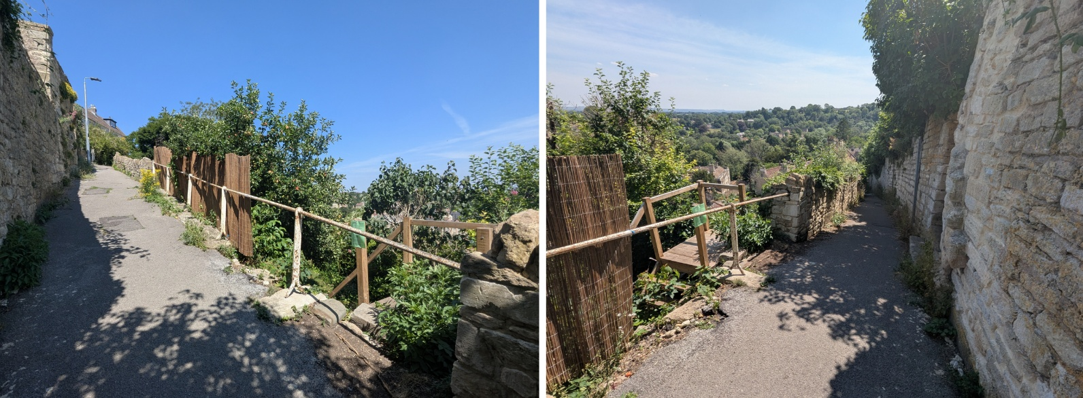
View North and South on the Well Path

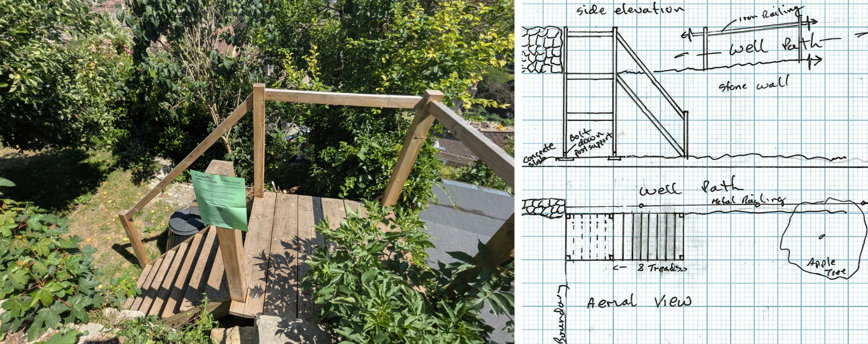
Site Image and Plans

Conservation and Heritage

Core Policy 58 outlines development consideration with regard to the historic environment. The policy states that heritage assets and their settings must be conserved and, where appropriate, enhanced through any proposed development.

Section 66 of the Planning (Listed Buildings and Conservation Areas) Act 1990 requires special regard to be given to the desirability of preserving the setting of listed buildings, whilst Section 72 requires special attention to be paid to preserving or enhancing the character and appearance of conservation areas. The site lies within the Bradford on Avon Conservation Area and in proximity to a number of listed buildings. The Council's Conservation Officer has assessed the proposal and raises no objection to the staircase itself. In reaching this conclusion, regard has been had to the contribution made by the network of historic footpaths, passageways and stepped routes which characterise this part of Bradford on Avon and form part of its significance. The submitted staircase is of a lightweight and open design which allows views through the structure and does not materially obstruct the expansive views available from the adjacent public footpath across the valley. Furthermore, by reason of its modest scale and location within the lower part of the rear garden, the staircase would not compete visually with nearby heritage assets or detract from their appreciation. Whilst the Conservation Officer identifies the existing bamboo screening attached to the adjacent handrail as a feature that causes harm to the character of the conservation area through the obstruction of views and introduction of an inappropriate material, that screening does not form part of the development proposed or require assessment as part of this application. The staircase itself is therefore considered to preserve the character and appearance of the Bradford on Avon Conservation Area and preserve the setting of nearby listed buildings, in accordance with Core Policy 58 of the Wiltshire Core Strategy, the duties of Sections 66 and 72 of the Planning (Listed Buildings and Conservation Areas) Act 1990, and the relevant provisions of the NPPF.

Amenity

Point vii of Core Policy 57 Ensuring High Quality Design and Place Shaping of the Wiltshire Core Strategy seeks to ensure that developments do not adversely affect neighbouring properties. The National Planning Policy Framework (NPPF), particularly Paragraph 135, stresses that planning decisions should ensure developments provide a high standard of amenity for existing and future users.

The proposed staircase would not give rise to any material adverse impact upon the living conditions of neighbouring occupiers. The structure is located at the furthest extent of the rear garden and does not introduce opportunities for overlooking beyond those already available from the adjacent public footpath, which is situated at a similar level to the top landing. Furthermore, due to its lightweight form, limited footprint and position adjacent to the retaining wall, the staircase would not appear unduly overbearing or result in a harmful loss of outlook. Given its scale and position, no significant loss of daylight or sunlight would arise. Accordingly, the proposal is considered to maintain an acceptable standard of residential amenity.

The proposal therefore accords with Core Policy 57 point vii in respect of safeguarding residential amenity and Appendix D of the Wiltshire Design Guide.

Transport and Highways

Core Policy 60 of the WCS states that Council will support and encourage safe and efficient movement of people and, where necessary, mitigate the impact of development on transport users and local communities. Core Policy 61 specifies that development should demonstrate that consideration has been given to a hierarchy of transport users and that proposals must, where relevant, serve as a safe access to the highway network. Paragraph 116 of the NPPF states that “Development should only be prevented or refused on highways grounds if there would be an unacceptable impact on highway safety, or the residual cumulative impacts on the road network, following mitigation, would be severe, taking into account all reasonable future scenarios”.

The proposal comprises a staircase located wholly within the domestic curtilage of the application property and does not involve any alterations to the public highway, public footpath network, parking arrangements or vehicular access serving the dwelling. The Local Highway Authority raises no objection to the proposal subject to the retention of the existing railing adjacent to the Well Path.

Objection has been received from the Council's Public Rights of Way Officer on the basis that the retained railing restricts direct movement between the staircase landing and the public footpath, such that users would be required to pass either beneath or over the railing in order to access the route. The objection also notes that the railing forms part of an established safety barrier and that its removal could compromise the safety of path users. In addition, concern is expressed that repeated use of the staircase may lead to damage or displacement of the coping stones associated with the retaining wall supporting the footpath.

These matters have been carefully considered. However, the proposal does not include any alteration, removal or modification of the existing railing, retaining wall, coping stones or public right of way. The development solely relates to the erection of a staircase on private land. Whilst it is accepted that the resulting arrangement does not provide a direct or unobstructed connection onto the public footpath, the staircase remains a private domestic structure intended to serve the occupiers of the property rather than public users of the right of way. The proposal does not create a new public access point, increase the use of the public right of way beyond normal domestic activity, or alter the function, route or operation of the highway network.
Core Policy 61 requires new development to be capable of being served by safe access arrangements. In this instance, the dwelling already benefits from an established and lawful means of access from Newtown, and the staircase does not form part of the principal access arrangements serving the property. The proposal therefore has no material implications for the safe operation of the public highway network and does not prejudice existing access arrangements. Significant weight is also afforded to the absence of any objection from the Local Highway Authority.

With regard to the concern relating to damage to the coping stones and retaining wall, the staircase is not physically attached to the retaining structure and no substantive evidence has been provided to demonstrate that the development would directly result in deterioration of the highway fabric. Any suggestion that future users may cause wear or damage through their manner of accessing the footpath is speculative and cannot reasonably be attributed as a direct consequence of the development itself. Should damage occur in the future, this would more appropriately be addressed through separate highways or public rights of way legislation rather than through the determination of the current planning application.

Overall, whilst the concerns raised by the Public Rights of Way Officer are acknowledged, it is not considered that they identify a demonstrable planning harm arising from the development itself. The proposal would not adversely affect highway safety, the operation of the public rights of way network or the integrity of the wider transport system. The development is therefore considered to accord with Core Policies 60 and 61 of the Wiltshire Core Strategy.

Ecology

The WCS, through Core Policy 50, states that development proposals are expected to avoid and reduce disturbance of sensitive wildlife species and habitats. Biodiversity Net Gain (BNG) was established as a mandatory aspect of planning evaluation through Schedule 7A of the Town and Country Planning Act 1990 (as amended by the Environment Act 2021 Schedule 14). Householder planning applications are exempt from the requirement to deliver Biodiversity Net Gain under Schedule 7A, Section 4(2)(a) of the Town and Country Planning Act 1990, as inserted by the Environment Act 2021.

The site falls within a number of mapped consultation zones associated with greater and lesser horseshoe bats. However, the proposal comprises a small-scale staircase within an established domestic garden and does not involve the removal of trees, hedgerows, buildings or other features that would be likely to support protected species. The development occupies a very limited footprint and would not affect identified habitat features or ecological corridors. Having regard to the nature and scale of the proposal, no adverse ecological impacts are identified and the development is considered consistent with the objectives of Core Policy 50 of the Wiltshire Core Strategy.

Flooding and Drainage

Core Policy 67 Flood Risk of the Wiltshire Core Strategy requires all development to be located, designed, and constructed to minimise vulnerability to flooding and to avoid increasing flood risk elsewhere. Proposals must demonstrate that surface water can be managed safely and sustainably, incorporating appropriate drainage solutions—such as sustainable drainage systems (SuDS)—that ensure runoff rates and volumes do not exceed pre‑development levels. Development should provide measurable betterment where necessary, ensuring that drainage strategies are robust, technically compliant, and aligned with national policy. The NPPF sets out the application of a sequential, risk-based approach to the location of new development in paragraph 172.

The site lies within Flood Zone 1 and the Council's Strategic Flood Risk Assessment identifies no notable risk from fluvial or surface water flooding. The proposal comprises an open timber staircase with a negligible footprint and does not introduce any significant areas of impermeable surfacing. As such, the development would not materially affect surface water drainage patterns or increase flood risk either on-site or elsewhere. No drainage constraints have been identified and the proposal is considered compliant with Core Policy 67 of the Wiltshire Core Strategy.

CONCLUSION

The proposed timber staircase constitutes a modest domestic addition within the curtilage of an existing dwelling. By reason of its scale, design and position, the development would preserve the character and appearance of the Bradford on Avon Conservation Area, preserve the setting of nearby listed buildings, safeguard neighbouring residential amenity, and would not give rise to unacceptable impacts in relation to ecology, drainage, flooding, highways or the public rights of way network. The proposal is therefore considered to accord with the relevant provisions of the Wiltshire Core Strategy, the Bradford on Avon Neighbourhood Plan, and the National Planning Policy Framework. Accordingly, planning permission is recommended for approval.

RECOMMENDATION: That Planning Permission be GRANTED subject to the following conditions:

1.
The development hereby permitted shall be carried out in accordance with the following approved plans and documents:

Location Plan (18 May 2026)
Elevations Plan (19 May 2026)

REASON: For the avoidance of doubt and in the interests of proper planning.

