Fram and
Stoke Farm, Broad Chalke
Pond Creation – Supplementary information
Simon Smart & Helen Green
03 July 2026
Version Number – 1.0



Introduction
Planning application PL/2025/09177 – Stoke Farm, High Road, Broad Chalke, SP5 5EF

In response to further queries from the Ecology team during the planning application process, this document confirms the details of the spreading of excavated materials, and mitigation for ground nesting birds.

Excavated materials: Pond A

Site A is a level site on land currently in a temporary grassland rotation; there are no statutory designations and it is outside of the County Wildlife site. The excavated spoil will be used to level the pond and then spread in the area indicated on the map below.

Figure 1: spoil area pond A
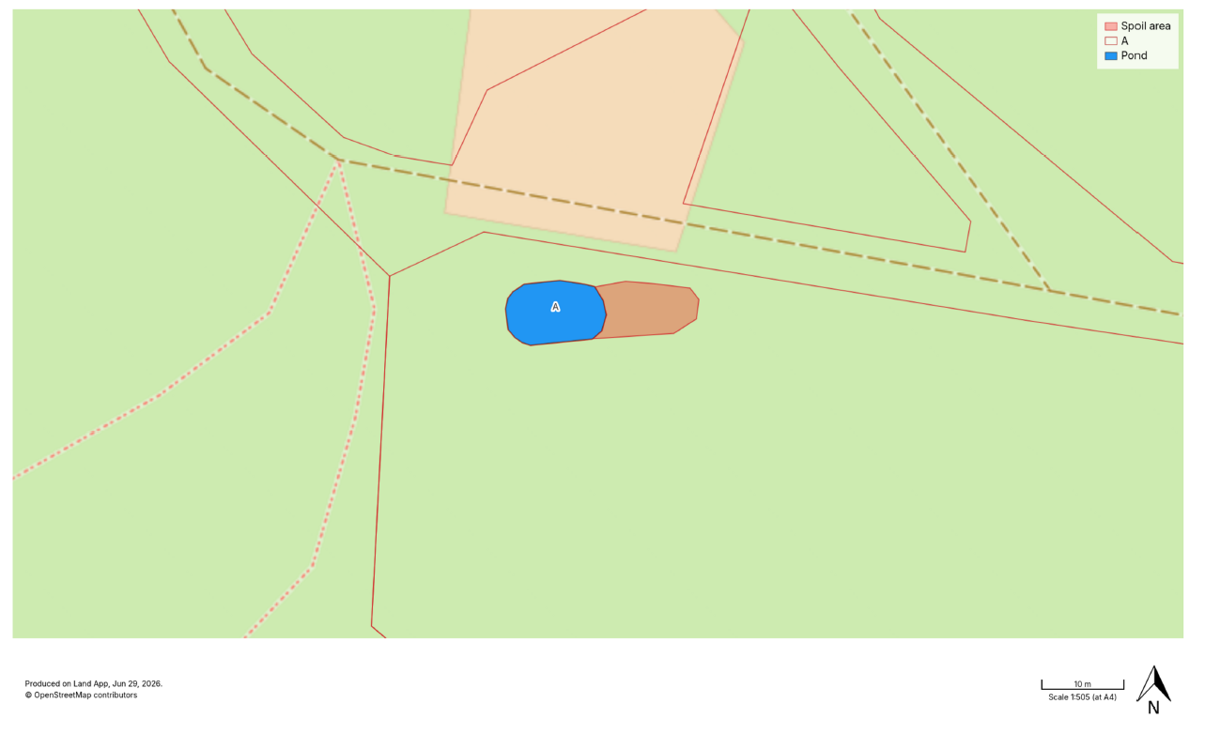

Excavated materials: Pond B

Site B is a level site in a valley bottom, currently modified grassland assessed as poor condition. There are no statutory designations and it is outside of the County Wildlife site. The excavated spoil will be used to level the pond and then spread in the area indicated on the map below.

Figure 2: spoil area pond B

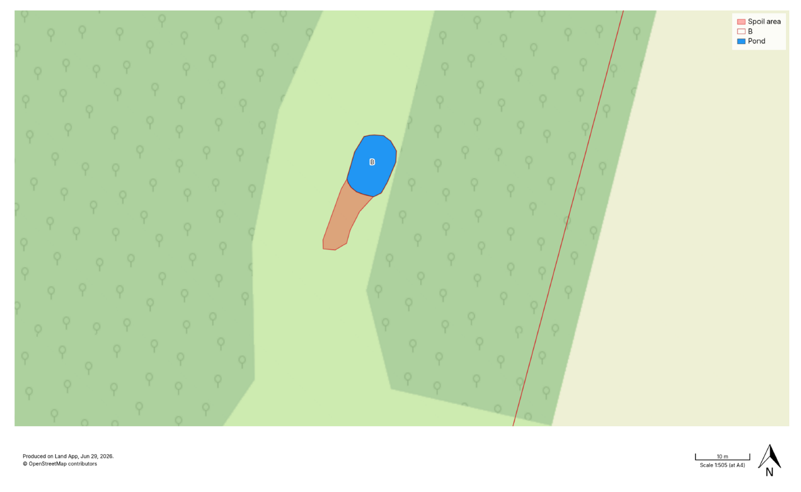

Mitigation for ground nesting birds

The sites will be surveyed by a qualified ornithologist immediately prior to works being undertaken to ensure no ground nesting birds are present or will be negatively impacted by the works.

