

SOUTH WRAXALL
South Wraxall Manor

Historical Analysis of the Outbuildings
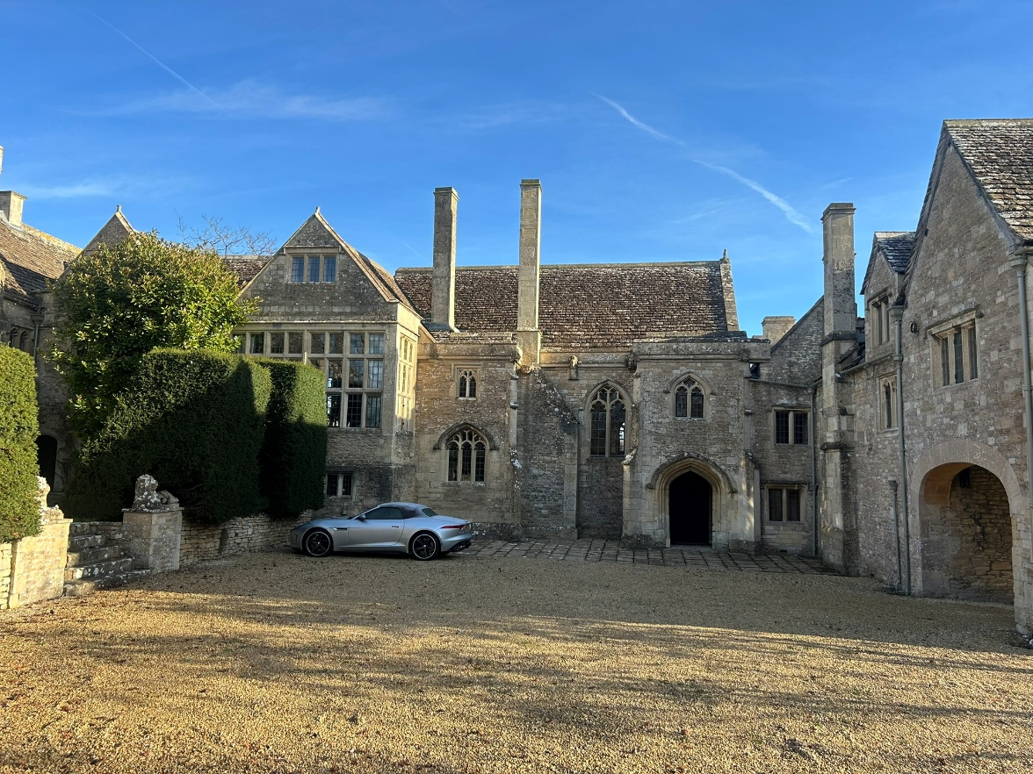

Project No 1084
December 2025
Rev -



CONTENTS

- Introduction

- Current Listing

- Historical Maps

- The Pavilion

- The Stables

- The Tack Room

- The Butler’s Cottage

- The Workshop

- INTRODUCTION

  - South Wraxall Manor is situated to the North of South Wraxall village on the southern edge of the Cotswold Hills, in Wiltshire. The estate is Grade I listed and the listing description is included in section 2 below. The house is also within the Lower & South Wraxall Conservation Area. The estate comprises 2 groups of buildings: the main house, and the outbuildings, these two groups are approximately 25m apart. The estate was in the ownership of the Long family since at least 1542 to 1814, it was then inherited by a different branch of the Long family, the Rood Ashtons until it was sold in 1999. The continuity of ownership had contributed to the survival of the historic fabric while the untroubled history also accounts for the lack of primary records from the house's history.

  - The main house (described in detail in the listing description included below) contains exemplars of Medieval, Elizabethan and Jacobean work and has been the subject of academic study since the 16th century, with a number of published histories in the 19th and 20th centuries. The development is generally described as having commenced in the late 14th or early 15th century, enlarged and added to considerably in the 16th C joined into a single structure in the 18th C prior to a prolonged period of abandonment, with significant repair and alteration in the late 19th and early 20th C. Neither of the significant 19th century studies of the buildings by Ponting and Walker discuss the garden pavilion, butlers cottage or stables.

  - The lack of primary records for the history of the house make the outbuilding difficult to date and some of the history is inferred from other documents. That said a very good archaeological report was produced on the house in 2002, there is a copy in the local records office in Wiltshire and much of the development described below is based on their findings.

- CURRENT LISTING

Heritage Category:
Listed Building
Grade:
I
List Entry Number:
1021853
Date first listed:
13-Nov-1962
List Entry Name:
SOUTH WRAXALL MANOR, WITH GARDEN WALL TO SOUTH
Statutory Address 1:
SOUTH WRAXALL MANOR, WITH GARDEN WALL TO SOUTH

Location
Statutory Address:
SOUTH WRAXALL MANOR, WITH GARDEN WALL TO SOUTH
The building or site itself may lie within the boundary of more than one authority.
District:
Wiltshire (Unitary Authority)
Parish:
South Wraxall
National Grid Reference:
ST 83312 65463
Details
ST 86 NW SOUTH WRAXALL
2/170 South Wraxall Manor, with garden wall to south 13-11-62
GV I
Manor house. Early C15 for Long family, altered late C16 and C17, c1700 and restored c1900 by A.C. Martin for E. Richardson Cox. Random rubble stone, stone slate roof with stone stacks. Plan: 4- bay hall with screens passage on east side of courtyard, services now to north range with gatehouse to south. Single-storey with attic, 8-window hall range has 2-storey porch to right with moulded Tudor-arched opening with hoodmould, diagonal buttresses, 2-light Perpendicular window over and to left side, cornice with gargoyles to parapet, hall to left has 2-light Perpendicular window, large gabled stack, square bay with 3-light Perpendicular window to ground floor and square-headed window with tracery over, moulded cornice with gargoyles to parapet, late C16 gabled addition to left has two mullioned casements to cellar, large 8-light mullioned and transomed window to main floor and 3-light mullioned casement to attic, another gabled bay to left has 4-light mullioned and transomed window with 3-light attic mullioned casement, saddleback coping. To right of hall is gable end of former services with C17 mullioned casements, gatehouse range projecting to right has lateral stack, 2-light mullioned casements with cusped arched lights and one 3-light mullioned casement to first floor, early C20 elliptical archway to right, gabled dormer with 2-light mullioned casement. Throughway below gatehouse has blocked doorway and winding stairs to upper floor, south side of this range has C20 double panelled doors to gabled gatehouse, hoodmould with lozenge terminals over elliptical archway, C15 oriel window with cusped lights over, diagonal buttresses, projection on east side for stairs, early C20 square bay with mullioned casement to right. South side of former service range has buttresses with offsets, C17 three-light and 2-light mullioned casements, one pointed window with Y tracery to ground floor, rear has early C20 added 2-storey corridor with formerly open 4-bay loggia to ground floor, studded timber-framed first floor with Ionic pilasters, wood mullioned casements. Rear of hall range has square stair turret with 4-light cross window with cusped arched lights, 3-light Perpendicular window either side and square light to first floor, wing projecting to right has 12-pane sashes in moulded architraves, round-arched half-glazed door to north side and large 8-light mullioned and transomed window with hipped roof to right (lighting rear of dining room). North range has Tudor-arched doorway left of centre, blocked pointed doorway and planked door to right, lateral stack, 2-light mullioned casements with cusped arched lights and hoodmoulds, projecting stair turret to left. Left return of north range has 3-light mullioned casements with arched lights to ground and first floors, rear has C20 door to right part, now offices, 2- light mullioned casement with cusped lights to left, first floor has inserted C20 steel casement and mullioned casement, early C20 parallel kitchen range attached to left has hipped roof and mullioned casements, range continues to left with closed 2-bay loggia and 4-light mullioned and transomed casement to first floor over and to east gable end, gable end has open 4-bay loggia on Tuscan columns to ground floor. Interior: Hall has" original 4-bay open roof; arch-braced collar trusses, on carved wooden animal corbels, cusped panels between principals and purlins, stone fireplace dated 1598 with strapwork overmantel, square surround, late C16 richly-carved wooden screen at lower end has arched openings, Ionic pilasters, gallery over. Late C16 passage and stair turret to rear of hall; Perpendicular windows and buttresses retained on former external wall, C18 stairs with turned balusters and ramped handrail. Dining room at upper end of hall, former solar, added by Walter Long late C16; very fine barrel-vaulted plaster ceiling with thin ribs and pendants, extravagantly carved stone fireplace with caryatids and figures in niches with square surround, full wainscot panelling with pilasters, unusual stone canted projection opposite fireplace with three shell-headed niches. North east wing drawing room has fine late C16 stone fireplace with Ionic columns, two strapwork cartouches to overmantel with Latin inscriptions, full fielded panelling, shell-headed niche to right of fireplace, bedroom over has large stone fireplace with two tiers of coupled columns, overmantel with cartouches. South east wing has 7-bay arch-braced collar truss roof with wind braced purlins, so-called Raleigh Room on first floor with linenfold panelling and Tudor-arched fireplace, stairs to this wing from screens passage are C18 with three turned or barley-twist balusters per tread, moulded ramped handrail. Good joinery throughout; C16 moulded doorcases and wainscot doors, some C18 panelled doors in moulded architraves. Rubble stone walls with saddleback coping and two moulded Tudor-arched doorways, enclosing west side of courtyard and continuing to gate piers at south entrance (q,v.). Robert Long owned the Manor here in 1433; this building may be a C15 rebuilding of the Manor on a new site, Manor Farmhouse (q.v.) possibly representing the C14 manor house. Robert Long was M.P. for Wiltshire in mid C15, the Long family held the property until early C20. (Country Life, March 26, 1904; January 14, 1905; N. Pevsner, The Buildings of England, Wiltshire, 1975)
Listing NGR: ST8331265463

Legacy
The contents of this record have been generated from a legacy data system.
Legacy System number:
314616
Legacy System:
LBS

Sources
Books and journals
Pevsner, N, The Buildings of England: Wiltshire, (1975)
'Country Life' in 14 January, (1905)
'Country Life' in 26 March, (1904)

- HISTORIC MAPS

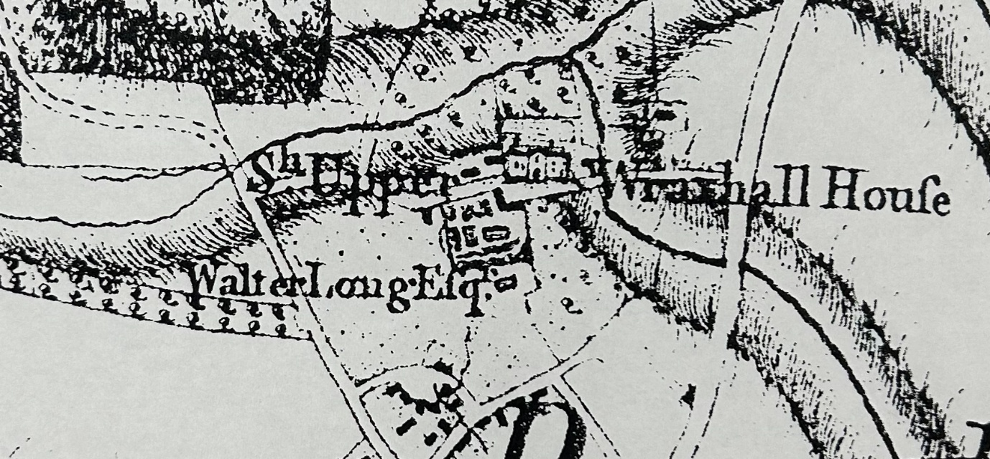
Early Andrew’s & Dury’s Maps of Wiltshire C.1773

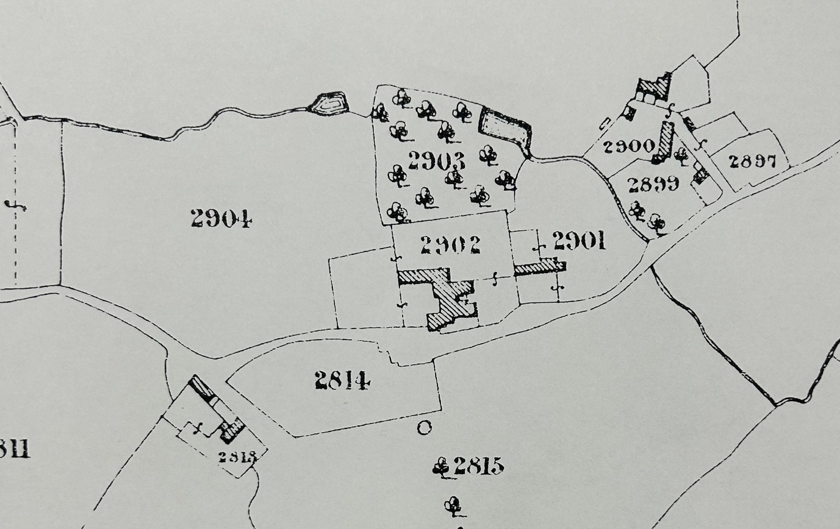
Tithe Map of 1841

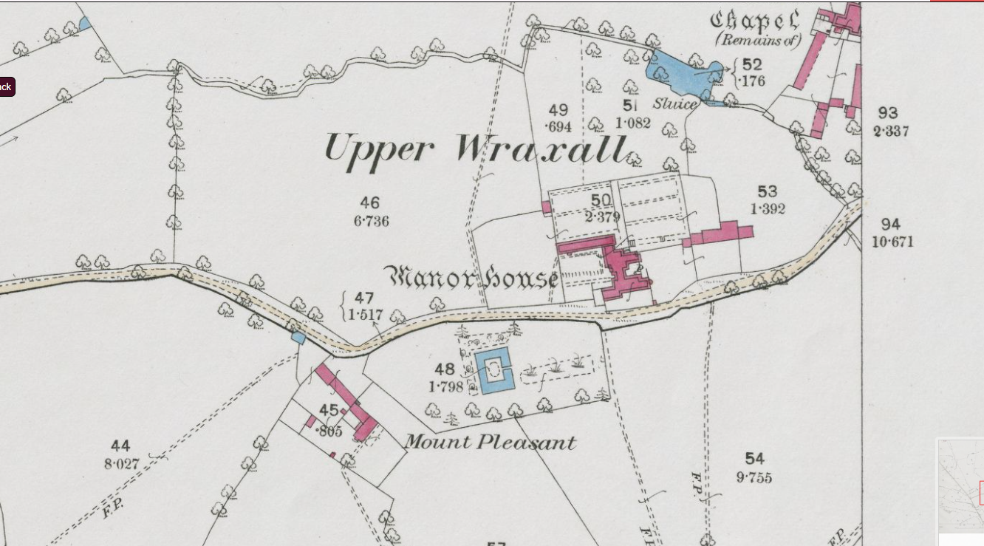

First edition of the OS 1886

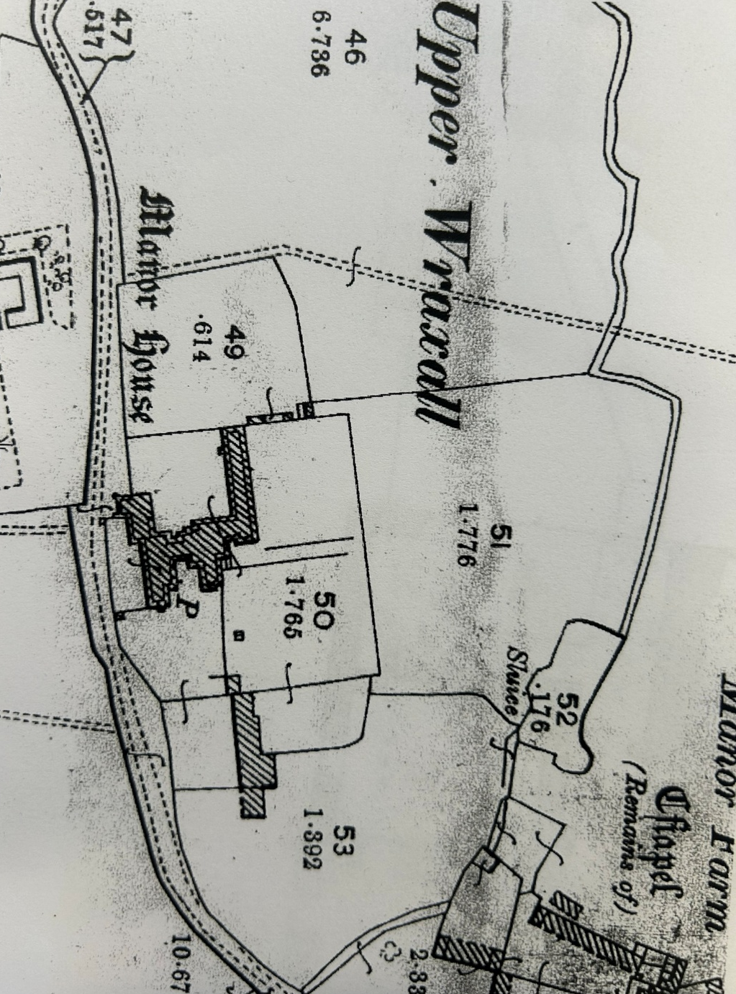
Second Edition OS 1901

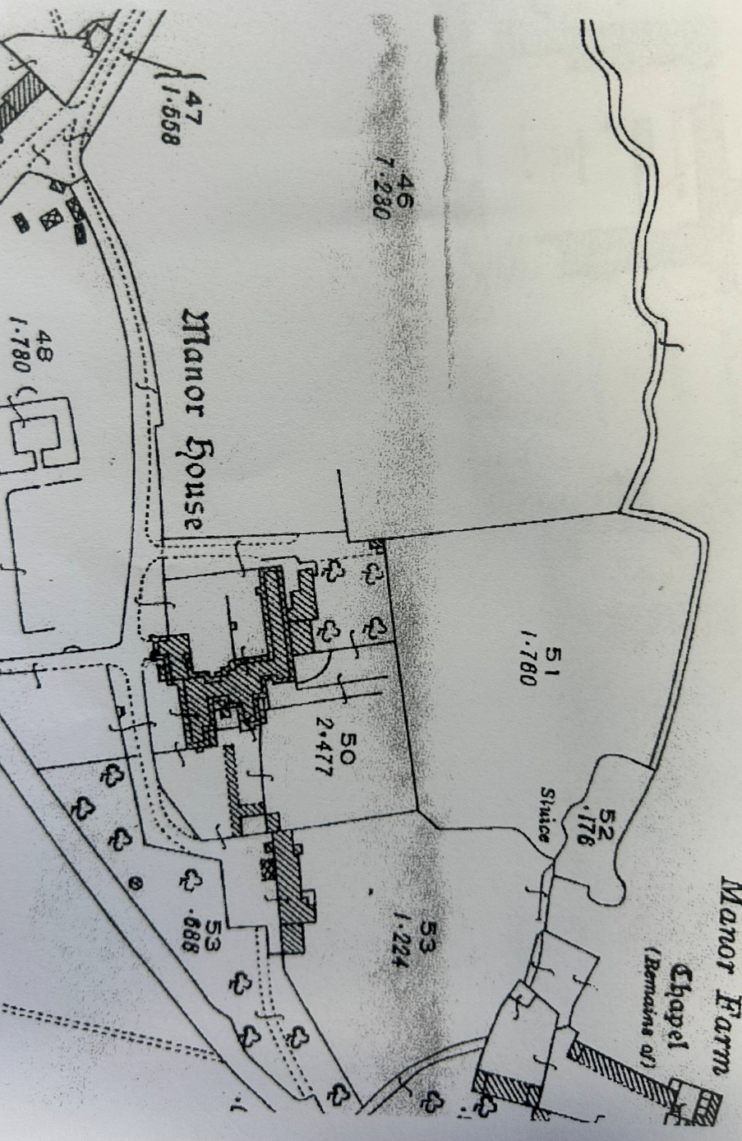
Third Edition OS 1924 – West & South walls of Workshop indicated

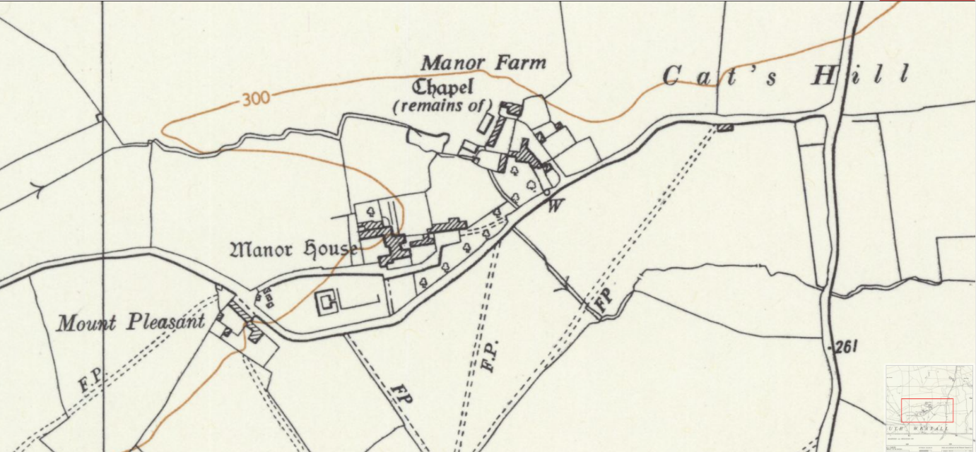
OS 1961

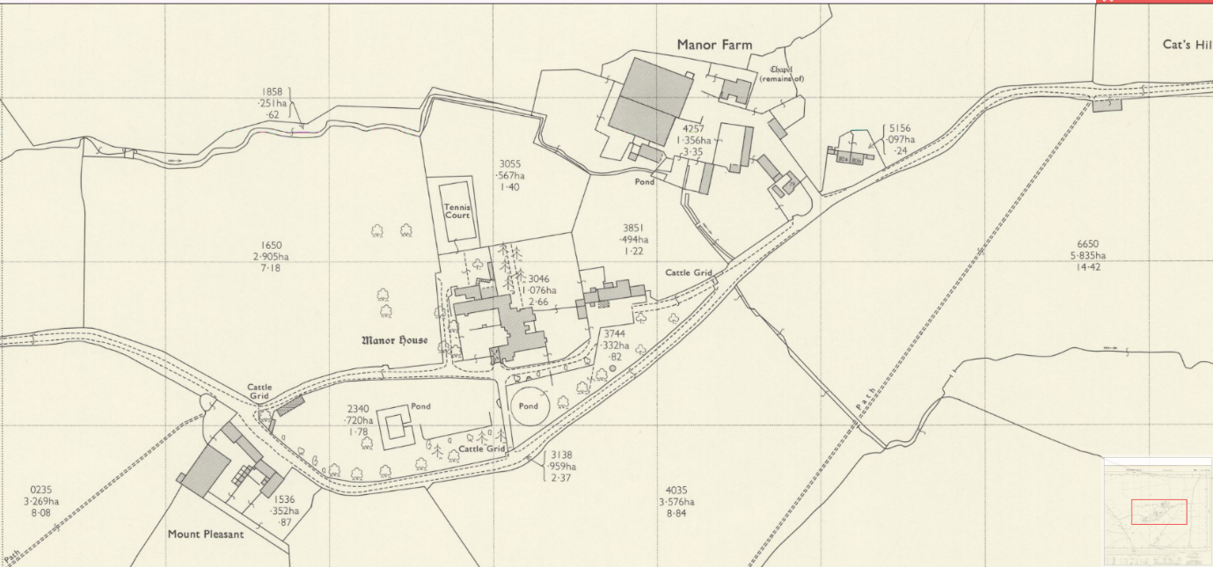
OS 1972 – Workshop appears

- THE PAVILION

The origin of the Pavilion is uncertain. It is 18th-century in style and is partially cut into by the Butler’s Cottage, the top floor of which appears in the background of Buckler’s 1808 image. However, the Pavilion is absent from the Tithe Map of 1841. The early Andrew’s and Dury’s maps of Wiltshire are not sufficiently detailed to show it. The 2002 archaeological report suggests that the Pavilion was built between 1600 and 1700, although this is described as “inferred.” The evidence would suggest that the omission of thepavilion from the 1841tithe map is likely an error.

The Pavilion is built of rubble-stone walling with large quoins aligned with the masonry, and it has a plain tile roof with stone dressings around the external doorway and window. Its floor has either been lowered to align with the workshop or has been underpinned with blockwork. More investigation will be required to ascertain the reason for the blockwork before it can be removed or altered. The north doorway appears to have been altered, or it may have shifted due to the loss of mortar, as there are large gaps surrounding the stones. It is inferred that the south doorway was opened when the workshop was built. The north door is simply a fixed panel, is in poor condition, and does not appear to have any intrinsic historic value. The west window is a blind window, constructed with poor-quality joinery and fixed in place with nails.

The Pavilion may previously have been rendered or shelter-coated, as there is some evidence of mortar or render beneath the eaves. The rainwater goods have been updated fairly recently, in line with the rest of the outbuildings, with driven-in brackets and painted cast iron guttering.

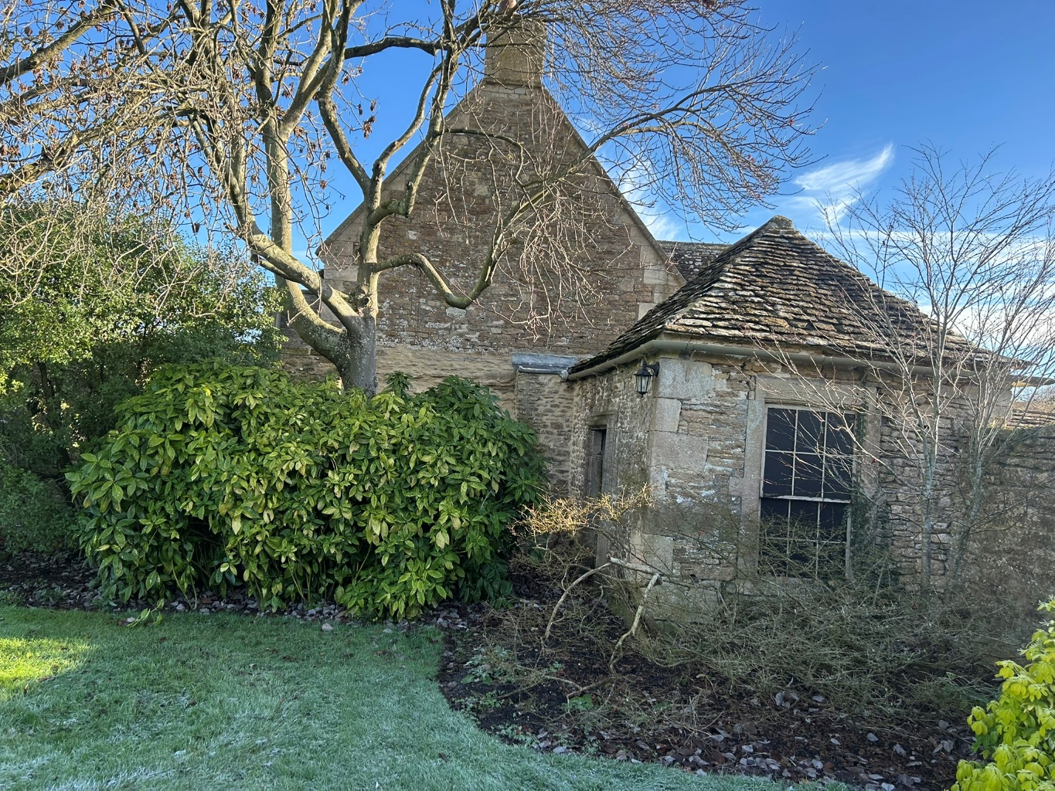
Pavillion and the Gable end of the Butler’s Cottage.

- THE STABLES

The stables and Butler’s Cottage block appear to have been part of a rental agreement in 1656. The stables were significantly renovated and altered in 1860, when the roof was entirely rebuilt and a gable with an integrated extension was added to the north. It appears the entire south elevation may have been reordered and rebuilt during these modifications. The canopy over the carriage doors is 20th century.

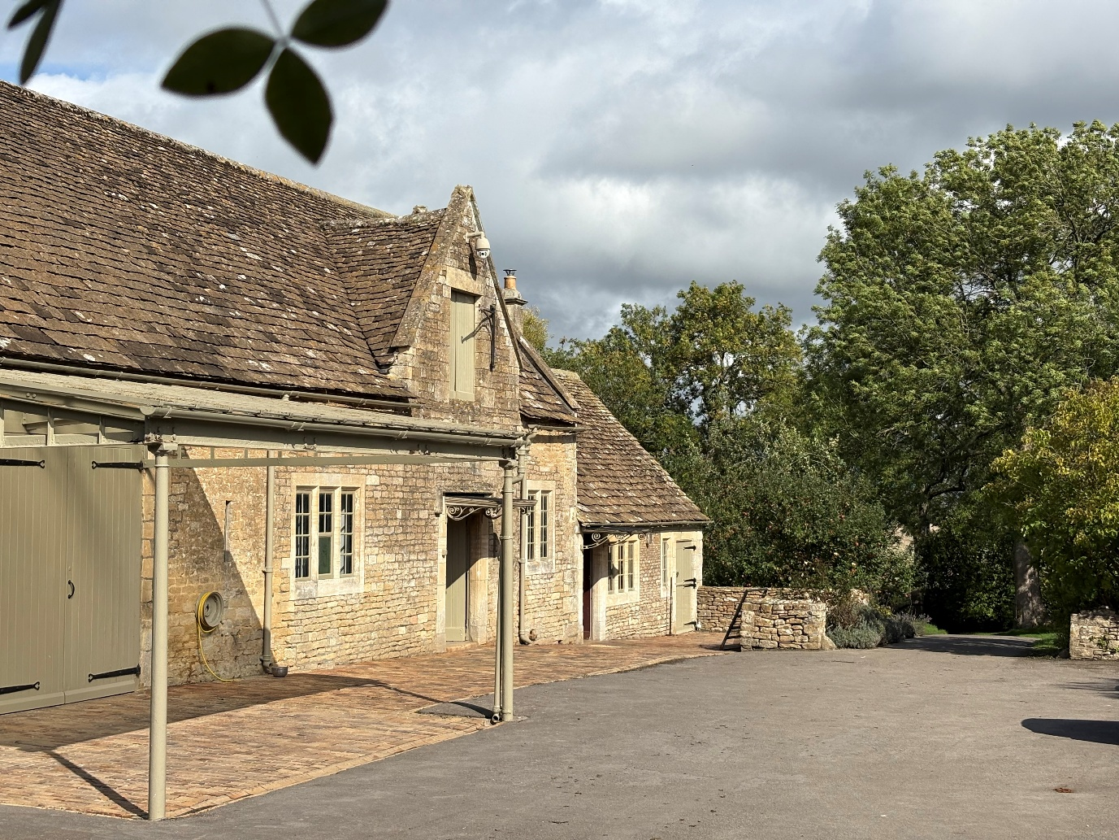
The stables including the 19th-century gable and the 20th-century canopy.

- THE TACK ROOM

The tack room appears to be contemporaneous with the adjacent stables, although it does not appear to have been reroofed in 1860. The 2002 archaeological report suggests that the south elevation was rebuilt at the same time as the stables in 1860.

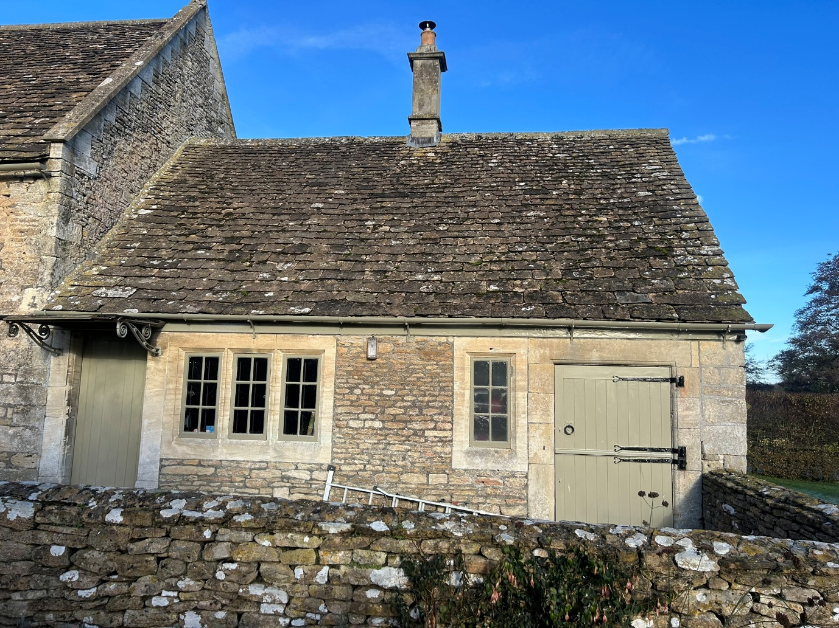
The Tack Room - currently a gardener’s lodge.

- THE BUTLER’S COTTAGE

The first floor of the Butler’s Cottage is visible in the background of one of Buckler’s images from 1808, although without the stair turret. The cottage appears to be of late-18th- or early-19th-century construction and is later than the adjacent stables and Pavilion. It was extended in the early 20th century with the addition of the south stair turret and the flat-roofed two-storey rear extension, which replaced a single-storey 19th-century lean-to.

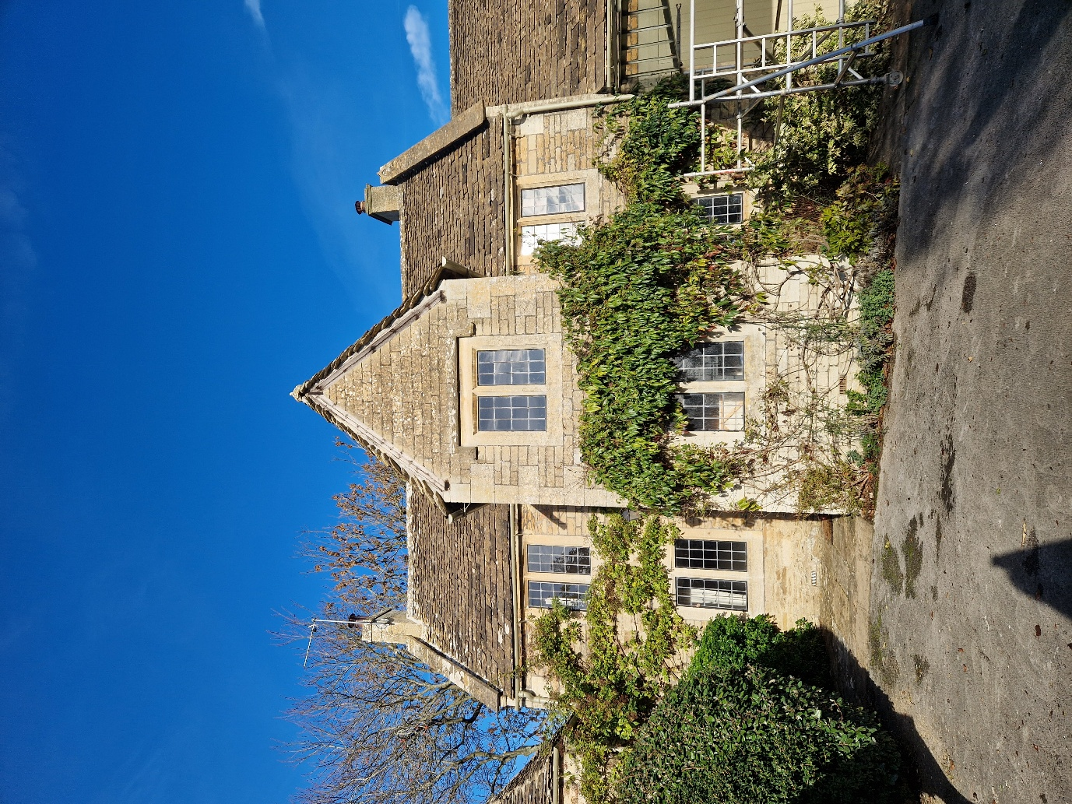
Butler’s Cottage South Elevation, top floor visible in Buckler’s image from 1808

- THE WORKSHOP

The workshop does not appear on maps until 1972, which aligns with its reconstituted-stone tile roof finish. However, the west and south walls may be earlier and appear to form solid boundaries to what seems to have been a mostly open-sided trellised walkway visible on the 1924 maps. Although the block is not filled in on the map, it is outlined, indicating some form of boundary to the east.

The floor level in the workshop appears to have been raised since its original construction, as indicated by the engineering-brick step covering the concrete slab at the threshold of the south door. While the quoins on most of the outbuildings are generally oversized, they appear particularly disproportionate on the workshop. The modest scale of the building relative to the surrounding outbuildings suggests that it could be suitable for future development to sit better in the context. There is no historic value to the fabric of the building.

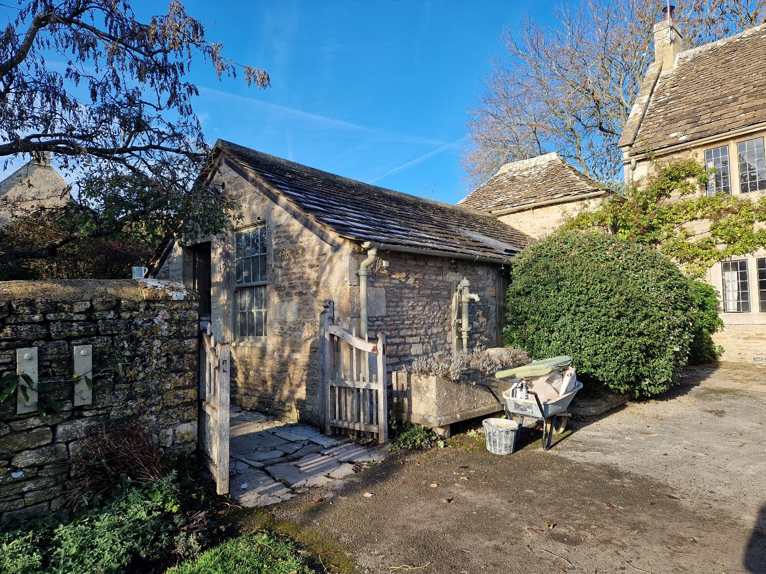
The Workshop with the pavilion and Butler’s Cottage in the background.

