APPLICATION FOR FULL PLANNING PERMISSION
DELEGATED REPORT

APPLICATION REFERENCE: | PL/2026/02642
APPLICATION TYPE: | Full planning permission
SITE ADDRESS: | Green Close, 62 Upper South Wraxall, Bradford on Avon, BA15 2SE
DEVELOPMENT DESCRIPTION: | Demolition and rebuild of existing stables and lean to structures (Barns C and D) and the erection of four timber clad loose boxes and a tack room on a reduced footprint. Current storage buildings F and G are demolished and replaced with Storage building H In total a reduced volume and footprint
RECOMMENDATION: | That Planning Permission be GRANTED

PROPOSAL

The proposal seeks full planning permission for the remodelling of two existing stables and a lean-to structure to create four timber clad loose boxes and the demolition of two store buildings and erection of a single timber clad store building over the footprint of the demolished buildings.

The application was originally submitted as a householder planning application but due to the proposed development relating to equine development was determined to fall within the remit of a full application. The outbuildings lie outside of the defined residential curtilage.

SITE DESCRIPTION/CONTEXT

This application relates to a domestic property known as 62 Upper South Wraxall, a two-storey rural dwelling accessed by a single-track road (a Public Right of Way SWRA5) to the north of the village of Upper South Wraxall, near Bradford on Avon.

The application site is located in the South/Lower South Wraxall Conservation Area and within the West Wiltshire Green Belt and also falls within the recreational impact zone of the Bath and Bradford on Avon Special Area of Conservation for bats and is located within an area that is subject to surface water flooding. The surrounding area is strongly characterised by a rural countryside appearance.

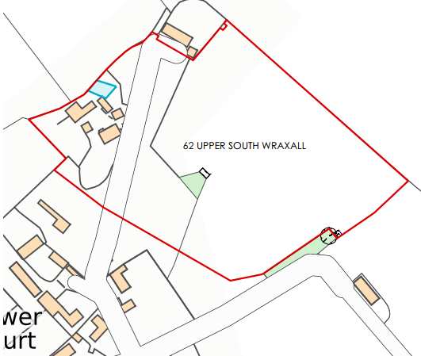

PLANNING HISTORY

Proposal / Summary
PL/2025/06307 - Full planning permission Decision - Approve with Conditions Date: 16/9/2025 – Erection of new field shelter to replace existing
PL/2025/07421 - Householder planning permission Decision - Approve with Conditions Date: 8/12/2025 – Demolition of single storey extension and erection of replacement extension to include first floor in pitched roof gable

RELEVANT POLICIES AND GUIDANCE
Wiltshire Core Strategy:
Core Policy 1 Settlement Strategy
Core Policy 2 Delivery Strategy
Core Policy 7 Bradford on Avon Community Area
Core Policy 50 Biodiversity and Geodiversity
Core Policy 51 Landscape
Core Policy 57 Ensuring High Quality Design and Place Shaping
Core Policy 58 Ensuring the Conservation of the Historic Environment
Core Policy 60 Sustainable Transport
Core Policy 61 Transport & Development
Core Policy 64 Demand Management
Core Policy 67 Flood Risk

Emerging Policy – Wiltshire Local Plan Review
At Full Council on 19 May, the elected members of Wiltshire Council agreed to withdraw the emerging WLP. This WLP has now been withdrawn and has no material weight for the purposes of the application. A new WLP is being prepared and is currently at Regulation 19 stage and therefore carries no weight in this assessment.
.

Wiltshire Design Guide

The National Planning Policy Framework (NPPF)
The Planning Practice Guidance
National Design Guide
Wiltshire Local Transport Plan 4 (LTP4) 2025 -2038
Wiltshire Local Transport Plan 3 2011 – 2026 (March 2015) (including car parking strategy)

CONSULTATION RESPONSES

South Wraxall Parish Council: No objection
Wiltshire Council Ecology – No objection
Wiltshire Council Rights of Way – No response received
Wiltshire Council Conservation – No comment

REPRESENTATIONS
No comments were received.

ASSESSMENT
Section 38(6) of the Planning and Compulsory Purchase Act 2004 states:

"If regard is to be had to the development plan for the purposes of any determination to be made under the planning Acts, the determination must be made in accordance with the plan unless material considerations indicate otherwise."

In accordance with this statutory requirement, this application has been assessed against the relevant policies of the Development Plan, including the adopted Wiltshire Core Strategy (2015) and, where applicable, any made Neighbourhood Plans.

Principle of Development
The local development plan and adopted Wiltshire Core Strategy have no specific policies relevant to equestrian development per se.

Whilst the site is situated in the countryside the proposals involve an equestrian use and
associated stables in an existing paddock which has an established use for equestrian purposes. The use is an appropriate one for such a location as it can only very rarely, be accommodated within an urban/built up area. The principle of the proposed equestrian use and development on this site is therefore accepted.

This in principle acceptability is however subject to the proposed stables being used for private
purposes only and that they are not to be used in any commercial capacity, as that would raise
other material planning considerations in terms of highway safety and neighbouring amenities
as well as raise concerns regarding the sustainability of the site for such a commercial business. It is therefore considered to be appropriate to impose a condition on any decision restricting the use to private use only. Accordingly, the proposal is acceptable in principle subject to the following considerations.

Impact on the Green Belt
The 2024 NPPF regards the construction of new buildings in the Green Belt as ‘inappropriate development’, unless the proposal falls within the criteria set out in paragraph 154. Within this list of exceptions, Paragraph 154b sets out “the provision of appropriate facilities (in connection with the existing use of land or a change of use), including buildings, for outdoor sport, outdoor recreation, cemeteries and burial grounds and allotments; as long as the facilities preserve the openness of the Green Belt and do not conflict with the purposes of including land within it’

Paragraph 153 of the 2024 NPPF states that “when considering any planning application, local planning authorities should ensure that substantial weight is given to any harm to the Green Belt, including harm to its openness. Inappropriate development is, by definition, harmful to the Green Belt and should not be approved except in very special circumstances. ‘Very special circumstances’ will not exist unless the potential harm to the Green Belt by reason of inappropriateness, and any other harm resulting from the proposal, is clearly outweighed by other considerations”

It has previously been determined within a recent permission (consented PL/2025/07421) that the original volume of the host dwelling sat at 642m3. It was concluded that once that scheme was implemented the green belt volume would increase to 780m3 (21% above the original volumes) which was considered proportionate and acceptable.

This scheme seeks to replace existing built form with outbuildings of a similar footprint, mass and scale. The Planning Statement calculates that the proposal would decrease the existing built form on site by 6.7% and officers broadly agree with this calculation. The proposed decrease in green belt volume would be a benefit of the scheme and officers conclude that the development would preserve the openness of the Green Belt by the reduction of existing built form and improvement of visual amenity on site

Officers have analysed the proposal and the site and have concluded that the proposed development would not result in material harm to the openness of the Green Belt given the proposed development would be of limited development within the confines of the application site. As such, Paragraph 153 of the NPPF would be satisfied, alongside Paragraph 154b, as the facilities would preserve the openness of the Green Belt and would not conflict with the purposes of including land within it, by not materially reducing the open character of the site.

Design and Impact upon the upon the character and context of the area
Core Policy 57 - Ensuring High Quality Design and Place Shaping of the Wiltshire Core Strategy seeks to ensure that all new development is of high design quality, reflecting local context, character, and distinctiveness.

The detached plot consists of the host dwelling and residential curtilage, outside of the curtilage to the north lies a paddock with a number of outbuildings The development would consist of small-scale operational development to create enhanced stabling and barns. The outbuildings would extend over the existing foundations The two small garages (F) and (G) would be removed and a store (H) of a reduced footprint, erected in a similar location, of a reduced footprint, Carport (A) Barns (B) and E) would remain as existing. The stable (D) would be demolished and replaced with new stables over a smaller footprint.

The development would extend over the existing footprint of the arrangement of buildings to the northwest of the host dwelling as illustrated in the plan inserts below. The proposals involve modest alterations to existing agricultural buildings to provide non-commercial stables.

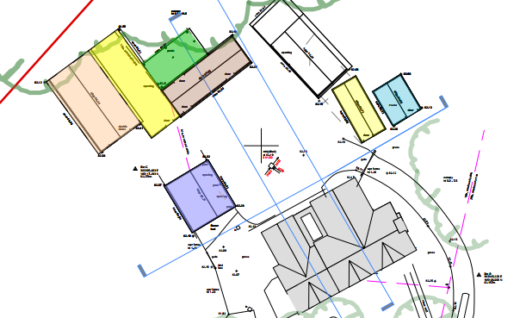
Existing site plan

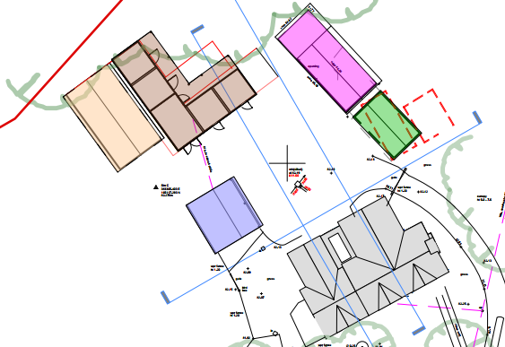
Proposed site plan

The buildings would sit at a maximum height of 4.5m with the retained barn E sitting at a height of 4.7m, the outbuildings would all consist of a traditional pitched roof form, timber board elevations and metal profile roofs. The ground floor plan below illustrates which buildings are being converted and those that are being removed and those being erected. The stables are believed to meet the size requirements of the British Horse Society guidance.
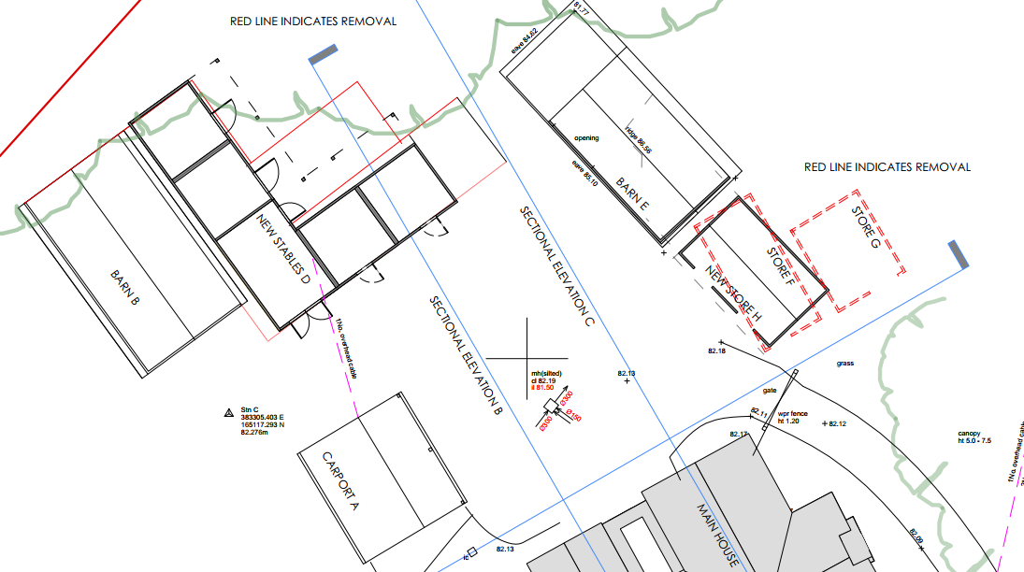

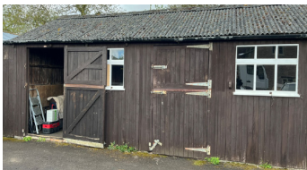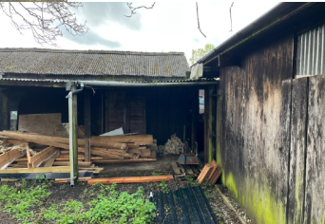
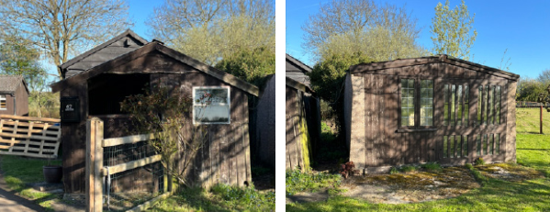

Photos of some of the existing buildings

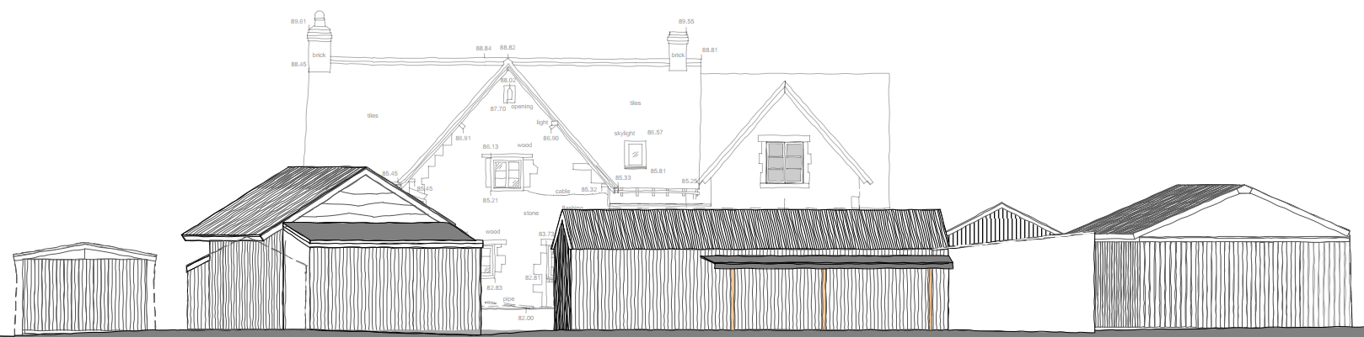
Existing view of outbuildings from the northwest

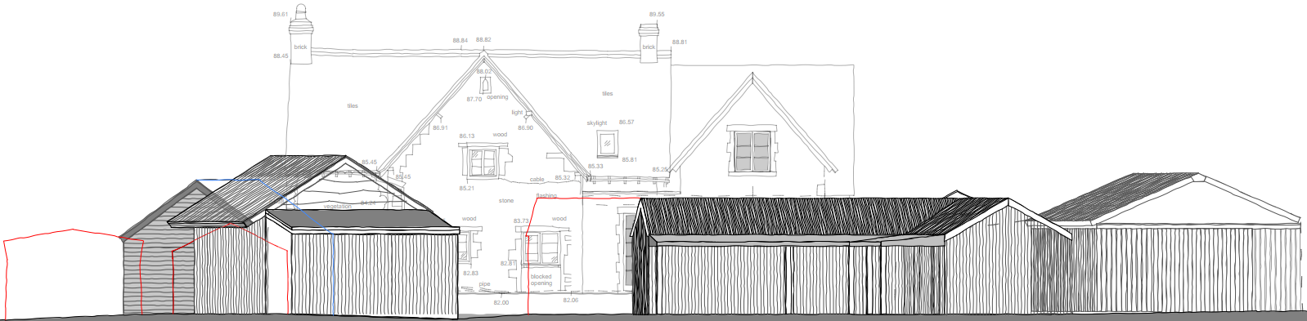
Proposed view of outbuildings from the northwest

The proposal seeks to introduce improved domestic stabling, of a similar mass and scale to existing, set within the confines of the application site largely obscured from view by the host dwelling. Officers consider that the proposed works would by virtue of their height, scale and design constitute acceptable additions within the immediate setting that would appear commensurate to the size of the generous application site.

Having regard to the above, the proposal complies with the design principles set out in Core Policy 57 of the Wiltshire Core Strategy and Appendix D of the Wiltshire Design Guide.

Amenity
Point vii of Core Policy 57 - Ensuring High Quality Design and Place Shaping of the Wiltshire Core Strategy seeks to ensure that developments do not adversely affect neighbouring properties.

The National Planning Policy Framework (NPPF), particularly Paragraph 135(f), stresses that planning decisions should ensure developments provide a high standard of amenity for existing and future users.

The proposed development has been assessed in terms of its potential impact on the residential amenity of neighbouring properties, with particular regard to loss of light, overshadowing, loss of privacy, and overbearing effects.

The host dwelling benefits from a semi-rural detached position with the absence of any immediate neighbours. The proposed works relate to the removal of some outbuildings and some replacement outbuildings, therefore due to the nature of the proposal officers are cognisant that no adverse neighbouring amenity impacts would be introduced.

The applicant has confirmed “the stables are for use only in adverse weather conditions or if they have to be stabled for veterinary reasons. The grazing paddocks are segregated, allowing them to be rotated and rested, meaning all manure currently produced is spread and harrowed in as fertiliser, thus avoiding the need for the use of chemical fertilisers. Any manure produced in the new stables, as and when they are in use, will be dealt with in the same manner.
Any manure collected directly from the stables will be heaped temporarily on the adjoining paddock and then transferred to the main field area by tractor for spreading on a regular basis. The applicant is aware that any temporary storage site must not exceed 12 months and is also aware of the 10m/50m rule with regards to proximity to watercourses”
Therefore, officers raise no concerns in regard to any adverse odour impacts from the storage of manure or soiled bedding.
The proposal therefore accords with Core Policy 57 point vii in respect of safeguarding residential amenity and Appendix D of the Wiltshire Design Guide.

Heritage Impact
From the point of view of the historic environment the main statutory tests are set out within the Planning (Listed Building and Conservation Areas) Act 1990.

Section 72(1) of the Act requires the Council to pay special attention to the desirability of preserving or enhancing the character or appearance of designated Conservation Areas.

The Council’s Core Strategy Policy CP58 ‘Ensuring the conservation of the historic environment’ requires that designated and non-designated heritage assets and their settings will be conserved, and where appropriate enhanced, in a manner appropriate to their significance and encourages proposals which improve the condition of heritage assets at risk.

The Council’s Core Strategy CP 57: Ensuring high quality design requires a high quality of design in all new developments. The policy requires applicants to “demonstrate how the proposal will make a positive contribution to the character of Wiltshire through (amongst other things) responding to the value of the natural and historic environment and being sympathetic to and conserving historic buildings and landscapes. Development is required to respond positively to the existing in terms of building layouts, built form, height, mass, scale, building line, plot size, elevational design, materials, streetscape and rooflines to effectively integrate the building into its setting.

The NPPF outlines government policy for planning. Chapter 16 of the NPPF 'Conserving and enhancing the historic environment' sets out the Government's high-level policies concerning heritage and sustainable development.

As the application site is located within the South Wraxall Conservation Area views into and out of the application site need to be appraised with any potential negative impact of any future development assessed. mindful of Section 72 of the abovementioned Act as well as CP58 of the Wiltshire Core Strategy and the relevant paragraphs of the NPPF.
To the south of the application lies a Grade II listed building, Lower Court Farmhouse, therefore any development has to be appraised in relation to any impact upon the immediate setting of this listed building.
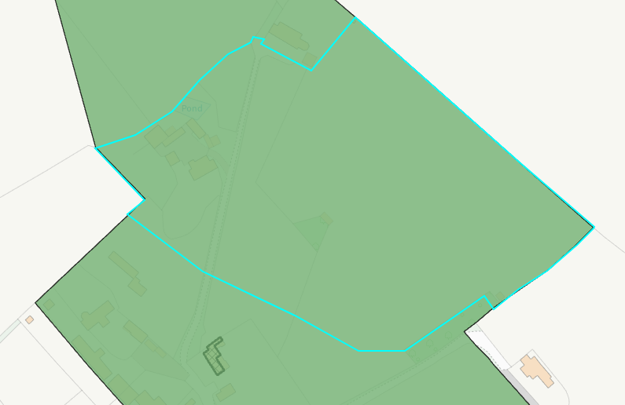
Conservation area (shaded green) and listed buildings (hatched black)

The works would be utilised with materials to match the existing outbuildings (some of which will be retained) with natural wooden elevations which would help them blend into the rural environment. The roofs would consist of dark grey corrugated metal, and the windows would consist of natural timber.

The height and scale of the development is considered to be commensurate to the size of the generous application site, and the use of the natural sustainable materials is supported. Given the limited works proposed, that would be set within the built envelope of the application site, it is considered that there would be nominal harm to the conservation area and the setting of the listed building nearby.

Officers raise no objections as the proposal, by virtue of its scale, would preserve the character and appearance of the conservation area and would not result in harm to the significance of any heritage assets. The development is therefore considered to comply with Core Policy 58 of the Wiltshire Core Strategy and Sections 66 and 72 of the Planning (Listed Buildings and Conservation Areas) Act 1990, as well as the relevant provisions of the NPPF.

Impact on the Public Right of Way
To the north and south of the access road lies a public right of way (SWRA5) as shown on the map insert below, the footpath runs through the north of the village to access a network of foot paths across the surrounding countryside.

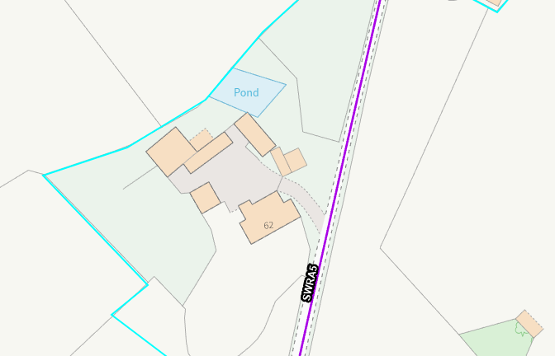

The Public Right of Way would not be altered by any of the works and the development would be set back a distance from the footpath obscured from view by the host dwelling. Therefore, officers do not raise any objections on the basis that there would not be any open views of surrounding countryside that would be obstructed by the proposal. Therefore, the proposed development would not have a detrimental effect to users of the public footpath.

An informative would be added to any permission granted to remind the applicant that it is a criminal offence to obstruct a public right of way under section 137 of the Highways Act 1980

Ecology Impact
Core Policy 50 of the Wiltshire Core Strategy seeks to protect and enhance biodiversity and geodiversity, including through ensuring that development avoids harm to protected species and habitats.

The National Planning Policy Framework (NPPF), in Paragraphs 193, requires that development minimises impacts on and provides net gains for biodiversity, including ensuring mitigation is secured where harm cannot be avoided.

The application was subject to consultation with The Council’s Ecology team who raised no objections in relation to the proposed development subject to the scheme being carried out in strict accordance with the supporting ecological documentation, and conditions would be added to ensure this

“The site comprises stables, outbuildings and a farmhouse. It is proposed to rebuild the stables and to add a tack room and loose boxes. Previously, permission was granted to replace a single storey extension (PL/2025/07421) with a bat box to be installed on a tree to the south, and bird box provided on the northwest elevation of the farmhouse (PL/2025/09892). It is understood that the current proposal does not impact the farmhouse, thereby it should not affect any mitigation agreed in relation to PL/2025/07421.

COMMENTS:
Bath and Bradford-on-Avon Bats Special Area for Conservation (SAC)
The site lies within a core roost buffer, and parcel roost buffer, for Greater Horseshoe bats associated with the Bath and Bradford-on-Avon Bats SAC. It therefore may have the potential to result in significant adverse impact on the special features of that site. Appropriate Assessment (AA) under Section 63 of the Habitats Regulations must be carried out by the relevant Competent Authority (the LPA) to determine the potential significant effects and the suitability of any measures proposed to avoid or mitigate those effects.

A test of likely significance has been carried out by the relevant Competent Authority (Wiltshire Council) as required by Regulation 63 of the Conservation of Habitats and Species Regulations 2017 (as amended). This concluded that given the scale and nature of the currently proposed development which does not propose removal of any bat habitat or Annex II roosts, and with no new lighting proposed, there is no mechanism for adverse impact on the Conservation Objectives of the SAC, and the proposal can be screened out of Appropriate Assessment.

Protected species
The farmhouse is a confirmed common pipistrelle roost (with a maximum count of 1 individual recorded). However, this building will not be affected by the current proposal. The outbuildings to be impacted were also assessed at the time of the original survey (September 2025) and found to possess limited potential for use by roosting bats, with no evidence of roosting bats observed. The applicant should note that under the Conservation of Habitats and Species Regulations 2017 (as amended), it is an offence to harm or disturb bats or damage or destroy their roosts. In the unlikely event that bats are found, works should cease and advice from a professional ecologist must be sought.

The bat survey letter recommends a number of precautionary measures to ensure the risk posed to bats, great crested newts and nesting birds remains minimal. These should be adhered to and secured via condition.

In line with NPPF and with CP50, applications that do not fall into the category where Biodiversity Net Gain is required must still ensure that no net loss of functional habitat for the benefit of wildlife in the local area will occur as a result of the proposed development. In addition, gains for biodiversity, relevant to local habitats and wildlife populations, should form part of the proposed development. As such, biodiversity enhancements, such as opportunities for nesting birds or roosting bats on or around the new buildings, should be secured via condition.

Biodiversity Net Gain
From 12 February 2024 Biodiversity Net Gain (BNG) became mandatory under Schedule 7A of the Town and Country Planning Act 1990 (as inserted by Schedule 14 of the Environment Act 2021).

It is noted that the applicant is seeking to apply an exemption, but it is not clear which. In any case, the plans demonstrated that the proposed building footprints are less than the existing, and that there will be no encroachment into the surrounding habitats. It is therefore considered that the development meets the following criteria and is therefore below the de minimis threshold, meaning the development:

*does not impact an onsite priority habitat (a habitat specified in a list published under
section 41 of the Natural Environment and Rural Communities Act 2006); and

* impacts less than 25 square metres of onsite habitat that has biodiversity value
greater than zero and less than 5 metres in length of onsite linear habitat (as defined
in the statutory metric).

Developments meeting these criteria may apply the de minimis exemption”

Given the proposal seeks to reduce the built form on site, and new development would extend over the footprint of existing built form, with limited disruption to any biodiversity with no net loss identified, no concerns are raised in relation to any adverse ecological impacts to be introduced by the proposed scheme. The proposal therefore meets the requirements contained in policy CP50 of the Wiltshire Core Strategy and the relevant provisions of the NPPF.

Drainage and Flood Risk
Core Policy 67 of the Wiltshire Core Strategy and paragraph 181 of the NPPF requires that all new development avoids increasing flood risk on-site or elsewhere and, where appropriate, incorporates sustainable drainage measures.

Development must also comply with national policy on flood risk management and drainage design. Paragraph 176 (via footnote 62) of the NPPF states that householder development should not be subject to the sequential test, nor the exception test.

The application site lies within flood zone 1 so does not trigger a consultation with the Environment Agency, however the area where the proposed development lies sits within an area with a risk of surface water flooding. Therefore, officers need to appraise the development to ensure the development would not increase flooding from surface water.
The proposal relates to limited development and would involve the removal of two outbuildings and the erection of a replacement building, over the existing foundations. Officers consider that the proposal would relate to limited development and the vulnerability of use is not increasing.
The applicant has submitted plans illustrating the existing and proposed surface water drainage systems for the site,
With evidence of surface waterflooding on site and given the nature of the use, the stabling of animals, with associated mucking out and use of water systems within the site, officers requested additional information in relation to how the proposal would be adequately drained. The applicant has submitted plans illustrating the proposed surface water drainage systems for the site, and these are deemed acceptable, a condition would be added to ensure that this would be adhered to.

Officers are satisfied that the works to be undertaken would not exacerbate flood risk, and the development would not be at risk from flooding as outlined in Paragraphs 170 and 181 of the NPPF 2024.The proposal therefore complies with Core Policy 67 of the Wiltshire Core Strategy ensuring that flood risk is not increased and that surface water drainage is appropriately managed.

CONCLUSION
In favour of the proposal, significant weight is afforded to the replacement of aging and dilapidated structures with a more visually coherent development, the reduction in overall built form within the Green Belt, the enhancement of private equestrian facilities, and the absence of any identified harm to heritage assets, ecology, residential amenity, flood risk or the wider countryside. No material planning harms have been identified that would outweigh these benefits

The proposal is therefore considered to comply with the relevant policies of the Wiltshire Core Strategy, the Wiltshire Local Plan, and the National Planning Policy Framework. As such, the application is recommended for approval, subject to the conditions set out below.

RECOMMENDATION: That Planning Permission be GRANTED subject to conditions.

Conditions
1.The development hereby permitted shall be begun before the expiration of three years from the date of this permission.
REASON: To comply with the provisions of Section 91 of the Town and Country Planning Act 1990 as amended by the Planning and Compulsory Purchase Act 2004.

2. The development hereby permitted shall be carried out in accordance with the following approved plans and documents:
Location & Site Plan DWG No 868 S_WOCP 100 - Received 08.05.2026
Location and Proposed Block Plan DWG No 868 S_WOCP 100 - Received 23.04.2026
Existing Elevations - 1 DWG No 868 S_WOCP 02 - Received 08.05.2026
Existing Elevations - 2 DWG No 868 S_WOCP 03 - Received 08.05.2026
Existing Block Plan DWG No 868 S_WOCP 04 - Received 23.04.2026
Existing Stables Site Plan DWG No 868 S_WOCP 04 - Received 08.05.2026
Existing Stable Floor Plans DWG No 868 S_WOCP 05 - Received 08.05.2026
Existing and Proposed Floor Plans of Stores F and G DWG No 868 S_WOCP 05.1 - Received 05.05.2026
Existing and Proposed Floor Plans of Stables C and D DWG No 868 S_WOCP 05.2 - Received 05.05.2026
Existing and Proposed Floor Plans of Stables F G and H DWG No 868 S_WOCP 05.1 - Received 05.05.2026
Existing Elevations (Carport, A, Sheds B, C D, E, F and G) DWG No 868 S_WOCP 02 - Received 23.04.2026
Existing and Proposed Elevations (C, D, E, F AND H) DWG No 868S_P_WOCP 03 - Received 23.04.2026
Proposed Elevations 1 - Barns C D and H - Northeast Views DWG No 868 P_WOCP 20 - Received 08.05.2026
Existing and Proposed Elevations 1 Barns - B, E, and Existing Carport DWG No 868 P_WOCP 20 - Received 23.04.2026
Proposed Elevations Barns C D and H - Northwest Views DWG No 868 P_WOCP 21 - Received 08.05.2026
Proposed Floor Plans DWG No 868 P-WOCP 40 - Received 23.04.2026
Existing and Proposed Block Plan DWG No 868 P_WOCP 50 - Received 23.04.2026
Volume Study Plan DWG No 868 P_WOCP 50 - Received 08.05.2026

REASON: For the avoidance of doubt and in the interests of proper planning.

3.The development will be carried out in strict accordance with the following documents:

• Mitigation measures detailed in ‘Bat Survey, Avondale Ecology, September 2025’

REASON: For the avoidance of doubt and for the protection, mitigation and enhancement of biodiversity.

4.Prior to the commencement of any works, including vegetation removal and demolition, details of the number, design and locations of ecological enhancements – including the type and locations of bat roosting opportunities – shall be submitted to the local authority for approval. The approved details shall be implemented before occupation of the final works.

REASON: To provide mitigation/enhancement for biodiversity.

5. The development hereby approved shall be carried out in strict accordance with the submitted Surface Water Strategy Proposal (DWG No 868 P_301 - submitted 24.07.2026). The development shall not be first brought into use until surface water drainage has been implemented in accordance with the approved scheme.
REASON: To ensure that the development can be adequately drained.

Informatives
Artificial Lighting
The habitat within the proposed development site and the surrounding area is suitable for roosting, foraging and commuting bats. An increase in artificial lux levels can deter bats which could result in roost abandonment and/or the severance of key foraging areas. This will likely result in a significant negative impact upon the health of bat populations across the region. Artificial light at night can have a substantial adverse effect on biodiversity. Any new lighting should be for the purposes for safe access and security and be in accordance with the appropriate Environmental Zone standards set out by the Institute of Lighting Engineers in their publication GN01:2021, ‘Guidance for the Reduction of Obtrusive Light’ (ILP, 2021), and Guidance note GN08-18 “Bats and artificial lighting in the UK”, issued by the Bat Conservation Trust and Institution of Lighting Professionals.

Protected Species
The applicant should note that under the terms of the Wildlife and Countryside Act (1981) and the Conservation of Habitats and Species Regulations 2017 (as amended) it is an offence to disturb or harm any protected species including for example, breeding birds and bats. The protection offered to some species such as bats, extends beyond the individual animals to the places they use for shelter or resting. Please note that this consent does not override the statutory protection afforded to any such species. In the event that your proposals could potentially affect a protected species you should seek the advice of a suitably qualified and experienced ecologist and consider the need for a licence from Natural England prior to commencing works. Please see Natural England’s website for further information on protected species.

Public Right of Way
The applicant should note that it is a criminal offence to obstruct a public right of way under section 137 of the Highways Act 1980 and therefore no materials, plant, temporary structures or excavations of any kind should be deposited / undertaken which obstruct or adversely affect the public right of way SWRA5 whilst development takes place, without prior consultation with, and the further permission of, the highways authority at Wiltshire Council.

Any damage caused to the surface of the right of way SWRA5 caused during construction must be repaired to its predevelopment condition. It is an offence under section 131A of the Highways Act 1980 to disturb the surface of a public right of way without lawful authority to do so. The Highway Authority have the power to take enforcement action as necessary

