Front Aspect from public road

The old cottage is on the left
The new build part of the house is wood cladded and is the new-ish extension to the cottage
The EV Charger will be on the right hand side, hidden in the recess (see next annotated image)
EV will be parked on the right hand side and parallel to the house.
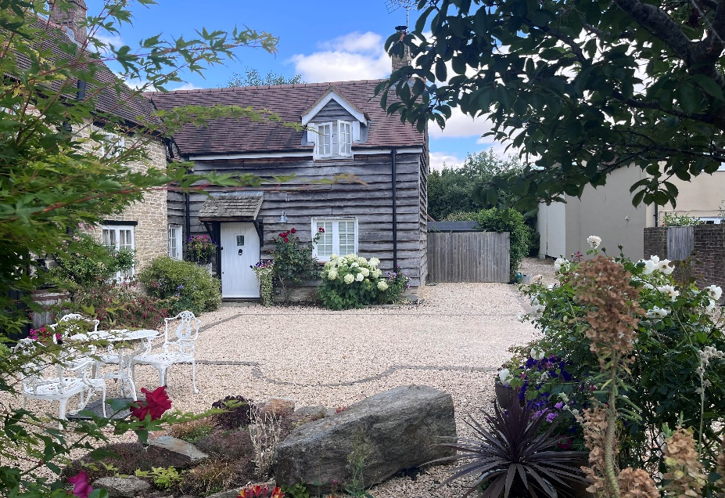

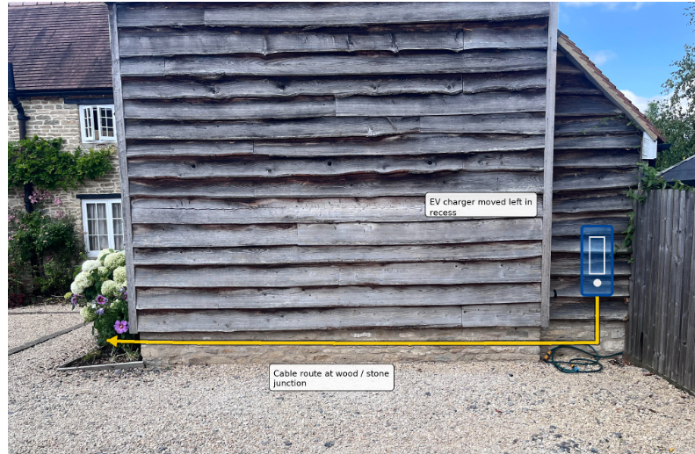
The EV Charging unit will be installed on the right hand side, in the recessed area, that is not visible from the front of the house / public road
The cable will be hidden in the cavity between the wood and the stone foundation of the hous and won’t be visible from the side , nor from the front of the house.

The cable continues around the corner and will follow the cladding line. It will be hidden behind the shrubs and will be nestled in the cavity under the lowest piece of cladding.

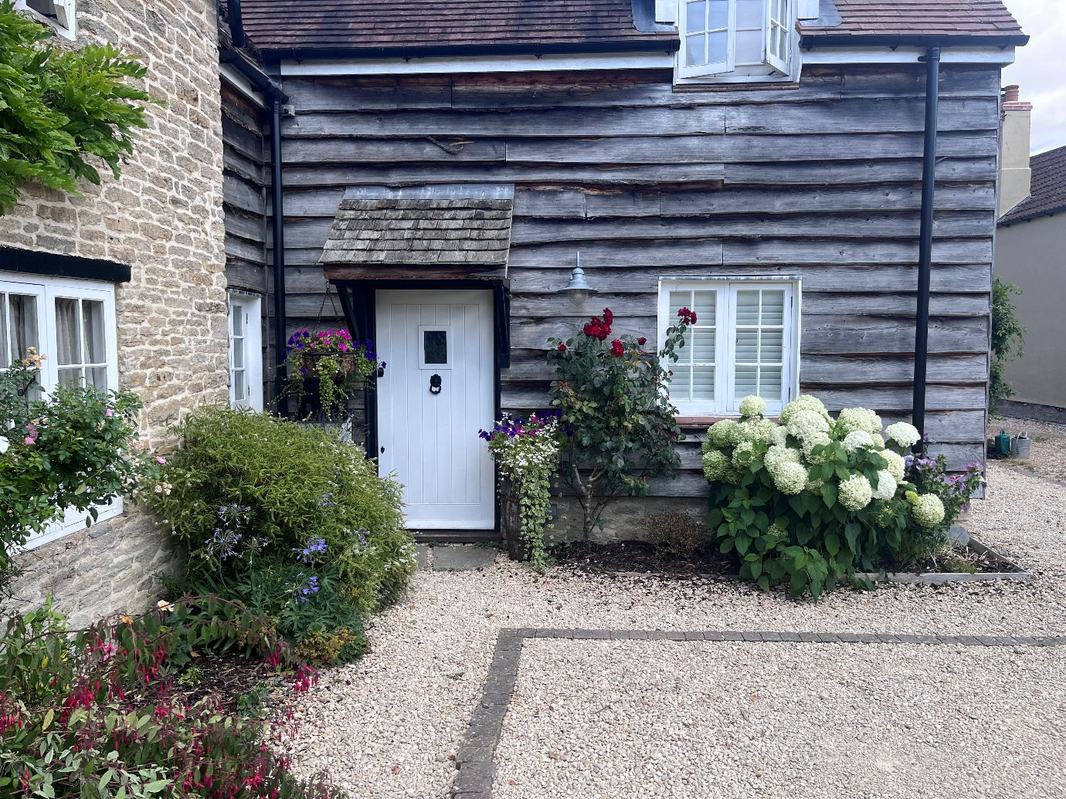

The final destination of the cable will be meeting up with the main electric and gas units. The external electricity unit is the one on the left.
