APPLICATION FOR FULL-PLANNING PERMISSION
CASE OFFICER REPORT

APPLICATION REFERENCE: | PL/2026/02193
APPLICATION TYPE: | Full planning permission
SITE ADDRESS: | Barn at Lifely Farm, West Ashton, Trowbridge, BA14 6AU
DEVELOPMENT DESCRIPTION: | Demolition of an existing agricultural barn (which has prior approval for conversion to two dwellings under Class Q permitted development) and the erection of two detached self-build dwellings.
RECOMMENDATION: | Refuse

SITE DESCRIPTION/CONTEXT

The application site is located in open countryside, outside any defined limits of development and is served by an existing established vehicular access from the A350 Yarnbrook Road. The application site is located to the southwest of West Ashton, which is a settlement identified in CP29 as a ‘Small Village’, which is included in the list of settlements which have had their boundaries removed in Appendix F of the adopted Wiltshire Core Strategy.

The application site is located in the ‘yellow zone’ of the Trowbridge and Westbury Bat Mitigation Strategy (TWBMS), which represents areas at medium risk for habitat loss. The site is also located in various buffer zones associated with the Bat and Bradford on Avon Bat Special Area of Conservation (SAC) and within the Salisbury Plain Special Area of Protection (SPA) 6.4km buffer.

The application site is shown to be at risk of groundwater flooding with reference to the Council’s Strategic Flood Risk Assessment mapping tool, as shown by the extract provided below. The area washed over with orange depicts the area at risk of high groundwater flooding.

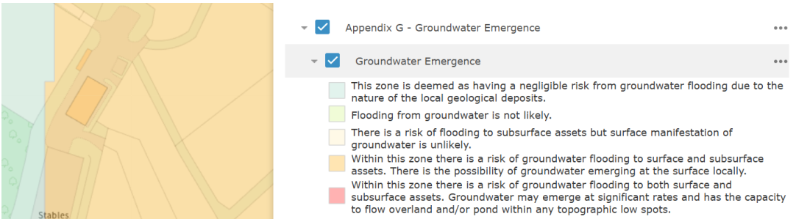

The site is, however, not shown to be at risk for fluvial or surface water flooding, according to the Environment Agency’s Flood Map for Planning.

PROPOSAL

This application follows a successful prior approval application under Class Q of the GPDO that sought to convert the existing barn into two, 3-bed dwellings, each with on-site car parking spaces, a rear garden, shared recycling storage and an EV charging point.

The current application seeks to demolish the existing barn (the subject building of the above Class Q decision) and to erect two detached self-build dwellings. The application puts forward the Class Q fallback argument to justify the new build dwellings.

The following plan extracts show the Class Q and newly proposed scheme:

Fig. 1: Class Q approved scheme

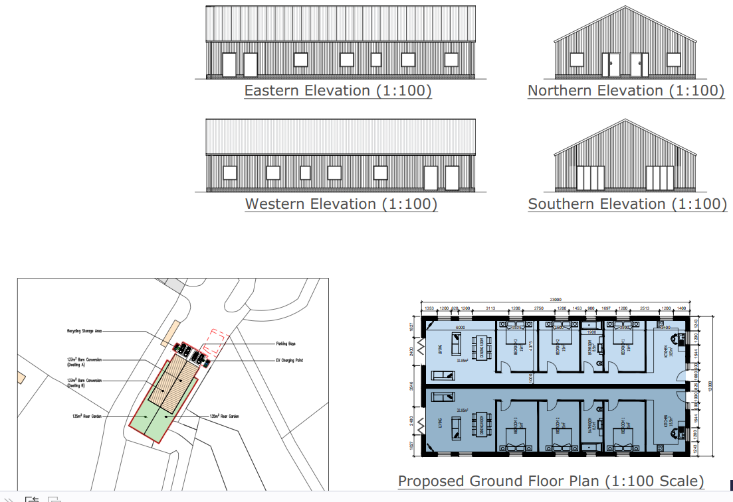

Fig. 2: Proposed replacement dwellings

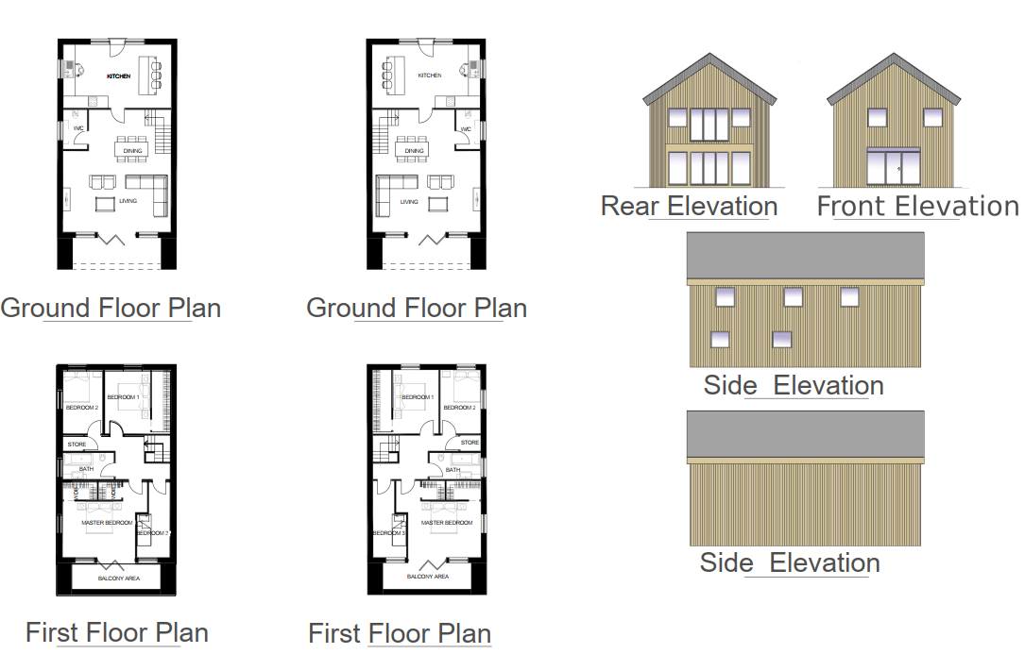

Fig. 3: Existing and proposed layouts

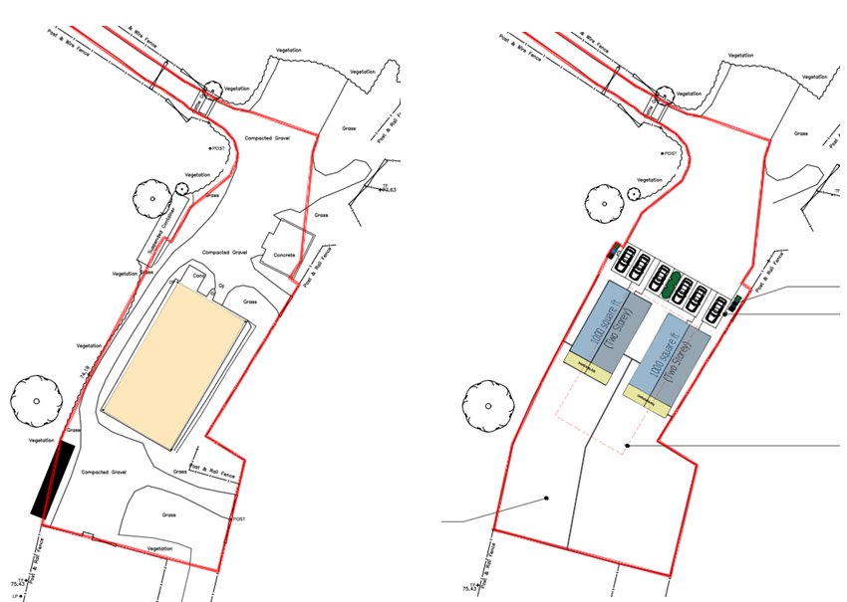

PROCEDURAL NOTE

The local ward member has called the application to Planning Committee if the recommendation is for approval on the following grounds:

Design – bulk, height, general appearance

PLANNING HISTORY

Proposal / Summary
PL/2025/08586 - Prior approval Part 3 Class Q: Agricultural buildings to dwellinghouses Decision - Prior Approval Granted Date: 19/1/2026 – Conversion of existing barn to two dwellings. The access track presently exists in serviceable order.
W/01/01478/FUL - Full planning permission Decision - Approve with Conditions Date: 4/4/2002 – Erection of agricultural building for livestock shelter and storage
W/05/01121/FUL - Full planning permission Decision - Withdrawn Date: 1/8/2005 – Change of use of land and buildings to mixed use of agriculture and equestrian (livery and breeding), together with provision of a menage
W/07/01375/FUL - Full planning permission Decision - Approve with Conditions Date: 12/7/2007 – Change of use from agriculture to mixed use of agriculture and livery/breeding of horses including the provision of a menage, the established barn and three mobile field shelters

RELEVANT LEGISLATION, POLICIES AND GUIDANCE

Statutory Legislation:

National Planning Policy:
- National Planning Policy Framework (NPPF)
- Planning Practice Guidance (PPG)
- National Design Guide
Development Plan:
The development plan for Wiltshire comprises the Wiltshire Core Strategy (WCS) (adopted January 2015) and any made neighbourhood plans, which remains the principal statutory planning document guiding development across the county. In line with Section 38(6) of the Planning and Compulsory Purchase Act 2004, planning decisions must be made in accordance with the development plan unless material considerations indicate otherwise.

Though the development plan is considered as a whole, those parts deemed to be particularly relevant to this application are listed below:

The adopted Wiltshire Core Strategy (WCS), with particular regard to:

- Core Policy 1 Settlement Strategy;
- Core Policy 2 Delivery Strategy;
- Core Policy 3 Infrastructure Requirements;
- Core Policy 29 Spatial Strategy: Trowbridge Community Area
- Core Policy 41 Sustainable Construction and Low-Carbon Energy;
- Core Policy 45 Meeting Wiltshire’s Housing Needs;
- Core Policy 48 Supporting Rural Life
- Core Policy 50 Biodiversity and Geodiversity;
- Core Policy 51 Landscape
- Core Policy 52 Green Infrastructure
- Core Policy 57 Ensuring High Quality Design and Place Shaping;
- Core Policy 60 Sustainable Transport;
- Core Policy 61 Transport & Development;
- Core Policy 62 Development Impacts on the Transport Network;
- Core Policy 63 Transport Strategies
- Core Policy 64 Demand Management
- Core Policy 67 Flood Risk;
- Core Policy 68 Water Resources;

Draft Local Plan: At Full Council on 19 May 2026, the elected members of Wiltshire Council agreed to withdraw the emerging WLP. As such, the WLP has no material weight for the purposes of the application.

Neighbourhood Plan:

West Ashton Neighbourhood Development Plan 2018-2026 (Made June 2021)

Supplementary Planning Documents and other Guidance:
- Wiltshire Design Guide (adopted April 2024)
- Wiltshire Local Transport Plan 2011-2026, adopted 2015 - including the Car Parking Strategy and Cycling Strategy, adopted 2015
- Wiltshire Council’s Waste Core Strategy, adopted July 2009

ISSUES

The main issues that need to be addressed in this case include:

- Whether the development is acceptable in principle (CP 1 and 2)
- Whether the scheme constitutes high quality design (CP 57)
- Whether the scheme would have an acceptable impact upon the reasonable living conditions of the adjoining occupants (CP 57)
- Whether the scheme would have an acceptable landscape impact (CP 51)
- Whether the proposal would have a negative effect upon highway safety, including if there is sufficient parking for the proposed development (CP 61 and 64)
- Whether the site can be adequately drained without increasing flood risk elsewhere (CP 67)
- Whether there would be any harmful impacts upon protected species or priority habitats (CP 50)
- Are there any other planning issues raised by the development?

CONSULTATION RESPONSES

The views of consultees are material considerations in the determination of the application. However, the decision-maker must exercise their own planning judgement. Where consultees raise concerns or recommend conditions, these have been considered and are addressed within the assessment section of this report.

WC Highways: No objection.

WC Ecology: No objection subject to conditions.

Parish/Town Council: Objection on the following grounds:

- Conflict with the Wiltshire Gypsies and Travellers Development Plan
- The Prior Approval Does Not Establish the Principle of New Residential Development in the Countryside
- Conflict with the Development Plan — Location Outside Defined Settlement Boundary
- The Tilted Balance Does Not Automatically Favour Approval
- Car Dependency and Transport Unsustainability
- The Adjacent Traveller Site — An Omitted Material Consideration
- Precedent for Further Development of the Agricultural Field
- Self-Build Conditions — Enforceability
- Character and Appearance — Qualitative Difference from the Class Q Scheme

REPRESENTATIONS
In accordance with the requirements of the Town and Country Planning (Development Management Procedure) (England) Order 2015 (as amended), the application was publicised by way of:

- Neighbour notification letters sent to adjoining and nearby properties;
- A site notice displayed near the site.
These methods were used to inform interested parties and provide a period of 21 days for comments to be submitted.

Below is a summary of the representations received during the consultation period. Only material planning considerations have been taken into account in the assessment of this application. Non-material issues, such as property values or private legal disputes, cannot be considered in the determination process.

Two supportive comments have been received:

Support the replacement of the unsightly and unused barn with two houses that meet building regulations.
Permission should be subject to clarification of the ownership and maintenance of the access track; requirements for ensuring the track is upgraded to improve drainage; and clarification of the ownership and arrangements for maintenance of hedgerows, trees and boundaries.
Favour development of this site, without supporting this particular application.
This disused, neglected site should be brought back into use and the site and access maintained.

Three objections have been received:

The proposal would mean a new barn is needed.
Future applications on surrounding land would follow.
The entrance is dangerous on the fast, high traffic road.
There are no cycle routes, no safe walkways, no buses, so they must rely on a private car.
This barn is a livery yard not agricultural. The permitted development application was just a precursor to this application. They are trying to circumvent the planning system.

Each material planning issue raised is addressed within the assessment below.

ASSESSMENT
Section 38(6) of the Planning and Compulsory Purchase Act 2004 states:

"If regard is to be had to the development plan for the purposes of any determination to be made under the planning Acts, the determination must be made in accordance with the plan unless material considerations indicate otherwise."

In accordance with this statutory requirement, this application has been assessed against the relevant policies of the Development Plan, including the Wiltshire Core Strategy (2015) and, where applicable, any made Neighbourhood Plans. Consideration has also been given to the policies of the National Planning Policy Framework (NPPF) as a material consideration in the assessment.

The assessment below considers each of the main issues identified above. Each topic is assessed in turn with reference to the relevant policy context, the evidence submitted, consultee responses, and all other material considerations, before a conclusion is reached.

Principle of Development
Policy Context
Core Policy 1: Settlement Strategy of the WCS establishes a hierarchy of settlements to guide where development should be focused. The policy prioritises growth in:
- Principal Settlements (e.g., Salisbury, Chippenham, Trowbridge) – main focus for strategic growth.
- Market Towns – support local services and employment; suitable for sustainable development.
- Local Service Centres – smaller towns and villages with a range of services; limited development supported.
- Large and Small Villages – development should be limited and respond to local needs.
- Outside the defined settlements – development is strictly controlled and generally not supported unless exceptional circumstances apply.
.
Core Policy 2: Delivery Strategy of the WCS sets out how development will be distributed and delivered across Wiltshire. The policy emphasises:
- Sustainable patterns of growth, reducing the need to travel and supporting local services.
- Development should be plan-led, aligning with the settlement strategy and supported by infrastructure.
- Windfall development (not allocated in plans) must still comply with the principles of sustainable development.
- Development outside settlement boundaries is generally not permitted, unless it meets specific policy exceptions (as set out in paragraph 4.25 of the WCS).

Together, CP1 and CP2 ensure that new development is strategically located, sustainable, and supports the character and function of Wiltshire’s communities.

Assessment

This application puts forward a scheme for two new self-build dwellings using an approved Class Q development for two dwellings formed within an existing barn as a fallback position.

Using a Class Q permitted development scheme as a fallback position is a valid argument, however this position does hinge on whether the proposed scheme meets the provisions of other policies in the Wiltshire Core Strategy, NPPF and other relevant documents.

The proposed scheme would have no impact on the Council’s 5 year housing land supply (HLS), currently at 2.8 years supply. The Class Q allows for two dwellings. The current scheme would maintain that level of units, and therefore there would be no benefit/disbenefit to the HLS.

Conclusion

In principle, this may be acceptable subject to the detailed considerations below. In this case it is found that the proposed replacement dwellings would be harmful to various issues and therefore is recommended for refusal.

Design and Impact on the Character and Appearance of the Area, Landscape and Visual Impact

Policy Context
Core Policy 57 of the WCS requires high-quality design that:
- Enhances local character.
- Responds to the natural, historic, and built environment.
- Retains important features (e.g., trees, hedges).
- Supports sustainable construction and compatibility with surrounding uses.
- Creates safe, legible, and accessible spaces.

Section 12 of the NPPF emphasises design that is:
- Visually attractive.
- Functionally effective.
- Contributes to the quality of the built environment.

The Wiltshire Design Guide encourages sensitivity to local character, materials, and architectural styles and supports modern living standards while maintaining aesthetic and functional quality.

Building for a Healthy Life Framework promotes healthy, inclusive, and sustainable places. The document encourages:

- Walkability.
- Access to green space.
- Active design principles for well-being.

Core Policy 51 of the Wiltshire Core Strategy requires development to:
- Protect, conserve, and enhance landscape character and quality.
- Respect local distinctiveness, key views, and visual receptors.
- Give particular weight to impacts on National Landscapes (formerly AONBs) and locally valued landscapes.

The Wiltshire Design Guide SPD (2024) promotes a context-led approach, encouraging integration with natural features and settlement patterns while avoiding visual intrusion.

The Green & Blue Infrastructure Strategy (2022–2030) supports landscape protection through green infrastructure, habitat connectivity, and nature-based solutions.

The NPPF emphasises the need to protect and enhance valued landscapes, particularly those with scenic, historic, or ecological significance. Planning decisions should:

- Recognise the intrinsic character and beauty of the countryside.
- Safeguard key views, local distinctiveness, and landscape settings.
- Ensure development is well-integrated into its surroundings and avoids visual intrusion, especially in sensitive or designated areas.

Landscape impact must be considered alongside biodiversity, heritage, and green infrastructure objectives, with mitigation measures encouraged where harm cannot be avoided.

Assessment
In assessing this aspect of the proposal, regard has been had to the site context, the details of the proposed development, the relevant development plan policies, and all other material considerations. The key considerations are set out below.

The existing barn, which can be converted to two dwellings under the extant Class Q approval, is of an agricultural character. It is a single storey barn capable of being converted and would sit within the local character and that of the landscape just as it does at present.

The local character is that of an agricultural setting on the edge of the small village of West Ashton. The site is separated from the village to the north by several small fields (see Fig. 4 below) and larger fields to the south.

The site sits on an elevated position with the lower land to the west towards Trowbridge. The landscape character is one of traditional farmland, a mixture of field sizes and scattered buildings either individually or in small groups between Trowbridge, Yarnbrook and West Ashton.

The existing barn is contextually appropriate for this area of agricultural character outside of the edge of West Ashton.

The fallback development has the character and appearance of a utilitarian rural building due to the limited glazing and general domestic features. The current proposal would replace the barn with two detached dwellings of two storeys each and domestic fenestration detail with large areas of glazing at ground floor level.

The character of the proposed development would be notably more residential, removing that agricultural context within the landscape and thereby changing the local character. Moreover, the residential use of the site would result in domestic paraphernalia and an overall domestication of the site and therefore an encroachment of residential development into the countryside.

As such, this fallback would have a notably lesser impact on the character and appearance of the area than the current proposal. As a result, the potential for fallback to be implemented is a matter that carries modest weight.

The Class Q can be implemented under permitted development and would contribute to the HLS whilst respecting the rural and agricultural character of the site and the surrounding areas.

This consideration has been made in relation to the merits of this particular scheme, however appeal decision ref 6005381 supports this view that the harm caused by the change in local character is unacceptable in a Class Q fallback argument.

Conclusion
Having regard to the above, it is considered that the proposed development would result in poor design that would not reflect the rural and agricultural character of the site and its surroundings. This would result in harm to the character of the area and the landscape, contrary to CP51 and CP57 of the Wiltshire Core Strategy and section 12 of the NPPF as the development would neither enhance nor respond to the landscape character and local character, instead creating an incongruous domestic development that would result in harm to these identified receptors.

Amenity
Policy Context
Core Policy 57 (Point vii) of the Wiltshire Core Strategy requires development to respect the amenity of existing occupants and ensure appropriate amenity levels for future residents.

The National Planning Policy Framework (NPPF), particularly Paragraph 135, reinforces the need for development to provide a high standard of amenity for both existing and future users.

These policies guide the assessment of amenity impacts.

The site is remote enough from surrounding dwellings that there would not be any demonstrable impact on neighbouring amenities of either the potential occupiers of the site, nor the neighbouring properties.

Fig. 4: Location Plan
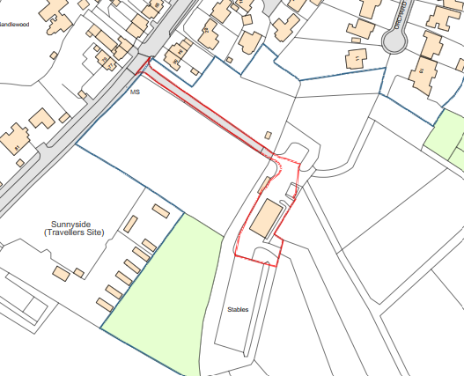

Highways Impacts and Parking
Policy Context
Transport implications are a key factor in assessing planning applications, especially for larger developments. Proposals must demonstrate:
- Safe and suitable access for all users, including pedestrians, cyclists, and those with mobility impairments.
- No severe residual impacts on the surrounding highway network.
- Promotion of sustainable travel, reducing reliance on private vehicles.
- Adequate parking and cycle provision, in line with adopted standards.
- Protection and enhancement of public rights of way and active travel routes.

Relevant policies include Core Policies 60–64 of the Wiltshire Core Strategy, supported by the Wiltshire Local Transport Plan, Car Parking Strategy, and Cycling Strategy. The Local Cycling and Walking Infrastructure Plan (LCWIP) and LTN 1/20 (DfT) provide further design guidance for active travel infrastructure.

Proposals must also ensure safe access for refuse collection vehicles and comply with the Wiltshire Council Waste Storage and Collection SPD (2017).

Assessment
In assessing this aspect of the proposal, regard has been had to the site context, the details of the proposed development, the relevant development plan policies, and all other material considerations. The key considerations are set out below.

The Council’s Highway Officer comments:

“I note the proposed demolition of the existing agricultural barn and the erection of two 4 bedroom dwellings. I also note that the existing barn is subject to Class Q Prior Notification Approval for conversion to two dwellings, under application PL/2025/08586.
“The location of the site would usually raise transport sustainability concerns for new build development, however, noting the abovementioned Class Q approval, I shall be guided by the Planning Officer in respect to the suitability of these proposals in principle.
“In terms of highway safety matters, access to the site is via a private track, which joins the public highway from the A350. The A350 is subject to a 40mph speed limit in this vicinity and experiences high volumes of traffic. It is unlikely that a significant intensification of use of this access track would be supported.
“Notwithstanding this, the proposals for two dwellings would not be expected to generate a significant amount of additional traffic movements when compared to the potential of the extant use. Furthermore, the track is sufficiently wide enough over the first 10m from the highway to enable vehicles to pass. Within the site, sufficient car parking can be provided for each unit.
“Therefore, if the Planning Officer is minded to accept the principle of the proposed development, I recommend that no Highway objection is raised.”

Conclusion
As considered in above sections, the main objection to the proposed development is related to the harm to the character of the local area and the landscape. Therefore, it is considered that the highways position of “no objection” is supported.

Ecology and Biodiversity

Habitats Regulations Assessment (HRA)
Regulation 63 of the Conservation of Habitats and Species Regulations 2017 (as amended) requires the Local Planning Authority, as the competent authority, to consider whether a plan or project is likely to have a significant effect on a European site, either alone or in combination with other plans or projects. Where likely significant effects cannot be ruled out, an Appropriate Assessment must be undertaken.

Bath & Bradford-on-Avon Bats SAC Habitat Regulations Assessment

The application site lies within the yellow medium risk zone and the grey hatched recreational zone of the Trowbridge and Westbury Bat Mitigation Strategy (TWBMS), adopted in July 2025. The site is also located within Bechstein’s bat core buffer zones due to its proximity to several confirmed breeding Bechstein’s bat roosts. Therefore, the development proposals must be considered under the Habitat Regulations.

The TWBMS yellow medium risk zone identifies areas where habitat has been shown, or are highly likely, to be important for bats associated with the Bath and Bradford-on-Avon Bats SAC, particularly foraging habitat and commuting routes used by horseshoe bats and Bechstein’s bats. The TWBMS recognises that an appropriate level of development may be accommodated within this zone, provided proposals are designed in accordance with the strategy’s principles and mitigation requirements. Impacts may arise from the loss, fragmentation or degradation of habitat used by SAC qualifying bat species, either alone or cumulatively in combination with other plans and projects.

The grey hatched recreational zone identifies areas where new residential development is likely to increase recreational pressure on important woodland bat sites. However, the proposed development comprises the redevelopment of a previously developed site and does not result in the loss or degradation of bat habitat. As such, the proposal can be screened out of Appropriate Assessment (AA) in relation to habitat-related effects associated with the yellow medium risk zone and Bechstein’s core buffer zone.

Notwithstanding the above, in accordance with the TWBMS the proposal includes residential development within the grey hatched recreational zone and is therefore expected to contribute towards the Council’s strategic recreational pressure mitigation scheme; all residential developments of 49 dwellings or less are required to provide a financial contribution of £925 per dwelling to mitigate increased recreational pressure on woodland habitats used by SAC qualifying bat species to ensure an AA can be concluded favourably.

This is to be secured via section 106 agreement (s106), a section 111 (s111) agreement or unilateral undertaking (UU) (legal fees will apply) prior to the commencement of development).

The total financial contribution to mitigate the burden would be £ 1850 plus legal fees.

Salisbury Plain Special Protection Area (SPA) Habitat Regulations Assessment

This application lies within the 6.4km zone of influence of the Salisbury Plain SPA and in light of the Habitat Regulations Assessment (HRA) for the Wiltshire Core Strategy and the HRA for the Wiltshire Housing Site Allocations Plan it is screened into Appropriate Assessment due to the potential impact of recreational pressure on stone curlew in combination with other plans and projects.

A strategic AA has been prepared pertaining to development within the 6.4km zone of influence that could result in a likely significant effect on the SPA as a result of an increase in recreational / visitor pressure. The AA reached a conclusion of no adverse effects on the integrity of the SPA or its qualifying features provided that the council’s mitigation strategy continues to be implemented. Annual stone curlew monitoring and protection measures continue to be secured by the Council.

In January 2026 Natural England (NE) confirmed that the strategic AA for Salisbury Plain SPA continues to be supported by NE until end of December 2026.

Appropriate Assessment
An Appropriate Assessment has been undertaken. This assessment considers the implications of the proposal for the conservation objectives of the relevant European site(s), including the effectiveness and certainty of any mitigation measures proposed.

Conclusion of AA – No Adverse Effect on Integrity
Having undertaken the above assessment, the Local Planning Authority is satisfied that the development would not adversely affect the integrity of any European site, either alone or in combination with other plans or projects. This conclusion is reached having regard to the conservation objectives of the site and is secured by mitigation measures which are considered effective and deliverable, and which are secured by planning condition and/or legal agreement.

Conclusion
Having regard to the above, it is considered that subject to Natural England’s endorsement the contribution under the TWBMS would be suitable to mitigate the impact on habitat. This would need to be secured by a legal agreement.

Flood Risk and Drainage
Policy Context
Core Policy 67 of the Wiltshire Core Strategy and NPPF paragraphs 170–182 require:
- Avoidance of increased flood risk.
- Use of appropriate mitigation measures.
- Application of the sequential and exception tests for developments in Flood Zones 2 or 3.

Sustainable Drainage Systems (SuDS) are required for all major developments and must:
- Manage runoff near its source.
- Improve water quality.
- Support biodiversity and amenity.
- Be integrated into the site layout and green infrastructure.

Assessment
In assessing this aspect of the proposal, regard has been had to the site context, the details of the proposed development, the relevant development plan policies, and all other material considerations. The key considerations are set out below.

Whilst the application site is identified on the Environment Agency’s Flood Map for Planning as lying within Flood Zone 1, indicating a low probability of flooding from rivers and the sea, the Council’s SFRA mapping tool has identified the site to be susceptible to groundwater flooding. It is important to mention that flood risk from all sources must be appraised, not solely fluvial.

In this case, the proposal seeks to replace a barn with two new dwellings. It is important that proposals are supported by appropriate flood risk mitigation to ensure the safety of future occupants.

On this basis, it is considered appropriate to ensure groundwater flood risk can be managed effectively through mitigation to be addressed through the submission of a drainage strategy.

However, this application is being recommended for refusal and therefore it would be inappropriate to request further studies at this stage.

Conclusion
Having regard to the above, it is considered that drainage issues could be dealt with my a condition on a permission, however the application is being recommended for refusal on other grounds.

Other Issues

The public comments raised issues of this application, if approved, leading to more applications in the area. Planning decisions cannot take into account what may or may not happen in the future. Each application is considered and determined on its own merits.

PLANNING BALANCE AND CONCLUSION
In reaching a decision, all identified harms and benefits must be weighed in the overall planning balance, having regard to Section 38(6) of the Planning and Compulsory Purchase Act 2004 and the provisions of the National Planning Policy Framework.

At the heart of the NPPF there is a presumption in favour of sustainable development requiring local planning authorities to approve development proposals that accord with an up-to-date development plan without delay; and where there are no relevant development plan policies, or the policies which are most important for determining the application are out-of-date, permission should be granted unless (taken from paragraph 11d of the NPPF):

- The application of policies in the NPPF that protect areas or assets of particular importance provides a clear reason for refusing development proposed; or
- any adverse impacts of doing so would significantly and demonstrably outweigh the benefits, when assessed against the policies in the NPPF taken as a whole;

Having regard to paragraph 11(d) of the National Planning Policy Framework and footnote 7, the Local Planning Authority does not consider that the presumption in favour of sustainable development (‘tilted balance’) is engaged, as the Class Q fallback position would provide two dwellings and the proposal for replacement with two dwellings would not result in a change in housing numbers.

The relevant policies of the NPPF that protect areas or assets of particular importance provide a strong reason for refusing the development.

In weighing the planning balance, the following factors have been considered:

Identified Harms
Where harms are identified, they must be considered in terms of their nature, extent, and policy conflict, and whether they significantly and demonstrably outweigh the benefits of the development. The following harms have been identified:

Landscape and Visual Impact
The proposal would result in an unacceptable change to the rural character and appearance of the site and its surroundings, including to the landscape, particularly where development encroaches into open countryside with an incongruous domestic appearance.
- Harm: Erosion of rural character and visual intrusion into the landscape.
- Weight: Moderate weight.

Design Quality and Local Character
The design of the proposed development fails to respond positively to the local context through inappropriate scale, massing, layout and architectural detailing. It would therefore result in harm to the character and appearance of the area. This is particularly relevant as the proposal does not meet the expectations of Core Policy 57 of the Wiltshire Core Strategy or the design objectives of the NPPF.
- Harm: Poor design quality that fails to respect or enhance local distinctiveness.
- Weight: Moderate weight.

In balancing these identified harms we must consider the benefits of the scheme. In this case, where there is a realistic Class Q fallback position that would secure the same number of dwellings, there are no discernible benefits other than short term construction jobs, although even then the barn conversion would also generate a similar level.

This proposal has no benefit to the HLS over the extant Class Q scheme – the creation of two dwellings in either case. As the Class Q scheme can be implemented without resulting in the harm that the current scheme would cause to the local distinctiveness and landscape character, it is recommended to the applicant that they implement the Class Q approval ref. PL/2025/08586.

RECOMMENDATION:
That Planning Permission be REFUSED.

Reason for refusal:

The proposed development would result in dwellings of incongruous and unsympathetic domestic design, scale and massing that would not reflect the rural and agricultural character of the site and its surroundings. This would result in harm to that character of the local area as well as the wider landscape character. This would be contrary to CP51 and CP57 of the Wiltshire Core Strategy and section 12 of the NPPF. The identified harm has not been outweighed by any benefits of the scheme, especially given the fallback Class Q position would yield the same benefits without resulting in harm to the local and landscape character.

Informative:

The development hereby refused has been considered with reference to the following submitted plans and documents:

Application Forms, Drawing Nos. 01 Rev A (Location Plan), Topological Survey, 05 Rev B (Approved Class Q Plans), 05 Rev C (Site Layout Plan – Proposed), 02 Rev B (Site Layout Plan – Existing) received on 1st April 2026

Drawing No. 06 Rev B (Proposed Plans) received on 15th April 2026

