APPLICATION FOR HOUSEHOLDER PLANNING PERMISSION
DELEGATED REPORT

APPLICATION REFERENCE: | PL/2026/03296
APPLICATION TYPE: | Householder planning permission
SITE ADDRESS: | Leat Cottage, 20, Crockerton, Warminster, BA12 8AU
DEVELOPMENT DESCRIPTION: | Demolition of existing porch and erection of replacement porch
RECOMMENDATION: | That Planning Permission be GRANTED

PROPOSAL

The proposal seeks planning permission for Demolition of existing porch and erection of replacement porch at Leat Cottage, 20, Crockerton, Warminster, BA12 8AU. The porch would be built using a mixture of natural stone, brick detailing and plain tiles.

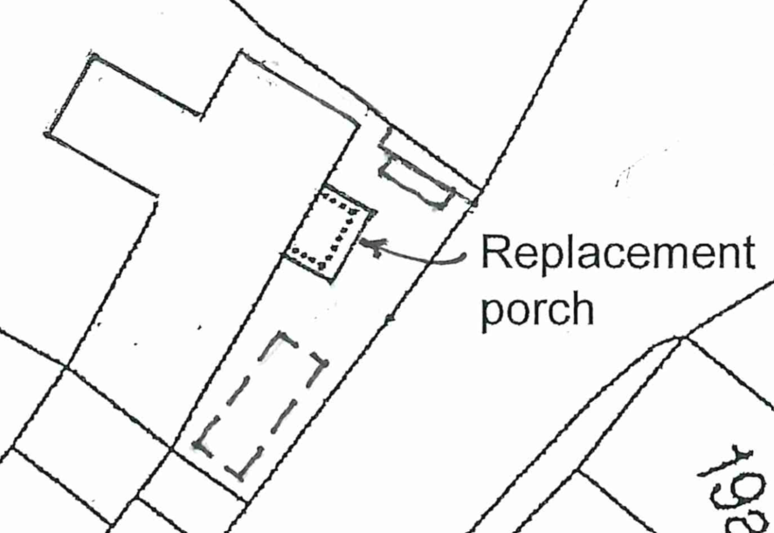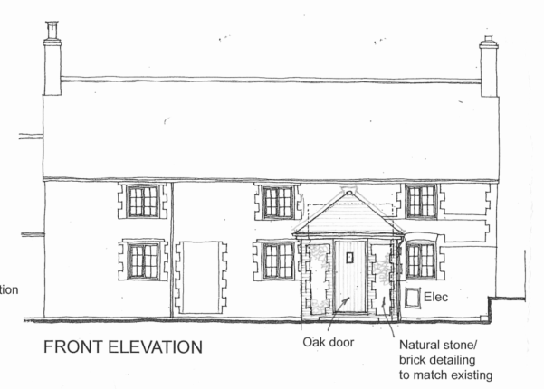

Extract from Proposed Block Plan and Proposed Front Elevations

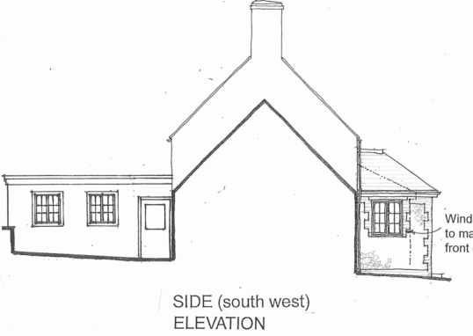

Proposed Side Elevation

SITE DESCRIPTION/CONTEXT

Leat Cottage is a two-storey end of terrace dwelling located on the edge of Crockerton near the A350. The dwelling is also on a no through road serving only 8 dwellings.

The site is near but not within the Cranbourne Chase and West Wiltshire Downs National Landscape. There is one grade II listed building (Green Farmhouse) but is 90m away around a corner. The setting of this listed building does not extend into the application site.

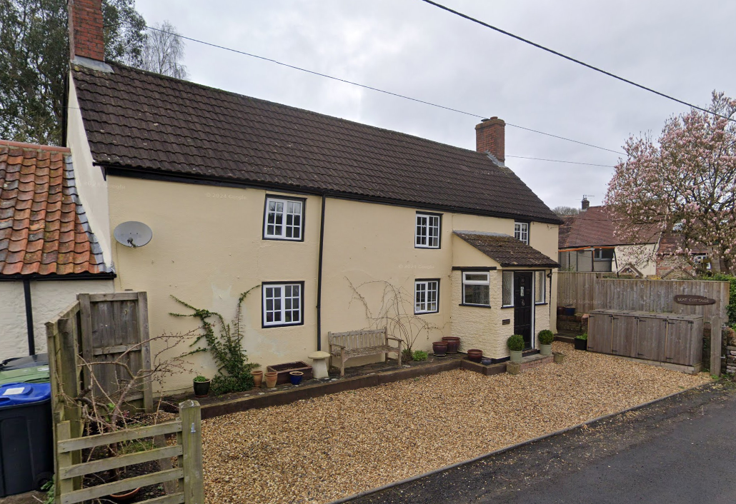

Google Street View Image of the Site – March 2024

The application site is subject to the following planning policy constraints:

- Sailsbury Plain Special Protection Area 6.4km buffer zone
- Ground water is between 0.025m and 0.5m below the ground surface

PLANNING HISTORY

There is no relevant planning history on this site

RELEVANT POLICIES AND GUIDANCE

National Context:

The National Planning Policy Framework (NPPF)

The Planning Practice Guidance

Local Context:

Wiltshire Core Strategy:

- Core Policy 57 Ensuring High Quality Design and Place Shaping
- Core Policy 67: Flood Risk

Longbridge Deverill does not have a neighbourhood plan or area designation

Wiltshire Design Guide: Appendix D – Design Guidance for Householder extensions

CONSULTATION RESPONSES

Longbridge Deverill Parish Council: No objection

Wiltshire Council Highways Officer: No objection

REPRESENTATIONS

No comments were received.

ASSESSMENT

Section 38(6) of the Planning and Compulsory Purchase Act 2004 states:

"If regard is to be had to the development plan for the purposes of any determination to be made under the planning Acts, the determination must be made in accordance with the plan unless material considerations indicate otherwise."

In accordance with this statutory requirement, this application has been assessed against the relevant policies of the Development Plan, including the adopted Wiltshire Core Strategy (2015) and, where applicable, any made Neighbourhood Plans.

Design and Impact upon the character and context of the area

Core Policy 57 - Ensuring High Quality Design and Place Shaping of the Wiltshire Core Strategy seeks to ensure that all new development is of high design quality, reflecting local context, character, and distinctiveness.

The dwelling already benefits from a relatively large lean-to porch, which is not especially sympathetic to the character of the cottage, particularly when compared with the more modest porches found on neighbouring properties.

The proposal would increase the footprint of the porch from approximately 3.3m² to 6.1m² and introduce a half-hipped roof. While the footprint would be enlarged, the overall visual impact of the increase—relative to the existing, prominently scaled lean-to porch—would be mitigated by the half-hipped roof design. This approach allows for a larger footprint without requiring a significant increase in the apparent bulk of the roof, which would likely occur if the lean-to form were retained.

Having regard to the above, the proposal complies with the design principles set out in Core Policy 57 of the Wiltshire Core Strategy and Appendix D of the Wiltshire Design Guide.

Amenity

Point vii of Core Policy 57 - Ensuring High Quality Design and Place Shaping of the Wiltshire Core Strategy seeks to ensure that developments do not adversely affect neighbouring properties.

The National Planning Policy Framework (NPPF), particularly Paragraph 135(f), stresses that planning decisions should ensure developments provide a high standard of amenity for existing and future users.

The proposed development has been assessed in terms of its potential impact on the residential amenity of neighbouring properties, with particular regard to loss of light, overshadowing, loss of privacy, and overbearing effects.

The porch would not be of a size nor close enough to neighbours in which to cause any harm by virtue of overlooking or overbearing impacts.

The proposal therefore accords with Core Policy 57 point vii in respect of safeguarding residential amenity and Appendix D of the Wiltshire Design Guide.

Highways

Core Policy 57 (xiv) of the Wiltshire Core Strategy seeks to ensure that development must meet the requirements of Core Policy 61. This policy requires proposals to be capable of being served by safe access to the highway network. Core Policy 64 seeks to ensure compliance with parking standards set out in the Local Transport Plan.

The National Planning Policy Framework (NPPF), particularly Paragraph 115 and 116, requires that development proposals do not have an unacceptable impact on highway safety and that safe and suitable access to the site can be achieved for all users.

The increase in porch size would result in the loss of some driveway space, but the existing (and unaffected) part of the driveway is only able to accommodate in one parking space. Therefore, the proposal would not result in the loss of an off-road parking space.

The proposed development would not result in any adverse impact on highway safety. Adequate parking and turning provision is provided in accordance with Wiltshire’s adopted parking standards, and access arrangements are acceptable.

The proposal is therefore considered to comply with Core Policies 57 (xiv), 61 and 64 of the Wiltshire Core Strategy, the NPPF, and the Wiltshire Local Transport Plan.

Drainage and Flood Risk

The application site is within flood zone 1 but is within the second highest risk category of ground water flooding and in accordance with the Council’s 2019 and 2024 Strategic flood risk assessments (SFRA) the site cannot be considered to be at a low risk of flooding.

Paragraph 176 of the NPPF states;

“Applications for some minor development and changes of use⁶² should also not be subject to the sequential test, nor the exception test set out below, but should still meet the requirements for site-specific flood risk assessments set out in footnote⁶³.

⁶² This includes householder development

⁶³ A site-specific flood risk assessment should be provided for all development in Flood Zones 2 and 3. In Flood Zone 1, an assessment should accompany all proposals involving: sites of 1 hectare or more; land which has been identified by the Environment Agency as having critical drainage problems; land identified in a strategic flood risk assessment as being at increased flood risk in future; or land that may be subject to other sources of flooding, where its development would introduce a more vulnerable use.”

This is a householder application and therefore footnote ⁶² applies (excluding the need for the sequential test) and the site is not within flood zone 2 and 3. However, as the site is within flood zone 1 and the SFRA shows this site to be in a high risk of ground water flooding, a site specific flood risk assessment should normally be required.

However, this application is for a small porch extension increasing from circa 3m2 to 6m2. It is considered that this very limited works should require a flood risk assessment which would detail mitigation measures of and for example floor levels, flood resilient materials and electrical sockets being 400mm above floor level.

It is clear from the plans that the ground floor level would be the same as the existing house (which is the main consideration). Therefore, for these reasons Officers are satisfied that the application should not require a flood risk assessment and that the proposal would not increase the risk of ground water flooding in the area.

The proposal therefore complies with Core Policy 67 of the Wiltshire Core Strategy and the policy in the NPPF, ensuring that flood risk is not increased.

Ecology:

Core Policy 50 of the Wiltshire Core Strategy seeks to protect and enhance biodiversity and geodiversity, including through ensuring that development avoids harm to protected species and habitats.

The National Planning Policy Framework (NPPF), in Paragraphs 193, requires that development minimises impacts on and provides net gains for biodiversity, including ensuring mitigation is secured where harm cannot be avoided.

The Council’s Ecology Officer has not been consulted on this application, but the application site is within the 6.4km zone of influence of the Salisbury Plain SPA and in light of the HRA for the Wiltshire Core Strategy and the HRA for the Wiltshire Housing Site Allocations Plan it is screened into Appropriate Assessment due to the potential impact of recreational pressure on stone curlew in combination with other plans and projects.

A strategic Appropriate Assessment (AA) has been prepared pertaining to development within the 6.4 km zone of influence that could result in a likely significant effect on the SPA as a result of an increase in recreational / visitor pressure. The AA reached a conclusion of no adverse effects on the integrity of the SPA or its qualifying features provided that the council’s mitigation strategy continues to be implemented. Annual stone curlew monitoring and protection measures continue to be secured by the Council.

In January 2026 Natural England (NE) confirmed that the 2025 strategic AA for Salisbury Plain SPA continues to be supported by NE.

Biodiversity Net Gain

Householder planning applications are exempt from the requirement to deliver Biodiversity Net Gain under Schedule 7A, Section 4(2)(a) of the Town and Country Planning Act 1990, as inserted by the Environment Act 2021.

CONCLUSION

The proposed development is considered to be acceptable in terms of its design, scale, and relationship with the surrounding area. It would not result in any unacceptable harm to the character of the locality, the amenities of neighbouring occupiers, or the interests of highway safety, heritage, or ecology.

The proposal is therefore considered to comply with the relevant policies of the Wiltshire Core Strategy, the Wiltshire Local Plan, and the National Planning Policy Framework. As such, the application is recommended for approval, subject to the conditions set out below.

RECOMMENDATION: That Planning Permission be GRANTED subject to conditions.

