APPLICATION FOR HOUSEHOLDER PLANNING PERMISSION
DELEGATED REPORT

APPLICATION REFERENCE: | PL/2026/03717
APPLICATION TYPE: | Full planning permission
SITE ADDRESS: | Chestnut Tree Barn, Hindon Road, Monkton Deverill, Warminster, BA12 7EX
DEVELOPMENT DESCRIPTION: | Replacement single storey home office and fitness area to include change of use of existing pathway linking both areas.
RECOMMENDATION: | That Planning Permission be GRANTED

PROPOSAL

The proposal seeks planning permission for Replacement single store home office and fitness area to include change of use of existing pathway linking both areas at Chestnut Tree Barn, Hindon Road, Monkton Deverill, Warminster, BA12 7EX

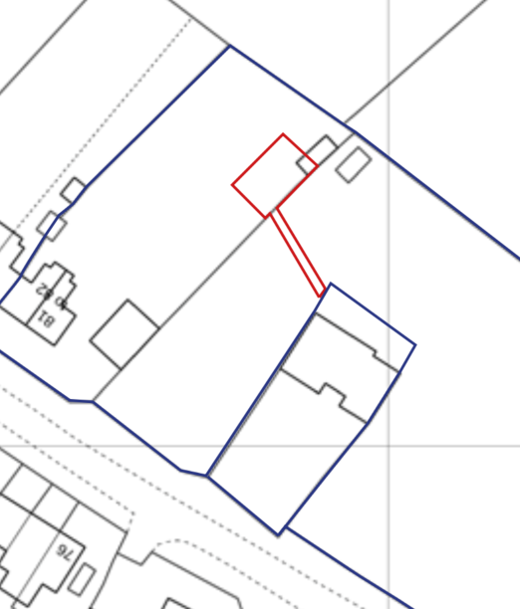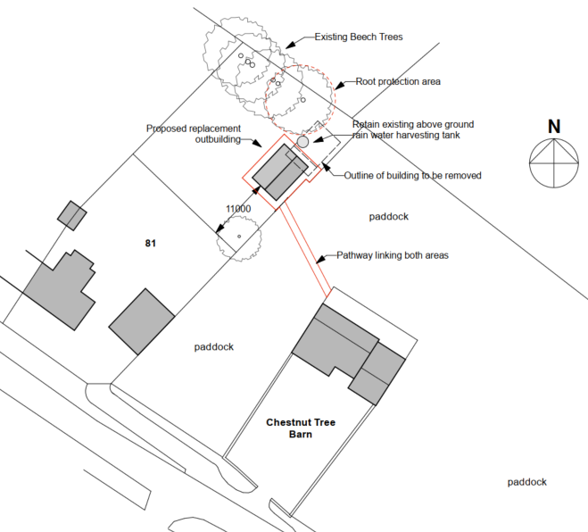

Site Location Plan and Proposed Block Plan

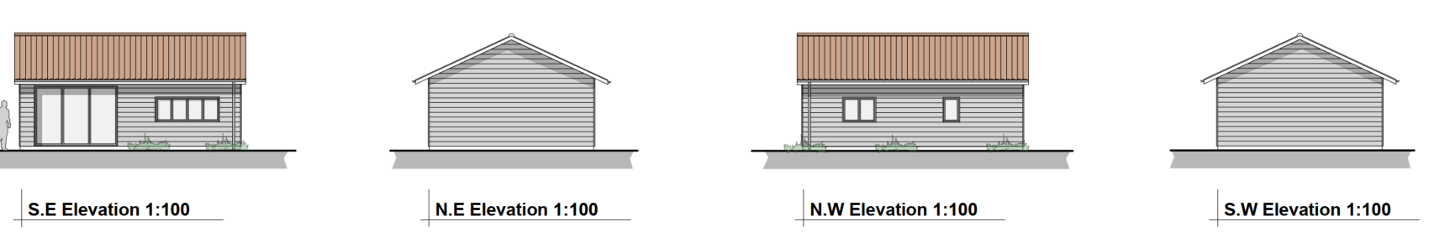

Proposed Elevation Plans

SITE DESCRIPTION/CONTEXT

Chestnut Tree Barn is a detached residential conversion approved under application PL/2025/01835. It is situated within open countryside. The current owners and occupiers previously resided in the adjacent two-storey dwelling, Nos. 81–82, which explains its inclusion within the blue line of the site location plan.

The applicants are in the process of selling Nos. 81–82, while retaining the rear section of the garden (as shown on the block plan) for use as residential curtilage associated with Chestnut Tree Barn. A fence has already been erected along the newly formed boundary.

This application seeks permission for the change of use of a small area of adjoining open countryside to residential curtilage, to facilitate access between Chestnut Tree Barn and the retained garden.

Application PL/2025/01835 was approved with a defined residential curtilage boundary, with the surrounding land explicitly identified and retained as open countryside.

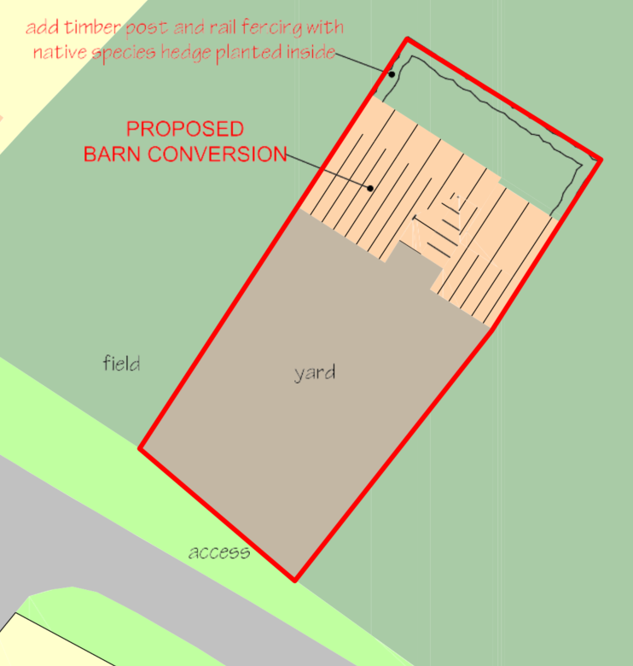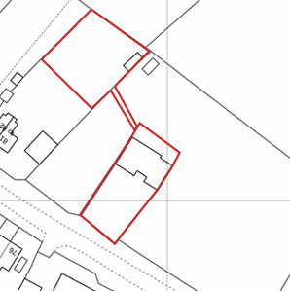

Approved and conditioned curtilage plan from PL/2025/01835 and Proposed curtilage Plan

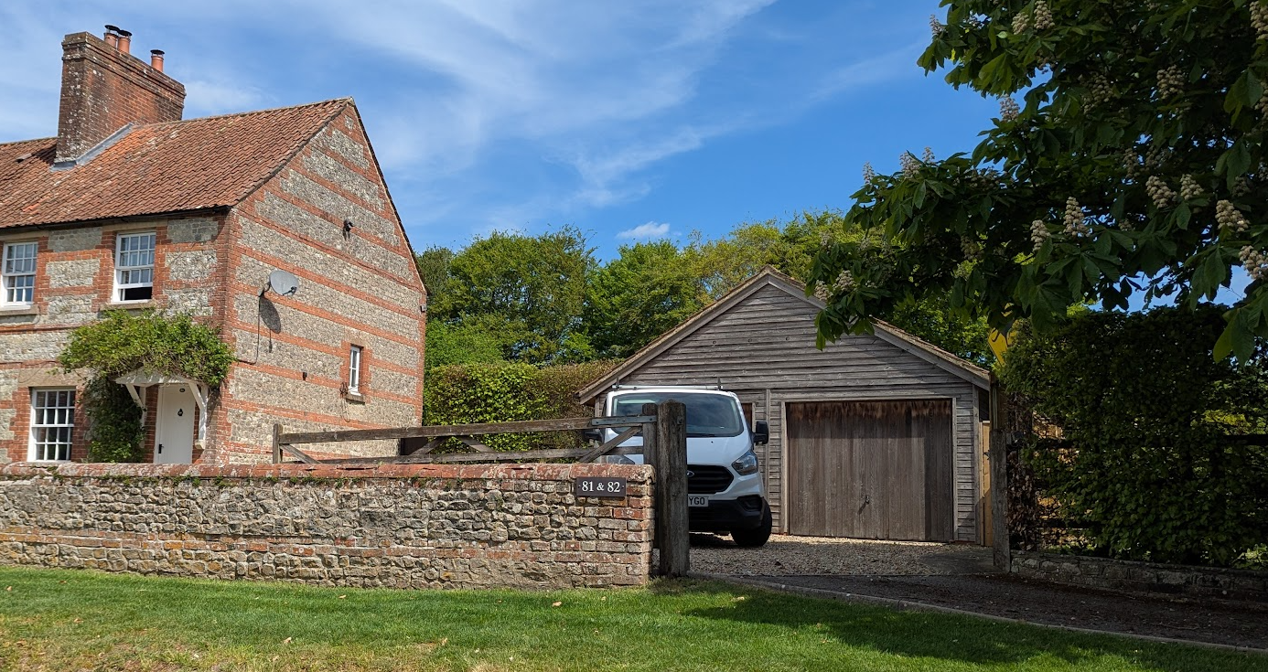

No 81-82 and its detached double garage

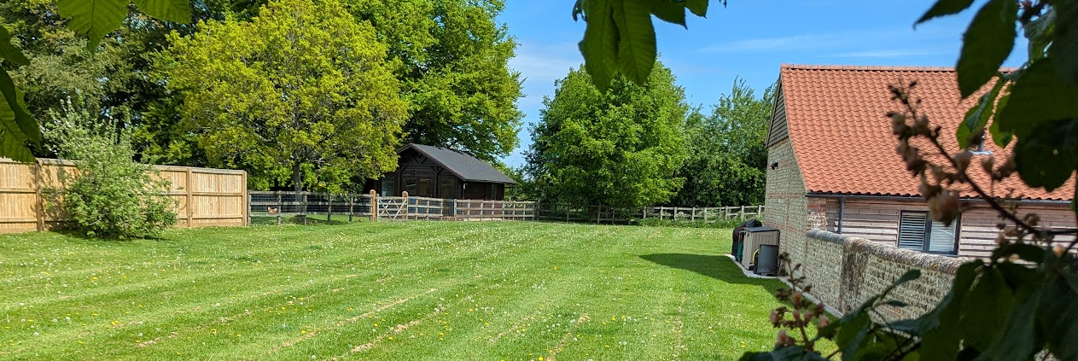

View through hedge of Chestnut Tree Barn (right), existing outbuilding (centre) and

No 81-82 fence (left)

The access path would be circa 10m long and only 1.3m wide. The path would not be formally identified with only stepping stones placed along the path.

The application site is subject to the following planning policy constraints:

- Cranbourne Chase and West Wiltshire Downs National Landscape
- Hampshire River Avon catchment area

PLANNING HISTORY

Proposal / Summary
19/04853/FUL - Conversion of barn into holiday accommodation with associated alterations including an extension to replace a lean-to store at the rear – Approve with conditions Date:11/07/2019
PL/2025/01835 - Removal/variation of conditions Decision - Approve with Conditions Date: 2/12/2025 – Remove condition 6 on planning permission 19/04853/FUL which restricts the approved development for holiday accommodation only
PL/2026/00321 - Approval of details reserved by a condition Decision - Approve Date: 6/5/2026 – Discharge of condition 2 (materials) ,5 (scheme of discharge of surface water),6 (Disposal of sewage),8 (External lighting scheme) ,9 (Water consumption levels) ,10 (River Avon SAC Mitigation Scheme) for PL/2025/01835 - Remove condition 6 on planning per
W/05/02397/FUL - Full planning permission Decision - Approve with Conditions Date: 29/11/2005 – Erection of log cabin at end of garden
W/06/02472/FUL - Full planning permission Decision - Refused Date: 3/10/2006 – Remove existing wooden garage, replacing with timber framed building
W/06/03379/FUL - Full planning permission Decision - Approve with Conditions Date: 4/1/2007 – Remove existing wooden garage replace with timber framed building

RELEVANT POLICIES AND GUIDANCE

National Context:

The National Planning Policy Framework (NPPF)

The Planning Practice Guidance

Local Context:

Wiltshire Core Strategy:

- Core Policy 50: Biodiversity and Geodiversity
- Core Policy 51: Landscape
- Core Policy 57 Ensuring High Quality Design and Place Shaping
- Core Policy 64: Demand Management

Neighbourhood Plan – Upper Deverills does not have a Neighbourhood Plan or Area designation.

Wiltshire Design Guide: Appendix D – Design Guidance for Householder extensions

CONSULTATION RESPONSES

Upper Deverills Parish Council: No comments received

REPRESENTATIONS

The application was advertised by 6 neighbour notification letters and the erection of a site notice on site for 21 days.

No comments were received.

ASSESSMENT

Section 38(6) of the Planning and Compulsory Purchase Act 2004 states:

"If regard is to be had to the development plan for the purposes of any determination to be made under the planning Acts, the determination must be made in accordance with the plan unless material considerations indicate otherwise."

In accordance with this statutory requirement, this application has been assessed against the relevant policies of the Development Plan, including the adopted Wiltshire Core Strategy (2015) and, where applicable, any made Neighbourhood Plans.

Principle of Development

This application is assessed as a full planning application because it includes a material change of use of a small area of land from open countryside to residential curtilage. The proposed replacement outbuilding is domestic/householder in character and would be used for purposes incidental to the enjoyment of Chestnut Tree Barn, but its acceptability depends upon the associated change of use and the relationship of the retained land to the lawful residential curtilage of that dwelling.

Outbuildings that are incidental to the enjoyment of a dwellinghouse do not normally require justification in terms of the principle of development. Where a building is clearly ancillary to a dwelling—for example, as a shed, hobby room, garage, storage space, or summerhouse—the principle is generally accepted.

In this instance, however, the outbuilding to be replaced lies on land that was formerly part of the curtilage of No. 81–82. While it is understood that the applicants have retained this parcel of land following the sale of that property, it currently remains physically and functionally separate from Chestnut Tree Barn (pending the determination of this associated change of use application for the connecting path). This distinction is important in planning terms, as the barn and No. 81–82 constitute separate planning units.

Furthermore, application PL/2025/01835 established a defined residential curtilage for Chestnut Tree Barn, clearly identifying the extent of land lawfully associated with that dwelling, with all adjoining land retained as open countryside.

The key planning issue is therefore not land ownership, but whether the limited area of land required to provide the link between Chestnut Tree Barn and the retained garden can acceptably be incorporated into the residential curtilage of Chestnut Tree Barn without harmful domestication of the surrounding countryside. Given the very limited width and length of the proposed pathway, its informal stepping-stone character, and its relationship to the retained garden and existing built form, the change of use would not materially erode the rural character of the wider paddock or undermine the curtilage control established under PL/2025/01835.

As the change of use is considered acceptable, the principle of replacing the outbuilding as part of the extended curtilage of Chestnut Tree Barn is also supported.

Accordingly, the principle of development is considered acceptable, subject to a detailed assessment of design, residential amenity, and other material considerations set out below.

For the avoidance of doubt whilst the red outline has been tightly drawn around the land required for the change of use and the retained garden for the replacement outbuilding, relevant conditions relating to PL/2025/01835 should now also be applied to this application. For example, condition 4 removed permitted development rights for outbuildings within the curtilage plan. It would not be consistent to have such a restriction for PL/2025/01835 and to not require the retained/transferred land to the same restriction.

The applicants have supplied an updated ‘curtilage plan’ to demonstrate the extent of the curtilage which will be conditioned under the approved plan list but also to re-apply condition 4 of PL/2025/01835.

Design and Impact upon the character and context of the area

Core Policy 57 - Ensuring High Quality Design and Place Shaping of the Wiltshire Core Strategy seeks to ensure that all new development is of high design quality, reflecting local context, character, and distinctiveness.

The rear garden of No 81 is quite large and is well screened by existing hedgerows. Consequently, the rear garden is not readily visible from the main road. Whilst the replacement outbuilding would be slightly larger than the building it will replace and be built forward of the existing building, it would not cause any adverse harm to the visual amenity of the area.

The plans also show that the footprints would slightly overlap which should indicate that the existing building has to be removed. However, this overlap only relates to a ground floor decking area rather than the physical structure itself. Therefore, it is possible that the proposed building could be built alongside a retained (existing) outbuilding.

In order to prevent against a potential proliferation of outbuildings in what is still a sensitive National Landscape, a condition will be added to ensure that the existing building is fully removed prior to the first use of the replacement building.

The building should also be far away enough from the root protection zones of the trees behind as to not require specific surveys or tree protection fences. Nonetheless, the applicant will be advised of the relevant British Standard via informative.

Having regard to the above, the proposal complies with the design principles set out in Core Policy 57 of the Wiltshire Core Strategy and Appendix D of the Wiltshire Design Guide.

Amenity

Point vii of Core Policy 57 - Ensuring High Quality Design and Place Shaping of the Wiltshire Core Strategy seeks to ensure that developments do not adversely affect neighbouring properties.

The National Planning Policy Framework (NPPF), particularly Paragraph 135(f), stresses that planning decisions should ensure developments provide a high standard of amenity for existing and future users.

The proposed development has been assessed in terms of its potential impact on the residential amenity of neighbouring properties, with particular regard to loss of light, overshadowing, loss of privacy, and overbearing effects.

The outbuilding would be quite large, 8m long, 5.6m wide and 3.55m to ridge but with the 11m gap to the new boundary fence of No 81, it is considered that there would be no adverse overbearing or overshadowing impacts.

The proposal therefore accords with Core Policy 57 point vii in respect of safeguarding residential amenity and Appendix D of the Wiltshire Design Guide.

National Landscape

Core Policy 51 of the Wiltshire Core Strategy requires all development to protect, conserve, and where possible enhance the character and quality of Wiltshire’s landscapes, giving particular weight to designated areas such as National Landscapes.

The National Planning Policy Framework (NPPF), in Paragraph 187, states that “great weight” should be given to conserving and enhancing landscape and scenic beauty in National Landscapes (formerly Areas of Outstanding Natural Beauty). Development within or affecting the setting of a National Landscape must demonstrate that it will not result in unacceptable harm to the special qualities of that area.

The proposal is small in scale, located within a visually contained rear garden area, and would replace an existing outbuilding. Subject to a condition requiring removal of the existing outbuilding before the replacement building is first brought into use, the development would not result in proliferation of domestic buildings or any material harm to the special qualities, landscape character or scenic beauty of the National Landscape.

The proposal, by virtue of its scale, siting, and design, would not harm the special qualities or scenic character of the Cranborne Chase and West Wiltshire Downs National Landscape.

The development therefore complies with Core Policy 51 of the Wiltshire Core Strategy and Paragraph 187 of the NPPF in conserving and enhancing the National Landscape.

Habitats / River Avon SAC screening

The site lies within the Hampshire River Avon catchment. The proposal would not create a new dwelling, tourist accommodation or other additional overnight accommodation, and no material increase in foul drainage is identified. The change of use relates to a very small area of land and the replacement outbuilding would be incidental to the existing dwelling. On this basis, officers are satisfied that the proposal would not give rise to a likely significant effect on the River Avon SAC, either alone or in-combination with other plans or projects, and no Appropriate Assessment is required in relation to nutrient impacts.

Biodiversity Net Gain

Householder planning applications are exempt from the requirement to deliver Biodiversity Net Gain under Schedule 7A, Section 4(2)(a) of the Town and Country Planning Act 1990, as inserted by the Environment Act 2021.

The change of use element affects approximately 22sqm of non-priority habitat, identified as managed grassland/lawn, and the small increase in built footprint associated with the replacement outbuilding would not take the total habitat impact above the 25sqm de minimis threshold. The proposal would not affect priority habitat. The development is therefore exempt from mandatory BNG by reason of the householder exemption for the outbuilding element and the de minimis exemption for the change of use element.

CONCLUSION

The proposal gives rise to a limited change in planning terms because it would incorporate a small area of open countryside into residential curtilage and replace an existing outbuilding with a slightly larger building. However, the pathway would be narrow and informal, the retained garden is visually contained, and the replacement building would sit within an area already characterised by domestic garden use and existing outbuilding development. Any limited harm arising from the extension of residential curtilage and the replacement building would be minor and would be appropriately controlled through conditions restricting the approved curtilage, requiring removal of the existing outbuilding, and limiting future outbuilding development. The proposal is therefore considered to accord with Core Policies 50, 51, 57 and 64 of the Wiltshire Core Strategy, relevant guidance in the Wiltshire Design Guide, and the NPPF.

RECOMMENDATION: That Planning Permission be GRANTED subject to conditions.

