APPLICATION FOR FULL PLANNING PERMISSION
DELEGATED OFFICER REPORT

APPLICATION REFERENCE: | PL/2026/01531
APPLICATION TYPE: | Full planning permission
SITE ADDRESS: | Southview Farm, Widbrook, Bradford on Avon, BA15 1UH
DEVELOPMENT DESCRIPTION: | Erection of agricultural storage building with integral domestic garage, and a polytunnel.
RECOMMENDATION: | APPROVE subject to conditions

SITE DESCRIPTION/CONTEXT: The application site relates to agricultural land at Southview Farm, located off Trowbridge Road at Widbrook, to the south of Bradford on Avon.

The application site is located within the designated Green Belt, and within an area subject to various core roost buffer zones associated with the Bath and Bradford on Avon Bat Special Area of Conservation (SAC).

The immediate character is rural, characterised by open pasture with established hedgerows, and the Kennet and Avon Canal is located to the north of the wider site. There are no public rights of way crossing the site, with BRAD27 (the canal towpath) located to the north of the application site, some 110m away. The surrounding area comprises agricultural land, sporadic farmsteads and established residential development to the north.

With reference to the Council’s Strategic Flood Risk Assessment (SFRA), the site is located within an area shown to be susceptible to high groundwater flooding (depicted by the area washed over in orange):

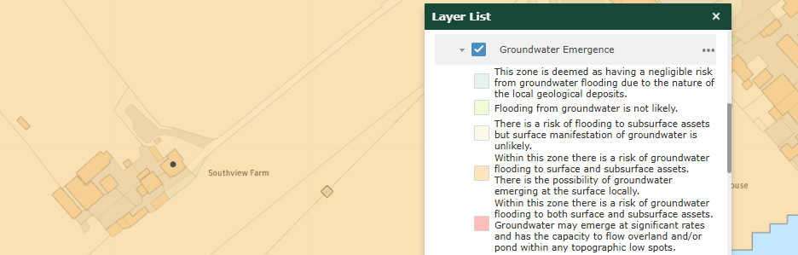

PROPOSAL: This application seeks planning permission for the construction of a three-bay agricultural storage building, and elsewhere on the site, to erect a polytunnel.

Two of the bays in the agricultural barn would be used for the storage of equipment and machinery for the applicant’s market garden business, which they intend to establish on the site, with an orchard, and for storing fodder and bedding for livestock on their holding. The remaining bay would be used as a domestic store and garage, ancillary to the existing farmhouse.

With reference to the applicant’s submitted Planning Statement (produced by LDPC, reference 2499_PS_v1), there are no agricultural buildings now associated with this particular holding, hence the submission of this application. The holding extends to 4.85 hectares, with the applicant stating in section 2.4 of their submitted Planning Statement that the remaining sheds and outbuildings on the site are not suitable for “the storage of either agricultural equipment or modern domestic uses or vehicles”.

The proposed barn would measure 20m in length, 10m in width and 4.9 in height (to the ridge) and would be completed in dark green coated profile-steel sheeting.

A twin-span polytunnel is also proposed to the growing of soft fruits and salad crops as part of the market garden. This would measure 20m in length, 12.8m in width with a height of 2.8m.

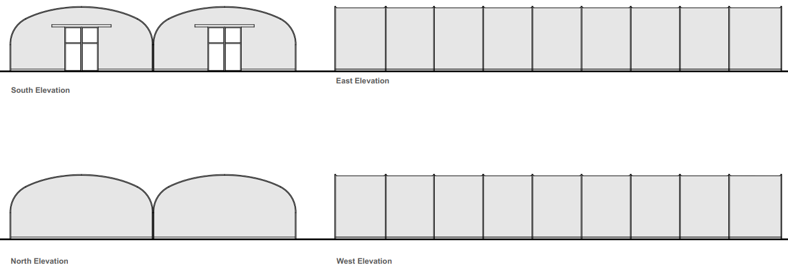

Proposed polytunnel elevations (drawing no. A0.23)

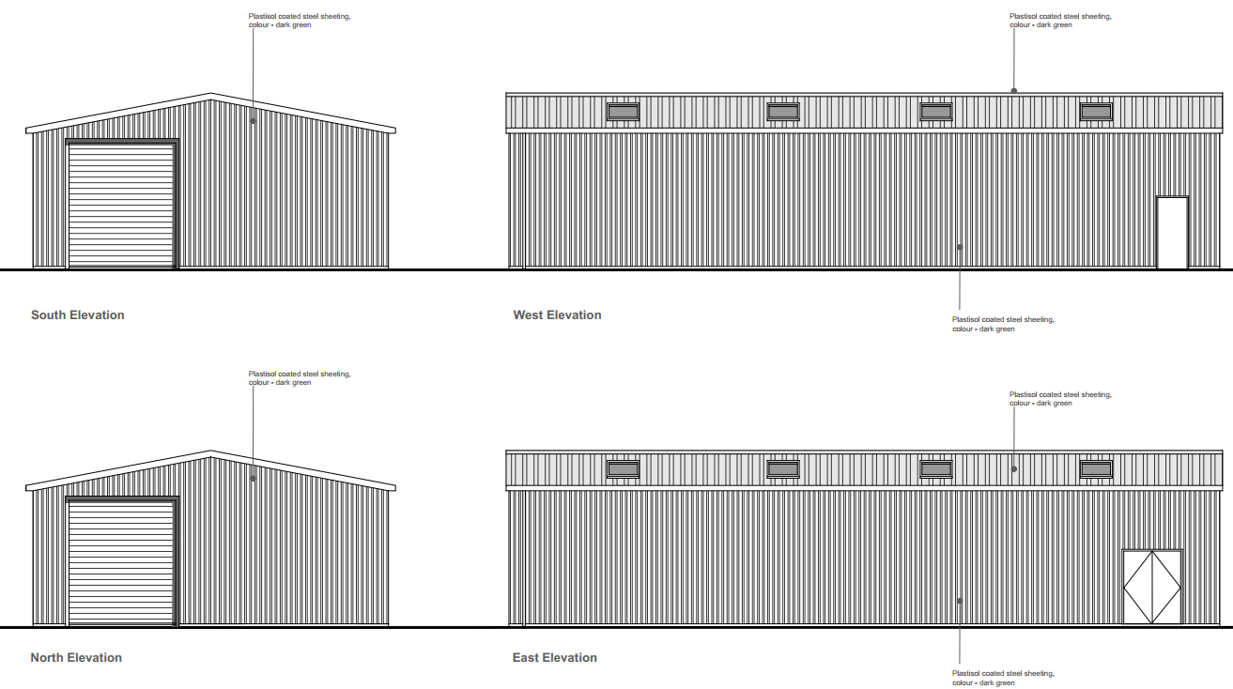

Proposed barn elevations (drawing no. A0.21A)

Both proposed buildings would be positioned to the north of the existing farmhouse, as illustrated in the extract on the next page taken from the submitted block plan drawing (A0.03):

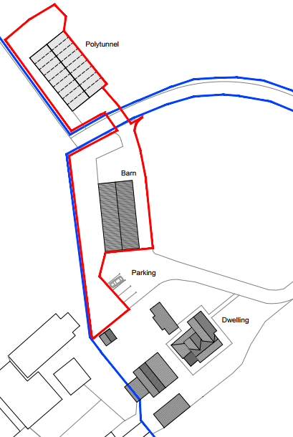

PLANNING HISTORY

PL/2026/01436 – Consent to display an advertisement for new signage to identify the property at the start of the driveway – Approved with conditions.

RELEVANT LEGISLATION, POLICIES AND GUIDANCE

National Planning Policy: National Planning Policy Framework (NPPF); Planning Practice Guidance (PPG)

Development Plan: The development plan for Wiltshire comprises the Wiltshire Core Strategy (WCS) (adopted January 2015) and any made neighbourhood plans, which remain the principal statutory planning document guiding development across the county. In line with Section 38(6) of the Planning and Compulsory Purchase Act 2004, planning decisions must be made in accordance with the development plan unless material considerations indicate otherwise.

Though the development plan is considered as a whole, those parts deemed to be particularly relevant to this application are listed below:

The adopted Wiltshire Core Strategy (WCS), with particular regard to:

- Core Policy 1 Settlement Strategy.
- Core Policy 2 Delivery Strategy.
- Core Policy 7 Spatial Strategy: Bradford on Avon Community Area.
- Core Policy 50 Biodiversity and Geodiversity.
- Core Policy 51 Landscape.
- Core Policy 52 Green Infrastructure.
- Core Policy 57 Ensuring High Quality Design and Place Shaping.
- Core Policy 60 Sustainable Transport.
- Core Policy 61 Transport & Development.
- Core Policy 67 Flood Risk.

Neighbourhood Plan: The ‘made’ Bradford on Avon Neighbourhood Plan 2013-2026 (made October 2017)

Draft Wiltshire Local Plan: At Full Council on 19 May 2026, the elected members of Wiltshire Council agreed to withdraw the emerging WLP. As such, the WLP has no material weight for the purposes of the application.

Supplementary Planning Documents and other Guidance:
- Wiltshire Local Transport Plan 2011-2026 (LTP3), adopted 2015 - including the Car Parking Strategy and Cycling Strategy
- Wiltshire Council Local Transport Plan 2025 -2038 (LTP4 adopted March 2025.

ISSUES: The main issues that need to be addressed in this case include principle of development; principle of the development in the Green Belt; design and visual impact; ecology; impact on neighbouring amenity; highway safety; and drainage.

CONSULTATION RESPONSES

Bradford on Avon Town Council: No objection

Wiltshire Council Ecology: No objection subject to conditions

Wiltshire Council Public Protection: No objections, subject to a condition restricting the hours of construction.

Wiltshire Council Highways: No objection

REPRESENTATIONS: In accordance with the requirements of the Town and Country Planning (Development Management Procedure) (England) Order 2015 (as amended), the application was publicised by way of:

- Neighbour notification letters sent to adjoining and nearby properties.
- A site notice displayed near the site.

These methods were used to inform interested parties and provide a period of 21 days for comments to be submitted.

Below is a summary of the representations received during the consultation period. Only material planning considerations have been taken into account in the assessment of this application. Non-material issues, such as property values or private legal disputes, cannot be considered in the determination process.

Bradford on Avon Preservation Trust: We have no objection and are pleased to see this proposal for the barn and polytunnel for agricultural and horticultural use to support the local economy.

ASSESSMENT: Section 38(6) of the Planning and Compulsory Purchase Act 2004 states:

"If regard is to be had to the development plan for the purposes of any determination to be made under the planning Acts, the determination must be made in accordance with the plan unless material considerations indicate otherwise."

In accordance with this statutory requirement, this application has been assessed against the relevant policies of the Development Plan, including the Wiltshire Core Strategy (2015) and, where applicable, any made Neighbourhood Plans. Consideration has also been given to the policies of the National Planning Policy Framework (NPPF) as a material consideration in the assessment.

Principle of Development: Policy CP1 of the adopted Settlement Strategy of the WCS establishes a hierarchy of settlements to guide where development should be focused. The policy prioritises growth in:
- Principal Settlements (e.g., Salisbury, Chippenham, Trowbridge) – main focus for strategic growth.
- Market Towns – support local services and employment; suitable for sustainable development.
- Local Service Centres – smaller towns and villages with a range of services; limited development supported.
- Large and Small Villages – development should be limited and respond to local needs.
- Outside the defined settlements – development is strictly controlled and generally not supported unless exceptional circumstances apply.

Policy CP2 of the WCS sets out how development would be distributed and delivered across Wiltshire. The policy emphasises:
- Sustainable patterns of growth, reducing the need to travel and supporting local services.
- Development should be plan-led, aligning with the settlement strategy and supported by infrastructure.
- Windfall development (not allocated in plans) must still comply with the principles of sustainable development.
- Development outside settlement boundaries is generally not permitted, unless it meets specific policy exceptions (as set out in paragraph 4.25 of the WCS).

Together, CP1 and CP2 ensure that new development is strategically located, sustainable, and supports the character and function of Wiltshire’s communities.

The NPPF sets out a clear and positive approach to supporting economic growth in rural areas, stating that planning decisions should enable the sustainable growth and expansion of all types of business in paragraphs 85 and 88, including agricultural and other land-based rural enterprises, and recognise that such development may need to be located in the countryside to operate effectively.

Paragraph 88 states that planning policies and decisions should enable the sustainable growth and expansion of all types of rural businesses and the development and diversification of agricultural and rural businesses.

In addition, Policy E1 of the Bradford on Avon Neighbourhood Plan supports sustainable economic development, including rural enterprise. The proposed agricultural building and associated market garden use are consistent with this objective.

Whilst the applicant proposes a market garden enterprise, limited evidence has been provided to demonstrate its operational need, scale, and viability of the proposed development. Notwithstanding this, the scale of development is modest and proportionate to the landholding (that is stated within the submitted information to measure 4.85ha), and it is accepted that some built form is reasonably required to support land management and an agricultural/horticultural; land use at this site.

This overarching national support is reflected at the local level within the adopted WCS, which provides a positive and flexible spatial framework for development and seeks to support a robust and diverse rural economy, including the expansion and diversification of existing businesses and the establishment of new enterprises within appropriate locations. Taken together, national and local policy provides strong in-principle support for new rural and agricultural businesses, subject to proposals being sustainable and compliant with all other material considerations.

Impact on the Green Belt: The fundamental aim of Green Belt policy is to prevent urban sprawl by keeping land permanently open. The essential characteristics of Green Belts are their openness and permanence. Development within the Green Belt is generally considered inappropriate unless it falls within specific exceptions set out in the NPPF Chapter 13. Any proposal that constitutes inappropriate development must demonstrate very special circumstances, which clearly outweigh the harm to the Green Belt and any other harm resulting from the proposal.

Paragraph 153 of the NPPF is clear that when assessing applications, “local planning authorities should ensure that substantial weight is given to any harm to the Green Belt, including harm to its openness. Inappropriate development is, by definition, harmful to the Green Belt and should not be approved except in very special circumstances. ‘Very special circumstances’ will not exist unless the potential harm to the Green Belt by reason of inappropriateness, and any other harm resulting from the proposal, is clearly outweighed by other considerations”.

With reference to paragraph 154(a) of the NPPF, the construction of new buildings for agricultural and forestry purposes are not considered to be inappropriate within the Green Belt, and therefore the construction of the proposed new agricultural barn and polytunnel for the stated purposes outlined in the application submission is considered acceptable in principle.

The made neighbourhood plan reiterates that development within the Green Belt is subject to strict control and aligns with national policy in this regard.

It is noted that the proposed agricultural barn would include an element of garaging, and domestic storage which does not fall within the above exception, as this aspect would be ancillary to the farmhouse. This is not uncommon on many farms across the County and given that the proposed building would primarily have an agricultural function, the use of one of the three bays, and subject to a planning condition restricting the non-agricultural use strictly to ancillary domestic storage and vehicle parking, the application can be supported.

The primary purpose of the proposed barn would be agricultural, and a condition can make that clear.

Design and Visual Impact on the Character and Appearance of the Area: Core Policy 57 of the WCS requires high-quality design that:
- Enhances local character.
- Responds to the natural, historic, and built environment.
- Retains important features (e.g., trees, hedges).
- Supports sustainable construction and compatibility with surrounding uses.
- Creates safe, legible, and accessible spaces.

In addition to the above, CP51 of the Wiltshire Core Strategy requires development to:
- Protect, conserve, and enhance landscape character and quality.
- Respect local distinctiveness, key views, and visual receptors.
- Give particular weight to impacts on National Landscapes (formerly AONBs) and locally valued landscapes.

Section 12 of the NPPF emphasises design that is:
- Visually attractive.
- Functionally effective.
- Contributes to the quality of the built environment.

The NPPF also emphasises the need to protect and enhance valued landscapes, particularly those with scenic, historic, or ecological significance. Planning decisions should:

- Recognise the intrinsic character and beauty of the countryside.
- Safeguard key views, local distinctiveness, and landscape settings.
- Ensure development is well-integrated into its surroundings and avoids visual intrusion, especially in sensitive or designated areas.

The Wiltshire Design Guide SPD promotes a context-led approach, encouraging integration with natural features and settlement patterns while avoiding visual intrusion.

The Green & Blue Infrastructure Strategy (2022–2030) supports landscape protection through green infrastructure, habitat connectivity, and nature-based solutions.

Landscape impact must be considered alongside biodiversity, heritage, and green infrastructure objectives, with mitigation measures encouraged where harm cannot be avoided.

Apart from Green Belt, the application site does not fall within any other protected landscape designations.

Existing hedgerows are present along the western boundary, and the scheme includes proposals for additional landscaping and planting along this boundary. However, the eastern boundary adjoins open countryside, and officers consider that the proposed agricultural building and polytunnel would remain visible within the wider landscape and from public viewpoints.

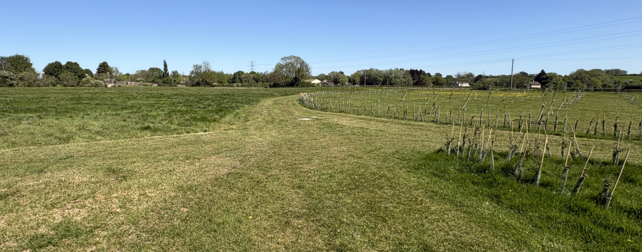
Site photo showing the new planting that the applicant has introduced along the eastern part of the site.

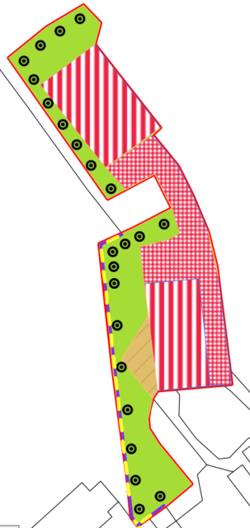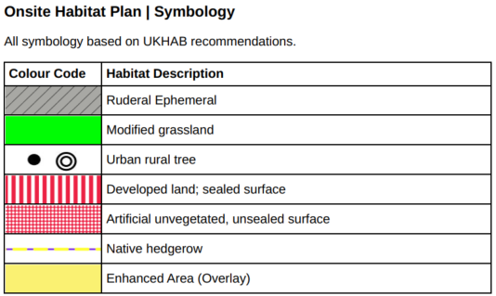
Extracts taken from the submitted post-development map, showing the on-site habitats.
In recognition of the site conditions and the afore cited on-site habitat symbology, there is limited scope to significantly alter the proposed siting of the buildings within the red line boundary. Notwithstanding this, during the site visit it was observed that the applicant has already undertaken planting within the field between the A363 Trowbridge Road and the proposed development. In time, this planting will establish and provide a degree of natural screening. The proposal is nevertheless going to be a functional agricultural building which is not considered inappropriate in the green belt as directed by the Government and the presence of agricultural buildings on the land identified, is not objectionable.

While some public views of the proposed buildings would be gained, the proposed structures would be read as agricultural development associated with the existing agricultural holding, relatively near to the farmhouse, would support a new agricultural operation and would not appear incongruous within the wider rural landscape.

Policy BE1 of the made neighbourhood plan requires development to reinforce local distinctiveness and respond appropriately to its wider landscape setting. Policy BE2 further requires development to integrate with its surroundings and respect local character.

The proposed agricultural building and polytunnel would be functional in appearance and subject to the establishment of proposed planting and landscaping, the development would broadly accord with Policies BE1 and BE2.

Based on the above, it is considered that there would be suitable screening provided on-site, and whilst some views of the polytunnels would be gained, given the proposed height of the structures and the distance between the proposed development and the road (which exceeds 200m), it is not considered that the proposed development would result in unacceptable visual or landscape harm.

Amenity: Policy CP57 (Point vii) of the WCS requires development to respect the amenity of existing occupants and ensure appropriate amenity levels for future residents.

Paragraph 135 of the NPPF, reinforces the need for development to provide a high standard of amenity for both existing and future users. Criterion 135(f) requires that development ensure a high standard of amenity for existing and future users.

With due regard to the separation distance between the proposed development and neighbouring properties, the proposed development is not considered to have an adverse impact on the amenity of neighbouring properties, due to its location and design.

Highways Impacts and Parking: Transport implications can be a material factor in assessing planning applications, especially for larger developments. Proposals must demonstrate:
- Safe and suitable access for all users, including pedestrians, cyclists, and those with mobility impairments.
- No severe residual impacts on the surrounding highway network.
- Promotion of sustainable travel, reducing reliance on private vehicles.
- Adequate parking and cycle provision, in line with adopted standards.
- Protection and enhancement of public rights of way and active travel routes.

Relevant policies include Core Policies 60–64 of the Wiltshire Core Strategy, supported by the Wiltshire Local Transport Plan, Car Parking Strategy, and Cycling Strategy. The Local Cycling and Walking Infrastructure Plan (LCWIP) and LTN 1/20 (DfT) provide further design guidance for active travel infrastructure.

Paragraphs 109–113 and para 116 of the NPPF require safe and suitable access, and that development should only be refused on transport grounds where impacts are severe.

The application is served by an established access via Trowbridge Road, and this application does not seek to alter the existing access arrangement to the site. The existing site has sufficient space to accommodate the parking of multiple cars and an on-site turning provision. The Council’s highways department were consulted on the application and raised no objections to the proposal. Therefore, the proposal is considered to comply with the above-listed policy.

Ecology and Biodiversity: Ecology and planning officers have considered the following pursuant to ecological/biodiversity matters:

- Protected species
- Priority habitats
- Ecological networks
- Green and blue infrastructure

Core Policy 50 of the Wiltshire Core Strategy requires development to:

- Avoid harm to ecological assets.
- Deliver measurable Biodiversity Net Gain (BNG), in line with the Environment Act 2021.
- Support habitat restoration and connectivity.
- Integrate biodiversity into site design.

The Green & Blue Infrastructure Strategy (2022–2030) promotes nature recovery, ecosystem services, and habitat connectivity through development.

Policy GS1 of the made Neighbourhood Plan supports biodiversity enhancement and seeks net gain as part of development proposals. Policy GS2 requires that development affecting bat habitats be supported by appropriate survey work and mitigation, having regard to Wiltshire Council’s Habitats Regulations Assessment guidance for the Bath and Bradford on Avon SAC.

Bath and Bradford-on-Avon Bats Special Area for Conservation (SAC): The application site is located within multiple Greater Horseshoe and Lesser Horseshoe core roost buffers associated with the Bath and Bradford-on-Avon bat SAC. The current proposal therefore has potential to result in significant adverse impact on the special features of the SAC. Appropriate Assessment (AA) under Section 63 of the Conservation of Habitats and Species Regulations 2017 (as amended) must be carried out by the relevant Competent Authority (the LPA) to determine the potential significant effects and the suitability of any measures proposed to avoid or mitigate those effects.

The submitted BNG metric identified that there would be a loss of ~0.08 ha of grassland and ruderal habitat. This habitat may be of some value to species such as Greater Horseshoe bats (known to be associated with patchworks of fields, particularly containing grazed pasture). It would therefore be appropriate for compensatory habitat to be secured.

The applicant has provided details (within the Biodiversity Net Gain Strategy, reference 2499B_BNG_strategy_v1) of the proposed planting, which includes details of tree and hedgerow planting, in addition to the proposed grassland meadow wildflower mix, and of lighting which would be motion sensor with a 5-minute shut-off setting, which would lit the building and would comprise downward-facing fixtures. It is considered that the proposed planting and lighting details are acceptable and would be sensitive to wildlife. Furthermore, the submissions demonstrate sufficient compensation for the loss of the modified grassland as a result of the proposed development.

As required by the Conservation of Habitats and Species Regulations 2017 (as amended) an Appropriate Assessment has been completed by the LPA with a favourable conclusion. The AA was sent to Natural England, who confirmed that they agree with the Council’s decision on the AA and have raised no objections to the proposal.

Biodiversity Net Gain (BNG): From 12 February 2024 Biodiversity Net Gain (BNG) became mandatory under Schedule 7A of the Town and Country Planning Act 1990 (as inserted by Schedule 14 of the Environment Act 2021)

The submitted Biodiversity Net Gain Strategy (reference 2499B_BNG-strategy_v1) confirms that the site has a baseline biodiversity value of 0.5737 habitat units and 0.0537 hedgerow units and sets out measures to ensure biodiversity enhancements in accordance with policy requirements. These include the planting of 23 native trees along the western site boundary, the establishment of a species-rich native hedgerow, and the creation of wildflower meadow grassland across undeveloped areas to improve habitat diversity. The strategy also provides for appropriate planting, protection, and management regimes to secure successful establishment and long-term biodiversity benefits.

External lighting has been designed to minimise ecological impacts, comprising low-level, downward-facing, motion-activated fittings to reduce light spill and disturbance. Overall, the proposals are considered to deliver measurable on-site biodiversity enhancements and achieve compliance with BNG objectives.

The submitted metric and separately submitted Biodiversity Gain Plan demonstrate a net gain exceeding the 10% requirement, providing 11.08% in area habitats and 301% of hedgerow units, thereby complying with Schedule 14 of the Environment Act 2021.

Having regard to the submitted ecological information, the proposed mitigation and enhancement measures in terms of additional planting, and the favourable AA to which Natural England agrees, the proposal complies with CP50 and policies GS1 and GS2 of the made neighbourhood plan.

Flood Risk and Drainage: Policy 67 of the Wiltshire Core Strategy and NPPF paragraphs 170–182 require:
- Avoidance of increased flood risk.
- Use of appropriate mitigation measures.
- Application of the sequential and exception tests for developments in Flood Zones 2 or 3.

Sustainable Drainage Systems (SuDS) are required for all major developments and must:
- Manage runoff near its source.
- Improve water quality.
- Support biodiversity and amenity.
- Be integrated into the site layout and green infrastructure.
The application has been supported by a Site-Specific Flood Risk Assessment & Drainage Strategy, which confirms that the site lies within Flood Zone 1 and is therefore at low risk of fluvial flooding. While the Council’s SFRA identifies there to be potential for groundwater emergence locally, the overall risk to the site is however considered to be limited and should not affect the proposed agricultural development.

The proposal comprising an agricultural barn (with restricted ancillary domestic storage provision) and a polytunnel, is classified as ‘less vulnerable’ and is appropriate within this flood zone.

Surface water would be managed sustainably via water butts and a soakaway to ground, ensuring no increase in runoff or off-site flood risk.

Overall, the development is considered to be at low risk of flooding, with negligible residual risk over its anticipated lifetime.

Officers are satisfied the proposal would neither increase flood risk elsewhere nor be subject to unacceptable flood risk itself.

PLANNING BALANCE AND CONCLUSION: The principle of development is considered acceptable when assessed against the adopted WCS and the NPPF.

The proposal would support an existing agricultural holding and proposed market garden enterprise, thereby contributing to rural economic activity in accordance with national and local plan policy objectives supporting sustainable rural businesses. Whilst the development introduces additional built form into the countryside/green belt, the proposal would be for agricultural purposes and functions that are considered appropriate in terms of siting, design, appearance and size.

There are no objections based on residential amenity, highway safety, biodiversity interests or flood risk.

Appropriate ecological mitigation and biodiversity enhancement measures are proposed, and a favourable Habitats Regulations Appropriate Assessment has been completed.

Taking all matters into account, the development is considered to accord with the development plan when read as a whole.

Accordingly, the proposal is considered acceptable in planning terms and in accordance with the Wiltshire Core Strategy, the National Planning Policy Framework, and all other relevant material considerations.

RECOMMENDATION: That Planning Permission be GRANTED, subject to conditions

