APPLICATION FOR FULL-PLANNING PERMISSION
CASE OFFICER REPORT

APPLICATION REFERENCE: | PL/2026/01636
APPLICATION TYPE: | Full planning permission
SITE ADDRESS: | Little Northfield Stables, Devizes Road, Poulshot, SN10 1TD
DEVELOPMENT DESCRIPTION: | Retrospective application for the siting of two containers and water storage tank, erection of small outbuildings including a greenhouse and shed, and extension of hardstanding
RECOMMENDATION: | Approve with Conditions

SITE DESCRIPTION/CONTEXT
The site stands on the northern outskirts of the small village of Poulshot as designated in the Wiltshire Core Strategy, on the western side of Devizes Road. The site is surrounded by fields, with residential development across Devizes Road to the southeast.

The site itself is set within the boundary of a field that holds a stable block which is served by an existing agricultural access. Planning consent was granted in 2009 for the erection of a stable and hay store. Poulshot Conservation Area stands some 60m to the south and a Public Right of Way crosses the field adjacent to that hosting the site, approximately 170m west of the site and separated by mature hedgerow.

PROPOSAL
The application seeks to regularise the siting of 2 shipping containers, a water storage tank, erection of small outbuildings comprising a greenhouse and shed and extension of hardstanding.

The outbuildings and containers are sited to the rear of the stable along the northern hedgerow of the field. The hardstanding forms an area around the stable allowing for turning of vehicles and the siting of the structures.
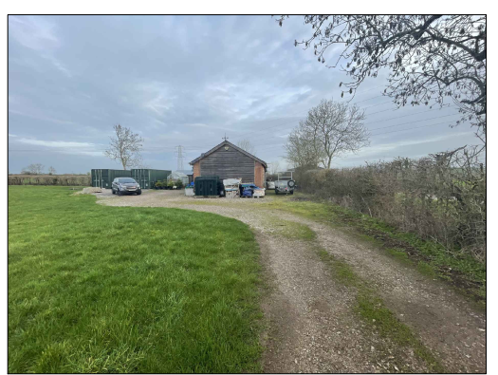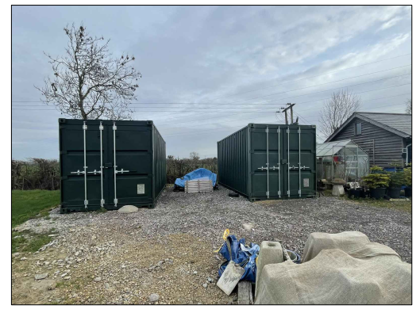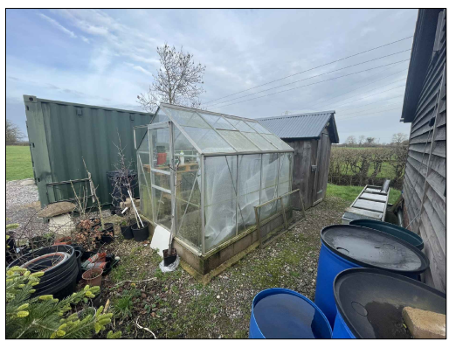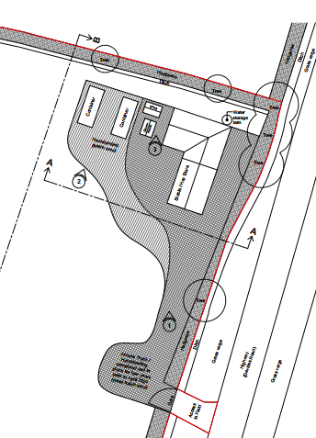

PLANNING HISTORY

Proposal / Summary
K/59957/F - Full planning permission Decision - Approve with Conditions Date: 9/2/2009 – Stable and hay store

RELEVANT LEGISLATION, POLICIES AND GUIDANCE

Statutory Legislation:

National Planning Policy:
- National Planning Policy Framework (NPPF)
- Planning Practice Guidance (PPG)
- National Design Guide
Development Plan:
The development plan for Wiltshire comprises the Wiltshire Core Strategy (WCS) (adopted January 2015) and any made neighbourhood plans, which remains the principal statutory planning document guiding development across the county. In line with Section 38(6) of the Planning and Compulsory Purchase Act 2004, planning decisions must be made in accordance with the development plan unless material considerations indicate otherwise.

Though the development plan is considered as a whole, those parts deemed to be particularly relevant to this application are listed below:

The adopted Wiltshire Core Strategy (WCS), with particular regard to:

- Core Policy 1 Settlement Strategy;
- Core Policy 2 Delivery Strategy;
- Core Policy 3 Infrastructure Requirements;
- Core Policy 12 Spatial Strategy Devizes Community Area
- Core Policy 41 Sustainable Construction and Low-Carbon Energy;
- Core Policy 48 Supporting Rural Life
- Core Policy 50 Biodiversity and Geodiversity;
- Core Policy 51 Landscape
- Core Policy 52 Green Infrastructure
- Core Policy 57 Ensuring High Quality Design and Place Shaping;
- Core Policy 58 Ensuring the Conservation of the Historic Environment;
- Core Policy 60 Sustainable Transport;
- Core Policy 61 Transport & Development;
- Core Policy 64 Demand Management
- Core Policy 67 Flood Risk;

Draft Wiltshire Local Plan Policies
At Full Council on 19 May, the elected members of Wiltshire Council agreed to withdraw the emerging WLP. It will now be subject to a legal process to finalise its withdrawal – which is likely to happen in July or August (2026). The said Plan has no material weight for the purposes of the application.

Neighbourhood Plan:
N/A

Supplementary Planning Documents and other Guidance:
- Wiltshire Design Guide (adopted April 2024)
- Wiltshire Local Transport Plan 2011-2026, adopted 2015 - including the Car Parking Strategy and Cycling Strategy, adopted 2015

ISSUES

The main issues that need to be addressed in this case include:

- Whether the proposal constitutes EIA development
- Whether the development is acceptable in principle (CP 1 and 2)
- Whether the scheme constitutes high quality design (CP 57)
- Whether the scheme would have an acceptable impact upon the reasonable living conditions of the adjoining occupants (CP 57)
- Whether the scheme would preserve or enhance the historic environment (CP 58)
- Whether the scheme would have an acceptable landscape impact (CP 51)
- Whether the proposal would have a negative effect upon highway safety, including if there is sufficient parking for the proposed development (CP 61 and 64)
- Whether the site can be adequately drained without increasing flood risk elsewhere (CP 67)
- Whether there would be any harmful impacts upon protected species or priority habitats (CP 50)
- Are there any other planning issues raised by the development?

CONSULTATION RESPONSES

WC Highways: No objection

Parish/Town Council: No objection

REPRESENTATIONS
In accordance with the requirements of the Town and Country Planning (Development Management Procedure) (England) Order 2015 (as amended), the application was publicised by way of:

- Neighbour notification letters sent to adjoining and nearby properties;
- A site notice displayed near the site;
- An advertisement placed in the local press.

These methods were used to inform interested parties and provide a period of 21 days for comments to be submitted.

Below is a summary of the representations received during the consultation period. Only material planning considerations have been taken into account in the assessment of this application. Non-material issues, such as property values or private legal disputes, cannot be considered in the determination process.

A total of 2 representations were made, both in support of the proposal:

- I can see the site from my rear garden, it always looks tidy and presentable and I have never been disturbed by noise or any other nuisance. I see no reason to refuse permission.

- I have never been disturbed by noise, light, nor have I been impacted visually by this rather small development and I support its approval.

ASSESSMENT
Section 38(6) of the Planning and Compulsory Purchase Act 2004 states:

"If regard is to be had to the development plan for the purposes of any determination to be made under the planning Acts, the determination must be made in accordance with the plan unless material considerations indicate otherwise."

In accordance with this statutory requirement, this application has been assessed against the relevant policies of the Development Plan, including the Wiltshire Core Strategy (2015) and, where applicable, any made Neighbourhood Plans. Consideration has also been given to the policies of the National Planning Policy Framework (NPPF) as a material consideration in the assessment.

Environmental Impact Assessment (EIA) Screening
In accordance with the Town and Country Planning (Environmental Impact Assessment) Regulations 2017 (as amended), the local planning authority has considered whether the proposed development constitutes EIA development.

No Screening Opinion Issued
No formal screening opinion was requested or issued. However, the local planning authority has considered the scale and nature of the development as part of the application process and is satisfied that it does not constitute EIA development under the 2017 Regulations.

Principle of Development
Policy Context
Core Policy 1: Settlement Strategy of the WCS establishes a hierarchy of settlements to guide where development should be focused. The policy prioritises growth in:
- Principal Settlements (e.g., Salisbury, Chippenham, Trowbridge) – main focus for strategic growth.
- Market Towns – support local services and employment; suitable for sustainable development.
- Local Service Centres – smaller towns and villages with a range of services; limited development supported.
- Large and Small Villages – development should be limited and respond to local needs.
- Outside the defined settlements – development is strictly controlled and generally not supported unless exceptional circumstances apply.
.
Core Policy 2: Delivery Strategy of the WCS sets out how development will be distributed and delivered across Wiltshire. The policy emphasises:
- Sustainable patterns of growth, reducing the need to travel and supporting local services.
- Development should be plan-led, aligning with the settlement strategy and supported by infrastructure.
- Windfall development (not allocated in plans) must still comply with the principles of sustainable development.
- Development outside settlement boundaries is generally not permitted, unless it meets specific policy exceptions (as set out in paragraph 4.25 of the WCS).

Together, CP1 and CP2 ensure that new development is strategically located, sustainable, and supports the character and function of Wiltshire’s communities.

Assessment
The proposal relates to the retention of two shipping containers, a water storage tank, a greenhouse, a shed and associated hardstanding within a field that already benefits from planning permission for a stable and hay store. The structures are used in connection with the management and maintenance of the land within the applicant's ownership and control, including land that is owned and rented by the applicant.

The proposed development does not comprise new residential, commercial or other forms of built development that would conflict with the settlement strategy. Rather, it represents ancillary storage and operational infrastructure associated with the ongoing management of land in a rural location. Such facilities are inherently rural in nature and are most appropriately located within the countryside where the associated land management activities occur.

Whilst the application site lies outside a defined settlement boundary, the proposal is of a scale and nature that is functionally related to the lawful use of the site and surrounding land. Having regard to the limited scale of the development and its rural function, the proposal is considered acceptable in principle subject to the detailed assessment set out below.

Conclusion
The proposal comprises ancillary storage and operational facilities associated with the management of land in a rural location. Having regard to its scale, nature and functional relationship with the lawful use of the site, the development is considered acceptable in principle and accords with the objectives of Core Policies 1 and 2 of the Wiltshire Core Strategy

Design and Impact on the Character and Appearance of the Area
Policy Context
Core Policy 57 of the WCS requires high-quality design that:
- Enhances local character.
- Responds to the natural, historic, and built environment.
- Retains important features (e.g., trees, hedges).
- Supports sustainable construction and compatibility with surrounding uses.
- Creates safe, legible, and accessible spaces.

Section 12 of the NPPF emphasises design that is:
- Visually attractive.
- Functionally effective.
- Contributes to the quality of the built environment.

The Wiltshire Design Guide encourages sensitivity to local character, materials, and architectural styles and supports modern living standards while maintaining aesthetic and functional quality.

Building for a Healthy Life Framework promotes healthy, inclusive, and sustainable places. The document encourages:

- Walkability.
- Access to green space.
- Active design principles for well-being.

Assessment
The structures subject of this application stand to the rear of the existing stable. They consist of a greenhouse, a timber shed, a water storage tank and 2 shipping containers. The greenhouse and timber shed are considered appropriate in design terms and their siting on the field would not be inappropriate in the countryside. The water storage tank is a temporary structure and would also be considered appropriate in an agricultural setting.

The shipping containers are utilitarian structures whose appearance is not reflective of the prevailing rural character of the surrounding countryside. By virtue of their standardised form, materials and industrial appearance, they appear incongruous when compared with the more traditional agricultural and rural buildings typically found within the area.

As such, the containers give rise to a degree of conflict with the design objectives of Core Policy 57 and the wider aims of national policy which seek development that responds positively to local character and distinctiveness.

However, the containers are positioned to the rear of the existing stable building and benefit from a degree of screening provided by existing hedgerows and vegetation around the site. Their visibility from public viewpoints is therefore limited and localised.

Whilst the development introduces a feature that is not characteristic of the rural environment, the resulting harm to character and appearance is considered limited rather than substantial.

Conclusion
The shipping containers are utilitarian in appearance and do not reflect the prevailing character of the rural area, giving rise to a limited degree of conflict with the design objectives of Core Policy 57. The proposal would therefore result in a moderate adverse effect upon the character and appearance of the site and its immediate surroundings.

Nevertheless, the identified harm attracts only moderate weight due to the extent of existing screening and the limited visibility of the structures from public vantage points. Furthermore, the permission sought is temporary for a period of three years, following which the containers would be removed and the land restored through an appropriately worded planning condition.

The identified harm is therefore temporary, localised and reversible. On balance, whilst conflict with Core Policy 57 is acknowledged, the temporary nature of the development significantly reduces the weight attributed to that conflict.

Impact on Heritage Assets
Policy Context
From the point of view of the historic environment the main statutory tests are set out within the Planning (Listed Building and Conservation Areas) Act 1990.

Section 72(1) of the Act requires the Council to pay special attention to the desirability of preserving or enhancing the character or appearance of designated Conservation Areas.

The Council’s Core Strategy CP 57: Ensuring high quality design requires a high quality of design in all new developments. The policy requires applicants to “demonstrate how the proposal will make a positive contribution to the character of Wiltshire through (amongst other things) responding to the value of the natural and historic environment and being sympathetic to and conserving historic buildings and landscapes. Development is required to respond positively to the existing in terms of building layouts, built form, height, mass, scale, building line, plot size, elevational design, materials, streetscape and rooflines to effectively integrate the building into its setting.

Assessment
The site lies approximately 60m north of the Poulshot Conservation Area, from which it is largely screened by the existing hedgerow along Devizes Road and the existing residential built form on Sillington Lane. The proposal is also set back from the road to the rear of the existing stable.

The site is located at a reasonable distance from the Conservation Area boundary and views towards the development would be substantially filtered by existing boundary hedgerows and the intervening stable building. As a result, the proposal would have limited visibility within the wider heritage setting and would not materially affect important views into, out of, or across the Conservation Area.

Whilst the shipping containers are not characteristic features within the setting of a Conservation Area, their visibility from the Conservation Area is limited by distance, intervening built form and established vegetation. Consequently, the proposal would not result in harm to the significance, character or appearance of the Poulshot Conservation Area

Conclusion
Having regard to the statutory duty under Sections 66 and 72 of the Planning (Listed Buildings and Conservation Areas) Act 1990, it is considered that the proposal would preserve the character and appearance of the Conservation Area.

Furthermore, the permission sought is temporary in nature. Any impacts arising from the development would therefore be reversible, with the site capable of being restored to its former condition upon cessation of the use. Consequently, while there may be a very limited and temporary change to the setting of the Conservation Area, this would be minor, reversible and would not result in harm to its significance.

Overall, the proposal would preserve the significance, character and appearance of the Conservation Area, and no heritage objection is raised.

Amenity
Policy Context
Core Policy 57 (Point vii) of the Wiltshire Core Strategy requires development to respect the amenity of existing occupants and ensure appropriate amenity levels for future residents.

The National Planning Policy Framework (NPPF), particularly Paragraph 135, reinforces the need for development to provide a high standard of amenity for both existing and future users.

These policies guide the assessment of amenity impacts, which have been considered.

Conclusion
Due to the siting of the proposal away from residential development there are no amenity impacts through overlooking, loss of privacy, loss of light, overshadowing, overbearing impact, noise or space standards from the proposal which therefore accords with Core Policy 57 of the Wiltshire Core Strategy and paragraph 135 of the National Planning Policy Framework.

Highways Impacts and Parking
Policy Context
Transport implications are a key factor in assessing planning applications, especially for larger developments. Proposals must demonstrate:
- Safe and suitable access for all users, including pedestrians, cyclists, and those with mobility impairments.
- No severe residual impacts on the surrounding highway network.
- Promotion of sustainable travel, reducing reliance on private vehicles.
- Adequate parking and cycle provision, in line with adopted standards.
- Protection and enhancement of public rights of way and active travel routes.

Relevant policies include Core Policies 60–64 of the Wiltshire Core Strategy, supported by the Wiltshire Local Transport Plan, Car Parking Strategy, and Cycling Strategy. The Local Cycling and Walking Infrastructure Plan (LCWIP) and LTN 1/20 (DfT) provide further design guidance for active travel infrastructure.

Proposals must also ensure safe access for refuse collection vehicles and comply with the Wiltshire Council Waste Storage and Collection SPD (2017).

Where necessary, Transport Assessments or Statements should be submitted to evaluate impacts and identify mitigation. Planning conditions or legal agreements may be used to secure off-site improvements, travel plans, or contributions to sustainable transport infrastructure.

Assessment
The proposal includes the regularisation of the existing hardstanding that provides parking and turning for vehicles within the boundary of the site. There is no change to the existing access arrangements which, as an agricultural field access, are considered appropriate for the development. That access is also made up of consolidated material and therefore there should be no impacts on highway safety as a result of the proposal.

Conclusion
Having regard to Core Policies 60-64 of the Wiltshire Core Strategy it is considered that the proposed development will not increase traffic to and from the site and as such will have no adverse impact on highway infrastructure or safety.

Ecology and Biodiversity
Policy Context
The ecological impact of development is a key planning consideration, especially for larger schemes. Proposals must assess and address potential effects on:

- Protected species
- Priority habitats
- Ecological networks
- Green and blue infrastructure

Core Policy 50 of the Wiltshire Core Strategy requires development to:

- Avoid harm to ecological assets.
- Deliver measurable Biodiversity Net Gain (BNG), in line with the Environment Act 2021.
- Support habitat restoration and connectivity.
- Integrate biodiversity into site design.

The Green & Blue Infrastructure Strategy (2022–2030) promotes nature recovery, ecosystem services, and habitat connectivity through development.

Unless exempt, National policy requires a minimum of 10% Biodiversity Net Gain (BNG) for major developments, demonstrated via:

- Biodiversity Metric calculations
- Ecological assessments (e.g. PEAs, Phase 1 surveys, protected species surveys)

Assessment
The proposal is a retrospective application for the siting of shipping containers, a shed and a greenhouse on land that is currently used for agriculture. Due to the small scale of the proposal set away from the adjacent hedgerow it is considered that it is unlikely that there will be significant impacts on ecological networks and habitat as a result of the development.

As retrospective development, the proposed development is exempt from the need to provide 10% Biodiversity Net Gain in accordance with Schedule 7A of the Town and Country Planning Act 1990.

Conclusion
The proposal is not considered to result in any unacceptable impact on ecology, protected species or biodiversity interests. Furthermore, statutory Biodiversity Net Gain requirements do not apply in this case. The proposal therefore accords with the objectives of Core Policy 50 of the Wiltshire Core Strategy.

Landscape and Visual Impact
Policy Context
Core Policy 51 of the Wiltshire Core Strategy requires development to:
- Protect, conserve, and enhance landscape character and quality.
- Respect local distinctiveness, key views, and visual receptors.
- Give particular weight to impacts on National Landscapes (formerly AONBs) and locally valued landscapes.

The Wiltshire Design Guide SPD (2024) promotes a context-led approach, encouraging integration with natural features and settlement patterns while avoiding visual intrusion.

The Green & Blue Infrastructure Strategy (2022–2030) supports landscape protection through green infrastructure, habitat connectivity, and nature-based solutions.

The NPPF emphasises the need to protect and enhance valued landscapes, particularly those with scenic, historic, or ecological significance. Planning decisions should:

- Recognise the intrinsic character and beauty of the countryside.
- Safeguard key views, local distinctiveness, and landscape settings.
- Ensure development is well-integrated into its surroundings and avoids visual intrusion, especially in sensitive or designated areas.

Landscape impact must be considered alongside biodiversity, heritage, and green infrastructure objectives, with mitigation measures encouraged where harm cannot be avoided.

Assessment
The application site is located within the open countryside. Whilst the rural character of the area is recognised, the site does not lie within a National Landscape, and therefore does not benefit from the highest levels of landscape protection.

The landscape impact identified arises primarily from the appearance of the shipping containers, which has already been considered within the design assessment above. In landscape terms, the principal issue is therefore the extent to which that visual effect is experienced within the wider countryside.

Whilst the shipping containers give rise to the same visual concerns identified within the design assessment, their effects on the wider landscape are limited by existing screening and vegetation surrounding the site. Views of the development are therefore localised and restricted.

The proposal would result in a minor adverse landscape effect. However, this harm is temporary and reversible by virtue of the proposed three-year permission. The landscape impacts therefore attract only limited weight in the overall planning balance and are not considered sufficient to justify refusal when considered alongside the benefits of the proposal and the temporary nature of the development.

Conclusion
On balance, whilst the proposal would give rise to a minor adverse effect on landscape character and visual amenity, the impact is not considered to be significant. Furthermore, the harm is capable of being mitigated by the imposition of a temporary permission condition requiring the removal of the containers and restoration of the site at the expiry of the consent period. The temporary and reversible nature of the development attracts moderate weight and reduces the overall significance of the identified landscape and visual harm. Therefore it is considered that the proposal will accord with Core Policy 51 of the Wiltshire Core Strategy.
Flood Risk and Drainage
Policy Context
Core Policy 67 of the Wiltshire Core Strategy and NPPF paragraphs 170–182 require:
- Avoidance of increased flood risk.
- Use of appropriate mitigation measures.
- Application of the sequential and exception tests for developments in Flood Zones 2 or 3.

Sustainable Drainage Systems (SuDS) are required for all major developments and must:
- Manage runoff near its source.
- Improve water quality.
- Support biodiversity and amenity.
- Be integrated into the site layout and green infrastructure.

Assessment
The site lies in Flood Zone 1 and is of a scale that no Flood Risk Assessment is required. The site also lies within an area of raised groundwater flood risk. However due to the location away from neighbouring development, the small scale of the proposal and its less than vulnerable use with regard to the impacts of flooding, it is considered that there are no concerns with regard to flood risk either to or from the development and that the proposal accords with Core Policy 67 of the Wiltshire Core Strategy and NPPF paragraphs 170–182.

PLANNING BALANCE AND CONCLUSION
The proposal comprises ancillary storage and operational facilities associated with the management of land in a rural location. The principle of development is therefore considered acceptable having regard to Core Policies 1, 2 and 48 of the Wiltshire Core Strategy.

The principal harm identified relates to the appearance of the shipping containers. The containers are utilitarian structures that do not respond positively to local character and therefore give rise to a moderate degree of conflict with the design objectives of Core Policy 57. A minor adverse landscape effect has also been identified under Core Policy 51.

However, the containers are positioned behind the existing stable building, benefit from existing hedgerow screening and have limited visibility from public viewpoints. The identified visual impacts are therefore localised rather than widespread.

Significant weight is attributed to the fact that the permission sought is temporary. The development would be removed following expiry of the consent period and the land restored through appropriately worded planning conditions. Consequently, the identified harm is temporary, reversible and capable of being fully mitigated over the longer term.

No unacceptable impacts have been identified in respect of heritage assets, neighbouring amenity, highway safety, flood risk, drainage, biodiversity or public rights of way. The proposal would provide storage facilities supporting the ongoing management of land in a rural location and this attracts moderate positive weight in favour of the development.

Taking all matters into account, the moderate conflict with Core Policy 57 and minor conflict with Core Policy 51 are outweighed by the benefits of the proposal, the absence of technical objections and the temporary and reversible nature of the identified harm. The overall planning balance therefore favours approval.

RECOMMENDATION:
That Planning Permission be GRANTED, subject to conditions

