APPLICATION FOR HOUSEHOLDER PLANNING PERMISSION DELEGATED REPORT

APPLICATION REFERENCE: | PL/2026/01882
APPLICATION TYPE: | Householder planning permission
SITE ADDRESS: | Wheelwrights Cottage, Burton, Mere, Warminster, BA12 6BR
DEVELOPMENT DESCRIPTION: | Rear and side extensions to house, with internal alterations
RECOMMENDATION: | That Planning Permission be GRANTED

PROPOSAL

The proposal seeks planning permission for the erection of extensions to the rear and side of the existing dwelling.

Existing and proposed ground floor plans

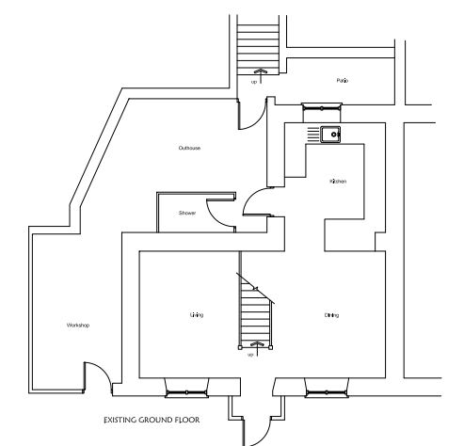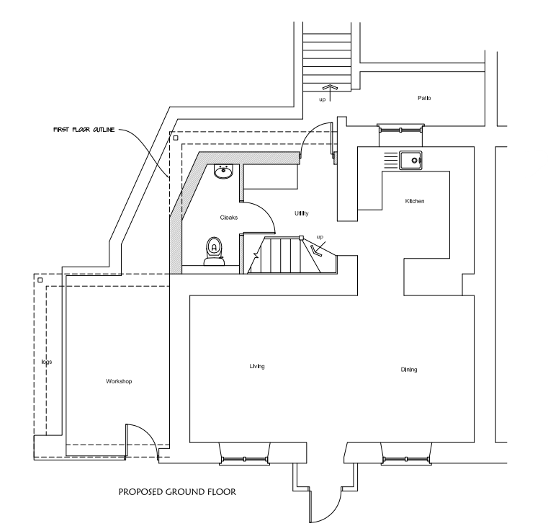

Existing and proposed first floor plans

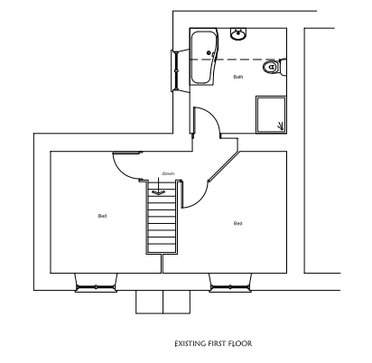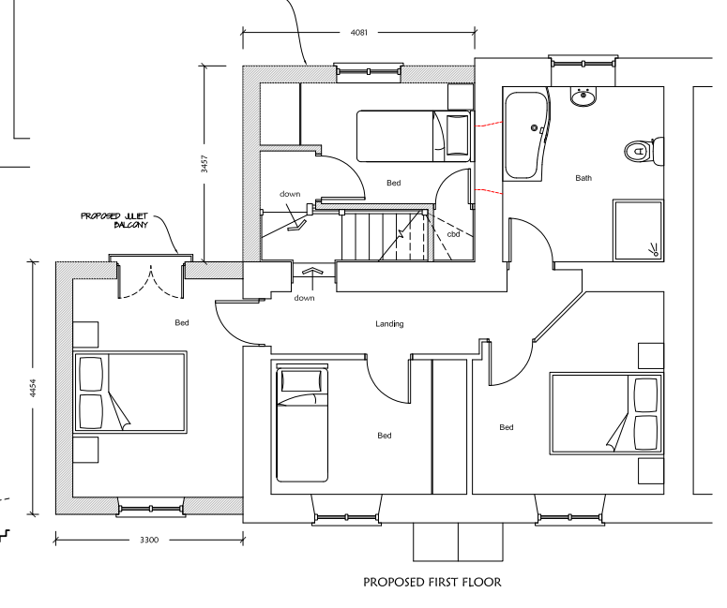

Existing and proposed front and rear elevations

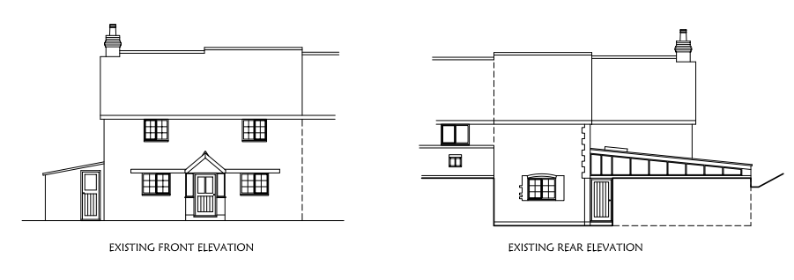

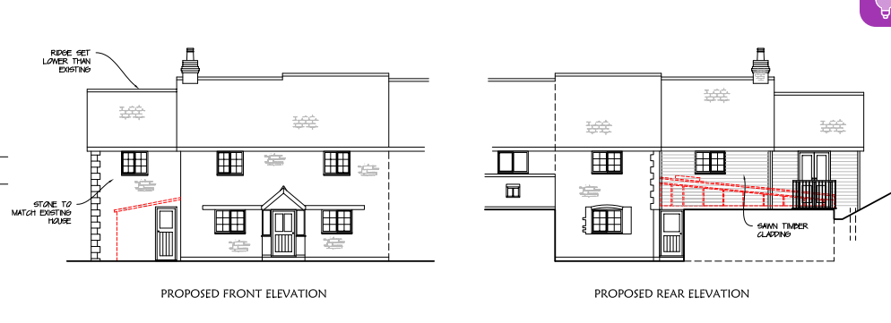

Existing and proposed side elevations

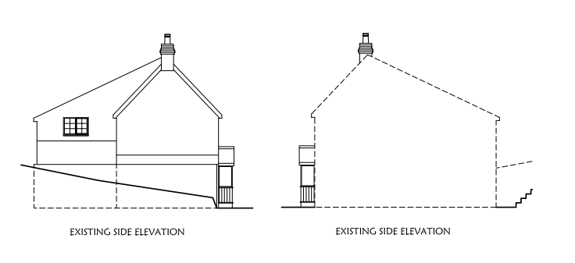

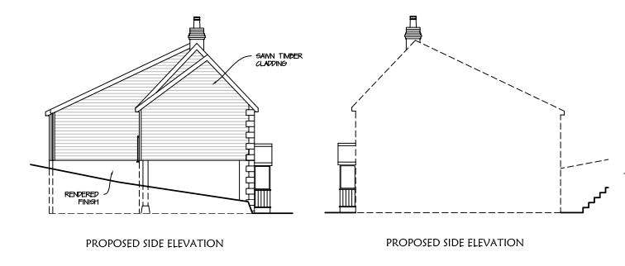

During the course of the application, following objections from the Council’s conservation officer relating to design, scale and materials, amended plans were received to address the objections.

SITE DESCRIPTION/CONTEXT

The application site comprises a two-storey, semi-detached, stone-built dwelling situated on a bend in the road and occupying a visually prominent position within the street scene. The site is located within the small hamlet of Burton in Mere. Burton is not identified as a settlement within the Wiltshire Core Strategy settlement hierarchy and is therefore considered to be within the open countryside, as defined by Core Policies 1, 2 and 17. The property is located level with the road and has an area to the front/side for use as off road parking. To the rear, the site has a steeply sloping enclosed garden which levels out towards the southern part.

Wheelwrights Cottage is not a listed building nor is it within a conservation area. However, whilst not listed it clearly has historic provenance. It retains a number of traditional features that reassert the impression that externally it has not been significantly altered. The later extensions are also evidently later extensions and have not undermined an appreciation of its original historic form. There are a number of listed buildings in close proximity to the application site as shown marked with black hatching on the map extract below.

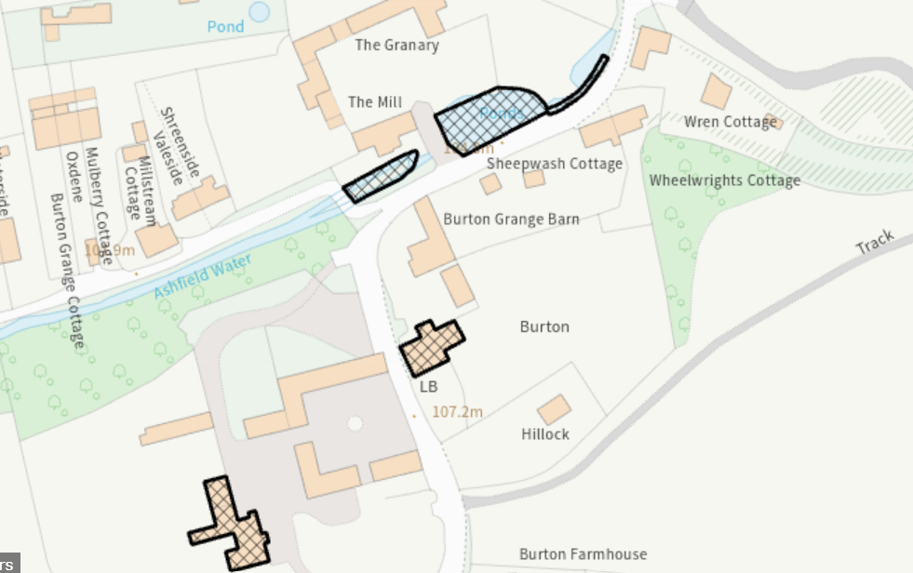

The site is situated within a Special Landscape Area, as defined by saved Salisbury District Local Plan (SDLP) policy C6.

Public right of way Mere19 is a footpath which passes to the north and east of the application site, this is shown with a purple line on the map extract below.

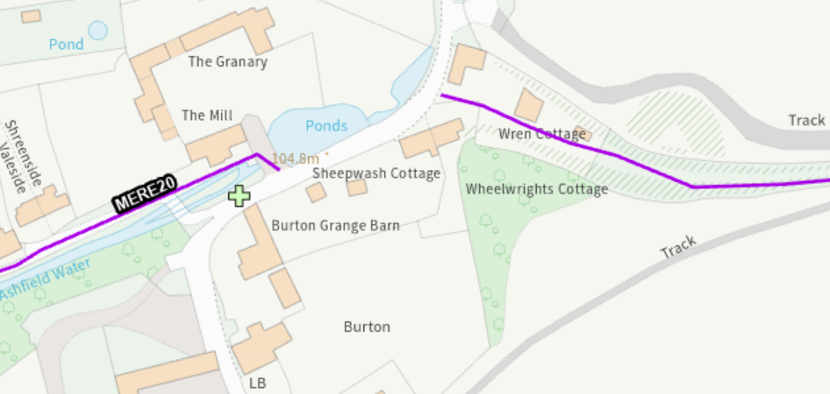

The site is located within flood zone 1 but is at high risk of ground water flooding.

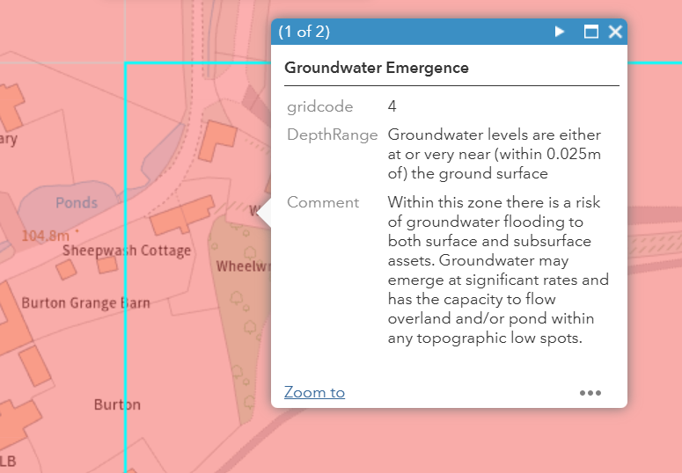

PLANNING HISTORY

Proposal / Summary
S/2011/1878 - Full planning permission Decision - Approve with Conditions Date: 15/3/2012 – Conversion of barn outbuilding to dwelling with existing access
S/2012/1832 - Full planning permission Decision - Legacy Officer Rec (South) Date: 25/2/2013 – The removal of a single storey side structure and rear structure and the construction of a two storey side extension, two storey rear extension and front porch.
14/09699/FUL - Full planning permission Decision - Approve with Conditions Date: 16/12/2014 – First floor extension

RELEVANT POLICIES AND GUIDANCE

The National Planning Policy Framework (NPPF)
The Planning Practice Guidance
National Design Guide

Wiltshire Core Strategy

Core Policy 1: Settlement Strategy
Core Policy 2: Delivery Strategy
Core Policy 17: Mere Community Area
Core Policy 51: Landscape
Core Policy 50: Biodiversity and Geodiversity
Core Policy 57: Ensuring High Quality Design & Space Shaping
Core Policy 58: Conservation
Core Policy 67: Flood Risk

Special Landscape Area - saved Salisbury District Local Plan (SDLP) policy C6

Wiltshire Design Guide: Appendix D – Design Guidance for Householder extensions
Creating Places Design Guide

CONSULTATION RESPONSES

Parish Council: Support

Conservation: No objections subject to conditions

REPRESENTATIONS

No comments were received.

ASSESSMENT

Section 38(6) of the Planning and Compulsory Purchase Act 2004 states:

"If regard is to be had to the development plan for the purposes of any determination to be made under the planning Acts, the determination must be made in accordance with the plan unless material considerations indicate otherwise."

In accordance with this statutory requirement, this application has been assessed against the relevant policies of the Development Plan, including the adopted Wiltshire Core Strategy (2015) and, where applicable, any made Neighbourhood Plans.

Design and Impact upon the character of the area including impacts on Heritage Assets and Special Landscape Area

The NPPF outlines government policy, including its policy in respect of the historic environment. Section 16 of the NPPF 'Conserving and enhancing the historic environment' sets out the Government's high-level policies concerning heritage and sustainable development. Paragraphs 214-16 of the NPPF require a balanced approach with any harm which would be caused being weighed against the potential public benefits which might be achieved. Paragraph 210 requires local planning authorities should take account of the desirability of sustaining and enhancing the significance of heritage assets and of new development making a positive contribution to local character and distinctiveness.

National Planning Practice Guidance provides guidance on interpreting the NPPF.

The Council’s Core Strategy Policy CP58 ‘Ensuring the conservation of the historic environment’ requires that “designated heritage assets and their settings will be conserved, and where appropriate enhanced, in a manner appropriate to their significance.” It is also required that distinctive elements of Wiltshire’s historic environment, including non-designated heritage assets, which contribute to a sense of local character and identity will be conserved, and where possible enhanced.

Wiltshire Council’s Core Strategy Policy CP57 ‘Ensuring high quality design and place shaping’: A high standard of design is required in all new developments, including extensions, alterations, and changes of use of existing buildings. Development is expected to create a strong sense of place through drawing on the local context and being complementary to the locality.

In terms of the impact on heritage assets, the Council's Conservation Officer has commented as follows: Wheelwrights Cottage is not a listed building nor is it within a conservation area. However, whilst not listed it clearly has historic provenance. It retains a number of traditional features that reassert the impression that externally it has not been significantly altered. The later extensions are also evidently later extensions and have not undermined an appreciation of its original historic form.

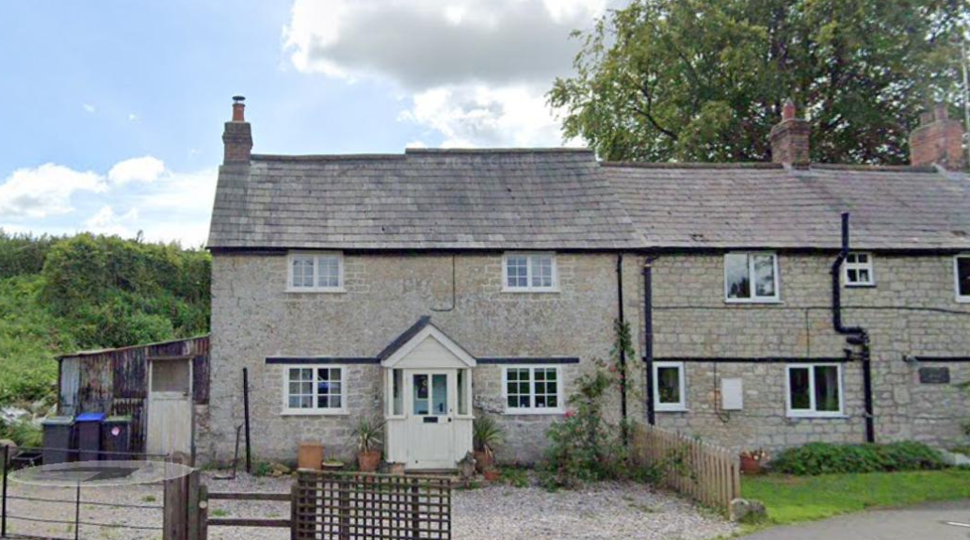

It is close to a former farmhouse (set back) and outbuilding, all of traditional character and utilising traditional materials. As such, it forms part of a pleasing group of traditional vernacular buildings constructed in the local Mere stone (no longer available). Its visual appeal is slightly compromised by the attached building with its PVCu windows and unsightly pipework. Indeed, the modern extension to Sheepwash Cottage serves to underline the impact of an insensitive extension on a historic cottage. (Although I note that this extension is at least recessed from the principal elevation). The existing building has some heritage interest. It makes a positive contribution to the character of this part of Burton and forms an attractive informal group with nearby buildings.

As mentioned above, initially the conservation officer objected to the proposed development

The existing building is a traditional-looking building in the local stone. The current side extension is modest in character and typical of wood stores added to rural cottages.

The proposals would see a tall two-storey extension. It would elongate the existing cottage and as such, the pre-eminence of the original cottage would be eroded. The arrangement is also contrived and not traditional in character (columns supporting a cantilevered first floor). In addition, the lack of windows on the proposed front first floor elevation would be at odds with the character of the host dwelling and draw attention to the extension.

Were this a pre-application enquiry for a listed building, I would be advising that a two-storey side extension is overly ambitious in this scenario. At the very least, I consider the proposed roof should step down from the main roof and that the side extension be set in, as at Sheepwash Cottage. I would also recommend a wall dormer (ie cutting through the eaves). In respect of the floorplan, I would recommend that the ground floor is stone (at least on the front elevation up to first floor level) and then timber over. I would also recommend that the extension is set further in from the front wall.

The revised plans addressed the concerns raised by the Conservation Officer through amendments including a set down ridge, inclusion of a front first floor window and the front elevation to be stone with no cladding. The design changes were subsequently accepted by the Conservation Officer, and no objections were received subject to conditions relating to the use of timber windows and doors and sample of stone/sample panel to be agreed with the Local Planning Authority.

Having regard to the revised design, scale and materials, the proposed extensions would remain visually subordinate to the host dwelling and would successfully integrate with the existing building. The proposals would preserve the character and appearance of the dwelling and would not adversely affect the setting of nearby heritage assets.

The proposal would also not materially harm the character and appearance of the Special Landscape Area given its limited scale and relationship with the existing built form.

Having regard to the above, the proposal complies with the design principles set out in Core Policy 57 and 58 of the Wiltshire Core Strategy and Appendix D of the Wiltshire Design Guide.

Amenity

Point vii of Core Policy 57 - Ensuring High Quality Design and Place Shaping of the Wiltshire Core Strategy seeks to ensure that developments do not adversely affect neighbouring properties.

The National Planning Policy Framework (NPPF), particularly Paragraph 135(f), stresses that planning decisions should ensure developments provide a high standard of amenity for existing and future users.

The proposed development has been assessed in terms of its potential impact on the residential amenity of neighbouring properties, with particular regard to loss of light, overshadowing, loss of privacy, and overbearing effects.

The proposed extensions due to their siting and relationship with the nearest residential properties are not considered to result in unacceptable overbearing impacts or overshadowing. In terms of overlooking, the rear addition includes a Juliet balcony. Whilst this initially raised some concerns with Officers and potential overlooking issues, the site visit showed that the Juliet balcony is angled away from the amenity space of neighbouring properties and looks towards the sloping bank at the rear of the site. Accordingly, no unacceptable overlooking or loss of privacy would arise.

The proposal therefore accords with Core Policy 57 point vii in respect of safeguarding residential amenity and Appendix D of the Wiltshire Design Guide.

Highways Impact

Core Policy 57 (xiv) of the Wiltshire Core Strategy seeks to ensure that development must meet the requirements of Core Policy 61. This policy requires proposals to be capable of being served by safe access to the highway network. Core Policy 64 seeks to ensure compliance with parking standards set out in the Local Transport Plan.

The National Planning Policy Framework (NPPF), particularly Paragraph 115 and 116, requires that development proposals do not have an unacceptable impact on highway safety and that safe and suitable access to the site can be achieved for all users.

The proposed development will increase the number of bedrooms at the application site and to meet the Council’s parking standards three off road parking spaces are required. A parking plan has been submitted with the application which demonstrates that appropriate parking can be accommodated at the site.

The proposed development would therefore not result in any adverse impact on highway safety. Adequate parking is provided in accordance with Wiltshire's adopted parking standards and access arrangements are considered acceptable. The proposal is therefore considered to comply with Core Policies 57 (xiv), 61 and 64 of the Wiltshire Core Strategy, the NPPF, and the Wiltshire Local Transport Plan.

Ecology Impact

Core Policy 50 of the Wiltshire Core Strategy seeks to protect and enhance biodiversity and geodiversity, including through ensuring that development avoids harm to protected species and habitats.

The National Planning Policy Framework (NPPF), at Paragraph 193, requires that development minimises impacts on and provides net gains for biodiversity, including ensuring mitigation is secured where harm cannot be avoided.

The application site is not subject to any statutory or non-statutory ecological designations, and the scale and nature of development is such that significant harm to biodiversity is unlikely.

Biodiversity Net Gain - Householder planning applications are exempt from the requirement to deliver Biodiversity Net Gain under Schedule 7A, Section 4(2)(a) of the Town and Country Planning Act 1990, as inserted by the Environment Act 2021.

As such, the development complies with Core Policy 50 of the Wiltshire Core Strategy and the relevant provisions of the NPPF.

Flood Risk

Core Policy 67 of the Wiltshire Core Strategy and paragraph 181 of the NPPF requires that all new development avoids increasing flood risk on-site or elsewhere and, where appropriate, incorporates sustainable drainage measures.

While the application site is a householder application for extensions to an existing dwellinghouse located in Flood Zone 1, the area is at high risk of groundwater flooding. The NPPF, PPG and CP67 require the LPA to consider the risk of flooding to the development from all sources, including groundwater and to ensure that the development would not exacerbate any existing flood risk in the area.

The NPPF excludes householder development from any requirement for the sequential test to be applied, in accordance with Footnote 63 of para 181: Applications for some minor development and changes of use should not be subject to the sequential or exception tests but should still meet the requirements for site-specific flood risk assessments set out in footnote 63. Footnote 63 states: A site-specific flood risk assessment should be provided for all development in Flood Zones 2 and 3. In Flood Zone 1, an assessment should accompany all proposals involving: sites of 1 hectare or more; land which has been identified by the Environment Agency as having critical drainage problems; land identified in a strategic flood risk assessment as being at increased flood risk in future; or land that may be subject to other sources of flooding, where its development would introduce a more vulnerable use.

While it is noted that the application site has been identified in a strategic flood risk assessment as being at high risk to groundwater flooding, the proposed extension does not introduce a more vulnerable use as it is a householder extension to an existing dwelling.

However, a flood risk assessment has been provided and includes a number of Flood Mitigation and Flood Resilience Measures at section 4 of this assessment, as below. Any permission will include a condition to secure the development is carried out in accordance with these details.

● Finished floor levels of the proposed extension to be set no lower than the existing dwelling's finished floor level, and not lowered relative to existing external ground levels.
● Solid, non-suspended timber ground floor construction to the extension, reducing the risk of water accumulating beneath a suspended floor void.
● External door thresholds to be finished flush with, or above, existing adjacent ground levels, with no reduction in threshold level.
● Sub-floor and land drainage (e.g. french drain / perimeter land drain connected to a suitable soakaway or surface water system, subject to ground conditions) to intercept shallow groundwater before it reaches the building.
● Any new below-ground drainage to include non-return (anti-flood) valves to prevent backflow during high water table conditions.
● Electrical sockets, switches and consumer units within the new extension to be positioned no lower than 450mm above finished floor level (raised from the standard 300mm), reducing the risk of damage and easing reinstatement should water ingress occur.
● Use of water-resistant materials to a minimum height of 300–600mm above finished floor level internally, such as lime-based renders/plasters in place of gypsum plaster, and water-resistant insulation, to ease drying and reinstatement.
● Solid floor finishes (e.g. tile) in lieu of moisture-sensitive coverings within the extension where practicable.
● Any new joinery (skirting, door linings) at low level to be in moisture-resistant material or easily replaceable

The proposal therefore complies with Core Policy 67 of the Wiltshire Core Strategy and the policy in the NPPF.

CONCLUSION

Having regard to the scale, design and siting of the proposed extensions, the development is considered to represent an appropriate form of householder development which would not result in unacceptable harm to the character and appearance of the dwelling, the Special Landscape Area, nearby heritage assets, neighbouring amenity, highway safety, flood risk or ecological interests.

The proposal is therefore considered to comply with the relevant policies of the Wiltshire Core Strategy, and the National Planning Policy Framework. As such, the application is recommended for approval, subject to the conditions set out below.

RECOMMENDATION: That Planning Permission be GRANTED subject to conditions.

1. The development hereby permitted shall be begun before the expiration of three years from the date of this permission.

REASON: To comply with the provisions of Section 91 of the Town and Country Planning Act 1990 as amended by the Planning and Compulsory Purchase Act 2004.

2. The development hereby permitted shall be carried out in accordance with the following approved plans:

Application form received 17/03/2026
Location plan P967/01 received 17/03/2026
Proposed block plan P967/04 Rev A received 19/06/2026
Proposed plans and elevations P0967/05 Rev A received 19/06/2026
Flood risk assessment received 22/07/2026

REASON: For the avoidance of doubt and in the interests of proper planning.

3. No development shall take place on site above slab level (other than demolition) until the details (can be brochure) of the new external window and door (workshop) in the front elevation of the proposed extension have been submitted to and approved in writing by the Local Planning Authority. The window and door shall be constructed of timber.

Development shall be carried out in accordance with the approved details.

REASON: The application contained insufficient information to enable this matter to be considered prior to granting planning permission and the matter is required to be agreed with the Local Planning Authority before development continues above slab level in order that the development is undertaken in an acceptable manner, in the interests of visual amenity and the character and appearance of the area.

4. No external stonework shall be constructed on site, until a sample panel of stonework, not less than 1 metre square, has been constructed on site, inspected and approved in writing by the Local Planning Authority. The stonework shall match the existing and be laid to course. The panel shall then be left in position for comparison whilst the development is carried out.

Development shall be carried out in accordance with the approved sample.

REASON: The application contained insufficient information to enable this matter to be considered prior to granting planning permission and the matter is required to be agreed with the Local Planning Authority before development continues above slab level in order that the development is undertaken in an acceptable manner, in the interests of visual amenity and the character and appearance of the area.

5. The roof tiles to be used in the development hereby permitted shall match those of the existing building in terms of their material, colour, texture, profile and pattern of laying.

REASON: In the interests of visual amenity and the character and appearance of the area.

6. The development hereby approved shall be carried out in full accordance with the flood mitigation and flood resilience measures set out within Section 4 of the Flood Risk Assessment received 22 July 2026, and those measures shall be maintained thereafter for the lifetime of the development.

REASON: In the interests of flood risk management

