APPLICATION FOR HOUSEHOLDER PLANNING PERMISSION
DELEGATED REPORT

APPLICATION REFERENCE: | PL/2026/00154
APPLICATION TYPE: | Householder planning permission
SITE ADDRESS: | 7 Stoke Mead, Limpley Stoke, Bath, BA2 7GX
DEVELOPMENT DESCRIPTION: | Proposed erection of a single storey rear extension following demolition of existing extension. Raise roof structure to main dwelling, incorporating dormers and Velux windows to form new first floor level. Renewal of windows, doors, fascia & soffit boards and gutters.
RECOMMENDATION: | That Planning Permission be GRANTED

PROPOSAL

The proposal seeks householder planning permission for a single storey rear extension, extending over the footprint of an existing extension, and raising of the roof to facilitate conversion of the loft space for habitable accommodation.

SITE DESCRIPTION/CONTEXT

The proposal relates to a detached bungalow, 7 Stoke Mead, set within a small cul-de-sac on the western edge of Limpley Stoke. The bungalow benefits from a generous plot with an off-road parking area to the front elevation and attached garage. The application site lies within the Cotswolds National Landscape, a Special Landscape Area, within the West Wiltshire Green Belt and the Bath and Bradford on Avon Special Area of Conservation for bats.

PLANNING HISTORY
N/A

RELEVANT POLICIES AND GUIDANCE

Wiltshire Core Strategy: The Wiltshire Core Strategy (WCS) 2015
Core Policy 2 – Delivery Strategy
Core Policy 7 – Spatial Strategy for the Bradford on Avon Community Area
Core Policy 50 – Biodiversity and Geodiversity
Core Policy 51 – Landscape
Core Policy 57 - Ensuring High Quality Design and Place Shaping
Core Policy 60 – Sustainable Transport
Core Policy 61 – Transport and Development
Core Policy 64 – Demand Management

Emerging Policy – Wiltshire Local Plan Review
At Full Council on 19 May, the elected members of Wiltshire Council agreed to withdraw the emerging WLP. The said Plan has no material weight for the purposes of the application.
C3 Special Landscape Areas saved policy from the West Wiltshire District Plan 1st Alteration
Wiltshire Design Guide: Appendix D – Design Guidance for Householder extensions

The Freshford and Limpley Stoke ‘made’ Neighbourhood Plan 2014-2039

The National Planning Policy Framework (NPPF)

The Planning Practice Guidance

National Design Guide

CONSULTATION RESPONSES
Limpley Stoke Parish Council: Support
Wiltshire Council Ecology: No objection

REPRESENTATIONS
No comments were received.

ASSESSMENT
Section 38(6) of the Planning and Compulsory Purchase Act 2004 states:

"If regard is to be had to the development plan for the purposes of any determination to be made under the planning Acts, the determination must be made in accordance with the plan unless material considerations indicate otherwise."

In accordance with this statutory requirement, this application has been assessed against the relevant policies of the Development Plan, including the adopted Wiltshire Core Strategy (2015) and, where applicable, any made Neighbourhood Plans.

Principle of Development in The Green Belt
The 2024 NPPF regards the construction of new buildings in the Green Belt as ‘inappropriate development’, unless the proposal falls within the criteria set out in paragraph 154. Within this list of exceptions, extensions or alterations to existing buildings may be acceptable if they do not result in “disproportionate additions over and above the size of the original building”.

Paragraph 153 of the 2024 NPPF states that “when considering any planning application, local planning authorities should ensure that substantial weight is given to any harm to the Green Belt, including harm to its openness. Inappropriate development is, by definition, harmful to the Green Belt and should not be approved except in very special circumstances. ‘Very special circumstances’ will not exist unless the potential harm to the Green Belt by reason of inappropriateness, and any other harm resulting from the proposal, is clearly outweighed by other considerations”

The NPPF does not quantify what disproportionate constitutes and the Council does not prescribe a volumetric /percentage maximum, so a planning judgement must be made in each case and be assessed on its own individual merits.

The NPPF does however define ‘original building’ as “a building as it existed on 1 July 1948 or, if constructed after 1 July 1948, as it was originally built.”
Planning history and aerial photography and the historic mapping of the original building reveals that the host dwelling has not received any permissions since it was originally built, however officers are cognisant that the rear extension has been added since it was originally built.

The agent has submitted green belt volumes of the original property (489m3) the volume as it currently exists (553m3) and the green belt volume of the property if the submitted scheme is implemented (786m3). These volumes broadly correspond with calculations that officers have undertaken.

Officer’s calculations
Original volume is calculated as 495m3
Existing volume is calculated as 550m3
Volume of the proposals 280m3
Volume on site (once proposal is implemented) 775m3

Based on these predicted green belt volumes the proposed development (if implemented) would increase the built development on site 56% above the volume of the original building (prior to 1948) which is considered disproportionate and as such the proposal would be considered inappropriate development in the green belt contrary to the guidance of the NPPF.

However, whilst a 56% increase arguably could be considered as a disproportionate addition, in this particular case, the extensions would largely be screened from public view and officers are mindful that the loft conversion would be less detrimental to the openness of the site in terms of visual amenity, extending over the original footprint of the host dwelling. From a spatial perspective the additional built form would be proportionate to the host building and therefore would be appropriate development in the Green Belt.

Officers have analysed the proposal and the site and have concluded that the proposed development would not result in material harm to the openness of the Green Belt given the proposed development would allow the majority of the proposed works to be partially obscured on the rear elevation of the host dwelling.

As such, Paragraph 153 of the NPPF is satisfied. A condition would need to be added to any approval to restrict any further extensions as these would likely to tip the balance of what could be considered acceptable in terms of appropriate development within the green belt

Design and Impact upon the character and context of the area
Core Policy 57 - Ensuring High Quality Design and Place Shaping of the Wiltshire Core Strategy seeks to ensure that all new development is of high design quality, reflecting local context, character, and distinctiveness.

The applicant seeks to raise the roof by a height of 1.5m to convert the existing loft space to habitable accommodation. The conversion would facilitate three first floor bedrooms and two bathrooms with the introduction of three dormer windows and a rooflight on the front elevation and a dormer window and two rooflights inserted on the rear elevation.

The scheme also seeks to remove the existing single storey gable end extension positioned on the rear elevation and replace it with a pitched roof single storey extension on the rear elevation.

The applicant also seeks to upgrade the existing elevations of the host dwelling with more contemporary materials with some elements of vertical cedar cladding, and dark grey UPVC fenestration alongside dark grey concrete roof tiles and black UPVC gutters and rainwater down pipes.

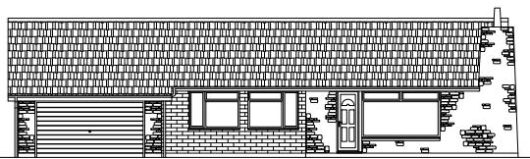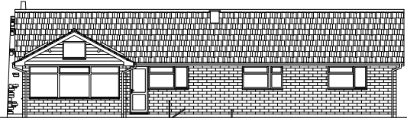

Existing front and rear elevations

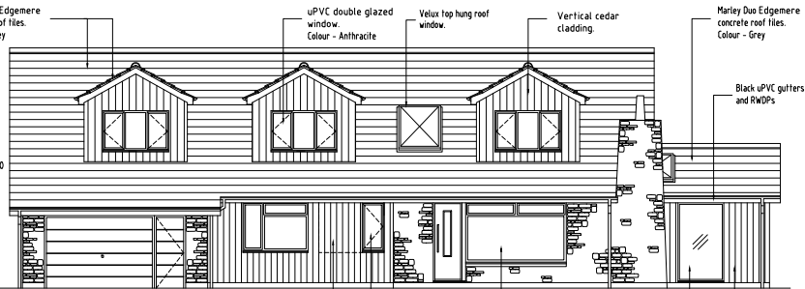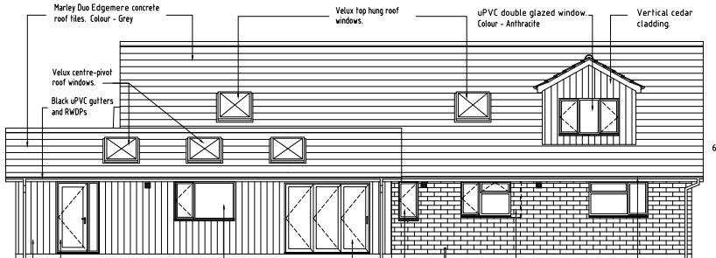

Proposed front and rear elevations

Whilst the use of the modern materials would deviate from the existing aesthetic the existing natural rubble stonework would remain with bath stone faced reconditioned blocks incorporated. Officers raise no concerns in regard to the proposed cladding which would be left to weather naturally and over time would result in a silvered finish that would be of a hue similar to the light-coloured blockwork of the host dwelling.

It is also noted that there are examples of timber cladding and contemporary materials used on properties within the vicinity of the application site and many properties within the cul-de-sac benefit from first floor dormer windows, therefore the proposal would not appear at odds with the character and appearance of the immediate environs.

It is considered that the extensions would by virtue of their height, scale and design constitute complementary additions to the host dwelling that would appear commensurate to the size of the property and plot. Having regard to the above, the proposal complies with the design principles set out in Core Policy 57 of the Wiltshire Core Strategy and Appendix D of the Wiltshire Design Guide.
Amenity
Point vii of Core Policy 57 - Ensuring High Quality Design and Place Shaping of the Wiltshire Core Strategy seeks to ensure that developments do not adversely affect neighbouring properties.

The National Planning Policy Framework (NPPF), particularly Paragraph 135(f), stresses that planning decisions should ensure developments provide a high standard of amenity for existing and future users.

The proposed development has been assessed in terms of its potential impact on the residential amenity of neighbouring properties, with particular regard to loss of light, overshadowing, loss of privacy, and overbearing effects.

The host dwelling lies within a generous detached plot with extended separation distances to any neighbouring occupiers. Therefore, the raising of the ridge height of the host dwelling and erection of the single storey rear extension raises no concerns in regard to any adverse overbearing, overshadowing or loss of light impacts to neighbouring properties.

The windows inserted at first floor would maintain extended separation distances to any adjacent dwellings, therefore no concerns are raised in regard to any adverse overlooking.

The proposal therefore accords with Core Policy 57 point vii in respect of safeguarding residential amenity and Appendix D of the Wiltshire Design Guide.

Highways Impact
Core Policy 57 (xiv) of the Wiltshire Core Strategy seeks to ensure that development must meet the requirements of Core Policy 61. This policy requires proposals to be capable of being served by safe access to the highway network. Core Policy 64 seeks to ensure compliance with parking standards set out in the Local Transport Plan.

The National Planning Policy Framework (NPPF), particularly Paragraph 115 and 116, requires that development proposals do not have an unacceptable impact on highway safety and that safe and suitable access to the site can be achieved for all users.

The proposed scheme would introduce an additional bedroom, increasing the number of bedrooms from 3 bedrooms to 4. In order to comply with the Wiltshire Local Transport Plan 2011 – 2026: Car Parking Strategy (March 2015) three on-site car parking spaces would be required for a 4+ bed dwelling (standard min. size 2.4m x 4.8m).
In order to count as a parking space a garage should have internal dimensions of 3m x 6m, and officers are cognisant that the existing garage would not meet the criteria set by the Transport Plan for the parking of one vehicle. However, officers acknowledge that sufficient off-street parking for a minimum of several cars is provided to the front elevation of the host dwelling.
The proposal retains the existing access and would not give rise to significant harm in terms of highway safety. Adequate parking and turning provision is provided in accordance with Wiltshire’s adopted parking standards, and access arrangements are acceptable.
The proposal is therefore considered to comply with Core Policies 57 (xiv), 61 and 64 of the Wiltshire Core Strategy, the NPPF, and the Wiltshire Local Transport Plan.

Ecology Impact
Core Policy 50 of the Wiltshire Core Strategy seeks to protect and enhance biodiversity and geodiversity, including through ensuring that development avoids harm to protected species and habitats.

The National Planning Policy Framework (NPPF), in Paragraphs 193, requires that development minimises impacts on and provides net gains for biodiversity, including ensuring mitigation is secured where harm cannot be avoided.

The application site sits within the Bath and Bradford on Avon Special Area of Conservation for bats and as this application involves disturbance to the existing roof due consideration has to be given to the potential disturbance of any bats because of the proposed development.

A preliminary bat roost assessment was submitted, and the Council’s Ecologist raised no objection to the scheme confirming that the building is subject to a sufficiently low risk of supporting roosting bats.

As such, the development complies with Core Policy 50 of the Wiltshire Core Strategy and the relevant provisions of the NPPF.

National Landscape
Core Policy 51 of the Wiltshire Core Strategy requires all development to protect, conserve, and where possible enhance the character and quality of Wiltshire’s landscapes, giving particular weight to designated areas such as National Landscapes.

The National Planning Policy Framework (NPPF), in Paragraph 176, states that “great weight” should be given to conserving and enhancing landscape and scenic beauty in National Landscapes (formerly Areas of Outstanding Natural Beauty). Development within or affecting the setting of a National Landscape must demonstrate that it will not result in unacceptable harm to the special qualities of that area.

Section 245 of the Levelling Up and Regeneration Act 20231 (LURA) introduced a statutory duty on relevant authorities to seek to further the statutory purposes of protected landscapes (the ‘seek to further’ duty).

Saved Policy C3 requires the landscape character of this area to be “conserved and enhanced and development will not be permitted which is considered to be detrimental to the high quality of these landscapes”.

The application site lies within the Cotswolds National Landscape and a Special Landscape Area therefore due consideration has to be given to any development that may adversely impact upon the scenic quality of the special landscape designations.

The scheme relates to a conversion of the existing attic space and a replacement single storey rear extension. The built form would be contained within the private residential curtilage of the host dwelling, with similar development present within the immediate environs. Therefore, no concerns are raised in relation to the impact on the National Landscape.

The scheme relates to limited development, and the use of natural sustainable materials is considered to be respectful of the natural setting, which would seek to further the purpose of conserving and enhancing the natural beauty of the National Landscape.

The proposal, by virtue of its scale, siting, and design, would not harm the special qualities or scenic character of the Cotswolds National Landscape or Special Landscape Area. The development therefore complies with Core Policy 51 of the Wiltshire Core Strategy and Paragraph 189 of the NPPF in conserving and enhancing the National Landscape and Special Landscape Area.

Biodiversity Net Gain
Householder planning applications are exempt from the requirement to deliver Biodiversity Net Gain under Schedule 7A, Section 4(2)(a) of the Town and Country Planning Act 1990, as inserted by the Environment Act 2021.

CONCLUSION
The proposed development is considered to be acceptable in terms of its design, scale, and relationship with the surrounding area. It would not result in any unacceptable harm to the character of the locality, the amenities of neighbouring occupiers, or the interests of highway safety, heritage, or ecology.

The proposal is therefore considered to comply with the relevant policies of the Wiltshire Core Strategy, the Wiltshire Local Plan, and the National Planning Policy Framework. As such, the application is recommended for approval, subject to the conditions set out below.

RECOMMENDATION: That Planning Permission be GRANTED subject to conditions.

