APPLICATION FOR FULL-PLANNING PERMISSION
CASE OFFICER REPORT

APPLICATION REFERENCE: | PL/2025/07553
APPLICATION TYPE: | Full planning permission
SITE ADDRESS: | Land forming the footpath network surrounding the Garden Lake at Stourhead, Wiltshire, BA12 6QD
DEVELOPMENT DESCRIPTION: | Footpath improvement works including associated engineering and landscaping works and new benches.
RECOMMENDATION:

SITE DESCRIPTION/CONTEXT

The Garden Lake is a reservoir in the headwaters of the River Stour in Stourton

The site is located within the Cranborne Chase National Landscape (NL), a SSSI Impact Zone extending from Heath Hill Farm, a Grade 1 Registered Park and Garden (Stourhead), Stourhead Conservation Area. Stourhead House is Grade I Listed. The area surrounding the lake is Flood Zone 1.

PROPOSAL

The majority of the existing footpaths around Stourhead are buff coloured self binding gravel. The existing paths struggle with drainage due to blocked gullies and drains especially as some paths have been repaired using alternative materials such as concrete. Excessive use of the footpaths has caused surface deterioration which is causing trip hazards to visitors. The existing paths measure between 2 and 3 metres wide.

The proposal sees improvements being made to the footpaths which ensure they are a minimum of 2.5 metres wide. The material to be used is Tar Spray & Chip bounded surface and Breedon Amber Gold unbounded surface. Some of the existing wooden path edging will be removed and replaced with metal edging. Some of the footpaths are to be rebuilt and are shown as follows:

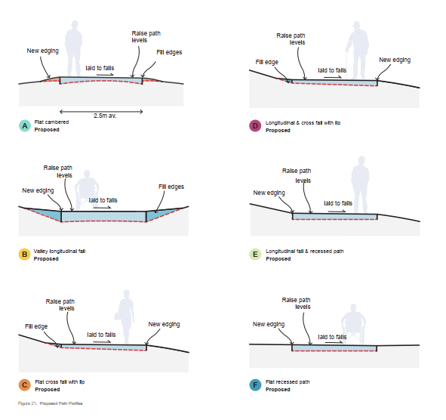

The footpath in front of the Pantheon is used by visitors to stop and as such an expanded hardstanding apron is proposed with a simple flush metal edge which will space 7.5 metres at its widest point.

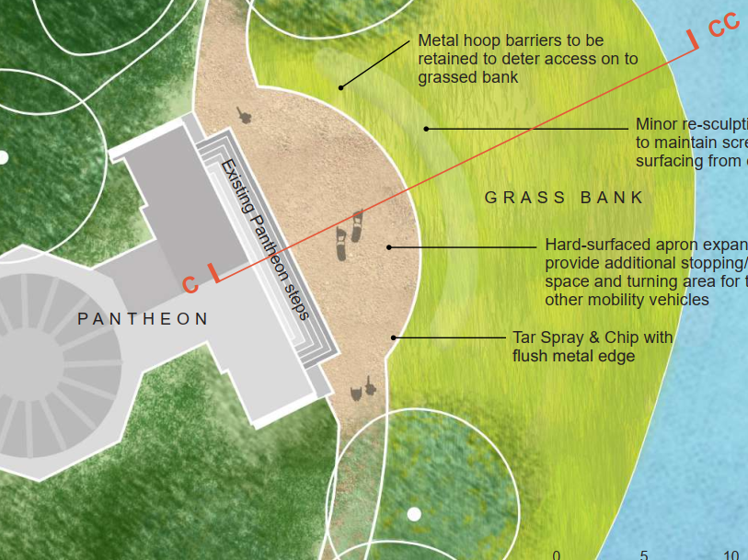

Also proposed as part of this application is a number of hard-surfaced pads to allow for fixed benches along the existing path.

The proposed works will be undertaken in phases. Phase 1 targets the path sections in most need and with the greatest drainage and surfacing defects.

The second phase will see the improvements to the remaining footpaths.

PLANNING HISTORY

Proposal / Summary
13/01925/PREAPP - Pre-Application enquiry Decision - Pre-App Response Date: 8/7/2016 – Replacement of lead roof covering to Pantheon portico, associated timber repairs and replacement, plaster repairs and rebidding and repair Pantheon front steps
13/03416/LBC - Listed building consent Decision - Approve with Conditions Date: 7/10/2013 – Repairs to Portico roof, plaster soffic and localised masonry - The Pantheon
13/06257/TCA - Work to Trees in a Cons Area Decision - Approve with Conditions Date: 22/1/2014 – Various tree works please see application form
16/00312/LBC - Listed building consent Decision - Approve with Conditions Date: 30/3/2016 – Proposed enlargement of existing W.C through removal of existing lathe and plaster wall and replacement with new timber studwall to create ensuite shower room
19/00366/FUL - Full planning permission Decision - Approve with Conditions Date: 26/2/2019 – To remove existing plastic oil tank and pipework. To replace with Air Source Heat Pump with associated pipework.
20/08377/FUL - Full planning permission Decision - Approve with Conditions Date: 24/11/2020 – Temporary use of land (including catering kiosks and fairground rides) for Christmas at Stourhead 2020 event
PL/2021/07567 - Full planning permission Decision - Approve with Conditions Date: 5/10/2021 – Temporary use of land (including catering kiosks and fairground rides) for Christmas at Stourhead event
PL/2022/06290 - Full planning permission Decision - Approve with Conditions Date: 10/11/2022 – Temporary use of land for Christmas at Stourhead event 2022
PL/2023/07038 - Full planning permission Decision - Approve with Conditions Date: 10/10/2023 – Temporary use of land for Christmas at Stourhead event 2023
PL/2023/09895 - Notification of proposed works to trees in a conservation area Decision - No Objection Date: 20/12/2023 – Beech tree - Crown reduction 25%
PL/2024/07030 - Full planning permission Decision - Approve with Conditions Date: 11/11/2024 – Temporary use of land to facilitate Christmas at Stourhead events 2024, 2025, and 2026
PL/2024/07590 - Notification of proposed works to trees in a conservation area Decision - No Objection Date: 24/9/2024 – All tree works as listed in attached Schedule
PL/2025/01634 - Full planning permission Decision - Approve with Conditions Date: 29/4/2025 – Installation of gravity fed drainage infrastructure to connect main house to mains sewer network
PL/2025/05519 - Notification of proposed works to trees in a conservation area Decision - No Objection Date: 14/8/2025 – 00140 Metasequoia Glyptostroboides - fell tree due to damage on base of tree and old split out leader. 00141 Sequoiadendron Giganteum - Deadwood crown and crown lift lower branches. 00142 Torreya Californica- Fell due to ill health, currently has full
PL/2025/05580 - Approval of details reserved by a condition Decision - Partial Discharge of Condition(s) Date: 20/8/2025 – Discharge of Condition 5 of PL/2025/01634 in Regards to a written programme of archaeological investigation
PL/2025/06753 - Approval of details reserved by a condition – Partial discharge of condition 3 (details of all revised lighting installations) for the Christmas 2025/2026 of PL/2024/06753 - Temporary use of land to facilitate Christmas at Stourhead events 2024, 2025, and 2026
PL/2025/07553 - Full planning permission – Footpath improvement works including associated engineering and landscaping works and new benches.
S/1984/0781 - Full planning permission Decision - Approved Date: 25/7/1984 – SMALL EXTENSION TO ACCOMMODATE NEW STAIRCASE
S/2006/0347 - Listed building consent Decision - Approved Date: 4/4/2006 – RETROSPECTIVE APPLICATION FOLLOWING URGENT SAFETY WORKS TO RESET FALLEN KEYSTONES AND PREVENT FURTHER COLLAPSE OVER PUBLIC HIGHWAY
S/2006/2283 - Listed building consent Decision - Withdrawn Date: 10/1/2007 – REDUCE HEIGHT OF IRON BRIDGE DAM TO STOURHEAD LAKE
S/2006/2366 - Full planning permission Decision - Approve with Conditions Date: 9/1/2007 – ENGINEERING WORKS TO REDUCE THE HEIGHT OF THE DAM AT THE IRON BRIDGE

RELEVANT LEGISLATION, POLICIES AND GUIDANCE

Statutory Legislation:

National Planning Policy:
- National Planning Policy Framework (NPPF)
- Planning Practice Guidance (PPG)
- National Design Guide
Development Plan:
The development plan for Wiltshire comprises the Wiltshire Core Strategy (WCS) (adopted January 2015) and any made neighbourhood plans, which remains the principal statutory planning document guiding development across the county. In line with Section 38(6) of the Planning and Compulsory Purchase Act 2004, planning decisions must be made in accordance with the development plan unless material considerations indicate otherwise.

Though the development plan is considered as a whole, those parts deemed to be particularly relevant to this application are listed below:

The adopted Wiltshire Core Strategy (WCS), with particular regard to:

- Core Policy 1 Settlement Strategy;
- Core Policy 2 Delivery Strategy;
- Core Policy 3 Infrastructure Requirements;
- Core Policy 17 Spatial Strategy Mere
- Core Policy 50 Biodiversity and Geodiversity;
- Core Policy 51 Landscape
- Core Policy 52 Green Infrastructure
- Core Policy 57 Ensuring High Quality Design and Place Shaping;
- Core Policy 58 Ensuring the Conservation of the Historic Environment;
- Core Policy 60 Sustainable Transport;
- Core Policy 61 Transport & Development;
- Core Policy 67 Flood Risk;

Neighbourhood Plan: There is no neighbourhood plan

ISSUES

The main issues that need to be addressed in this case include:

- Whether the proposal constitutes EIA development
- Whether the development is acceptable in principle (CP 1 and 2)
- Whether the scheme constitutes high quality design (CP 57)
- Whether the scheme would preserve or enhance the historic environment (CP 58)
- Whether the scheme would have an acceptable landscape impact (CP 51)
- Whether the proposal would have a negative effect upon highway safety, including if there is sufficient parking for the proposed development (CP 61 and 64)
- Whether the site can be adequately drained without increasing flood risk elsewhere (CP 67)
- Whether there would be any harmful impacts upon protected species or priority habitats (CP 50)
- Are there any other planning issues raised by the development?

CONSULTATION RESPONSES

WC Highways: No objection

WC Conservation: No objection

WC Archaeology: No objection subject to conditions

WC Landscape: No objection

WC Ecology: No objection subject to conditions

WC Arboriculturalist: No objection

Cranborne Chase National Landscape: No objection

Historic England: No objection

The Garden Trust: No objection

Stourton with Gasper Parish Council: No objection

REPRESENTATIONS
In accordance with the requirements of the Town and Country Planning (Development Management Procedure) (England) Order 2015 (as amended), the application was publicised by way of:

- Neighbour notification letters sent to adjoining and nearby properties;
- A site notice displayed near the site;
- An advertisement placed in the local press

These methods were used to inform interested parties and provide a period of 21 days for comments to be submitted.

Below is a summary of the representations received during the consultation period. Only material planning considerations have been taken into account in the assessment of this application. Non-material issues, such as property values or private legal disputes, cannot be considered in the determination process.

ASSESSMENT
Section 38(6) of the Planning and Compulsory Purchase Act 2004 states:

"If regard is to be had to the development plan for the purposes of any determination to be made under the planning Acts, the determination must be made in accordance with the plan unless material considerations indicate otherwise."

In accordance with this statutory requirement, this application has been assessed against the relevant policies of the Development Plan, including the Wiltshire Core Strategy (2015) and, where applicable, any made Neighbourhood Plans. Consideration has also been given to the policies of the National Planning Policy Framework (NPPF) as a material consideration in the assessment.

Environmental Impact Assessment (EIA) Screening
In accordance with the Town and Country Planning (Environmental Impact Assessment) Regulations 2017 (as amended), the local planning authority has considered whether the proposed development constitutes EIA development.

No Screening Opinion Issued
No formal screening opinion was requested or issued. However, the local planning authority has considered the scale and nature of the development as part of the application process and is satisfied that it does not constitute EIA development under the 2017 Regulations.

Principle of Development
Policy Context
Core Policy 1: Settlement Strategy of the WCS establishes a hierarchy of settlements to guide where development should be focused.

Core Policy 2: Delivery Strategy of the WCS sets out how development will be distributed and delivered across Wiltshire

Together, CP1 and CP2 ensure that new development is strategically located, sustainable, and supports the character and function of Wiltshire’s communities.

Assessment
Whilst the site is location in the open countryside, the proposal is for alterations to an existing footpath that surrounds Stourhead which is a visitor attraction and as such is considered to be acceptable in principle.

Conclusion
The proposal is considered to be acceptable in principle.

Design and Impact on the Character and Appearance of the Area
Policy Context
Core Policy 57 of the WCS requires high-quality design that:
- Enhances local character.
- Responds to the natural, historic, and built environment.
- Retains important features (e.g., trees, hedges).
- Supports sustainable construction and compatibility with surrounding uses.
- Creates safe, legible, and accessible spaces.

Section 12 of the NPPF emphasises design that is:
- Visually attractive.
- Functionally effective.
- Contributes to the quality of the built environment.

The Wiltshire Design Guide encourages sensitivity to local character, materials, and architectural styles and supports modern living standards while maintaining aesthetic and functional quality.

Building for a Healthy Life Framework promotes healthy, inclusive, and sustainable places. The document encourages:

- Walkability.
- Access to green space.
- Active design principles for well-being.

Assessment

The proposed alterations to the footpaths and the apron to the front of the Pantheon would be seen in conjunction with the existing network of pathways and the proposed materials are considered to be complimentary to the existing which have been considered appropriate to their historic landscape.

The majority of the footpath (85%) falls within the root protection areas of the existing trees. The submitted arboricultural report identifies careful treatment to ensure tree health is not impacted upon and includes “no dig” path resurfacing for the majority of the areas. It also details proposals for tree/ground protection and arboricultural supervision.

The Councils Arboriculturist has assessed the submitted information and raised no objections subject to the development being carried out in accordance with the arboricultural impact assessment, arboricultural method statement and arboricultural file note dated 03/02/2026 which can be controlled via condition.

Conclusion
The proposal is considered to comply with CP57.

Impact on Heritage Assets
Policy Context
From the point of view of the historic environment the main statutory tests are set out within the Planning (Listed Building and Conservation Areas) Act 1990.

Paragraph 58B of the Planning Act 1990 requires that in considering whether to grant planning permission or permission in principle for the development of land in England which affects a registered park and garden, the LPA must have special regard to the desirability of preserving or enhancing the asset or its setting.

Section 72(1) of the Act requires the Council to pay special attention to the desirability of preserving or enhancing the character or appearance of designated Conservation Areas.
The NPPF outlines government policy for planning. Chapter 16 of the NPPF 'Conserving and enhancing the historic environment' sets out the Government's high-level policies concerning heritage and sustainable development. In particular:

Paragraph 208 requires LPAs should “avoid or minimise any conflict” between the heritage asset’s conservation (which includes achieving its optimum viable use) and any aspect of a proposal.

Paragraph 210 requires local planning authorities should take account of the desirability of sustaining and enhancing the significance of heritage assets and putting them to viable new uses and of new development making a positive contribution to local character and distinctiveness.

Paragraphs 212 requires “great weight” to be given to an asset’s conservation “irrespective of whether any potential harm amounts to substantial harm, total loss or less than substantial harm to its significance.”

Paragraph 213 advises that harm to the significance of a designated heritage asset should require “clear and convincing justification”.

Paragraphs 213-215(214-216) require a balanced approach with any harm which would be caused being weighed against the potential public benefits which might be achieved.

Paragraph 220 advises that not all elements of a Conservation Area or World Heritage Site will necessarily contribute to its significance. Loss of a building (or other element) which makes a positive contribution to the significance of the Conservation Area or World Heritage Site should be treated either as substantial harm or less than substantial harm as appropriate.

The Planning Practice Guidance provides guidance on interpreting the NPPF.
The Council’s Core Strategy Policy CP58 ‘Ensuring the conservation of the historic environment’ requires that designated and non-designated heritage assets and their settings will be conserved, and where appropriate enhanced, in a manner appropriate to their significance and encourages proposals which improve the condition of heritage assets at risk.

The Council’s Core Strategy CP 57: Ensuring high quality design requires a high quality of design in all new developments. The policy requires applicants to “demonstrate how the proposal will make a positive contribution to the character of Wiltshire through (amongst other things) responding to the value of the natural and historic environment and being sympathetic to and conserving historic buildings and landscapes. Development is required to respond positively to the existing in terms of building layouts, built form, height, mass, scale, building line, plot size, elevational design, materials, streetscape and rooflines to effectively integrate the building into its setting.

Assessment
The Councils Conservation Officer has had special regard to the desirability of preserving the significance and setting of the Grade I Registered Park and Garden and any nearby listed buildings, and has paid special attention to the desirability of preserving or enhancing the character and appearance of the Stourhead Conservation Area. Having regard to the submitted Heritage Impact Assessment, consultation responses and the nature of the works proposed, it is concluded that the development would preserve the significance of these designated heritage assets and would not give rise to harm requiring assessment under paragraphs 214-216 of the NPPF.

Historic England have raised no objections to the proposal and support the use of the proposed materials.

The Heritage Impact Assessment (Purcell, July 2025) notes (p.44) that, although the pathways were original to the garden, the paths in some parts of the landscape garden have been altered, sometimes repeatedly. As a result, the pathways that survive have originated at many different times over the years since the gardens were first created and therefore have a variable significance. The Assessment does note that there is a potential for some pathways to hold an archaeological interest as buried elements of the original pathways may survive.
The Councils Archaeologist is of the opinion that the precise extent of below ground impacts are not entirely clear within the application documentation but seems to involve reprofiling, resurfacing and drainage works. It would therefore be precautionary to provide for some archaeological monitoring of these proposed works to identify and record any original constructional elements of the historic pathways. The monitoring may be selective based on the relative significance of different sections of the pathways and the nature and extent of the conservation works at various locations. This archaeological monitoring and recording can be secured by a condition:

Conclusion
The proposal complies with the relevant policies in relation to the historic environment.

Amenity
Policy Context
Core Policy 57 (Point vii) of the Wiltshire Core Strategy requires development to respect the amenity of existing occupants and ensure appropriate amenity levels for future residents.

The National Planning Policy Framework (NPPF), particularly Paragraph 135, reinforces the need for development to provide a high standard of amenity for both existing and future users.

Given that the proposal is set away from neighbouring properties, it is considered that there would be no overlooking, overshadowing, overbearing or noise issues that would occur as a result of the proposed development that would warrant a reason to refuse the application and as such it is considered that the proposal would comply with CP57.

Highways Impacts and Parking
Policy Context
Transport implications are a key factor in assessing planning applications, especially for larger developments. Proposals must demonstrate:
- Safe and suitable access for all users, including pedestrians, cyclists, and those with mobility impairments.
- No severe residual impacts on the surrounding highway network.
- Promotion of sustainable travel, reducing reliance on private vehicles.
- Adequate parking and cycle provision, in line with adopted standards.
- Protection and enhancement of public rights of way and active travel routes.

Relevant policies include Core Policies 60–64 of the Wiltshire Core Strategy, supported by the Wiltshire Local Transport Plan, Car Parking Strategy, and Cycling Strategy. The Local Cycling and Walking Infrastructure Plan (LCWIP) and LTN 1/20 (DfT) provide further design guidance for active travel infrastructure.

Assessment
The Councils Highway Officer has assessed the submitted information and noted that the works are located off the public highway and as such raises no objections to the proposal.

Conclusion
No objection is raised regarding highway matters.

Ecology and Biodiversity
Policy Context
The ecological impact of development is a key planning consideration, especially for larger schemes. Proposals must assess and address potential effects on:

- Protected species
- Priority habitats
- Ecological networks
- Green and blue infrastructure

Core Policy 50 of the Wiltshire Core Strategy requires development to:

- Avoid harm to ecological assets.
- Deliver measurable Biodiversity Net Gain (BNG), in line with the Environment Act 2021.
- Support habitat restoration and connectivity.
- Integrate biodiversity into site design.

The Green & Blue Infrastructure Strategy (2022–2030) promotes nature recovery, ecosystem services, and habitat connectivity through development.

Unless exempt, National policy requires a minimum of 10% Biodiversity Net Gain (BNG) for major developments, demonstrated via:

- Biodiversity Metric calculations
- Ecological assessments (e.g. PEAs, Phase 1 surveys, protected species surveys)

Assessment
The application site falls within two County Wildlife Sites (CWSs) - Stourhead Woods CWS at the west of the site, and Garden Lake CWS, central to the site. Stourhead Woods is a coniferous woodland of over 340 ha, with corridors of wet alder woodland. Garden Lake comprises a 7.5 ha lake, also considered Priority Habitat. There are several additional CWSs nearby; approximately 90m south is Bonham Hanging CWS, 300m southwest is Top Wood (ancient woodland) CWS, and 440m west is Lynch Wood (ancient woodland) CWS. These sites are considered to be of county-level importance.

A preliminary Ecological Assessment has been undertaken which covered the path and a 10 metre buffer which found 9 habitat types. A badger survey found no evidence of activity and most habitats were unsuitable for reptiles, although long grass and scrub could support slow worm, common lizard and grass snake. The Ecological Assessment was of the opinion that given the nature and phasing of works, the project can proceed under a Precautionary Ecological Method of Works with oversight from a suitably experienced Ecologist.

In reference to Stourhead Woods CWS, Section 7.3.1 of the Ecological Impact Assessment states that “no works will take place within or immediately adjacent to these habitats”. However, the western section of the footpath (bordering the western edge of the lake) falls within Stourhead Woods CWS. The report also states that “a minor positive” impact on the Stourhead Woods CWS is predicted. Additional information has been submitted which demonstrates that the proposal will use of off-site compounds outside of root protection area and low impact machinery will transport material onto the site. Construction will be timed to avoid the wetter months which will reduce runoff that could cause pollution to the garden lake. Specialist equipment will also be used to avoid compaction. A full CEMP will be required to be submitted and approved to request more details.

The majority of the footpaths fall within tree root protection areas, including that of several veteran trees. Trees of this type are important to protected and notable species, including bats. There is an expectation that all veteran and nearly veteran trees will be retained and protected by the development. Paragraph 193c of the NPPF states “development resulting in the loss or deterioration of irreplaceable habitats (such as ancient woodland and ancient or veteran trees) should be refused, unless there are wholly exceptional reasons and a suitable compensation strategy exists”. The submitted information demonstrates that impacts on trees will be minimised and in the long-term reduce the negative implications of pedestrian traffic through the re-location of footpaths. The information also confirms that any works undertaken in root protection areas of veteran trees will take place under the supervision of an ECoW and arborist. As such it is considered that a CEMP be conditioned.

Given the site’s connectivity to high-value habitats suitable for use by protected species such as bats, badgers and nesting birds, as well as the nature of the proposals (no significant habitat loss is proposed, but there is risk of temporary degradation or disturbance), it is considered that the risk posed to protected fauna should be minimised through the implementation of a construction method statement. This can be secured via a condition, should planning permission be forthcoming.

Under Schedule 7A of the Town and Country Planning Act 1990 (as inserted by Schedule 14 of the Environment Act 2021) this application is required to deliver 10% Biodiversity Net Gain (BNG). The Biodiversity Gain Plan condition will automatically apply if approval is forthcoming.
A completed statutory metric calculation, condition assessments and map (Biodiversity Net Gain Report, Johns Associates, March 2026; Statutory Biodiversity Metric, Ellie Brine, January 2025) stating the baseline and predicted post-development biodiversity units of the site have been submitted with the following values:

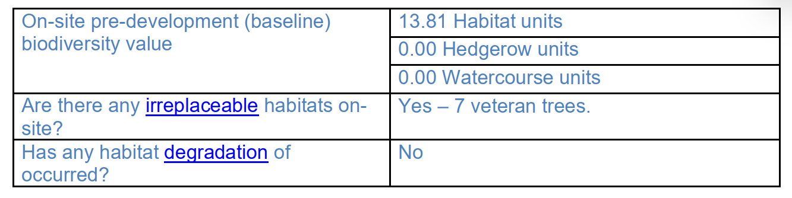

Confirmation of how the development will achieve BNG is a post-determination matter, however, consideration should be given to how any proposed BNG will be secured. The metric shows that a 10.08% gain can be achieved on-site, primarily via grassland enhancement as well as the creation of shrub and grassland areas. Further, some enhancements to individual trees have been proposed, and are noted in the metric as “enhancement due to path narrowing/realignment to avoid RPZ”, linking to criterion D (which requires little evidence of adverse impact on tree health caused by human activity). This is considered a reasonable approach through which to capture the reduction in recreational pressure upon the trees that will be achieved through this development.
The site contains irreplaceable habitat – 7 veteran trees – that are not included in the BNG requirement as standard, because loss of irreplaceable habitats is impossible to achieve. Compensation for impacts upon these habitats should not be recorded within the metric (neither as enhancement nor creation, see Biodiversity net gain - GOV.UK). One veteran tree, T396, has been recorded in the “On-Site Enhancement” tab. However, this is considered acceptable as it is not ‘compensation’ per se and instead reflects a genuine enhancement (its root protection area is currently encroached by the existing footpath, and the footpath will be redirected away from this zone). Provided protective measures for the veteran trees are secured during the construction phases, the development is unlikely to result in any additional losses or deterioration of irreplaceable habitat, therefore, bespoke compensation is not required.

It is proposed to implement the footpath works over three phases, which will include the phasing of BNG delivery. Therefore, prior to the commencement of development of each phase, the applicant will be required to submit a phased biodiversity gain plan (that sets out how each phase will contribute to the overall gain), in addition to the overall biodiversity gain plan.

Whilst the proposed on-site gains are not considered “significant” and a Habitat Management and Monitoring Plan is not required in this case, a Landscape and Ecological Management Plan (LEMP) would be appropriate, with particular regard to the sensitive habitats on and surrounding the site. The LEMP should also detail measures to manage and monitor enhanced and created habitats, and must be secured via condition.

Conclusion
The proposal is considered to comply with CP50.

Landscape and Visual Impact
Policy Context
Core Policy 51 of the Wiltshire Core Strategy requires development to:
- Protect, conserve, and enhance landscape character and quality.
- Respect local distinctiveness, key views, and visual receptors.
- Give particular weight to impacts on National Landscapes (formerly AONBs) and locally valued landscapes.

The Wiltshire Design Guide SPD (2024) promotes a context-led approach, encouraging integration with natural features and settlement patterns while avoiding visual intrusion.

The Green & Blue Infrastructure Strategy (2022–2030) supports landscape protection through green infrastructure, habitat connectivity, and nature-based solutions.

The NPPF emphasises the need to protect and enhance valued landscapes, particularly those with scenic, historic, or ecological significance. Planning decisions should:

- Recognise the intrinsic character and beauty of the countryside.
- Safeguard key views, local distinctiveness, and landscape settings.
- Ensure development is well-integrated into its surroundings and avoids visual intrusion, especially in sensitive or designated areas.

Landscape impact must be considered alongside biodiversity, heritage, and green infrastructure objectives, with mitigation measures encouraged where harm cannot be avoided.

Paragraph 189 of the NPPF requires that great weight should be given to conserving and enhancing landscape and scenic beauty in National Landscapes which have the highest status of protection in relation to these issues.

Under Section 245 of the Levelling-up and Regeneration Act 2023, LPAs and other relevant authorities must now “seek to further” the statutory purposes of National Landscapes (formerly Areas of Outstanding Natural Beauty), replacing the previous duty to merely “have regard to” them.

This is an active duty, requiring authorities to take reasonable and proportionate steps to support the conservation and enhancement of the natural beauty, special qualities, and key characteristics of these designated areas when exercising any function that affects them.

Assessment
The Councils Landscape Officer has assessed the submitted information and given that the proposal is utilising natural stone materials which is in-keeping with the historic character of the garden and the proposed benches will preserve important key views no objection has been raised.

The proposed works represent sensitive improvements to an established footpath network within a highly managed historic landscape. The use of materials compatible with the character of the registered park, together with measures to protect mature trees and key views, ensures that the proposal conserves the natural beauty, special qualities and scenic character of the Cranborne Chase National Landscape.

Conclusion
It is considered that the proposed works would be of benefit to the wider area and would not harm the National Landscape.

Flood Risk and Drainage
Policy Context
Core Policy 67 of the Wiltshire Core Strategy and NPPF paragraphs 170–182 require:
- Avoidance of increased flood risk.
- Use of appropriate mitigation measures.

Assessment
The site is located within Flood Zone 1 and the majority of the works are related to improving and extending existing pathways including their drainage requirements. As such it is considered that the proposed works are acceptable, would benefit the existing immediate drainage network would not result in flooding elsewhere.

Conclusion
The proposal is considered to comply with CP67.

Pre-commencement Condition Agreement

This recommendation includes pre-commencement planning condition(s) relating to Ecology. In accordance with Section 100ZA of the Town and Country Planning Act 1990 and the Town and Country Planning (Pre-commencement Conditions) Regulations 2018, the Local Planning Authority formally notified the applicant/agent of the proposed condition(s) and sought their agreement. Written confirmation of agreement was received from the applicant’s agent on 21st July 2026.

PLANNING BALANCE AND CONCLUSION
The proposal relates to the maintenance and enhancement of existing visitor infrastructure associated with the ongoing use and management of the Stourhead estate and does not introduce a materially different land use or inappropriate form of countryside development. As such the principle of development is considered acceptable when assessed against the relevant policies of the Wiltshire Core Strategy.

Accordingly, the proposal is considered acceptable in planning terms and in accordance with the Wiltshire Core Strategy, the National Planning Policy Framework, and all other relevant material considerations.

RECOMMENDATION:
That Planning Permission be GRANTED, subject to conditions

