APPLICATION FOR LISTED BUILDING CONSENT
OFFICER DELGATED REPORT

APPLICATION REFERENCE: | PL/2026/02799
APPLICATION TYPE: | Listed building consent (Alt/Ext)
SITE ADDRESS: | 46 Fore Street, Trowbridge, BA14 8EL
DESCRIPTION OF WORKS: | Facade maintenance / restoration works consisting of; Repair and redecoration to sash windows. Replacement of sash windows. Various stonework repairs to facade.
RECOMMENDATION: | Approve with Conditions

SITE DESCRIPTION/CONTEXT

The building is located at the centre of Trowbridge and was constructed in the early C18 as a dwelling in classical style with a particularly high-quality ashlar front elevation. The current property also incorporates one bay of the adjacent former George Hotel, No.47 Fore Street. The property is located in a prominent position at the heart of the town centre and conservation area. The list description reads as follows:

FORE STREET 1. 5411 (North East Side) No 46, Midland Bank (Formerly listed as premises occupied by Midland Bank and Sun Insurance) ST 8558 5/26 ST 8557 7/26 29,12.50. GV
2. Built between 1727 and 1741, an extremely imposing palazzo fronting to south west. 3 storeys and basement. A tall square block of ashlar stone on moulded plinth, with angle rusticated piers full height, moulded cornice strings over ground and 1st floor windows. Bold moulded cornice and square section balustrade with panelled dies, moulded base and moulded coping. 7 windows to upper floors in stone architrave surrounds with moulded cillsand projecting aprons on moulded bases. 6 windows on ground floor of similar type, except for the 4th and 6th to right hand, now 2 doorways. The 5th window has been slightly widened and now restored. 8-panel central door with rectangular fanlight diagonal pattern in stone recess with stone doorcase of Doric engaged columns and entablature with triglyph frieze and modillioned cornice. The central let floor window has surround of engaged Corinthian columns and entablature with curved frieze and segmental pediment. The right hand return front has 5 similar windows to upper moors and 4 on ground floor. Central 6-panel door with 3 lane rectangular fanlight in rusticated surround with Doric doorcase of stone pilasters and entablature now blocked. The central 1st floor window has surround of fluted Corinthian pilasters and entablature with pediment. Interesting rear part with a flight of 3 narrow round-headed stair windows in centre (outer ones now blocked). All windows have raised flat surrounds with beaded inner edges. 1 blocked doorcase with bolection surround. Lead rainwater pipe with conical hopper to right. Interior retains fine oak ramped staircase and magnificent hallway arch. Panelled doors on 1st floor; fine shell niche cupboard with shaped shelves also on 1st floor landing.. Fine carved bank counter inserted on ground floor.
Nos 37 to 44 (consec), No 38A and Nos 46 to 48 (consec) form a group with No 13 Church Walk. No 43 is of local interest.

The list description for No. 47 reads:

2. Late C18 front (altered C19) to late C16 building. 3 storey. Bath stone. String at 1st floor level. Small moulded cornice at 2nd floor level. Tall parapet with moulded string and coping broken by 3 later gabled 2nd floor segmental-headed casements. 4 windows, no glazing bars, under drip moulds on 1st floor. 2 windows on ground floor and wide central entry with surround of Doric pilasters and entablature. 2 storey C19 angular bay to right hand. The interior originally had an open court in centre, now built in and greatly altered.

PROPOSAL

The proposals relate to repairs to the main facades including minor localised stonework and window repairs (which include the replacement of some sashes – these are set out within the condition survey and identifiable via reference to the numbered elevations).

RELEVANT PLANNING HISTORY

Proposal / Summary
W/83/00489/LBC - Listed building consent Decision - Approved Date: 18/7/1983 – Forming 3 openings within flank wall of banking hall to link and extend into the rebuilt and refurbished premises formerly the George Hotel
W/94/00958/LBC - Listed building consent Decision - Approve with Conditions Date: 24/11/1994 – Refurbishment of building, rearrangement of internal layout and reinstatement of door to south elevation
W/11/00448/LBC - Listed building consent Decision - Approve with Conditions Date: 19/5/2011 – Installation of security railings/gates, cameras and flood lights to rear elevations. Replacement timber casement window to front elevation second floor.
15/03270/LBC - Listed building consent Decision - Withdrawn Date: 26/5/2015 – Replacement and relocation of external ATM machines and replacement of one internal machine.
15/05209/PREAPP - Pre-Application enquiry Decision - Pre-App Response Date: 28/7/2015 – Minor repairs to listed building
W/82/00066/HIS - Historic apps 1974 to 1983 Decision - Approve with Conditions Date: 22/6/1982 – Demolition of some buildings to rear of site and conversion, extension and refurbishment of remaining buildings to form one office and two retail units
W/82/00067/LBC - Listed building consent Decision - Approved Date: 22/6/1982 – Demolition of rear buildings with retention of front facade and roof and refurbishment to George Hotel and No. 48 over looking Fore Street with new extension at rear to form office and 2 shop units
W/83/00299/FUL - Full planning permission Decision - Approve with Conditions Date: 19/4/1983 – Alteration of ground floor windows to Unit No 1
W/83/00300/LBC - Listed building consent Decision - Approve with Conditions Date: 19/4/1983 – Alterations to ground floor windows to unit one

RELEVANT LEGISLATION, POLICIES AND GUIDANCE
Legislation
From the point of view of the historic environment the main statutory tests are set out within the Planning (Listed Building and Conservation Areas) Act 1990. Section 16 requires that special regard be given to the desirability of preserving listed buildings, their settings or any features of special architectural or historic interest which they possess.

Section 72(1) of the Planning (Listed Building and Conservation Areas) Act 1990 also requires the Council to pay special attention to the desirability of preserving or enhancing the character or appearance of designated Conservation Areas.

National Policy and Guidance
The National Planning Policy Framework (NPPF) sets out government policy, including in respect of the historic environment.

Section 16 of the NPPF ('Conserving and enhancing the historic environment') sets out the Government's high-level policies concerning heritage and sustainable development.

Paragraphs 213-215 of the NPPF require a balanced approach with any harm which would be caused being weighed against the potential public benefits which might be achieved. Paragraph 210 requires local planning authorities to take account of the desirability of sustaining and enhancing the significance of heritage assets and of new development making a positive contribution to local character and distinctiveness.

National Planning Practice Guidance provides guidance on interpreting the NPPF.

Historic England Advice Note 2: Making changes to Heritage Assets, illustrates the application of policies set out in the NPPF in determining applications for LBC (and planning permission).

Historic England’s publication ‘Traditional Windows – Their Care, Repair and Upgrading (2017)’ encourages the retention of windows that contribute to the significance of listed buildings but sets also out their approach to the alteration/replacement of windows where this is acceptable in principle:

- Where historic windows, whether original or later insertions, make a positive contribution to the significance of a listed building they should be retained and repaired where possible. If beyond repair they should be replaced with accurate copies.
- Where historic windows have already been replaced with windows whose design follows historic patterns, these usually make a positive contribution to the significance of listed buildings. When they do, they should therefore be retained and repaired where possible. If beyond repair they should be replaced with accurate copies.
- Where historic windows or replacement windows of historic pattern survive without historic glass it may be possible to introduce slim-profile double-glazing without harming the significance of the listed building. There are compatibility issues to consider as the introduction of double-glazing can require the renewal of the window frame to accommodate thicker glazing, thereby harming significance. These issues are covered in Section 4 of this guidance.
- Where historic windows have been replaced with ones whose design does not follow historic patterns, these are unlikely to contribute to the significance of listed buildings. Replacing such windows with new windows of a sympathetic historic pattern, whether single-glazed or incorporating slim-profile double-glazing, may cause no additional harm. It also provides an opportunity to enhance the significance of the building, which is the desired outcome under national policy.
- Where a new window or re-glazing is agreed, the reflective properties of secondary and double-glazing as compared to modern, polished single-glazing, do not usually harm the significance of the building. But when new multi-paned windows are proposed, the desirability of reproducing broken reflections by individually glazing each pane should be considered. Where the aesthetic value of the building is high, then the impact on the whole of the relevant elevation should be considered, including the desirability of accurately matching other windows.

Wiltshire Core Strategy:
Whilst not directly relevant to listed building consent applications, the below policies give an indication of the Council’s approach to development affecting heritage assets:

- Core Policy 57 ‘Ensuring high quality design and place shaping’: A high standard of design is required in all new developments, including extensions, alterations, and changes of use of existing buildings. Development is expected to create a strong sense of place through drawing on the local context and being complementary to the locality.

- Core Policy 58 ‘Ensuring the conservation of the historic environment’ requires that “designated heritage assets and their settings will be conserved, and where appropriate enhanced, in a manner appropriate to their significance.”

ISSUES

Impact upon the preservation of the listed building or its setting or any features of special architectural and/or historic interest.

CONSULTATION RESPONSES

Trowbridge Town Council – no objection
Historic England – directs the Council towards HE’s standing guidance in respect of windows and stone works to assist them in making a determination.

REPRESENTATIONS
In accordance with the requirements of Section 5(1) of the Planning (Listed Buildings and Conservation Areas) Regulations 1990 (as amended) the application for listed building consent was publicised by way of:

- A site notice displayed near the site;
- An advertisement placed in the local press.

These methods were used to inform interested parties and to allow a statutory consultation period of 21 days for representations to be submitted.

None received.

ASSESSMENT
In accordance with Section 16(2) of the Planning (Listed Buildings and Conservation Areas) Act 1990, special regard has been given to the significance of the listed building, including its architectural and historic interest, and the desirability of preserving both the building and its setting. Relevant policies within the National Planning Policy Framework (NPPF), particularly Section 16: Conserving and Enhancing the Historic Environment, have also been taken into account. These policies require that any harm to the significance of a designated heritage asset must be clearly justified and weighed against the public benefits of the proposal.

In order to be acceptable, the application needs to be assessed against the following criteria:

Information considered/submitted
Paragraph 207 requires that applicants describe the significance of any heritage assets affected, including any contribution made by their setting. This should include sufficient information to provide a clear understanding of the significance of the heritage asset and its setting and the potential impact of any proposals on that significance.

The application is accompanied by a Heritage Statement and this includes some information but also contains some errors. However, Paragraph 208 also provides for the local planning authority to make its own assessment of impact and the following heritage recommendations are offered on this basis.

Assessment of significance:
According to the National Planning Policy Framework (NPPF), significance is defined as:

“The value of a heritage asset to this and future generations because of its heritage interest. The interest may be archaeological, architectural, artistic or historic. Significance derives not only from a heritage asset’s physical presence, but also from its setting.”

Historic England further categorises significance into four key values:

- Evidential – the potential of the asset to yield evidence about past human activity.
- Historic – the ways in which the asset illustrates aspects of history.
- Aesthetic – the sensory and design qualities of the asset.
- Communal – the meanings and associations attached to the asset by people.

In this case the significance of the building lies largely with the high quality of its architecture and its historic fabric - its form, layout and architectural expression/detailing and use of high-quality design and materials which have significant aesthetic and architectural interest and which contribute to the character of the conservation area. In addition, it is significant in illustrating the wealth and status of Trowbridge and its inhabitants at the time of construction (local sources suggest it was built for John Watts, a wealthy merchant) and the high status of the banks in the early C20 at the time that the building was converted to this use.

The building is annotated as a bank on historic mapping by the tie of the 3rd Edition OS (early C20). By the time of the 1950 list description it was clearly in established use as the Midland Bank.

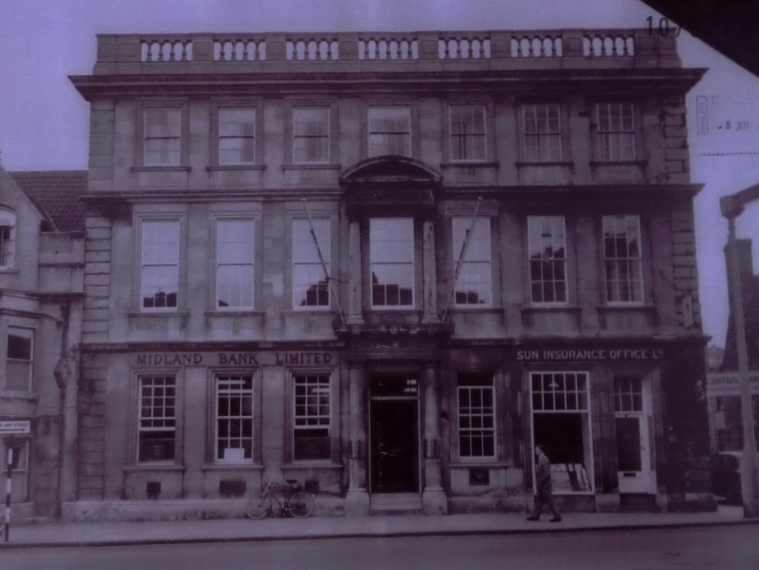

Photograph of front elevation dated 1953

Impact of proposals on the significance and setting of the building/structure:
Understanding the impact of proposed works on a listed building requires a careful and proportionate assessment of how those changes affect the asset’s heritage significance and its setting. This includes both the physical alterations to the building itself and any changes to its spatial or visual relationship with surrounding structures or spaces.

The significance of a heritage asset is not static; it is shaped by its architectural, historic, and communal values, and by how these are experienced in context. Therefore, any intervention must be considered in light of the asset’s identified significance, with attention given to both potential harm and benefits. Benefits may include repairs that support the long-term conservation of the building, improved energy performance, or enhanced public access and understanding.

This assessment is grounded in the statutory duty under Section 16 of the Planning (Listed Buildings and Conservation Areas) Act 1990, which requires special regard to be given to the desirability of preserving the building and its features of special interest. It is also informed by national policy, particularly paragraphs 212-221 of the National Planning Policy Framework (NPPF), and relevant local heritage policies and guidance.

In this case the proposals are for the repair of the building fabric and will see general façade, stonework and window repairs across all elevations.

The proposed façade and stonework repairs are limited to modest localised repair and cleaning and replacement of flashings. Confirmation has been provided that notes in the survey relating to larger scale works including opening of blind windows, addition of further lengths of balustrade and wholesale stone cleaning are not proposed to take place.

The existing windows appear to reflect two main periods. The majority are potentially early C20 horned sashes with standard ovolo mouldings. These appear to be in place in the 1953 photograph above and possibly date from the conversion to a bank in the early C20. Some of these also have later glazing bars and other alterations. All are glazed with modern plate glass.

In addition, a few windows date from an earlier period. These are without sash horns and include WE19 and 20, WE 27 and 28, WN 1-4 and WN14. WE19 and 20 retain some historic glazing (all others are glazed in modern standard plate glass). These windows largely retain finer (probably lambs tongue under layers of paint) mouldings, although in several places the glazing bars have been replaced with clumsy mouldings at some more recent date.

Windows in the single bay fronted bay of the former George Hotel which has been incorporated into the property are 2 over 2 sashes with horns. The mouldings, whilst fine, are quite crisp and it is clear that the windows have been replaced since the 1953 photo which shows them with single pane plate glass windows and since the 1976 list description which notes ‘no glazing bars’. Replacement had, however, taken place before the c.1983 incorporation into No.46 as the design is consistent across the whole frontage.

The proposals are for a comprehensive programme of maintenance of the windows, with the replacement of individual sashes where these are considered by the contractor to be beyond economic repair. All frames are proposed to be retained and repaired. The works fall within categories 1 and 2 outlined in the Historic England guidance:
- Where historic windows, whether original or later insertions, make a positive contribution to the significance of a listed building they should be retained and repaired where possible. If beyond repair they should be replaced with accurate copies.
- Where historic windows have already been replaced with windows whose design follows historic patterns, these usually make a positive contribution to the significance of listed buildings. When they do, they should therefore be retained and repaired where possible. If beyond repair they should be replaced with accurate copies.

Inspection on site has confirmed that the sashes proposed for replacement are in poor condition with the lower elements in particular being significantly decayed. Whilst a number of the C20 units could possibly be repaired to extend their lives for a period, the current proposals represent a significant investment in repair and the public benefits secured by securing a comprehensive upgrading of the external envelope at a time when many of the former banks are disposing of properties and the empty units risk falling into disrepair, are considered to be sufficient to offset the modest level of harm caused.

As there is no objection from Historic England, the application may be determined by the LPA without further referral.

Impact on Ecology
While Sections 16 and 72 of the Planning (Listed Buildings and Conservation Areas) Act 1990 do not explicitly reference protected species, Local Planning Authorities have a statutory duty to consider potential impacts on protected species when determining applications. This responsibility arises from broader environmental legislation and national planning policy, and must be taken into account where relevant.

Does the site or proposed development possess/impact on any of the features where
protected species are likely to be present (assessed against Natural England’s standing
advice) and where species are likely to be found?
 |  | Y / N / NA
(a) | Does the site or proposed development possess/impact on any of the features where protected species are likely to be present (assessed against Natural England’s standing advice) and where species are likely to be found? | N
(b) | If yes, has a protected species survey been submitted?
(c) | If yes, does the survey show a detailed consideration of ecological impacts, wildlife mitigation and the creation, restoration and enhancement of wildlife corridors to preserve and enhance biodiversity in accordance with the standing advice?

Comments (if any): None required.

CONCLUSION
The NPPF confirms that when considering the impact of a proposed development on the significance of a designated heritage asset, great weight should be given to the asset’s conservation (and the more important the asset, the greater the weight should be). It makes clear that any harm to a designated heritage asset requires clear and convincing justification.

In this case the proposals will also result in considerable heritage benefits by virtue of the proposed investment in repair and upgrading which will help to secure the continuing use of the building in good condition within its established use.

In this case, the majority of the widows are of modern date and there will be no loss of historic fabric. A small number of the windows are of earlier date but all those sashes to be replaced are in a poor state of repair. Replacements are proposed to use details to match, and final details are to be conditioned. The stone works repairs are also relatively minor and appropriately specified. Whilst there will be some minor loss of historic fabric in the form of the loss of a number of historic sashes, the overall impact of the proposals on heritage assets will be neutral and on this basis no specific justification is required. However, the proposals will also result in considerable heritage benefits by virtue of the proposed investment in repair which will help to secure the future of the building in good repair in its current and optimum viable use. The requirements of current conservation legislation, policy or guidance are therefore considered to be met.

RECOMMENDATION:
That Listed Building Consent be GRANTED, subject to the following conditions:
Time limit
Plans list
Joinery details to be submitted
Stonework to match
Leadwork to be carried out to Lead Sheet Assoc. standards.

