APPLICATION FOR HOUSEHOLDER PLANNING PERMISSION
DELEGATED REPORT

APPLICATION REFERENCE: | PL/2026/03790
APPLICATION TYPE: | Householder planning permission
SITE ADDRESS: | The Old House, Station Road, Semley, Shaftesbury, SP7 9AN
DEVELOPMENT DESCRIPTION: | Single storey side porch, utility and shower room
RECOMMENDATION: | That Planning Permission be GRANTED

PROPOSAL

The proposal seeks planning permission for a single storey side extension to provide a porch, utility room and shower room.

Existing and proposed site plans

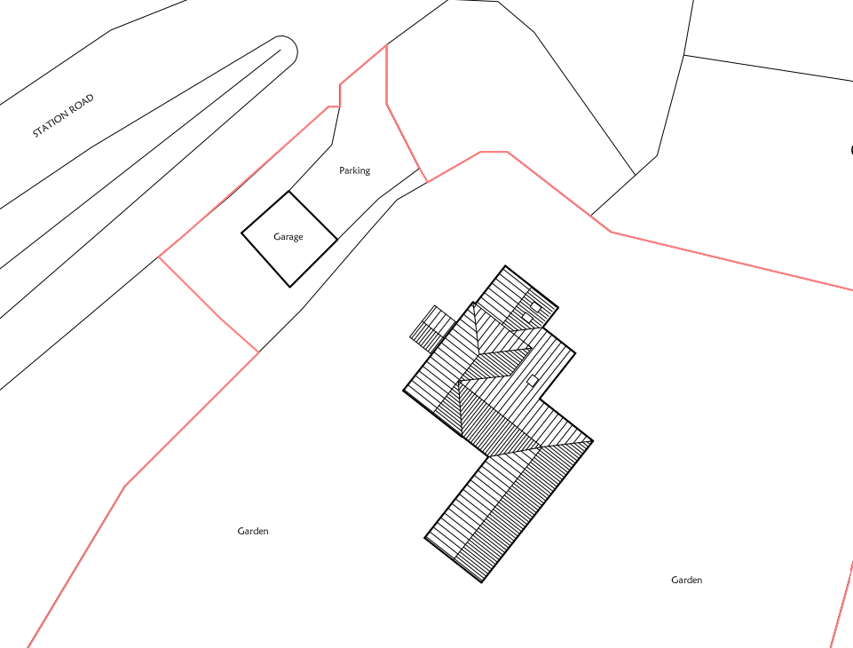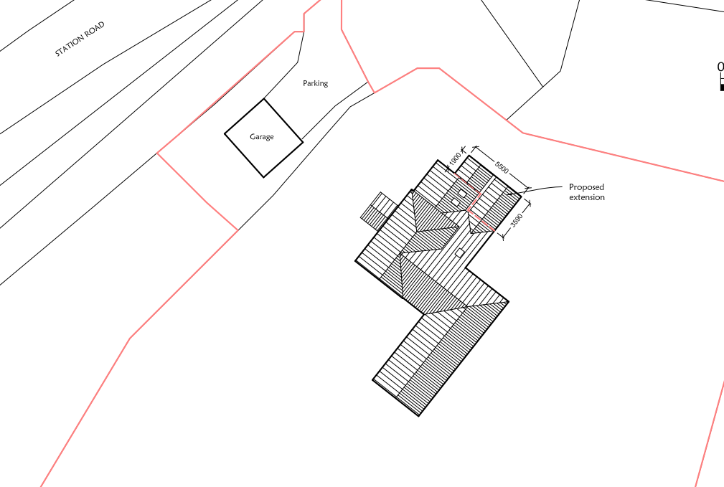

Existing plans

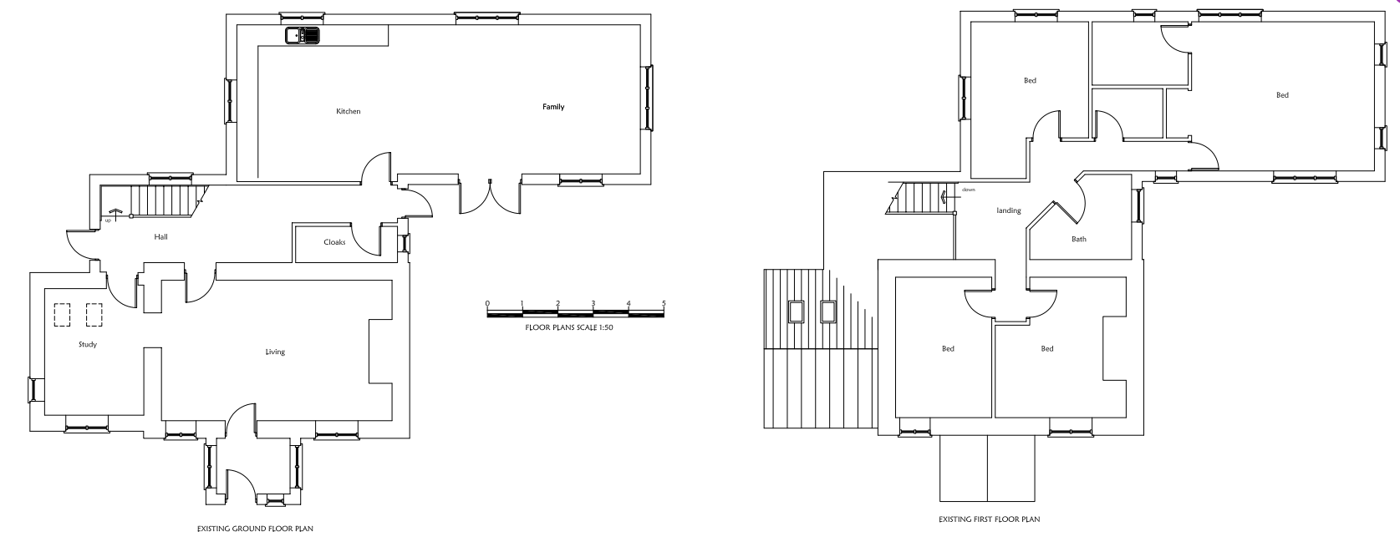

Proposed plans

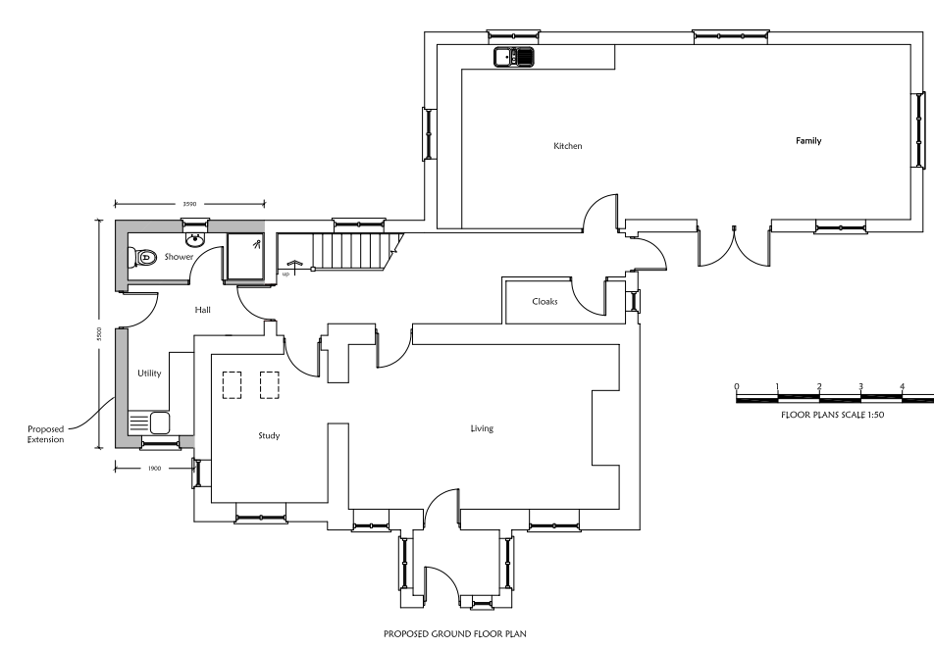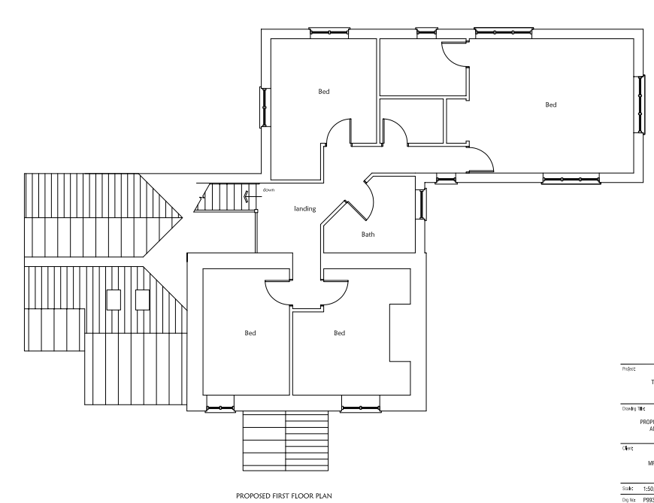

Existing and proposed front elevation

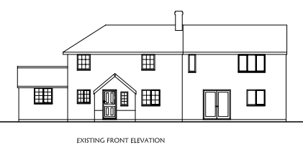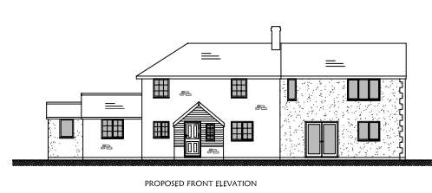

Existing and proposed rear elevation

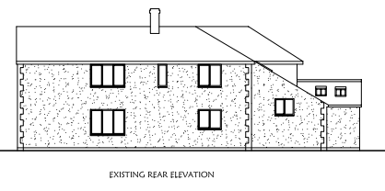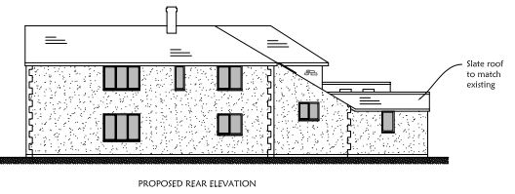

Existing and proposed side elevation

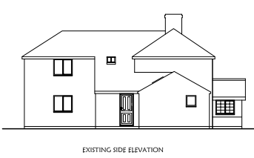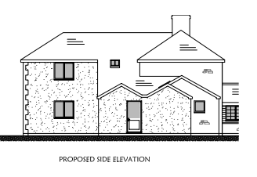

SITE DESCRIPTION/CONTEXT

The application site relates to an existing extended detached residential dwelling located within a large residential curtilage on the south side of Station Road in Semley. Semley is defined as a small village without a settlement boundary by Core Polices 1, 2 and 17 of the Wiltshire Core Strategy. The site is bounded by agricultural fields to the north and east, EG Coles & Son agricultural and groundcare dealership to the south, and residential dwellings at Dairy Cottages to the west. The site is located within the Cranborne Chase and West Wiltshire Downs National Landscape.

PLANNING HISTORY

Proposal / Summary
S/2004/1198 - Full planning permission Decision - Approve with Conditions Date: 13/7/2004 – TWO STOREY AND FIRST FLOOR EXTENSION
S/2005/2055 - Full planning permission Decision - Approve with Conditions Date: 6/12/2005 – 2 STOREY EXTENSION TO PREVIOUSLY APPROVED 2 STOREY EXTENSION (04/1198)
S/2005/2071 - Full planning permission Decision - Approve with Conditions Date: 9/12/2005 – CHANGE OF USE OF AGRICULTURAL LAND TO DOMESTIC GARDEN WITH A TREE SCREEN
17/11760/FUL - Full planning permission Decision - Approve with Conditions Date: 19/1/2018 – Single storey porch extension and installation of roof lights over study.

RELEVANT POLICIES AND GUIDANCE

The National Planning Policy Framework (NPPF)
The Planning Practice Guidance
National Design Guide

Wiltshire Core Strategy

Core Policy 1: Settlement Strategy
Core Policy 2: Delivery Strategy
Core Policy 17: Mere Community Area
Core Policy 51: Landscape
Core Policy 50: Biodiversity and Geodiversity
Core Policy 57: Ensuring High Quality Design & Space Shaping

Wiltshire Design Guide: Appendix D – Design Guidance for Householder extensions
Creating Places Design Guide

CONSULTATION RESPONSES

Parish Council: None received

REPRESENTATIONS

No comments were received.

ASSESSMENT

Section 38(6) of the Planning and Compulsory Purchase Act 2004 states:

"If regard is to be had to the development plan for the purposes of any determination to be made under the planning Acts, the determination must be made in accordance with the plan unless material considerations indicate otherwise."

In accordance with this statutory requirement, this application has been assessed against the relevant policies of the Development Plan, including the adopted Wiltshire Core Strategy (2015) and, where applicable, any made Neighbourhood Plans.

Design and Impact upon the character and context of the area including National Landscape

Core Policy 57 - Ensuring High Quality Design and Place Shaping of the Wiltshire Core Strategy seeks to ensure that all new development is of high design quality, reflecting local context, character, and distinctiveness.

Core Policy 51 of the Wiltshire Core Strategy requires all development to protect, conserve, and where possible enhance the character and quality of Wiltshire’s landscapes, giving particular weight to designated areas such as National Landscapes.

The National Planning Policy Framework (NPPF), in Paragraph 189, states that “great weight” should be given to conserving and enhancing landscape and scenic beauty in National Landscapes (formerly Areas of Outstanding Natural Beauty). Development within or affecting the setting of a National Landscape must demonstrate that it will not result in unacceptable harm to the special qualities of that area.

The proposed development comprises a modest single-storey L-shaped extension wrapping around part of the northern elevation of the dwellinghouse. The extension would provide a porch, utility room and shower room and would be constructed using materials that match the existing dwelling.

In terms of its scale, form and appearance, the extension would appear subordinate to the host dwelling and would integrate satisfactorily with the existing building. Given its modest size and location, the development would not appear visually intrusive or incongruous within the site or wider area.

The dwelling occupies a generous plot and is screened from wider public views by existing boundary vegetation, including mature trees and hedgerows. Therefore, the extension would have a limited visual presence within the surrounding landscape. Furthermore, having regard to its scale and relationship with the existing dwelling, the proposal would preserve the character and appearance of the site and would not result in any adverse impact on the scenic quality or special qualities of the Cranborne Chase National Landscape.

The proposal is therefore considered to comply with Core Policies 51 and 57 of the Wiltshire Core Strategy and Appendix D of the Wiltshire Design Guide.

Amenity

Point vii of Core Policy 57 - Ensuring High Quality Design and Place Shaping of the Wiltshire Core Strategy seeks to ensure that developments do not adversely affect neighbouring properties.

The National Planning Policy Framework (NPPF), particularly Paragraph 135(f), stresses that planning decisions should ensure developments provide a high standard of amenity for existing and future users.

The proposed extension has been assessed in terms of its potential impact on the residential amenity of neighbouring occupiers, with particular regard to loss of light, overshadowing, loss of privacy and overbearing effects.

The extension would be located on the northern side of the dwelling and is single storey in scale. Given the separation distances to neighbouring residential properties and the absence of any dwelling directly adjacent to the proposed extension, the development would not give rise to any unacceptable impacts in terms of overshadowing, loss of light, overbearing impact or loss of privacy.

The proposal therefore complies with Core Policy 57 (criterion vii) of the Wiltshire Core Strategy and Appendix D of the Wiltshire Design Guide.

Ecology Impact

Core Policy 50 of the Wiltshire Core Strategy seeks to protect and enhance biodiversity and geodiversity, including through ensuring that development avoids harm to protected species and habitats.

The National Planning Policy Framework (NPPF), at Paragraph 193, requires that development minimises impacts on and provides net gains for biodiversity, including ensuring mitigation is secured where harm cannot be avoided.

The application site is not subject to any statutory or non-statutory ecological designations, and the scale and nature of development is such that significant harm to biodiversity is unlikely.

Biodiversity Net Gain - Householder planning applications are exempt from the requirement to deliver Biodiversity Net Gain under Schedule 7A, Section 4(2)(a) of the Town and Country Planning Act 1990, as inserted by the Environment Act 2021.

As such, the development complies with Core Policy 50 of the Wiltshire Core Strategy and the relevant provisions of the NPPF.

CONCLUSION

The proposed development is considered to be acceptable in terms of its design, scale, and relationship with the surrounding area including impact on National Landscape. It would not result in any unacceptable harm to the character of the locality, the amenities of neighbouring occupiers or ecology.

The proposal is therefore considered to comply with the relevant policies of the Wiltshire Core Strategy and the National Planning Policy Framework. As such, the application is recommended for approval, subject to the conditions set out below.

RECOMMENDATION: That Planning Permission be GRANTED subject to conditions.

1. The development hereby permitted shall be begun before the expiration of three years from the date of this permission.
REASON: To comply with the provisions of Section 91 of the Town and Country Planning Act 1990 as amended by the Planning and Compulsory Purchase Act 2004.
2. The development hereby permitted shall be carried out in accordance with the following approved plans:

Application form received 10/06/2026
Location plan Drg no P993/01 received 22/06/2026
Proposed block plan Drg no P993/04 received 10/06/2026
Proposed floor plans and elevations Drg no P993/05 received 10/06/2026

REASON: For the avoidance of doubt and in the interests of proper planning.

3. The materials to be used in the construction of the external surfaces of the development hereby permitted shall match in material, colour and texture those used in the existing building.

REASON: In the interests of visual amenity and the character and appearance of the area.

