Scouts Island Photos
T1 – Poplar ///latter.ripe.plots
Poplar. Monolith above cavity to retain habitat feature.
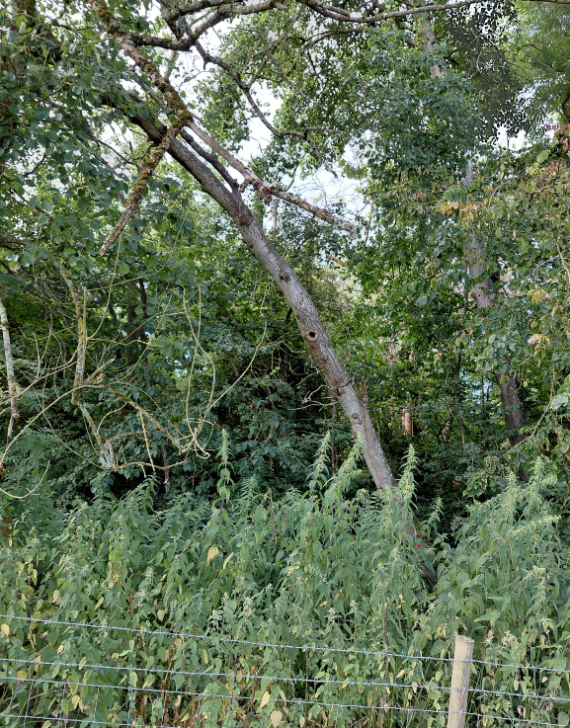

T2 – Ash – ///treat.surely.traded
Remove front stem adjacent to fence with advanced ash dieback 