88 Montgomery Gardens

G1 – Mixed group -Prune back trees 2m from property
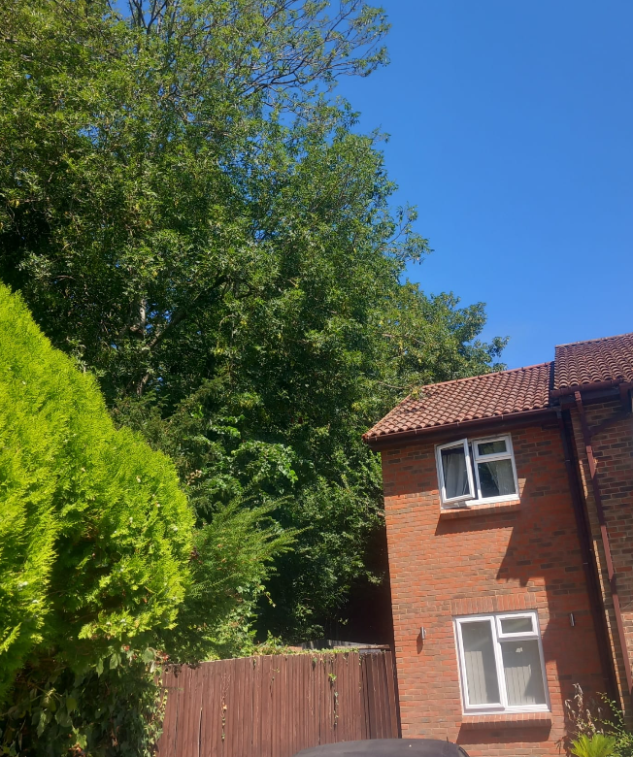

G2 mixed group – prune back 2m from shed
