APPLICATION FOR FULL PLANNING PERMISSION
DELEGATED REPORT

APPLICATION REFERENCE: | PL/2026/03343
APPLICATION TYPE: | Full Planning Permission
SITE ADDRESS: | Windy Ridge Playing Field, Westwood, Trowbridge, BA14 6GP
DEVELOPMENT DESCRIPTION: | The installation of 2 no Shipping Containers, placed back to back, to provide storage and welfare facilities for Westwood Football Club.
RECOMMENDATION: | That Planning Permission be GRANTED

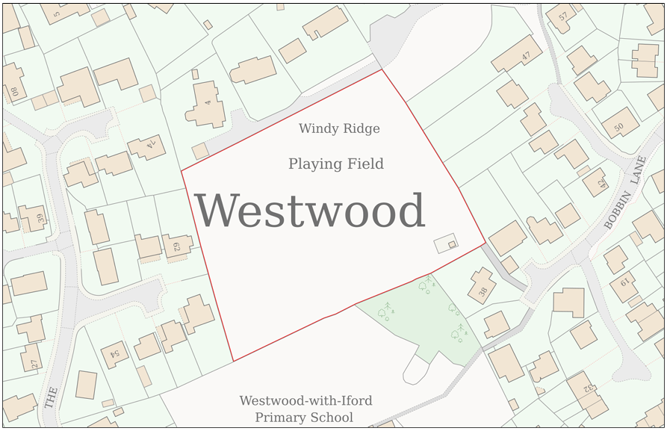

PROPOSAL

The application seeks planning permission for the siting of two ISO shipping/storage containers positioned immediately adjacent to one another on an existing area of hardstanding within the corner of an established playing field. One container would provide ancillary toilet and washing facilities and measures approximately 3m by 2.4m in footprint, whilst the second would provide secure equipment storage and measures approximately 6m by 2.4m. Both structures would have a maximum height of approximately 2.4m and would be finished in a dark green colour. The containers would be constructed from profiled steel, reflecting the appearance typically associated with ISO storage containers.

SITE DESCRIPTION / CONTEXT

The application site forms part of a large established playing field located within the Westwood settlement boundary, designated as a Larger Village. The site is surrounded by residential development along its northern, eastern and western boundaries, with Westwood-with-Iford Primary School situated immediately to the south. The playing field is enclosed by substantial and mature hedgerows which create a strong sense of enclosure and significantly restrict views both into and out of the site. The proposed development is located on an existing hardstanding area in a corner of the playing field. There are three TPO protected trees located along the eastern boundary, with the nearest approximately 10m from the proposed containers. The site lies within Flood Zone 1 and is identified by the Council's Strategic Flood Risk Assessment as being at negligible risk from both surface water and groundwater flooding. Ecological constraints include the site falling within the GHS 4km Core Roost Buffer and SAC Parcel Buffer, and the LHS 2km Core Roost Buffer and SAC Parcel Buffer. There are no conservation area, listed building or other heritage constraints affecting the site.

PLANNING HISTORY

Reference No. | Proposal / Summary | Decision
W/83/01112/FUL | Erection of a sports pavilion | Approved
W/97/01472/OUT | Erection of sports/playing field changing facility (outline) | Approved

RELEVANT LEGISLATION, POLICIES AND GUIDANCE

Wiltshire Core Strategy:

Core Policy 1 Settlement Strategy;
Core Policy 2 Delivery Strategy;
Core Policy 7 Spatial Strategy: Bradford on Avon Community Area;
Core Policy 50 Biodiversity and Geodiversity;
Core Policy 51 Landscape;
Core Policy 57 Ensuring High-Quality Design and Place Shaping;
Core Policy 60 Sustainable Transport;
Core Policy 61 Transport and Development;
Core Policy 64 Demand Management;
Core Policy 67 Flood Risk;

The National Planning Policy Framework (NPPF)

The Planning Practice Guidance (PPG)

Wiltshire Design Guide - Appendix D – Design Guidance for Householder extensions

The Wiltshire Local Transport Plan 2011 – 2026: Car Parking Strategy (March 2015).

The Wiltshire Local Transport Plan 4 (LTP4) (March 2025)

Emerging Policy – Wiltshire Local Plan Review

At Full Council on 19 May, the elected members of Wiltshire Council agreed to withdraw the emerging WLP. The said Plan has no material weight for the purposes of the application.

CONSULTATION RESPONSES

No consultation responses.

REPRESENTATIONS

Two comments of support were received in relation to the application. One respondent raised no objection to the proposal but requested that any planning permission include a condition restricting the installation of external lighting without the prior written approval of the Local Planning Authority, citing the site's proximity to the Bath and Bradford-on-Avon Bats SAC and the sensitivity of local bat populations to artificial lighting. A further respondent expressed support for the proposal, noting that use of the playing field and opportunities for young people to participate in outdoor exercise should be encouraged and observing that the field is currently underused.

ASSESSMENT

Section 38(6) of the Planning and Compulsory Purchase Act 2004 states:

"If regard is to be had to the development plan for the purposes of any determination to be made under the planning Acts, the determination must be made in accordance with the plan unless material considerations indicate otherwise."

In accordance with this statutory requirement, this application has been assessed against the relevant policies of the Development Plan, including the adopted Wiltshire Core Strategy (2015) and, where applicable, any made Neighbourhood Plans.

The playing field is an established recreational use and the proposed facilities are considered reasonably ancillary to and supportive of that use. The provision of secure storage for equipment, together with toilet and washing facilities for users of the site, represents infrastructure that would directly facilitate the continued operation and enjoyment of the recreational facility. The scale and nature of the proposal are clearly subordinate to the primary use of the site as a playing field and would not result in any loss of the recreational function of the land. As such, the principle of the development is considered acceptable.

Design and Impact the upon the character and context of the area

Core Policy 57 Ensuring High Quality Design and Place Shaping of the Wiltshire Core Strategy requires all new development to achieve a high standard of design that responds positively to its local context. Proposals must reinforce and enhance local character and distinctiveness, relate appropriately to the surrounding landscape, and demonstrate a thoughtful response to existing townscape features. This includes careful consideration of elements such as building height, scale, massing, building line, materials, and overall appearance, ensuring new development integrates harmoniously with its setting.

The proposed containers are modest in scale, with a maximum height of only 2.4m, and would be confined to an existing hardstanding area within the corner of the playing field. Owing to the substantial and dense boundary hedgerows surrounding the site, views of the structures from the public realm and surrounding properties would be very limited. Furthermore, the proposed dark green finish would assist the development in visually integrating with the dominant characteristics of the surrounding environment, namely the extensive green hedgerows and grassed playing field. Whilst the utilitarian appearance of the containers is acknowledged, their limited scale, discreet siting and proposed colour treatment ensure that they would not appear visually intrusive or out of character within their setting. Accordingly, the proposal would have no harmful impact upon the character or appearance of the area.

Having regard to the above, the proposal complies with the design principles set out in Core Policy 57 of the Wiltshire Core Strategy and the Wiltshire Design Guide.

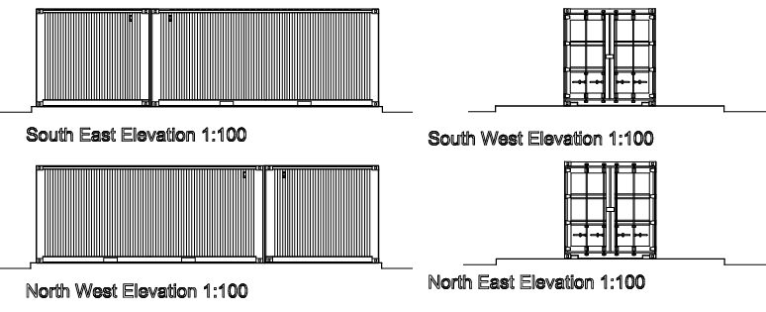
Proposed Elevations

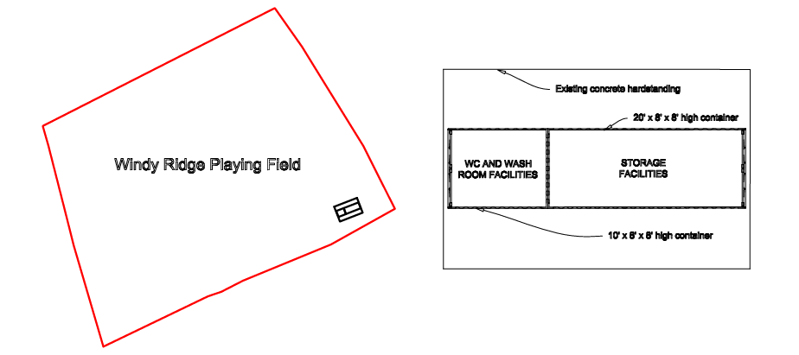
Site Plan and Floor Plan

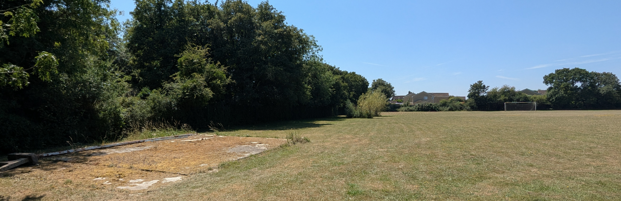
Site Visit

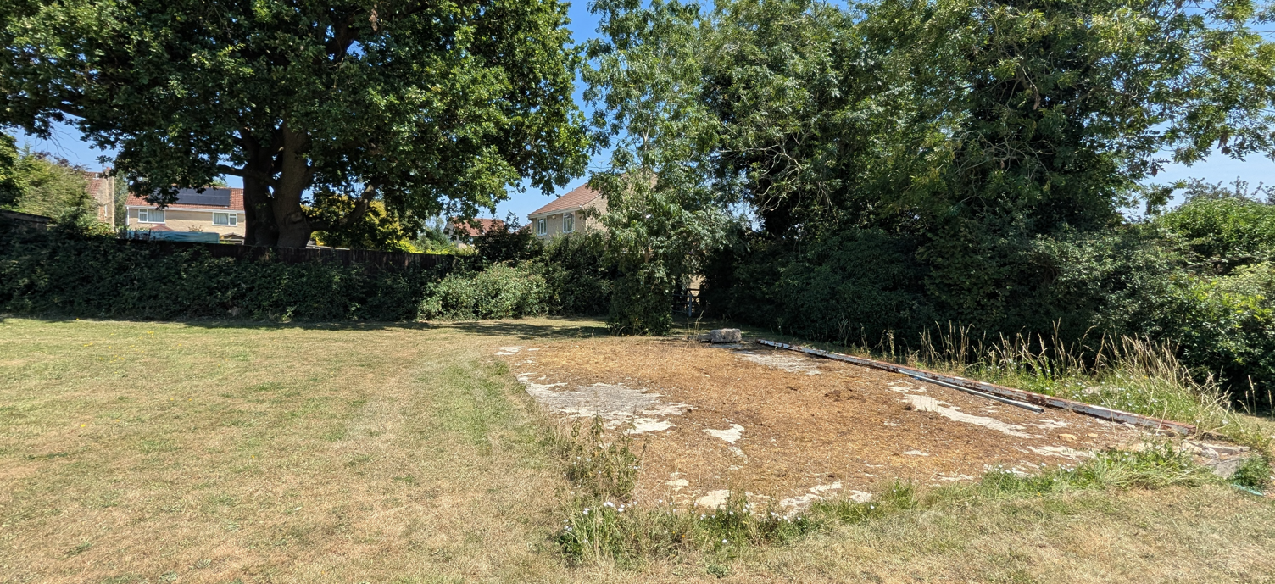
Site Visit

Amenity

Point vii of Core Policy 57 Ensuring High Quality Design and Place Shaping of the Wiltshire Core Strategy seeks to ensure that developments do not adversely affect neighbouring properties. The National Planning Policy Framework (NPPF), particularly Paragraph 135, stresses that planning decisions should ensure developments provide a high standard of amenity for existing and future users.

The proposed development would not result in any unacceptable impacts upon the amenities of neighbouring occupiers. The containers would contain no windows and therefore would not give rise to overlooking, loss of privacy or perceptions of overlooking. In addition, at only 2.4m in height, the structures would sit below the height of the established boundary hedgerows and nearby trees which already define the site's enclosure. Given the modest scale of the proposal, its separation from neighbouring dwellings and its positioning within the established playing field, it is considered that the development would not give rise to any overbearing impacts, loss of outlook or material overshadowing. The proposal is therefore acceptable in terms of residential amenity.

Transport and Highways

Core Policy 60 of the WCS states that Council will support and encourage safe and efficient movement of people and, where necessary, mitigate the impact of development on transport users and local communities. Core Policy 61 specifies that development should demonstrate that consideration has been given to a hierarchy of transport users and that proposals must, where relevant, serve as a safe access to the highway network. Paragraph 116 of the NPPF states that “Development should only be prevented or refused on highways grounds if there would be an unacceptable impact on highway safety, or the residual cumulative impacts on the road network, following mitigation, would be severe, taking into account all reasonable future scenarios”.

The proposal would have no adverse implications for highway safety or the operation of the local highway network. The development would not alter existing vehicular or pedestrian access arrangements, nor would it affect the availability of existing parking provision associated with the playing field. Furthermore, the proposed toilet, washing and storage facilities are ancillary to the established use of the site and are not expected to generate additional vehicle movements. Indeed, the provision of on-site storage has the potential to reduce the need for trips associated with transporting equipment to and from the playing field. The proposal is therefore considered acceptable from a highways and access perspective.

Ecology

The WCS, through Core Policy 50, states that development proposals are expected to avoid and reduce disturbance of sensitive wildlife species and habitats. Biodiversity Net Gain (BNG) was established as a mandatory aspect of planning evaluation through Schedule 7A of the Town and Country Planning Act 1990 (as amended by the Environment Act 2021 Schedule 14).

The proposed development comprises the siting of two containers with a combined footprint of approximately 21.6 square metres. As the development would affect less than 25 square metres of on-site habitat, the statutory Biodiversity Net Gain (BNG) requirements are not triggered in this instance. Furthermore, the containers would be positioned entirely upon an existing area of concrete hardstanding which is of negligible ecological and biodiversity value. The proposal would therefore not result in the loss or degradation of any meaningful habitat and would not adversely affect ecological connectivity within the wider site. Whilst the site falls within various bat-related consultation buffers associated with the Bath and Bradford-on-Avon Bats SAC, the proposal relates solely to the placement of structures on an existing hardstanding area and would not involve the removal of vegetation, trees or other habitat features.

A representation received during the public consultation process requested that a condition be imposed to control any future external lighting due to the sensitivity of local bat habitats. This has been considered; however, no external lighting forms part of the proposal and the development has been assessed on that basis. Consequently, it is not considered necessary to impose a lighting condition, with any future lighting proposals requiring separate consideration of their planning and ecological impacts.

Given the limited scale of the development and the absence of any habitat loss, it is considered that the proposal would not give rise to any unacceptable ecological impacts and is therefore acceptable in this regard.

Flooding and Drainage

Core Policy 67 Flood Risk of the Wiltshire Core Strategy requires all development to be located, designed, and constructed to minimise vulnerability to flooding and to avoid increasing flood risk elsewhere. Proposals must demonstrate that surface water can be managed safely and sustainably, incorporating appropriate drainage solutions—such as sustainable drainage systems (SuDS)—that ensure runoff rates and volumes do not exceed pre‑development levels. Development should provide measurable betterment where necessary, ensuring that drainage strategies are robust, technically compliant, and aligned with national policy. The NPPF sets out the application of a sequential, risk-based approach to the location of new development in paragraph 172.

The site lies within Flood Zone 1 and is identified as being at negligible risk from both surface water and groundwater flooding. The development comprises a relatively small footprint of approximately 21.6 square metres in total and would be located entirely on an existing concrete hardstanding area. As a result, the proposal would not increase the extent of impermeable surfacing on the site and would not materially alter existing drainage arrangements or surface water runoff characteristics.

The applicant has confirmed that the proposed washroom facility will connect to an existing private sewer connection serving a former washroom block previously located on the site. Given the modest scale of the development, the use of an existing foul drainage connection, the site's location within Flood Zone 1, and the absence of any increase in impermeable surfacing, no drainage or flood risk concerns are raised by the proposal and it is therefore acceptable.

CONCLUSION

Taking all relevant material considerations into account, the proposed siting of two ancillary containers to provide storage, toilet and washing facilities is considered to represent an appropriate form of development in support of the established recreational use of the playing field. The proposal is acceptable in principle, would not result in harm to the character or appearance of the area, would have no adverse impact upon neighbouring residential amenity, and raises no concerns in relation to drainage, flood risk, highway safety or ecology. The development is of a modest scale, contained within an existing hardstanding area, and benefits from substantial screening provided by the surrounding boundary vegetation. Having regard to the development plan and all other material considerations, it is concluded that the proposal constitutes sustainable development and is recommended for approval subject to appropriate planning conditions.

RECOMMENDATION: That Planning Permission be GRANTED subject to the following conditions:

1.
The development hereby permitted shall be begun before the expiration of three years from the date of this permission.
REASON: To comply with the provisions of Section 91 of the Town and Country Planning Act 1990 as amended by the Planning and Compulsory Purchase Act 2004.

2.
The development hereby permitted shall be carried out in accordance with the following approved plans and documents:

Proposed Elevations and Floor Plans (With Block Plan) 001 (26 May 2026)
Location Plan (26 May 2026)

REASON: For the avoidance of doubt and in the interests of proper planning.

