APPLICATION FOR PRIOR NOTIFICATION – PART 3
CASE OFFICER REPORT

APPLICATION REFERENCE: | PL/2026/03031
APPLICATION TYPE: | Prior approval part 3 Class G - COU from Use Class E, to a mixed use including one flat
SITE ADDRESS: | 37A Silver Street, Bradford on Avon, Wiltshire, BA15 1JX
DEVELOPMENT DESCRIPTION: | Prior approval part 3 Class G - COU from Use Class E - Offices to a mixed use live/work unit (First floor office/meeting room, kitchen for both uses, second floor living room and bedroom and shower room/WC for both uses)
RECOMMENDATION: | That Prior Approval is required and GRANTED

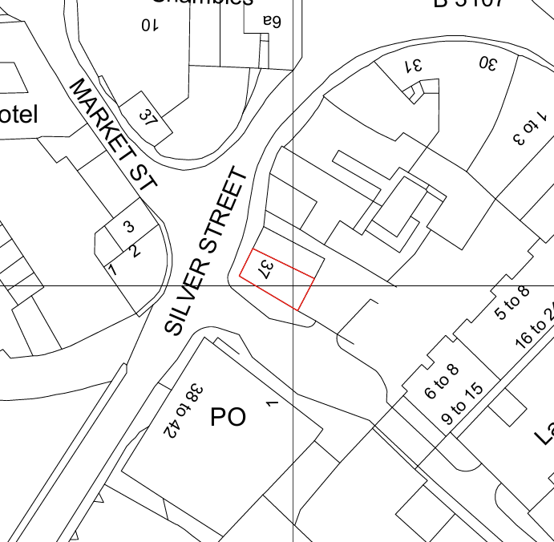

SITE DESCRIPTION/CONTEXT

The application site comprises the upper floors of 37A Silver Street, located at a prominent junction within the historic core of Bradford on Avon. The site lies within the Bradford on Avon Conservation Area and is surrounded by a number of Grade II listed buildings, reflecting the highly sensitive historic character of the town centre. The building forms one half of a distinctive pair of attached properties with gable ends facing Silver Street. The building is finished in painted render with sash windows and a pitched tiled roof behind a parapet frontage. The ground floor remains in commercial use (Class E) whilst the first and second floors are currently occupied as offices. The site lies within the Bradford on Avon settlement boundary and occupies a highly sustainable town centre location with immediate access to shops, services, public transport and employment opportunities. The site is affected by Flood Zone 3 associated with the River Avon and is located within the relevant bat mitigation areas associated with the Bath and Bradford on Avon Bats SAC. The site is also within proximity of several designated heritage assets.

PROPOSAL

The application seeks prior approval under Schedule 2, Part 3, Class G of the Town and Country Planning (General Permitted Development) (England) Order 2015 (as amended). The proposal involves the change of use of part of the existing office accommodation above the ground floor commercial unit to create a mixed-use live/work unit. The first-floor front room would remain in office use and continue to function as a meeting room/workspace. The rear first floor room, which already contains kitchen facilities, would serve a dual purpose as a kitchen for both the office and residential elements of the development. The second floor would be converted to provide residential accommodation comprising a living room, a bedroom and access to the existing shower room and WC facilities. No external alterations are proposed to the building, and the existing ground floor Class E commercial use would be retained.

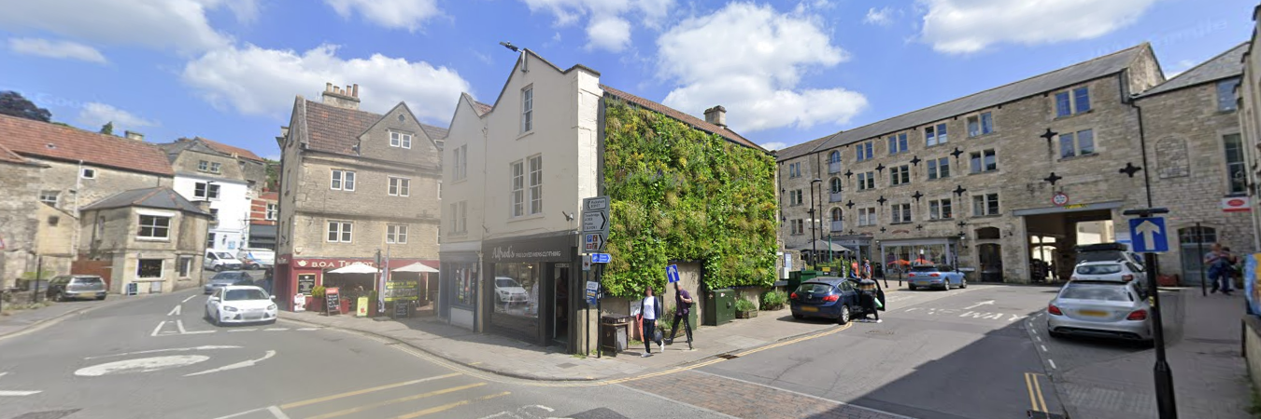
Site Image

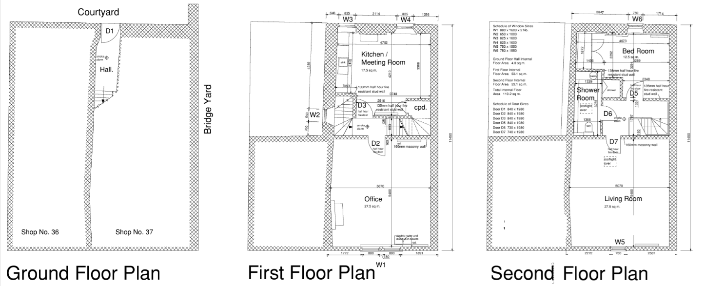

Proposed Floor Plans

RELEVANT LEGISLATION, POLICY AND GUIDANCE
Under Schedule 2, Part 3, Class G of the Town and Country Planning (General Permitted Development) (England) Order 2015 (as amended), development consisting of a change of use of a building and any land within its curtilage from a use falling within Class E (commercial, business and service) to a mixed use comprising a use falling within Class E and up to two flats is permitted development subject to limitations, conditions and the prior approval procedure.

Conservation of Habitats and Species Regulations 2017 (as amended).

Bradford on Avon Neighbourhood Plan 2013-2026.

National Planning Policy Framework (NPPF).

RELEVANT PLANNING HISTORY

Reference No. | Proposal / Summary | Decision
W/99/00673/FUL | Change of use from offices to dwelling | Approved
16/00800/FUL | Replacement of a window and door | Approved

CONSULTATIONS

Bradford on Avon Town Council: No Objection

Wiltshire Council Highways Officer: No Objection

Environment Agency: No Objection
Whilst the site lies within Flood Zones 2 and 3, the proposal relates to an existing building and would not result in any additional loss of floodplain. The Environment Agency notes the potential for occupants to become isolated during a flood event and recommends the Local Planning Authority considers matters relating to safe access and egress.

REPRESENTATIONS
Bradford on Avon Preservation Trust:
This is an application for Prior Approval for works falling within Part 3 Class G - COU from Use Class to a mixed use including up to 2 Flats on the upper floors. All the local planning authority can consider is whether or not a formal planning application is required. It is our view that no application is required because the space above Class E use can be converted into up to 2 flats without needing to apply for permission. However, it will require a future application for listed building consent if any changes affecting the character of the building are proposed and the proposals must be compliant with Building Regulations.

ASSESSMENT

Does the Proposal Qualify as Permitted Development?
This application seeks prior approval under Class G, which permits the change of use of a building from a Class E use to a mixed-use comprising Class E and up to two flats, although only one flat is proposed under this prior approval.

The site currently comprises a ground floor commercial unit with office accommodation on the upper floors. The proposal would retain an office function on the first floor whilst introducing a single residential unit at second floor level. As such, the proposal constitutes a mixed-use development falling squarely within the provisions of Class G.

Having established that the proposal involves the creation of a mixed-use development comprising office use being kept in part on the first floor as well as dual shared space with the creation of one self-contained residential unit, it is necessary to assess whether the proposal complies with the conditions set out in Schedule 2, Part 3, Class G. The relevant provisions are considered below.

Criterion G.1(a)
Class G requires that some or all of the parts of the building remaining in commercial use are situated on a floor below the lowest part of the building to be used as a flat. In this case, the proposed residential accommodation would be located at second floor level with some shared access space on the first floor, whilst office accommodation would be retained at first floor level. The ground floor commercial unit would also remain. All commercial activity would therefore be located on the floors below the residential accommodation. Accordingly, the proposal complies with the requirements of paragraph G.1(a).

Criterion G.1(b)
Where development consists of the change of use of a building with a display window at ground floor level, Class G requires that the ground floor must not be used, either wholly or partly, as a flat. The building contains display windows at ground floor level associated with the existing commercial premises. However, no residential accommodation is proposed at ground floor level, and the existing commercial use would be retained on ground and first floor levels. The proposal therefore complies with paragraph G.1(b).

Criterion G.1(c)
Class G requires that any flat created is occupied either by a single person, persons living together as a family, or by no more than six residents living together as a single household. Whilst this provision primarily relates to the future occupation of the flat rather than its physical form, the submitted plans demonstrate the creation of a modest one-bedroom dwelling. There is nothing within the submitted details to indicate that the accommodation would be occupied in a manner contrary to the requirements of paragraph G.1(c). The proposal is therefore capable of complying with this condition.

Criterion G.1(d)
Class G requires that, before development begins, the developer applies to the local planning authority for a determination as to whether prior approval is required in respect of certain specified matters. This application has been submitted for that purpose and seeks a determination in relation to the matters prescribed by paragraph G.1(d), namely:

- contamination risks in relation to the building;
- flooding risks in relation to the building;
- impacts of noise from commercial premises on the intended occupiers of the development;
- the provision of adequate natural light in all habitable rooms of the dwellinghouse; and
- arrangements required for the storage and management of domestic waste.

The submission of the current application satisfies this procedural requirement, and it is therefore necessary for the Local Planning Authority to consider each of these matters through the prior approval process.

Conclusion on Permitted Development Status
Having assessed the proposal against the relevant conditions contained within Class G, it is concluded that the development complies with the requirements of paragraphs G.1(a) to G.1(c). The proposal is therefore capable of benefiting from permitted development rights under Schedule 2, Part 3, Class G of the Town and Country Planning (General Permitted Development) (England) Order 2015 (as amended), subject to consideration of the prior approval matters identified under paragraph G.1(d). The assessment therefore proceeds to determine whether prior approval is required and, if so, whether it should be granted.

PRIOR APPROVAL

(i) Contamination Risks

Policy Context
Paragraph 196 of the National Planning Policy Framework (NPPF) sets out the expectations for planning decisions in relation to land quality and safety. It states that:

- Sites must be suitable for their proposed use, taking into account ground conditions and any risks arising from land instability or contamination. This includes risks from natural hazards or former activities such as mining, and any proposed mitigation measures, including land remediation and its potential environmental impacts.
- Following any necessary remediation, land should not be capable of being determined as contaminated under Part IIA of the Environmental Protection Act 1990.
- Adequate site investigation information, prepared by a competent person, must be available to inform the assessment of these risks.

In the context of this proposal, the Local Planning Authority must be satisfied that the site is not subject to contamination or instability that would render it unsuitable for the proposed use, and that any necessary investigations or mitigation measures have been appropriately considered.

Assessment
The site comprises an existing building within a long-established town centre location. There is no evidence before the Local Planning Authority to suggest the site has been subject to contaminating uses or that contamination would result from the proposed change of use. The Council's Public Protection Officer was consulted on the application, but no response has been received within the consultation period. There is no evidence before the Local Planning Authority to indicate that unacceptable noise impacts would arise from the proposal.

Conclusion
Prior approval in relation to contamination risks is required and is granted.

(ii) Flooding Risks

Policy Context
The NPPF makes clear that inappropriate development in areas at risk of flooding should be avoided by steering development towards areas with the lowest risk, whether that risk is current or future. Where development is necessary in areas at risk, it must be demonstrated that the development can be made safe for its lifetime without increasing flood risk elsewhere.

Assessment
The site lies within Flood Zone 3, and a Flood Risk Assessment has been submitted. The proposal does not involve any extensions, alterations to the building footprint, or loss of floodplain. The residential accommodation would be located on the second floor of the building above historic flood levels.

The submitted Flood Risk Assessment notes that flooding has historically affected only the entrance hall area at ground floor level, with flood depths of approximately 150mm during the most significant flood events. The upper floor office accommodation has not been affected by flooding. Proposed mitigation includes the installation of a demountable flood barrier to the entrance doorway.

The Environment Agency raise no objection to the proposal and acknowledges that the development relates solely to the upper floor levels of an existing building with no loss of floodplain.

It is also noted that the proposed residential accommodation would be located entirely at second floor level, with historical flooding limited to the entrance area at ground floor level. The proposal therefore does not introduce sleeping accommodation into an area known to be affected by floodwater and future occupiers would retain access to safe refuge above predicted flood levels.

Conclusion
Prior approval in relation to flood risk matters is required and is granted.

(iii) Noise Impacts

Policy Context
Paragraph 187(e) of the National Planning Policy Framework (NPPF) requires that planning decisions contribute to and enhance the natural and local environment by ensuring that new and existing development does not contribute to, or is not exposed to, unacceptable levels of noise pollution. This includes preventing development from being put at risk or adversely affected by such impacts.

Further to this, Paragraph 198(a) advises that new development should be appropriate for its location, taking into account the likely effects, including cumulative impacts, of pollution on health, living conditions, and the natural environment. It emphasises the need to mitigate potential adverse impacts arising from noise and to avoid noise that could result in significant harm to health or quality of life.

In the context of this proposal, the key consideration is whether the development would result in, or be exposed to, unacceptable levels of noise, and whether any such impacts can be appropriately mitigated to ensure a suitable living environment.

Assessment
The prior approval consideration under Class G is concerned with the potential impact of noise arising from commercial premises on the intended occupiers of the proposed residential accommodation.

The site occupies a central town centre location within Bradford on Avon where a range of commercial, retail, service and hospitality uses are present. As such, the future occupiers of the dwelling could reasonably expect to experience a degree of noise associated with day-to-day town centre activity, including pedestrian movements, vehicle movements, servicing activity and the operation of nearby businesses.

The proposal would retain commercial floorspace within the building, with the submitted plans indicating continued use of the first floor as an office and meeting room associated with the live/work unit. Whilst the retained accommodation would remain within Use Class E and therefore benefits from a degree of operational flexibility, there is no evidence before the Local Planning Authority that the premises are likely to be occupied by a noise-intensive commercial use. The proposal is assessed on the basis of the circumstances that currently exist and the information submitted in support of the application.

It is also relevant that the proposed residential accommodation would be located at second floor level above the retained office accommodation. The arrangement reflects a common pattern of development found throughout Bradford on Avon and other historic market towns, where residential accommodation is located above or adjacent to commercial premises. The separation provided by the intervening floor and the established mixed-use character of the area are considered to reduce the likelihood of unacceptable noise impacts arising.

Whilst it is acknowledged that occupiers of the proposed dwelling may be exposed to a greater level of background activity than would typically be experienced within a wholly residential area, this does not in itself indicate an unacceptable living environment. The site is situated within an established town centre environment, and occupiers would reasonably expect some level of commercial activity during daytime and evening periods. There is no substantive evidence before the Local Planning Authority to demonstrate that the proposal would expose future occupiers to noise levels so significant as to make the accommodation unsuitable for residential occupation.

Having regard to the location of the site, the nature of the surrounding uses, the retention of office accommodation within the building and the absence of any objection from the Council's Public Protection officers, it is considered that the proposal would provide an acceptable living environment for future occupiers in respect of noise.

Conclusion
Prior approval in relation to impacts of noise from commercial premises on the intended occupiers of the development is required and granted.

(iv) Provision of Adequate Natural Light in all Habitable Rooms

Policy Context
Paragraph 135 of the NPPF seeks to secure a high standard of amenity for existing and future users of development. The prior approval provisions of Class G require the Local Planning Authority to consider whether adequate natural light would be provided to all habitable rooms within the proposed dwelling.

For the purposes of this assessment, habitable rooms comprise the living room and bedroom accommodation. Non-habitable spaces such as bathrooms, stairwells and circulation areas are not subject to this requirement.

Assessment
The proposed dwelling would comprise a living room and bedroom at second floor level. Both habitable rooms benefit from direct external windows serving opposite elevations of the building. The living room would be served by a window within the west-facing elevation measuring approximately 0.8m by 1.6m. In addition, a rooflight is proposed toward the rear of the room, providing further daylight penetration into what is the largest habitable space within the dwelling, measuring approximately 5m by 5.5m.

The bedroom would be served by a window within the east-facing elevation measuring approximately 0.8m by 1.6m. The bathroom benefits from a rooflight; however, as a non-habitable room this does not form part of the Class G assessment. Similarly, whilst the internal stairwell does not benefit from direct natural light, this is not a habitable room and therefore falls outside the scope of the prior approval consideration.

Having regard to the size and positioning of the windows serving both habitable rooms, together with the additional rooflight serving the living room, it is considered that all habitable rooms would receive an adequate level of natural light. There is no evidence before the Local Planning Authority to suggest that either room would provide substandard living conditions in this regard.

Conclusion
Prior approval in relation to the provision of adequate natural light is required and is granted.

(v) Arrangements for the Storage and Management of Domestic Waste

Policy Context
The prior approval provisions of Class G require consideration of the arrangements proposed for the storage and management of domestic waste associated with the dwelling. The purpose of this assessment is to ensure that future occupiers are provided with suitable refuse and recycling facilities that can be practically managed without resulting in adverse impacts on visual amenity, neighbouring occupiers or the operation of the surrounding area.

Assessment
The building currently operates as a commercial premises and benefits from existing arrangements for waste storage associated with the lawful use of the site. The applicant confirms that refuse storage is available within the rear courtyard area and that rights exist for its continued use. The site currently accommodates a commercial use which already generates waste requiring collection and management. In the absence of evidence to the contrary, the Local Planning Authority is satisfied that the existing arrangements are capable of accommodating the limited domestic waste likely to arise from a single one-bedroom dwelling.

The proposal would create a single one-bedroom dwelling only. Given the modest scale of the residential accommodation, the volume of domestic waste likely to be generated would be limited. The existing waste storage arrangements are considered capable of accommodating the needs of the proposed dwelling without requiring any alterations to the building or surrounding land.

The proposed refuse storage area is located outside the public realm within the rear courtyard and can be readily accessed by occupiers. There is no evidence before the Local Planning Authority to suggest that the existing arrangements would be inadequate for the storage and management of domestic waste arising from a single residential unit.

Accordingly, it is considered that satisfactory arrangements exist for the storage and management of domestic waste.

Conclusion
Prior approval in relation to arrangements for the storage and management of domestic waste is required and is granted.

CONCLUSION

The proposed development has been assessed against the provisions, limitations and conditions set out in Schedule 2, Part 3, Class G of the Town and Country Planning (General Permitted Development) (England) Order 2015 (as amended).

As set out earlier in this report, it is concluded that the proposal complies with the requirements of Class G and therefore constitutes permitted development. The proposal comprises a mixed-use development whereby commercial floorspace would be retained within the building and a single residential unit would be created at second floor level.

Paragraph G.1(d) requires the developer to apply to the Local Planning Authority for a determination as to whether prior approval is required in relation to specified matters. Accordingly, the Local Planning Authority has considered each of the matters prescribed by paragraph G.1(d), namely:

- contamination risks in relation to the building;
- flooding risks in relation to the building;
- impacts of noise from commercial premises on the intended occupiers of the development;
- the provision of adequate natural light in all habitable rooms of the dwellinghouse; and
- arrangements for the storage and management of domestic waste.

Having considered the submitted plans, supporting information, consultation responses and all other material considerations, it is concluded that the proposal would not give rise to unacceptable impacts in respect of any of these matters.

In particular, the proposal is considered to provide satisfactory living conditions for future occupiers in terms of noise exposure and natural lighting, appropriate arrangements for the storage and management of domestic waste and would not result in unacceptable contamination or flood risk impacts.
For the reasons set out above, prior approval is required and is granted.

RECOMMENDATION

That prior approval is required in relation to contamination risks, flooding risks, impacts of noise from commercial premises on the intended occupiers of the development, the provision of adequate natural light in all habitable rooms of the dwellinghouse, and arrangements for the storage and management of domestic waste, and is GRANTED.

A
APPENDIX 1 – PERMITTED DEVELOPMENT CHECKLIST CLASS G
Class G – Commercial, business and service or betting office or pay day loan shop to mixed use
 |  | Yes / No
G. | Permitted Development  Note: If the answer is "No" to all, the proposal does not qualify as permitted development under this class.
(a) | Is the proposed development a change of use of a building from Class E (commercial, business and service) to a mixed use for any purpose within that Class and as up to 2 flats? | YES
(c) | Is the proposed development a change of use of a within article 3(6)(n) (betting office) or 3(6)(o) (pay day loan shop) of the Use Classes Order, to a mixed use for any purpose within Class E (commercial, business and service) and up to 2 flats? | NO
(e) | Is the proposed development a change of use of a within article 3(6)(n) (betting office) or 3(6)(o) (pay day loan shop) of the Use Classes Order, to a mixed use falling within article 3(6)(n) (betting office) or 3(6)(o) (pay day loan shop) and as up to 2 flats? | NO

A

