APPLICATION FOR FULL-PLANNING PERMISSION
CASE OFFICER REPORT

APPLICATION REFERENCE: | PL/2026/01605
APPLICATION TYPE: | Full planning permission
SITE ADDRESS: | Charnage Quarry, Mere, Warminster, BA12 6AP
DEVELOPMENT DESCRIPTION: | Installation of four temporarily portable cabins (including security, office, welfare and rest rooms units) ranging in size from 4.8m to 12m in length to support essential site operations
RECOMMENDATION: | Refuse

SITE DESCRIPTION/CONTEXT

The application site relates to Charnage Quarry also known as Charnage Down Chalk Pit, an inactive chalk quarry located on the north side of the A303 approximately 2 km to the east of the settlement boundary of the local service centre of Mere as defined by core polices 1, 2 and 17 of the Wiltshire Core Strategy. The site has an existing open sided pitched roof building sited along the west boundary.

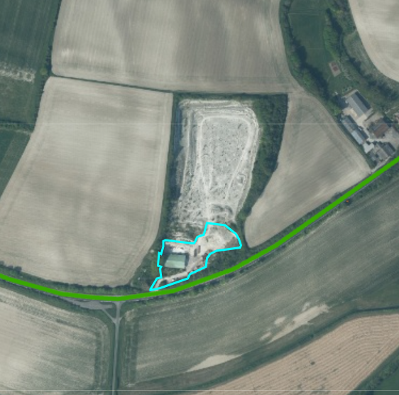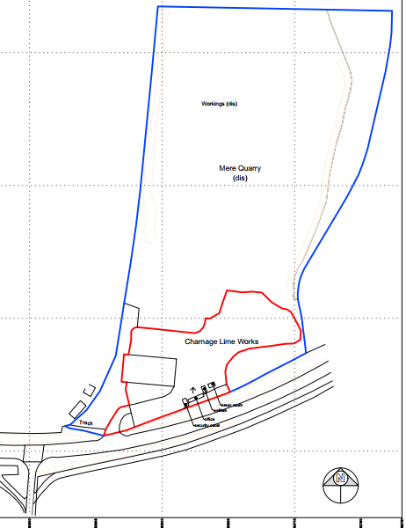

The application site lies just outside of the Special Landscape Area (saved policy C6 of the Salisbury District Local Plan) shown as green wash/stripes on the map extract below; the site is located within the Cranborne Chase & West Wiltshire Downs National Landscape.

.

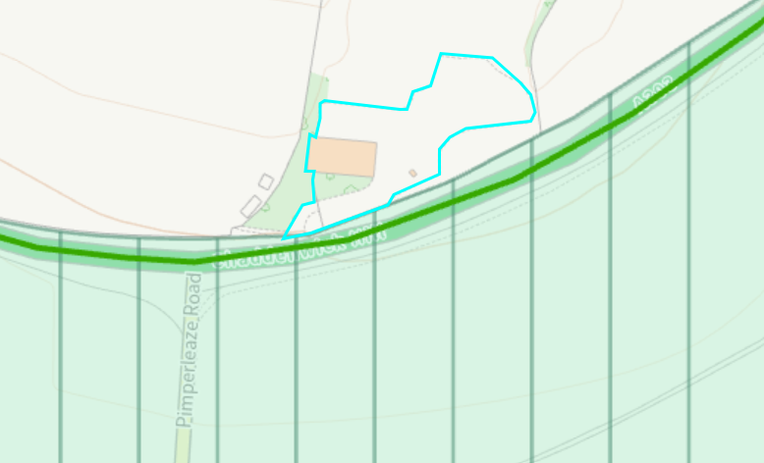

To the west, the site is bounded by trees protected by a tree preservation order which is marked with green hatches on the map extract below.

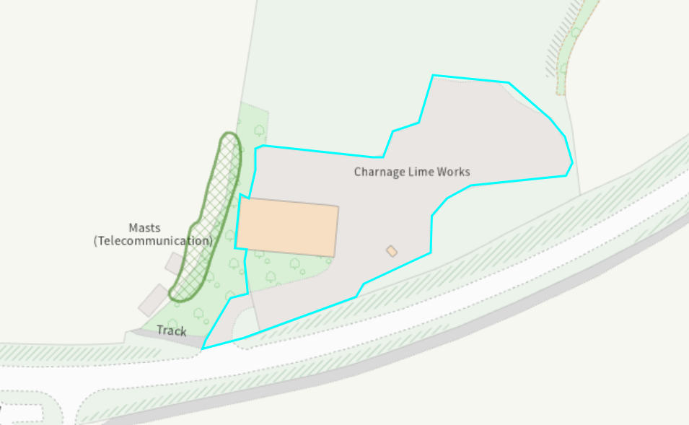

Part of the application site is a designated Site of Special Scientific Interest (SSSI) notified under Section 28 of the Wildlife and Countryside Act 1981 on account of the special geological features of interest that are found at the site.

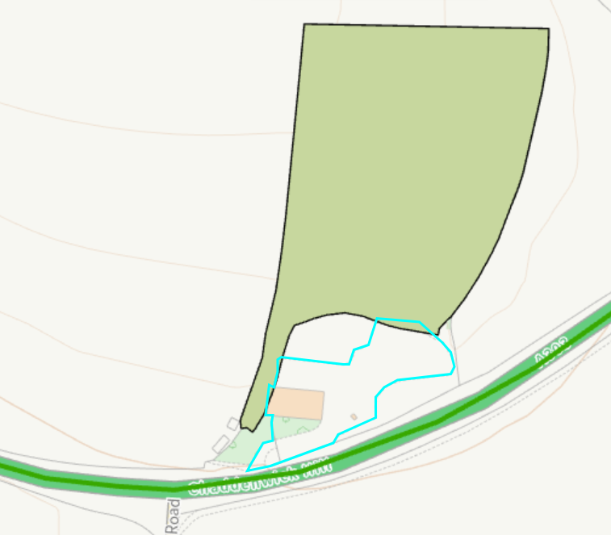

The site is located within flood zone 1 but is at risk of surface water flooding and at high risk of ground water flooding.

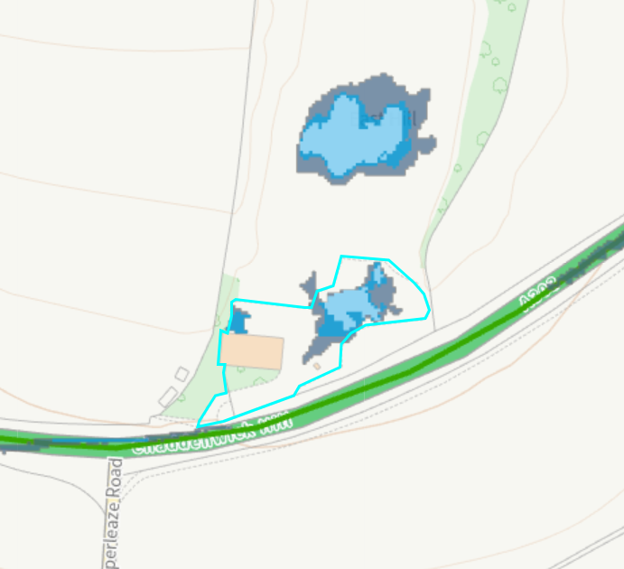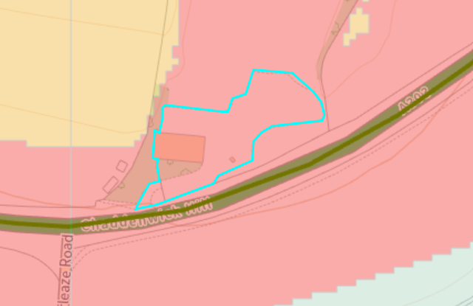

PROPOSAL

The application is seeking consent for the retention of four portacabins which have been installed on the site without seeking prior consent.

Condition 2 of the original consent (S/1994/0675) removed permitted development rights for the additional of other buildings on site.

The application site is located within a quarry subject to a mineral planning permission granted in 1994 for chalk extraction. Quarrying operations are understood to have ceased some time ago; however, the status of the historic mineral permission has not been formally assessed and falls outside the scope of this application. The proposal relates solely to the siting of portacabins for security, toilet, welfare and office accommodation. It does not seek to authorise quarrying activities, nor does it confirm the status of any existing mineral planning permission.
Given the limited nature of the development proposed, the application has been assessed on its own planning merits. Accordingly, this decision should not be interpreted as confirming that quarrying operations may lawfully recommence at the site, as that matter has not been considered as part of the current application.

PLANNING HISTORY

Proposal / Summary
S/1994/0675 - Full planning permission Decision - Approved Date: 29/6/1994 – THE WINNING AND WORKING OF CHALK TOGETHER WITH ALL ANCILLARY ACTIVITIES AND ALTERATION OF ACCESS

RELEVANT LEGISLATION, POLICIES AND GUIDANCE

Statutory Legislation:

National Planning Policy:

- National Planning Policy Framework (NPPF)
- Planning Practice Guidance (PPG)
- National Design Guide

Development Plan:

The development plan for Wiltshire comprises the Wiltshire Core Strategy (WCS) (adopted January 2015) and any made neighbourhood plans, which remains the principal statutory planning document guiding development across the county. In line with Section 38(6) of the Planning and Compulsory Purchase Act 2004, planning decisions must be made in accordance with the development plan unless material considerations indicate otherwise.

Though the development plan is considered as a whole, those parts deemed to be particularly relevant to this application are listed below:

- National Planning Policy Framework (NPPF)
- Planning Practice Guidance (PPG)
- National Design Guide

Wiltshire Core Strategy:

CP1 Settlement Strategy
CP2 Delivery Strategy
CP17 Spatial Strategy: Mere Community Area
CP35 Existing employment sites
CP48 Supporting Rural Life
CP50 Biodiversity
CP51 Landscape
CP57 Ensuring High Quality Design and Place Shaping
CP60-64 Highways
CP65 Movement of goods
CP66 Strategic transport network
CP67 Flood Risk

Salisbury District Saved local plan policy E19

National Landscape Management Plan
Wiltshire Design Guide
Creating Places Design Guide
Wiltshire Local Transport Plan 2011-2026
The Wiltshire and Swindon Minerals Core Strategy 2006-2026 (adopted June 2009)
The Conservation of Habitats and Species Regulations 2010,
EC Habitats Directive when as prescribed by Regulation 3(4) of the Conservation (Natural Habitats, &c.) Regulations 1994 (as amended). Circular 06/2005

ISSUES

Principle
Design and Impact on the Character and Appearance of the Area and Landscape Impacts
Amenity
Highways
Ecology
Flood risk

CONSULTATION RESPONSES

Parish Council – Comment - The Town Council felt that it had insufficient information on which to make a decision. There is no planning statement to accompany the planning application and so there is no indication as to why the four portable cabins are required and the planning application also states that it is for the installation of four temporarily portable cabins – does this mean that the portable cabins are required for a temporary period only? Please could some clarification be sought and provided.

Trees – Comment - I cannot assess impact on trees without the relevant information. If trees are considered an issue, I will require Tree Survey, Impact Assessment and Constraints Plan, prepared in accordance with BS5837:2012.

Environmental Agency – No comments to make

National Highways – Object

Ecology – Object

REPRESENTATIONS

None received

ASSESSMENT

Section 38(6) of the Planning and Compulsory Purchase Act 2004 states:

"If regard is to be had to the development plan for the purposes of any determination to be made under the planning Acts, the determination must be made in accordance with the plan unless material considerations indicate otherwise."

In accordance with this statutory requirement, this application has been assessed against the relevant policies of the Development Plan, including the Wiltshire Core Strategy (2015) and, where applicable, any made Neighbourhood Plans. Consideration has also been given to the policies of the National Planning Policy Framework (NPPF) as a material consideration in the assessment.

Environmental Impact Assessment (EIA) Screening

In accordance with the Town and Country Planning (Environmental Impact Assessment) Regulations 2017 (as amended), the local planning authority has considered whether the proposed development constitutes EIA development.

No formal screening opinion was requested or issued. However, the local planning authority has considered the scale and nature of the development (installation of four portacabins) based on the information submitted by the applicant as part of the application process and is satisfied that it does not constitute EIA development under the 2017 Regulations.

Principle of Development

The application seeks retrospective planning permission for the siting of four portacabins at Charnage Quarry. It is understood that these are for use as a security building, office, welfare building and toilet/rest room. Photos below show the structures as existing on site.

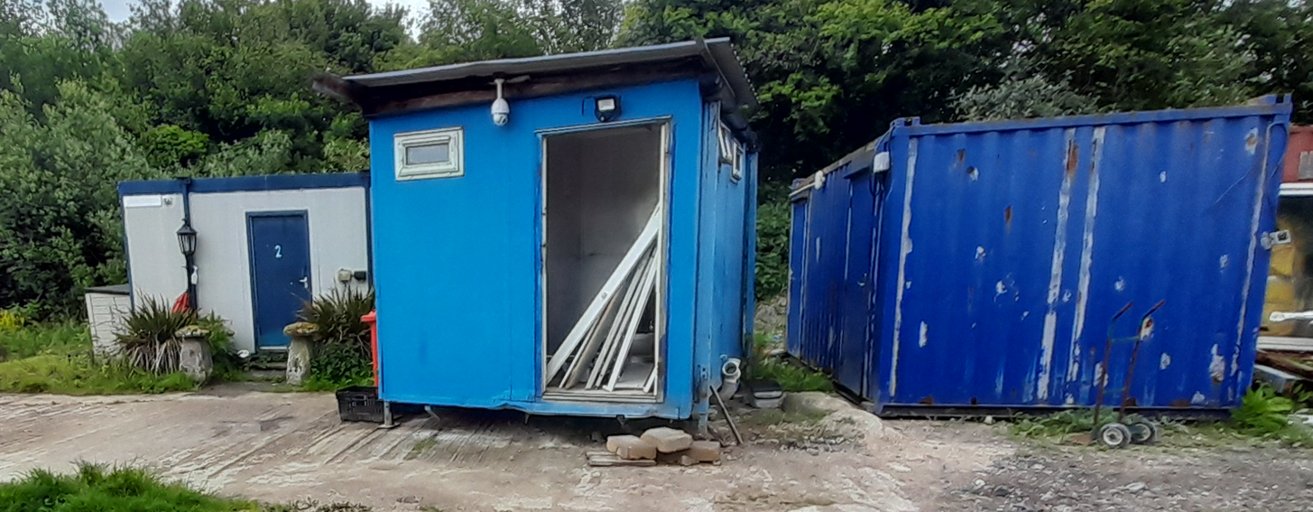
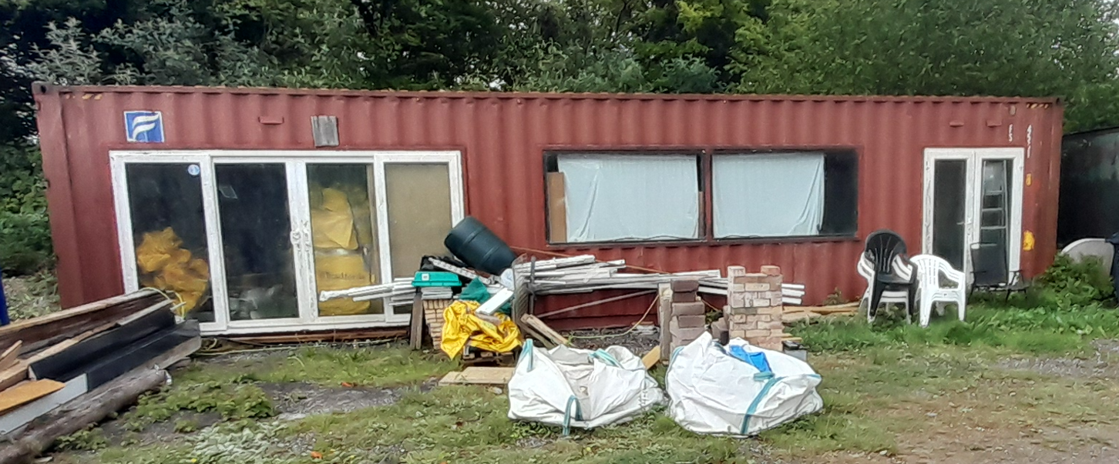
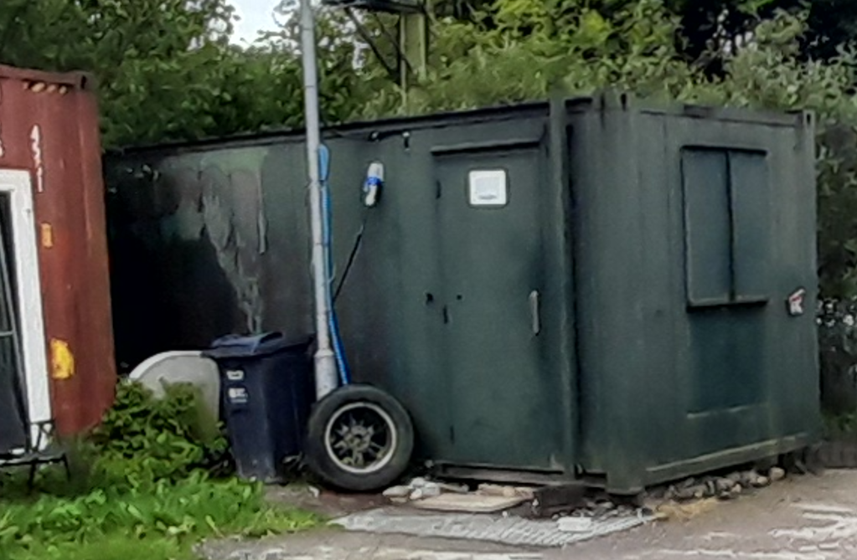

Chapter 17 of the NPPF relates to – “Facilitating the sustainable use of minerals” and is relevant to this application at Charnage Quarry.

Paragraph 224 states that - When determining planning applications, great weight should be given to the benefits of mineral extraction, including to the economy. In considering proposals
for mineral extraction, minerals planning authorities should :

a) as far as is practical, provide for the maintenance of landbanks of non-energy minerals from outside National Parks, the Broads, National Landscapes and World Heritage Sites, scheduled monuments and conservation areas;
b) ensure that there are no unacceptable adverse impacts on the natural and historic environment, human health or aviation safety, and take into account the cumulative effect of multiple impacts from individual sites and/or from a number of sites in a locality;
c) ensure that any unavoidable noise, dust and particle emissions and any blasting vibrations are controlled, mitigated or removed at source, and establish appropriate noise limits for extraction in proximity to noise sensitive properties;
d) not grant planning permission for peat extraction from new or extended sites;
e) provide for restoration and aftercare at the earliest opportunity, to be carried out to high environmental standards, through the application of appropriate conditions. Bonds or other financial guarantees to underpin planning conditions should only be sought in exceptional circumstances;
f) consider how to meet any demand for the extraction of building stone needed for the repair of heritage assets, taking account of the need to protect designated sites; and
g) recognise the small-scale nature and impact of building and roofing stone quarries, and the need for a flexible approach to the duration of planning permissions reflecting the intermittent or low rate of working at many sites.

Officer emphasis on point (b) above relating to ensuring there are no unacceptable adverse impacts on the natural environment.

As mentioned above, the site relates to a chalk quarry where quarrying activities are understood to have paused many years ago however, in Planning terms, the site has permission which runs until 2044 (condition 9 of S/1994/0675) and therefore the quarry use remains extant in Planning terms.

This application does not involve the change of use to a quarry/mineral working usage. During the course of the application, concerns have been raised by consultees and the Parish Council regarding the purpose of the portacabins, the intended use of the site, the relationship of the structures to any existing or proposed quarrying activities and the potential impacts arising from any associated business operations.

The National Planning Policy Framework (NPPF) makes clear that planning applications should be supported by sufficient information to enable the Local Planning Authority to understand and assess the likely impacts of the proposal.

Wiltshire & Swindon Minerals Core Strategy 2006-2026 is relevant. The Council notes Policy MCS1 which requires minerals development and ancillary development associated with quarrying to demonstrate that environmental impacts have been properly considered. Whilst the proposal comprises ancillary accommodation rather than a proposal for mineral extraction itself, in this case insufficient information has been supplied to understand the relationship between the portacabins and any intended mineral operations.

Policy MCS1(B) of the Wiltshire & Swindon Minerals Core Strategy identifies a range of matters that should inform the appraisal of minerals development, including impacts on designated sites, habitats, flood risk, local communities, landscape character and transport networks. Insufficient information has been submitted to enable the Local Planning Authority to assess these matters

Paragraph 5.66 of the Wiltshire & Swindon Minerals Core Strategy 2006-2026 states -

5.66 The strategic approach to the protection of the natural and historic environment is to be found in Policy ENV1 of the Regional Spatial Strategy for the South West. That policy does not go into detail on specific designations and topics such as soil, the water environment or air quality. These more detailed aspects will be incorporated into policies within the emerging Minerals Development Control Policies DPD. However, the tools that the Councils and developers will have to use to demonstrate the impacts of proposals on the issues outlined above and in accordance with the policy will include:
• Landscape Character Assessment;
• Visual Impact Assessment;
• Appropriate Assessment (also referred to as Habitats Regulations Assessment);
• Historic Landscape Character Assessment;
• Flood Risk Assessment; and
• Biodiversity Assessment.
(Note: this list is not meant to be exhaustive)

Core Policy 57 of the Wiltshire Core Strategy requires development proposals to be appropriately designed and to satisfactorily address their environmental, highway and amenity impacts.

Despite repeated requests from the Local Planning Authority, the applicant has failed to provide a supporting statement or other documentation explaining queries such as the following:

- why four separate units are required;
- the number of employees proposed on the site;
- hours of operation;
- vehicle movements associated with the development;
- whether quarrying activities are proposed to recommence;
- the relationship between the portacabins and any wider business operations at the site;
- the anticipated level of activity associated with the proposal.

Further information is also required regarding:
- why the existing barn-like building cannot provide the required facilities;
- the works necessary to bring the portacabins into use;

During the officer site visit, the applicant indicated that should permission be given for the portacabins this would facilitate the recommencement of quarrying activities at the site. However, no information has been provided explaining why the proposed structures are required to enable such operations, how they relate to any intended quarrying activities, or the scale and nature of those activities. This further reinforces the Local Planning Authority's concern that insufficient information has been submitted to properly understand and assess the purpose of the development and its likely impacts.

Officers have repeatedly sought clarification through correspondence relating to a number of points and the applicant was advised that a supporting statement was required explaining the development, business operations, staffing levels, vehicle movements and intentions for the site. The applicant was further advised that four portacabins would not ordinarily be expected if the site were occupied by a single individual with no employees and therefore additional information was required to understand the operational need for the development such as staffing. Despite these requests, no meaningful supporting information has been forthcoming.

Given the absence of this information, officers are unable to establish whether the scale of development proposed is proportionate to the operational requirements of the site or to fully understand the purpose which the development is intended to serve.

The provision of four separate units for office, welfare, security and rest facilities indicates that a level of occupation and activity is anticipated; however, insufficient information has been provided to explain the scale or nature of that activity. In the absence of information regarding the intended operations of the site, the Local Planning Authority is unable to determine the likely effects of the development on highway safety, biodiversity interests, landscape character and neighbouring amenity.

Design and Impact on the Character and Appearance of the Area and Landscape Impacts

Policy CP57 of the WCS requires high quality design and place shaping for all new development and includes the expectation that proposals should make a positive contribution to the character of Wiltshire. Proposals should demonstrate how the development meets the expectations of criteria of CP57 which includes the following summarised points which are relevant for assessment of the scheme on landscape matters:

(i) Enhancing local distinctiveness by responding to the value of the natural and historic environment, relating positively to its landscape setting and the existing pattern of development and responding to local topography by ensuring that important views into, within and out of the site are to be retained and enhanced.
(ii) The retention and enhancement of important landscaping and natural features.
(vi) making efficient use of land whilst taking account of the characteristics of the site and the local context
(xii) The use of high standards of building materials, finishes and landscaping

Section 12 of the NPPF emphasises design that is visually attractive, functionally effective and contributes to the quality of the built environment.

Section 17 of the NPPF relates to mineral workings., in particular para 224 and that great weight to be given to the benefits of mineral works, but within criterion b) adverse impacts on the natural environment must be taken into account.

Saved policy C6 states - Within the Special Landscape Area, proposals for development in the countryside will be considered having particular regard to the high quality of the landscape. Where proposals which would not have an adverse effect on the quality on the landscape are acceptable, they will be subject to the following criteria;

(i) the siting and scale of development to be sympathetic with the landscape; and
(ii) high standards of landscaping and design, using materials which are appropriate to the locality and reflect the character of the area.

Core Policy 51 of the Wiltshire Core Strategy requires all development to protect, conserve, and where possible enhance the character and quality of Wiltshire’s landscapes, giving particular weight to designated areas such as National Landscapes.

The National Planning Policy Framework (NPPF), in Paragraph 189, states that “great weight” should be given to conserving and enhancing landscape and scenic beauty in National Landscapes (formerly Areas of Outstanding Natural Beauty). Development within or affecting the setting of a National Landscape must demonstrate that it will not result in unacceptable harm to the special qualities of that area.

The Wiltshire Design Guide SPD promotes a context-led approach, encouraging integration with natural features and settlement patterns while avoiding visual intrusion. The Wiltshire Design Guide also encourages sensitivity to local character, materials, and architectural styles and supports modern living standards while maintaining aesthetic and functional quality.

The NPPF emphasises the need to protect and enhance valued landscapes, particularly those with scenic, historic, or ecological significance. Planning decisions should recognise the intrinsic character and beauty of the countryside, safeguard key views, local distinctiveness, and landscape settings and ensure development is well-integrated into its surroundings and avoids visual intrusion, especially in sensitive or designated areas.

Landscape impact must be considered alongside biodiversity, heritage, and green infrastructure objectives, with mitigation measures encouraged where harm cannot be avoided.

Under Section 245 of the Levelling-up and Regeneration Act 2023, LPAs and other relevant authorities must now “seek to further” the statutory purposes of National Landscapes (formerly Areas of Outstanding Natural Beauty), replacing the previous duty to merely “have regard to” them.

This is an active duty, requiring authorities to take reasonable and proportionate steps to support the conservation and enhancement of the natural beauty, special qualities, and key characteristics of these designated areas when exercising any function that affects them.

The site lies within the Cranborne Chase and West Wiltshire Downs National Landscape, where great weight must be given to conserving and enhancing landscape character and scenic beauty. Whilst the site benefits from a degree of screening from the A303 by an established tree belt, which limits wider views of the development, the portacabins remain prominent within the site itself. The development does not appear to impact on any trees and therefore no further information has been requested in this regard.

The four portacabins are functional and utilitarian structures that are currently in a poor state of repair; officers note that whilst the applicant describes the structures as portacabins they appear more as adapted metal storage containers. It is considered that individually and cumulatively, they make a limited positive contribution to the character and appearance of the site and, notwithstanding their temporary nature, detract from the quality of the landscape setting.

The application seeks temporary retention of the structures; however, insufficient information has been provided regarding their intended function, operational requirements, justification for four separate units, or the period for which they are required. In the absence of this information, the Local Planning Authority is unable to determine whether the scale and siting of the development is proportionate to the needs of the quarry or to fully assess its effects on the character and appearance of the site and the wider National Landscape.

Whilst existing vegetation provides some visual mitigation, the poor quality and appearance of the structures, together with the lack of sufficient information to demonstrate that their scale, number and siting are justified, weighs against their retention. As such, insufficient information has been submitted to demonstrate that the proposal would conserve the character, appearance and landscape quality of the area, contrary to Core Policies 51 and 57 of the Wiltshire Core Strategy and the relevant provisions of the NPPF.

Amenity

Core Policy 57 (Point vii) of the Wiltshire Core Strategy requires development to respect the amenity of existing occupants and ensure appropriate amenity levels for future residents.

The National Planning Policy Framework (NPPF), particularly Paragraph 135, reinforces the need for development to provide a high standard of amenity for both existing and future users.

The application submission contains no information regarding staffing levels, operating hours, site activities, vehicle movements, deliveries or the extent of day-to-day occupation of the site.
The provision of office, welfare, security and rest facilities indicates a level of occupation and activity associated with the site beyond that described within the application. However, the applicant has provided no information explaining the frequency or intensity of that activity, particularly given that the quarry is understood to have been inactive for a number of years.

In the absence of such information, the Local Planning Authority is unable to properly assess the likely effects of the development in terms of noise, disturbance, vehicle activity or other impacts associated with the use of the site.

Notwithstanding the above comments, Officers note that the application site is surrounded by fields, the nearest residential property known as Pitching Piece Farm is located approx. 300 metres to the east, given the separation distance it is unlikely that significant harm would arise from the development to the amenity of the nearest residential property. With the submission of further details, it is likely that suitable conditions could be used to help mitigate any impacts arising.

The proposal therefore fails to demonstrate compliance with Core Policy 57 of the Wiltshire Core Strategy and the relevant provisions of the NPPF.

Highways Impacts and Parking

Transport implications are a key factor in assessing planning applications, especially for larger developments. Proposals must demonstrate:
- Safe and suitable access for all users, including pedestrians, cyclists, and those with mobility impairments.
- No severe residual impacts on the surrounding highway network.
- Promotion of sustainable travel, reducing reliance on private vehicles.
- Adequate parking and cycle provision, in line with adopted standards.
- Protection and enhancement of public rights of way and active travel routes.

Relevant policies include Core Policies 60–64 of the Wiltshire Core Strategy, supported by the Wiltshire Local Transport Plan, Car Parking Strategy, and Cycling Strategy.

Core Policies 57, 60 and 61 of the Wiltshire Core Strategy seek to ensure development is served by appropriate infrastructure and does not result in unacceptable impacts upon highway safety.

National Highways have raised concerns regarding the lack of information submitted in support of the application and has raised a holding objection until further information has been provided; their comments are included below -

The application is seeking permission for the siting of four temporary portacabins at Charnage Quarry, east of Mere. It is understood that the cabins are required to provide security, office, welfare and rest facilities to support what the application states to be “essential site operations” connected with lime processing. National Highways understands that the Quarry has been disused for some period of time, although the application suggests that the current activities may have commenced in January 2025.

National Highways primary consideration is the ongoing safe and efficient operation of the A303, and it is in that context that our comments are made.

The Quarry site has the benefit of a direct access from the A303 Chaddenwick Hill, which was provided to facilitate chalk quarry operations which we believe were approved in 1994 under permission S/1994/0675. However, as mentioned above, we understood that the Quarry had been disused for some years. The A303 in this location is single carriageway, subject to the national speed limit and with overtaking restrictions due to the road geometry and restricted forward visibility. The site access is located on the inside of a curve on a fairly steep hill and would not comply with current design standards, particularly in respect of available visibility and swept paths for large vehicles. We would therefore have significant highway safety concerns about development which would result in turning movements at this junction without improvements, which may be neither achievable nor deliverable.

However, National Highways recognises that the site has an extant consent for specific chalk quarrying/processing activities under the 1994 permission, and that operations could restart under that consent without the need for further permissions. National Highways therefore requests that the applicant provide further information to demonstrate that the proposed site operations that the portacabins are intended to support fall within the 1994 permission.

If it is confirmed by the applicant that the proposed site operations are permitted by the 1994 permission, National Highways will expect the applicant to demonstrate that the proposed operations will be carried out in compliance with the conditions attached to that permission, particularly with regards to vehicle trips and provision of works access warning signs on the A303 (conditions 18 and 8). Noting that the application suggests activities may have already commenced on site this is particularly concerning.

The requirement for works access warning signs on the A303 was clearly considered necessary at the time of the 1994 permission to mitigate what would otherwise be an unacceptable road safety impact, and National Highways is strongly of the opinion that the associated safety risk is even greater now under current network conditions. No works access warning signs are currently present on the A303 – although they may have been prior to quarry operations ceasing around 2009. National Highways therefore considers that it is necessary on highways safety grounds for the required signs to be re-instated prior to operations re-commencing. The sign design, location, construction method and any associated road safety audit requirements will need to be agreed with National Highways via a s278 agreement under the Highways Act 1980, with all costs met by the applicant.

To comply with the condition requirements, we consider that A303 access warning signs will need to be in place prior to the re-starting of quarrying/processing activities and would look to the local planning authority to take enforcement action should that not be the case. We would also additionally look to recommend a planning condition to secure signage as part of any permission in respect of the portacabins, assuming the associated site operations are confirmed to be a permitted use. If these operations have indeed already re-started on site in breach of the 1994 permission, we will expect the local planning authority to consider taking immediate enforcement action to cease operations until the condition requirements are met, to protect the safety of trunk road traffic.

Should the site operations which the portacabins are intended to support not be permitted under the 1994 permission, then National Highways would need to reconsider its recommendation and would be likely to object to any new development proposals on highway safety grounds, without the provision of acceptable improvements to the site access arrangements.

Recommendation
National Highways recommends that Wiltshire Council does not grant permission in respect of application reference PL/2026/01605 for a period of 6 months from the date of this recommendation.

This is to allow time for the applicant to provide the further information necessary to enable National Highways to understand the impact of the development on the safe and efficient operation of the A303 trunk road.

The applicant was requested to provide a response to the National Highways comments and provide further details. These could have been incorporated into the supporting statement that had already been requested. The applicant replied stating that a speed reduction on the A303 would be safest.

Given that the applicant has failed to provide details of anticipated staffing levels, customer visits, deliveries, HGV movements or any other transport activity associated with the proposed use; and that the proposed development includes office, welfare and security accommodation, which has the potential to facilitate additional operational activity at the site. However, the extent of that activity has not been explained.

Consequently, neither the Local Planning Authority nor National Highways is able to determine
whether the proposal would generate additional vehicle movements, intensify use of the existing access onto the strategic road network, or give rise to any highway safety concerns.

Accordingly, the proposal fails to demonstrate compliance with Core Policies 57, 60, 61 and 66 of the Wiltshire Core Strategy and the relevant provisions of the NPPF.

Ecology and Biodiversity

Core Policy 50 of the Wiltshire Core Strategy seeks to protect, conserve and enhance biodiversity and geodiversity interests within Wiltshire. Development proposals are expected to demonstrate that they will avoid adverse impacts on designated sites, protected species and priority habitats and, where necessary, provide appropriate ecological information to enable the Local Planning Authority to assess the likely effects of the development.

The application site lies within close proximity to, and partially encompasses, Charnage Down Chalk Pit Site of Special Scientific Interest (SSSI), which is designated for its geological importance. The site also contains areas of vegetation and habitat that have the potential to support protected and notable species.

No ecological appraisal, protected species survey, biodiversity information or supporting ecological assessment has been submitted in support of the application. Furthermore, insufficient information has been provided regarding the activities associated with the use of the site, the level of occupation proposed, vehicle movements, or any operational requirements linked to the portacabins.

The Local Planning Authority's Ecologist has objected to the application due to the need to consult Natural England on the impacts on the SSSI. However, the application contains no supporting ecological statements upon which to base a consultation request to Natural England.

In the absence of sufficient ecological information, the Local Planning Authority cannot adequately assess the effects of the development on protected species, habitats, ecological networks of the Charnage Down Chalk Pit SSSI, nor can it be satisfied that the proposal would conserve and enhance biodiversity interests in accordance with Core Policy 50 of the Wiltshire Core Strategy and the relevant provisions of the National Planning Policy Framework. It has therefore not been demonstrated that the development would avoid unacceptable harm to ecological interests.

Flood Risk

Core Policy 67 of the Wiltshire Core Strategy seeks to ensure that development is appropriately located and designed to manage flood risk and avoid increasing flood risk elsewhere. The National Planning Policy Framework similarly requires development to be safe for its lifetime, without increasing flood risk on or off site.

As mentioned above the application site is in an area at high risk of ground water flooding and at risk of surface water flooding but otherwise is located within flood zone 1. The applicant was requested to provide a flood risk assessment to accompany the application.

A flood risk assessment was provided however; this was inadequate and did not mention the flood zones or address flood risk appropriately. However, given the nature of the development and that the works do not relate to residential or overnight accommodation, Officers are content that the development is unlikely to result in adverse flood risk impacts either on or off the site.

PLANNING BALANCE AND CONCLUSION

The application seeks retrospective planning permission for the retention of four portacabins at Charnage Quarry to provide office, welfare, toilet/rest room and security accommodation.

Section 17 of the NPPF relates to mineral workings, in particular to para 224 and the great weight to be given to the benefits of mineral works, however, point b) relates to adverse impacts on the natural environment; the site is located within the National Landscape where Officers must consider the impacts on this special landscape.

It is acknowledged that the site benefits from some screening from the A303 by an established tree belt, which helps to mitigate the wider visual impact of the structures. It is also recognised that portacabins are generally functional buildings and that the applicant is seeking temporary consent for their retention.

The proposal would provide office, welfare, security and rest facilities at the site. However, insufficient information has been submitted to demonstrate the operational need for the four portacabins, the activities they are intended to support or the duration for which they are required. The structures are also in a poor state of repair and make a limited positive contribution to the character and appearance of the site. Furthermore, insufficient information has been provided to enable a full assessment of the proposal's effects in relation to biodiversity, including the Charnage Down Chalk Pit SSSI, highway safety and landscape considerations. Whilst the weight to be attached to continuation of the mineral workings has been fully considered, the likely landscape, highway and ecological harms weigh significantly against approval of the scheme as submitted, and these harms are considered to outweigh the positive benefit of the continuation of the mineral operation. Consequently, the Local Planning Authority cannot conclude that the development accords with the Development Plan or represents sustainable development. Planning permission is therefore recommended for refusal.

RECOMMENDATION:
That Planning Permission be REFUSED.

The applicant has failed to provide sufficient information to demonstrate the purpose and operational need for the proposed development or to enable a full assessment of its impacts. In the absence of adequate information relating to the function of the portacabins, the scale of activities proposed at the site, biodiversity interests including the Charnage Down Chalk Pit SSSI, highway impacts and landscape effects, the Local Planning Authority is unable to conclude that the development would represent an appropriate or sustainable form of development. Whilst the weight to be attached to continuation of the mineral workings has been fully considered, the likely landscape, highway and ecological harms weigh significantly against approval of the scheme as submitted, and these harms are considered to outweigh the positive benefit of the continuation of the mineral operation. The proposal therefore conflicts with Core Policies 50, 51, 57, 60 and 61 of the Wiltshire Core Strategy Core Policy MCS1 and MCS 1B of Wiltshire & Swindon Minerals Core Strategy and the relevant provisions of the National Planning Policy Framework.

Informative

For the avoidance of doubt, the plans and supporting documents considered in this refusal are as follows:

Application form received 09/03/2026
Break room cabin floor plan and elevations Drg no 2025/02/P005-A received 07/04/2026
Security cabin floor plan and elevations Drg no 2025/02/P002-A received 07/04/2026
Welfare cabin floor plan and elevations Drg no 2025/02/P004-A received 07/04/2026
Office cabin floor plan and elevations Drg no 2025/02/P003-A received 07/04/2026
Flood risk assessment received 22/05/2026
Location plan and site plan Drg no 2025/02/P001-B received 28/04/2026

