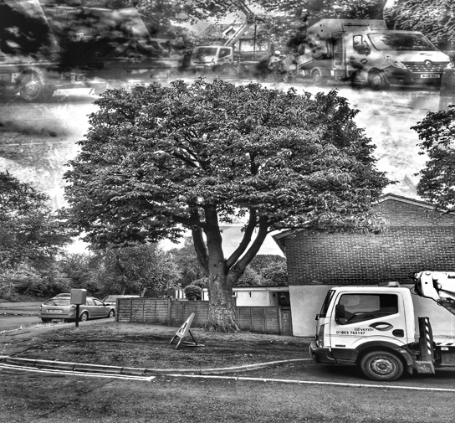
Date: 20.7.2026
Client: Trowbridge town council. Holy trinity church. SURVEYOR: Will Jones Weather: Clear/dry
Site Address: Trowbridge, BA14 9AA Additional site notes:

DBH: Estimated Diameter at 1.5M in MM. Approx. Height: measured in Meters
Target: Takes in to account occupancy, usage, targets in close proximity to the tree: 1) Negligible 2) Low 3) Moderate 4) High 5) Very high
Age: Y) Young, S.M) Semi mature, E.M) Early mature, M) Mature, OM) Over mature, V) veteran
Species: Common name: E.g. Oak, Ash, Beech,
Observations / Management recommendations: Dead wood, broken branch, branch touching building, etc.
Tree vigour: objective assessment of a trees vigour at time of inspection: (N) Normal or (L) Low (M) Monitor – for example: Ash die back.

Priority of works

U Urgent: Undertake work as soon as possible. – identified as urgent to address the immediate risk of damage or harm.

1 High Priority: Work to be undertaken within one year – not urgent but still essential in order to resolve safety issues picked up in tree inspection – deadwood etc. In high use areas

2 Moderate Priority: Work to be undertaken within two years – essential works to reduce longer term safety issues – lower priority then 1, this may be due to the trees location being in a lower target area or the defect noted may not be an immediate threat to safety.

3 Low Priority: Work to be undertaken as a part of routine management, 3-5 years – none essential works. This includes routine management and amenity works, trees in a lower risk area or remedial pruning for longer term management,

Tree No | Species:  Common  Name | Approx.  Height  M | Approx  DBH  MM | Approx.  Age | OBSERVATIONS  MANAGEMENT RECOMMENDATIONS | Tree  Vigour | Priority of works | Target  Rating | zone
G1 | Lime species | 3-5M | - | S.M | - 48 Lime trees situated around the church boundary.  - Lapsed pollards.  - Re-pollard back to original pruning points. | N | 1 | N/A | 1

Risk Zoning

Zone 1: Frequent public access to trees – school buildings/grounds/access points. Urban centres. Busy road, footways, pavements and Rd Junctions. Car parks and bus stops. Frequently used seating/picnic areas. Frequent access by unsupervised or partially supervised children.

Zone 2: Peak time pedestrian traffic – access to school buildings. Occasional traffic use – rural roads and Footpaths. Peripheral areas of large parks/open public spaces and school plying fields. Regularly used woodland footpaths.

Zone 3: No formal public access or official rights of way – un-official footpaths, minor woodland footpaths. Country hedges within farmland.

