APPLICATION FOR PRIOR NOTIFICATION - AGRICULTURAL
CASE OFFICER REPORT

APPLICATION REFERENCE: | PL/2025/09652
APPLICATION TYPE: | Prior notification: Building
SITE ADDRESS: | Whyr Farm, Worton Road, Devizes, SN10 5PU
DEVELOPMENT DESCRIPTION: | Agricultural building including for storage of hay, straw and fodder etc
RECOMMENDATION: | Prior Approval Granted

SITE DESCRIPTION/CONTEXT

This prior notification site is located approximately 180m to the east of Worton (which is designated as a large village in the Wiltshire Core Strategy). The site is an agricultural field in the open countryside.

The access from Worton Road involves an approximate 8.5m wide apron laid to a compacted MOT surface which then splits into two separate accesses, one for Whyr Farm (left) and to the right for Ware Farm. The access continues for approximately 470m until it reaches Ware Farm (a residential farmhouse and its ancillary outbuildings). Immediately adjacent to Ware Farm to the north, Whyr Farm has a small barn used to accommodate cows.

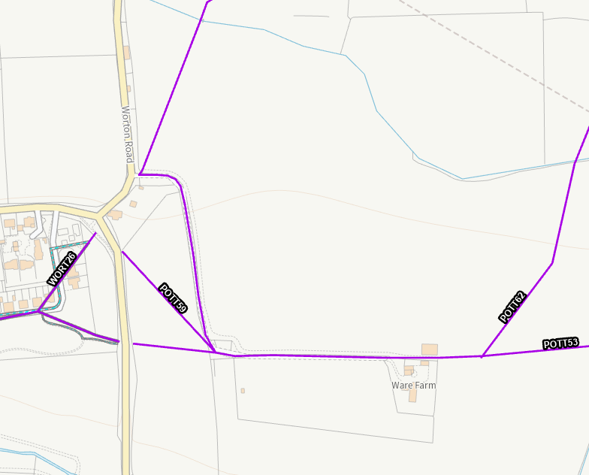

Council Mapping Image of Worton (left), Ware Farm (bottom right) with Prior Approval site in between. Purple lines show Public Rights of Way

The site is fairly level and is predominantly surrounded by further agricultural land and woodland. There is a visible grade II listed building ‘The Manor House’ located approximately 800m to the northeast of the proposed barn. Approximately 950m away to the east are a further 6 listed buildings, one of which is a grade II* ‘The Red House at Eastwell House’. However, due to woodlands these buildings are not visible from the prior notification site or generally from the internal access leading to Ware Farm.

The land is understood to be grade 3 agricultural land, although there is no distinction whether it is 3a or 3b. The site is not within a National Landscape and is not considered to be a ‘valued landscape’ as set out in paragraph 187 of the NPPF.

There are other visible farm complexes that can be seen from the site (understood to be Cherry Farm and Larborough Farm).

The site is within the Sailsbury Plain Special Protection Area 6.4km buffer.

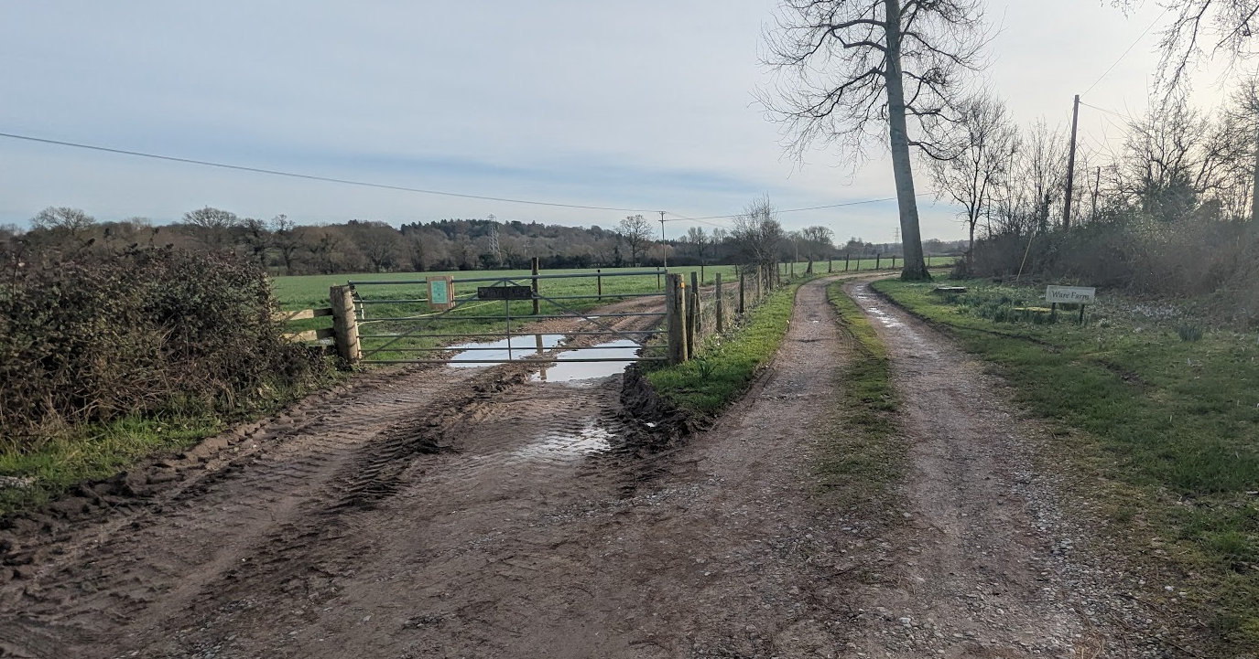

Shared vehicle access with adjacent farm from Worton Road (proposed building would be broadly straight ahead)

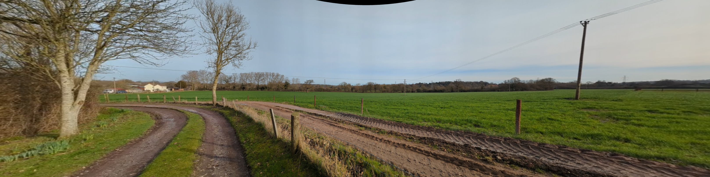

View from the access track (PRoW POTT53) near the main access to Worton Road (proposal building would be broadly behind the electricity pole and to the right)

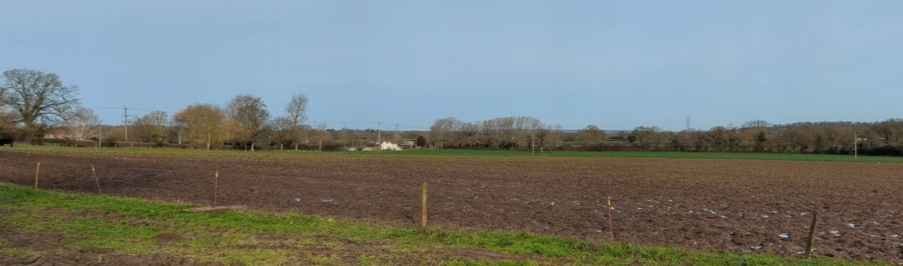

View from the South further along access track (PRoW POTT53) to Ware Farm (the proposed barn would be broadly in line with the white building in the background)

PROPOSAL

The proposed barn would be used to store hay, straw and fodder and has been submitted alongside a full planning application PL/2025/09651 for a beef unit building. No decision has been made on this application and is currently out for a second round of public consultation. For the avoidance of doubt, the test in this application is whether the building is reasonably necessary for agriculture. Whilst related to application PL/2025/09651, this prior approval application must be assessed independently on its own merits

The barn would be 46m long, 32.5m wide and 11.9m high. The internal floor area would be c1,493m2. The walls would be built with concrete panels at a lower level with tanalised timber space boarding above. Some elevations will be left open. The roof would be finished with ‘natural grey’ fibre cement profile 6 corrugated roof sheeting with a few 10% translucent GRP sheets.

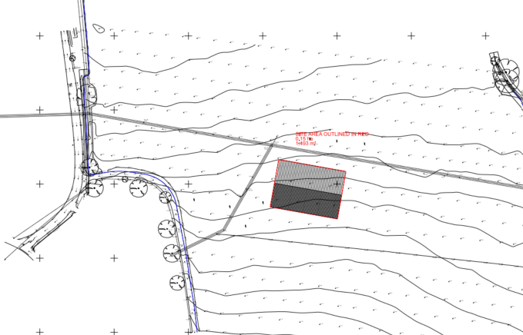

Proposed Site Plan

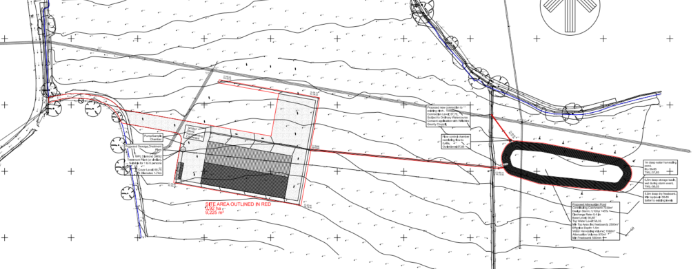

Proposed Site Plan for sister planning application PL/2025/09651 for the beef unit. The proposed prior approval building in this application would be immediately to the north of the building in this image but within the confines of the electricity poles

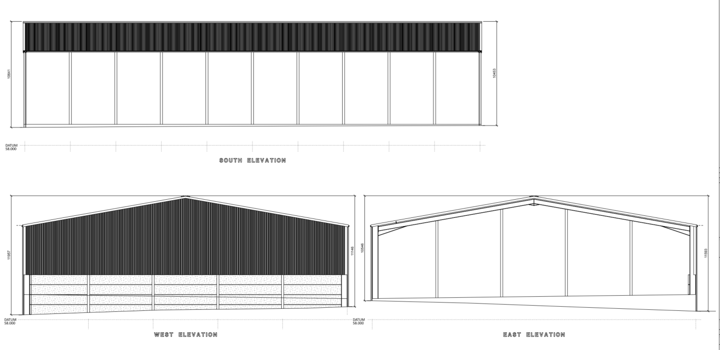

Proposed Elevations

In respect of the sister application PL/2025/09651, the Council has received a consultation response from an independent agricultural consultant who has assessed the agricultural submission of the applicants. It is confirmed that this is an existing cattle enterprise that is being re-located and expanded on this site. The business already operates a beef enterprise at Crookwood Farm with 50 suckler cows and 100 youngstock, with the proposal being to relocate to Whyr Farm. The suckler herd would increase to 100 cows along with an expansion of the youngstock cows and introduce a new calf rearing element (purchasing 120 calves a year).

Crookwood Farm is located circa 3km (due east as the bird fly’s) and is an approximate 7-minute drive (according to google maps). The applicant owns the application site whilst Crookwood Farm is understood to be leased and does not have any additional space for expansion. Therefore, re-location is the only reasonable option should the applicant wish to invest capital to expand the business enterprise. The applicant also already has the existing cow barn within the blue outline of the application site adjacent to Ware Farm.

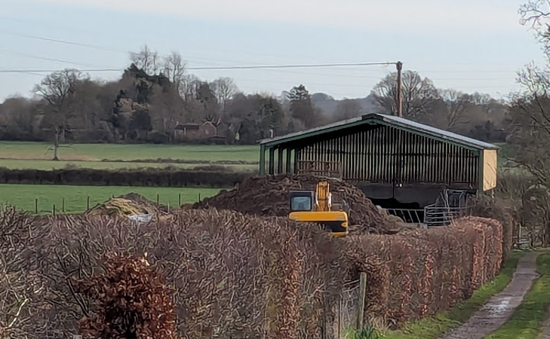

View down POTT53 towards existing Cow Barn adjacent to Ware Farm

RELEVANT PLANNING HISTORY

Proposal / Summary
PL/2025/09652 - Prior notification: Building – Agricultural building including for storage of hay, straw and fodder etc

RELEVANT LEGISLATION, POLICY AND GUIDANCE

This application is assessed under Article 3 of the Town and Country Planning (General Permitted Development) (England) Order 2015 (as amended), which grants planning permission for certain types of development described in Schedule 2 of the Order. The grant of permission is subject to the limitations, conditions, and provisions set out within the relevant Classes of permitted development.

Under Schedule 2, Part 6, Class A of the Town and Country Planning (General Permitted Development) (England) Order 2015 (as amended), certain types of agricultural development may be permitted, including:

- The erection, extension, or alteration of a building;
- The formation or alteration of a private way;
- Excavations or the deposit of waste material (where the relevant area exceeds 0.5 hectares);
- The placing or assembly of a tank in any waters.

Where such development is proposed, the developer is required to apply to the local planning authority for a determination as to whether prior approval is needed. This prior approval process is limited in scope and relates only to the following matters:

- The siting, design, and external appearance of the building;
- The siting and means of construction of the private way;
- The siting of the excavation or deposit;
- The siting and appearance of the tank.

CONSULTATION RESPONSES

Wiltshire Council Agricultural Consultant: No objection – the development is reasonably necessary for the purposes of agriculture within the unit.

Public Consultation:

Once it was determined that prior approval would be required a site notice was erected on site with a 21-day consultation period.

3 representations were received with one letter of support, one letter of objection and one general comment received. The objection mainly related to the sister application PL/2025/09651 but did make the following relevant points:

- There is no genuine agricultural need for this building, with it being an extension of an existing farm
- The scale and siting of the development would negatively impact the character of the open countryside, damaging the area’s natural landscape

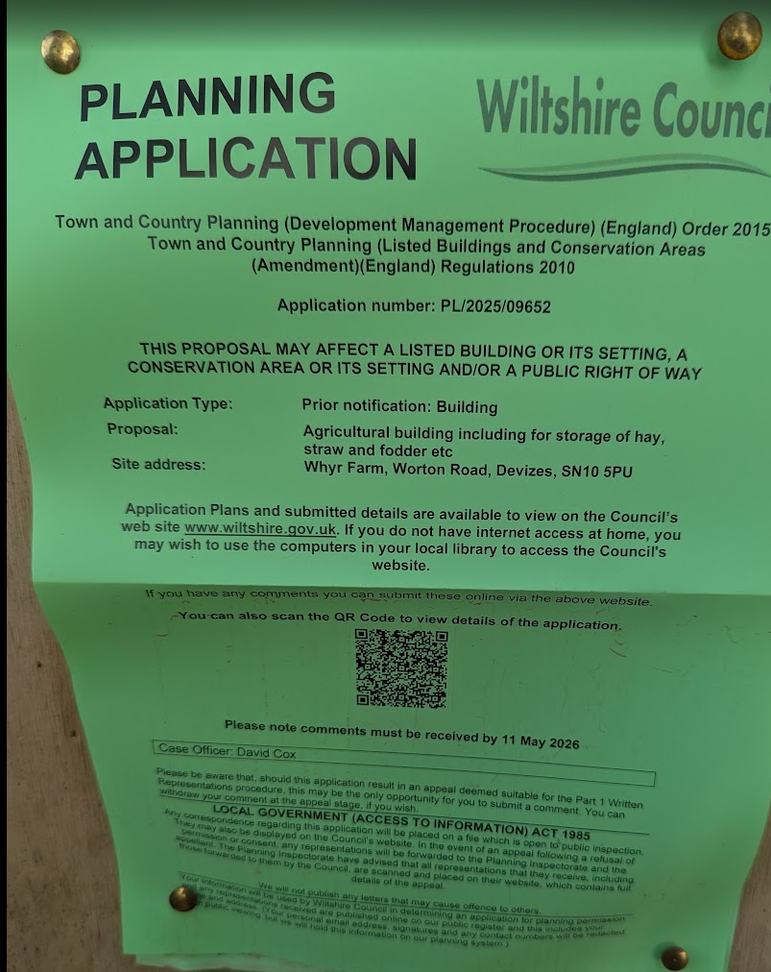

ASSESSMENT

Does the Proposal Qualify as Permitted Development? Yes.

The applicant operates an existing agricultural enterprise within close proximity to the site (approximately 3 miles from the application site), which demonstrates that this is an established and active farming business rather than a speculative proposal.

The applicant has indicated that the building would be used in connection with a proposed beef enterprise, which is the subject of a separate planning application currently under consideration.

The Council has had regard to an independent agricultural appraisal, which confirms that the proposed building would be required primarily for the storage of hay, straw, grain and associated agricultural materials. The report identifies that the majority of the building would be utilised for fodder and bedding storage, with the remainder required for machinery and associated agricultural uses, and concludes that the scale of the building is broadly commensurate with the needs of the holding.

The Council's independent agricultural consultant also confirms that the applicant owns the application site (the red and blue outlines on the site location plan) and already operates from a small existing agricultural building within the blue outline. The applicant currently relies upon off-site leased accommodation at Crookwood Farm, which is understood to be constrained and unable to accommodate future expansion.

In this context, the proposed building represents a logical investment in the applicant's own holding, providing capacity for the storage of hay, straw, grain and machinery and supporting the ongoing operation of the agricultural enterprise.

Whilst the agricultural appraisal acknowledges that the building is intended to support the associated development proposed under application PL/2025/09651, this relationship is not determinative of the present assessment. The storage requirements identified relate to the operation of an established agricultural enterprise and would remain relevant to the ongoing use of the holding irrespective of the outcome of that application. The building would therefore be capable of serving a general agricultural function in its own right.

The agricultural appraisal notes that whilst the majority of the proposed floorspace is justified by the identified storage requirements, there is limited detailed evidence in respect of the precise use of all areas of the building. However, it is common for agricultural buildings to provide a degree of operational flexibility and for internal arrangements to vary over time according to seasonal and operational requirements. In this regard, the Local Planning Authority considers that the overall scale of the building remains broadly proportionate to the needs of the agricultural unit.

Having regard to the supporting agricultural information as a whole, the Local Planning Authority is satisfied that the proposed building demonstrates a clear functional requirement and that its scale and nature are reasonably necessary for the purposes of agriculture within the unit.

Having completed the detailed assessment checklist at Appendix 1 of this report, it is concluded that the proposed development qualifies as permitted development under Schedule 2, Part 6, Class A of the Town and Country Planning (General Permitted Development) (England) Order 2015 (as amended), and the assessment may now proceed to consider the siting, design and external appearance of the development as required by the GPDO.

Is Prior Approval Required?

Schedule 2, Part 6, Class a, is subject to condition A.2 (2) (i) “the developer must, before beginning the development, apply to the local planning authority for a determination as to whether the prior approval of the authority will be required as to the siting, design and external appearance of the building, the siting and means of construction of the private way, the siting of the excavation or deposit or the siting and appearance of the tank, as the case may be;

- The siting, design, and external appearance of the building

The proposed building would be quite large and highly visible, as the site comprises a large open field and Public Rights of Way POTT60, POTT53 and POTT62 would all afford clear views of the building, which would appear as a new and noticeable feature within the immediate landscape.

Whilst there would be a degree of visual change, the local rights of way network already provides views of several farm complexes and agricultural buildings within the wider landscape. Although the application site itself is relatively undeveloped, the surrounding landscape contains a pattern of agricultural development and associated infrastructure. In this context, it is considered that the proposal is of a scale and design that can be accommodated within the wider landscape setting.

Accordingly, prior approval is required in respect of the siting, design and external appearance of the building. Having assessed those matters, the Local Planning Authority is satisfied that they are acceptable and that prior approval should therefore be granted.

Officers acknowledge that the associated full planning application includes a landscape mitigation strategy comprising tree and hedgerow planting, which is proposed to be secured by condition. The purpose of that planting is to assist in mitigating localised visual effects, particularly in views from nearby public rights of way, whilst also providing biodiversity benefits.

The full planning application is being assessed against the wider requirements of the Development Plan, including Core Policy 51 and the Landscape Character Assessment. By contrast, under the prior approval process the Local Planning Authority is limited to considering the siting, design and external appearance of this proposed storage building. The assessment must therefore focus on whether the building is acceptable in those respects and not whether it would be acceptable only with the benefit of landscape mitigation.

It is not considered necessary or reasonable to secure landscaping through this prior approval application. The proposed storage building would be smaller than the associated livestock building proposed under application PL/2025/09651 and would be viewed in the context of existing agricultural infrastructure, including the overhead electricity transmission lines which cross the site. Whilst the building would be visible from nearby public rights of way, its siting, design and external appearance are considered acceptable in their own right.

The proposed landscaping associated with the full planning application would provide additional mitigation should that scheme be implemented. However, the acceptability of the current prior approval application does not depend upon that landscaping and has been assessed on its own merits. Officers are satisfied that the siting, design and external appearance of the proposed storage building are acceptable without reliance upon additional planting.
,
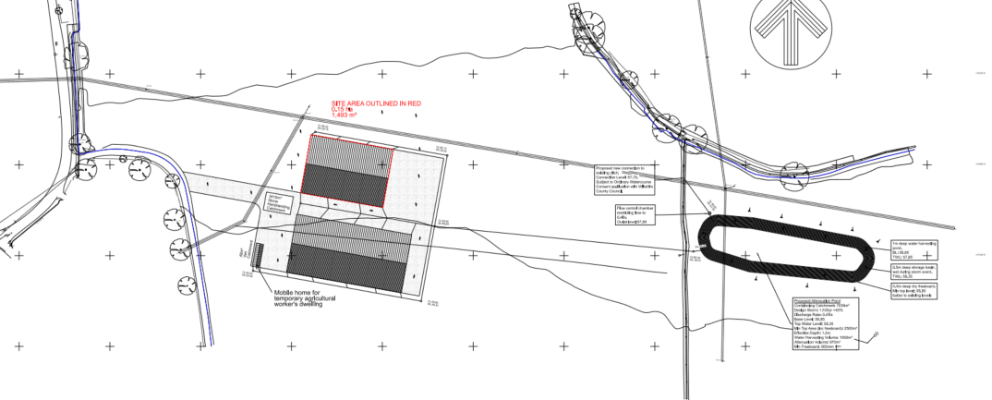

Combined Proposed Site Plan with Prior Approval Application PL/2025/09651

- The siting and means of construction of the private way

The proposed private way (although not shown on the site plan for this application but is for the full planning application PL/2025/09651 would only require a c42m long straight access from the existing access track. The proposed building is therefore located in a logical and efficient position, avoiding the watercourses, field boundary hedges and is also located away from neighbouring residential properties. The proposed siting and private way would lead to the least amount of combined impact on the landscape and neighbouring amenity.

- The siting of the excavation or deposit

No excavation is proposed other than subtle changes to allow for a level site. There would not be any obvious retaining walls or requirement for re-grading of land levels.

- The siting and appearance of the tank

No tank is proposed.

Conditions:

The planning application for the beef unit (PL/205/09651) will have a specific condition that will allow for the use of any agricultural use but explicitly exclude the use of pigs or poultry (due to the potential for high odour levels).

However, such a condition would not be necessary for this prior approval storage building because the application site lies within 400 metres of a protected building (Turnpike Cottage). In this regard, Condition A.2(1)(a) of Part 6, Class A of Schedule 2 to the GPDO applies, which prevents any building resulting from the development being used for the accommodation of livestock, except in the limited circumstances specified in paragraph D.1(3) of Part 6. Those circumstances relate to temporary welfare, quarantine or emergency situations. Accordingly, the building cannot be used as a permanent livestock building without the benefit of a separate planning permission.

CONCLUSION

In summary, the proposed development meets the criteria for permitted development under Schedule 2, Part 6, Class A of the Town and Country Planning (General Permitted Development) (England) Order 2015 (as amended). As required by the GPDO, an assessment has been made regarding the siting, design, and external appearance of the building, as well as the siting and construction of the private way, any excavations or deposits, and the provision of tanks.

The proposed agricultural building, while of notable scale and visible from several public rights of way, is considered appropriate in design and characteristic of typical agricultural development within a landscape already defined by similar farm complexes. The siting has been sensitively selected to minimise impacts on neighbouring properties, avoid physical constraints such as watercourses and boundaries, and facilitate practical access. The proposed private way is logical and proportionate, and no significant excavation or tanks are proposed.

Although prior approval is required, it is concluded that the details submitted in respect of siting, design, and external appearance are acceptable. Therefore, prior approval should be granted.

RECOMMENDATION:
That prior approval is required and GRANTED

Conditions:

Subject to development in accordance with the approved plans and the specified materials.

A
APPENDIX 1 – PERMITTED DEVELOPMENT CHECKLIST
 | Permitted Development | Yes / No
A | Does the proposal involve the carrying out, on agricultural land forming part of an agricultural unit of 5 hectares or more, of either:  (a) works for the erection, extension, or alteration of a building; or  (b) any excavation or engineering operations,  which are reasonably necessary for the purposes of agriculture within that unit? | Yes.  Although the barn is large, the submitted agricultural appraisal demonstrates that the majority of the building would be required for the storage of hay, straw and grain associated with the agricultural unit, with the remaining space needed for machinery and ancillary agricultural uses. On this basis, the scale of the proposal is considered reasonably necessary.
Criteria (A.1) – Development not permitted by Class A:
(a) | Is the development proposed to be carried out on a separate parcel of land forming part of the agricultural unit that is less than 1 hectare in area? | No – the field is over 1 hectare in size
(b) | Would the development consist of the erection or extension of any agricultural building on an established agricultural unit where development under Class Q or Class S of Part 3 (changes of use) has been carried out within the last 10 years? | There has been no Class Q or Class S development within the last 10 years within the agricultural unit. This includes a search of the applicant’s other freehold land at South Park Farm at Shoddesden (within Test Valley Borough Council) where agricultural prior approval applications were found but not Class Q or S development.
(c) | Would the development consist of, or include, the erection, extension, or alteration of a dwelling? | No
(d) | Would it involve the provision of a building, structure or works not designed for agricultural purposes? | No
(e)(i) | Would the ground area covered by any works or structures (excluding fences) for accommodating livestock or plant/machinery arising from engineering operations exceed 1,000 square metres? | The building is 1,493m2 but would not accommodate livestock. Application PL/2025/09651 is to accommodate livestock.
(e)(ii) | Would the ground area of any building erected, extended, or altered under Class A exceed 1,500 square metres? | No, it would be 1,493m2.
(f) | Is any part of the proposed building, structure, or works within 3 kilometres of the perimeter of an aerodrome and would exceed 3 metres in height? | No – RAF Keevil and Lydeway Field airstrip are both over 5km away
(g) | Is any part of the proposed building, structure, or works not within 3 kilometres of an aerodrome and would exceed 12 metres in height? | The building would be 11.93m high and over 3km from the nearest aerodrome
(h) | Would any part of the development be within 25 metres of a metalled part of a trunk road or classified road? | No, it would be over 100m from the main road.
(i) | Would the development consist of, or include, the erection or construction of, or works to, a building, structure, or excavation used or intended for the accommodation of livestock or storage of slurry/sewage sludge, and be within 400 metres of the curtilage of a protected building? | No. The proposed building is for agricultural storage. Furthermore, the site lies within 400 metres of protected buildings and, pursuant to Condition A.2(1)(a) of Part 6 Class A, the building may not subsequently be used for livestock accommodation other than in the limited circumstances specified in paragraph D.1(3).
(j) | Would the development involve excavations or engineering operations on or over article 2(4) land that are connected with fish farming? | No
(k)(i) | Would any building for storing fuel for or waste from a biomass boiler or anaerobic digestion system be used for storing waste not produced by that system or fuel not produced on land within the unit and be within 400 metres of the curtilage of a protected building? | No
(k)(ii) | Would any building for storing fuel for or waste from a biomass boiler or anaerobic digestion system and be within 400 metres of the curtilage of a protected building? | No
(l) | Would the erection or extension of a building be carried out on land or a building that is, or is within the curtilage of, a scheduled monument? | No

