APPLICATION FOR FULL-PLANNING PERMISSION
CASE OFFICER REPORT

APPLICATION REFERENCE: | PL/2025/09651
APPLICATION TYPE: | Full planning permission
SITE ADDRESS: | Whyr Farm, Worton Road, Devizes, SN10 5PU
DEVELOPMENT DESCRIPTION: | New beef unit comprising a livestock building and temporary siting of mobile home for use as an agricultural worker’s dwelling together with associated works.
RECOMMENDATION: | Approve with Conditions

SITE DESCRIPTION/CONTEXT

The planning application site is located approximately 180m to the east of Worton (which is designated as a large village in the Wiltshire Core Strategy). The site is an agricultural field in the open countryside.

The access from Worton Road involves an approximate 8.5m wide apron laid to a compacted MOT aggregate surface which then splits into two separate accesses, one for Whyr Farm (left) and to the right for Ware Farm. Both accesses then continue for approximately 470m until they reach Ware Farm (a residential farmhouse and its ancillary outbuildings). Immediately adjacent to Ware Farm to the north, Whyr Farm has a small barn used to accommodate cattle.

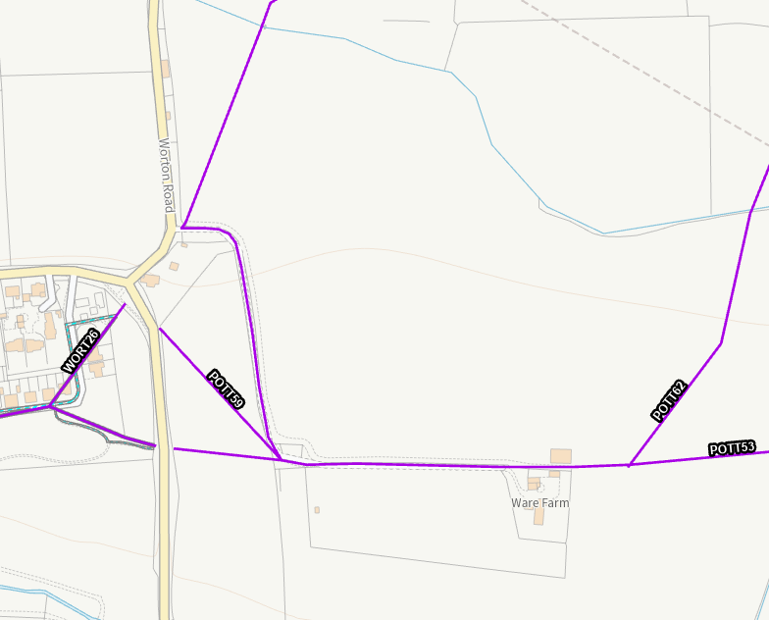

Council Mapping Image of Worton (left), Ware Farm (bottom right) with full planning application site in between. Purple lines show Public Rights of Way

The site is generally level and is predominantly surrounded by further agricultural land and woodland. A grade II listed building, ‘The Manor House’, is located approximately 800m to the northeast of the proposed barn. Approximately 950m away to the east are a further 6 listed buildings, one of which is the grade II* ‘The Red House at Eastwell House’. However, due to the presence of woodland, these buildings are not visible from the application site or generally from the internal access leading to Ware Farm.

The land is understood to be grade 3 agricultural land although there is no distinction whether it is 3a or 3b. The site is not within a National Landscape and is not considered to be a ‘valued landscape’ as set out in paragraph 187 of the NPPF.

There are other farm complexes that can be seen from the site (understood to be Cherry Farm and Larborough Farm).

The site is within the Sailsbury Plain Special Protection Area 6.4km buffer.

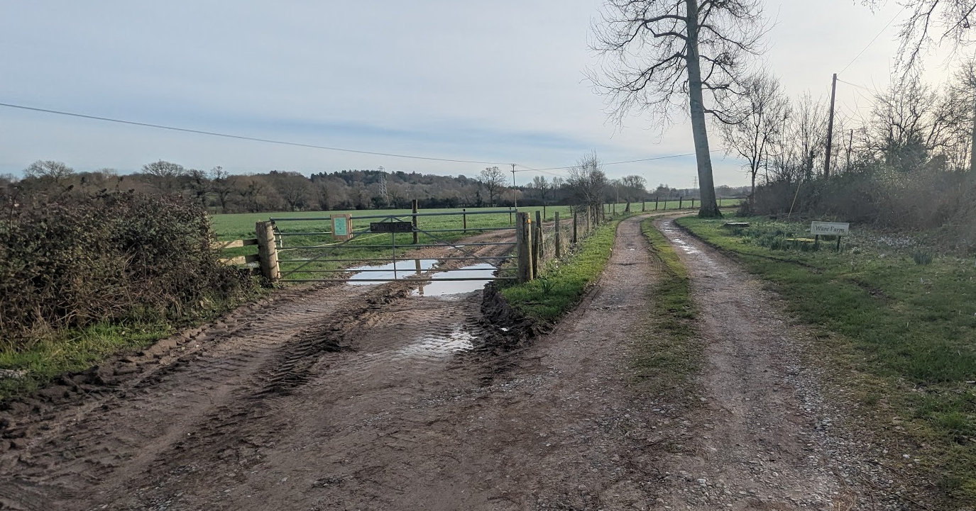

Shared vehicle access with adjacent farm from Worton Road (proposed building would be broadly straight ahead)

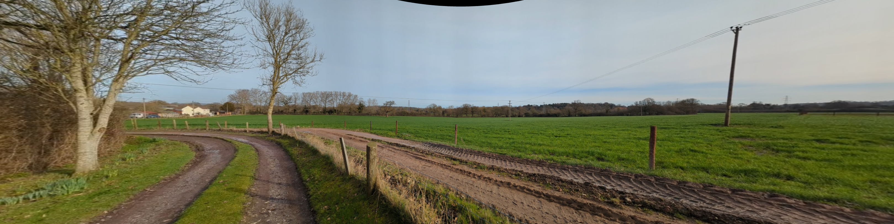

View from the access track (and PRoW POTT53) near the main access to Worton Road (proposed building would be broadly to the right of the electricity pole)

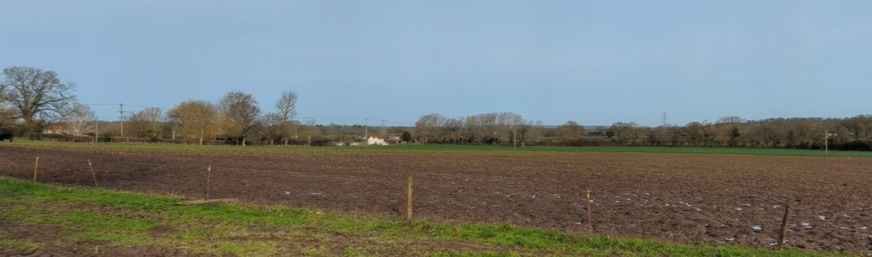

View from the South further along access track (PRoW POTT53) to Ware Farm (the proposed barn would be broadly in line with the white building in the background)

PROPOSAL

The proposed development comprises the following elements: a cattle barn; a temporary agricultural worker’s dwelling (mobile home); and an attenuation pond.

The proposed barn would measure approximately 64m long, 32.7m wide, and 11.1 metres tall (sloping to 6.4m at the eaves). It would be used to accommodate approximately 390 cattle at one time but with the anticipation that 320 would be ‘wintered’ (so used for winter accommodation). This reflects that not all age groups of cattle would be housed simultaneously on site as some stock would be sold, or at different stages of the production cycle. It is appreciated that absolute numbers will fluctuate over time and for different reasons.

This application has been submitted alongside a prior approval application PL/2025/09652 for a second barn – this would be used for the storage of hay, straw and fodder and approximately 46m long, 32.5m wide and 11.9m high. Both applications are to be determined at the same time.

The walls of the barn would be built of concrete panels at a lower level with tanalised timber space boarding above. The east and north elevations would be left open. The roof would be finished with ‘natural grey’ fibre cement profile 6 corrugated roof sheeting, incorporating 10% translucent GRP sheets.

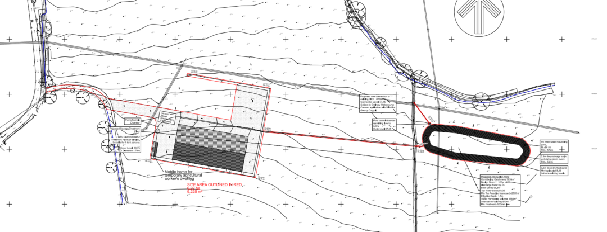

Proposed Site Plan

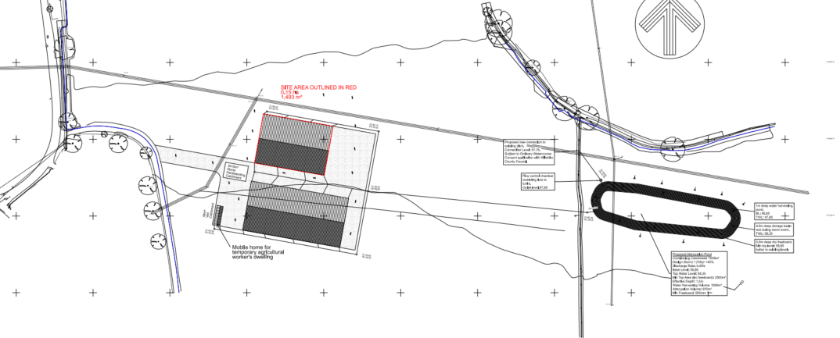

Combined Proposed Site Plan with Prior Approval Application PL/2025/09652

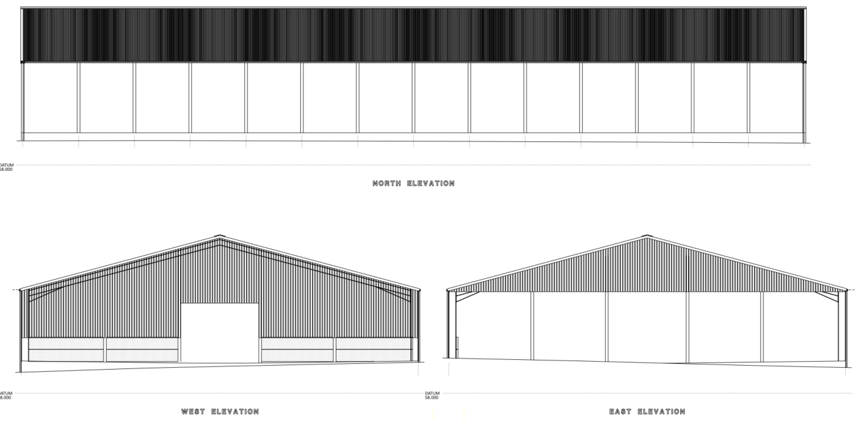

Proposed Elevations

The proposed cattle enterprise at Wyre Farm is structured around a mixed-age beef production system, meaning that a range of livestock types would be present on site at any one time rather than a single uniform herd. The core breeding herd comprises approximately 100 suckler cows, which calve throughout the year, resulting in a continuous presence of cattle both with and without dependent calves. In addition, youngstock would be retained on the holding across multiple age groups, typically including calves (0–6 months), weaned cattle (6–12 months), and older growing animals (12–24 months).

A further component of the system is the periodic purchase of young calves, reared alongside home-bred stock as part of an integrated finishing enterprise. As a result of this overlapping cycle of breeding, rearing and finishing, several cohorts of cattle are present simultaneously, giving rise to a peak on-site population in the order of approximately 390–400 head. This figure represents a realistic worst-case scenario during periods such as winter housing, when all stock is accommodated indoors – this forms the basis of the environmental assessments submitted in support of the application.

The table below summarises the typical composition of the herd at any one time:

Cow Type | Number
Suckler cows | 100
Calves | Circa 100
Youngstock (6-12m) | Circa 100
Youngstock (12-24m) | Circa 90
Purchased calves (annual batches) | 120 a year (but not all on site at once)
Total Cattle on site | Circa 390

The application has been supported by a noise report and odour report and an agricultural need assessment. A redacted version of the agricultural need assessment has been made publicly available.

The noise report has used a rounded ‘worst case’ total number of cattle (quoting 400 cattle) The odour report has used a qualitative classification system rather than being based on a single total figure.

The proposal also includes the siting of a mobile home to be used as a temporary agricultural worker’s dwelling (situated on the hardstanding area in front of the beef unit); and an attenuation pond to capture surface water from the development.

PLANNING HISTORY

Proposal / Summary
PL/2025/09651 - Full planning permission – New beef unit comprising a livestock building and temporary siting of mobile home for use as an agricultural worker’s dwelling together with associated works.
PL/2025/09652 - Prior notification: Building – Agricultural building including for storage of hay, straw and fodder etc

This application is supported by associated agricultural infrastructure, including a fodder storage building that has been assessed separately under the prior approval process. This suggests that the applicant is seeking to establish a coherent and functional agricultural unit on land within their control, rather than relying on dispersed or constrained off-site facilities.

Whilst that development has been considered under a separate legislative framework, it provides context in demonstrating the overall agricultural strategy for the holding. The acceptability of the current proposal has, however, been assessed on its own planning merits.

RELEVANT LEGISLATION, POLICIES AND GUIDANCE

Statutory Legislation:

From the point of view of the historic environment the main statutory tests are set out within the Planning (Listed Building and Conservation Areas) Act 1990.

Section 66 (Planning Permission) requires that special regard be given to the desirability of preserving listed buildings, their settings or any features of special architectural or historic interest which they possess.

National Planning Policy:
- National Planning Policy Framework (NPPF)
- Planning Practice Guidance (PPG)
The NPPF outlines government policy for planning. Chapter 16 of the NPPF 'Conserving and enhancing the historic environment' sets out the Government's high-level policies concerning heritage and sustainable development. In particular:

Paragraph 208 requires that LPAs should “avoid or minimise any conflict” between the heritage asset’s conservation (which includes achieving its optimum viable use) and any aspect of a proposal.

Paragraph 210 requires that local planning authorities should take account of the desirability of sustaining and enhancing the significance of heritage assets and putting them to viable new uses and of new development making a positive contribution to local character and distinctiveness.

Paragraphs 212 requires “great weight” to be given to an asset’s conservation “irrespective of whether any potential harm amounts to substantial harm, total loss or less than substantial harm to its significance.”

Paragraph 213 advises that harm to the significance of a designated heritage asset should require “clear and convincing justification”.

Paragraphs 213-215(214-216) require a balanced approach with any harm which would be caused being weighed against the potential public benefits which might be achieved.

Paragraph 220 advises that not all elements of a Conservation Area or World Heritage Site will necessarily contribute to its significance. Loss of a building (or other element) which makes a positive contribution to the significance of the Conservation Area or World Heritage Site should be treated either as substantial harm or less than substantial harm as appropriate.

The Planning Practice Guidance provides guidance on interpreting the NPPF.

Development Plan:
The development plan for Wiltshire comprises the Wiltshire Core Strategy (WCS) (adopted January 2015) and any made neighbourhood plans, which remains the principal statutory planning document guiding development across the county. In line with Section 38(6) of the Planning and Compulsory Purchase Act 2004, planning decisions must be made in accordance with the development plan unless material considerations indicate otherwise.

The Wilshire Core Strategy has 6 strategic objectives – in order to achieve sustainable development. These include;

- Delivering a thriving economy
- Addressing climate change
- Providing everyone with access to a decent, affordable home
- help build resilient communities
- protect and enhance the natural, historic and built environment
- ensuring that adequate infrastructure is in place to support our communities

Though the development plan is considered as a whole, those parts deemed to be particularly relevant to this application are listed below:

The adopted Wiltshire Core Strategy (WCS), with particular regard to:

- Core Policy 1 Settlement Strategy;
- Core Policy 2 Delivery Strategy;
- Core Policy 34 Additional Employment Land
- Core Policy 48 Supporting Rural Life
- Core Policy 50 Biodiversity and Geodiversity;
- Core Policy 51 Landscape
- Core Policy 57 Ensuring High Quality Design and Place Shaping;
- Core Policy 58 Ensuring the Conservation of the Historic Environment;
- Core Policy 64 Demand Management
- Core Policy 67 Flood Risk;

The Council’s Core Strategy CP 57: Ensuring high quality design requires a high quality of design in all new developments. The policy requires applicants to “demonstrate how the proposal will make a positive contribution to the character of Wiltshire through (amongst other things) responding to the value of the natural and historic environment and being sympathetic to and conserving historic buildings and landscapes. Development is required to respond positively to the existing in terms of building layouts, built form, height, mass, scale, building line, plot size, elevational design, materials, streetscape and rooflines to effectively integrate the building into its setting.”

The Council’s Core Strategy Policy CP58 ‘Ensuring the conservation of the historic environment’ requires that designated and non-designated heritage assets and their settings will be conserved, and where appropriate enhanced, in a manner appropriate to their significance and encourages proposals which improve the condition of heritage assets at risk.

At Full Council on 19 May 2026, the elected members of Wiltshire Council agreed to withdraw the emerging Wiltshire Local Plan. It will now be subject to a legal process to finalise its withdrawal - which is likely to happen in July or August (2026). The said Plan has no material weight for the purposes of the application.

Neighbourhood Plan: Potterne Neighbourhood Plan 2017

The Plan predominantly relates to housing allocations, community facilities and development within and adjoining the settlement boundary of Potterne. No specific neighbourhood plan policy relates directly to agricultural livestock development in the open countryside. Accordingly, the principal policy considerations remain the Wiltshire Core Strategy and the National Planning Policy Framework. Nevertheless, the wider objectives of the Neighbourhood Plan seeking to protect the character of the countryside, local landscape and highway safety have been taken into account in the assessment of the application.

Supplementary Planning Documents and other Guidance:
- Wiltshire Design Guide (adopted April 2024)
- Wiltshire Council Countryside Character Area – 11c Rolling Clay Lowland
- Wiltshire Council Strategic Flood Risk Assessments 2019 and 2024

ISSUES

The main issues that need to be addressed in this case include:

- Whether the proposal constitutes EIA development
- Whether the development is acceptable in principle (CP34 and CP48)
- Whether the scheme constitutes high quality design (CP 57)
- Whether the scheme would have an acceptable impact upon the reasonable living conditions of the adjoining occupants (CP 57)
- Whether the scheme would preserve or enhance the historic environment (CP 58)
- Whether the scheme would have an acceptable landscape impact (CP 51)
- Whether the proposal would have a negative effect upon highway safety, including if there is sufficient parking for the proposed development (CP 61 and 64)
- Whether the site can be adequately drained without increasing flood risk elsewhere (CP 67)
- Whether there would be any harmful impacts upon protected species or priority habitats (CP 50)

CONSULTATION RESPONSES

Councillor Reay has called the application into planning committee in the event that officers recommend refusal of the application. As this application is to be recommended for approval, the application can be determined using delegated powers.

Potterne Parish Council: No objection but comments:

We question whether there is 'an essential need' for anybody to live 'permanently' on site, but if the LPA are satisfied that such be the case then we would expect conditions to be imposed that the occupation of the temporary dwelling and any replacement/substitution thereof (a) shall not commence until the proposed development has been fully completed and the enterprise shown to have become financially viable, and (b) shall be limited to a person solely or mainly employed in the essential management of the beef unit the subject of this application.

The village of Potterne is well under a mile away and directly downwind from the site and must be protected from offensive odour. Whilst we are prepared to accept that the anticipated odour from the beef cattle is unlikely to be significant or unacceptable, that would certainly not be the case if pigs or chickens were involved. We therefore expect conditions to be imposed (a) restricting the use of the proposed beef building to the housing and rearing of beef cattle only with a specific prohibition against poultry or pigs, and (b) restricting the use of the other proposed building to agricultural storage only.

Wiltshire Council Agricultural Consultant: No objection

Wiltshire Council Highways Officer: No objection subject to conditions

Wiltshire Council Ecology Officer: No objection subject to condition

Wiltshire Council Drainage Officer: No objection subject to condition

Wiltshire Council Public Rights of Way Officer: No objection subject to informative

Wiltshire Council Landscape Officer: No comment to make

Wiltshire Council Public Protection Officer: No objection subject to conditions

Environment Agency: No comment to make – falls outside EA remit.

REPRESENTATIONS
In accordance with the requirements of the Town and Country Planning (Development Management Procedure) (England) Order 2015 (as amended), the application was publicised by way of:

- Neighbour notification letters sent to adjoining and nearby properties;
- A site notice displayed near the site;

For the avoidance of doubt two site notices were erected on this site when the application was originally registered in December 2025 and then again on 5 May when the application was re-validated as a major application.

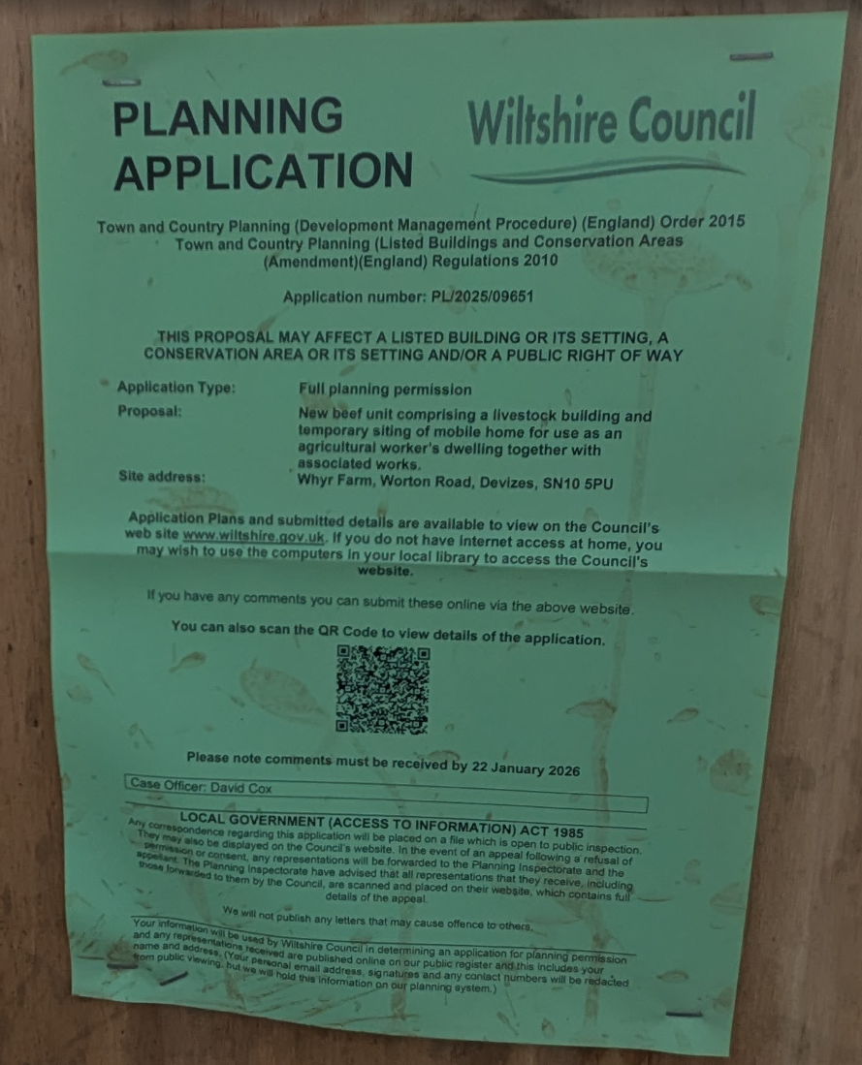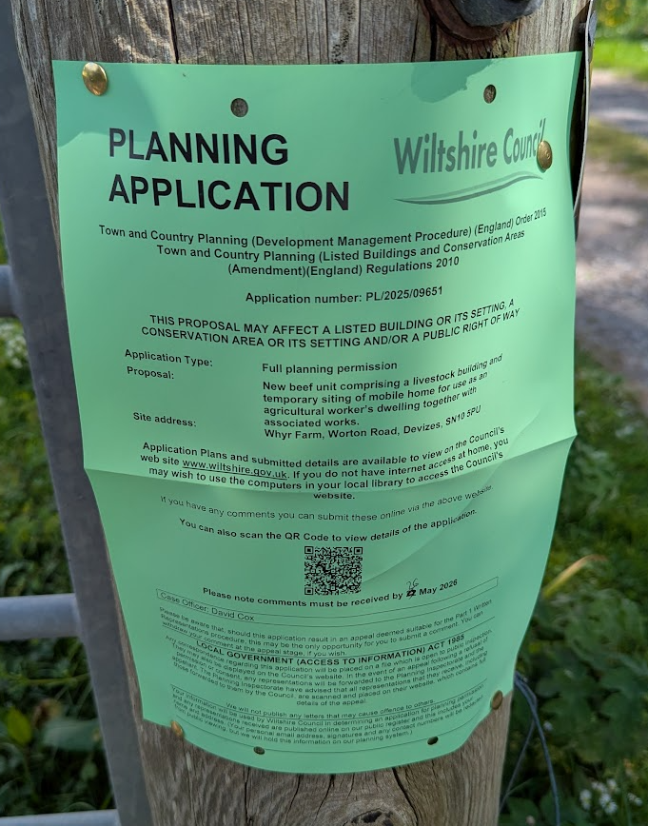

Photos of the site notices

These methods were used to inform interested parties and provide a period of 21 days for comments to be submitted.

Below is a summary of the representations received during the consultation period. Only material planning considerations have been taken into account in the assessment of this application. Non-material issues, such as property values or private legal disputes, cannot be considered in the determination process.

A total of 2,198 representations have been received from members of the public.

Of these:
- 2,178 representations raise objections or concerns in relation to the proposal
- 20 representations express support for the application
- There are no clearly identifiable neutral submissions, although some responses are framed as general comments whilst still raising concerns about the development

Given the sheer volume of responses, it is confirmed that AI has been used to summarise the responses, which are produced below. The issues raised will be considered in the report under the various headings where relevant.

Summary of Objections
Principle of Development
- Objection to the scale and nature of the proposal, with concerns that it represents an intensive or industrial form of agriculture
- View that the development is not justified as an essential agricultural need and constitutes an inappropriate expansion
Highway Safety and Traffic Impact
- Increase in HGV movements associated with the development
- Concerns regarding road safety, congestion, and suitability of the local road network
Residential Amenity (Odour, Noise, Disturbance)
- Potential for significant odour impacts on nearby settlements
- Noise from livestock, operations and vehicle movements
- Concerns regarding flies and general disturbance to neighbouring residents
Landscape and Visual Impact
- Harm to the rural character of the area
- Scale and massing of buildings considered visually intrusive
- Insufficient mitigation or landscaping proposed
Ecology and Biodiversity
- Potential harm to wildlife and habitats from construction and operation
- Pressure on local biodiversity and nearby designated or sensitive sites
Flood Risk and Drainage
- Insufficient clarity regarding drainage infrastructure and slurry management
- Risk of pollution to nearby watercourses and soils
Environmental Impact and Sustainability
- Concerns regarding greenhouse gas emissions and wider climate impacts
- Perception that the proposal conflicts with sustainable farming objectives
Other Concerns
- Lack of clarity on operational details, including number of livestock and management practices
- Concerns regarding soil degradation, air quality, and waste handling

Summary of Support
Economic and Rural Benefits
- Support for sustaining and diversifying a local farming business
- Contribution to rural employment and the local economy
Agricultural and Land Use Benefits
- Use of land for agriculture rather than alternative forms of development
- Need for livestock housing to support traditional farming practices
Community and Social Benefits
- Support for enabling a younger generation to establish a farming enterprise
- Recognition of the applicant’s role within the local community
Land Management and Environmental Benefits
- Grazing seen as beneficial for maintaining grassland habitats
- Support for established farming practices and food production

Non Material Considerations Raised
Several representations raise matters that are not material planning considerations. These include ethical objections to livestock farming, views on dietary choices, commentary on global agricultural systems, and wider concerns about the consumption of meat. Concerns relating to perceived motives of the applicant and generalised opposition to farming practices have also been noted. Whilst these matters are acknowledged, they are not material to the determination of the application

Overview of Key Issues Raised
The representations are overwhelmingly in objection to the proposal, with the principal concerns relating to the environmental effects of intensified agricultural activity, including impacts on residential amenity, the local landscape, drainage and pollution risk. Highway impacts and the scale of development are also frequently raised. Animal welfare and wider sustainability issues form a significant theme throughout many representations. In contrast, supporting comments highlight the economic and social benefits of maintaining a viable agricultural enterprise, the continuation of farming traditions, and the role of the proposal in supporting the rural economy and local food production.

ASSESSMENT

Section 38(6) of the Planning and Compulsory Purchase Act 2004 states:

"If regard is to be had to the development plan for the purposes of any determination to be made under the planning Acts, the determination must be made in accordance with the plan unless material considerations indicate otherwise."

In accordance with this statutory requirement, this application has been assessed against the relevant policies of the Development Plan, including the Wiltshire Core Strategy (2015) and, where applicable, any made Neighbourhood Plans. Consideration has also been given to the policies of the National Planning Policy Framework (NPPF) as a material consideration in the assessment.

Environmental Impact Assessment (EIA) Screening
In accordance with the Town and Country Planning (Environmental Impact Assessment) Regulations 2017 (as amended), the local planning authority has considered whether the proposed development constitutes EIA development.

Whilst a formal Screening Opinion has not been requested, the Local Planning Authority has undertaken an assessment of the proposal against the criteria set out in Schedule 2 and Schedule 3 of the EIA Regulations. Having regard to the scale of the development, its location outside sensitive areas, and the nature of the potential impacts (which have been assessed through supporting technical evidence), it is concluded that the proposal would not be likely to give rise to significant environmental effects and therefore does not constitute EIA development.

Principle of Development
Policy Context – The need for the agricultural beef unit building
Core Policy 34 of the Wiltshire Core Strategy sets out that outside the principal settlements, market towns, and local service centres, developments will be supported where they:

  - Are adjacent to these settlements and seeks to retain or expand businesses currently located within or adjacent to the settlements; or
  - Support sustainable farming and food production through allowing development required to adapt to modern agricultural practices and diversification; or
  - Are for new and existing rural based businesses within or adjacent to large and small villages
where they:

- Meet sustainable development objectives as set out in the polices of this Core Strategy; and
- Are consistent in scale with their location, do not adversely affect nearby buildings and the surrounding area or detract from residential amenity and
- Are supported by evidence that they area required to benefit the local economic and social needs and
- Would not undermine the delivery of strategic employment allocations and
- Are supported by adequate infrastructure

For the avoidance of doubt, only one criterion of i-iii) must be satisfied; however, all criteria a)-e) must also be met.

The National Planning Policy Framework (NPPF) also contains relevant supporting paragraphs. Paragraph 88 states that planning policies and decisions should enable “the development and diversification of agricultural and other land-based rural businesses”, whilst Paragraph 89 recognises that rural development may need to be located beyond existing settlements.

Policy Context – The need for the agricultural worker’s dwelling
Core Policy 48 of the Wiltshire Core Strategy sets out that proposals for residential development outside defined settlement limits will be supported where they are required to enable workers to live at or in the immediate vicinity of their place of work in the interests of agriculture. Such proposals must be supported by robust functional and financial evidence.

Paragraph 84(a) of the National Planning Policy Framework states that “Isolated homes in the countryside should be avoided unless there is an essential need for a rural worker to live permanently at or near their place of work”.

Assessment – Agricultural need for the beef unit

It is considered that the proposal meets two of the quoted criteria of CP34, namely ii and iii); noting that there only needs to be one of the criteria met. It does not meet criterion i) because the application site is not adjacent to a Principal Settlement, Market town or Local Service Centre.

It does however meet criterion ii) because it supports sustainable farming and food production by facilitating development required to adapt to modern agricultural practices and livestock management. In this respect, the Council’s independent Agricultural Consultant confirms that the proposed livestock building is of an appropriate size and design for the intended beef enterprise, with its scale directly derived from the operational and welfare requirements of the herd. The consultant identifies that the building is specifically designed to accommodate cattle during the winter housing period, as well as for year-round calving and calf rearing, which are essential components of the proposed system.

The consultant further confirms that the number of livestock proposed, including suckler cows, calves and youngstock across multiple age groups, necessitates a building of the scale proposed, with space standards based on recognised farm management data. Animal welfare considerations are therefore a key driver of the design, with housing required for extended winter periods and for indoor calving, which is a wholly appropriate and accepted modern farming practice. Officers are satisfied that the scale of development is justified and proportionate to the needs of the enterprise and has been independently verified.

The proposal also meets criterion iii) in that it relates to an existing and expanding rural business located adjacent to the large village of Worton. The site lies approximately 180m from the defined Limits of Development and is therefore considered to reasonably and clearly meet the definition of being ‘adjacent’.

Core Policy 34 further requires that criteria a)–e) are satisfied.

In respect of criterion a), the proposal accords with the Core Strategy’s sustainable development objectives, in particular those relating to supporting a thriving rural economy, building resilient rural communities, and protecting the natural and historic environment. The development would support an established agricultural enterprise and contribute to food production, which is a key component of the rural economy.

The application site forms part of the applicant’s wider farming business, extending to approximately 121ha across a number of holdings. The existing beef enterprise is currently operated from Crookwood Farm under a leasehold arrangement, comprising approximately 50 breeding cows and associated youngstock. The proposal seeks to relocate and expand this enterprise onto land within the applicant’s ownership, increasing the suckler herd and introducing a calf rearing operation. This would consolidate the business within a single, purpose-built farmstead, allowing for improved efficiency, enhanced infrastructure and greater long-term security over land and production. Accordingly, criterion a) is satisfied.

With regard to criterion b), the scale, siting and design of the development are considered appropriate to its rural location and agricultural function. The impacts on the surrounding landscape and neighbouring amenity are assessed elsewhere within this report, and it is concluded that no unacceptable adverse impacts would arise. Criterion b) is therefore satisfied.

Criterion c) requires the proposal to be supported by evidence demonstrating benefits to local economic and social needs. The proposal would directly support agricultural productivity through increased beef production and would contribute to the local economy through the operation of a viable rural enterprise and the creation of at least one full-time agricultural role. These are recognised economic and social benefits, and the proposal is therefore considered to comply with criterion c).

In respect of criterion d), the proposal relates to an agricultural use and is not of a type that would compete with or undermine the delivery of allocated employment land, which is intended for industrial and commercial development. Criterion d) is therefore satisfied.

Finally, in relation to criterion e), the site benefits from an established access and the development can be adequately served by existing infrastructure. Detailed consideration of highways matters is set out elsewhere in this report, and no objections have been raised. Criterion e) is therefore satisfied.

Conclusion on agricultural need for the beef unit:

Having regard to the above, it is concluded that the proposal satisfies the requirements of Core Policy 34. The development demonstrably supports sustainable farming and food production in accordance with criterion ii) and relates to the expansion of an established rural business in close proximity to a large village, thereby also satisfying criterion iii).

The scale, siting and design of the proposed livestock building are directly informed by the operational and welfare requirements of the enterprise, including the management of suckler cows, calves and youngstock across the production cycle. Independent agricultural advice confirms that the building is appropriate and proportionate to the needs of the enterprise.

Furthermore, the proposal complies with criteria a)–e) of Core Policy 34, in that it supports the rural economy and sustainable development objectives of the Core Strategy, is appropriately scaled to its location, delivers clear economic and social benefits, does not prejudice strategic employment land, and can be supported by appropriate infrastructure.

Accordingly, the proposal represents a justified and policy-compliant form of agricultural development, and the principle of development is therefore acceptable.

Assessment – Agricultural need for the agricultural workers dwelling

Core Policy 48 requires that proposals for rural worker dwellings demonstrate a clear functional need for a worker to reside at or near their place of work, supported by robust financial and operational evidence.

Functional Need

The Council’s independent Agricultural Consultant confirms that the proposed enterprise would generate a labour requirement in excess of one full-time worker. The enterprise includes the management of a herd of approximately 100 suckler cows, together with associated calves and youngstock across multiple age groups (to make a typical total number on site of circa 390).

The nature of the enterprise involves year-round calving, the rearing of youngstock, and the housing of cattle over the winter period. These operations give rise to continuous and time-critical supervision requirements, particularly during calving periods, where immediate intervention may be required to safeguard animal welfare.

The evidence demonstrates that such requirements cannot be reasonably met from a remote location, and that a worker must be readily available on site at all times. It is therefore concluded that there is a clear and essential functional need for a worker to reside at the holding.

Financial and Operational Viability

The independent Agricultural Consultant has confirmed that the existing beef enterprise is a valid and established rural business, and that its proposed expansion is credible and viable. The proposal seeks to increase the herd size and introduce a calf rearing enterprise, thereby expanding output and improving efficiency.

The relocation of the enterprise from a leasehold arrangement to land within the applicant’s ownership further supports the long-term viability and sustainability of the business. The proposed consolidation would provide a secure operational base, allowing for appropriate investment in infrastructure and improved herd management.

Officers are therefore satisfied that the enterprise is financially sound and capable of supporting the provision of a rural worker dwelling.

Siting and Relationship to the enterprise

As shown on the proposed block plan, the proposed dwelling is to be located within the farmstead to which it would relate and would provide direct oversight of the livestock buildings and associated operations. This siting would ensure that the dwelling fulfils its functional purpose in supporting the agricultural enterprise.

The scale and temporary nature of the accommodation would reflect its intended use and is proportionate to the needs of the holding at this stage of the enterprise’s development.

Conclusion on CP48

Having regard to the above, it is concluded that the proposal satisfies the requirements of Core Policy 48 in that it demonstrates:

- a clear and essential functional need for a worker to live at or near the site;
- a viable and established agricultural enterprise capable of supporting the development; and
- appropriate siting and scale directly related to the operational needs of the holding.

Overall Principle of Development Conclusion

The scale and form of the proposed development directly reflect the operational requirements of an expanded beef enterprise comprising approximately 100 suckler cows and associated livestock (circa 390 in total). The evidence provided, including independent agricultural assessment, demonstrates that both the buildings and the associated worker dwelling are necessary to support the efficient, compliant and welfare-led operation of the enterprise.

The proposal is therefore supported by clear agricultural, economic and functional justification, and accords with the requirements of Core Policies 34 and 48, as well as national policy within the NPPF. This is subject to the mobile home element of the proposal being conditioned to limit occupation to agricultural workers and to be temporary only (as is proposed by the applicant) to ensure full policy compliance.

Design and Impact on the Character and Appearance of the Area
Policy Context
Core Policy 57 of the WCS requires high-quality design that:
- Enhances local character.
- Responds to the natural, historic, and built environment.
- Retains important features (e.g., trees, hedges).
- Supports sustainable construction and compatibility with surrounding uses.
- Creates safe, legible, and accessible spaces.

Section 12 of the NPPF emphasises design that is:
- Visually attractive.
- Functionally effective.
- Contributes to the quality of the built environment.

The Wiltshire Design Guide encourages sensitivity to local character, materials, and architectural styles and supports modern living standards while maintaining aesthetic and functional quality.

Assessment

The scale and form of the proposed barn have been driven by the operational requirements of the herd, and this has been independently verified by the Council’s Agricultural Consultant. The structure would be constructed using standard concrete panels with timber boarding, with the east and north elevations remaining open. As such, the building would present a functional agricultural appearance appropriate to its rural context.

Whilst the barn would be large, this is characteristic of modern agricultural developments. Farmsteads typically comprise multiple structures which collectively form large complexes. In this instance, the proposal, together with the associated prior approval application (PL/2025/09652), would meet the operational needs of the holding through two principal buildings. These have been designed to share access arrangements and hardstanding areas, thereby limiting additional land take and visual clutter.

The proposed roofing material would be a natural grey fibre cement profile sheet, incorporating translucent panels to allow natural light. Such materials typically have a matt finish, reducing reflectivity and ensuring a subdued appearance. It is therefore considered appropriate to secure by condition the use of these specified materials in the roof’s construction.

The timber cladding would be tanalised, initially presenting a pale green hue before weathering to a warmer brown and ultimately to a silvery grey. These natural changes are typical and would not appear incongruous within the rural landscape.

The siting of the barn has also been carefully considered. It is positioned to maximise operational efficiency, located close to the access and oriented accordingly, whilst maintaining as much separation as practicable from neighbouring boundaries to reduce potential impacts on surrounding receptors.

Conclusion

Overall, the proposed development is considered to accord with the requirements of Core Policy 57, Section 12 of the NPPF and the Wiltshire Design Guide. The scale, appearance and siting of the barn reflect its functional agricultural purpose and are consistent with modern farming practices. Subject to appropriate conditions, particularly in respect of external materials, the development would integrate satisfactorily within its rural setting and would not result in unacceptable harm to local character or visual amenity.

Landscape and Visual Impact
Policy Context
Core Policy 51 of the Wiltshire Core Strategy requires development to:
- Protect, conserve, and enhance landscape character and quality.
- Respect local distinctiveness, key views, and visual receptors.

The Wiltshire Design Guide SPD (2024) promotes a context-led approach, encouraging integration with natural features and settlement patterns while avoiding visual intrusion.

The Green & Blue Infrastructure Strategy (2022–2030) supports landscape protection through green infrastructure, habitat connectivity, and nature-based solutions.

The NPPF emphasises the need to protect and enhance valued landscapes, particularly those with scenic, historic, or ecological significance. Planning decisions should:

- Recognise the intrinsic character and beauty of the countryside.
- Safeguard key views, local distinctiveness, and landscape settings.
- Ensure development is well-integrated into its surroundings and avoids visual intrusion, especially in sensitive or designated areas.

Landscape impact must be considered alongside biodiversity, heritage, and green infrastructure objectives, with mitigation measures encouraged where harm cannot be avoided.

Wiltshire Councils Landscape character assessment (LCA) – Landscape Type 11 – Rolling Clay Lowland – does show some evidence towards the potential of a ‘valued ‘landscape for the landscape area as a whole, However it cannot be used to specifically to assess the application site or its immediate surroundings.

The LCA shows that the area is a ‘largely peaceful, rural landscape’ with inherent landscape sensitivities being rural tranquillity, hedgerow patterns. However, under the heading ‘strength of character’ the varied land use of mixed arable and pastoral farming, the coniferous planting which has affected the character of the historic woodlands and the influence of prominent urban edges and transport corridors including noise and light pollution make the strength of character of the type moderate overall.

The ‘strategy’ for the Rolling Clay Lowland is to conserve the peaceful rural landscape with its hedgerow network and pattern of scattered farmsteads and to strengthen its character through
measures to minimise the urbanising influence of large towns, new settlement and transport routes and to improve the woodlands and farmlands by encouraging management to retain or enhance their biodiversity and historic character.

Applicants’ submission

The applicant has submitted a Landscape and Visual Impact Assessment (LVIA) which considers the proposed beef unit alongside the associated storage building (submitted under prior approval application PL/2025/09652), the agricultural worker’s dwelling, site access, and the attenuation basin to the east of the development. The LVIA is presented as a proportionate assessment rather than a full Environmental Impact Assessment.

The LVIA confirms that the site does not lie within a designated landscape and concludes that it does not form part of a ‘valued landscape’. It identifies the receiving landscape as being of ‘medium’ value, characterised by a strong hedgerow structure and a typical agricultural farmland setting.

The LVIA acknowledges that the proposal would introduce a substantial built form into a large open field. However, it notes that agricultural buildings are a characteristic feature of the surrounding area and that the site benefits from partial containment provided by existing vegetation.

In terms of effects, the LVIA concludes that landscape impacts would range from moderate/minor to moderate. Localised adverse effects are identified, particularly in views from nearby public rights of way, but the wider landscape effects are assessed as neutral. Visibility is expected to be largely confined to within approximately 200 metres of the site, with more distant views limited by existing screening. Visual effects are therefore assessed as moderate at a local level, reducing to moderate/minor beyond the immediate site. Overall, effects are described as locally adverse but neutral in the wider landscape context.

The LVIA concludes that proposed mitigation planting, including new hedgerow and tree planting, would further reduce impacts over time, resulting in a residual level of minor harm that would be acceptable in landscape terms.

A landscape mitigation strategy accompanies the application, proposing reinforcement of the western boundary hedgerow along Worton Road and the access track, together with new hedgerow planting to the south and east of the site. This would also assist in screening the attenuation basin.

Assessment

The Council’s Landscape Officer raises no objection to the proposal and is satisfied that the LVIA has been undertaken using an appropriate methodology.

Having regard to the submitted assessment, site visits, and the wider evidence base, officers broadly agree with the conclusions reached. The site is not located within a designated landscape and does not constitute a ‘valued landscape’ in planning terms. Whilst the landscape is of moderate value and exhibits characteristics typical of the local rural setting, this does not in itself elevate it beyond the status of ordinary countryside.

The site forms part of a wider area of active agricultural land characterised by large, open fields enclosed by managed hedgerows, with intermittent tree cover. These features are positive but commonplace within the locality and do not demonstrate the particular attributes required to justify classification as a valued landscape. There is no evidence of notable rarity, scenic quality, or other special qualities that would distinguish the site from the surrounding countryside.

In this regard, paragraph 180 of the NPPF, alongside relevant case law including Stroud District Council v Secretary of State for Communities and Local Government [2015], makes clear that valued landscapes must demonstrate specific attributes that take them beyond the ordinary. The site does not meet that threshold.

The proposed buildings would be of a substantial scale and would be visually prominent in views from nearby public rights of way, including POTT60, POTT53 and POTT62. As such, a degree of localised visual harm is acknowledged. However, the presence of agricultural buildings within the wider landscape is an established characteristic, and the proposal would be viewed within that context.

The visual effects would be largely confined to the immediate vicinity of the site. Existing woodland and hedgerows provide a degree of containment, limiting longer-distance views and restricting wider landscape impacts. Whilst mitigation planting will take time to mature, native hedgerow species such as hawthorn, blackthorn and hazel are capable of relatively rapid establishment, and the proposed planting is expected to provide early-stage screening. Over time, this would further reduce the level of visual impact.

Officers also note the presence of overhead power lines crossing the site, which introduce an existing element of visual intrusion. The proposed development would be seen in association with this infrastructure, which already contributes to a limited urbanising influence in the immediate landscape.

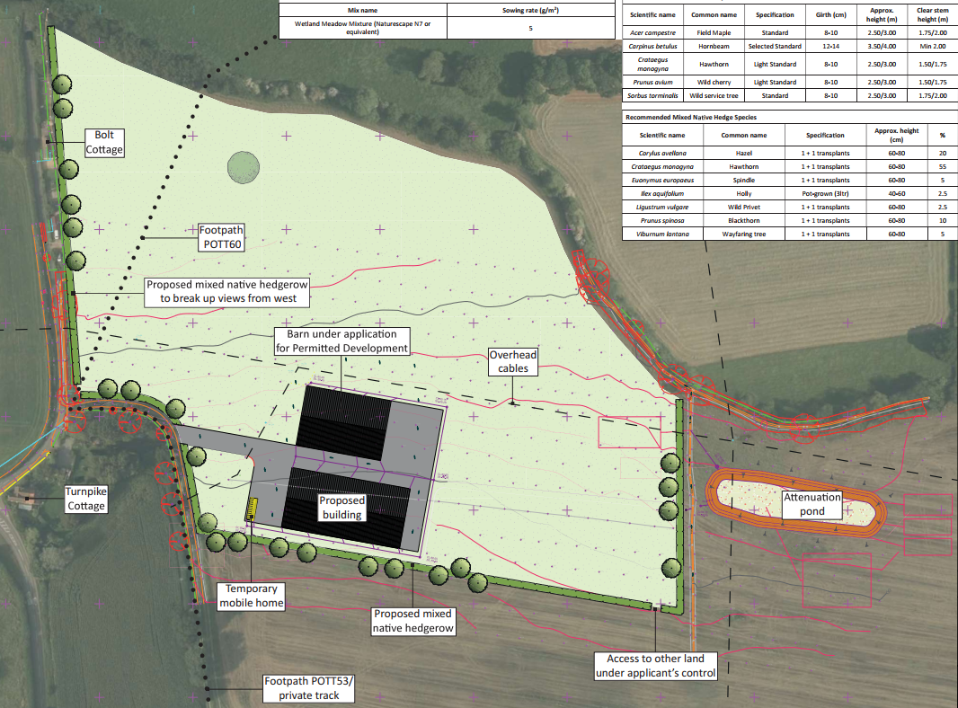

Proposed Landscape Plan

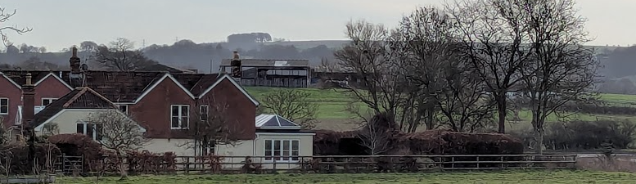

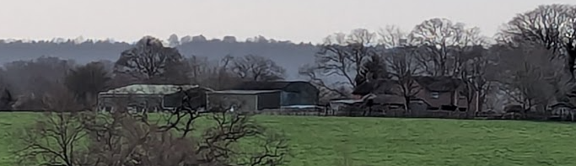

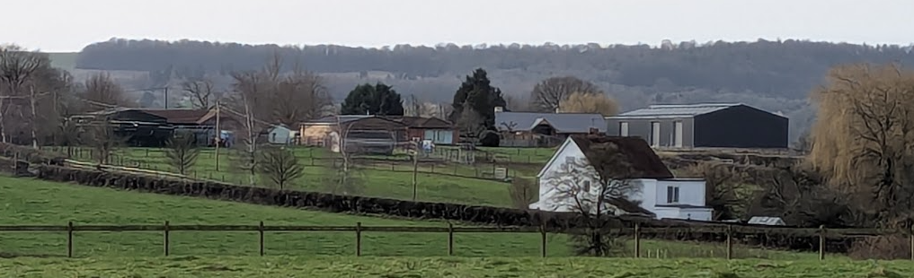

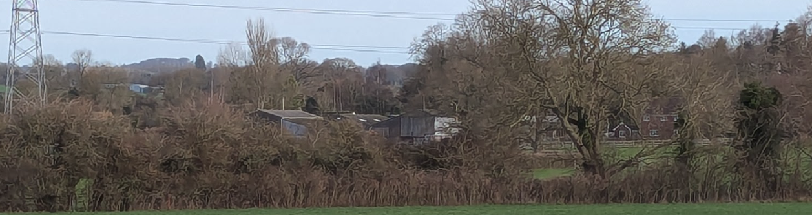
Views of various other farm complex’s from the application site

Conclusion

Overall, the proposed development would introduce a substantial built form into an open agricultural field, resulting in localised adverse visual effects, particularly from nearby public rights of way. However, the site does not form part of a valued landscape and is not subject to any landscape designation. The surrounding area is characterised by typical mixed farmland with existing agricultural development, and the proposal would be viewed in that context.

The effects would be largely contained to the immediate vicinity of the site, with wider landscape impacts limited by existing vegetation and landform. Proposed hedgerow and tree planting would further mitigate views over time, reducing the level of harm.

Having regard to the above, the development is considered to accord with Core Policy 51 of the Wiltshire Core Strategy and the NPPF. Whilst some localised harm would arise, this would not be unacceptable in planning terms.

Amenity
Policy Context
Core Policy 57 (Point vii) of the Wiltshire Core Strategy requires development to respect the amenity of existing occupants and ensure appropriate amenity levels for future residents.

The National Planning Policy Framework (NPPF), particularly Paragraph 135, reinforces the need for development to provide a high standard of amenity for both existing and future users.

These policies guide the assessment of amenity impacts, which will be considered in detail under the below headings.

Assessment

The proposed development has been carefully sited to ensure it would not have an overbearing or unneighbourly impact on neighbours. Overall, it is considered that it would be sufficiently far enough away not to cause significant harm in this regard.

Noise

A noise assessment has been submitted with the application. The assessment considers the likely noise effects arising from typical and worst‑case activities associated with the development, including farm machinery, deliveries, and livestock.

The site is located at a separation distance of approximately 170–270 metres from the nearest residential properties, and the proposed layout and building design incorporate solid elements and orientation that provide a degree of acoustic screening towards these receptors.

Noise modelling has been undertaken using robust assumptions, including peak operational scenarios. Predicted noise levels at neighbouring dwellings are in the range of 47–50 dB LAeq (general operations) and 39–48 dB LAeq (feed delivery). These levels comply with, or are better than, the guidance set out in BS8233:2014 for external amenity areas and internal living conditions, including with windows open.

The report concludes that the proposed development would not give rise to unacceptable impacts on residential amenity. It further recommends that planning permission could be granted from a noise perspective, subject to appropriate conditions and the implementation of good practice measures to minimise noise generation.

The Council’s Public Protection has reviewed the submitted noise assessment and raises no objection to the proposal, confirming that the development is acceptable in terms of noise impact.

Odour

An odour assessment has been undertaken in support of the proposed livestock building which uses a qualitative methodology consistent with Institute of Air Quality Management (IAQM) guidance. The assessment considers the source of odour, the pathways by which odour may travel, and the sensitivity of surrounding receptors, including residential properties.

The proposed development comprises a beef cattle operation, with good management practices (supported by the presence of an on-site worker residing in the temporary dwelling), including regular cleaning, straw bedding, and appropriate manure handling. On this basis, the odour source has been classified as having a medium odour potential.

Wind rose data has been reviewed to inform the assessment of odour pathways. Whilst some of this data has been taken from a comparable site at Lyneham, Wiltshire, it is considered representative of the local area. This indicates that, although the prevailing wind direction is from the south-west, there are occasional variations, including winds from the west, south and north-east.

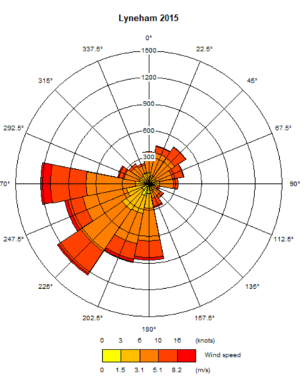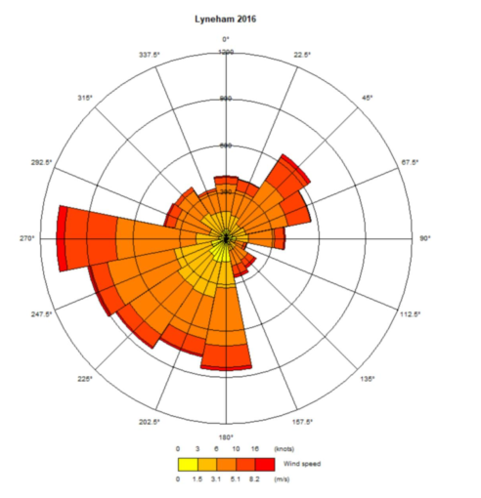

Lyneham Wind Rose Data 2015 and 2016

Mapping demonstrates that the majority of receptors are located to the west at Worton and to the north-east at Potterne, with a smaller number of receptors at Court Hill and along the A360. The closest receptors are as follows:

- West: Turnpike Cottage (approximately 130m), with the remainder of Worton approximately 185m away
- South: Ware Farm (approximately 235m)
- North: Boundary House (approximately 290m)
- East: Larborough Farm (approximately 700m)

The southern edge of Potterne is located approximately 1.1km from the site.

It is evident that the main concentration of nearby receptors lies to the west at Worton. Both wind data sources indicate that winds from the east (towards Worton) occur infrequently. Whilst the prevailing wind is from the south-west, receptors at Potterne are sufficiently distant such that any odour effects would be limited.

Accordingly, the assessment of odour pathways indicates that receptors are either located at a distance from the site or are infrequently downwind, based on prevailing wind conditions. Consequently, pathway effectiveness is assessed as ineffective in all cases, limiting the potential for odour to reach sensitive receptors.

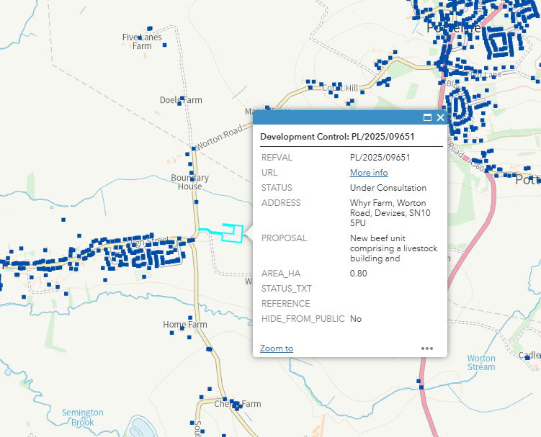

Council Mapping Image of the site and the registered address points for any property or buildings – Note the picture containing the application details only obscures Ware Farm, Larborough Farm, Little Larborough and Eastwell Manor

The nearest receptors are predominantly residential and are therefore considered to be of high sensitivity; however, some are associated with agricultural uses and are less sensitive to typical farming odours. It is also noted that the site is located within a rural area where baseline odour from agricultural activity is an established characteristic.

The combined assessment of source, pathway, and receptor sensitivity identifies that the risk of odour impact is negligible at all receptors, with effects ranging from negligible to slight adverse. In accordance with IAQM guidance, effects at this level are not considered significant.

The Council’s Public Protection Team has been consulted – it raises no objection in respect of odour impacts.

Overall, the assessment concludes that the proposed development would have an insignificant effect on local amenity in terms of odour and would not materially alter the existing odour environment. This combined with the ‘no objection’ from Public Protection, confirms that there are no odour-related constraints to the development, and that the proposal is considered compliant with relevant national and local planning policies.

Notwithstanding the above and in accordance with the advice of Public Protection, it is considered both reasonable and necessary (as has been agreed with the applicant) to impose a planning condition restricting the use of the approved agricultural buildings so as to exclude pigs and poultry. In the absence of such a condition, a building granted planning permission for agricultural use could otherwise be used for any agricultural purpose, including more intensive livestock operations which could present an odour nuisance.

Whilst the submitted assessment identifies cattle as having a medium odour potential, other livestock such as pigs and poultry are typically associated with a significantly higher odour potential. Given the proximity of neighbouring receptors, it is therefore necessary to prevent the use of the unit for pig or poultry rearing to safeguard residential amenity. This restriction would not prevent the building being used for other agricultural purposes, such as cattle housing or crop and grain storage.

Conclusion

Taking all matters into account, including separation distances to neighbouring receptors, the submitted noise and odour assessments, and the design and layout of the scheme, it is concluded that the proposed development would not give rise to unacceptable impacts on residential amenity.

The predicted noise levels fall within recognised acceptable standards, and the odour assessment identifies effects that are negligible to slight and not significant. These conclusions have been independently reviewed by the Council’s Environmental Health Officers, who raise no objection subject to conditions, and significant weight is afforded to this specialist advice in the absence of any substantive evidence (e.g. other odour or noise reports) to the contrary.

The imposition of appropriate planning conditions, including the restriction of livestock type and adherence to good management practices, will ensure that impacts remain within the parameters assessed.

Accordingly, the proposal is considered to accord with Core Policy 57 of the Wiltshire Core Strategy and the relevant provisions of the NPPF, and there are no amenity‑based grounds to refuse planning permission.

Impact on Heritage Assets
Policy Context
The policy context is set out in the National Planning Policy and Development Plan Policy section of the report.

Assessment

The nearest designated heritage assets comprise The Manor House (Grade II), located approximately 800m to the north-east, and a group of listed buildings at Eastwell (including the Grade II* Red House), located approximately 950m to the east of the site.

The Manor House is on raised ground and is visible from the application site, although this is at a distance and is marred by the existing electricity pylons as seen in the image below. It is also worthy of note that the photograph below was taken in February 2026 hence the Manor House is visible, however, it is largely screened from view during the summer months by the tree canopies.

Eastwell House, whilst also on a similar OS contour line as The Manor House, was not visible on the case officer site visit, even in winter months, due to the greater extent of existing woodland.

Having regard to these separation distances, and noting the presence of intervening woodland and landform, there is limited intervisibility between the application site and the identified heritage assets.

Where views of the proposed development may be possible between the application site and the Manor House, these would be limited and largely filtered by existing vegetation and intervening features. Any such views would typically be oblique in nature and likely to be experienced intermittently, including potentially from elevated positions such as upper floor windows and more so during winter months when tree cover is reduced. In this context, the development would be perceived within a wider agricultural landscape where modern farm buildings and infrastructure are already present features. Given the separation distance between the proposed buildings and The Manor House, and the intervening vegetation and landscape context, the scale of the agricultural buildings would not appear imposing or visually dominant in views towards or from the asset.

The proposal would therefore not materially diminish or alter the way in which the significance of the nearby heritage assets is experienced. Whilst it could be argued that the setting of The Manor House does extend as far as the application site, that wider setting is already influenced by existing infrastructure, including overhead electricity lines and pylons, which form a notable feature in views of the listed building. The introduction of the proposed buildings is not considered to fundamentally change this baseline context.

It is therefore considered that the development would give rise to no change to the wider setting of the identified heritage assets. This would be experienced as a minor increment within an already modified agricultural landscape. Such change would be localised and would not harm key attributes of significance, including the architectural or historic interest of the buildings or their principal settings.

In these circumstances, having regard to the separation distances, limited and filtered views, and the existing agricultural context any effect on the significance of designated heritage assets would be neutral.

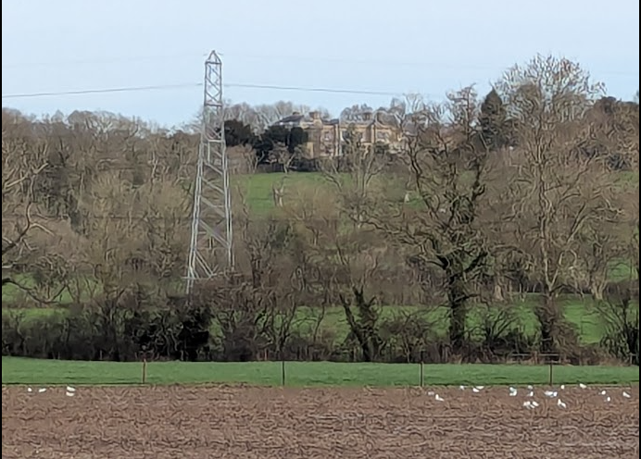

February 2026 photograph from application site looking at The Manor House

Conclusion

Overall, having regard to the separation distances, limited and filtered views, and the existing agricultural context, it is concluded that the proposal would result in no harm or, at most, a very low level of less than substantial harm at the lowest end of the NPPF spectrum.

This limited harm is clearly outweighed by the public benefits of the proposal, and the development is therefore considered to preserve the setting of nearby listed buildings and to comply with Section 66 of the Act, Core Policy 58 and the NPPF.

Highways Impacts and Parking
Policy Context
Transport implications are a key factor in assessing planning applications, especially for larger developments. Proposals must demonstrate:
- Safe and suitable access for all users, including pedestrians, cyclists, and those with mobility impairments.
- No severe residual impacts on the surrounding highway network.
- Promotion of sustainable travel, reducing reliance on private vehicles.
- Adequate parking and cycle provision, in line with adopted standards.
- Protection and enhancement of public rights of way and active travel routes.

Relevant policies include Core Policies 60–64 of the Wiltshire Core Strategy, supported by the Wiltshire Local Transport Plan, Car Parking Strategy, and Cycling Strategy. The Local Cycling and Walking Infrastructure Plan (LCWIP) and LTN 1/20 (DfT) provide further design guidance for active travel infrastructure.

Proposals must also ensure safe access for refuse collection vehicles and comply with the Wiltshire Council Waste Storage and Collection SPD (2017).

Where necessary, Transport Assessments or Statements should be submitted to evaluate impacts and identify mitigation. Planning conditions or legal agreements may be used to secure off-site improvements, travel plans, or contributions to sustainable transport infrastructure.

Assessment

The application is supported by a Transport Note, visibility splay drawings, a vehicle tracking plan and details showing the consolidation of the first section of the access. The swept path analysis demonstrates that the site access can accommodate larger agricultural and delivery vehicles, as requested by the Council's Highway Officer.

The submitted Transport Note considers both the current full planning application and the associated prior approval application. It confirms that the site is served from an existing access onto Worton Road and concludes that adequate visibility is available in both directions. It further notes that the surrounding roads are subject to a 30mph speed limit and are capable of accommodating the anticipated vehicle movements associated with the proposed agricultural enterprise.

The Transport Note estimates that the existing arable operation generates traffic associated with cultivation, spraying, harvesting and slurry spreading. It then assesses the proposed beef enterprise and estimates vehicle movements associated with feed and forage deliveries, livestock movements, waste removal and staff travel. The note concludes that the overall level of traffic would not increase significantly beyond the existing agricultural use of the land and that the local highway network is capable of accommodating the development.

The proposal has been assessed by the Council's Highway Officer, who raises no objection subject to a condition requiring the first five metres of the access to be properly consolidated in accordance with the submitted plans. Significant weight is afforded to the professional advice of the Highway Authority, which has considered the operational requirements of the proposed development and the suitability of the access arrangements. The Highway Officer is satisfied that the access can safely accommodate the vehicles likely to be associated with the development.

Many public representations raise concerns regarding increased traffic, HGV movements, highway safety and the suitability of the local road network. These concerns are acknowledged. The Transport Note identifies approximately 12 feed deliveries per annum together with agricultural vehicle movements associated with livestock, forage, bedding and waste management. Whilst the submitted information does not provide a detailed breakdown of the individual categories of livestock collections, calf deliveries, finished cattle movements or forage deliveries, no substantive technical evidence has been submitted to demonstrate that the applicant's forecasts are materially inaccurate or that the level of traffic likely to be generated would result in an unacceptable impact on highway safety.
The agricultural evidence submitted with the application indicates a maximum herd of approximately 390–400 cattle comprising suckler cows, youngstock and rearing calves. Whilst this level of activity will inevitably generate vehicle movements, the proposal remains an agricultural use operating from an existing access onto the public highway. The Highway Authority has reviewed the proposal and has not identified any resulting highway safety concerns or capacity issues.

Having regard to the submitted access details, vehicle tracking information, the conclusions of the Transport Note and the absence of an objection from the Highway Authority, Officers are satisfied that the development would not give rise to an unacceptable impact on highway safety and would not result in a severe residual cumulative impact on the road network. The proposal is therefore considered to accord with Core Policies 60–64 of the Wiltshire Core Strategy and the relevant provisions of the NPPF.

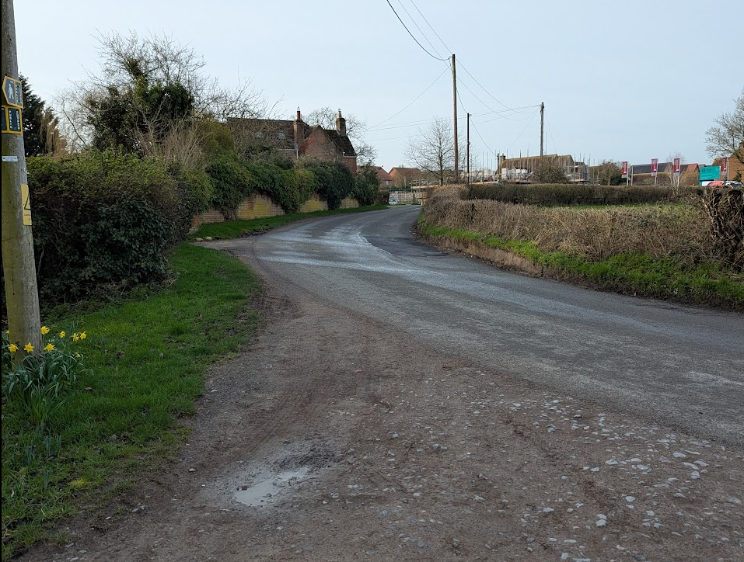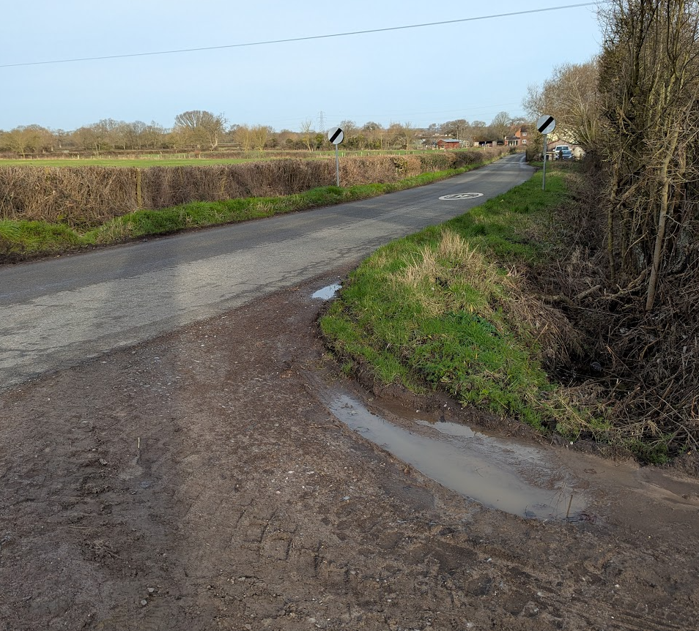

Visibility Splay looking south west towards Worton and north along Worton Road

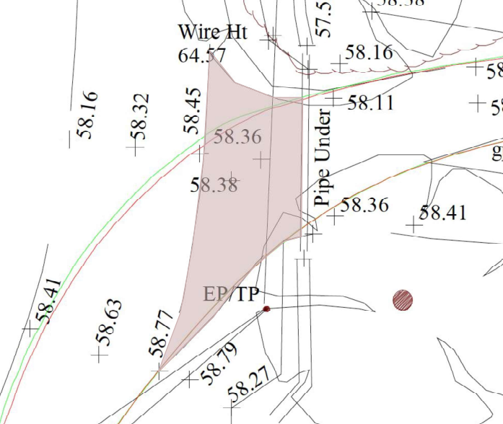

Extract from surface consolidation plan

Conclusion

The proposed development would utilise an existing agricultural access which has been demonstrated to provide adequate visibility and to be capable of accommodating the types of vehicles likely to be associated with the proposed use. The submitted vehicle tracking information confirms that larger agricultural and delivery vehicles can safely enter and leave the site, and the Local Highway Authority raises no objection to the proposal subject to a condition requiring consolidation of the first five metres of the access.

Whilst a significant number of representations raise concerns regarding increased traffic, HGV movements and highway safety, the evidence submitted with the application indicates that the development would generate a level of vehicle activity consistent with the operation of a rural agricultural enterprise. The Highway Authority has reviewed the proposal and is satisfied that the local highway network can safely accommodate the anticipated movements.

Having regard to the submitted transport information, the professional advice of the Highway Authority, and the absence of evidence demonstrating an unacceptable impact on highway safety or a severe residual cumulative impact on the road network, Officers conclude that the proposal is acceptable in highways terms and complies with Core Policies 60–64 of the Wiltshire Core Strategy and the relevant provisions of the National Planning Policy Framework.

Ecology and Biodiversity
Policy Context
The ecological impact of development is a key planning consideration, especially for larger schemes. Proposals must assess and address potential effects on:

- Protected species
- Priority habitats
- Ecological networks
- Green and blue infrastructure

Core Policy 50 of the Wiltshire Core Strategy requires development to:

- Avoid harm to ecological assets.
- Deliver measurable Biodiversity Net Gain (BNG), in line with the Environment Act 2021.
- Support habitat restoration and connectivity.
- Integrate biodiversity into site design.

The Green & Blue Infrastructure Strategy (2022–2030) promotes nature recovery, ecosystem services, and habitat connectivity through development.

Unless exempt, National policy requires a minimum of 10% Biodiversity Net Gain (BNG) for major developments, demonstrated via:

- Biodiversity Metric calculations
- Ecological assessments (e.g. PEAs, Phase 1 surveys, protected species surveys)

Assessment

The Council’s Ecology Officer provided an initial detailed consultation response which stated:

Habitats Regulation Assessment (HRA)

Salisbury Plain SPA

This development falls within the 6.4km recreational ZoI around the Salisbury Plain SPA. A test of likely significance has been carried out by the relevant Competent Authority (Wiltshire Council) as required by Regulation 63 of the Conservation of Habitats and Species Regulations 2017 (as amended). This concluded that given the scale and nature of the development, there is no mechanism for adverse effect. The HRA has concluded that the application is not likely to have significant impacts on the SPA and subsequently the application is screened out of Appropriate Assessment.

Nationally Designated Sites

The Stert Brook Exposure SSSI is located approximately 2.9km to the north east of the site at the closest point. Given the SSSI is a geological SSSI and the distance from the site, it is not considered likely that the proposed works would impact the SSSI.

Non-Statutory Sites

The Potterne Park Farm Meadows Local Wildlife Site (LWS) is located approximately 1.6km to the east of the site. Given the distance and the intervening landform, it is not considered likely that the proposed works would impact this LWS.

Protected Species

The proposals are located across three main habitat types, the temporary grass and clover ley, the non-cereal crop and the modified grassland. The modified grassland is considered to be in poor condition with limited botanical diversity. The proposals would not impact on any trees or hedgerows and there are no existing buildings within the redline boundary.

There are records of bats, birds including barn owls, badgers, reptiles and water voles within the surrounding area. There appear to be 3 ponds within 500m of the site, the closest approximately 231m to the south east across the high street.

It is not considered likely that the proposals would have an impact on protected species given the nature of the proposals and the habitats present on site.

Neighbourhood Plan

The Potterne Neighbourhood Plan (NP) was made in 2017 however the site is not allocated in the plan and none of the policies directly relate to a development of this type or within this area of the NP area. There are no ecology policies within the NP. Bullet point 1 of paragraph 2.1.1 in the NP seeks to ensure the retention of green corridors between settlements within the NP area. Whilst these green corridors are not illustrated in the NP, the proposals are not considered to impact any green corridors and are therefore in keeping with the NP.

Biodiversity Net Gain (BNG)

Under Schedule 7A of the Town and Country Planning Act 1990 (as inserted by Schedule 14 of the Environment Act 2021) this application is required to deliver 10% Biodiversity Net Gain (BNG). The Biodiversity Gain Plan condition will automatically apply if approval is forthcoming.

A completed statutory metric calculation (BNG Metric. Planning Application V2. January 2026) confirming the baseline and predicted post- development biodiversity units of the site has been submitted (including the habitat maps).

The condition assessment sheet is provided in Appendix B of the Biodiversity Net Gain Report.

Information in the completed on-site baseline habitat tabs is accepted as accurate based on the information submitted. The pre-development (baseline) situation is summarised below.

On-site pre-development (baseline) biodiversity value | 1.74 Habitat units
On-site pre-development (baseline) biodiversity value | 0 Hedgerow units
On-site pre-development (baseline) biodiversity value | 0 Watercourse units
Are there any irreplaceable habitats on-site? | No
Has any habitat degradation of occurred? | No

In order for the council to fulfil its BNG monitoring responsibilities. A Biodiversity Net Gain On-site 30 year Monitoring Fee must be paid prior to commencement of development and secured via legal agreement. In the absence of a S106 the fee can be paid by a section 111 agreement. Where the applicant elects to use the S111 process the fee must be paid and S111 signed by both the applicant and the council on the granting of planning permission.

In order for the council to fulfil is monitoring obligations, the BNG monitoring fee would be £1,148 plus legal fees.

The proposed seed mix has been changed to Naturescape N6 Clay Soils Meadow Mixture, this is welcomed and is considered to be more appropriate for the proposed water storage basin which will be seasonally inundated.

Conclusion

The submitted ecological information, including the revised Biodiversity Net Gain Report and Metric, has satisfactorily addressed all matters raised during the consultation process. The baseline habitat assessment is accepted as accurate, the proposed habitat creation and enhancement measures are considered deliverable, and the development is capable of achieving the statutory Biodiversity Net Gain requirement. The Habitats Regulations Assessment has screened the proposal out of Appropriate Assessment, and no significant adverse effects on designated sites, protected species, or priority habitats have been identified.

The application has therefore demonstrated compliance with relevant ecological legislation, national policy and local biodiversity requirements. Subject to the recommended planning conditions, the statutory Biodiversity Gain Plan process, and completion of the Section 111 Agreement securing the Council's Biodiversity Net Gain monitoring fee, there are no outstanding ecological matters requiring further scrutiny. Ecology is satisfied that the proposal meets its ecological requirements and raises no objection to the grant of planning permission.

The Council’s Ecologist subsequently amended her comments and advised that a Section 111 would no longer be required. The proposal is therefore considered acceptable in ecology terms subject to the suggested conditions being imposed.

Flood Risk and Drainage
Policy Context
Core Policy 67 of the Wiltshire Core Strategy and NPPF paragraphs 170–182 require:
- Avoidance of increased flood risk.
- Use of appropriate mitigation measures.
- Application of the sequential and exception tests for developments in Flood Zones 2 or 3.

Sustainable Drainage Systems (SuDS) are required for all major developments and must:
- Manage runoff near its source.
- Improve water quality.
- Support biodiversity and amenity.
- Be integrated into the site layout and green infrastructure.

Proposal:

The application is supported by a Flood Risk Assessment (FRA) which considers the cumulative impact of both the development subject of this application and the associated prior approval development, including the access arrangements, hardstanding areas and roof drainage from the proposed agricultural buildings.

The submitted drainage strategy acknowledges that the underlying mudstone and sandstone geology has poor infiltration characteristics and therefore soakaways are not considered an appropriate primary drainage solution. Instead, surface water runoff would be managed through a combination of permeable stone surfacing, where practicable, and a sustainable drainage system comprising an attenuation pond and flow-control chamber. Surface water would be discharged at a restricted rate into a new drainage channel before entering an existing ditch and ultimately the adjacent watercourse.

The attenuation pond would form a storage basin approximately 100 metres in length and 30 metres in width. Topographical survey information indicates that ground levels within the basin area range between approximately 58.52m and 58.92m AOD, whereas the proposed basin floor would be formed at 56.85m AOD. As such, the basin would primarily be formed through excavation requiring approximately 1.7m to 2.0m of excavation below existing ground levels.

The submitted design identifies a maximum design water level of 58.35m AOD and a freeboard of 0.5 metres above that level. This would result in a crest level of approximately 58.85m AOD. Given the surrounding topography, the attenuation feature would largely sit below existing ground levels to the south, east and west. However, a modest embankment or bund would be required along parts of the northern edge, likely ranging between approximately 0.3 and 0.6 metres in height. Clarification has been sought on the submitted data and it has been confirmed by the applicant’s agent to be correct.

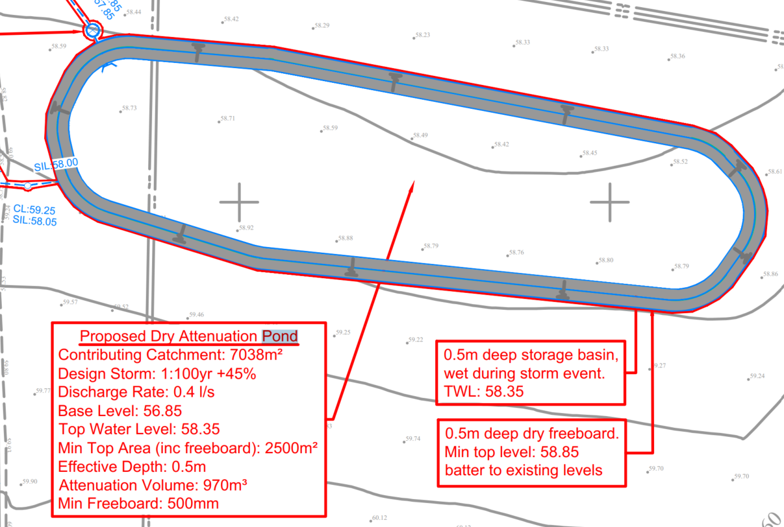

Extract from Flood Risk Assessment

Flood Risk on the site:

The application site (red line boundary) lies wholly within Flood Zone 1, although parts of the wider land holding shown within the blue line boundary extend into Flood Zones 2 and 3, associated with the adjacent watercourse. The proposed attenuation pond would be located approximately 25 metres south of this watercourse. Environment Agency flood mapping indicates that the nearest extent of Flood Zones 2 and 3 is approximately 12 metres north of the attenuation pond and its proposed northern bund.

The proposal also includes a new drainage connection from the attenuation pond to an existing ditch via a flow-control chamber. A review of available flood mapping indicates that this connection route also lies wholly within Flood Zone 1.

Groundwater flood risk within the area is identified as negligible. Whilst a 1 in 30 year surface water flood risk event is identified within the receiving drainage ditch, no significant surface water flood risk is identified within the red line application site itself.

The FRA therefore concludes that the site is at low risk from all recognised sources of flooding and that the development would not increase flood risk elsewhere.

Assessment

Officers are satisfied that the site is at low risk of flooding as defined by the Council's Strategic Flood Risk Assessment. Consequently, the proposal does not require the application of the sequential or exception tests. The Environment Agency has also confirmed that the proposal falls outside its consultation remit, further demonstrating that the development site itself is not located within Flood Zones 2 or 3.

The Council's Drainage Officer has assessed the submitted drainage strategy and raises no objection subject to conditions. Officers are therefore satisfied that the proposed attenuation basin and wider drainage strategy would provide an appropriate means of managing surface water runoff from the development.

Notwithstanding this conclusion, limited information has been provided regarding the management of agricultural waste arising from the proposed beef enterprise. The supporting information indicates that the livestock operation would utilise straw bedding and that waste would be managed as solid farmyard manure rather than slurry. Excess manure is stated to be removed from the site under contract to other locations.

However, no manure storage area has been identified on the submitted plans despite it being reasonable to expect that temporary on-site storage would be required prior to removal or land spreading. Whilst there appears to be sufficient space within the wider complex, including hardstanding areas to the east of the approved agricultural building, no details have been provided regarding the location, design or management of any such facility.

Furthermore, the application does not explain how manure storage, dirty water, vehicle washings or other contaminated runoff would be separated from the surface water drainage network. This is an important consideration as the attenuation pond has been designed solely to accommodate clean surface water runoff. In the absence of appropriate controls, there is potential for manure-contaminated runoff to enter the drainage system, adversely affecting water quality and compromising the operation of the attenuation pond and downstream drainage features.

Given that the proposed surface water drainage strategy is otherwise acceptable and noting that the detailed management of agricultural waste can reasonably be controlled by condition, officers do not consider this matter to warrant refusal of the application.

Conclusion

The application site is located entirely within Flood Zone 1 and is therefore at low risk from fluvial flooding. The submitted Flood Risk Assessment demonstrates that the development can be appropriately drained through a sustainable drainage system comprising permeable surfacing, an attenuation basin and a restricted discharge to the adjacent watercourse.

The Council's Drainage Officer has not objected to the principle of the proposed drainage strategy and has confirmed that the site can be appropriately drained subject to conditions. Officers are satisfied that the outstanding matters relate primarily to the detailed management of agricultural waste and contaminated runoff rather than the adequacy of the surface water drainage strategy itself. These matters are operational details which can reasonably be secured through planning condition prior to the first use of the development and do not undermine the overall conclusions of the submitted Flood Risk Assessment.

Whilst further details are required regarding the management of manure and contaminated runoff to ensure the attenuation pond receives clean surface water only, this matter can be satisfactorily addressed by condition. Subject to the recommended conditions, officers are satisfied that the development would not increase flood risk on-site or elsewhere and would comply with Core Policy 67 of the Wiltshire Core Strategy and national planning policy relating to flood risk and drainage.

PLANNING BALANCE AND CONCLUSION

The proposed development seeks permission for a new beef unit comprising a livestock building, associated infrastructure, an attenuation basin and a temporary agricultural worker's dwelling. The proposal represents the establishment and expansion of a livestock enterprise within the applicant's wider farming business and would support the continued operation of a rural agricultural enterprise. The proposal has been independently assessed by the Council's Agricultural Consultant, who confirms that both the scale of the livestock building and the need for an on-site worker are justified by the operational requirements of the enterprise.

Significant weight is afforded to the economic and rural benefits arising from the proposal. The development would support sustainable food production, contribute to the rural economy, provide employment opportunities and facilitate the long-term viability of an agricultural enterprise operating from land within the applicant's control. These factors attract substantial weight in favour of the proposal and align with the aims of Core Policies 34 and 48 of the Wiltshire Core Strategy and national planning policy supporting rural businesses and agricultural development.

The proposal would introduce substantial agricultural buildings into an open countryside location and would inevitably result in a degree of visual change. Officers acknowledge that localised adverse effects would arise, particularly from nearby public rights of way and surrounding farmland. However, the site does not form part of a valued or designated landscape and the wider area is characterised by active agricultural land, agricultural buildings and associated infrastructure. The visual effects are therefore considered localised and capable of further mitigation through the proposed landscaping. The resulting harm attracts moderate but not overriding weight against the proposal.

In relation to residential amenity, extensive public concern has been expressed regarding odour, noise and wider environmental effects. These concerns have been carefully considered. However, the application is supported by specialist noise and odour assessments which have been reviewed by the Council's Environmental Health Officers. No technical objections have been raised and it is concluded that, subject to conditions, the proposal would not result in unacceptable impacts on neighbouring occupiers. This attracts neutral weight in the planning balance.

Similarly, no objections have been raised by the Highway Authority, Ecology Officer or Drainage Officer. The evidence before the Council demonstrates that the site can be safely accessed, that biodiversity impacts can be appropriately mitigated and enhanced through the Biodiversity Net Gain process, and that flood risk can be satisfactorily managed through the proposed sustainable drainage strategy. Whilst some uncertainty remains regarding the detailed management of manure and contaminated runoff, officers are satisfied that these matters can reasonably be addressed through appropriately worded planning conditions requiring a detailed management plan prior to operation of the development.

With regard to heritage assets, officers conclude that the proposal would have a neutral impact on the setting of nearby listed buildings.

The Council has received a substantial number of objections to the proposal, and these have been carefully considered. Whilst the concerns raised are acknowledged, officers must determine the application on the basis of planning policy and the technical evidence before the authority. Having regard to the consultation responses from specialist officers and the supporting assessments submitted with the application, officers are satisfied that the identified impacts can be appropriately mitigated and controlled through planning conditions.

Overall, the proposal would deliver significant economic, agricultural and rural benefits and would support the long-term sustainability of an established farming business. Although some localised landscape and visual impacts would arise, together with the need for careful management of agricultural waste and drainage, these impacts are not considered to significantly and demonstrably outweigh the benefits of the scheme. The proposal is therefore considered to accord with the Development Plan when read as a whole and there are no material considerations indicating that planning permission should be withheld.

RECOMMENDATION:
That Planning Permission be GRANTED, subject to conditions

