APPLICATION FOR HOUSEHOLDER PLANNING PERMISSION DELEGATED REPORT

APPLICATION REFERENCE: | PL/2026/02539
APPLICATION TYPE: | Householder planning permission
SITE ADDRESS: | Gas Cottage, Home Farm, Humber Lane, Tidworth
DEVELOPMENT DESCRIPTION: | Demolition of existing lean-to, removal of mobile home, erection of a subservient extension to the dwelling linking to the existing outbuilding, formation of front courtyard, new gated access to retained rear walled garden, continued provision of 3 parking spaces, and associated hard and soft landscaping including new 120m native hedgerow planting.
RECOMMENDATION: | That Planning Permission be GRANTED

PROPOSAL

The proposal seeks planning permission for demolition of an existing lean-to addition, removal of a mobile home, erection of a part single part two storey extension to the dwelling linking the main house to an existing outbuilding to form a front courtyard, new gated access to retained rear walled garden, continued provision of 3 parking spaces, and associated hard and soft landscaping including new 120m native hedgerow planting.

Existing dwelling plans and elevations

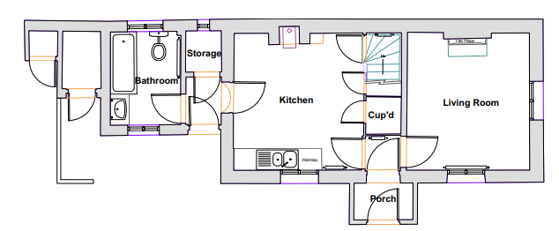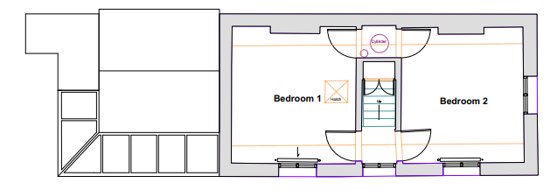

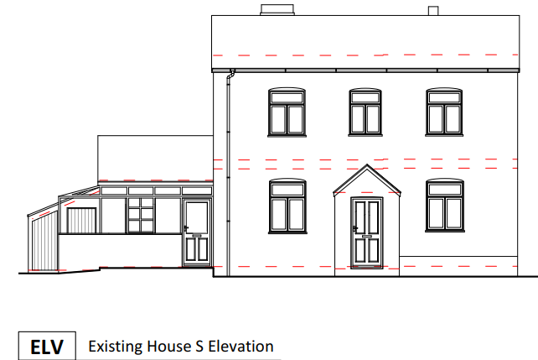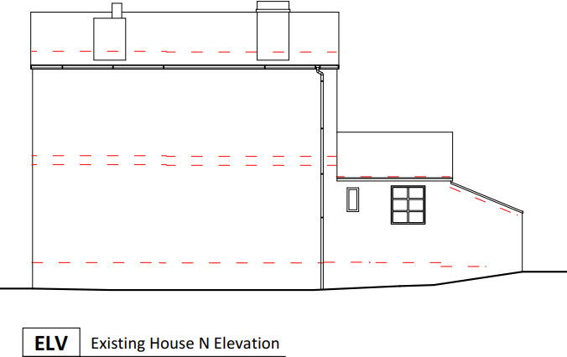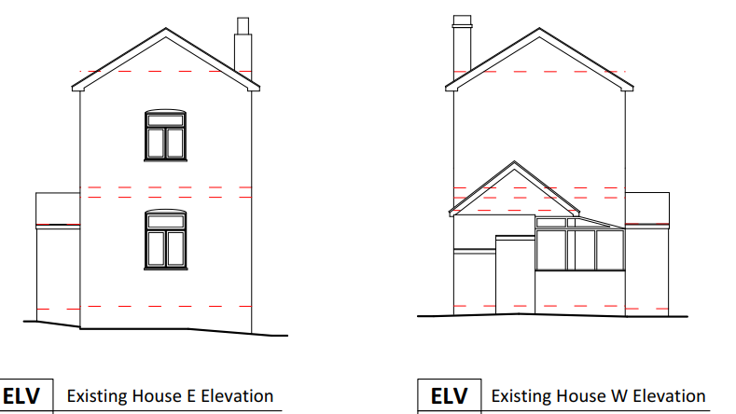

Existing outbuildng plans and elevations

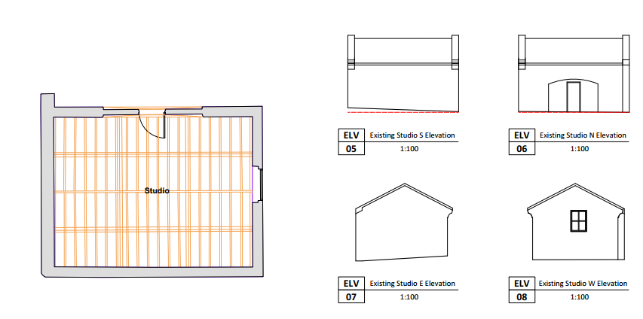

Proposed plans and elevations

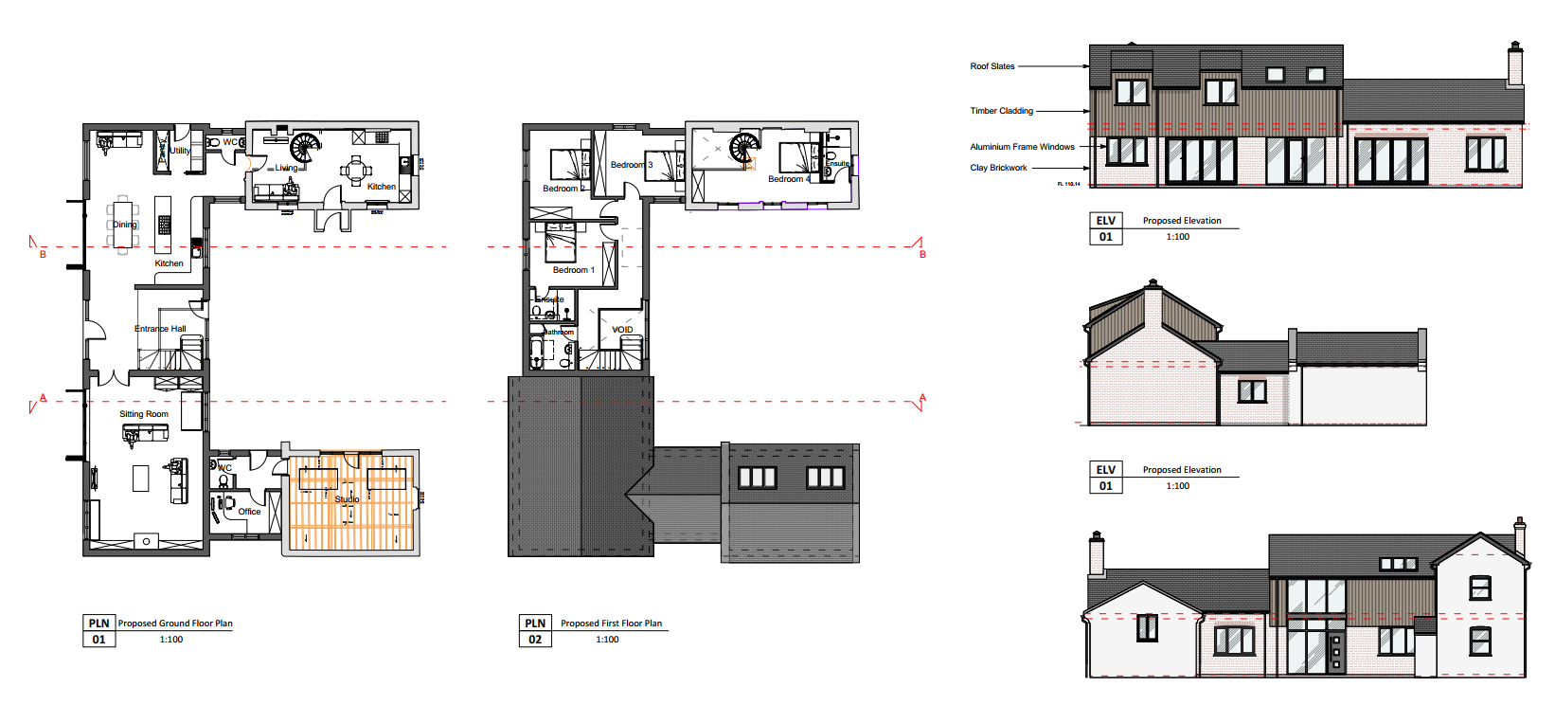

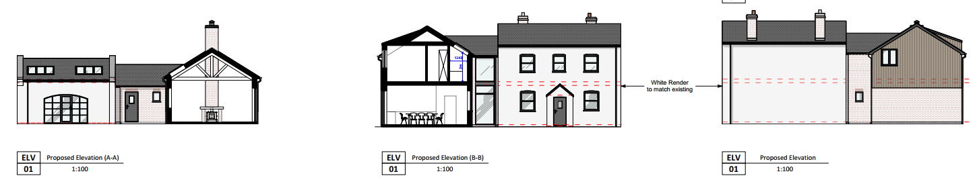

The applicant provided some photomontages of the finished works to help aid visualisation of the proposed scheme.

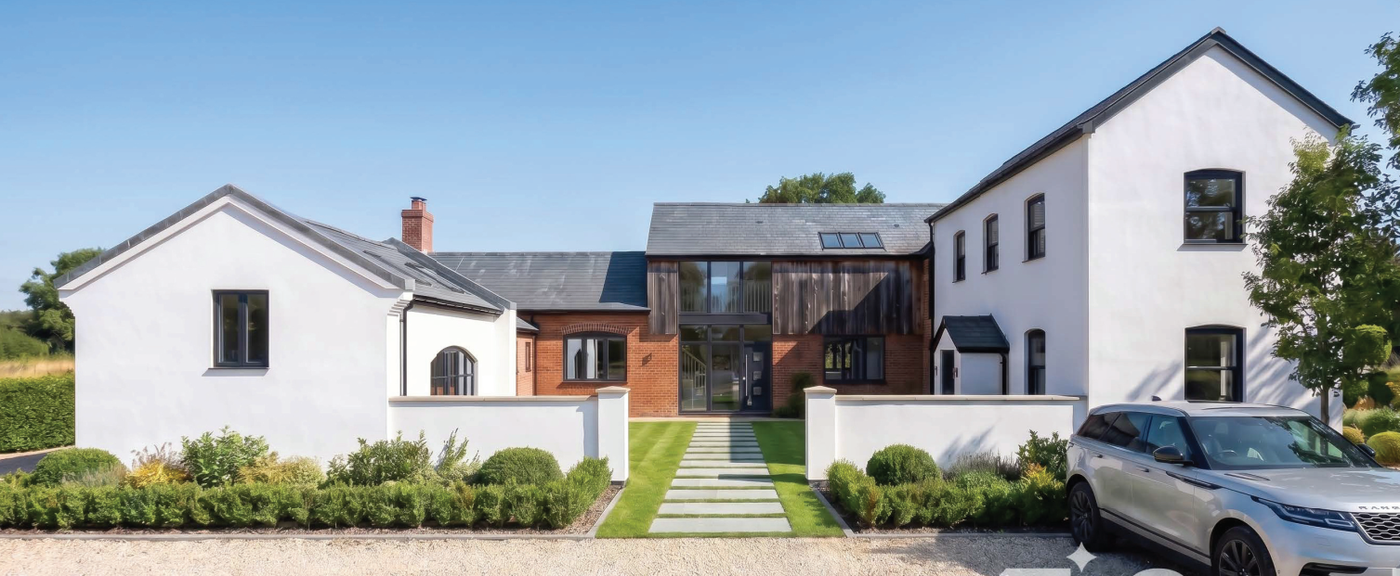

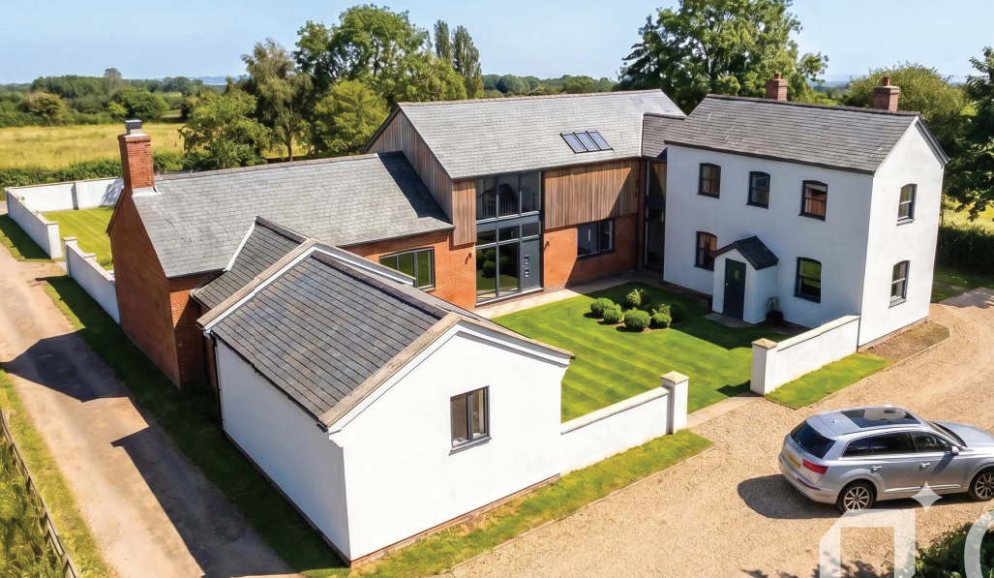

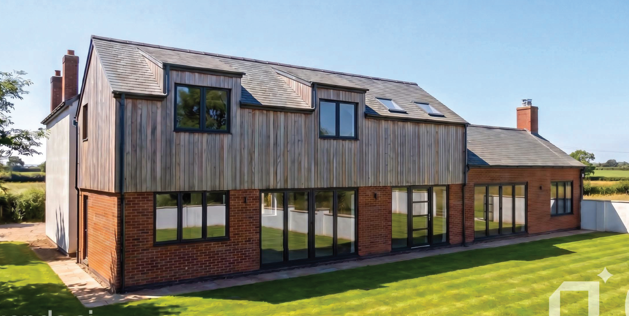

SITE DESCRIPTION/CONTEXT

The application site relates to an existing modest two storey detached dwelling and associated single storey detached outbuilding and associated domestic curtilage known as Gas Cottage. The site is situated in the open countryside outside of any defined settlement boundary as defined by Core Policies CP1 and CP2 of the Wiltshire Core Strategy. It is approximately 700 metres to the south west of the settlement boundary of Tidworth which is defined as a Market Town by WCS policy CP26 (Tidworth Community Area).
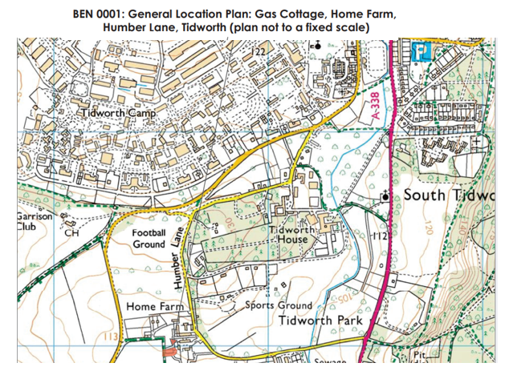
The existing dwelling is located in the north east corner of the site and the outbuilding towards the south east corner. A dilapidated portacabin/mobile home is located immediately west of the existing outbuilding. The site is located to the west of the Home Farm Close residential development and is surrounded by fields on all other sides, lying within an inherently rural location. The site is enclosed by a combination of walls, fencing, trees and other vegetation.
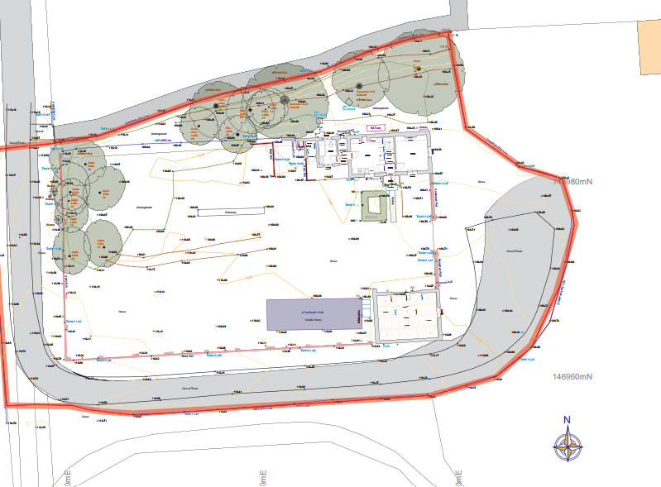

View from the west

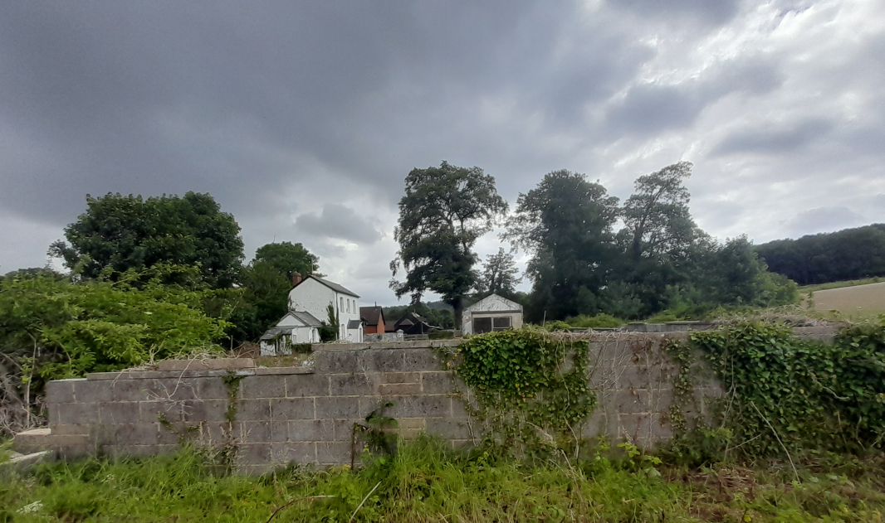

View from the east

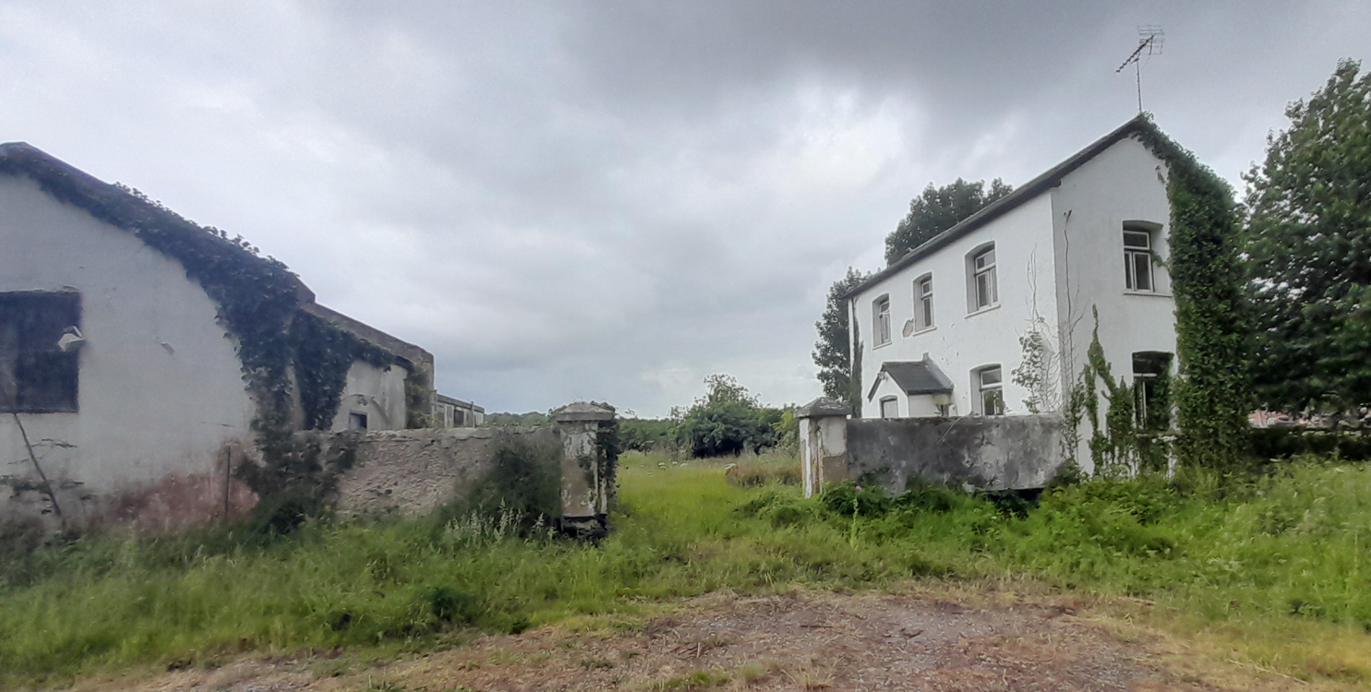

Access to the site is via an existing no through track which leads from Bulford Road and serves a handful of other residential properties. The access is also a public right of way, bridleway STID24 (which runs along the western boundary of the site). The track runs alongside the west and south boundaries of the site, ending to the east of the site in an area used for parking for the property.

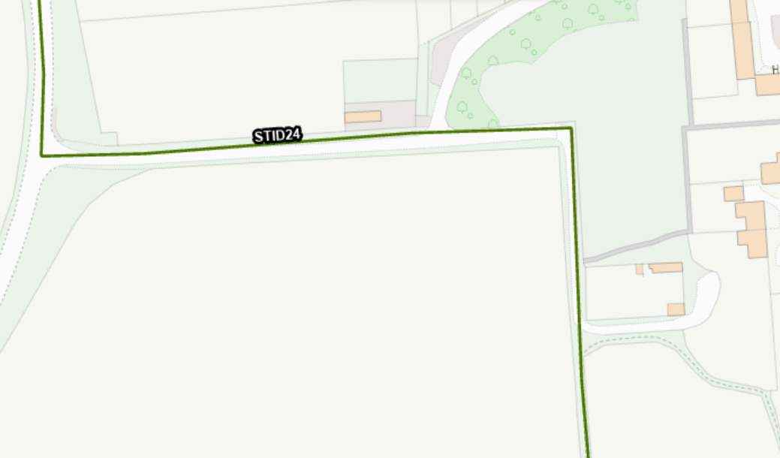

None of the buildings on the application site are listed and it is not located within a conservation area; both the house and outbuilding are however considered to be non-designated heritage assets. There are no other nearby listed buildings.

The site is located within flood zone 1, within the River Avon SAC and within the 6.4km buffer zone of the Salisbury Plain SPA.

PLANNING HISTORY

NA

RELEVANT POLICIES AND GUIDANCE

Planning (Listed Building and Conservation Areas) Act 1990
The National Planning Policy Framework (NPPF)
The Planning Practice Guidance
National Design Guide

Wiltshire Core Strategy

Core Policy 1: Settlement Strategy
Core Policy 2: Delivery Strategy
Core Policy 26: Tidworth Community Area
Core Policy 50: Biodiversity and Geodiversity
Core Policy 57: Ensuring High Quality Design & Space Shaping
Core Policy 58: Ensuring the Conservation of the Historic Environment
Core Policy 60: Sustainable Transport
Core Policy 61: Transport and New Development
Core Policy 64: Demand Management
Core Policy 69: Hampshire River Avon Catchment

Wiltshire Local Transport Plan 2011-2026
Wilshire Design Guide.

CONSULTATION RESPONSES

Town Council - No objection

Conservation – No objections in principle

Highways – No objection subject to conditions

Ecology - No objection subject to conditions

Rights of way – No comments have been received

Archaeology – No objections

REPRESENTATIONS

One letter of support has been received, stating – “I support this application on the basis that it respects the historic significance of Gas Cottage whilst its modern and architecturally appropriate design is in keeping with the wider Home Farm Development. The site is currently in a poor state, and this development will improve the local area for all”.

ASSESSMENT

Section 38(6) of the Planning and Compulsory Purchase Act 2004 states:

"If regard is to be had to the development plan for the purposes of any determination to be made under the planning Acts, the determination must be made in accordance with the plan unless material considerations indicate otherwise."

In accordance with this statutory requirement, this application has been assessed against the relevant policies of the Development Plan, including the adopted Wiltshire Core Strategy (2015) and, where applicable, any made Neighbourhood Plans.

Design and Impact on the Character and Appearance of the Area and Heritage Asset

From the point of view of the historic environment the main statutory tests are set out within the Planning (Listed Building and Conservation Areas) Act 1990.

The Council’s Core Strategy Policy CP58 ‘Ensuring the conservation of the historic environment’ requires that designated and non-designated heritage assets and their settings be conserved, and where appropriate enhanced, in a manner appropriate to their significance and encourages proposals which improve the condition of heritage assets at risk.

The Council’s Core Strategy CP 57: Ensuring high quality design requires a high quality of design in all new developments. The policy requires applicants to demonstrate how the proposal will make a positive contribution to the character of Wiltshire through (amongst other things) responding to the value of the natural and historic environment and being sympathetic to and conserving historic buildings and landscapes. Development is required to respond positively to the existing character of the area in terms of building layouts, built form, height, mass, scale, building line, plot size, elevational design, materials, streetscape and rooflines to effectively integrate the building into its setting.

The application relates to Gas Cottage and an associated outbuilding which have been identified within the submitted Heritage Statement as non-designated heritage assets. The Council's Conservation Officer acknowledges that the application site has modest heritage significance and agrees with the applicant's assessment that the buildings warrant consideration as non-designated heritage assets due to their historic origins and association with the Grade II* listed Tedworth House. Whilst noting there is some uncertainty regarding the precise date of construction, the Officer considers the buildings to be of historic interest and comments on their unusual form and proportions. Importantly, the proposal would retain the existing buildings and their legibility as historic structures, with the Conservation Officer advising that their significance would be largely unaffected by the development. Whilst noting that the proposed linking extension is ambitious in scale, the Officer raises no objection in principle and leaves consideration of the scale and acceptability of the extension to the overall planning balance.

The retention, repair and continued use of these non-designated heritage assets attracts moderate weight in favour of the scheme. The proposal would remove the existing lean-to extension and portacabin/mobile home and secure the future use of the historic buildings through the creation of a larger family dwelling. In heritage terms, officers agree that the significance of the non-designated heritage assets would be preserved and that the proposal would result in benefits through the long-term conservation of the buildings.

Officers acknowledge that the proposed extension represents a significant addition relative to the scale of the existing cottage and outbuilding. Adopting a contemporary architectural approach, it contrasts markedly with the simple vernacular character of the historic buildings and would appear as a substantial and prominent element within the overall composition, particularly in views from the adjacent public right of way. Accordingly, careful consideration has been given to its scale, prominence and relationship with the existing buildings, including whether it remains appropriately subservient. While the extension does not replicate the vernacular detailing of the historic structures, the use of contrasting materials and a clearly contemporary architectural language enables the historic buildings to remain identifiable and visually distinct, clearly showing the site's historic evolution.

The applicant advises that these design objectives such as subservience have been considered through the use of lower ridge heights than the principal cottage, stepped roof forms, clearly differentiated materials and the physical retention of the existing buildings as distinct elements within the overall development. Whilst the proposed extension does not directly replicate the proportions, detailing or architectural language of the cottage and outbuilding, national and local policy do not require new development to imitate historic buildings and allow for contemporary design where this is appropriately justified.

Officers acknowledge that the proposed extension would alter the existing hierarchy of development on the site and that, when viewed on the submitted plans, the new built form appears considerably larger than the buildings it seeks to connect. However, considerable weight is given to the submitted photomontages and heritage assessment which demonstrate that the cottage and outbuilding would remain clearly identifiable as separate historic structures within the completed development. The contrasting materials and architectural treatment assist in maintaining this distinction and avoid any confusion between the historic and modern phases of development.

It is further recognised that the proposal would secure the removal of unsympathetic additions, including the existing lean-to and portacabin, and facilitate the long-term retention and viable use of the non-designated heritage assets. The Council's Conservation Officer has confirmed that the significance and legibility of the historic buildings would be largely unaffected and has raised no objection to the proposal in heritage terms.

Whilst officers acknowledge the extension would be prominent, particularly in views from the adjoining public right of way, the resulting impact is not considered to give rise to unacceptable harm as overall the site and dwelling would retain a domestic character and form. On balance, the proposal is considered to represent an acceptable design response to the site which preserves the significance of the heritage assets, respects the character of the wider area and complies with the objectives of Core Policies 57 and 58 of the Wiltshire Core Strategy.

The internal arrangement of the proposed development has also been carefully considered. The scheme effectively comprises three distinct elements, namely the original cottage, the new extension and the existing outbuilding/studio. Whilst these elements would form a single planning unit following completion of the works, the degree of internal connection between the three elements is relatively limited, with the original dwelling connected to the new extension via a single doorway and with no internal connections from the outbuilding to the extension. The layout therefore has the potential to function as separate areas of accommodation. Officers acknowledge that the submitted plans indicate no intention to create additional residential units and the application has been assessed on the basis of a single dwellinghouse only. In order to ensure that the accommodation remains ancillary and is not occupied independently from the main dwelling, a condition is considered necessary and reasonable requiring all elements of the development to remain in single residential occupation.

Amenity

Point vii of Core Policy 57 - Ensuring High Quality Design and Place Shaping of the Wiltshire Core Strategy seeks to ensure that developments do not adversely affect neighbouring properties.

The National Planning Policy Framework (NPPF), particularly Paragraph 135(f), stresses that planning decisions should ensure developments provide a high standard of amenity for existing and future users.

The proposed development has been assessed in terms of its potential impact on the residential amenity of neighbouring properties, with particular regard to loss of light, overshadowing, loss of privacy, and overbearing effects.

The application site has no immediate neighbouring dwellings to the north, west or south, the nearest properties are located to the north east/east at Home Farm Close, in particular No’s 4 and 5. The existing dwelling, Gas Cottage, is located approximately 20 metres from the rear elevation of No5 Home Farm Close and approximately 23 metres from the rear of No4 Home Farm Close. The proposed extension will be set back within the site and will be further from these nearest neighbouring dwellings than the main house. The development would remain contained within the existing residential curtilage and the use of the site would remain residential in nature. The siting of the proposed extension is such that it is not considered to overbear or overshadow neighbouring dwellings.

In terms of impact on privacy of neighbouring dwellings, the existing dwelling has an existing bedroom window on the east gable which provides views towards properties at Home Farm Close. The proposed extension will include a number of openings in the east elevation at ground and first floor level, whilst these will inevitably provide views to the east, given the setback position of the proposed extension and the relationship with the existing dwelling (Gas Cottage), it is considered that direct views towards dwellings in Home Farm Close are unlikely with Gas Cottage providing screening to block these additional views.
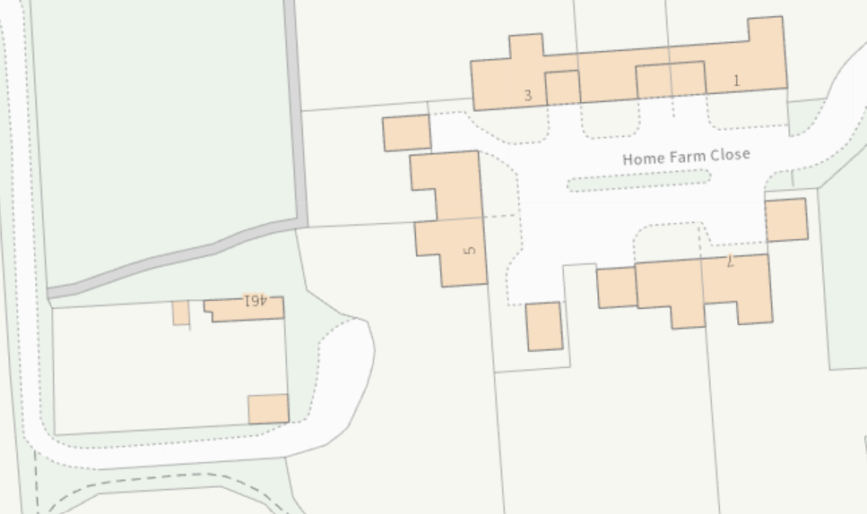

Officers are also satisfied that sufficient separation distances (of at least 20m) would be maintained between the proposed development and neighbouring dwellings to safeguard residential amenity from any undue overlooking or loss of privacy from this extended single dwelling. The proposal therefore accords with Core Policy 57 point vii in respect of safeguarding residential amenity and Appendix D of the Wiltshire Design Guide.

Highways Impact including impact on public right of way

Core Policy 57 (xiv) of the Wiltshire Core Strategy seeks to ensure that development must meet the requirements of Core Policy 61. This policy requires proposals to be capable of being served by safe access to the highway network. Core Policy 64 seeks to ensure compliance with parking standards set out in the Local Transport Plan.

The National Planning Policy Framework (NPPF), particularly Paragraph 115 and 116, requires that development proposals do not have an unacceptable impact on highway safety and that safe and suitable access to the site can be achieved for all users.

The Council's Highways Development Management Officer has raised no objection to the proposal. It is acknowledged that the site is accessed via Bridleway STID24 from Bulford Road and that an established vehicular right of access to the existing dwelling is presumed to exist. The proposal would not result in the creation of an additional residential unit and would retain and improve the existing parking and turning area within the site.

The Highway Officer advises that the level of parking proposed is sufficient to meet the Council's parking standards for a four-bedroom dwelling, with adequate space available for vehicle manoeuvring. The Officer also notes that while the submitted plans demonstrate vehicle turning within the site, waste and recycling collections would need to be undertaken from an agreed location on the adopted highway rather than via the bridleway. Subject to conditions relating to ancillary occupation of the annexe-style accommodation, construction traffic management and cycle parking provision, no highway safety or parking concerns are identified.

The Council’s rights of way team were consulted but have not provided any comments in respect of the proposed development. Given that the development relates to householder extensions and alterations to an existing residential dwelling with presumed historic vehicular rights it is not considered that the use of the PROW for continued access is a particular concern. Appropriate conditions can be added to any permission given to protect the use of the right of way for all users. There are therefore no concerns regarding impacts on the public right of way.

The proposed development would therefore not result in any adverse impact on highway safety. Adequate parking and turning provision are provided in accordance with Wiltshire’s adopted parking standards, and access arrangements are acceptable.

The proposal is therefore considered to comply with Core Policies 57 (xiv), 61 and 64 of the Wiltshire Core Strategy, the NPPF, and the Wiltshire Local Transport Plan.

Ecology Impact

Core Policy 50 of the Wiltshire Core Strategy seeks to protect and enhance biodiversity and geodiversity, including through ensuring that development avoids harm to protected species and habitats.

The National Planning Policy Framework (NPPF), in Paragraph 193, requires that development minimises impacts on and provides net gains for biodiversity, including ensuring mitigation is secured where harm cannot be avoided.

The Council's Ecology Officer raises no objection to the proposal subject to conditions. The application is supported by a Preliminary Ecological Appraisal and Phase 2 Bat and Reptile Survey. Surveys identified three common pipistrelle bat roosts within the existing buildings which would be affected by the proposed development. The Ecology Officer is satisfied that appropriate mitigation measures have been submitted to ensure bats are not adversely affected, although a European Protected Species Mitigation Licence will be required prior to the commencement of works.

Reptile surveys recorded a small population of common lizards on site and hedgehogs were also observed during the survey work. The Ecology Officer advises that appropriate construction and mitigation measures are required to protect these species during development.

Subject to conditions securing the recommended ecological mitigation, enhancement measures and construction management requirements, no ecological objections are raised. The applicant has confirmed agreement to the imposition of the suggested pre-commencement ecology conditions.

The Council's Habitats Regulations Assessment also concludes that the proposal is not likely to have a significant effect on the River Avon SAC as the development relates to householder extensions and does not create an additional/new residential unit and can therefore be screened out from Appropriate Assessment

Householder planning applications are exempt from the requirement to deliver Biodiversity Net Gain under Schedule 7A, Section 4(2)(a) of the Town and Country Planning Act 1990, as inserted by the Environment Act 2021.

As such, the development complies with Core Policies 50 and 69 of the Wiltshire Core Strategy and the relevant provisions of the NPPF.

CONCLUSION

Whilst the proposal raises some concerns regarding the scale and prominence of the proposed extension, it would retain and secure the long-term future of the site's non-designated heritage assets and would not result in unacceptable harm to the character of the area, neighbouring amenity, highway safety or ecological interests. Having carefully weighed up all material planning considerations, officers conclude that the proposal accords overall with the objectives of the development plan and that planning permission should therefore be granted subject to conditions

RECOMMENDATION: That Planning Permission be GRANTED subject to conditions.

1. The development hereby permitted shall be begun before the expiration of three years from the date of this permission.
REASON: To comply with the provisions of Section 91 of the Town and Country Planning Act 1990 as amended by the Planning and Compulsory Purchase Act 2004.
2. The development hereby permitted shall be carried out in accordance with the following approved plans:

Application form received 20/04/2026
Location plan Drg no 1163/07 received 01/05/2026
Proposed master plan Drg no 1163/05 Rev A received 01/05/2026
Proposed plans and elevations Drg no 1163/04 Rev C received 01/05/2026

REASON: For the avoidance of doubt and in the interests of proper planning.

3. No development shall take place on site above slab level (other than demolition) until the exact details and samples of the materials to be used for the external walls (brick and timber cladding) have been submitted to and approved in writing by the Local Planning Authority.

Development shall be carried out in accordance with the approved details.

REASON: The application contained insufficient information to enable this matter to be considered prior to granting planning permission and the matter is required to be agreed with the Local Planning Authority before development continues above slab level in order that the development is undertaken in an acceptable manner, in the interests of visual amenity and the character and appearance of the area.

4. The extension and converted outbuilding (studio) hereby permitted shall not be occupied at any time other than for purposes ancillary to the residential use of the dwelling known as Gas Cottage and shall remain in the same planning unit.

REASON: The accommodation is sited in a position where the Local Planning Authority, having regard to the reasonable standards of residential amenity, access, and planning policies pertaining to the area, would not permit a wholly separate dwelling.

5. No construction vehicle access may be taken along Bridleway STID24 without prior consultation with the Wiltshire Council Rights of Way Warden. Where appropriate any safety/mitigation/reinstatement measures must be approved by the Wiltshire Council Rights of Way Warden.

Reason: To ensure the public right of way remains available and convenient for public use.

6. The extended dwelling hereby permitted shall not be occupied until three covered and secure cycle parking spaces have been provided in accordance with details to be submitted to and approved in writing by the Local Planning Authority.

Reason: To promote sustainable transport choices and to accord with LTP Cycling Strategy

7. The development will be carried out in strict accordance with the following documents:

• Appendix 7 and Appendix 8 of Preliminary Ecological Appraisal and phase 2 Bat and Reptile Survey. April 2026. Bourne Ecology

REASON: For the avoidance of doubt and for the protection, mitigation and enhancement of biodiversity.

8. No development hereby permitted shall commence on site, including vegetation removal, demolition or works to existing structures, until details of the number, design and locations of the ecological enhancement features including bat boxes and bird boxes, have been submitted to and approved in writing by the Local Planning Authority. The enhancement features shall be implemented in accordance with the approved details before the development hereby approved is first occupied and shall be retained and maintained in situ for the lifetime of the development.

REASON: The application contained insufficient information to enable this matter to be considered prior to granting planning permission and the matter is required to be agreed with the Local Planning Authority before development commences in order that the development is undertaken in an acceptable manner, to provide mitigation /enhancement for biodiversity.

9. No development hereby permitted shall commence on site, including any vegetation removal, demolition or works to existing structures, until a Construction Method Statement has been submitted to, and approved in writing by the Local Planning Authority. The Construction Method Statement shall include all precautionary measures to be implemented during the construction period, for the protection of sensitive habitats and species known to be present within or adjacent the site, with particular reference to:

• Reptiles and;
• Hedgehogs

The development shall be carried out in strict accordance with the approved Construction Method Statement for the duration of the works.

REASON: The application contained insufficient information to enable this matter to be considered prior to granting planning permission and the matter is required to be agreed with the Local Planning Authority before development commences in order that the development is undertaken in an acceptable manner, to ensure adequate protection, mitigation and compensation for protected species and priority habitats throughout the construction period.

10. All external lighting provided on site shall accord with the appropriate Environmental Zone standards set out by the Institute of Lighting Professionals (ILP) Guidance Notes on the Avoidance of Obtrusive Light (GN 01/2021) and Guidance note GN08/23 “Bats and artificial lighting at night”, issued by the Bat Conservation Trust and Institution of Lighting Professionals.

REASON: In the interests of the amenities of the area and to minimize impacts on biodiversity caused by light spillage to areas above and outside the development site avoiding illumination of habitat used by bats.

11. The development hereby permitted shall not be first occupied until all resulting demolition materials and debris from the demolition of the existing extension and portacabin have been permanently removed from the land.

REASON: In the interests of the character and appearance of the area

12. All soft landscaping comprised in the approved details of landscaping on Drg no 1163/05 Rev A shall be carried out in the first planting and seeding season following the first occupation of the building(s) or the completion of the development whichever is the sooner. The proposed hedge shall comprise native species only. All shrubs, trees and hedge planting shall be maintained free from weeds and shall be protected from damage by vermin and stock. Any trees or plants which, within a period of five years, die, are removed, or become seriously damaged or diseased shall be replaced in the next planting season with others of a similar size and species.

All hard landscaping shall also be carried out in accordance with the approved details prior to the occupation of any part of the development hereby approved.

REASON: To ensure a satisfactory landscaped setting for the development and the protection of existing important landscape features.

Informatives

1. Nesting Birds - The adults, young, eggs and nests of all species of birds are protected by the Wildlife and Countryside Act 1981 (as amended) while they are breeding.

Please be advised that works should not take place that will harm nesting birds from March to August inclusive. All British birds, their nests and eggs are protected under Section 1 of the Wildlife and Countryside Act 1981 (as amended) and the Countryside and Rights of Way Act 2000 while birds are nesting, building nests and sitting on eggs. The applicant is advised to check any structure or vegetation capable of supporting breeding birds and delay removing or altering such features until after young birds have fledged. Damage to extensive areas that could contain nests/breeding birds should be undertaken outside the breeding season. This season is usually taken to be the period between 1st March and 31st August, but some species are known to breed outside these limits.

2. Bats - The roof space of Gas Cottage is used as a bat roost. Under the Conservation of Habitats and Species Regulations 2017 (as amended), it is an offence to harm or disturb bats or damage or destroy their roosts. Planning permission for development does not provide a defence against prosecution under this legislation. The applicant is advised that a European Protected Species Licence will be required before any work is undertaken to implement this planning permission. Future conversion of the roof space to living accommodation or replacing the roof could also breach this legislation and advice should be obtained from a professional bat ecologist before proceeding with work of this nature.

3. The applicant is requested to note that this permission does not affect any private property rights and therefore does not authorise the carrying out of any work on land outside their control. If such works are required, it will be necessary for the applicant to obtain the landowners consent before such works commence.

If you intend carrying out works in the vicinity of the site boundary, you are also advised that it may be expedient to seek your own advice with regard to the requirements of the Party Wall Act 1996.

4. Any alterations to the approved plans, brought about by compliance with Building Regulations or any other reason must first be agreed in writing with the Local Planning Authority before commencement of work

5. The applicant should note that it is a criminal offence to obstruct a public right of way under section 137 of the Highways Act 1980 and therefore no materials, plant, temporary structures or excavations of any kind should be deposited / undertaken which obstruct or adversely affect the public right of way STID24 whilst development takes place, without prior consultation with, and the further permission of, the highways authority at Wiltshire council.

6. The effect of paragraph 13 of Schedule 7A to the Town and Country Planning Act 1990 is that planning permission granted for development of land in England is deemed to have been granted subject to the condition (biodiversity gain condition) that development may not begin unless:

(a) a Biodiversity Gain Plan has been submitted to the planning authority, and
(b) the planning authority has approved the plan.

The planning authority, for the purposes of determining whether to approve a Biodiversity Gain Plan, if one is required in respect of this permission would be Wiltshire Council.

There are statutory exemptions and transitional arrangements which mean that the biodiversity gain condition does not always apply. For further information on exempt developments please refer to: https://www.gov.uk/guidance/biodiversity-net-gain-exempt-developments.

Based on the information available this permission is considered to be one which will not require the approval of a biodiversity gain plan before development is begun because one or more of the statutory exemptions or transitional arrangements is considered to apply.

7. The applicant is advised that the development hereby approved may represent chargeable development under the Community Infrastructure Levy Regulations 2010 (as amended) and Wiltshire Council's CIL Charging Schedule. If the development is determined to be liable for CIL, a Liability Notice will be issued notifying you of the amount of CIL payment due. If an Additional Information Form has not already been submitted, please submit it now so that we can determine the CIL liability. In addition, you may be able to claim exemption or relief, in which case, please submit the relevant form so that we can determine your eligibility. The CIL Commencement Notice and Assumption of Liability must be submitted to Wiltshire Council prior to commencement of development. Should development commence prior to the CIL Liability Notice being issued by the local planning authority, any CIL exemption or relief will not apply, and full payment will be required in full and with immediate effect. Should you require further information or to download the CIL forms please refer to the Council's Website www.wiltshire.gov.uk/planninganddevelopment/planningpolicy/communityinfrastructurelevy

