APPLICATION FOR HOUSEHOLDER PLANNING PERMISSION
DELEGATED REPORT

APPLICATION REFERENCE: | PL/2026/03293
APPLICATION TYPE: | Householder planning permission
SITE ADDRESS: | 10 Tennyson Close, Warminster, BA12 8HL
DEVELOPMENT DESCRIPTION: | Proposed demolition of existing garage and construction of a new single storey garden structure housing a gym and other accommodation ancillary to the principal dwelling.
RECOMMENDATION: | That Planning Permission be GRANTED

SITE DESCRIPTION/CONTEXT
The subject property is a semi-detached dormer bungalow, that benefits from a semi-detached garage, paired with its immediate neighbour no.8 across the intervening driveways.

The site is part of the C20 modern expansion to the west of Warminster town centre in an area of shared design and materiality along modern road layouts.

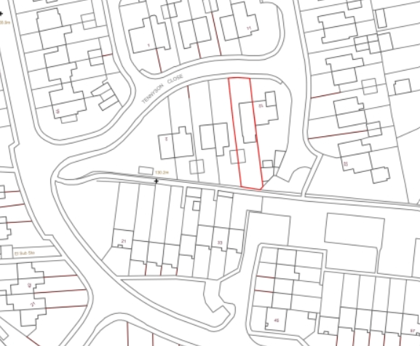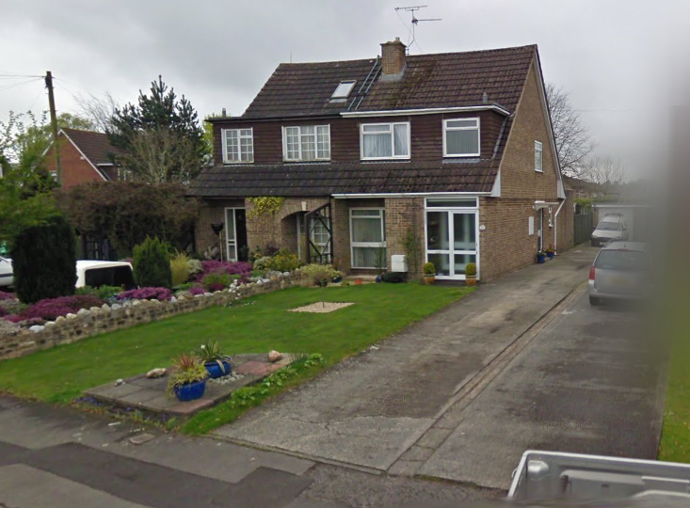

Location Plan and Google Earth Site Photo

It is noted that Public Right of Way WARM7 runs to the rear of the property – distanced 10m from the rear of the existing garage, such that the proposal would not impact its use.

Whilst in Flood Zone 1 of lowest risk, the site is at increased risk of ground water flooding with ground water close to the ground surface.

PROPOSAL

The proposal seeks planning permission for:
- Demolition of existing semi-detached garage
- Erection of a flat-roofed single storey garden structure on the footprint of the demolished garage (15m²), so still paring the neighbouring garage in scale, and a second single storey structure (24m²), with pitched roof, set away from the shared boundary, but attached to the rear of the rebuilt element.
- The rebuilt garage would contain a kitchen with the new structure to be additional gym/ancillary accommodation/gym.
- Rooflights to gym and French doors throughout.
- Standard fencing across the driveway, to enable greater privacy.

Proposed materials include vertical timber cladding, single ply roofing system, fixed and sliding aluminium framed windows/doors and aluminium clad corner post.

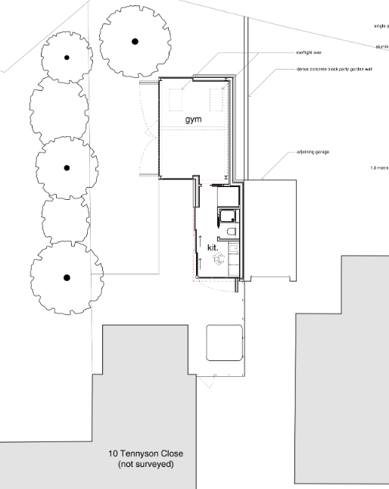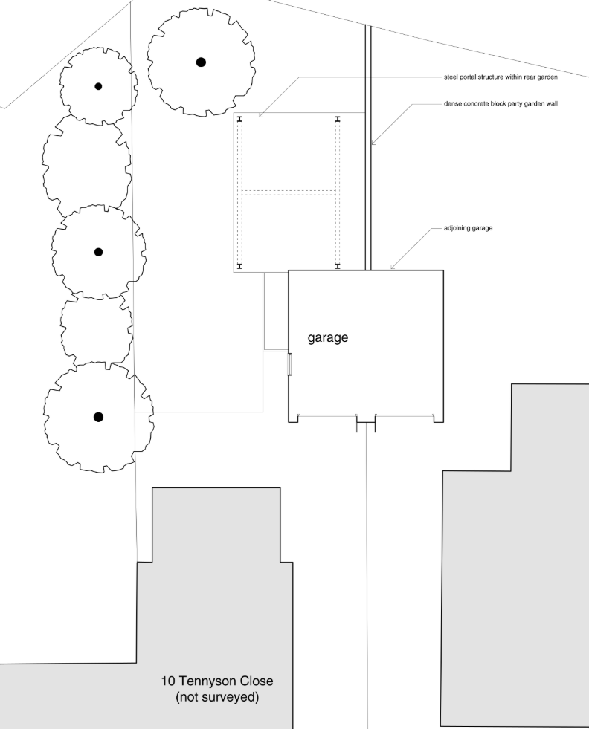

Existing and Proposed Site Plans

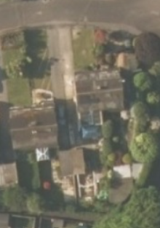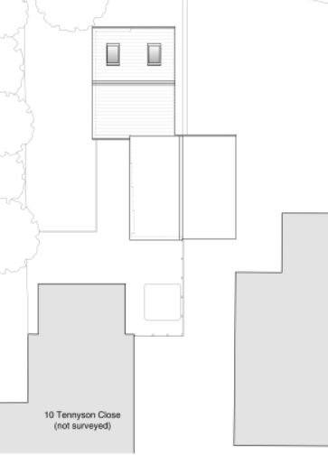

Aerial Photo showing existing garden structures and Proposed Roof Plan

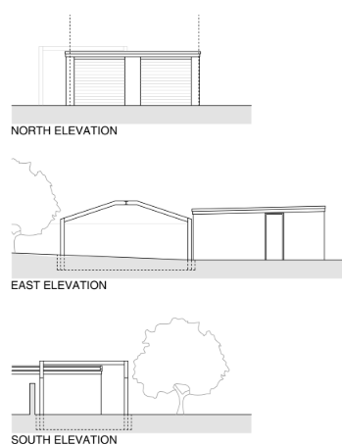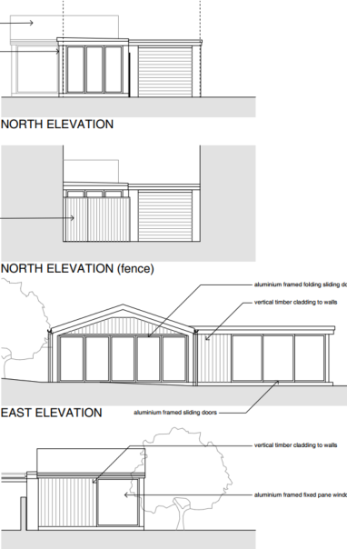

Existing and Proposed North Elevation – facing house

– showing proposed kitchen and abutting neighbouring garage

Proposed North Elevation – facing streetscape

– fencing in front of proposed kitchen

Existing and Proposed East Elevation – facing across the rear garden

Existing and Proposed South Elevation – facing rear of garden

PLANNING HISTORY
W/79/00301/HIS - Historic apps 1974 to 1983 Decision - Approved Date: 2/5/1979 – Kitchen and dining room extension

RELEVANT POLICIES AND GUIDANCE
The National Planning Policy Framework (NPPF)
The Planning Practice Guidance
National Design Guide
Wiltshire Design Guide: Appendix D – Design Guidance for Householder extensions

Wiltshire Core Strategy:
- Core Policy 57 Ensuring High Quality Design and Place Shaping
- Core Policy 67: Flood Risk

Warminster Neighbourhood Plan, made 2016

CONSULTATION RESPONSES
Warminster Town Council: No objection, on the condition that it will not be used for a commercial business.
Highways: No objection.

REPRESENTATIONS
No comments were received.

ASSESSMENT
Section 38(6) of the Planning and Compulsory Purchase Act 2004 states:

"If regard is to be had to the development plan for the purposes of any determination to be made under the planning Acts, the determination must be made in accordance with the plan unless material considerations indicate otherwise."

In accordance with this statutory requirement, this application has been assessed against the relevant policies of the Development Plan, including the adopted Wiltshire Core Strategy (2015) and, where applicable, any made Neighbourhood Plans.

Design and Impact upon the upon the character and context of the area
Core Policy 57 - Ensuring High Quality Design and Place Shaping of the Wiltshire Core Strategy seeks to ensure that all new development is of high design quality, reflecting local context, character, and distinctiveness.

It is noted that there is no planning permission for the existing pergola, but that it is a garden structure, apparently erected under PD and so does not hold any material weight as an existing form of built development.

The proposal seeks to replica the scale, form and siting of the garage, retaining the pairing with its attached neighbour. As such, there is minimal impact on the streetscape, the French Doors being minimally visible behind the proposed fencing.

An informative highlights that planning permission does not affect any private property rights and therefore does not authorise the carrying out of any work on land outside the applicant’s control.

The proposed gym structure, being slightly larger at 24m², to the rear of the rebuilt garage, and with a low double pitch, would have minimal impact on the streetscape, and would be at a scale commensurate to the existing garage and host dwelling.

A flat roof system and aluminium windows and framing is proposed against the exiting dwelling of brick and concrete roof tiles, but as a separate ancillary structure, this is considered acceptable.

It is considered necessary to impose a condition to ensure that the structure be used as proposed for ancillary residential purposes. Any change of use, or separation from the main dwelling would therefore require planning permission.

The proposed development, at a commensurate scale to the plot, with the use of neutral materials, and retention of roof form, siting and scale of the existing replacement garage element would ensure no adverse visual impact and would harmonise with the host dwelling and wider area.

Having regard to the above, the proposal complies with the design principles set out in Core Policy 57 of the Wiltshire Core Strategy and Appendix D of the Wiltshire Design Guide.

Amenity
Point vii of Core Policy 57 - Ensuring High Quality Design and Place Shaping of the Wiltshire Core Strategy seeks to ensure that developments do not adversely affect neighbouring properties.

The National Planning Policy Framework (NPPF), particularly Paragraph 135(f), stresses that planning decisions should ensure developments provide a high standard of amenity for existing and future users.

The proposed development has been assessed in terms of its potential impact on the residential amenity of neighbouring properties, with particular regard to loss of light, overshadowing, loss of privacy, and overbearing effects.

As a single storey structure distanced from main dwellings, there are no concerns with overshadowing or overbearing.

French doors are proposed that would face down the driveway, with views limited by proposed fencing, down the rear garden, and across the garden. At single storey level, any impact to privacy is easily managed by standard boundary treatments.

The proposed rooflights would face the rear garden. Proposed elevations show an eaves height of 2.2m such that the rooflights would not pose a negative impact to neighbouring privacy.

The proposal therefore accords with Core Policy 57 point vii in respect of safeguarding residential amenity and Appendix D of the Wiltshire Design Guide.

Highways Impact
Core Policy 57 (xiv) of the Wiltshire Core Strategy seeks to ensure that development must meet the requirements of Core Policy 61. This policy requires proposals to be capable of being served by safe access to the highway network. Core Policy 64 seeks to ensure compliance with parking standards set out in the Local Transport Plan.

The National Planning Policy Framework (NPPF), particularly Paragraph 115 and 116, requires that development proposals do not have an unacceptable impact on highway safety and that safe and suitable access to the site can be achieved for all users.

The proposal seeks the removal of a sub-standard garaged parking space.
The site photo shows a long driveway that even when shortened by the proposed fencing, can accommodate at least 3 cars. Therefore, if the gym were to be used as an additional bedroom in the future, the associated increased parking demand could be accommodated.

The proposal does not seek alterations to access.

The proposal is therefore considered to comply with Core Policies 57 (xiv), 61 and 64 of the Wiltshire Core Strategy, the NPPF, and the Wiltshire Local Transport Plan.

Drainage and Flood Risk
Core Policy 67 of the Wiltshire Core Strategy and paragraph 181 of the NPPF requires that all new development avoids increasing flood risk on-site or elsewhere and, where appropriate, incorporates sustainable drainage measures. Development must also comply with national policy on flood risk management and drainage design. Paragraph 176 (via footnote 62) of the NPPF states that householder development should not be subject to the sequential test, nor the exception test.

Householder development is considered Minor Development, under the Flood Risk planning guidance, if “physical extensions to the existing dwelling itself,” and, barring a few exceptions not relevant here, “are unlikely to raise significant flood risk.” The proposal to remodel an existing property, is therefore deemed to not result in any loss of land prone to flood risk.

The existing drainage arrangements are unaltered by the proposals.

As such, the proposal is deemed to be safe for its users for the intended lifetime of the development with respect to the level and nature of the flood risk.

Biodiversity Net Gain
Householder planning applications are exempt from the requirement to deliver Biodiversity Net Gain under Schedule 7A, Section 4(2)(a) of the Town and Country Planning Act 1990, as inserted by the Environment Act 2021.

CONCLUSION
The proposed development is considered to be acceptable in terms of its design, scale, and relationship with the surrounding area. It would not result in any unacceptable harm to the character of the locality, the amenities of neighbouring occupiers, or the interests of highway safety, heritage, or ecology.

The proposal is therefore considered to comply with the relevant policies of the Wiltshire Core Strategy, the Wiltshire Local Plan, and the National Planning Policy Framework. As such, the application is recommended for approval, subject to the conditions set out below.

RECOMMENDATION: That Planning Permission be GRANTED subject to conditions.

