APPLICATION FOR FULL-PLANNING PERMISSION
CASE OFFICER REPORT

APPLICATION REFERENCE: | PL/2026/02719 & PL/2026/02976
APPLICATION TYPE: | Full planning permission
SITE ADDRESS: | The Wheatsheaf Inn, Chilton Foliat, Hungerford, RG17 0TE
DEVELOPMENT DESCRIPTION: | Creation of new door opening, construction of external staircase and installation of new window opening in rear gable wall, change to hard landscaping and car park surfacing.
RECOMMENDATION: | Refuse

SITE DESCRIPTION/CONTEXT

The application relates to the Wheatsheaf PH in Chilton Foliat. The PH is a Grade II listed building which benefits from a number of outbuildings, beer garden and parking to the rear. The site lies within the North Wessex Downs National Landscape and the Chilton Foliat Conservation Area.

The Historic England listing description reads as follows:

House, now public house. Early C19. Daiper brickwork with laced flintwork on return. Thatched roof. 2-storey, 3 bays with 2 half glazed 6-panel doors with bracketed pent roofs. 2 late C19 canted and hipped bays. First floor has 3-light segmental headed windows. Blue vitrified brick band at first floor level. Gable stacks and stack between 1st and 2nd bays. To left, rear 2-bay wing of early C19 with 12- and 20-pane sashes.

The key site constraints are as follows:

- Within the built-up area of Chilton Foliat
- Chilton Foliat Conservation Area
- The Wheatsheaf Inn is a grade II building
- The outbuilding within the grounds of the pub forming part of this application is considered to be curtilage listed
- Proximity to grade II listed buildings (No. 67 and 72-78 Chilton Foliat)
- The village of Chilton Foliat is washed over by the North Wessex Downs National Landscape

The site is neighboured to the north and west by residential properties and the village hall to the east. Planning permission has also been previously granted for the erection of a building in the north-east corner of the site together with the conversion of an existing curtilage listed outbuilding for guest accommodation and office space.

PROPOSAL

The application proposes the creation of new door opening, construction of external staircase and installation of new window opening in rear gable wall, change to hard landscaping and car park surfacing.

This report covers both the full planning permission (ref: PL/2026/02719) and listed building consent (ref: PL/2026/02976) applications.

EXISTING SITUATION / BACKGROUND

It was noted during the course of the site inspection that a number of works have been undertaken within the site, some of which do not form part of the current applications and do not appear to correspond with the approved plans held on the Council's records. The works observed include alterations affecting the listed building itself, together with operational development and other alterations within the curtilage of the listed building.

Such works have not formed part of the assessment of the current applications and any requirement for planning permission and/or listed building consent in respect of those works would be a separate matter for the Local Planning Authority.

For the avoidance of doubt, the current applications have been assessed on the basis of the proposals submitted for determination and the site circumstances observed at the time of the officer's site inspection.

PLANNING HISTORY

Proposal / Summary
K/50671/LBC - Listed building consent Decision - Approve with Conditions Date: 29/9/2004 – Remove existing kitchen extract duct and cowl and fit wall mounted unit at low level. Retain chimney at existing height with spark arrester. Install new door in passage adjacent to kitchen.
K/74/0007/AD - Consent to display an advertisement Decision - Refused Date: 23/4/1974 – Illuminated sign
K/79/0005/AD - Consent to display an advertisement Decision - Refused Date: 27/10/1980 – Illuminated polesign
K/10040 - Full planning permission Decision - Approve with Conditions Date: 19/2/1987 – CONSTRUCTION OF ADDITIONAL CAR PARKING AREA.
15/12723/FUL - Full planning permission Decision - Approve with Conditions Date: 28/4/2016 – Proposed alterations, minor extension, alterations to outbuilding and alterations to parking & garden
16/00162/LBC - Listed building consent Decision - Approve with Conditions Date: 28/4/2016 – Proposed alterations, minor extension, alterations to outbuilding and alterations to parking & garden
K/47343/L - Listed building consent Decision - Refused Date: 14/5/2004 – Extract flue and ducting from trade kitchen
20/01218/FUL - Full planning permission Decision - Approve with Conditions Date: 27/4/2020 – Proposed guest accommodation ancillary to the Wheatsheaf PH, including the conversion and extension of the existing outbuilding.
20/01831/LBC - Listed building consent Decision - Approve with Conditions Date: 27/4/2020 – Proposed guest accommodation ancillary to the Wheatsheaf PH, including the conversion and extension of the existing outbuilding.
K/46694/A - Consent to display an advertisement Decision - Approve with Conditions Date: 21/1/2004 – New Signage and Lighting.
20/03978/LBC - Listed building consent Decision - Approve with Conditions Date: 12/4/2021 – Minor internal alterations
PL/2023/03563 - Listed building consent (Alt/Ext) Decision - Approve with Conditions Date: 29/6/2023 – Proposed guest accommodation ancillary to the Wheatsheaf PH, including the conversion and extension of the existing outbuilding.
PL/2023/03749 - Full planning permission Decision - Approve with Conditions Date: 14/12/2023 – Change of use of Staff Accommodation and Gallery Space to Guest Accommodation ancillary to the Wheatsheaf PH, comprising internal alterations and new external staircase.
PL/2023/03985 - Listed building consent (Alt/Ext) Decision - Approve with Conditions Date: 14/12/2023 – Change of use of Staff Accommodation and Gallery Space to Guest Accommodation ancillary to the Wheatsheaf PH, comprising internal alterations and new external staircase.
PL/2023/05571 - Approval of details reserved by a condition Decision - Approve Date: 11/7/2023 – Discharge of Condition No 2 on PL/2023/01602 (Variation of condition 2 of 20/01218/FUL (Proposed guest accommodation ancillary to the Wheatsheaf PH, including the conversion and extension of the existing outbuilding) - to allow alterations to the internal
PL/2024/03175 - Removal/variation of conditions Decision - Approve with Conditions Date: 30/9/2024 – Variation of condition 2 (approved plans) on 20/01218/FUL to amend the proposed site layout, plan and elevations of the new accommodation barn
PL/2024/03348 - Full planning permission Decision - Approve with Conditions Date: 2/5/2025 – Construction of restaurant extension to rear, internal alterations to create a new kitchen servery hatch, insertion of rear door to kitchen, construction of cellar access, creation of new bay window to front elevation, raising of ceilings in the 3 first f
PL/2024/03701 - Listed building consent (Alt/Ext) Decision - Approve with Conditions Date: 2/5/2025 – Construction of restaurant extension to rear, internal alterations to create a new kitchen servery hatch, insertion of rear door to kitchen, construction of cellar access, creation of new bay window to front elevation, raising of ceilings in the 3 first f
PL/2024/04900 - Full planning permission Decision - Withdrawn by Council Date: 5/6/2024 – Extension of restaurant to rear with servery hatch to kitchen, construction of cellar access and delivery door to Kitchen, creation of new bay window to front elevation and raising of ceilings in the 3 first floor bedrooms. Alteration to car park layout,
PL/2024/10731 - Full planning permission Decision - Approve with Conditions Date: 20/5/2025 – Change of use of ground floor of detached accommodation barn to 4no. self-contained offices.
PL/2025/00588 - Approval of details reserved by a condition Decision - Approve Date: 4/3/2025 – Discharge of Condition 3 - Materials for new accommodation building & Condition 10 - Details of the external staircase screen (Variation of condition 2 (approved plans) on 20/01218/FUL to amend the proposed site layout, plan and elevations of the new acco
PL/2025/02378 - Listed Building Discharge of Condition Decision - Approve Date: 9/4/2025 – Discharge of conditions 3 (Elevation Drawings of New Openings), 5 (Details of Timber Cladding for New External Staircase) & 7 (Details of New Vents and Flues) relating to application PL/2023/03985.
PL/2025/06814 - Approval of details reserved by a condition Decision - Approve Date: 5/1/2026 – Discharge of Conditions 3 materials, 5 joinery, 6 orangery sectional drawings, 7 method statement of planning application PL/2024/03701 (Construction of restaurant extension to rear, internal alterations to create a new kitchen servery hatch, insertion of

RELEVANT LEGISLATION, POLICIES AND GUIDANCE

Statutory Legislation:
Sections 16, 66 & 72 of the Planning (Listed Buildings and Conservation Areas) Act 1990

National Planning Policy:
- National Planning Policy Framework (NPPF)
- Planning Practice Guidance (PPG)
- National Design Guide
Development Plan:
The development plan for Wiltshire comprises the Wiltshire Core Strategy (WCS) (adopted January 2015) and any made neighbourhood plans, which remains the principal statutory planning document guiding development across the county. In line with Section 38(6) of the Planning and Compulsory Purchase Act 2004, planning decisions must be made in accordance with the development plan unless material considerations indicate otherwise.

Though the development plan is considered as a whole, those parts deemed to be particularly relevant to this application are listed below:

The adopted Wiltshire Core Strategy (WCS), with particular regard to:

- Core Policy 1: Settlement Strategy
- Core Policy 2: Delivery Strategy
- Core Policy 14: Spatial Strategy Marlborough Community Area
- Core Policy 40: Hotels, Bed & Breakfasts, Guest Houses and Conference Facilities
- Core Policy 41: Sustainable construction and low carbon energy
- Core Policy 49: Protection of rural services and community facilities
- Core Policy 50: Biodiversity and Geodiversity;
- Core Policy 51: Landscape
- Core Policy 57: Ensuring High Quality Design and Place Shaping;
- Core Policy 58: Ensuring the Conservation of the Historic Environment;
- Core Policy 60: Sustainable Transport
- Core Policy 61: Transport and New Development
- Core Policy 64: Demand Management

Draft Wiltshire Local Plan
At Full Council on 19 May 2026, the elected members of Wiltshire Council agreed to withdraw the emerging Wiltshire Local Plan. It will now be subject to a legal process to finalise its withdrawal - which is likely to happen in July or August (2026). The said Plan has no material weight for the purposes of the application.

Neighbourhood Plan:

Area currently not designated for a Neighbourhood Plan

Supplementary Planning Documents and other Guidance:
- Wiltshire Local Transport Plan 2011 – 2026 – Car Parking Strategy (March 2011)
- Chilton Foliat Conservation Area Statement December 2003
- Wiltshire Design Guide March 2024
- Historic England - GPA 2 - Managing Significance in Decision-Taking in the Historic Environment
- Historic England - GPA3 - The setting of Heritage Assets

ISSUES

The main issues that need to be addressed in this case include:

- Whether the proposal constitutes EIA development
- Whether the development is acceptable in principle (CP 1 and 2)
- Whether the scheme constitutes high quality design (CP 57)
- Whether the scheme would have an acceptable impact upon the reasonable living conditions of the adjoining occupants (CP 57)
- Whether the scheme would preserve or enhance the historic environment (CP 58)
- Whether the scheme would have an acceptable landscape impact (CP 51)
- Whether the proposal would have a negative effect upon highway safety, including if there is sufficient parking for the proposed development (CP 61 and 64)
- Whether the site can be adequately drained without increasing flood risk elsewhere (CP 67)

CONSULTATION RESPONSES

WC Arboricultural Officer: commented “The tree officer is unable to provide any formal comments as the proposed hard landscaping and car park resurfacing has already been undertaken”

WC Archaeology: No comment

WC Conservation: Objection (refer to ‘Impact on Heritage Assets’ section and website for full comment)

WC Highways: No objection subject to conditions

Chilton Foliat Parish Council: Mixed stance, commenting as follows:

At the meeting held Tuesday 16th June 2026, the Wheatsheaf proposals were approved, with the amendments noted below, on the basis that we (Chilton Foliat PC) have agreement signed on the Deed of Easement.
1. New timber framed sash window to gable – PC no objection
2. Ground level to beer garden – PC no objection
3. Ground reinforcement mesh with Cotswold stone gravel infill to areas below trees – PC no objection
4. Pedestrian access from footpath – PC no objection
5. Tarmac surface to areas outside of trees, with white lined parking spaces – PC no objection
6. Dwarf wall to edge of parking spaces in red brick – PC no objection
7. Change of level in soft landscaping with steps constructed of red brick – PC no objection
8. Planting beds and steps to garden area – PC no objection
9. New oak framed staircase with slate roofed canopy, Oak louvred screen for privacy to neighbouring, Covered external staircase & landing – PC no objection on the proviso that cladding on the west elevation extends to the full width of the staircase and balcony to ensure no oversight to neighbouring gardens.
10. Kitchen access door – PC no objection
11. Frontage: PC would support changes to the frontage.
5no. rows stone setts with aco drain channel
Herringbone pavers to main entrance
Random length stone flags with stone sett edging
5no. rows stone setts with aco drain Channel
Ground reinforcement mesh with Cotswold stone gravel infill
Delivery space with 2.4m clear for access. PC comfortable with delivery space but request that the delivery space boundaries are sensitively marked (e.g. grey paint) to ensure 2.4m clearance from Calstone House

REPRESENTATIONS
In accordance with the requirements of the Town and Country Planning (Development Management Procedure) (England) Order 2015 (as amended), the application was publicised by way of:

- Neighbour notification letters sent to adjoining and nearby properties;
- A site notice displayed near the site;
- An advertisement placed in the local press

These methods were used to inform interested parties and provide a period of 21 days for comments to be submitted.

It should be noted that at the time of the Case Officer’s initial site visit it was evident that the site notices sent to the applicant had not been displayed. A subsequent site visit was made by the Case Officer to erect the site notices, with a consultation expiry date of 26 June 2026. As a result of the delay in displaying the site notices the consultation expiry date stated on the site notices (26 June 2026) was later than the original target decision date of 22 June 2026.

Below are the representations received during the consultation period. Only material planning considerations have been taken into account in the assessment of this application. Non-material issues, such as property values or private legal disputes, cannot be considered in the determination process.

The following objections were received at the time of writing:

Occupier of 2 Popham Close:
“I object to the proposed parking bay for delivery vans/lorries between The Wheatsheaf pub and the adjacent residential property. The proposed parking bay will be dangerous because delivery vans/lorries will need to either reverse into it from the main road, or reverse back onto the main road, both of which will cause traffic congestion and potential accidents. A bay sited here would also block access for the neighbouring residential property (which has it's own turning area) because the alley is not wide enough.

The last plan showed a parking bay positioned in front of the pub, which would avoid lorries reversing and could be used as an additional parking space by customers in busy periods. The optimal solution would be the kitchen door in the north wall of the kitchen (as shown on the original plans) and then delivery vans/lorries could use the pubs own vehicular access and turn around around in the car park.”

Occupier of 64-65 Chilton Foliat:
“I have 2 objections to the amended plans for The Wheatsheaf. Firstly, concerning the new proportions of the staircase to the rear gable of the pub. The enlarged platform at the top of the staircase means that people standing on that platform are able to see into my bathroom. This causes me huge concern as to a violation of my privacy and that of my family, one member of which is a young child. I do not want guests or staff of The Wheatsheaf to be able to do this.

Secondly, the installation of the new door opening on the footpath will endanger pedestrians using that path. Many children use this in order to access the playground on Popham Close and the school bus that leaves from outside the village hall, any delivery vehicle on this path could cause a serious accident. Vehicles delivering here will also block access to Calstone House which will cause further disruption on the main road which is already severely impacted by the large number of vehicles parked on the road due to the customers of the pub having nowhere to park, even when the car park is opened there are not enough parking spaces to accommodate the customers of The Wheatsheaf let alone the residents of this village.”

Occupier of Calstone House:
“The lane between the Wheatsheaf and Calstone House belongs to the Parish Council and should not be used for a delivery parking place for the Wheatsheaf. This would cause traffic problems if the lane is blocked when a vehicle is trying to gain access to Calstone House hence blocking the main street of Chilton Foliat.”

ASSESSMENT
Section 38(6) of the Planning and Compulsory Purchase Act 2004 states:

"If regard is to be had to the development plan for the purposes of any determination to be made under the planning Acts, the determination must be made in accordance with the plan unless material considerations indicate otherwise."

In accordance with this statutory requirement, this application has been assessed against the relevant policies of the Development Plan, including the Wiltshire Core Strategy (2015) and, where applicable, any made Neighbourhood Plans. Consideration has also been given to the policies of the National Planning Policy Framework (NPPF) as a material consideration in the assessment.

Environmental Impact Assessment (EIA) Screening
In accordance with the Town and Country Planning (Environmental Impact Assessment) Regulations 2017 (as amended), the local planning authority has considered whether the proposed development constitutes EIA development.

No formal screening opinion was requested or issued. However, the local planning authority has considered the scale and nature of the development as part of the application process and is satisfied that it does not constitute EIA development under the 2017 Regulations.

Principle of Development
The proposal involves works to an existing public house within a small rural village. The following provides a brief summary of both the local and national policy which is supportive of the principle of such proposals.

The National Planning Policy Framework (NPPF) emphasises the importance of supporting and enhancing community facilities in rural areas, including those within villages. Specifically:

- Paragraph 98 encourages the creation and enhancement of social infrastructure, such as community facilities (including restaurants, pubs, and other local services), to promote strong, vibrant, and healthy communities. It highlights the role of these facilities in meeting the needs of local residents and visitors, as well as fostering social interaction.

- Paragraph 88 stresses the need for planning policies that support sustainable development in rural areas, including the retention and expansion of local businesses and services. This supports the viability of rural communities by enhancing the quality and availability of services.

In summary, the NPPF advocates for the protection, improvement, and expansion of community facilities, especially in rural villages, as part of broader efforts to create sustainable and vibrant communities. The expansion or enhancement of these facilities is encouraged where it contributes to the overall well-being of the community and does not harm the character or function of the area.

The Wiltshire Core Strategy (2015) includes several policies that support the enhancement of community facilities in rural areas, as follows:

Core Policy 49 - Protection of Rural Services and Community Facilities:
- This policy aims to protect existing community facilities, such as shops, pubs, and community centres, from unnecessary loss in rural areas.
- It encourages the retention of these facilities and supports efforts to enhance their viability, including the development of new services where there is a clear need.
- Proposals that improve or add to community facilities in rural areas are encouraged, particularly where they enhance local accessibility and contribute to the overall sustainability of communities.

Core Policy 40 - Tourist Accommodation and Visitor Attractions:
- This policy promotes the development of tourist accommodation and facilities in sustainable locations, including rural areas. It supports developments that enhance the visitor economy.
- The policy stresses the importance of maintaining the character and scale of rural settlements, and encourages high-quality development that complements the area’s environment. In all cases it must not have a detrimental impact on the vitality of the town centre and it must avoid unacceptable traffic generation.

Core Policy 14 - Marlborough Community Area:
- This policy highlights the importance of supporting new tourist accommodation in the Marlborough Community Area, where there is identified demand. It emphasises the role of these facilities in supporting rural economies and local services, particularly in areas where existing provision is limited.

In conclusion, the Wiltshire Core Strategy strongly supports the enhancement of community facilities in rural areas through policies that protect existing services and encourage the development of new, sustainable amenities, including tourist accommodation and local services. These policies aim to ensure that rural communities remain vibrant, sustainable, and well-served by essential facilities.

Although there is no specific policy solely focused on the enhancement of rural community facilities, the policies outlined above strongly suggest that support should be given towards the principle of the proposed development – namely, the improvement of a highly valued community asset. In this regard, it is important to note the recent planning history outlined above, which demonstrates that the Council has been proactive in permitting the expansion of accommodation and facilities at the pub to support its vitality and long-term viability.

However, it is equally crucial to recognise that support for the enhancement of community facilities is conditional upon the acceptance of the detailed design elements of the proposal. These must adhere to the relevant place-shaping policies within the local plan, including Core Policies 57, 58, 61, and 64. These policies ensure that the development's design and its broader impact are in harmony with the character, quality, and sustainability of the surrounding area.

As such, while officers may be supportive of the principle of development and commend the applicant’s efforts to protect a well-loved village asset, this must be carefully weighed in the planning balance against any potential conflicts with other policies of the development plan which are covered in

Design and Impact on the Character and Appearance of the Area
Core Policy 57 of the WCS requires high-quality design that:
- Enhances local character.
- Responds to the natural, historic, and built environment.
- Retains important features (e.g., trees, hedges).
- Supports sustainable construction and compatibility with surrounding uses.
- Creates safe, legible, and accessible spaces.

Section 12 of the NPPF emphasises design that is:
- Visually attractive.
- Functionally effective.
- Contributes to the quality of the built environment.

The Wiltshire Design Guide encourages sensitivity to local character, materials, and architectural styles and supports modern living standards while maintaining aesthetic and functional quality.

The application relates to a series of relatively modest alterations to the existing public house, comprising the provision of a kitchen access door, amendments to the external staircase, insertion of a window within the rear gable, alterations to hard surfacing, and associated landscaping works within the site's curtilage. The works are limited in scale and do not involve any significant enlargement of the building or substantial alteration to its overall form.

The submitted plans indicate that the staircase is constructed as an oak-framed structure with a slate-roofed canopy, whilst the new window comprises a traditional timber sash design. The hard landscaping includes the replacement of areas of tarmac with natural stone flags and pavers to the forecourt, alongside revised surfacing arrangements within the rear car park and additional planting beds, steps and dwarf walls within the beer garden. These materials are considered to be of a high quality and are appropriate to the character of the building and its surroundings.

Significant weight is afforded to the fact that the majority of the works have already been undertaken. The Local Planning Authority has therefore been able to assess the alterations in situ rather than relying solely on the submitted drawings. Based on the site inspection and submitted plans, the works are considered to be subordinate to the host building and remain proportionate in scale. The new door and window are minor interventions, whilst the staircase and associated structures are located to the rear of the building and do not appear visually dominant or incongruous.

It is noted that, at the time of the site inspection, the louvred screen shown on the proposed plans had not been constructed as approved. Whilst this matter is not considered to materially alter the conclusions reached in respect of the design, scale and appearance of the development, it has implications for neighbouring amenity and is considered separately later within this report.

Overall, the alterations are considered to be modest, subservient to the existing building and in keeping with the character of the area. The use of traditional and high-quality materials, including oak framing, slate roofing, timber joinery and natural stone paving, ensures that the development integrates satisfactorily with its surroundings. The proposal is therefore considered to accord with the design objectives of the NPPF and Core Policy 57 of the Wiltshire Core Strategy.

Whilst the proposals are considered, in isolation, to represent works of an appropriate quality and design having regard to Core Policy 57 and national design guidance, this does not override the statutory and policy tests relating to designated heritage assets. Compliance with general design principles does not in itself justify harm to the significance of a listed building or the character and appearance of a conservation area, which is considered in detail below.

Notwithstanding the above assessment, the site comprises a Grade II listed building located within the Chilton Foliat Conservation Area. As such, the impact of the development on the significance of the listed building and on the character and appearance of the conservation area are material planning considerations. These matters are considered separately within the heritage section of this report.

Impact on Heritage Assets
From the point of view of the historic environment the main statutory tests are set out within the Planning (Listed Building and Conservation Areas) Act 1990.

Section 16 (Listed Building Consent)/Section 66 (Planning Permission) requires that special regard be given to the desirability of preserving listed buildings, their settings or any features of special architectural or historic interest which they possess.

Section 72(1) of the Act requires the Council to pay special attention to the desirability of preserving or enhancing the character or appearance of designated Conservation Areas.
The NPPF outlines government policy for planning. Chapter 16 of the NPPF 'Conserving and enhancing the historic environment' sets out the Government's high-level policies concerning heritage and sustainable development. In particular:

Paragraph 208 requires LPAs should “avoid or minimise any conflict” between the heritage asset’s conservation (which includes achieving its optimum viable use) and any aspect of a proposal.

Paragraph 210 requires local planning authorities should take account of the desirability of sustaining and enhancing the significance of heritage assets and putting them to viable new uses and of new development making a positive contribution to local character and distinctiveness.

Paragraphs 212 requires “great weight” to be given to an asset’s conservation “irrespective of whether any potential harm amounts to substantial harm, total loss or less than substantial harm to its significance.”

Paragraph 213 advises that harm to the significance of a designated heritage asset should require “clear and convincing justification”.

Paragraphs 213-215(214-216) require a balanced approach with any harm which would be caused being weighed against the potential public benefits which might be achieved.

Paragraph 220 advises that not all elements of a Conservation Area or World Heritage Site will necessarily contribute to its significance. Loss of a building (or other element) which makes a positive contribution to the significance of the Conservation Area or World Heritage Site should be treated either as substantial harm or less than substantial harm as appropriate.

The Planning Practice Guidance provides guidance on interpreting the NPPF.

The Council’s Core Strategy Policy CP58 ‘Ensuring the conservation of the historic environment’ requires that designated and non-designated heritage assets and their settings will be conserved, and where appropriate enhanced, in a manner appropriate to their significance and encourages proposals which improve the condition of heritage assets at risk.

The Council’s Core Strategy CP 57: Ensuring high quality design requires a high quality of design in all new developments. The policy requires applicants to “demonstrate how the proposal will make a positive contribution to the character of Wiltshire through (amongst other things) responding to the value of the natural and historic environment and being sympathetic to and conserving historic buildings and landscapes. Development is required to respond positively to the existing in terms of building layouts, built form, height, mass, scale, building line, plot size, elevational design, materials, streetscape and rooflines to effectively integrate the building into its setting.

The following assessment has been carefully considered by the Local Planning Authority, and the conclusions below reflect the Authority’s own judgement having regard to that advice.

In consideration of the proposals, the council’s Conservation Officer has provided the following assessment, summary and conclusion:

“The Wheatsheaf Public House is a grade II listed building located in the Chilton Foliat Conservation Area.

The main frontage building runs parallel to the road and is probably mid-to-late 18th century rather than the early 19th century as per the list description. In any case, the frontage building is the oldest part of the listed building and was originally a house but had become an Inn by the mid-19th century. The rear parts of the building are mid-Victorian, and the portion to the rear, at right-angles to the main building, is a former brew house.

House, now public house. Early C19. Daiper brickwork with laced flintwork on return. Thatched roof. 2-storey, 3 bays with 2 half glazed 6-panel doors with bracketed pent roofs. 2 late C19 canted and hipped bays. First floor has 3-light segmental headed windows. Blue vitrified brick band at first floor level. Gable stacks and stack between 1st and 2nd bays. To left, rear 2-bay wing of early C19 with 12- and 20-pane sashes.

Internally the thatched building has been altered to the point that the ground floor is more-or-less open plan, and the original staircase(s) have been lost, the access to the first floor being beyond the original external wall within the mid-Victorian part of the building, to address the changes in floor levels.

The position with the village (a designated conservation area) contributes to the character and significance of the building. Many public houses and inns within villages were formed from mixed use developments, and this can be seen within the historic OS maps that show a collection of outbuildings which would have offered a range of facilities and services and were not solely reliant of the function of the inn (a pub with letting rooms). It is acknowledged that the role of a pub/ inn has altered in the recent years, but the basic function of offering accommodation, food and beverage remain.

In this case the significance of the building lies largely with its historic fabric and architecture - its form, layout and vernacular design, and its long-term use as a village Inn, which have significant aesthetic and architectural interest, and which contribute to the character of the conservation area.

Assessment: The submitted application looks to undertake the ‘Creation of new door opening, construction of external staircase and installation of new window opening in rear gable wall, change to hard landscaping and car park surfacing’. This is a regularising application as the works have been completed. Under the Planning (Listed Buildings and Conservation Areas) Act 1990, it is not possible to submit a ‘retrospective application’ as the Act is there to protect (or enhance) the significance of the listed building. Being a listed building and a commercial property, there is a restriction on permitted development rights (PDR’s), and therefore some aspects, like the external landscaping are subject to planning control, as these need to consider the setting of the designated heritage assets, which include the host building, the adjoining listed buildings and the conservation area.

The submitted Heritage Statement has provided an Impact Assessment and this has been used as part of the assessment process. The justification of the works within the Heritage Statement Assessment are shown in italics for ease of reference.

Installation of new door opening
The proposed addition of the external door will result in a low level of less than substantial harm being caused to the designated heritage asset through the removal of historic fabric. Whilst there are no heritage benefits arising directly through this, it is recognised that the works form part of a wider scheme of regeneration and development at the site. This element of the scheme was identified as required owing to the completion of a detailed kitchen layout scheme. Such works will ensure the successful operation of the site, subsequently helping ensure business longevity and retention of the pub use within the building. The door has changed location from the previously consented location on the rear gable wall.

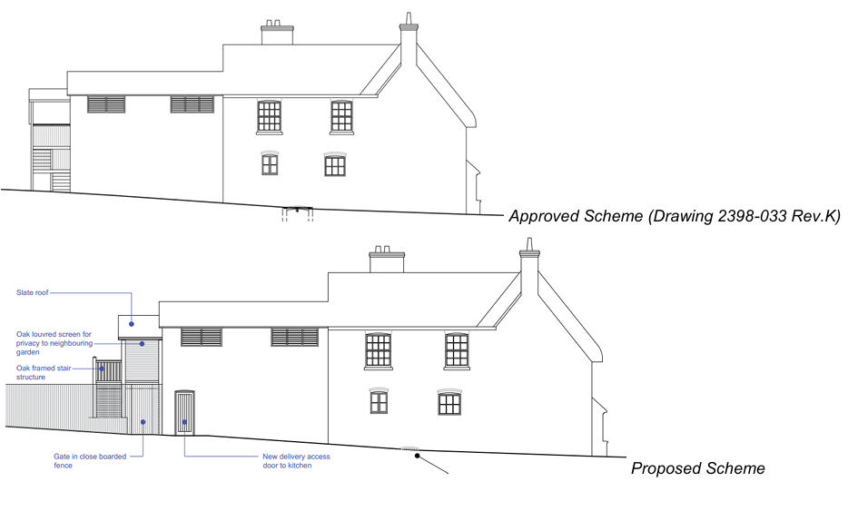

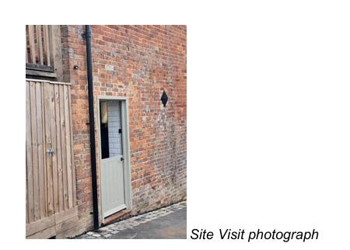

The insertion of a stable door to the rear of the kitchen extension to the former Brewery Room (outbuilding) has resulted in the loss of historic fabric and has changed the external appearance of the side elevation, which until the recently approved works to create staff facilities to the first floor/ kitchen extension, was a blank elevation. As part of the consented works, new windows were installed to the first floor, but these were screened with louvres which retain the simplicity of this former outbuilding and the entrance door to the kitchen was in the gable/ rear elevation.

The rear of the historic inn complex would have looked inwardly, both for ease of operation but also for security. The new door changes this approach and creates a new link to the public realm where there would not historically be one. Due to the staircase structure, it would not be possible to insert the door to the approved position, so this has had a cumulative impact on the unauthorised works. It has not been demonstrated why the door needs to be inserted here, or why the kitchen layout needed to be amended from the approved layout of the building necessitating the relocation of the door.

The inserted doorway has resulted in a change of appearance and relationship with the wider street scene and has resulted in a loss of fabric. No information in the submitted application has been provided on how the door opening was formed (ie, type of lintel), joinery details or if any historic/ significant details have been lost or altered internally. Whilst it is acknowledged that the interior was consented to be altered, this does not mean that there were no elements of significance. There is no discussion with the submitted application for the change of floor plan.
The relocation of the door has resulted in harm due to the visual impact on the side elevation and the loss of fabric. Whilst it is acknowledged that some loss of fabric was accepted by creating the door in the gable end, this would retain the appearance of the side elevation and retain the openings within the curtilage.

Staircase to rear gable
The addition of an external staircase was permitted under previous applications. The design of this has been amended slightly in order to provide a concealed bin store and to descend to the ground level in the garden area which are higher that the ground floor of the building. The alterations to the design are minimal and the high-quality workmanship of this element means these alterations do not change the impact of this intervention.

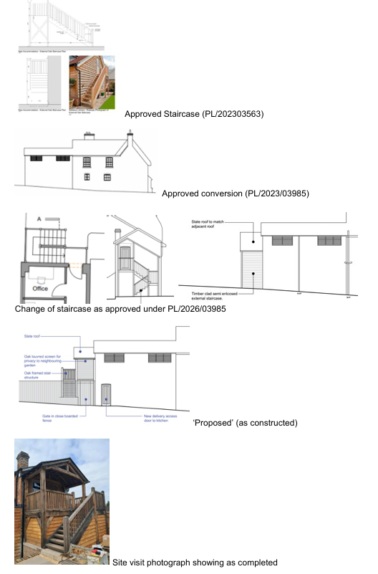

The first approved staircase did not create a balcony or roof and followed a traditional form that is common on outbuildings of a single flight and landing that sat flush with the building. A later application looked to alter and adjust the design, and consent was granted for a small, pitched roof to the staircase which allow access to the staff facilities to the first floor. This retained an open appearance of the treads, reducing the appearance of bulk, and did not create a space that would encourage loitering or seating which would reduce the need for privacy screening. The width was limited to allow for safe access and therefore responded to the relationship between the outbuilding and the main pub building.

The constructed staircase creates a balcony with an extended roof form, which is not a typical detail found on outbuildings. This staircase has been fully enclosed with timber cladding creating a bulky appearance, with complexity of the structure contrasting with the former gable elevation, increasing the dominance of the structure within the garden and the public realm.

The proposed scheme (drawing) looks to create additional screening to prevent overlooking to the neighbour by infilling the side elevation. This is considered to add to the bulkiness of the addition that is already in existence. As previously noted, the original staircase would not encourage loitering and seating, and therefore there would be limited requirement to add in privacy measures.

The submitted Heritage Statement notes that the staircase now allows for an enclosed bin store to be formed underneath the balcony, but this raises safety concerns as this is a means of escape for the staff faculties.

The undertaken works creates a more clutter appearance to the side elevation, and whilst each element on its own could be considered to cause limited harm, the accumulation of the elements of the door and staircase are considered to create harm (less than substantial), and it is considered that is has not been demonstrated that there is justification for the extent of the harm. This part of the application is not supported as it has not been demonstrated that these elements are required to outweigh the harm.

Window in rear gable
The addition of a window to the gable of the attached outbuilding at first floor will cause a low level of less than substantial harm to the designated heritage asset through the removal of historic fabric. The window opening has been designed to replicate those existing on the rear of the property to ensure consistency in design. The provision of the window will provide natural light to the office.

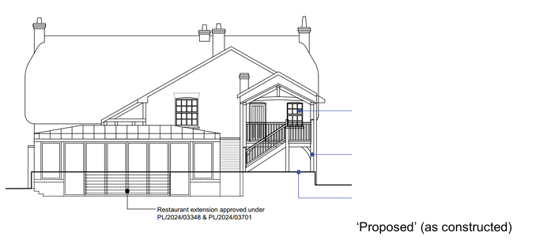

The window replicates the window found on the main building, therefore does not respond to the relationship of the outbuilding and the main building. The previously approved scheme ensured the balance between function and significance by retaining the external appearance of an outbuilding with the louvred windows to both elevations and placing the doors to the gabled elevation. The insertion of a window introduces a domestic appearance, which is further enhanced by replicating the window of the main building which raises the status of the outbuilding to main building.

It is recommended that if a window is required, then this should be of a scale and form to suit the appearance of the outbuilding, so a smaller scale opening in a casement design, rather than the larger sash window. This would be a compromise to allow some natural light and ventilation into the office whilst respecting the significance of the structure.

No information in the submitted application has been provided on how the window opening was formed (ie, type of lintel), joinery details or if any historic/ significant details have been lost or altered internally. Whilst it is acknowledged that the interior was consented to be altered, this does not mean that there were no items of significance. There is no discussion with the submitted application for the change of floor plan.

The undertaken works creates a more clutter appearance to the side elevation, and whilst each element on its own could be considered to cause limited harm, the accumulation of the elements of the door and staircase are considered to create harm (less than substantial), and it is considered that is has not been demonstrated that there is justification for the extent of the harm. This part of the application is not supported as it has not been demonstrated that these elements are required to outweigh the harm.

Hard Landscaping to Forecourt
The hard landscaping provided to the front of the property includes yorkstone flags and red brick. The area was previously covered with asphalt which had downgraded the buildings setting. The reinstatement of a traditional surface treatment has created public benefit in the form of heritage benefit thereby enhancing the listed building and wider conservation area.

These could be seen as a positive improvement to the external elevation of the pub as it could be considered to create a more welcoming or attractive entrance. There is concern that the external levels have been altered which will prevent the vapour permeability (breathability) of the front elevation, which has the potential to cause long term issues with the historic fabric. This concern can be easily resolved by reducing the level of the shingle and ensuring the slabs allow ventilation to the front elevation.

The use of York stone flags is not a local material but is recognised as a hard-wearing stone. Brick is a local material, and the use of this as a finish is considered acceptable. The installed planters could be considered to offer a more urban appearance due to the material choice, but as these are removable, these are considered to have limited impact to the setting of the listed building.

The installation of the hedges and planters will need to ensure viability of the property the visibility of the pub should be retained from the street scene and the safe access (vision splays) to the parking to the rear as parking to the front of the building would be seen as a negative to the significance of the designated heritage assets. It could also deter possible patrons if they felt usure or unsafe accessing the parking due to the height of the plants or restriction of the turning space due to the planters.

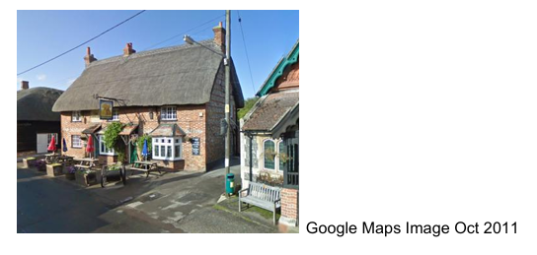
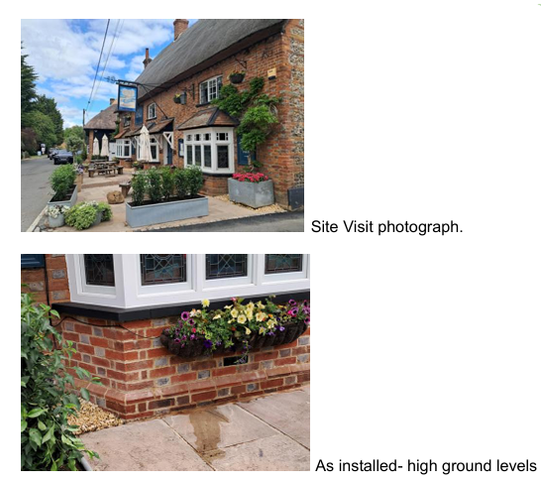

Car Park surface
The carparking surface is a mixture of asphalt and gravel which will be retained through a slight redesign of the layout. These works will have a neutral impact on the setting of the listed building.

The proposed works are not considered to cause harm to the setting of the designated heritage assets. As noted above, ensuring safe access/ egress and sufficient parking to support the use of the pub is required as parking to the front will cause harm to the setting and have the potential to discourage visitors.

Steps, dwarf walls and raised planting beds
The addition of some formal features within the garden of the public house has had a neutral impact on the character and significance of the setting of the listed building. Previously, external seating was provided in a hard landscaped area on the site of the orangery which included dwarf walls and hardcore surfacing. The new landscaping scheme sees tables situated on grass with small dwarf walls and raised planting beds which gives a more informal appearance to the garden.

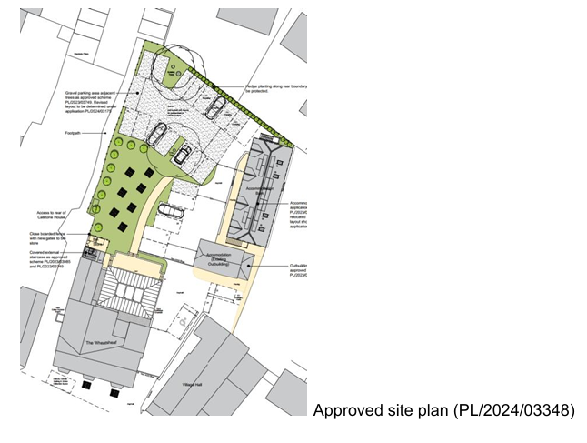

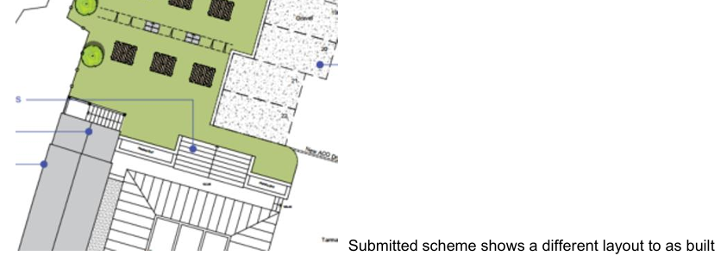

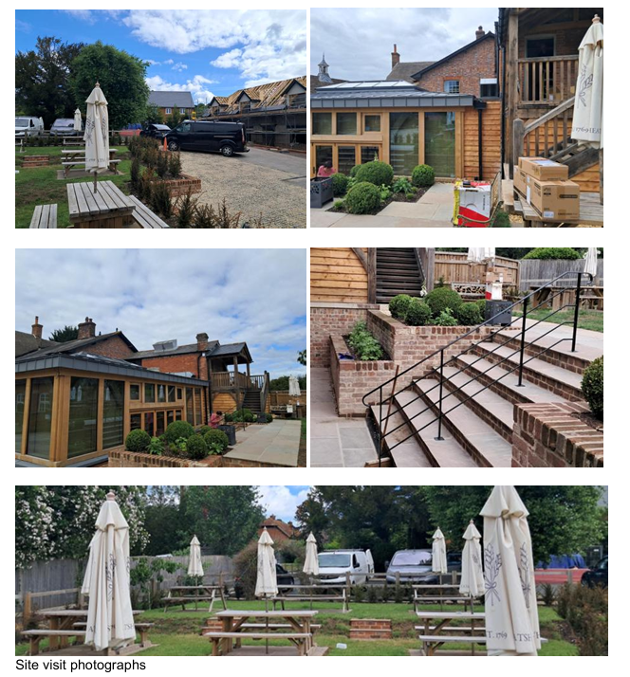

The patio outside of the Orangery has been altered to create a stepped planting either side of the steps. This is different from the proposed plan which forms part of this submission which shows less hardstanding and planting and an increase in the grass area. The proposed scheme offers a softer appearance than the more formal, urban form of formal planters (as built). The proposed drawing of the garden offers a balanced approach between creating an attractive and useable beer garden and the change of levels. The current layout would not be supported from a heritage consideration due to its more urban form and the extent of the hard landscaping.

The introduction of the dwarf walls and hedging create a visual separation within the open courtyard, disconnecting the buildings. Whilst some separation is understandable to allow the garden to be enjoyed without views of the car park or creating a safe space for families, the use of low-level brick walls introduces a more permanent separation of the space, and if some separation was required, the use of an open fence could be considered which has been used at the end of the garden to separate the garden/ seating area and the parking. This fence is open and is not considered to cause harm to the setting of the listed building but allow some separation between garden and parking but is not shown on the proposed plans.

To the public path at the side of the property, a tall, close boarded fence has been erected further than the approved scheme which noted the closed boarded fence with new gates to the bin store. As the bin store has currently been installed under the rear staircase structure, it is unclear why the close boarded fence has been extended blocking the garden from the public realm which might prevent public from seeing the garden.
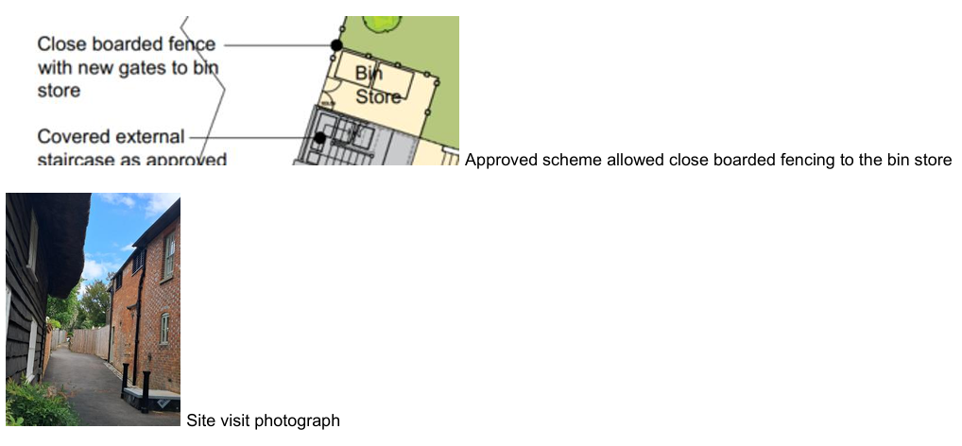

Conclusion
On balance it is seen that the proposed works captured within this application will have a neutral impact on the character and significance of the listed building and wider conservation area.

The works have been undertaken, and therefore the application is to regulate the unauthorised works. Whilst each element on their own could be deemed as causing limited harm, the accumulation of the elements, is considered to result in less than substantial harm. Under the NPPF, this could be offset by public benefits, which could include heritage benefits. It is deemed that within this application, no evidence has been provided to support the heritage benefits. There is some benefit with the forecourt works, but this is not considered to outweigh the balance of harm from a heritage perspective.

The application has provided limited information on how the works were undertaken, so it is not possible to make an informed decision regarding any additional harm that may have been caused, such as the loss of fabric or plan form.

Consideration
It is acknowledged that the public houses have been struggling to operate over recent years. However, there is evidence that the more traditional drinking pubs are making a positive increase in trade, resulting in a shift in the type of pubs that are becoming profitable and/ or visited. This is not uncommon with long running institutions who adapt and alter to suit the changing demands.

The works to the rear staircase which are considered the most harmful to the significance of the listed building are not part of the public area as they offer access for staff facilities only, therefore there original or amended scheme could be installed without affecting trade potential. This would then allow for the consented position of the doorway in the gable to be installed and allowing this elevation to return to have limited openings. The location of the bin store within an enclosed space which is also a means of escape for the staff does raise concerns from a Building Control/ Means of Escape consideration. Enclosed bin stores can help keep commercial properties tidy but installing them in enclosed or restricted spaces requires careful planning around ventilation, fire safety, and access. Failing to manage these factors can lead to trapping foul odours, attracting pests, or creating serious fire hazards.

There is limited information submitted within the application on how the new door and window opening were made, the significance of the fabric lost, or how the opening were made good. There are no joinery details which would be expected within a LBC application (which could be conditioned) to ensure the protection of the significance of the listed building.

Unconsented changes
Reviewing the application, the site visit and the various approved drawings, there are a few elements that have not been built as consented.

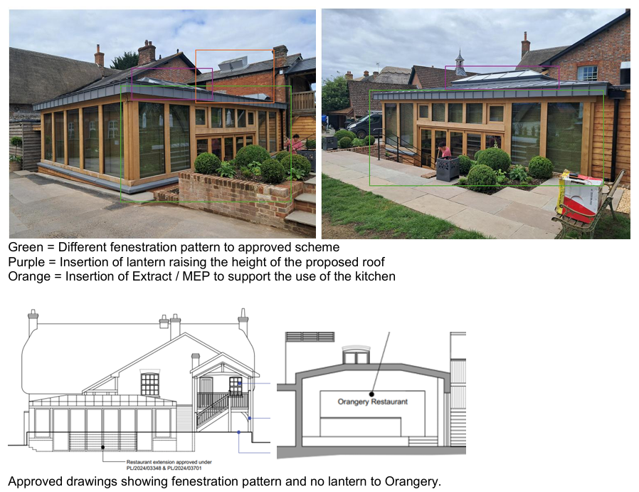
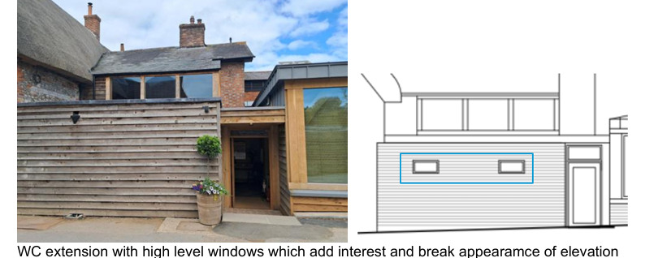

These elements should be regularised via an application or altered to suit the approved scheme.

It also appears that the signage has altered. The attachment of signs, menu boards, notices, etc., to a listed building requires LBC. The pub had a sign painted directly onto the building, and this has been covered with a new sign. The painted sign responds to the rural village nature of the inn, and forms part of the character.

Summary & conclusion: The NPPF confirms that when considering the impact of a proposed development on the significance of a designated heritage asset, great weight should be given to the asset’s conservation (and the more important the asset, the greater the weight should be). It makes clear that any harm to a designated heritage asset requires clear and convincing justification.

The proposals will result in harm to the building via the loss of historic fabric and character and via change to its layout and original external form. The proposals involve only part of the building and could therefore be considered as causing ‘less than substantial harm’ for the purposes of interpreting the NPPF, but they involve the loss of important structural historic fabric and should not be seen as being of lesser consequence. Indeed, the wording of the NPPF and the ‘special regard’ by Sections 16 and 66 of the Act requires that any level harm caused should be taken seriously.

Whilst paragraph 215 allows that a level of harm may be offset by public benefits, which could include conservation benefits, in this case no objective justification has been provided for the works and it has not been demonstrated that the works will result in any public benefit. As a result, the proposals fail to meet with the requirements of current conservation legislation, policy or guidance and I therefore recommend refusal.”

The applications seek to regularise a number of unauthorised works to the Grade II listed Wheatsheaf Inn, including the formation of a new door opening, construction of an amended external staircase, insertion of a new window opening and associated landscaping works. In reaching a recommendation, significant weight has been afforded to the statutory duty under Sections 16, 66 and 72 of the Planning (Listed Buildings and Conservation Areas) Act 1990, together with the requirements of the NPPF and Core Policies 57 and 58 of the Wiltshire Core Strategy.

The Conservation Officer has undertaken a detailed assessment of the proposals and concludes that, whilst certain individual elements may result in only limited harm when considered in isolation, the cumulative impact of the unauthorised works has resulted in less than substantial harm to the significance of the listed building and its contribution to the character and appearance of the Chilton Foliat Conservation Area.

The Local Planning Authority acknowledges that the applicant's Heritage Statement identifies a number of claimed public benefits arising from the proposals, including operational improvements to the public house, support for the long-term viability of the business and enhancements to areas of hard landscaping. However, whilst these matters have been taken into account as part of the assessment, the Local Planning Authority affords them only limited weight for the reasons set out below.

The Local Planning Authority concurs with the Conservation Officer's findings that the proposals have resulted in a loss of historic fabric and harm to the significance of the listed building. Whilst the Heritage Statement acknowledges that the insertion of the door and window openings would result in the loss of historic fabric and less than substantial harm, the Local Planning Authority reaches a different conclusion regarding the cumulative impact of the alterations and the weight to be afforded to the resulting heritage harm.

Having had special regard to the desirability of preserving the listed building, its setting and features of special architectural and historic interest, and having paid special attention to the desirability of preserving the character and appearance of the Conservation Area, the Local Planning Authority agrees with the Conservation Officer that the proposals fail to satisfy the requirements of the Planning (Listed Buildings and Conservation Areas) Act 1990, the NPPF, and Core Policies 57 and 58 of the Wiltshire Core Strategy.

Having carefully considered the detailed assessment provided by the Conservation Officer, the Local Planning Authority concurs with the overall findings and adopts that reasoning, whilst placing particular weight on the cumulative impact of the works and the absence of clear and convincing justification for the identified heritage harm, the applications are recommended for refusal.

The Case Officer notes that the Conservation Officer has also identified a number of works that appear to have been undertaken without the benefit of listed building consent. These comments have been considered insofar as they are relevant to the assessment of the proposals before the Local Planning Authority. However, they should not be construed as a definitive or exhaustive assessment of all potentially unauthorised works at the site that may require planning permission and/or listed building consent. Any investigation into the extent of unauthorised works and the consideration of any subsequent enforcement action would be a separate matter for the Council's Enforcement Team and falls outside the scope of the current application.

In addition, the Local Planning Authority has had regard to the absence of sufficient technical detail and supporting evidence in respect of the works undertaken, including the lack of information relating to construction methods, the extent of historic fabric loss, and the absence of a clear justification for the relocation and form of the alterations when compared to previously approved schemes. In the absence of such information, the Local Planning Authority cannot be satisfied that the identified heritage harm is necessary or has been appropriately minimised.

Amenity
Core Policy 57 (Point vii) of the Wiltshire Core Strategy requires development to respect the amenity of existing occupants and ensure appropriate amenity levels for future residents.

The National Planning Policy Framework (NPPF), particularly Paragraph 135, reinforces the need for development to provide a high standard of amenity for both existing and future users.

The application relates to a number of alterations to the Grade II listed public house, including the retention of a revised external staircase to the rear elevation, insertion of a kitchen access door, insertion of a window within the rear gable, hard landscaping works and alterations within the beer garden and car park. The submitted Design and Access Statement confirms that the previously approved staircase incorporated a privacy screen to prevent overlooking of neighbouring residential properties and that this principle has been retained within the current proposal through the provision of an oak louvred screen.

Having regard to the nature and scale of the proposed works, it is considered that the kitchen access door, window insertion, surfacing alterations and landscaping works would not give rise to any significant adverse impacts in terms of overlooking, loss of privacy, loss of light, overbearing impact, noise or disturbance to neighbouring occupiers. The proposed kitchen access door would facilitate the operation of an established public house and is unlikely to result in such a material increase in activity beyond that associated with the lawful use of the site to warrant a reason for refusal.

Particular consideration has however been given to the external staircase and raised platform on the western side of the building, given its proximity to neighbouring residential properties. The approved drawings show the provision of an oak louvred privacy screen to the western side of the staircase and landing to prevent views towards adjacent private garden areas.

It was noted during the site inspection that the staircase and platform have been constructed without the louvred privacy screen shown on the approved drawings. In the absence of this screening, the development has the potential to result in overlooking and a consequent loss of privacy to neighbouring occupiers to the west. The louvred screen is therefore considered an essential component of the development in amenity terms. The proposed window within the rear gable is not considered to give rise to unacceptable overlooking or loss of privacy, having regard to its position, intended use and relationship with neighbouring properties.

In the event that planning permission were to be granted, it is considered that a condition would be necessary to ensure that the oak louvred privacy screen is installed and thereafter retained in perpetuity. Subject to this being conditioned, it is considered that the proposed development would not result in unacceptable harm to neighbouring residential amenity by reason of overlooking, loss of privacy, overbearing impact, loss of light, noise or disturbance. The proposal is therefore considered to comply with Core Policy 57 of the Wiltshire Core Strategy.

Highways Impacts and Parking
Transport implications are a key factor in assessing planning applications, especially for larger developments. Proposals must demonstrate:
- Safe and suitable access for all users, including pedestrians, cyclists, and those with mobility impairments.
- No severe residual impacts on the surrounding highway network.
- Promotion of sustainable travel, reducing reliance on private vehicles.
- Adequate parking and cycle provision, in line with adopted standards.
- Protection and enhancement of public rights of way and active travel routes.

Relevant policies include Core Policies 60–64 of the Wiltshire Core Strategy, supported by the Wiltshire Local Transport Plan, Car Parking Strategy, and Cycling Strategy. The Local Cycling and Walking Infrastructure Plan (LCWIP) and LTN 1/20 (DfT) provide further design guidance for active travel infrastructure.

Proposals must also ensure safe access for refuse collection vehicles and comply with the Wiltshire Council Waste Storage and Collection SPD (2017).

Where necessary, Transport Assessments or Statements should be submitted to evaluate impacts and identify mitigation. Planning conditions or legal agreements may be used to secure off-site improvements, travel plans, or contributions to sustainable transport infrastructure.

The application includes alterations to the front forecourt, rear car park and associated external areas of The Wheatsheaf Inn. The front forecourt has been resurfaced, replacing the existing tarmac with stone flags and pavers. These works have already been undertaken and form part of the retrospective application.
To the rear, amendments are proposed to the approved car park surfacing, involving changes to the extent of tarmac and gravel-filled permeable geogrid paving..

The proposals also include an alternative external access door serving the commercial kitchen, and relocating the delivery/collection parking space from the front forecourt to the access track between the public house and the neighbouring property (Calstone House).

In consideration of the application, the council’s Highways Officer has provided the following comment:

“I refer to the above planning application for the creation of a new door opening, the construction of an external staircase and the installation of a new window opening in the rear gable wall, change to hard landscaping and car park surfacing.

The number of parking spaces is remaining the same as in the previous proposal which was given permission under PL/2024/03348 and objected to by the Highway Authority on lack of parking. I note however that this application shows the delivery parking space located in the track to the side of the pub rather than to the front of the pub as in the previous application. I understand that the adjacent track is owned by a third party and serves as access to residential properties and therefore access rights and permission to use this area as a parking space must be ensured.

The submitted plans show the whole of the area to the front of the pub paved with flag stones and pavers and I note that these works have already been undertaken. Please note, however that the majority of this area is public highway and it was permitted to be used as a delivery parking space by the LHA under the previous application (PL/2024/03348) as the site lacked parking provision. However for this application, the tables and chairs and planters could be allowed on the highway if The Council issue the applicant with a ‘Pavement Licence’ although the planters and tables and chairs need to be set back from the carriageway edge by a minimum of 450mm. I have copied Highway Enforcement into this email and request that an application form for a Pavement Licence is sent to the applicant, however should this planning applicant not be successful and permission is not granted, the area to the front of the pub must revert to being a delivery van parking space. Please note that having the tables, chairs and planters on the highway currently without a licence is an enforcement issue and the positioning of the tables, chairs and planters are preventing the parking as permitted under the previous application (PL/2024/03348), so the applicant is in breach of their current permission.

The applicant must also be aware that the area remains public highway and should these pavers or flags get broken, Wiltshire Council as the highway authority would only make repairs by removing the damaged pavers or flags and filling the area with preparatory Cold Lay Bitumen.

Therefore providing a delivery parking bay is maintained, and taking all of the above into account, I do not object to the current proposal, however, I must stress again that the lack of parking provision for the site as a whole remains a concern to the LHA and an objection is only being withheld due to the fact that the previous application was approved against the LHA’s advice and this application provides the same amount of parking spaces as that.”

The Highways Officer has reviewed the application and raises no objection to the proposed development, subject to the retention of a delivery parking space serving the public house. The Highway Officer notes that the proposals do not reduce the number of parking spaces previously approved under application PL/2024/03348 and therefore do not materially worsen the existing parking situation. Whilst concerns remain regarding the overall level of parking provision at the site, these concerns are longstanding and were previously considered under earlier permissions. The Highway Authority confirms that an objection is withheld on the basis that the current proposals provide the same level of parking provision as the previously approved scheme.

The Highway Officer has also highlighted that the area to the front of the public house forms part of the public highway and that the existing tables, chairs and planters require appropriate licensing if they are to remain in situ. However, these matters are subject to separate highway and licensing controls and do not form a reason to object to the current application.

The Highways Officer notes that the proposed delivery parking space is shown within the access lane to the west of the site, which is understood to be in third-party ownership. Whilst land ownership is not a material planning consideration and does not prevent the submission or determination of a planning application, the use of the parking space for servicing purposes would be dependent upon the applicant securing the necessary legal rights and permissions from the landowner. The Local Planning Authority notes that planning permission PL/2024/03348 included a condition requiring written confirmation of third-party agreement in relation to works and parking arrangements on adjoining land. In the event that planning permission were to be granted, it is considered that a similarly worded condition would be necessary to secure evidence that the proposed delivery parking space could be lawfully provided and retained for the benefit of the development.

Having carefully considered the comments of the Highways Officer, the Case Officer agrees with their assessment and concludes that the proposals would not result in an unacceptable impact on highway safety or parking provision. Subject to the continued availability of a delivery parking space serving the site, no highway reason exists to warrant refusal of the application. Accordingly, the proposal is considered to accord with the relevant objectives of Core Policy 61 of the Wiltshire Core Strategy.

Landscape and Visual Impact
Core Policy 51 of the Wiltshire Core Strategy requires development to:
- Protect, conserve, and enhance landscape character and quality.
- Respect local distinctiveness, key views, and visual receptors.
- Give particular weight to impacts on National Landscapes (formerly AONBs) and locally valued landscapes.

The Wiltshire Design Guide SPD (2024) promotes a context-led approach, encouraging integration with natural features and settlement patterns while avoiding visual intrusion.

The Green & Blue Infrastructure Strategy (2022–2030) supports landscape protection through green infrastructure, habitat connectivity, and nature-based solutions.

The NPPF emphasises the need to protect and enhance valued landscapes, particularly those with scenic, historic, or ecological significance. Planning decisions should:

- Recognise the intrinsic character and beauty of the countryside.
- Safeguard key views, local distinctiveness, and landscape settings.
- Ensure development is well-integrated into its surroundings and avoids visual intrusion, especially in sensitive or designated areas.

Landscape impact must be considered alongside biodiversity, heritage, and green infrastructure objectives, with mitigation measures encouraged where harm cannot be avoided.

Paragraph 189 of the NPPF requires that great weight should be given to conserving and enhancing landscape and scenic beauty in National Landscapes which have the highest status of protection in relation to these issues.

Under Section 245 of the Levelling-up and Regeneration Act 2023, LPAs and other relevant authorities must now “seek to further” the statutory purposes of National Landscapes (formerly Areas of Outstanding Natural Beauty), replacing the previous duty to merely “have regard to” them.

This is an active duty, requiring authorities to take reasonable and proportionate steps to support the conservation and enhancement of the natural beauty, special qualities, and key characteristics of these designated areas when exercising any function that affects them.

The proposed development comprises alterations to the existing public house, including the provision of a kitchen access door, amendments to the external staircase, insertion of a window, alterations to hard surfacing, and associated landscaping works within the existing curtilage of the site. The submitted information indicates that the works are largely confined to existing built form and previously developed areas, with existing trees within the car park retained and protected.

Whilst the proposals do not necessarily seek to further the purposes of the protected landscape, the proposed development would be read in the context of the existing buildings on site and neighbouring properties and as there would be no encroachment into open countryside, the proposed development would have a neutral impact upon the special qualities of the North Wessex Downs National Landscape.

Flood Risk and Drainage
Core Policy 67 of the Wiltshire Core Strategy and NPPF paragraphs 170–182 require:
- Avoidance of increased flood risk.
- Use of appropriate mitigation measures.
- Application of the sequential and exception tests for developments in Flood Zones 2 or 3.

Sustainable Drainage Systems (SuDS) are required for all major developments and must:
- Manage runoff near its source.
- Improve water quality.
- Support biodiversity and amenity.
- Be integrated into the site layout and green infrastructure.

The application does not propose any fundamental change to the approved drainage strategy. The revised parking layout includes a combination of permeable geogrid paving with gravel infill and areas of tarmac surfacing. The submitted Design and Access Statement indicates that permeable surfacing will continue to be used within the parking area and there is no evidence that foul drainage arrangements have changed from those previously approved. Subject to the approved drainage arrangements being maintained, it is considered that the proposal would not result in an unacceptable increase in surface water runoff.

Impact upon buried archaeology:
The proposed development comprises alterations to the existing public house, including the provision of a kitchen access door, amendments to the external staircase, insertion of a window, alterations to hard surfacing, and associated landscaping works within the existing curtilage of the site. The submitted information indicates that the works are largely confined to existing built form and previously developed areas, with existing trees within the car park retained and protected.

The proposed development does not give rise to any concerns from an archaeological perspective due to the nature of the works. Furthermore, the Assistant County Archaeologist was consulted on the application and confirmed that they had no comment to make.

Impact upon trees:
The Council's Arboricultural Officer was consulted on the application and advised that they were unable to provide any formal comments as the proposed hard landscaping and car park resurfacing works have already been undertaken.

The proposals comprise alterations to the existing public house, including the provision of a kitchen access door, amendments to the external staircase, insertion of a window, alterations to hard surfacing, and associated landscaping works within the existing curtilage of the site. The submitted information indicates that the works are largely confined to existing built form and previously developed areas. Furthermore, the Design and Access Statement confirms that the two existing trees within the car park are to be retained and references an Arboricultural Method Statement which sought to ensure their protection throughout the works.

Given that the trees are to be retained, no arboricultural objections have been raised, and the application relates primarily to minor alterations within an established commercial curtilage, it is not considered that the proposal would result in unacceptable harm to existing trees or would conflict with the aims of Core Policy 51 of the Wiltshire Core Strategy.

Biodiversity Net Gain (BNG)
Mandatory Biodiversity Net Gain (BNG) was introduced through the Environment Act 2021 and Schedule 7A of the Town and Country Planning Act 1990. Since February 2024, most planning permissions have been required to deliver a minimum 10% biodiversity net gain, measured using the statutory biodiversity metric, unless a statutory exemption applies. The requirement is supported by the National Planning Policy Framework (NPPF), Planning Practice Guidance (PPG) and Wiltshire Core Strategy Core Policy 50 (Biodiversity and Geodiversity).

The proposed development comprises minor alterations to the existing public house, including the provision of a kitchen access door, amendments to the external staircase, insertion of a window, alterations to hard surfacing, and associated landscaping works within the existing curtilage of the site. The submitted information indicates that the works are largely confined to existing built form and previously developed areas, with existing trees within the car park retained and protected.

Having regard to the nature and scale of the development, and based on the information submitted, the proposal is considered to constitute a de minimis development for the purposes of the Biodiversity Gain Requirements (Exemptions) Regulations. There is no evidence that the proposal would result in the loss of more than 25 square metres of habitat, more than 5 metres of hedgerow, or any priority habitat.

Accordingly, the proposal is considered to be exempt from the mandatory Biodiversity Net Gain requirements and the submission of a Biodiversity Gain Plan or statutory biodiversity metric calculation is not required. Notwithstanding this exemption, the proposed planting within the site is welcomed and is capable of providing a modest biodiversity enhancement.

PLANNING BALANCE AND CONCLUSION
Officers acknowledge that The Wheatsheaf Inn is an important community facility within Chilton Foliat and the objectives of Core Policy 49 of the Wiltshire Core Strategy, together with national policy within the NPPF, support the retention and long-term viability of public houses in rural communities. In this regard, the Local Planning Authority acknowledges that over recent years a number of planning permissions and listed building consents have been granted at the site to facilitate the ongoing operation of the business, including guest accommodation, extensions, alterations and associated works intended to support its continued viability. These permissions demonstrate that the Council has consistently sought to support the optimum viable use of the listed building as a public house and associated hospitality business.

However, the current applications must be assessed on their own merits. The Conservation Officer concludes that the cumulative impact of the alterations, including the relocated doorway, amended staircase and additional window opening, has resulted in less than substantial harm to the significance of the Grade II listed building through the loss of historic fabric and alterations to its character and appearance. The works are also considered harmful to the character and appearance of the Chilton Foliat Conservation Area. The Case Officer agrees with this assessment.

Whilst the applicant's Heritage Statement concludes that the individual elements of the scheme would result in only low levels of less than substantial harm, the Local Planning Authority considers that greater weight should be afforded to the cumulative impact of the alterations on the significance of the listed building and the character and appearance of the conservation area.

Notwithstanding the information submitted by the applicant regarding the heritage impacts of the proposals, sufficient information is available from the submitted plans, supporting documents and site inspection to conclude that the proposals result in less than substantial harm to the significance of the designated heritage asset and the conservation area.

In reaching this conclusion, the Local Planning Authority has had special regard to the desirability of preserving the Grade II listed building, its setting and the features of special architectural and historic interest which it possesses, in accordance with Sections 16 and 66 of the Planning (Listed Buildings and Conservation Areas) Act 1990. The Local Planning Authority has also paid special attention to the desirability of preserving the character and appearance of the Chilton Foliat Conservation Area in accordance with Section 72 of the Act. Considerable importance and weight has been afforded to the conservation of these designated heritage assets throughout the decision-making process.

Paragraph 215 of the NPPF requires that where a proposal would lead to less than substantial harm to the significance of a designated heritage asset, that harm should be weighed against the public benefits of the proposal, including, where appropriate, securing its optimum viable use. The Local Planning Authority has undertaken this balancing exercise in reaching its conclusion.

The identified harm to the significance of the designated heritage asset, whilst categorised as less than substantial harm, nevertheless attracts great weight in accordance with paragraph 212 of the National Planning Policy Framework. The Local Planning Authority has had regard to the public benefits advanced by the proposal, including the continued use of the public house and its contribution to the vitality of the rural community, which are afforded moderate weight. Limited weight is afforded to the claimed operational efficiencies arising from the revised layout, given the absence of robust evidence demonstrating that these changes are necessary. Furthermore, there is no substantive evidence demonstrating why the benefits of the proposal could not be achieved through the implementation of previously approved schemes which would result in less harm to the significance of the heritage asset. In these circumstances, the public benefits of the proposal are not considered sufficient to outweigh the identified heritage harm.

Although the forecourt surfacing and certain landscaping works may provide some modest enhancement to the setting of the building, these benefits are not considered sufficient, either individually or cumulatively, to outweigh the identified heritage harm. On balance, officers conclude that the public benefits of the proposal do not outweigh the less than substantial harm arising to the significance of the designated heritage assets.

Accordingly, the proposals fail to preserve the special architectural and historic interest of the Grade II listed building and fail to preserve the character and appearance of the Chilton Foliat Conservation Area.

The applications therefore conflict with Sections 16, 66 and 72 of the Planning (Listed Buildings and Conservation Areas) Act 1990, paragraphs 212, 213 and 215 of the National Planning Policy Framework, and Core Policies 57 and 58 of the Wiltshire Core Strategy. For these reasons, the applications are recommended for refusal

RECOMMENDATION:
That Planning Permission be REFUSED for the following reason:

