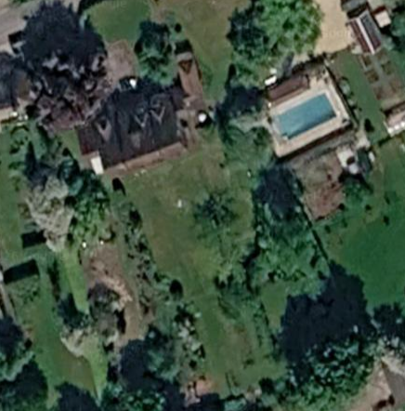
T1 – Copper Beech

T2 – Norway Maple

