ECOLOGICAL SURVEY REPORT (BATS)
(Emergence Surveys)

DEAN LODGE
MILES LANE WHITEPARISH
SALISBURY
WILTSHIRE
SP5 2QU

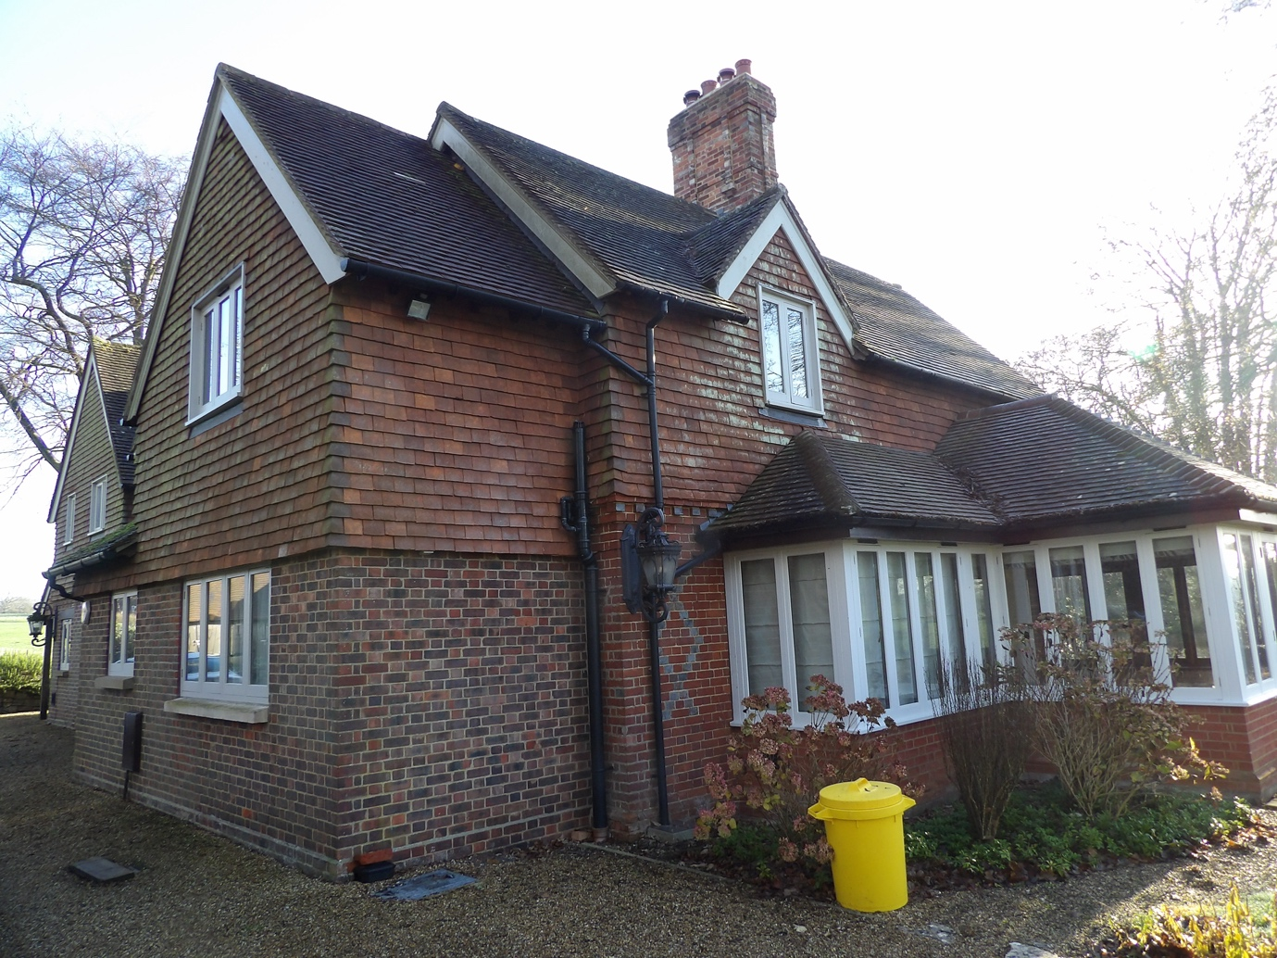

Prepared for:
Mr C. ROCHE.
Date: 30/062/26.
Ref: NWP/ESR-30/06/26-version 1.

CONTENTS
Executive Summary
- Introduction
1.1 Instruction
1.2 Aims and Objectives
1.3 Proposed works
1.4 Surveyor Background and Experience
- Survey Methodology
2.1 Constraints/limitations
2.2 Dusk Survey
3 Survey Findings
  - Dusk Surveys.
- Conclusion/interpretations
- References
- Queries
Appendix 1.

DEAN LODGE, MILES LANE, WITEPARISH, SALISBURY, WILTSHIRE SP5 2QU.
EXECUTIVE SUMMARY
BatCraft was commissioned Mr C. ROCHE to carry out three dusk emergence surveys at DEAN LODGE, MILES LANE, WITEPARISH, SALISBURY, WILTSHIRE SP5 2QU. The surveys were undertaken at the property to provide presence/absence of bats following the PEA undertaken by BATCRAFT dated 15/12/25 REF: NWP/ESR-15/12/25 Version 1 of the same address to inform appropriate mitigation for the proposed works, if required. This report is to support a forthcoming planning application
A search of the local records centre has not been undertaken.
The DNA testing confirmed pipistrellus pipistrellus
A desk top study was conducted prior to the surveys based upon a 2km search radius and it revealed 3 statutory designated sites within, these are:
NEW FOREST-SPECIAL AREA of CONSERVATION (SAC).
WHITEPARISH COMMON- SITE of SPECIAL SCIENTIFIC INTEREST (SSSI)
BRICKWORTH DOWN AND DEAN HILL- SITE of SPECIAL SCIENTIFIC INTEREST (SSSI)
MOTTISFONT BATS- SPECIAL AREA of CONSERVATION (SAC) lies to the northeast c7500 metres.
The dusk emergence surveys were conducted on 2/5/26, 27/5/26 and 22/6/26.
Three species of bat were heard and seen throughout the surveys. This report is an addendum to and must be read in conjunction with the preliminary roost assessment completed by BATCRAFT dated 15/12/25, ref; NWP/ESR-15/12/25 Version 1 of the same address.

This report confirms the findings of the survey, completed by an experienced licensed bat ecologist, in accordance with current best practice where possible, and outlines any ecological constraints or issues with the proposed works.
The combined result from the preliminary survey (POSITIVE) and activity surveys (NEGATIVE) provides a high level of confidence set out in this report. No bats or evidence of bats were seen entering or emerging from the property during the activity surveys. This indicates that the property was being used as a transitional roost, an EPSL from Natural England (NE) is required.

DEAN LODGE, MILES LANE, WITEPARISH, SALISBURY, WILTSHIRE SP5 2QU..
1.INTRODUCTION

  - Instruction
BatCraft was instructed by Mr C. ROCHE to carry out three dusk emergence surveys of DEAN LODGE, MILES LANE, WITEPARISH, SALISBURY, WILTSHIRE SP5 2QU. to support a forthcoming planning application.

  - Aims and Objectives
The dusk emergence surveys are designed to:
• Identify the presence/likely absence of bats using the building to roost.
• Estimate the size and status of any existing bat roost within the building.
• Establish where the bats are accessing the building.
• Determine the potential impacts on any bat roost from the proposed development.
• Determine if an EPSL and ecological method statement is required.
The emergence surveys and report writing were carried out in accordance with Bat Surveys for Professional Ecologists Good Practice Guidelines 4th edition.
  - Proposed Works
The survey was commissioned in connection with an under-consultation application REF: PL/2025/08949, for a two-storey extension to rear of property along with alterations to roof and window over landing.
1.4 Surveyor Background and Experience
The activity surveys were undertaken by Nicholas Powell and Adam Carroll and the report written by Nicholas Powell. Nicholas holds a Class 2 Bat License (CLS-11742) and has received training in bat ecology and surveying, bat detector use, acoustic monitoring/sonogram analysis, architectural terms for bat workers, bats and development, H & S awareness for bat workers, legislation for bat workers, British bats their ecology and conservation, surveying trees for bats, Bat ID and handling, bat biology.
Adam has received training in bat ecology and biology, surveying techniques, bat detector use, identification, acoustic monitoring, infrared equipment for ecologists, H and Safety awareness for bat workers.

DEAN LODGE, MILES LANE, WITEPARISH, SALISBURY, WILTSHIRE SP5 2QU.
2.Survey Methodology
2.1 Constraints/limitations
An external and internal assessment of the buildings was conducted on 2/5/26 prior to the first survey being undertaken and there appeared to be no significant material changes to the site and no constraints or limitations to the surveys. Weather conditions were suitable for the surveys, being conducted during warm weather and with insects in abundance with bats being observed foraging and in transit during the surveys.

2.2 Dusk Surveys.
The dusk surveys were conducted on the evenings of 2nd May 27th May and 22nd June 2026.
The surveyors/remote cameras were stationed (as shown in Figure 1) to ensure the features identified in the preliminary report could be observed, each surveyor position was covered with infrared equipment, a screenshot from each at the darkest point is shown below.
During the surveys bat activity was monitored using Batlogger m bat detectors along with Sony handycam night shot video cameras with high intensity IR lamps and guide tk 612 thermal monoculars.
The detectors and cameras were fitted with SD cards for recording bat activity, allowing for later analysis with Kaleidoscope pro 3 software, VLC media player and Motion Meerkat.
Figure 1.
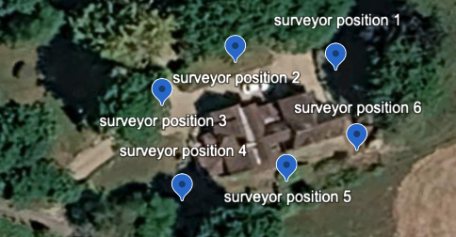

During the surveys no bats were seen emerging from and/or returning to the buildings to roost. In total 3 species were recorded and
A simple summary of the bats recorded can be seen in Table 2.
The most frequently used flight paths of pipistrelle bats are shown in figure 3 in red, the flight path of the Noctule are shown in yellow.
Figure 3. 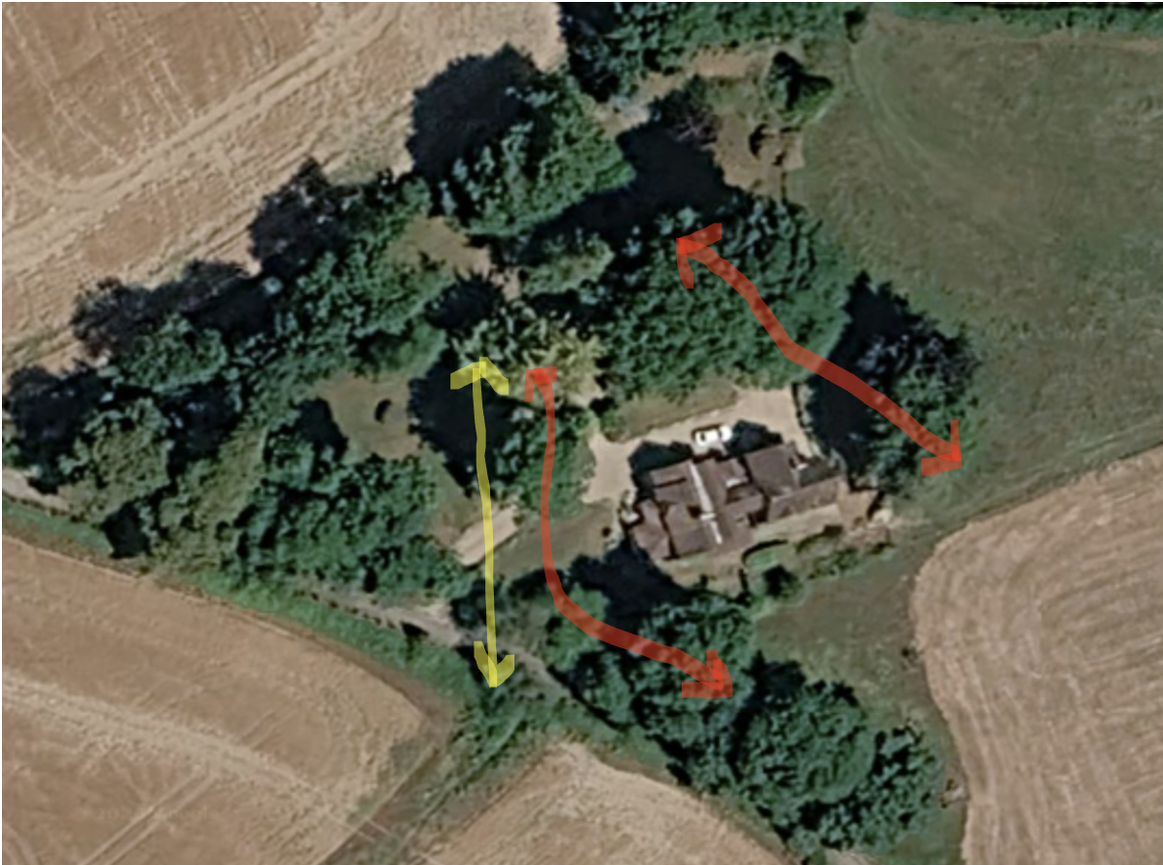
DEAN LODGE, MILES LANE, WITEPARISH, SALISBURY, WILTSHIRE SP5 2QU.
3.Survey Findings

DATE: | 2nd May 2026 | 27th May 2026 | 22nd June
SURVEYOR AND LOCATION | 1.REMOTE  2.N.POWELL  3. REMOTE  4.REMOTE  5.A.CARROLL  6.REMOTE | 1.REMOTE  2.N.POWELL  3. REMOTE  4.REMOTE  5.A.CARROLL  6.REMOTE | 1.REMOTE  2.N.POWELL  3. REMOTE  4.REMOTE  5.A.CARROLL  6.REMOTE
WEATHER CONDITIONS -START | Temperature 16.6°C  Cloud cover 0%  Humidity 63.6%  Dry Wind Beaufort 0 | Temperature 22.2°C  Cloud cover 5%  Humidity 72.6%  Dry Wind Beaufort 0- 1 | Temperature 24.2°C  Cloud cover 0%  Humidity 62.6%  Dry Wind Beaufort 0
SUNSET | 20.30 | 21.05 | 21.24
START TIME | 20.10 | 20.45 | 21.05
FINISH TIME | 22.40 | 23.15 | 23.35
DURATION | 02.30 | 02.30 | 02.30
WEATHER CONDITIONS – FINISH | Temperature 15°C  Cloud cover 10%  Humidity 71.4%  Dry Wind Beaufort 0- 1 | Temperature 21.8°C  Cloud cover 0%  Humidity 76.6%  Dry Wind Beaufort 0- 1 | Temperature 23.24°C  Cloud cover 10%  Humidity 68.9%  Dry Wind Beaufort 0- 2

DEAN LODGE, MILES LANE, WITEPARISH, SALISBURY, WILTSHIRE SP5 2QU.
Table 2. Summary of bats seen and recorded.
DATE | SURVEYOR POSITION | TIME | SEEN | HEARD | SPECIES | COMMENT
2/5/26 | 1. Remote | 20.10-22-40 | N | N/A |  | No emergences/re-entry recorded
2/5/26 | 2. N.Powell | 20.00-22-40 | Y | Y | C-PIP  BLE  NOC | 20.53 first C-PIP seen and heard foraging along the hedge/treeline on the northeastern boundary. 11 seen passes and heard throughout the survey, 7 heard, not seen. Reviewed gps data from Batlogger shows recorded position of C-pip/s using flight path as above.  At 21.11, 2 C-pip entered site from southeastern direction, foraged over and around the pond in the garden. This was constant for approximately 40 mins before the foraging became intermittent, no further calls/sightings of bats using this flight path after 22.10.  Last recorded C-PIP call for complete site recorded at 22.17.  At 21.02 a single BLE was seen/heard foraging in front of the treeline on the southwestern boundary, there were 3 passes in total between 7-11 minute intervals.  1 pass by NOC at 21.11  Insect activity was prolific during the survey.
2/5/26 | 3. Remote | 20.10-22.40 | N | N |  | No emergences/re-entry recorded
2/5/26 | 4 Remote | 20.10-22-40 | N | N/A |  | No emergences/re-entry recorded
2/5/26 | 5. A. Caroll | 20.10-22-40 | Y | Y | C-PIP  BLE  NOC | C-pip activity along the southwestern boundary hedge was recorded and seen by surveyor.  First call 20.42, last call at 22.37.  The BLE was recorded as seen not heard.  1 pass by NOC at 21.11/12.  No interaction between the dwelling/buildings and bats recorded.
2/5/26 | 6. Remote | 20.10-22-40 | N | N |  | No emergences/re-entry recorded

DEAN LODGE, MILES LANE, WITEPARISH, SALISBURY, WILTSHIRE SP5 2QU.

DATE | SURVEYOR POSITION | TIME | SEEN | HEARD | SPECIES | COMMENT
27/5/26 | 1 Remote | 20.45-23.15 | N | N/A |  | No emergences/re-entry recorded
27/5/26 | 2. N. Powell | 20.45-23.15 | Y | Y | C-PIP  BLE | At 21.11 2x C-PIP seen and heard foraging along northeastern boundary hedge.  3 further sightings of singular c-pip following same flight path, 7 passes by C-PIP foraging over/around garden between 21.32 and 22.41.  BLE seen and heard in transit across southern western edge of site, 1 pass at 22.11.
27/5/26 | 3.Remote | 20.45-23.15 | N | N/A |  | No emergences/re-entry recorded.
27/5/26 | 4 Remote | 20.45-23.15 | N | N/A |  | No emergences/re-entry recorded.
27/5/26 | 5 A. Caroll | 20.45-23.15 | Y | Y | C-PIP | C-pip/s were seen and recorded foraging along the southwestern boundary hedge/treeline.  5 total passes were heard and seen and 9 heard but not seen with intervals approximately 7-9 minutes apart. First recorded call at 21.05, feint and brief, last call at 22.52.  No interaction between the dwelling/buildings and bats recorded.
27/5/26 | 6 Remote | 20.45-23.15 | N | N/A |  | No emergences/re-entry recorded.

DEAN LODGE, MILES LANE, WITEPARISH, SALISBURY, WILTSHIRE SP5 2QU.
DATE | SURVEYOR POSITION | TIME | SEEN | HEARD | SPECIES | COMMENT
22/6/25 | 1.Remote | 21.05-23.35 | N | N/A |  | No emergences/re-entry recorded.
22/6/25 | 2.N. Powell | 21.05-23.35 | Y | Y | C-PIP  BLE  NOC | 3 passes by NOC, high in transit south to west direction.  First at 21.41, last at 22.07.  C-pip activity as with last 2 surveys-C-pip/s were seen and recorded foraging along the northeastern boundary hedge/treeline.  First at 21.22, last call at 23.21.  BLE heard but not seen, 3 calls in total.
22/6/25 | 3.Remote | 21.05-23.35 | N | N/A |  | No emergences/re-entry recorded.
22/6/25 | 4.Remote | 21.05-23.35 | N | N/A |  | No emergences/re-entry recorded.
22/6/25 | 5. A. Caroll | 21.05-23.35 | Y | Y | C-PIP  BLE | C-pip/s were seen and recorded foraging along the southwestern boundary hedge/treeline.  21 total passes were heard and seen and 14 heard but not seen with intervals approximately 3 minutes apart. First recorded call at 21.18, feint and brief, last call at 23.17  BLE heard not seen 22.07, 3 calls, feint.  No interaction between the dwelling/buildings and bats recorded
22/6/25 | 6.Remote | 21.05-23.35 | N | N/A |  | No emergences/re-entry recorded.
DEAN LODGE, MILES LANE, WITEPARISH, SALISBURY, WILTSHIRE SP5 2QU.
Screen shot from each camera at darkest point of survey.
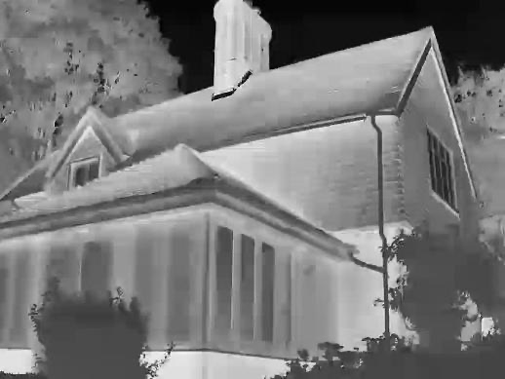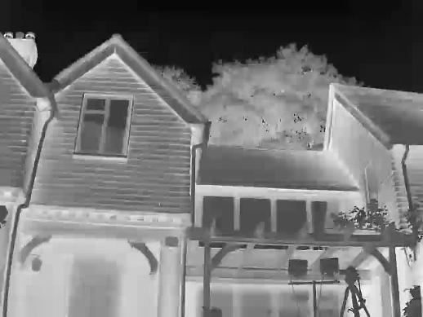
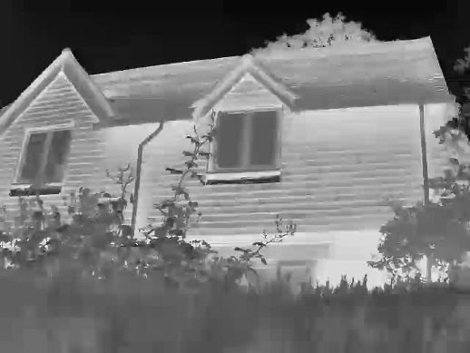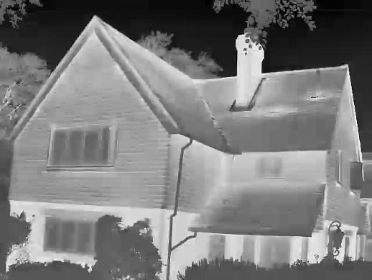
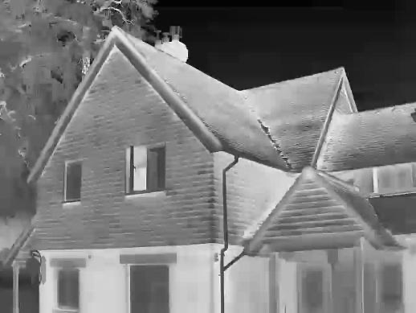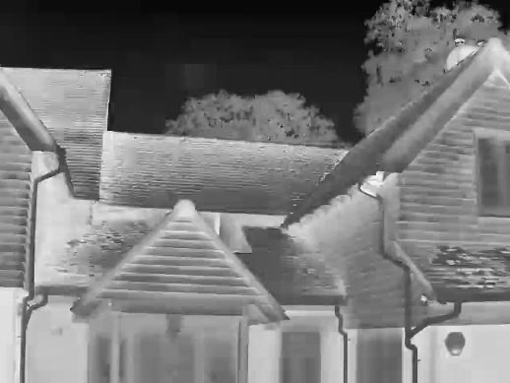

DEAN LODGE, MILES LANE, WITEPARISH, SALISBURY, WILTSHIRE SP5 2QU.

Mottisfont Bats SAC -Mitigation.

Lighting: Where new external lighting is provided the Institute of Lighting Professionals (ILP) guide must be followed. For example, all external lighting must be Light Emitting Diode (LED) and directed downward or be located at a low level. LED bulbs produce the least amount of heat and no UV light minimising the attraction effect of impact on insects and foraging bats. By carefully directing light downwards any using a PIR with short illumination sensor the impact of external lighting on any foraging bats will be minimal.

Habitat loss
There is no habitat loss relating to this scheme and no requirement for habitat compensation.

Post construction work
There is no requirement for post-construction monitoring of this scheme.

DEAN LODGE, MILES LANE, WITEPARISH, SALISBURY, WILTSHIRE SP5 2QU.

4. Conclusions/Interpretation
4.1 The calls detected and recorded from the survey provided identification of Common Pipistrelle, pipistrellus pipistrellus and Brown long Eared, Plecotus auritus and Noctule Nyctalus noctule foraging and/or in transit with no bat passes on the night vision cameras and no bat/s observed by the surveyors interacting with the buildings, when combined this data provides a high level of confidence in the species detected during the survey at DEAN LODGE, MILES LANE, WITEPARISH, SALISBURY, WILTSHIRE SP5 2QU
4.2. The property has features suitable for crevice dwelling bats to roost, however, there is no evidence to indicate that bats are using the building during the peak months of May-September.
4.3 The survey conditions were good, with warm weather with a variety of insects flying in abundance.
4.4. The bat calls and field observations provide a high level of confidence in support of the opinions set out in this report. The calls from Common Pipistrelle/Brown Long Eared/Noctule were recorded throughout the surveys, with both Pipistrelle/Noctule seen multiple times, the most commonly used flight paths of the C-pip easily identified.
4.5. The cumulative evidence leads me to conclude that the bat observed roosting at the property during the preliminary survey was using it opportunistically as a transitional roost due to many factors such as the warmer weather allowing for bat activity at the time of year, an EPSL is required so the development can proceed legally.

4.6 All bats and their roosts are protected under the Conservation of Habitats and Species Regulations 2017, and the Wildlife and Countryside Act 1981 (as amended).

DEAN LODGE, MILES LANE, WITEPARISH, SALISBURY, WILTSHIRE SP5 2QU.
5. References
Bat Surveys for Professional Ecologists: Good Practice Guidelines (4th Edition).
Bat Workers Manual – Mitchell-Jones & McLeish 2004.
Bat Mitigation Guidelines – Natural England 2006.
The Conservation and Habitat Regulations – 2017.

6.Queries
Any queries regarding this report should be addressed in the first instance to BatCraft.
Telephone; 07960 351558. Email: info@batcraft.co.uk
1 The Chestnuts, East Grimstead, Salisbury, Wiltshire SP5 3RU.

APPENDIX 1
In summary, the legislation combined makes it an offence to:
- • Intentionally or recklessly damage, destroy or obstruct access to a structure or place used for shelter by a bat.
- • Intentionally or recklessly disturb bats; in particular any disturbance which is likely to impair the ability of bats to survive, breed or reproduce or nurture their young; or in the case of hibernating or migrating bats, to hibernate or migrate.
- • Intentionally or deliberately kill, injure or take any bat.
Planning Considerations:
Government guidance to Local Planning Authorities stipulates the need to consider biodiversity and protected species during the consideration of planning applications. The NPPF makes clear that the planning system should help minimise the impacts that development can have on biodiversity and provide net gains in biodiversity where possible. In addition, the ODPM Circular 04/2005 states “It is essential that the presence or otherwise of protected species, and the extent that they may be affected by the proposed development, is established before the planning permission is granted, otherwise all relevant material considerations may not have been addressed in making the decision”.
Developments that compromise the protection afforded to bats or roosts under the provisions of the Conservation of Habitats and Species Regulations 2017 and the Wildlife and Countryside Act 1981 will require a European Protected Species (EPS) licence from Natural England (NE).
NE, the government’s statutory conservation advisory organisation, is responsible for issuing EPS licences that would permit activities that would otherwise lead to an infringement of the Habitat Regulations.
Three tests must be satisfied before this licence (to permit otherwise prohibited acts) can be issued:
- • Reg 44(2)(e) – the derogation is “in the interests of public health and public safety, or for other imperative reasons of overriding public interest, including those of a social or economic nature and beneficial consequences of primary importance for the environment”.
- • Reg 44(3)(a) – there is “no satisfactory alternative” to the derogation.
- • Reg 44(3)(b) –the derogation is “not detrimental to the maintenance of the populations of the species concerned at a favourable conservation status in their natural range”.
Tests (a) and (e) can be met with the issue of planning permission for the proposed works. Test (b) is determined by NE’s ecology department that requires the development of a suitable mitigation strategy that would ensure that any bats present on site, are retained at the same population level or better.

