APPLICATION FOR HOUSEHOLDER PLANNING PERMISSION
DELEGATED REPORT

APPLICATION REFERENCE: | PL/2026/02666
APPLICATION TYPE: | Householder planning permission
SITE ADDRESS: | 39 Crawley Crescent, Trowbridge, BA14 9SP
DEVELOPMENT DESCRIPTION: | First floor extension forming additional bedroom suite, associated internal alterations and alterations to driveway.
RECOMMENDATION: | That Planning Permission be GRANTED

SITE DESCRIPTION/CONTEXT
The subject property is a semi-detached, two-storey dwelling in the Broadmead estate, which is characterised by shared C20 design, materiality, modern road layouts and green spaces.

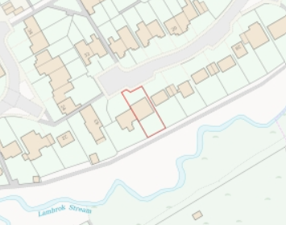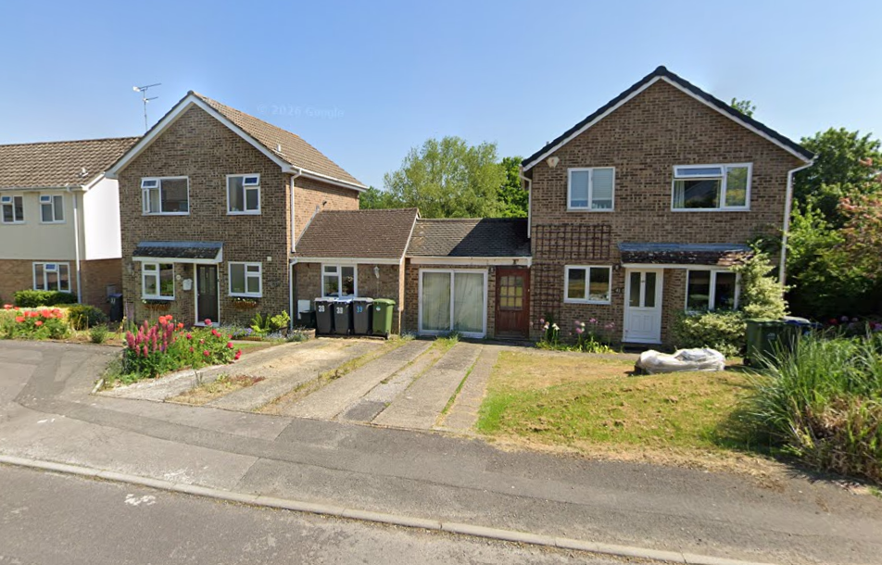

Location Plan and Google Earth Site Photo

Due to the rear garden backing on to Lambrok Stream, the site has an increased risk of groundwater flooding.

The property benefits from previous development and a wrap-around single storey extension such that the subject property is noticeably larger than neighbouring pair no. 41.

PROPOSAL

The proposal seeks planning permission for a first-floor side extension to create an additional 4th bedroom and ensuite. Proposed materials include brick and concrete roof tiles to match existing.

The proposal includes associated internal reconfiguration and structural support, rooflights to the rear kitchen and an additional off-street parking space.

During the lifecycle of the application, revisions have been received, including a reduced ridge and specified Suds-appropriate driveway material.

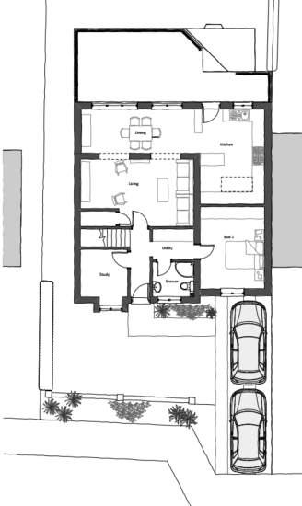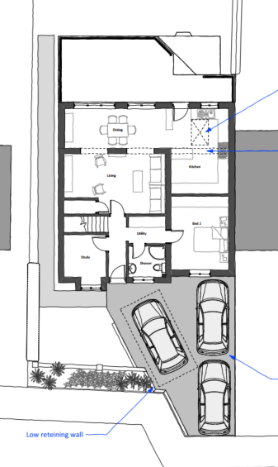

Existing and Proposed Ground Floor Plan

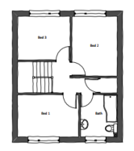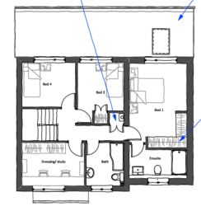

Existing and Proposed First Floor Plan

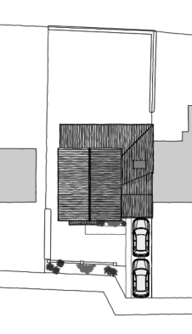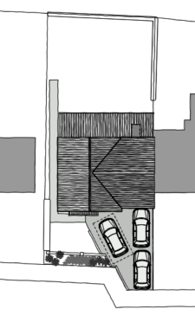

Existing and Proposed Roof Plan

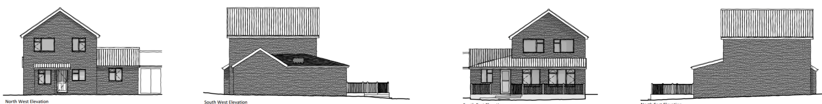

Existing Elevations

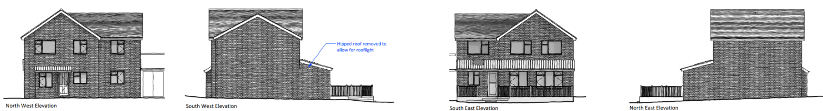

Proposed Elevations

PLANNING HISTORY
W/84/00348/FUL - Full planning permission Decision - Approve with Conditions Date: 24/4/1984 – Pitched roof to garage and forming covered way
W/07/02017/FUL - Full planning permission Decision - Refused Date: 25/7/2007 – Demolish garage to side and erect single storey extension to side and rear
W/07/02552/FUL - Full planning permission Decision - Approve with Conditions Date: 27/9/2007 – Demolish garage to side and erect single storey extension to side and rear
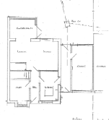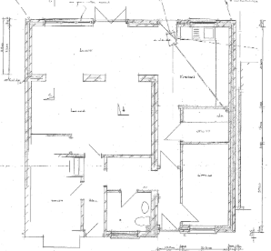
W/98/01407/FUL - Full planning permission Decision - Approve with Conditions Date: 2/11/1998 – Conservatory
W/81/00433/HIS - Historic apps 1974 to 1983 Decision - Approved Date: 12/5/1981 – Garage and study extension – no.41

RELEVANT POLICIES AND GUIDANCE
The National Planning Policy Framework (NPPF)
The Planning Practice Guidance
National Design Guide
Wiltshire Design Guide: Appendix D – Design Guidance for Householder extensions

Wiltshire Core Strategy:
- Core Policy 1: Settlement Strategy
- Core Policy 2: Delivery Strategy
- Core Policy 29: Spatial Strategy, Trowbridge Community Area
- Core Policy 57: Ensuring High Quality Design and Place Shaping
- Core Policy 61: Transport and New Development
- Core Policy 64: Demand Management
- Core Policy 67: Flood Risk

Trowbridge has a designated Neighbourhood Plan Area, but no made plans as yet.
Wiltshire Local Transport Plan 2011-2026, Car Parking Strategy

CONSULTATION RESPONSES
Trowbridge Town Council: No objection.
Highways: No objection.

REPRESENTATIONS
No comments were received.

ASSESSMENT
Section 38(6) of the Planning and Compulsory Purchase Act 2004 states:

"If regard is to be had to the development plan for the purposes of any determination to be made under the planning Acts, the determination must be made in accordance with the plan unless material considerations indicate otherwise."

In accordance with this statutory requirement, this application has been assessed against the relevant policies of the Development Plan, including the adopted Wiltshire Core Strategy (2015) and, where applicable, any made Neighbourhood Plans.

Design and Impact upon the character and context of the area
Core Policy 57 - Ensuring High Quality Design and Place Shaping of the Wiltshire Core Strategy seeks to ensure that all new development is of high design quality, reflecting local context, character, and distinctiveness.

The proposed first floor extension would maintain existing building lines and simplify the rear elevation by extending the single storey monopitch across the rear elevation.

Proposed materials include brick and concrete roof tiles to match the host dwelling to ensure successful integration.

A reduced roof ridge is proposed, in line with the standard lexicon of extension building so enabling legibility and reducing sense of massing.

Whilst it is noted that the first-floor extension would be over a previous wraparound single storey extension, such that the dwelling is significantly larger than other similar properties on the road, the design and materiality ensures the development would successfully harmonise with the host dwelling and wider streetscape.

Having regard to the above, the proposal complies with the design principles set out in Core Policy 57 of the Wiltshire Core Strategy and Appendix D of the Wiltshire Design Guide.

Amenity
Point vii of Core Policy 57 - Ensuring High Quality Design and Place Shaping of the Wiltshire Core Strategy seeks to ensure that developments do not adversely affect neighbouring properties.

The National Planning Policy Framework (NPPF), particularly Paragraph 135(f), stresses that planning decisions should ensure developments provide a high standard of amenity for existing and future users.

The proposed development has been assessed in terms of its potential impact on the residential amenity of neighbouring properties, with particular regard to loss of light, overshadowing, loss of privacy, and overbearing effects.

Given the orientation of the property, the proposal would create shadows to the front garden primarily, and minimally to the front gardens/driveway of its immediate neighbours - not the primary rear amenity space.

The existing building lines would be maintained, and the intervening converted garage of no.41 would create a spatial gap at first floor level such that there are no concerns with overbearing or sense of overshadowing.

It is noted that no.41 across the intervening garage, as per the photo below, does not have any windows on its side (east) elevation facing the proposed extension.

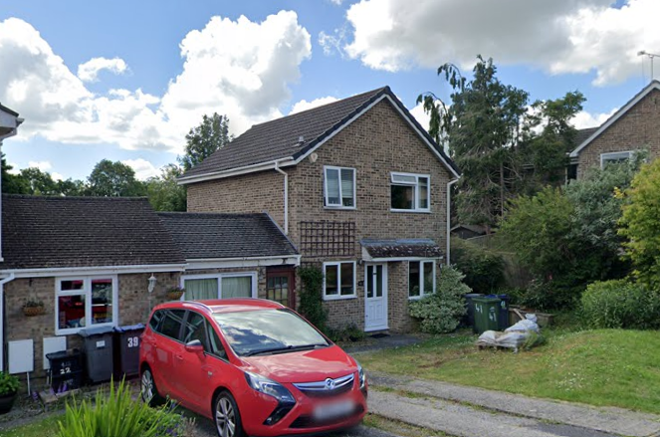

The proposed rooflight in the kitchen is at a height to not cause concern to neighbouring privacy. All other additional windows would look along the front and rear gardens so as to not cause a negative impact to neighbouring privacy.

The proposal therefore accords with Core Policy 57 point vii in respect of safeguarding residential amenity and Appendix D of the Wiltshire Design Guide.

Highways Impact
Core Policy 57 (xiv) of the Wiltshire Core Strategy seeks to ensure that development must meet the requirements of Core Policy 61. This policy requires proposals to be capable of being served by safe access to the highway network. Core Policy 64 seeks to ensure compliance with parking standards set out in the Local Transport Plan.

The National Planning Policy Framework (NPPF), particularly Paragraph 115 and 116, requires that development proposals do not have an unacceptable impact on highway safety and that safe and suitable access to the site can be achieved for all users.

The proposal includes an additional 4th bedroom, which would entail the potential for increased parking demand. As per Wiltshire’s Car Parking Strategy, 3 off-street parking spaces are required.

The submitted proposed block plan shows an additional 3rd off-street parking space. Whilst, from the site photo, it is dubious if 3 cars could actually fit on the proposed driveway, there are no objections from the Highways Officer.

Permeable block paving is proposed for the driveway which is SuDS-appropriate.

The proposed development would not result in any adverse impact on highway safety. Adequate parking and turning provision is provided in accordance with Wiltshire’s adopted parking standards, and access arrangements are acceptable.

The proposal is therefore considered to comply with Core Policies 57 (xiv), 61 and 64 of the Wiltshire Core Strategy, the NPPF, and the Wiltshire Local Transport Plan.

Drainage and Flood Risk
CP67 of the WCS, Flood risk, highlights that “development proposed in flood risk zones 2 and 3, will require measures to reduce rainwater runoff and improve sustainable urban drainage.”

The proposal site is within flood risk zone 1, with the additional risk of groundwater flooding.

The NPPF, paragraph 167, states that where appropriate, an application should be supported by a site-specific flood risk assessment.

Householder development is considered Minor Development, under the Flood Risk planning guidance, if “physical extensions to the existing dwelling itself,” and, barring a few exceptions not relevant here, “are unlikely to raise significant flood risk.” The proposal to remodel an existing property, is therefore deemed to not result in any loss of land prone to flood risk.

The existing drainage arrangements are unaltered by the proposals and SuDS-appropriate permeable block paving for the driveway is proposed.

As such, the proposal is deemed to be safe for its users for the intended lifetime of the development with respect to the level and nature of the flood risk.

The proposal therefore complies with Core Policy 67 of the Wiltshire Core Strategy and the policy in the NPPF, ensuring that flood risk is not increased and that surface water drainage is appropriately managed.

Biodiversity Net Gain
Householder planning applications are exempt from the requirement to deliver Biodiversity Net Gain under Schedule 7A, Section 4(2)(a) of the Town and Country Planning Act 1990, as inserted by the Environment Act 2021.

CONCLUSION
The proposed development is considered to be acceptable in terms of its design, scale, and relationship with the surrounding area. It would not result in any unacceptable harm to the character of the locality, the amenities of neighbouring occupiers, or the interests of highway safety.

The proposal is therefore considered to comply with the relevant policies of the Wiltshire Core Strategy, the Wiltshire Local Plan, and the National Planning Policy Framework. As such, the application is recommended for approval, subject to the conditions set out below.

RECOMMENDATION: That Planning Permission be GRANTED subject to conditions.

