APPLICATION FOR FULL PLANNING PERMISSION DELEGATED REPORT

APPLICATION REFERENCE: | PL/2026/02830
APPLICATION TYPE: | Full planning permission
SITE ADDRESS: | St John The Baptist Church, Church Lane, Bishopstone, Salisbury, SP5 4AS
DEVELOPMENT DESCRIPTION: | Replacement wooden shed which houses a camping toilet in the churchyard.
RECOMMENDATION: | That Planning Permission be GRANTED

PROPOSAL

The proposal seeks planning permission for the replacement of a wooden shed.

Existing shed

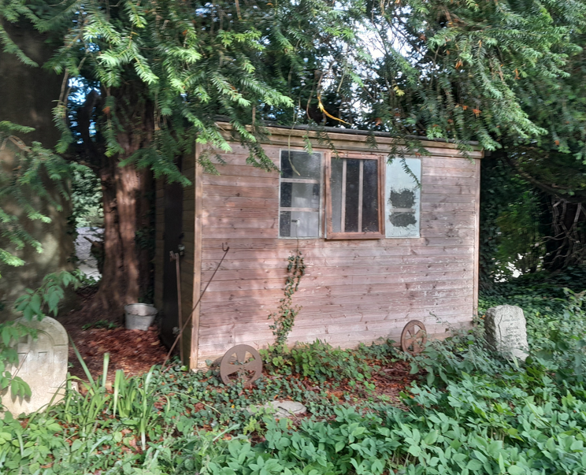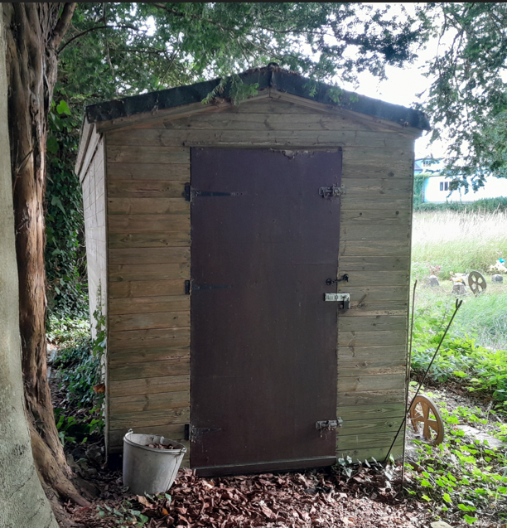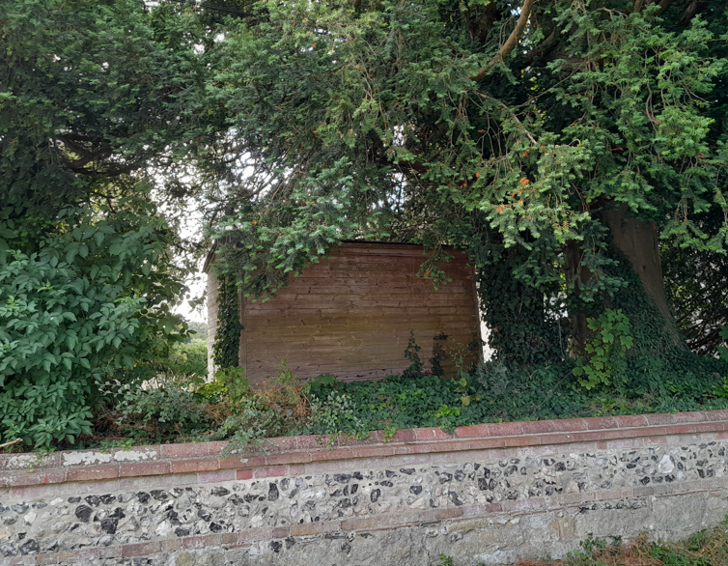

Proposed shed

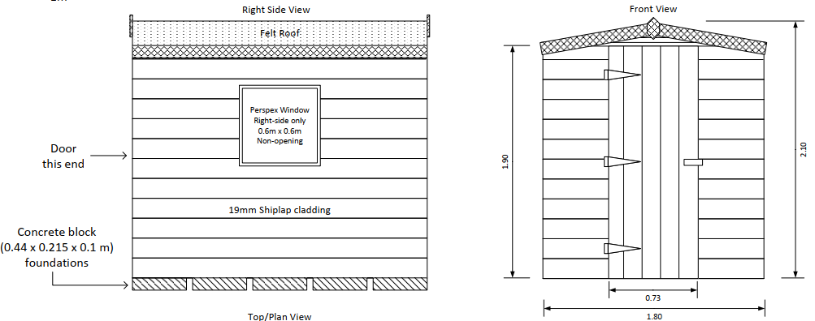

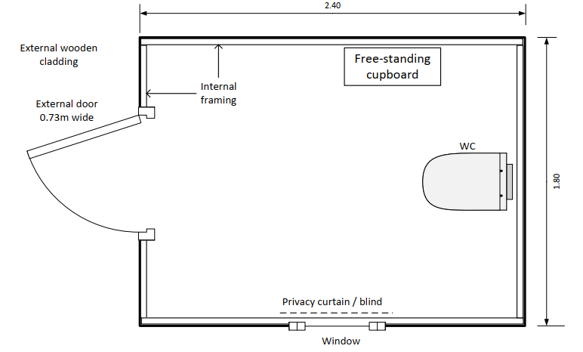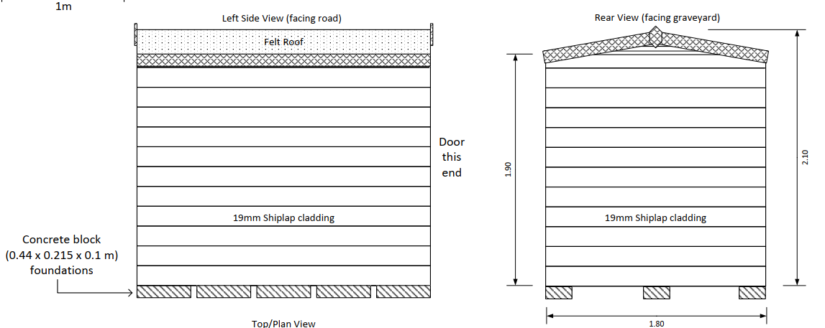

SITE DESCRIPTION/CONTEXT

The application site relates to St John the Baptist Church, a Grade 1 listed building located on the east side of Church Lane in Bishopstone which lies outside of defined settlement boundaries as defined by Wiltshire Core Strategy (WCS) policies CP1, CP2, and CP33. There are other nearby listed buildings to the east, south and west as shown with black hatching on the map extract below.

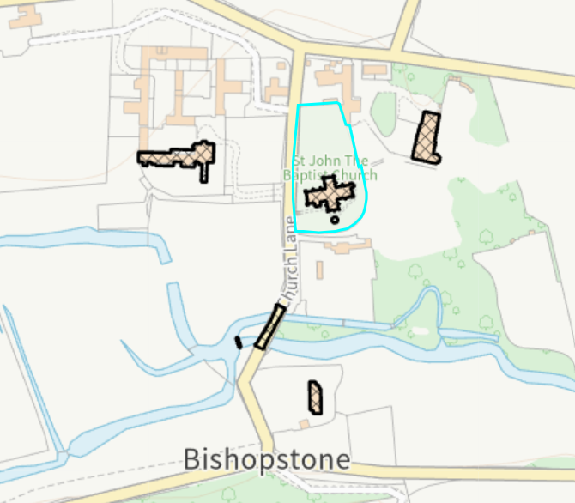

The site is not located within a conservation area but does lie within the Cranborne Chase and West Wiltshire Downs National Landscape. It is situated within the Hampshire River Avon Catchment and within the 13.8 kilometre recreational buffer of the New Forest Special Protection Area (SPA). However, these designations are not relevant to the assessment of this full planning application due to the nature of the proposed development concerned.

There are three public rights of way close to the application site, but none run through the site itself, these are marked with purple lines on the map extract below.

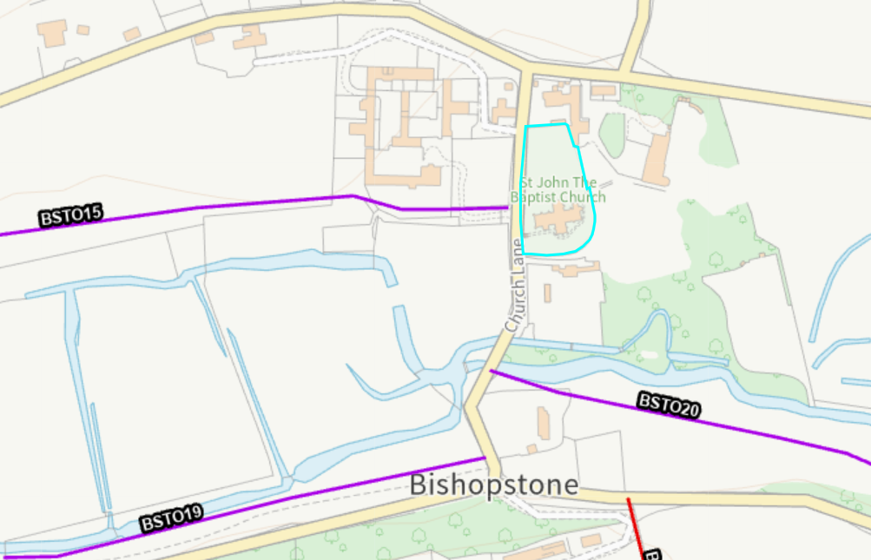

PLANNING HISTORY

Proposal / Summary
PL/2023/00432 - Full planning permission Decision - Approve with Conditions Date: 14/3/2023 – Installation of hand rails beside steps of entrance to church (Not attached to the Grade 1 listed building)

RELEVANT POLICIES AND GUIDANCE

S66 of the Planning (Listed Building and Conservation Areas) Act 1990

The National Planning Policy Framework (NPPF)
The Planning Practice Guidance
National Design Guide

Wiltshire Core Strategy:

- Core Policy 1: Settlement Strategy
- Core Policy 2: Delivery Strategy
- Core Policy 33: Spatial Strategy for the Wilton Community Area
- Core Policy 50: Biodiversity and Geodiversity
- Core Policy 51: Landscape
- Core Policy 57: Ensuring High Quality Design and Place Shaping
- Core Policy 58: Conservation
- Core Policy 61: Transport and New Development
- Core Policy 64: Demand Management
- Core Policy 69: River Avon SAC

Wiltshire Design Guide: Appendix D – Design Guidance for Householder extensions
Creating Places Design Guide

CONSULTATION RESPONSES

Parish Council: No objection

Historic England: No comments

REPRESENTATIONS

No comments were received.

ASSESSMENT

Section 38(6) of the Planning and Compulsory Purchase Act 2004 states:

"If regard is to be had to the development plan for the purposes of any determination to be made under the planning Acts, the determination must be made in accordance with the plan unless material considerations indicate otherwise."

In accordance with this statutory requirement, this application has been assessed against the relevant policies of the Development Plan, including the adopted Wiltshire Core Strategy (2015) and, where applicable, any made Neighbourhood Plans.

Design and Impact upon the upon the character and context of the area, National Landscape and setting of adjacent listed buildings.

From the point of view of the historic environment the main statutory tests are set out within the Planning (Listed Building and Conservation Areas) Act 1990.

Section 66 requires that special regard be given to the desirability of preserving listed buildings, their settings or any features of special architectural or historic interest which they possess.

The Council’s Core Strategy CP 57: Ensuring high quality design requires a high quality of design in all new developments. The policy requires applicants to “demonstrate how the proposal will make a positive contribution to the character of Wiltshire through (amongst other things) responding to the value of the natural and historic environment and being sympathetic to and conserving historic buildings and landscapes. Development is required to respond positively to the existing in terms of building layouts, built form, height, mass, scale, building line, plot size, elevational design, materials, streetscape and rooflines to effectively integrate the building into its setting.

The Council’s Core Strategy Policy CP58 ‘Ensuring the conservation of the historic environment’ requires that designated and non-designated heritage assets and their settings will be conserved, and where appropriate enhanced, in a manner appropriate to their significance and encourages proposals which improve the condition of heritage assets at risk.

The NPPF outlines government policy for planning. Chapter 16 of the NPPF 'Conserving and enhancing the historic environment' sets out the Government's high-level policies concerning heritage and sustainable development.

Core Policy 51 of the Wiltshire Core Strategy requires all development to protect, conserve, and where possible enhance the character and quality of Wiltshire’s landscapes, giving particular weight to designated areas such as National Landscapes.

The National Planning Policy Framework (NPPF), in Paragraph 189, states that “great weight” should be given to conserving and enhancing landscape and scenic beauty in National Landscapes (formerly Areas of Outstanding Natural Beauty). Development within or affecting the setting of a National Landscape must demonstrate that it will not result in unacceptable harm to the special qualities of that area.

The proposal relates to the replacement of an existing timber shed situated within the churchyard of the Grade I listed Church of St John the Baptist. The replacement structure would occupy the same position as the existing shed and would be slightly smaller in overall footprint. Whilst the design and appearance of the shed are functional and utilitarian in nature, its scale, form and materials are broadly comparable to the existing structure it replaces. It is noted that no planning history can be found for the existing shed but from Google maps it has been in position for at least 5 years. As such, the proposal would not introduce a significantly different or more visually prominent feature within the churchyard.

The shed is located adjacent to mature trees which provide a degree of natural screening and visual containment. The trees are not protected by virtue of a tree preservation order or by being located in a conservation area, technically no consent is required to undertake any works to the trees. However, the applicant has confirmed that there will be no digging involved with the installation of the shed and therefore the root protection area should not be affected. Given the proposals relate toa replacement shed in the same location as the existing but with a smaller footprint it is not considered that there will be harmful impacts on the nearby trees.

The applicant has confirmed that the proposed shed will be painted a dark green colour called Ducks Back by Cuprinol to help the shed blend in with the dark green foliage of the two overhanging yew trees. A condition will be added to any permission to ensure the external paint is done in this colour and within a limited timeframe of 3 months from the installation of the shed to secure this external dark finish to the shed.

Furthermore, its position within the churchyard limits its visibility from the wider locality. Given the modest scale of the building, its replacement of an existing structure and the absence of any increase in footprint or prominence, the development would not result in material harm to the character or appearance of the site or the surrounding area.

The existing and proposed shed is used/to be used ancillary to the Church for storage and to house a camping toilet due to their being no facilities which serve the Church or surrounding area. The toilet is used for emergencies only; the applicant has confirmed that the camping toilet is self-contained and does not require any new drainage infrastructure. Waste is collected within a removable tank and disposed of separately. Consequently, the proposal does not necessitate any excavation, or drainage works within the churchyard.

Particular regard has been given to the site's heritage context. The Church of St John the Baptist is a Grade I listed building and there are other heritage assets within the vicinity. However, the proposal involves the replacement of an existing timber shed of a similar appearance and in the same location. Owing to its limited scale, ancillary function and visually recessive position, the shed would not compete with, detract from, or otherwise adversely affect appreciation of the church or its setting.

The proposal is therefore considered to preserve the setting of the Grade I listed church and nearby listed buildings, in accordance with Section 66 of the Planning (Listed Buildings and Conservation Areas) Act 1990, Core Policy 58 of the Wiltshire Core Strategy and the heritage objectives of the NPPF.

The site also lies within the Cranborne Chase National Landscape. Having regard to the replacement nature of the proposal, the reduced footprint of the shed, its discreet siting and limited visibility within the wider landscape, the development would conserve the natural beauty and special qualities of the National Landscape. Consequently, the proposal is not considered to give rise to any unacceptable landscape or visual harm

Having regard to the above, the proposal complies with the above listed planning policies and guidance.

Amenity

Point vii of Core Policy 57 - Ensuring High Quality Design and Place Shaping of the Wiltshire Core Strategy seeks to ensure that developments do not adversely affect neighbouring properties.

The National Planning Policy Framework (NPPF), particularly Paragraph 135(f), stresses that planning decisions should ensure developments provide a high standard of amenity for existing and future users.

The proposed development has been assessed in terms of its potential impact on the residential amenity of neighbouring properties, with particular regard to loss of light, overshadowing, loss of privacy, and overbearing effects.

Given the scale, siting, design and use of the proposed shed, together with the fact that it replaces an existing structure in the same location, the proposal would not result in any material change to the relationship with neighbouring land uses. Given the separation distances involved, no unacceptable impacts in terms of outlook, privacy, overshadowing or disturbance are identified.

The proposal therefore accords with Core Policy 57 point vii in respect of safeguarding residential amenity and Appendix D of the Wiltshire Design Guide.

Archaeological Impact

The application site is located within the historic churchyard of St John the Baptist Church and therefore consideration has been given to the potential for impacts upon below-ground archaeological remains, including historic burials. The supporting information confirms that the replacement shed will be positioned in the same location as the existing structure and raised on blocks, with no excavation, foundations or other ground disturbance proposed as part of the development. Furthermore, the applicant has confirmed that the replacement of the existing shed can be undertaken without any digging or groundworks.

Given the replacement nature of the development, the absence of any proposed ground disturbance and the ability to secure this through an appropriately worded planning condition, it is considered that the proposal would not result in harm to any potential archaeological remains or historic burials that may exist beneath the site. The development is therefore acceptable in archaeological terms.

Ecology Impact

Core Policy 50 of the Wiltshire Core Strategy seeks to protect and enhance biodiversity and geodiversity, including through ensuring that development avoids harm to protected species and habitats.

The National Planning Policy Framework (NPPF), in Paragraph 193, requires that development minimises impacts on and provides net gains for biodiversity, including ensuring mitigation is secured where harm cannot be avoided.

The development as detailed above relates to the erection of a replacement shed in the same location as the existing but covering a smaller footprint for use ancillary to the associated Church.

Biodiversity Net Gain (BNG) became mandatory from 12 February 2024 under Schedule 7A of the Town and Country Planning Act 1990. The proposal relates to the replacement of an existing shed within the same location and footprint area and falls within the exemptions from the mandatory BNG requirement. Consequently, no Biodiversity Gain Plan is required.

As such, the development complies with Core Policy 50 of the Wiltshire Core Strategy and the relevant provisions of the NPPF.

CONCLUSION

The proposed development is considered to be acceptable in terms of its design, scale, and relationship with the surrounding area. It would not result in any unacceptable harm to the amenities of neighbouring occupiers, the significance or setting of heritage assets, archaeology, landscape character or ecology.

The proposal is therefore considered to comply with the relevant policies of the Wiltshire Core Strategy, the Wiltshire Local Plan, and the National Planning Policy Framework. As such, the application is recommended for approval, subject to the conditions set out below.

RECOMMENDATION: That Planning Permission be GRANTED subject to conditions.

1. The development hereby permitted shall be begun before the expiration of three years from the date of this permission.

REASON: To comply with the provisions of Section 91 of the Town and Country Planning Act 1990 as amended by the Planning and Compulsory Purchase Act 2004.

2. The development hereby permitted shall be carried out in accordance with the following approved plans:

Application form received 27/05/2026
Location plan received 27/05/2026
Site plan received 27/05/2026
Proposed elevations Drg no BC006 sheet 1 of 3 received 16/07/2026
Proposed elevations Drg no BC006 sheet 2 of 3 received 16/07/2026
Proposed floor plan Drg no BC006 sheet 3 of 3 received 16/07/2026
Dimensions and construction details of the shed including window details x 3 sheets received 01/05/2026
Supporting statement received 09/07/2026

REASON: For the avoidance of doubt and in the interests of proper planning.

3. Within three months of the erection of/completion of the development hereby approved, the shed shall be painted using the a dark green stain called Ducks Back by Cuprinol and shall be maintained for the lifetime of the development.

REASON: In the interests of visual amenity and the character and appearance of the area.

4. The replacement shed hereby permitted shall be installed using a no-dig construction method and shall be supported on blocks above ground level as detailed within the submitted supporting statement received 09/07/2026. No excavation, foundations or other groundworks shall take place without the prior written approval of the Local Planning Authority.

Reason: In the interests of safeguarding potential archaeological remains and historic burials beneath the site and to protect the adjacent trees

Informative

1. BNG not required

The effect of paragraph 13 of Schedule 7A to the Town and Country Planning Act 1990 is that planning permission granted for development of land in England is deemed to have been granted subject to the condition (biodiversity gain condition) that development may not begin unless:

(a) a Biodiversity Gain Plan has been submitted to the planning authority, and
(b) the planning authority has approved the plan.

The planning authority, for the purposes of determining whether to approve a Biodiversity Gain Plan, if one is required in respect of this permission would be Wiltshire Council.

There are statutory exemptions and transitional arrangements which mean that the biodiversity gain condition does not always apply. For further information on exempt developments please refer to:
https://www.gov.uk/guidance/biodiversity-net-gain-exempt-developments
Based on the information available this permission is considered to be one which will not require the approval of a biodiversity gain plan before development is begun because one or more of the statutory exemptions or transitional arrangements is considered to apply.

