5. Winterbourne Technical Note

Planning Application for Improvements to the External Area at Tilshead Village Hall

Introduction
This note has been prepared in support of the planning application for improvements to the external area adjoining Tilshead Village Hall.
Its purpose is to describe the existing intermittent winterbourne within the application site and explain how the proposed development has been designed to preserve its natural function while improving public safety.

Existing Winterbourne
An intermittent winterbourne emerges within the application site during periods of exceptionally high groundwater.
Records maintained by the Village Hall Committee indicate that the spring has been observed on seven occasions during the past fifteen years. The spring emerges during periods of extreme water levels and usually for a period during Feb/Mar. It is therefore an occasional seasonal feature rather than a permanent watercourse.
The point at which the spring emerges contains a natural depression in the ground. When the spring is not flowing, this depression is difficult to see and presents a potential trip hazard for users of the Village Hall grounds. The depression is sufficiently deep that there is a risk of ankle injury should someone step into it unexpectedly.
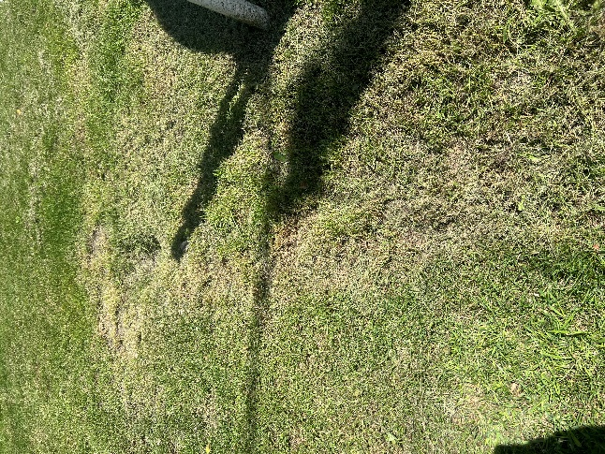
Depression formed by emergence of winterbourne spring.

Proposed Works
The proposal does not involve:
- diverting the winterbourne;
- culverting or piping the spring;
- altering its natural course;
- restricting or preventing the emergence of groundwater; or
- affecting the operation of the winterbourne in any way.
The only proposed work is the installation of a suitably designed protective grating over the existing ground depression.
The grating will allow groundwater to continue to emerge and flow naturally while providing a safe walking surface over the depression throughout the reminder of the year.
The proposal therefore preserves the natural function of the winterbourne while removing an existing safety hazard.

Consultation
Details of the proposed grating have been submitted to Daniel Everett, Principal Drainage Engineer, Highways Asset Management and Commissioning, for technical comment as requested in this email received from him on the 1st July.
From: "Everett, Daniel" <Daniel.Everett@wiltshire.gov.uk>
Date: 1 July 2026 at 09:33:34 BST
To: Sarah Jones <sarah2505@hotmail.co.uk>
Cc: "Barton, Souya" <Souya.Barton@wiltshire.gov.uk>
Subject: RE: Land drainage consent Tilshead
﻿Hi Sarah
If you aren't doing works to the watercourse and only adding a grill, Land Drainage Consent would not be required
As any work around the village hall is very visible, I would suggest that you do an application (no fee) and outline the plans and we can respond.
This will cover the PC against any questions and confirm that we have been fully consulted
Regards
Danny
We await for the final result of that application and will forward it to you as soon as we receive it. (received 14/07/26) please see below.
The Village Hall Committee will take account of any recommendations arising from that consultation before the works are undertaken.

Conclusion
The proposal has been carefully designed to balance public safety with the protection of the site’s natural features.
The intermittent winterbourne will remain entirely unaltered in its natural location and will continue to function as it does at present. The proposed grating is intended solely to remove an existing trip hazard and improve the safety of visitors using the Village Hall grounds.
It is therefore considered that the proposed works will have no adverse impact on the winterbourne while providing a significant safety benefit for users of the site.

Email received with formal permission: 14/07/2026

LDC Reference: LDC911
Works being undertaken: Installation of metal grille over the head of the spring situated within the grounds of the Village Hall.
Location: Tilshead Village Hall, High St, Tilshead, Salisbury SP3 4RZ

Thank you for providing the LDC application and supporting information for the above works.

Wiltshire Council would give Assent for the works as outlined due to the works not impacting on the watercourse channel. The application has been logged under reference 100/911/07.26

Conditions:
- The metal grille installed over the head of the spring shall be securely fixed and maintained in good condition at all times. Ongoing inspection and maintenance shall remain the responsibility of the landowner in accordance with their riparian ownership responsibilities.
- The metal grille shall be designed, installed, and maintained so as not to impede or restrict the flow of the watercourse.
- The grille shall be kept free from debris, sediment, vegetation, and any other obstruction that could restrict flows or reduce its effectiveness.
- The installation shall not increase flood risk or cause flooding, erosion, or obstruction either upstream or downstream of the site.
- Wiltshire Council reserves the right to require modification or removal of the grille should it be found to adversely affect the watercourse.

If you have any further queries, please do not hesitate to contact us.

Kind Regards

Souya Barton
Land Drainage Engineer
Weather and Drainage Team
Highways Asset Management and Commissioning

